Software Requirements
Specification
For
QuitMate-
Tobacco Awareness
Prepared by
Mohammed Karimul Mowla

ID: ASH2325031M

Md. Ariful Islam
ID: MUH2325010M

Institute of Information Technology
Noakhali Science and Technology University

Date : 16-08-2026

Table of Contents
1. Introduction 6
1.1 Purpose 7
1.2 Project Scope 7
2. Stakeholders 8
2.1 Primary Stakeholders 8
2.1.1 Tobacco Quitter 8
2.1.2 Peer Group Member 9
2.1.3 Moderator 9
2.1.4 Medical Advisor 9
2.1.5 System Administrator 10
2.2 Secondary Stakeholders 10
2.2.1 Project Owner (Authority) 10
3. Requirement Specification 11
3.1 Business Requirements 11
3.2 Business Objectives 12
3.3 User Requirements 12
3.3.1 Primary Users 12
3.3.2 Secondary Users 14
3.4 Business Rules 14
3.5 Functional Requirements 15
3.6 Quality Attributes / Performance Requirements 18
3.7 External Interface Requirements 19
3.8 Design Constraints 20
3.9 Data Requirements 21
4. Requirement Engineering Process 22
4.1 Requirement Elicitation Techniques 23
4.1.1 Interviews 23
4.1.2 Workshops 24
4.1.3 Focus Group Discussion 24
4.1.4 Observation 25
4.1.5 Questionnaires 26
4.1.6 User Interface Analysis 27
4.2 Sample of Requirement Collection 27
4.3 Requirement Validation 28
4.3.1 Review the Requirements 28
4.3.2 Test the Requirements 28
4.3.3 Simulate the Requirements 29
5. Use Case Diagram 30
6. Use case Description 31
6.1 UC-01 : Manage Profile 31
6.2 UC-02 : Set Quit Date 31
6.3 UC-03 : View Quit Plan 32
6.4 UC-04 : Daily Check-in 33
6.5 UC-05 : Track Saving 34
6.6 UC-06 : Craving Support 35
6.7 UC-07 : Start Survival Timer 36
6.8 UC-08 : Breathing Exercise 36
6.9 UC-09 : Quick Distraction 37
6.10 UC-10 : Access Peer Support Group 38
6.11 UC-11 : View QuitMate - Tobacco Awareness 39
6.12 UC-12 : View Gamification Progress 39
6.13 UC-13 : Send Peer Support Messages 40
6.14 UC-14 : Receive Peer Support Messages 41
6.15 UC-15 : Offline Data Caching 42
6.16 UC-16 : Send Notification 42
6.17 UC-17 : Manage Content 43
6.18 UC-18 : System Administration & Community Moderation 44
7 Activity Diagrams 46
7.1 Activity Diagram for Manage Profile 46
7.2 Activity Diagram for Set Quit Date 47
7.3 Activity Diagram for View Quit Plan 48
7.4 Activity Diagram for Daily Check-in 49
7.5 Activity Diagram for Track Saving 50
7.6 Activity Diagram for Craving Support 51
7.7 Activity Diagram for Start Survival Timer 52
7.8 Activity Diagram for Breathing Exercise 53
7.9 Activity Diagram for Quick Distraction 54
7.10 Activity Diagram for Access Peer Support Group 55
8. Sequence Diagram 55
8.1 Sequence Diagram for Manage Profile 55
8.2 Sequence Diagram for Set Quit Date 56
8.3 Sequence Diagram for View Quit Plan 57
8.4 Sequence Diagram for Daily Check-in 58
8.5 Sequence Diagram for Track Saving 59
8.6 Sequence Diagram for Craving Support 60
8.7 Sequence Diagram for Start Survival Timer 60
8.8 Sequence Diagram for Breathing Exercise 61
8.9 Sequence Diagram for Quick Distraction 62
8.10 Sequence Diagram for Access Peer Support Group 63
9 Swimlane Diagram 65
9.1 Swimlane Diagram for Manage Profile 65
9.2 Swimlane Diagram for Set Quit Date 66
9.3 Swimlane Diagram for View Quit Plan 67
9.4 Swimlane Diagram for Daily Check-in 68
9.5 Swimlane Diagram for Track Saving 69
9.6 Swimlane Diagram for Craving Support 70
9.7 Swimlane Diagram for Start Survival Timer 71
9.8 Swimlane Diagram for Breathing Exercise 72
9.9 Swimlane Diagram for Quick Distraction 73
9.10 Swimlane Diagram for Access Peer Support Group 74
10. Requirement Traceability Matrix 75
11. Database Design 77
11.1 Entity Relationship Diagram 77
11.2 ER Diagram to Relational Schema: 78
13 Conclusion 78
14 Reference 79
15 Appendix 79

List of Figures
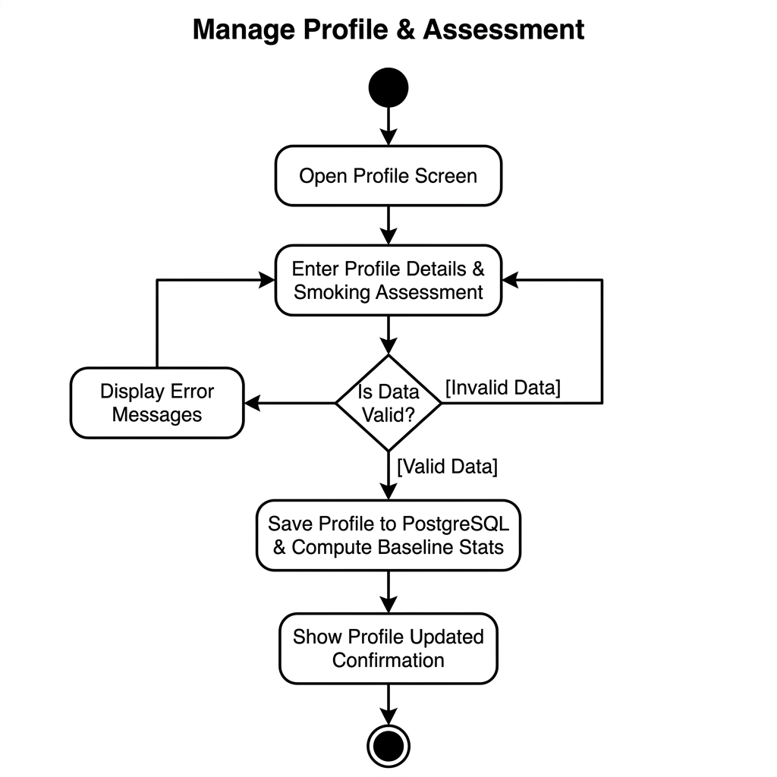
Figure 2: Activity Diagram for Manage Profile 56
Figure 3: Activity Diagram for Set Quit Date 57
Figure 4: Activity Diagram for View Quit Plan 58
Figure 5: Activity Diagram for Daily Check-in 59
Figure 6: Activity Diagram for Track Saving 60
Figure 7: Activity Diagram for Craving Support 61
Figure 8: Activity Diagram for Start Survival Timer 62
Figure 9: Activity Diagram for Breathing Exercise 63
Figure 10: Activity Diagram for Quick Distraction 64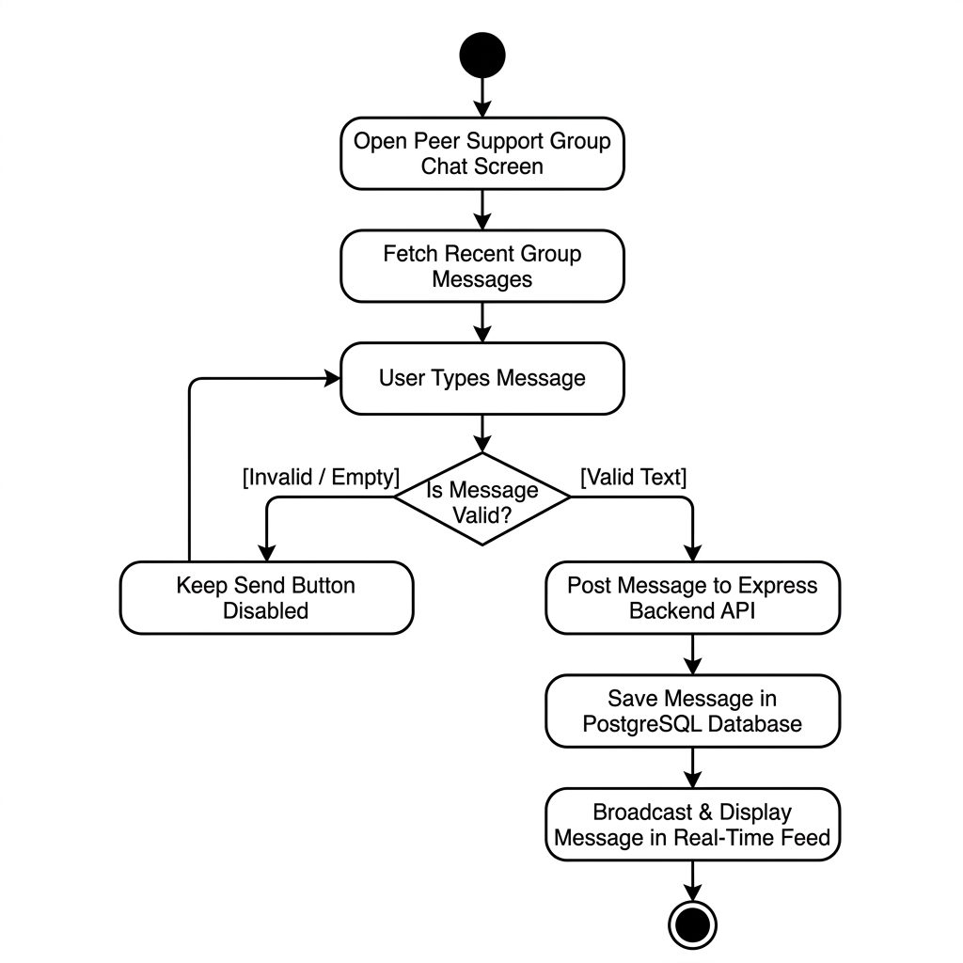
Figure 11: Activity Diagram for Access Peer Support Group 65

Figure 12: Sequence Diagram for Manage Profile 74
Figure 13: Sequence Diagram for Set Quit Date 75
Figure 14: Sequence Diagram for View Quit Plan 76
Figure 15: Sequence Diagram for Daily Check-in 77
Figure 16: Sequence Diagram for Track Saving 78
Figure 17: Sequence Diagram for Craving Support 79
Figure 18: Sequence Diagram for Start Survival Timer 80
Figure 19: Sequence Diagram for Breathing Exercise 81
Figure 20: Sequence Diagram for Quick Distraction 82
Figure 21: Sequence Diagram for Access Peer Support Group 83
Figure 22: Swimlane Diagram for Manage Profile 84
Figure 23: Swimlane Diagram for Set Quit Date 85
Figure 24: Swimlane Diagram for View Quit Plan 86
Figure 25: Swimlane Diagram for Daily Check-in 87
Figure 26: Swimlane Diagram for Track Saving 88
Figure 27: Swimlane Diagram for Craving Support 89
Figure 28: Swimlane Diagram for Start Survival Timer 90
Figure 29: Swimlane Diagram for Breathing Exercise 91
Figure 30: Swimlane Diagram for Quick Distraction 92
Figure 31: Swimlane Diagram for Access Peer Support Group 93
Figure 32: Requirement Traceability Matrix 95
Figure 33: Entity Relationship Diagram 96
Figure 34: Relational Schema 98

1. Introduction
QuitMate - Tobacco Awareness is a mobile application designed to help people quit smoking and other tobacco products. The application supports tobacco quitters by providing step-by-step guidance, daily goals, craving management tools, emotional support, and motivational features.
Many people want to quit tobacco but face difficulties because of addiction, stress, social influence, or lack of support. This system simplifies the quitting journey by dividing the process into manageable daily activities and providing assistance during difficult moments.
The application also helps tobacco quitters monitor their progress, track money saved from avoiding tobacco products, and set personal savings goals for meaningful rewards.
Overall, QuitMate - Tobacco Awareness aims to support tobacco quitters in achieving a healthier and tobacco-free lifestyle.

1.1 Purpose
The purpose of this Software Requirements Specification (SRS) document is to provide a clear and structured description of the QuitMate - Tobacco Awareness mobile-based tobacco cessation system.
This document describes the system objectives, features, functional requirements, non-functional requirements, and limitations to ensure a proper understanding among all stakeholders, including tobacco quitters, peer group members, moderators, medical advisors, system administrators, and project authorities.
The document serves as a guideline for system analysis, design, development, testing, and maintenance. It also defines the expected behavior and performance of the system and acts as a reference for the development team, supervisors, clients, and other stakeholders involved in the project.

1.2 Project Scope
QuitMate - Tobacco Awareness is a mobile application that helps tobacco quitters stop tobacco use through a structured and supportive quitting process.
The system allows tobacco quitters to:
- Create a profile with basic information such as age, gender, institution, and tobacco type.
- Select a personal quit date.
- Receive a personalized quit plan for 7, 14, or 30 days.
- Set daily quitting goals.
- Identify personal tobacco triggers such as stress, friends, or after meals.
- Complete daily check-ins regarding tobacco usage.
- Track craving levels using a scale from 1 to 10.
- Monitor mood conditions such as stress, anxiety, and boredom.
- Write short daily reflections and progress notes.
- Use an SOS button during strong cravings.
- Follow a 5-minute survival timer during cravings.
- Practice guided breathing exercises using the 4-7-8 breathing method.
- Access quick distraction techniques during cravings.
- Track money saved by avoiding tobacco products.
- Create a wishlist goal using saved money.
- View savings progress through a progress bar.
- Join peer support group chats.
- Send messages to peer group members.
- Ask anonymous questions.
- Request immediate support when necessary.
- Earn badges for completing activities.
- Increase levels such as Beginner, Warrior, and Smoke-Free Champion.
- Read tobacco awareness articles and educational content.
- Receive motivational notifications and reminders.
The system mainly focuses on behavior change, emotional support, motivation, awareness, and progress tracking.

2. Stakeholders
The system contains different categories of stakeholders. Each stakeholder has specific roles, responsibilities, and system requirements.

2.1 Primary Stakeholders

2.1.1 Tobacco Quitter
Description
The primary stakeholder of the system who uses the application to quit tobacco products.
Needs
- Easy and personalized quit plans
- Daily motivational support
- Craving management assistance
- Progress monitoring tools
- Financial savings tracking
- Peer and peer member support
- Awareness and educational materials
Responsibilities
- Provide accurate information during registration
- Use the application honestly and responsibly
- Follow community guidelines and rules

2.1.2 Peer Group Member
Description
A support person who provides emotional guidance and encouragement to tobacco quitters.
Needs
- Access to support requests
- Secure messaging system
- Communication tools for guidance and peer support
Responsibilities
- Respect tobacco quitter privacy
- Provide supportive and appropriate advice
- Follow platform policies and ethical standards

2.1.3 Moderator
Description
A stakeholder responsible for monitoring community discussions and maintaining a safe communication environment.
Needs
- Access to group chats and reports
- Ability to remove inappropriate content
- Monitoring and moderation tools
Responsibilities
- Enforce community guidelines
- Maintain respectful discussions
- Prevent misuse of the platform

2.1.4 Medical Advisor
Description
A healthcare or awareness professional who provides verified quitting guidelines, awareness articles, and day-wise quitting tasks for the system. The development team collects and manages this information from medical advisors for use inside the application.
Needs
- Ensure awareness information is medically accurate
- Provide verified quitting guidance and recommendations
- Support the preparation of educational content
Responsibilities
- Provide authentic and evidence-based information
- Review awareness materials and quitting guidance
- Ensure the accuracy and reliability of health-related content

2.1.5 System Administrator
Description
The stakeholder responsible for managing and maintaining the entire system.
Needs
- Manage tobacco quitters, community members, and moderators
- Manage awareness content and system settings
- Monitor system performance and security
- Handle backups and technical maintenance
Responsibilities
- Maintain system stability and security
- Perform system updates and backups
- Resolve technical and operational issues

2.2 Secondary Stakeholders

2.2.1 Project Owner (Authority)
Description
The authority responsible for overseeing and approving the project.
Needs
- Monitor system effectiveness and public impact
- Approve major updates and improvements
- Ensure achievement of public health objectives
Responsibilities
- Provide overall project direction
- Approve major decisions and policies
- Support long-term system sustainability

3. Requirement Specification
All the requirements based on the elicitation process are described in this section.

3.1 Business Requirements
BR-1: Provide Structured Tobacco Cessation Support System
Field | Content | Field | Content
BR-1 | The system shall provide a structured mobile-based tobacco cessation support system for tobacco quitters.
Description | The system shall offer personalized quit plans, craving management tools, emotional support features, savings tracking, awareness materials, and motivational mechanisms to assist tobacco quitters in achieving a tobacco-free lifestyle.
Stakeholders | Tobacco Quitter, Peer Group Member, Medical Advisor, System Administrator, Project Owner | Priority | High

BR-2: Enable Digital Peer Support and Peer Support Services
Field | Content | Field | Content
BR-2 | The system shall enable secure peer support and digital peer support services.
Description | The system shall support peer group discussions, peer support messaging, anonymous questions, and emergency support requests under moderation and administrative supervision.
Stakeholders | Tobacco Quitter, Peer Group Member, Moderator, System Administrator | Priority | High

3.2 Business Objectives
BO-1: Improve tobacco quitting success rate
Field | Content | Field | Content
BO-1 | The system shall improve quitting success rates through structured behavioral guidance and monitoring.
Description | Tobacco Awareness shall support daily check-ins, craving tracking, survival tools, emotional monitoring, savings visualization, and motivational rewards to encourage sustained quitting behavior.
Stakeholders | Tobacco Quitter, Medical Advisor, Project Owner | Priority | High

BO-2: Promote Public Health Awareness and Behavioral Change
Field | Content | Field | Content
BO-2 | The system shall promote awareness of tobacco-related health risks and encourage healthy lifestyle habits.
Description | The system shall provide verified educational content, awareness articles, day-wise quitting guidance, and motivational notifications to increase knowledge and prevent relapse.
Stakeholders | Tobacco Quitter, Medical Advisor, Project Owner | Priority | High

3.3 User Requirements

3.3.1 Primary Users
UR-P1: Personalized Quit Planning
Field | Content | Field | Content
UR-P1 | The system shall allow tobacco quitters to create a personalized quit plan.
Description | Tobacco quitters shall select a quit date and receive a structured 7, 14, or 30-day quitting plan with daily goals.
Stakeholders | Tobacco Quitter, Medical Advisor | Priority | High

UR-P2: Daily Check-in and Craving Tracking
Field | Content | Field | Content
UR-P2 | The system shall allow tobacco quitters to complete daily check-ins and track cravings.
Description | Tobacco quitters shall record daily tobacco usage status, craving level (1–10 scale), mood condition, and short reflections.
Stakeholders | Tobacco Quitter | Priority | High

UR-P3: Craving Emergency Support Tools
Field | Content | Field | Content
UR-P3 | The system shall provide emergency craving support tools.
Description | Tobacco quitters shall access SOS support, survival timer, breathing exercises (4-7-8 method), and quick distraction activities during cravings.
Stakeholders | Tobacco Quitter | Priority | High
UR-P4: Savings and Reward Tracking
Field | Content | Field | Content
UR-P4 | The system shall allow tobacco quitters to track money saved from quitting tobacco.
Description | The system shall calculate daily, weekly, and monthly savings and allow tobacco quitters to create wishlist goals with progress visualization.
Stakeholders | Tobacco Quitter | Priority | High

UR-P5: Peer Support and Peer Support Communication
Field | Content | Field | Content
UR-P5 | The system shall allow tobacco quitters to communicate with peer group members and support groups.
Description | Tobacco quitters shall join peer support groups, send messages to community members, request support, and ask anonymous questions.
Stakeholders | Tobacco Quitter, Peer Group Member | Priority | High

3.3.2 Secondary Users
UR-S1: Peer Support Message Delivery
Field | Content | Field | Content
UR-S1 | The system shall allow peer group members to send motivational and peer support messages.
Description | Peer community members shall provide emotional guidance and respond to support requests securely.
Stakeholders | Peer Group Member, Tobacco Quitter | Priority | High

UR-S2: Administrative System Management
Field | Content | Field | Content
UR-S2 | The system shall allow administrators to manage users, community members, and content.
Description | Administrators shall manage awareness materials, peer member accounts, reports, system performance, and moderation controls.
Stakeholders | System Administrator, Moderator | Priority | High

3.4 Business Rules
BRule-1: Verified Awareness Content Only
Field | Content | Field | Content
BRule-1 | The system shall publish awareness materials only after administrative verification.
Description | Educational content provided by medical advisors shall be reviewed and approved before being visible to tobacco quitters.
Stakeholders | Medical Advisor, System Administrator | Priority | High
BRule-2: Secure and Ethical Communication
Field | Content | Field | Content
BRule-2 | The system shall enforce respectful and secure communication guidelines.
Description | Moderators shall monitor peer discussions and peer support communications to prevent misuse or inappropriate content.
Stakeholders | Moderator, Peer Group Member, Tobacco Quitter | Priority | High

3.5 Functional Requirements
FR1 – User Registration & Profile Management: The system shall provide secure user registration, authentication, and baseline profile assessment.
Field | Content | Field | Content
FR-1 | The system shall allow tobacco quitters to manage profile information and set a quit date.
Description | Tobacco quitters shall update personal details and select a target quit date which will be stored and used for quit plan generation.
Stakeholders | Tobacco Quitter, System Administrator | Priority | High

FR2 – Quit Date & Financial Baseline Setup: The system shall allow quitters to schedule a target quit date, specify pack costs, and calculate daily baseline expenditure.
Field | Content | Field | Content
FR-2 | The system shall generate and display personalized quit plans.
Description | The system shall provide structured 7, 14, or 30-day quit plans with daily goals and milestone tracking.
Stakeholders | Tobacco Quitter, Medical Advisor | Priority | High

FR3 – Daily Check-in & Habit Tracking: The system shall log daily cravings intensity (1-10), mood rating, and cigarettes smoked count while updating clean streaks and awarding badges.
Field | Content | Field | Content
FR-3 | The system shall allow tobacco quitters to complete daily check-ins.
Description | The system shall record daily tobacco usage status, craving levels (1–10), mood conditions, and reflections for progress tracking.
Stakeholders | Tobacco Quitter | Priority | High

FR4 – Financial Savings Calculation & Wishlist Tracking: The system shall calculate total financial savings accumulated since quit date and track percentage progress toward wishlist goals.
Field | Content | Field | Content
FR-4 | The system shall calculate and display money saved from avoiding tobacco use.
Description | The system shall calculate daily, weekly, and monthly savings and allow tobacco quitters to set wishlist goals with progress tracking.
Stakeholders | Tobacco Quitter | Priority | High

FR5 – Emergency SOS Craving Support: The system shall provide an emergency SOS hub featuring a 5-Minute Survival Timer, Guided 4-7-8 Breathing exercises, and Quick Distraction tools.
Field | Content | Field | Content
FR-5 | The system shall provide emergency craving support tools.
Description | The system shall provide SOS support, survival timer, breathing exercise (4-7-8), and quick distraction activities during strong cravings.
Stakeholders | Tobacco Quitter | Priority | High

FR6 – Peer Support Community Chat: The system shall provide a real-time community chatroom for tobacco quitters to share encouragement and peer motivation.
Field | Content | Field | Content
FR-6 | The system shall support peer group communication and peer support messaging.
Description | The system shall allow tobacco quitters to join support groups, send messages to peer group members, and request support.
Stakeholders | Tobacco Quitter, Peer Group Member, Moderator | Priority | High

FR7 – Groq AI Craving Assistant Integration: The system shall integrate with Groq AI Service API to deliver intelligent, personalized craving coping advice.
Field | Content | Field | Content
FR-7 | The system shall implement gamification features to motivate tobacco quitters.
Description | The system shall assign badges, levels (Beginner, Warrior, Champion), streaks, and badges based on completed activities.
Stakeholders | Tobacco Quitter, System Administrator | Priority | Medium

FR8 – Tobacco Awareness Articles & Health Timeline: The system shall present educational awareness articles and a health recovery timeline (20m to 1yr recovery milestones).
Field | Content | Field | Content
FR-8 | The system shall send reminders and motivational notifications.
Description | The system shall generate scheduled and event-based notifications for daily check-ins, milestones, and awareness content.
Stakeholders | Tobacco Quitter, System Administrator | Priority | High

FR9 – Offline Data Caching & Auto-Synchronization: The system shall locally cache user entries in Hive offline storage, auto-syncing with the PostgreSQL backend when internet connectivity is restored.
Field | Content | Field | Content
FR-9 | The system shall locally cache user check-ins, profile edits, and savings goals in Hive offline storage, auto-syncing with PostgreSQL database when internet connectivity is restored.
Description | The system shall automatically synchronize pending offline Hive caches with the PostgreSQL backend database upon network restoration.
Stakeholders | Tobacco Quitter, System Administrator, PostgreSQL Database | Priority | Medium

3.6 Quality Attributes / Performance Requirements
QA-1: System Availability
Field | Content | Field | Content
QA-1 | The system shall maintain 99% monthly availability for all core features.
Description | The system shall remain operational with high uptime so tobacco quitters can access support tools, check-ins, and resources at any time.
Stakeholders | Tobacco Quitter, System Administrator, Project Owner | Priority | High

QA-2: Response Time
Field | Content | Field | Content
QA-2 | Standard operations shall respond within 2 seconds.
Description | The system shall provide fast response for profile updates, daily check-ins, craving tools, savings calculation, and content loading.
Stakeholders | Tobacco Quitter | Priority | High

QA-3: Offline Data Synchronization Speed
Field | Content | Field | Content
QA-3 | Offline data synchronization shall complete within 3 seconds under normal network conditions.
Description | The system shall ensure quick and reliable local caching of user check-in entries during offline operation.
Stakeholders | Tobacco Quitter, System Administrator, Project Owner | Priority | Medium

QA-4: Security and Privacy
Field | Content | Field | Content
QA-4 | All user data shall be securely encrypted and role-protected.
Description | The system shall protect personal information, health-related data, messages, and progress records using encryption and proper access control.
Stakeholders | Tobacco Quitter, System Administrator, Project Owner | Priority | High

QA-5: Scalability
Field | Content | Field | Content
QA-5 | The system shall scale to support increasing users and data growth.
Description | The system shall maintain stable performance as the number of tobacco quitters, messages, and daily records increases.
Stakeholders | Project Owner, System Administrator | Priority | Medium

3.7 External Interface Requirements
EIR-1: PostgreSQL Database Interface
Field | Content | Field | Content
EIR-1 | The system shall integrate with external offline cache services.
Description | The system shall connect with secure financial savings services to process entries for app features and peer support sessions.
Stakeholders | Tobacco Quitter, System Administrator, Project Owner | Priority | High

EIR-2: Notification Service Interface
Field | Content | Field | Content
EIR-2 | The system shall integrate with notification services (SMS/Push).
Description | The system shall connect with external services to deliver motivational reminders, craving alerts, and daily check-in notifications.
Stakeholders | Tobacco Quitter, System Administrator | Priority | High

EIR-3: Database Service Interface
Field | Content | Field | Content
EIR-3 | The system shall interface with secure database services.
Description | The system shall securely store and retrieve all user profiles, quit plans, daily records, messages, and savings data.
Stakeholders | System Administrator, Project Owner | Priority | High

3.8 Design Constraints
DC-1: Mobile-First Design
Field | Content | Field | Content
DC-1 | The system shall follow a mobile-first design approach.
Description | The application shall be designed primarily for smartphones with simple and easy navigation suitable for tobacco quitters.
Stakeholders | Tobacco Quitter, Project Owner | Priority | High

DC-2: Secure Communication
Field | Content | Field | Content
DC-2 | The system shall support secure HTTPS communication.
Description | All data transmission between the mobile application and server shall use secure HTTPS protocol.
Stakeholders | System Administrator, Project Owner | Priority | High

DC-3: Public Health Data Protection
Field | Content | Field | Content
DC-3 | The system shall follow public health data protection standards.
Description | The system shall comply with health data privacy guidelines while handling sensitive information related to tobacco quitting and emotional state.
Stakeholders | Medical Advisor, System Administrator, Project Owner | Priority | High

3.9 Data Requirements
DR-1: User Profile and Quit Plan Data
Field | Content | Field | Content
DR-1 | The system shall store user profile and quit plan data.
Description | Data shall include age, gender, tobacco type, quit date, personalized quit plan, and daily goals.
Stakeholders | Tobacco Quitter, System Administrator | Priority | High

DR-2: Daily Check-in and Craving Records
Field | Content | Field | Content
DR-2 | The system shall store daily check-in and craving records.
Description | Data shall include daily usage status, craving level (1-10), mood conditions, reflections, and survival timer usage.
Stakeholders | Tobacco Quitter, Medical Advisor | Priority | High
DR-3: Messaging and Peer Support Records
Field | Content | Field | Content
DR-3 | The system shall store messaging and peer support records securely.
Description | Data shall include peer group messages, peer support conversations, support requests, and anonymous questions.
Stakeholders | Tobacco Quitter, Peer Group Member, System Administrator | Priority | High

DR-4: Financial Savings and Wishlist Goal Records
Field | Content | Field | Content
DR-4 | The system shall store financial savings goal records and wishlist milestone progress.
Description | Data shall include money saved, wishlist goals, progress bar status, and financial savings history for app features.
Stakeholders | Tobacco Quitter, System Administrator | Priority | Medium

DR-5: Notification and System Logs
Field | Content | Field | Content
DR-5 | The system shall store notification logs and delivery history.
Description | Data shall include sent notifications, motivational messages, delivery status, and system activity logs.
Stakeholders | System Administrator | Priority | Medium

4. Requirement Engineering Process
The Requirement Engineering process for the QuitMate - Tobacco Awareness mobile application involved systematic identification, analysis, documentation, and validation of requirements from all relevant stakeholders. The primary goal was to understand the behavioral, emotional, technical, and health-related needs of tobacco quitters and support providers. The process ensured that the system requirements are accurate, complete, feasible, and aligned with public health objectives.
Multiple elicitation techniques were used to gather comprehensive information from stakeholders including tobacco quitters, peer group members, medical advisors, moderators, the system administrator, and the project authority.

4.1 Requirement Elicitation Techniques
Requirement elicitation for QuitMate - Tobacco Awareness used several complementary techniques to ensure a clear understanding of user expectations, quitting challenges, emotional triggers, and system usability requirements. Each technique targeted specific stakeholder groups to ensure balanced and reliable information gathering.

4.1.1 Interviews
Purpose:
The purpose of interviews was to collect detailed qualitative insights about tobacco quitting challenges, craving behavior, emotional triggers, and expectations from a digital cessation support system.
Approach:
- Semi-structured one-on-one interviews were conducted.
- Interviews were held both face-to-face and online.
- Each interview lasted approximately 20 to 30 minutes.
Stakeholders Involved:
- Ten tobacco quitters from different age groups.
- Two peer group members.
- One medical advisor.
Example Interview Questions:
- What are the main difficulties you face when trying to quit tobacco?
- What situations usually trigger your cravings?
- Would daily reminders help you stay committed to quitting?
- How important is emotional support during strong cravings?
- Would tracking money saved motivate you to continue quitting?
- Which support tool do you prefer during cravings: breathing exercises or distraction activities?
Findings:
- Most tobacco quitters struggle due to stress, social influence, and habitual triggers.
- Strong cravings typically last between 3 to 10 minutes.
- Immediate support tools increase confidence and control.
- Financial savings tracking improves motivation.
- Emotional encouragement significantly improves quitting consistency.
Impact on SRS:
The interview findings directly influenced the inclusion of features such as the survival timer, SOS support button, breathing exercise module, savings tracker, daily check-in system, and peer peer support communication.

4.1.2 Workshops
Purpose:
The purpose of workshops was to collaboratively identify system priorities, quitting flow, feature importance, and interaction design among stakeholders.
Method:
- A workshop was conducted in a university health awareness session.
- Participants included five tobacco quitters, two peer group members, and one faculty advisor.
- Brainstorming and feature prioritization techniques were applied.
Outputs:
- The quitting journey flow was defined as Profile Setup, Quit Date Selection, Personalized Plan, Daily Check-in, Craving Support, and Progress Tracking.
- The need for an emergency SOS feature was confirmed.
- A five-minute survival timer was strongly recommended.
- Gamification elements such as Streak Badges and levels were suggested.
- Wishlist goals based on saved money were proposed.
Result:
Workshop outcomes significantly shaped the gamification requirements, craving management tools, and milestone visualization features.

4.1.3 Focus Group Discussion
Purpose:
The purpose of the focus group discussion was to explore emotional, behavioral, and motivational aspects of quitting tobacco collectively.
Setup:
- Eight participants were involved, including six tobacco quitters and two peer group members.
- The session lasted approximately one hour and was moderated.
Key Discussion Topics:
- Emotional triggers and relapse risks.
- Importance of peer support.
- Role of daily motivational messages.
- Clarity and simplicity of awareness content.
Findings:
- Many quitters feel isolated during relapse moments.
- Group support reduces relapse risk.
- Short motivational messages are highly effective.
- Awareness content must be simple and easy to understand.
Impact:
The discussion resulted in the inclusion of peer support group chat, peer support messaging, motivational notifications, and structured awareness content sections.

4.1.4 Observation
Purpose:
The purpose of observation was to understand real behavioral patterns during cravings and stress situations.
Process:
- Quitting attempts were observed during awareness sessions.
- Reactions during simulated craving situations were monitored.
- Stress-handling behavior and coping strategies were recorded.
Insights:
- Cravings usually peak within a short duration of around five minutes.
- Guided breathing reduces anxiety levels.
- Distraction activities reduce urge intensity.
Result:
Observation findings inspired the implementation of the five-minute survival timer, guided breathing animation, and quick distraction module.

4.1.5 Questionnaires
Purpose:
The purpose of questionnaires was to collect quantitative data to validate system requirements on a larger scale.
Respondents:
- Twenty tobacco quitters.
- Five peer group members.
Sample Questions for Tobacco Quitters:
- What usually triggers your tobacco cravings?
- Would a daily progress tracker help you stay motivated?
- Do you prefer group support or private peer support?
- Would tracking saved money encourage you to continue quitting?
- How useful would breathing exercises be during cravings?
- Would gamification features such as Streak Badges and levels increase your engagement?
Sample Questions for Peer Group Members:
- What type of support do tobacco quitters need most?
- Should peer support messages be instant or scheduled?
- How important is monitoring craving levels?
- Do you require tools to monitor user progress?
- Should the system allow anonymous questions?
Findings:
- Ninety percent of respondents prefer daily reminders.
- Eighty-five percent want craving tracking tools.
- Seventy-eight percent believe peer support improves quitting success.
- Seventy-two percent prefer money-saving visualization.
- Eighty-eight percent support gamification features.
Impact:
The questionnaire results confirmed the importance of daily check-ins, craving scales, savings progress bars, peer communication features, and Streak Badges-based motivational systems.

4.1.6 User Interface Analysis
Purpose:
The purpose of user interface analysis was to evaluate usability and accessibility expectations for mobile users.
Process:
- Low-fidelity mobile wireframes were created.
- Navigation patterns were observed.
- User feedback on layout and design was collected.
Findings:
- Users prefer calm and simple color schemes.
- Large buttons are necessary for the SOS feature.
- A simple dashboard is preferred over complex graphs.
- Quick access to craving support tools is essential.
Impact:
These findings influenced the mobile-first design constraint, simplified dashboard structure, large SOS button placement, and clear progress indicators.

4.2 Sample of Requirement Collection
This section demonstrates how raw stakeholder inputs were transformed into formal system requirements.
TQ-01: Tobacco Quitter want immediate help during cravings.
The system shall provide a survival timer and breathing exercise module.
TQ-02: Tobacco Quitter want financial motivation.
The system shall calculate and display money saved from avoiding tobacco products.
PC-03: Community Members require communication tools.
The system shall support secure peer support messaging and support requests.
MED-04: Verified awareness content is required.
The system shall publish awareness materials only after proper verification.
PERF-05: Users expect fast system response.
The system shall respond within two seconds under normal operating conditions.
All documented requirements are traceable to their elicitation sources.

4.3 Requirement Validation
Requirement validation ensures that the documented requirements for the QuitMate - Tobacco Awareness system are correct, complete, consistent, and feasible. Even when requirements appear clear during documentation, ambiguities or conflicts may arise during development. Therefore, comprehensive validation is essential.
The validation process ensures that the system effectively supports tobacco quitting through structured plans, craving management tools, emotional support features, savings tracking, and awareness content in a reliable and user-friendly manner.

4.3.1 Review the Requirements
A structured review process was conducted involving the development team, academic supervisor, peer group members, and the medical advisor.
Review activities focused on:
- Functional and non-functional requirements.
- User workflows for tobacco quitters and community members.
- Emotional safety and ethical communication.
- Privacy and data protection.
- Feasibility of mobile implementation.
This process helped identify ambiguities, inconsistencies, and unrealistic expectations early, reducing potential development risks.

4.3.2 Test the Requirements
Requirement-based validation tests were defined to ensure:
- Each requirement is measurable and verifiable.
- Craving support tools function correctly.
- Messaging services operate reliably.
- Savings calculations are accurate.
- Notifications are triggered appropriately.
Testing requirements before full implementation ensures that development aligns with defined expectations.

4.3.3 Simulate the Requirements
Simulation-based validation was conducted using interactive prototypes to visualize system behavior before implementation.
Simulation activities included:
- Clickable mobile interface mockups.
- Craving support workflow demonstrations.
- Quit plan generation simulations.
- Messaging and notification scenarios.
- Savings tracking and gamification flow demonstrations.
Simulation enabled early detection of usability issues and workflow gaps, improving overall system quality prior to development.

5. Use Case Diagram
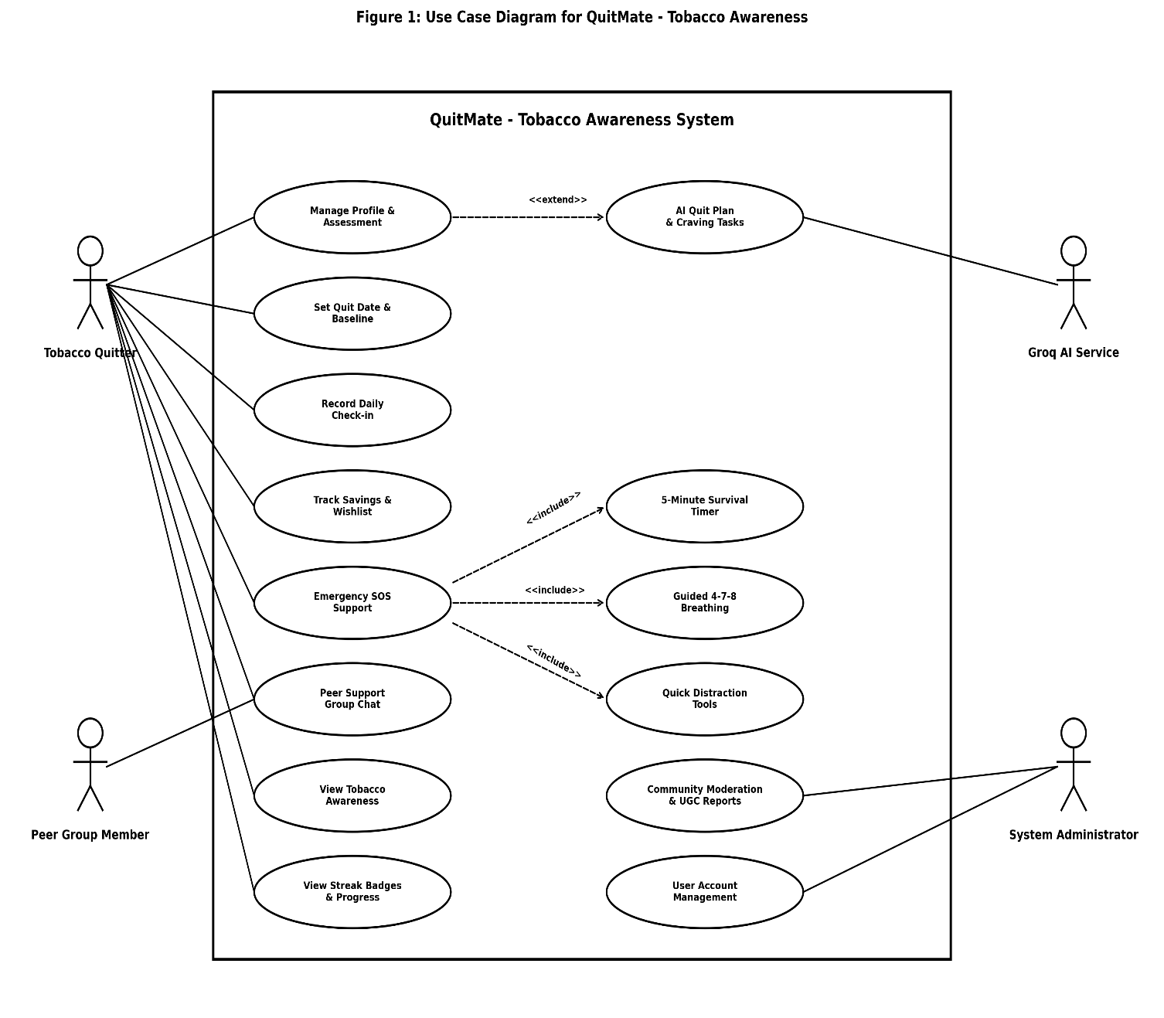
Figure 1: Use Case Diagram for QuitMate - Tobacco Awareness

6. Use case Description

6.1 UC-01 : Manage Profile
Field | Description
Use Case No | UC-01
Use Case Name | Manage Profile & Assessment
Goal | To allow the tobacco quitter to create, view, and update personal profile details and baseline smoking assessment.
Primary Actors | Tobacco Quitter
Secondary Actors | None
Precondition | N/A
Success End Condition | Profile and initial assessment details are successfully recorded in the system.
Failed End Condition | Profile update fails due to invalid form input.
Trigger | The tobacco quitter opens the profile assessment section.
Main Success Flow | 1. The tobacco quitter opens the profile assessment screen. 2. The system presents profile fields and smoking habit assessment questions. 3. The tobacco quitter enters personal details, cigarettes smoked per day, and stick price. 4. The system validates the entered information. 5. The system stores the updated profile and calculates initial baseline stats. 6. The system displays a profile updated confirmation.
Alternative Flows | A1: Invalid Profile Input  4a. The system detects missing or invalid profile data.  4b. The system displays specific field error messages.  4c. The tobacco quitter corrects the data and resubmits.
Quality Attributes | 1. Security: Personal profile data shall be protected. 2. Usability: Form fields shall be intuitive and clear. 3. Reliability: User profile data shall be stored accurately.

6.2 UC-02 : Set Quit Date
Field | Description
Use Case No | UC-02
Use Case Name | Set Quit Date & Baseline
Goal | To allow the tobacco quitter to select a target quit date and establish a baseline smoking cost.
Primary Actors | Tobacco Quitter
Secondary Actors | None
Precondition | N/A
Success End Condition | The target quit date and financial baseline parameters are saved.
Failed End Condition | Quit date setting fails due to invalid date selection.
Trigger | The tobacco quitter selects the Set Quit Date feature.
Main Success Flow | 1. The tobacco quitter opens the Quit Plan setup section. 2. The system prompts for a target quit date and cigarette cost. 3. The tobacco quitter selects the target date and cost per stick/pack. 4. The system validates the date parameter. 5. The system saves the target quit date and calculates daily baseline cost. 6. The system confirms successful setup.
Alternative Flows | A1: Past Date Selected  4a. The system detects a selected date prior to allowed range.  4b. The system prompts the quitter to select a valid future date.  4c. The tobacco quitter selects a valid date.
Quality Attributes | 1. Usability: Date picker shall provide easy selection. 2. Accuracy: Daily cost baseline calculations shall be precise.

6.3 UC-03 : View Quit Plan
Field | Description
Use Case No | UC-03
Use Case Name | View & Personalize Quit Plan
Goal | To allow the tobacco quitter to view milestone stages, health recovery timelines, and personalized quit plan recommendations.
Primary Actors | Tobacco Quitter
Secondary Actors | None
Precondition | N/A
Success End Condition | The quit plan milestones and recovery progress are displayed.
Failed End Condition | Unable to load quit plan details.
Trigger | The tobacco quitter navigates to the Quit Plan screen.
Main Success Flow | 1. The tobacco quitter opens the Quit Plan section. 2. The system retrieves stage milestones and progress calculations based on quit date. 3. The system renders stage cards, recovery timeline, and personalized advice. 4. The tobacco quitter views plan stages.
Alternative Flows | A1: Network Disconnection  2a. The system detects lack of server connectivity.  2b. The system retrieves locally cached quit plan data.  2c. The quit plan is displayed in offline mode.
Quality Attributes | 1. Performance: Quit plan screen shall load within 1.5 seconds. 2. Usability: Stages shall be presented visually.

6.4 UC-04 : Daily Check-in
Field | Description
Use Case No | UC-04
Use Case Name | Daily Check-in
Goal | To log daily smoking status, craving intensity, mood rating, and update clean streak progress.
Primary Actors | Tobacco Quitter
Secondary Actors | None
Precondition | N/A
Success End Condition | Daily check-in entry is recorded, clean streak is incremented, and badges are awarded.
Failed End Condition | Check-in submission fails due to incomplete form data.
Trigger | The tobacco quitter initiates daily check-in from dashboard.
Main Success Flow | 1. The tobacco quitter opens the Daily Check-in screen. 2. The system prompts for craving intensity score, mood rating, and cigarettes smoked count. 3. The tobacco quitter completes the entries and submits. 4. The system validates the check-in data. 5. The system records the check-in, updates clean streak, and computes earned Streak Badges. 6. The system displays check-in summary and streak animation.
Alternative Flows | A1: Duplicate Check-in Today  4a. The system detects a check-in already logged for today.  4b. The system allows updating existing check-in entries.  4c. The updated entry is saved.
Quality Attributes | 1. Usability: Check-in form shall take under 30 seconds to complete. 2. Reliability: Streak calculations shall be strictly accurate.

6.5 UC-05 : Track Saving
Field | Description
Use Case No | UC-05
Use Case Name | Track Financial Savings & Wishlist
Goal | To calculate financial money saved since quit date and track progress toward user wishlist savings goals.
Primary Actors | Tobacco Quitter
Secondary Actors | None
Precondition | N/A
Success End Condition | Total money saved is calculated and wishlist goal progress is updated.
Failed End Condition | Wishlist goal creation fails due to invalid price input.
Trigger | The tobacco quitter opens the Money Saver screen.
Main Success Flow | 1. The tobacco quitter navigates to Money Saver screen. 2. The system calculates accumulated money saved based on quit date and daily cost. 3. The tobacco quitter views total saved amount and existing wishlist items. 4. The tobacco quitter adds a new wishlist item with target cost. 5. The system computes progress percentage for each goal. 6. The system displays active savings progress.
Alternative Flows | A1: Invalid Target Price  5a. The system detects zero or negative target price.  5b. The system prompts for a valid positive amount.  5c. The quitter corrects the amount.
Quality Attributes | 1. Accuracy: Financial math calculations shall be exact. 2. Usability: Visual progress bars shall represent percentage completed.

6.6 UC-06 : Craving Support
Field | Description
Use Case No | UC-06
Use Case Name | Trigger Emergency SOS Craving Support
Goal | To provide immediate, high-priority craving relief options when a tobacco quitter encounters a sudden smoking urge.
Primary Actors | Tobacco Quitter
Secondary Actors | None
Precondition | N/A
Success End Condition | SOS emergency support hub is presented with immediate intervention options.
Failed End Condition | SOS tool launch fails due to interface error.
Trigger | The tobacco quitter taps the red emergency SOS button.
Main Success Flow | 1. The tobacco quitter taps the emergency SOS button on dashboard. 2. The system launches the high-priority SOS Support Hub. 3. The system presents quick craving options: 5-Minute Timer, Guided 4-7-8 Breathing, and Distraction Tools. 4. The system logs the SOS event for craving analytics. 5. The quitter selects an emergency intervention mode.
Alternative Flows | A1: Quick Exit  5a. The quitter closes the SOS hub.  5b. The system logs short SOS duration.  5c. The dashboard returns to normal state.
Quality Attributes | 1. Availability: SOS button shall be instantly accessible from main screen. 2. Performance: SOS hub shall open in under 0.5 seconds.

6.7 UC-07 : Start Survival Timer
Field | Description
Use Case No | UC-07
Use Case Name | Start 5-Minute Survival Timer
Goal | To initiate a 300-second countdown timer to help the quitter endure and overcome a peak craving impulse.
Primary Actors | Tobacco Quitter
Secondary Actors | None
Precondition | N/A
Success End Condition | The 5-minute survival timer completes, craving urge subsides, and completion feedback is shown.
Failed End Condition | Timer is cancelled prematurely by user.
Trigger | The quitter selects 5-Minute Survival Timer from SOS hub.
Main Success Flow | 1. The tobacco quitter selects 5-Minute Survival Timer. 2. The system initializes a 300-second countdown clock with motivational quotes. 3. The timer ticks down second-by-second while displaying survival tips. 4. The countdown reaches 0:00. 5. The system plays a completion audio signal and displays a success badge. 6. The quitter confirms feeling relieved.
Alternative Flows | A1: User Cancels Timer Early  3a. The quitter taps cancel button before 300 seconds elapse.  3b. The system stops countdown and offers breathing tool instead.  3c. The quitter switches tool.
Quality Attributes | 1. Usability: Countdown text shall be large and highly visible. 2. Reliability: Timer tick loop shall run smoothly in foreground.

6.8 UC-08 : Breathing Exercise
Field | Description
Use Case No | UC-08
Use Case Name | Perform Guided 4-7-8 Breathing Exercise
Goal | To guide the tobacco quitter through calming 4-7-8 deep breathing cycles (Inhale 4s, Hold 7s, Exhale 8s) to reduce craving anxiety.
Primary Actors | Tobacco Quitter
Secondary Actors | None
Precondition | N/A
Success End Condition | Breathing cycles complete and user experiences reduced physical tension.
Failed End Condition | Breathing session interrupted by user.
Trigger | The quitter selects Guided Breathing from SOS hub.
Main Success Flow | 1. The tobacco quitter selects Guided Breathing exercise. 2. The system displays an animated breathing circle with audio cues. 3. The system leads user through 4s Inhale -> 7s Hold -> 8s Exhale phases. 4. The cycle repeats for designated duration. 5. The system finishes the session with calming audio feedback.
Alternative Flows | A1: Audio Disabled  2a. Device audio is muted.  2b. The system continues visual color-coded animation cues.  2c. Session completes visually.
Quality Attributes | 1. Usability: Visual animations shall expand and contract rhythmically. 2. Performance: Smooth 60fps graphic transitions.

6.9 UC-09 : Quick Distraction
Field | Description
Use Case No | UC-09
Use Case Name | Quick Distraction Activities
Goal | To engage the tobacco quitter in quick physical or sensory activities (drinking water, short walk, sound effect) to divert attention from cravings.
Primary Actors | Tobacco Quitter
Secondary Actors | None
Precondition | N/A
Success End Condition | Distraction activity is completed and logged.
Failed End Condition | Distraction activity is dismissed.
Trigger | The quitter selects Quick Distractions from SOS hub.
Main Success Flow | 1. The quitter opens Quick Distractions. 2. The system presents distraction choices: Drink Water Tracker, Walk Counter, Sound Distraction. 3. The quitter selects an activity (e.g., Drink Water). 4. The system executes activity actions and plays interactive sound. 5. The quitter confirms completion. 6. The system records completed distraction task.
Alternative Flows | A1: Change Distraction Choice  3a. Quitter switches from walking to sound distraction.  3b. System activates sound player interface.  3c. Activity proceeds.
Quality Attributes | 1. Interactivity: Immediate visual/auditory feedback upon user tap. 2. Usability: Simple one-tap logging.

6.10 UC-10 : Access Peer Support Group
Field | Description
Use Case No | UC-10
Use Case Name | Participate in Peer Support Group Chat
Goal | To allow tobacco quitters to share encouragement, progress, and mutual support in a public community chatroom.
Primary Actors | Tobacco Quitter, Peer Group Member
Secondary Actors | None
Precondition | N/A
Success End Condition | Group message is posted and visible in real-time to community members.
Failed End Condition | Message delivery fails due to empty message text.
Trigger | The quitter enters the Peer Support screen.
Main Success Flow | 1. The quitter opens Peer Support Group Chat. 2. The system loads recent group messages. 3. The quitter types a supportive message. 4. The system validates text content. 5. The system posts message to backend chat endpoint. 6. The message appears in real-time chat feed.
Alternative Flows | A1: Empty Message  4a. System detects empty text string.  4b. Send button remains disabled.  4c. User enters text.
Quality Attributes | 1. Performance: Messages shall sync within 1 second. 2. Security: Inappropriate content filtering.

6.11 UC-11 : View QuitMate - Tobacco Awareness
Field | Description
Use Case No | UC-11
Use Case Name | View Tobacco Awareness & Health Timeline
Goal | To provide educational content, health recovery milestones, and tobacco harm awareness articles.
Primary Actors | Tobacco Quitter
Secondary Actors | None
Precondition | N/A
Success End Condition | Awareness articles and health recovery timeline cards are displayed.
Failed End Condition | Educational content fails to load.
Trigger | The quitter selects Education & Awareness section.
Main Success Flow | 1. The quitter opens Tobacco Awareness section. 2. The system fetches awareness categories and recovery timeline (24h, 7d, 1yr health improvement). 3. The quitter selects a health article. 4. The system renders detailed article text and graphics.
Alternative Flows | A1: Offline Mode  2a. Device is offline.  2b. System loads offline bundled articles.  2c. Content displays seamlessly.
Quality Attributes | 1. Usability: Typography shall be clear and readable. 2. Educational Value: Information based on health guidelines.

6.12 UC-12 : View Gamification Progress
Field | Description
Use Case No | UC-12
Use Case Name | View Gamification Progress & Unlock Badges
Goal | To track user badges and streak milestones, clean streak levels, and display unlocked achievement badges.
Primary Actors | Tobacco Quitter
Secondary Actors | None
Precondition | N/A
Success End Condition | Streak Badges progress, current user level, and earned achievement badges are displayed.
Failed End Condition | Gamification stats fail to refresh.
Trigger | The quitter opens Gamification & Achievements screen.
Main Success Flow | 1. The quitter opens Gamification screen. 2. The system calculates current user level, total Streak Badges, and unlocked badges. 3. The system renders level progress gauge and badge gallery. 4. The quitter reviews earned achievements and upcoming milestones.
Alternative Flows | A1: Badge Unlocked Event  2a. System detects criteria met for new badge (e.g. 7 Days Clean).  2b. System triggers celebratory dialog animation.  2c. Badge added to gallery.
Quality Attributes | 1. Gamification Appeal: Visual badges and Streak Badges counters shall motivate user. 2. Accuracy: Streak Badges calculations match check-in logs.

6.13 UC-13 : Send Peer Support Messages
Field | Description
Use Case No | UC-13
Use Case Name | Interact with AI Craving Companion
Goal | To provide intelligent, personalized craving advice and motivational conversation using Groq AI Service integration.
Primary Actors | Tobacco Quitter
Secondary Actors | Groq AI Service
Precondition | N/A
Success End Condition | AI companion responds with helpful craving coping strategies.
Failed End Condition | AI response fails due to API timeout.
Trigger | The quitter sends a query to the AI Assistant.
Main Success Flow | 1. The quitter opens AI Craving Companion tab. 2. The quitter types a craving query or feeling. 3. The system sends prompt payload to Groq AI Service API endpoint. 4. Groq AI generates intelligent response. 5. System renders response in chat view.
Alternative Flows | A1: AI Service Timeout  4a. Groq AI API times out.  4b. System displays fallback motivational response.  4c. Quitter receives immediate guidance.
Quality Attributes | 1. Intelligence: Responses tailored to tobacco cessation context. 2. Performance: AI reply rendered within 2.5 seconds.

6.14 UC-14 : Receive Peer Support Messages
Field | Description
Use Case No | UC-14
Use Case Name | Receive Peer Support Group Messages
Goal | To receive real-time community chat messages posted by other group members.
Primary Actors | Tobacco Quitter, Peer Group Member
Secondary Actors | None
Precondition | N/A
Success End Condition | Incoming peer group messages are delivered and appended to chat feed.
Failed End Condition | Incoming chat payload fails to parse.
Trigger | Another community member posts a message to group chat.
Main Success Flow | 1. Community member posts message. 2. Backend chat server receives payload. 3. System broadcasts message to connected app clients. 4. App receives payload and updates UI stream. 5. Quitter reads new message.
Alternative Flows | A1: App in Background  4a. App is minimized.  4b. System issues subtle local notification.  4c. User opens app to view message.
Quality Attributes | 1. Real-time: Sub-second message delivery. 2. Reliability: No dropped message events.

6.15 UC-15 : Offline Data Caching
Field | Description
Use Case No | UC-15
Use Case Name | Offline Data Caching & Auto-Synchronization
Goal | To cache check-ins, profile edits, and savings goals locally when offline, and auto-sync with database when connection returns.
Primary Actors | Tobacco Quitter
Secondary Actors | None
Precondition | N/A
Success End Condition | Local changes stored in Hive offline cache are synced to PostgreSQL database upon reconnection.
Failed End Condition | Sync fails due to persistent network failure.
Trigger | App detects restored internet connection or user performs action while offline.
Main Success Flow | 1. Quitter performs app action (check-in, goal creation) offline. 2. System saves data payload to local Hive storage box. 3. System monitors network status. 4. Internet connection is restored. 5. System initiates background sync service. 6. System sends cached payloads to PostgreSQL backend. 7. Server confirms successful database update.
Alternative Flows | A1: Conflict Resolution  6a. Server detects version conflict.  6b. Server resolves using latest timestamp.  6c. Database updated cleanly.
Quality Attributes | 1. Seamlessness: Sync runs silently in background. 2. Integrity: Zero data loss during offline operation.

6.16 UC-16 : Send Notification
Field | Description
Use Case No | UC-16
Use Case Name | Receive Local & Push Notifications
Goal | To deliver daily check-in reminders, motivational quotes, and survival alerts to keep quitter engaged.
Primary Actors | Tobacco Quitter
Secondary Actors | None
Precondition | N/A
Success End Condition | Notification alert is displayed on device and opens relevant app screen when tapped.
Failed End Condition | Notification permission disabled by user.
Trigger | Scheduled daily check-in time or system trigger event occurs.
Main Success Flow | 1. System schedules check-in reminder event. 2. Local notification manager triggers alert at scheduled time. 3. Device presents banner alert to quitter. 4. Quitter taps notification. 5. App opens directly to Daily Check-in screen.
Alternative Flows | A1: Permission Denied  2a. Notification permissions disabled.  2b. App falls back to in-app banner badges.  2c. Quitter sees badge on next launch.
Quality Attributes | 1. Timeliness: Notifications delivered precisely on schedule. 2. Usability: Tapping banner routes to exact target screen.

6.17 UC-17 : Manage Content
Field | Description
Use Case No | UC-17
Use Case Name | Educational Content Management
Goal | To allow system administrator to publish, edit, or remove tobacco awareness articles and health resources.
Primary Actors | System Administrator
Secondary Actors | None
Precondition | N/A
Success End Condition | Content article is created or updated in database and available to all app users.
Failed End Condition | Publishing fails due to missing mandatory title or body text.
Trigger | System administrator accesses Web Admin Portal content section.
Main Success Flow | 1. Administrator logs into Web Admin Portal. 2. Administrator opens Content Management tab. 3. Administrator fills article title, category, and markdown body. 4. System validates required fields. 5. System saves article to PostgreSQL database. 6. Article becomes visible in mobile app.
Alternative Flows | A1: Validation Failure  4a. Missing title or body.  4b. System highlights required input box.  4c. Admin fills missing content.
Quality Attributes | 1. Security: Requires admin authorization token. 2. Usability: Rich text editor interface.

6.18 UC-18 : System Administration & Community Moderation
Field | Description
Use Case No | UC-18
Use Case Name | System Administration & Community Moderation
Goal | To allow system administrator to review community chat messages, moderate inappropriate content, and manage user status.
Primary Actors | System Administrator
Secondary Actors | None
Precondition | N/A
Success End Condition | Moderation action is executed and database audit log is updated.
Failed End Condition | Action cancelled by admin.
Trigger | Administrator reviews reported messages or user management tab.
Main Success Flow | 1. Administrator accesses Moderation Control Panel. 2. Administrator views list of chat messages and registered user accounts. 3. Administrator selects an inappropriate message or user record. 4. Administrator executes delete message or flag account action. 5. System updates database tables and updates live chatroom.
Alternative Flows | A1: Undo Action  4a. Admin cancels moderation dialog.  4b. Action is aborted.  4c. No database change occurs.
Quality Attributes | 1. Control: Instant moderation execution. 2. Auditability: All admin actions recorded in audit log.

7 Activity Diagrams

7.1 Activity Diagram for Manage Profile


Figure 2: Activity Diagram for Manage Profile

7.2 Activity Diagram for Set Quit Date
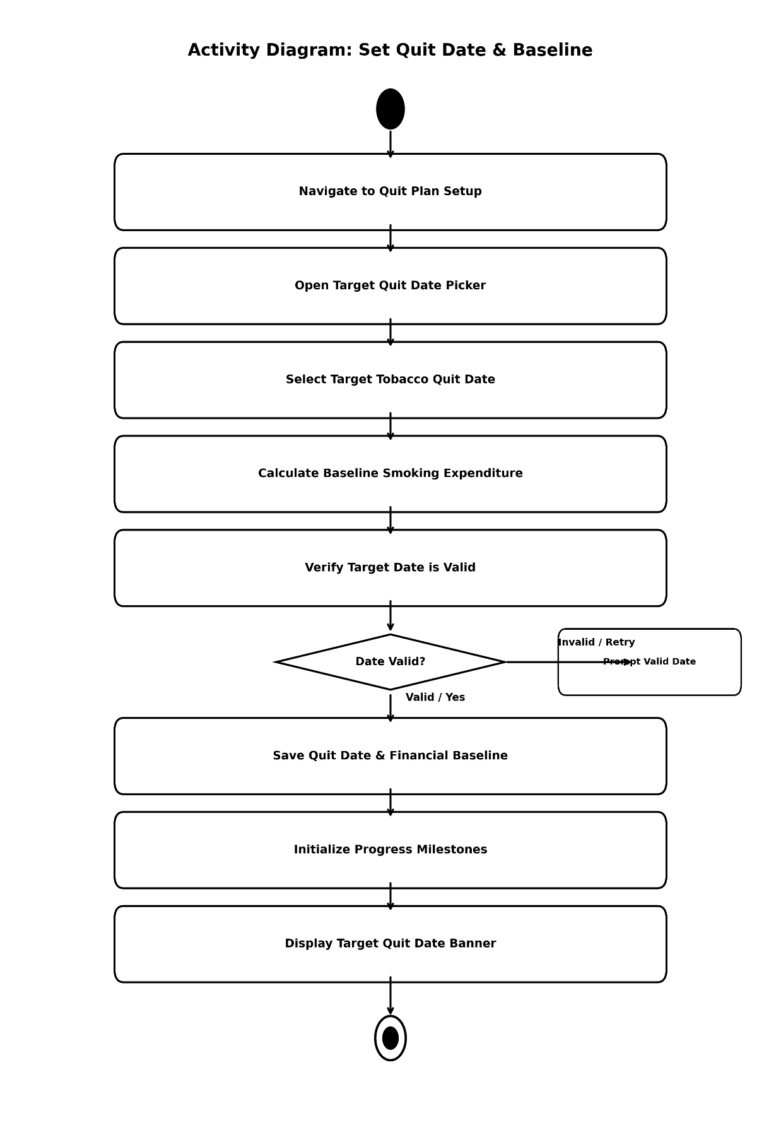
Figure 3: Activity Diagram for Set Quit Date

7.3 Activity Diagram for View Quit Plan 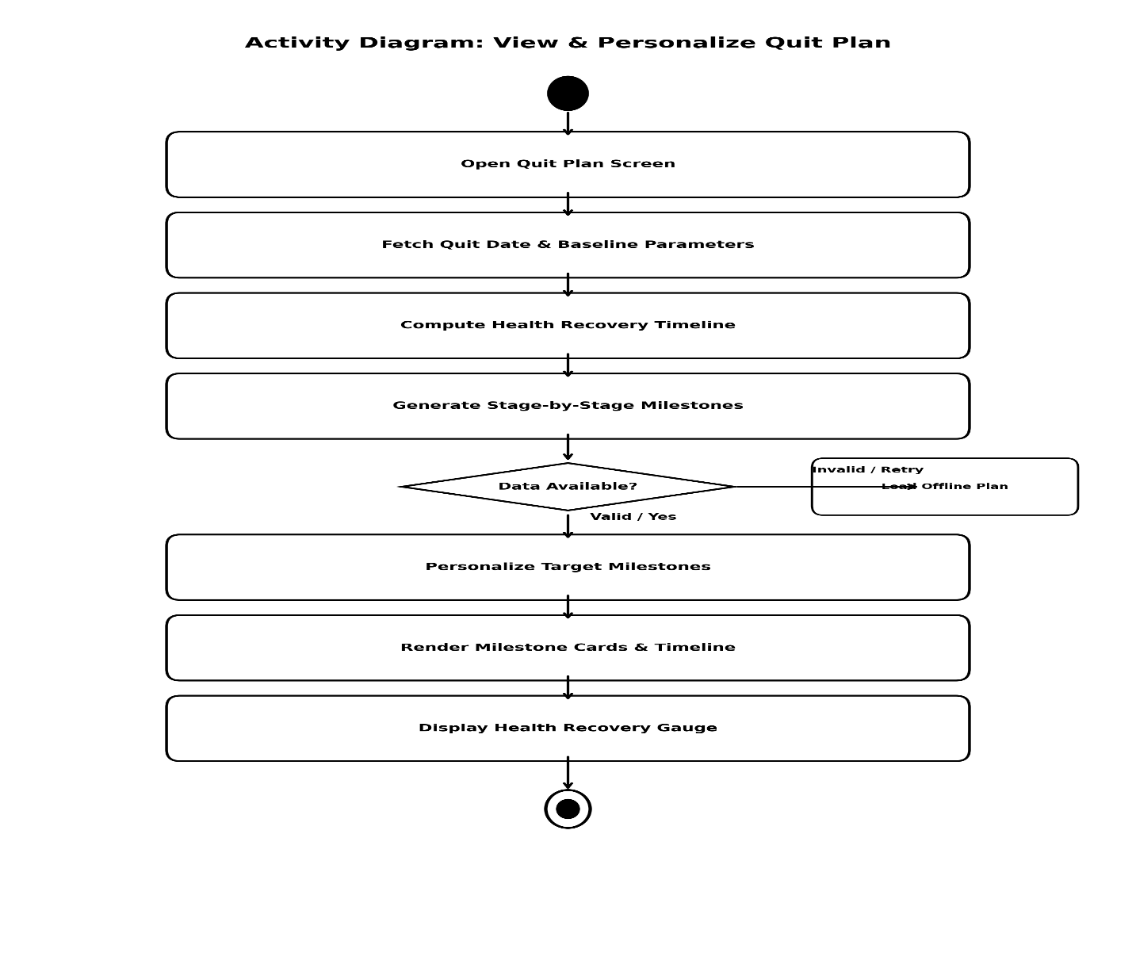
Figure 4: Activity Diagram for View Quit Plan

7.4 Activity Diagram for Daily Check-in
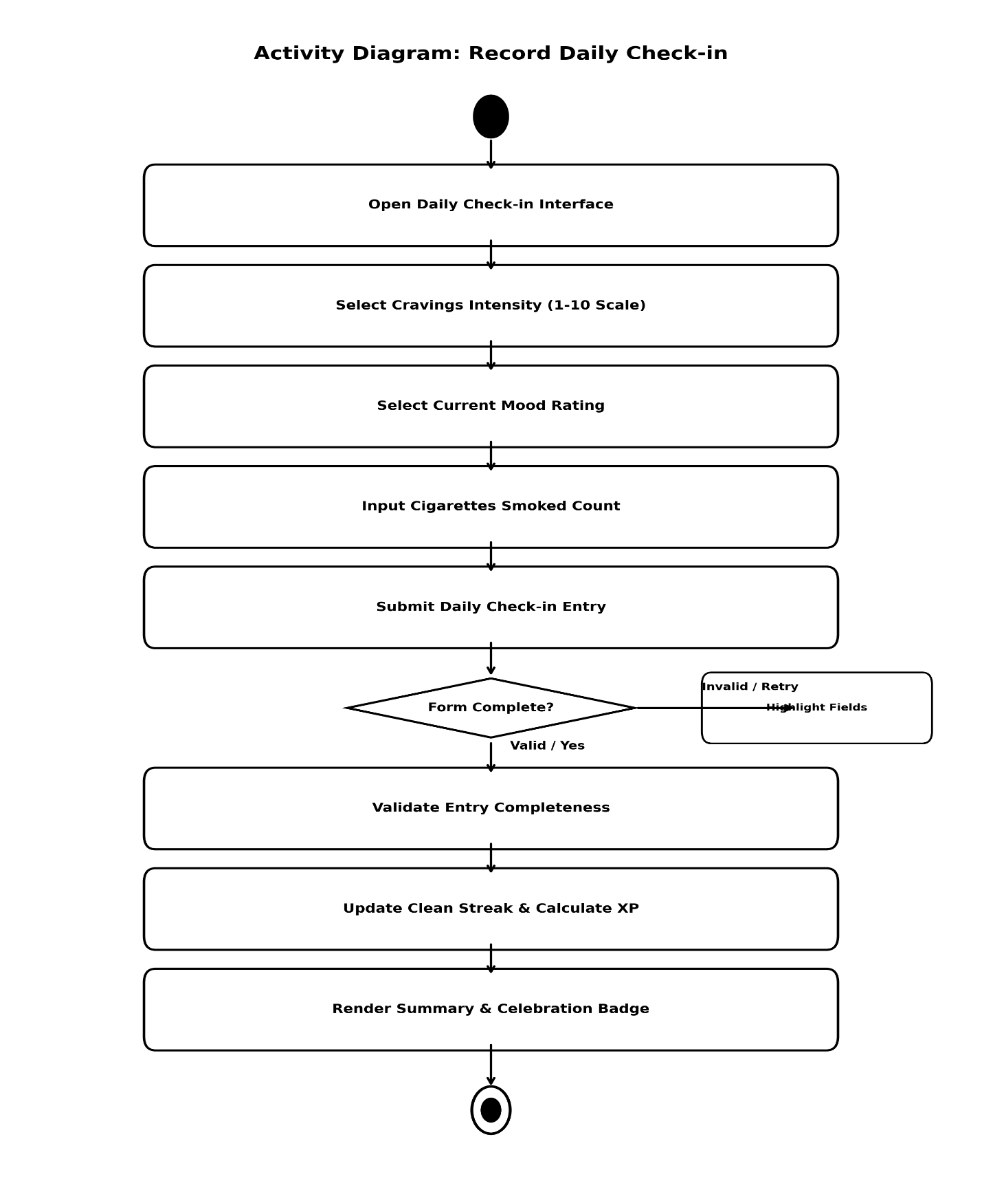
Figure 5: Activity Diagram for Daily Check-in

7.5 Activity Diagram for Track Saving
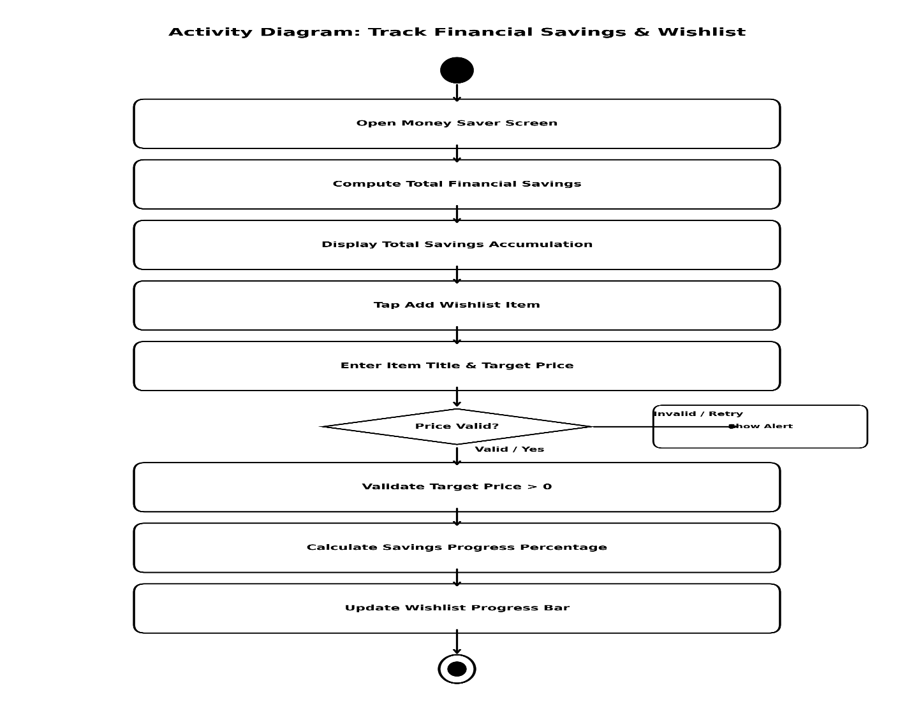
Figure 6: Activity Diagram for Track Saving

7.6 Activity Diagram for Craving Support
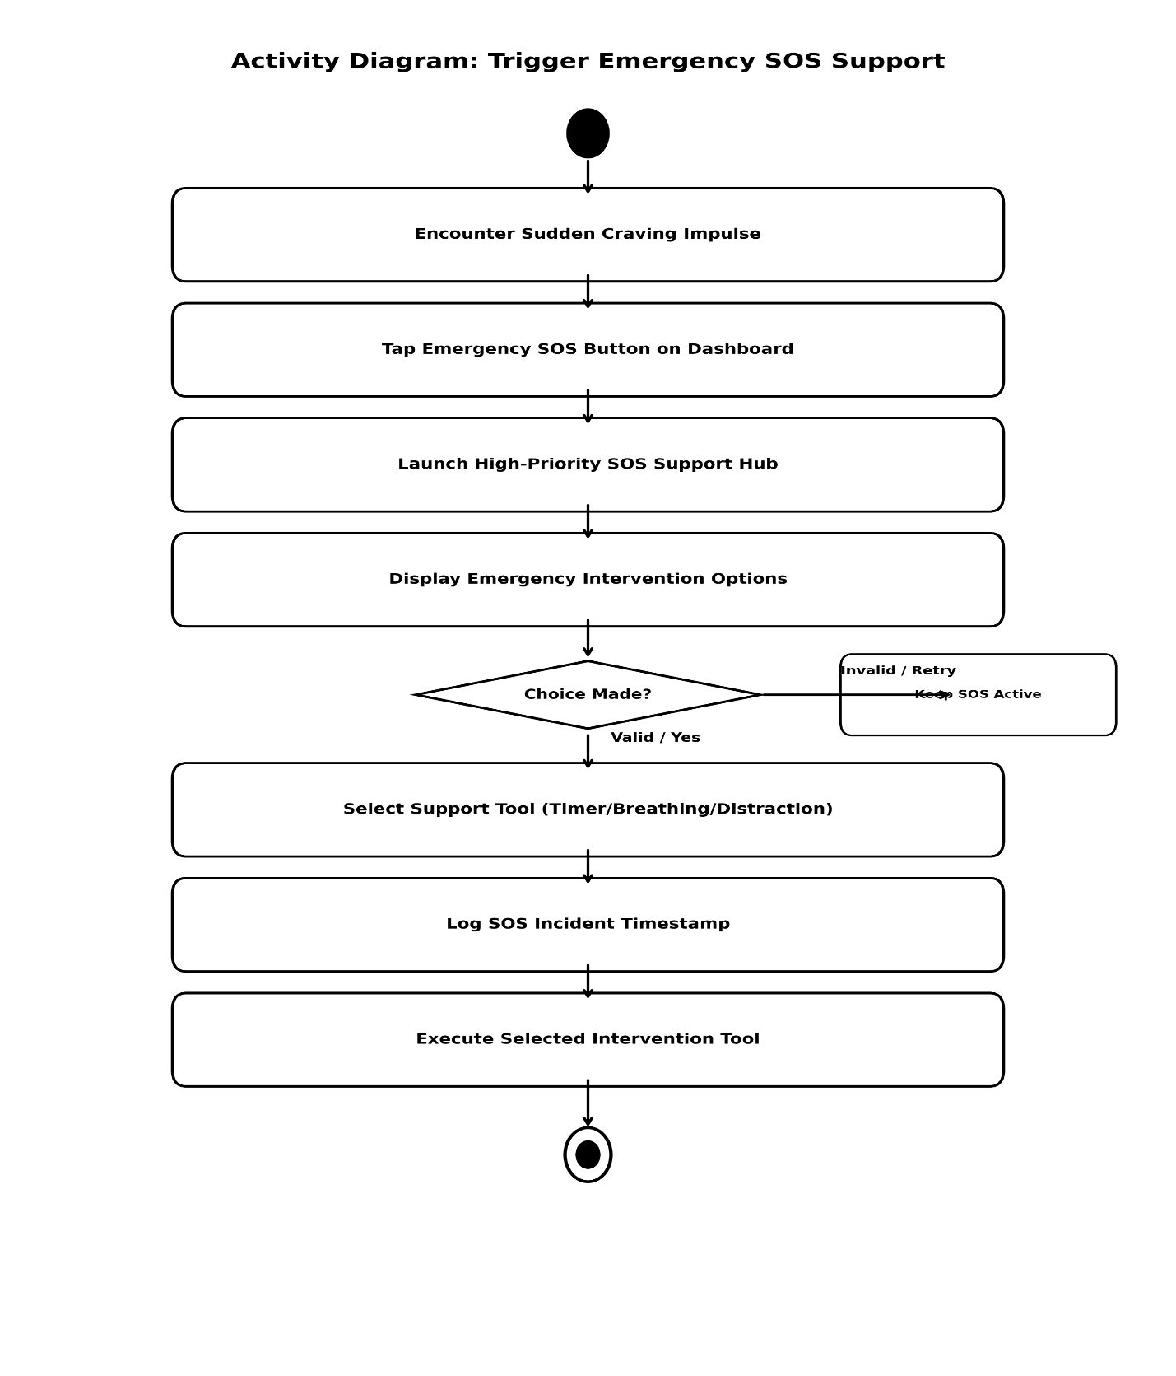
Figure 7: Activity Diagram for Craving Support

7.7 Activity Diagram for Start Survival Timer
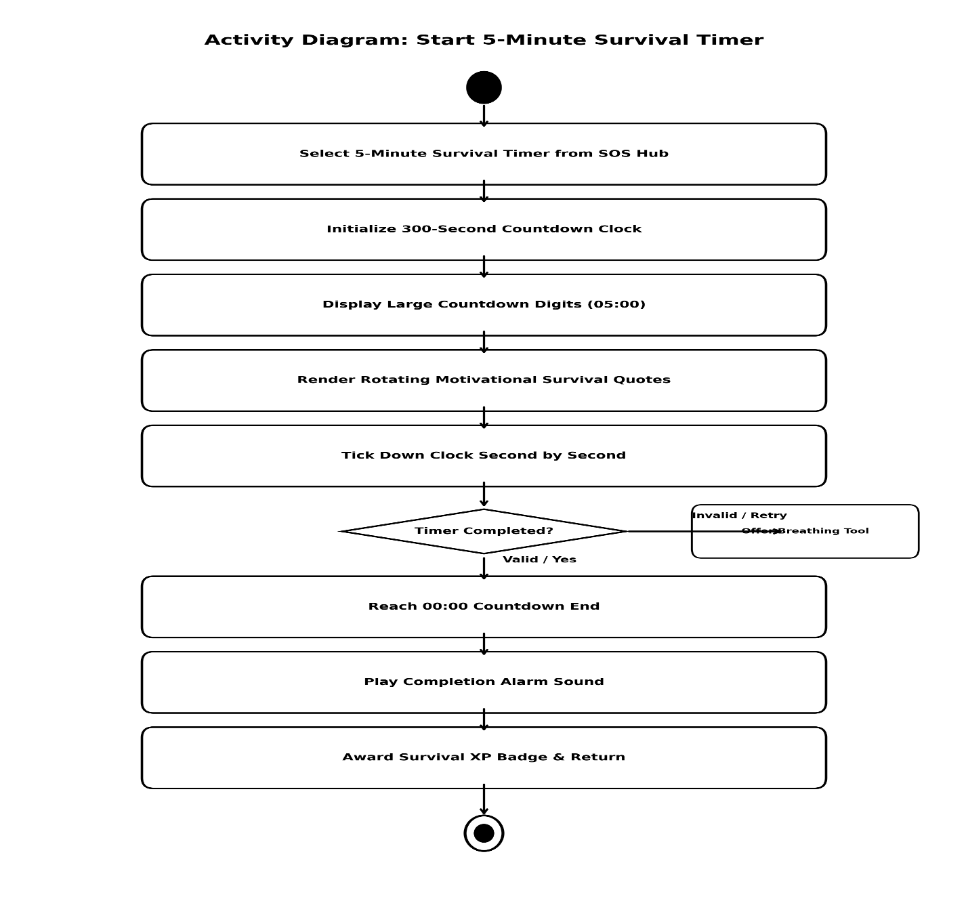
Figure 8: Activity Diagram for Start Survival Timer

7.8 Activity Diagram for Breathing Exercise
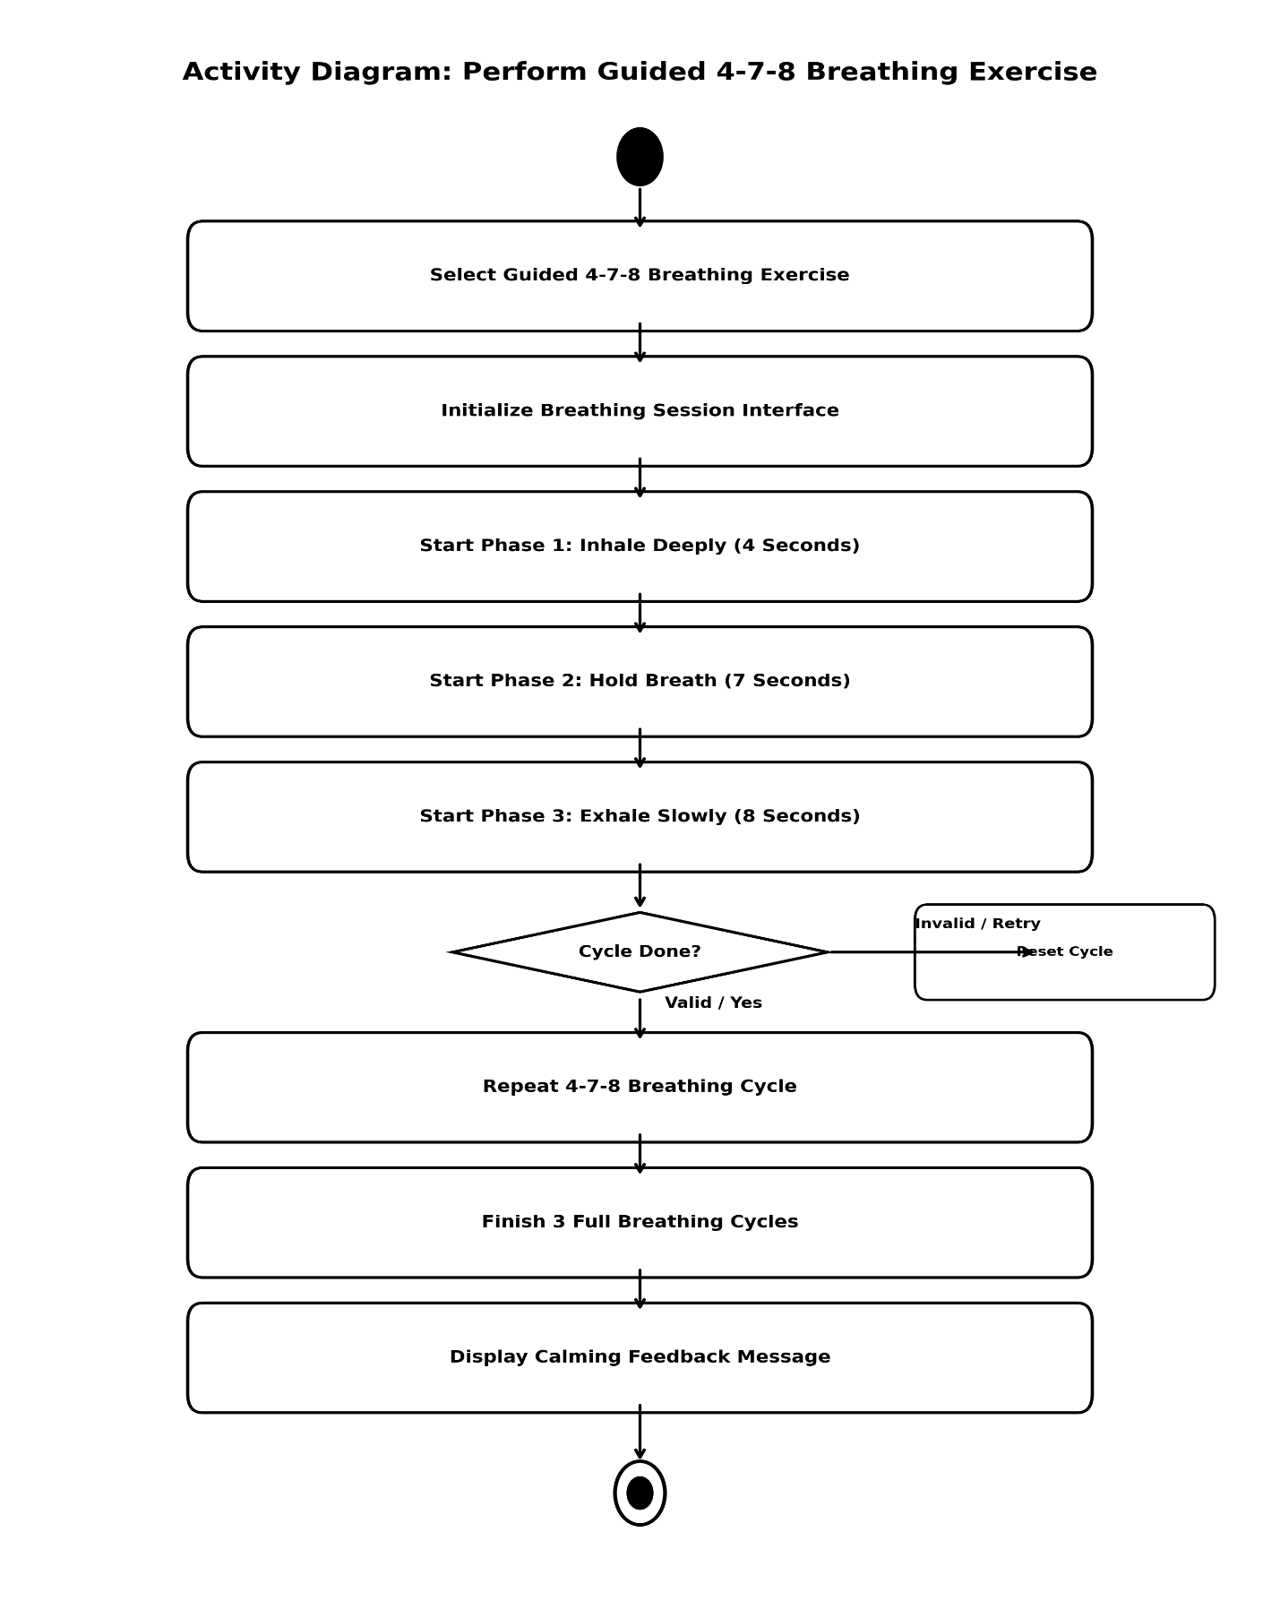
Figure 9: Activity Diagram for Breathing Exercise

7.9 Activity Diagram for Quick Distraction
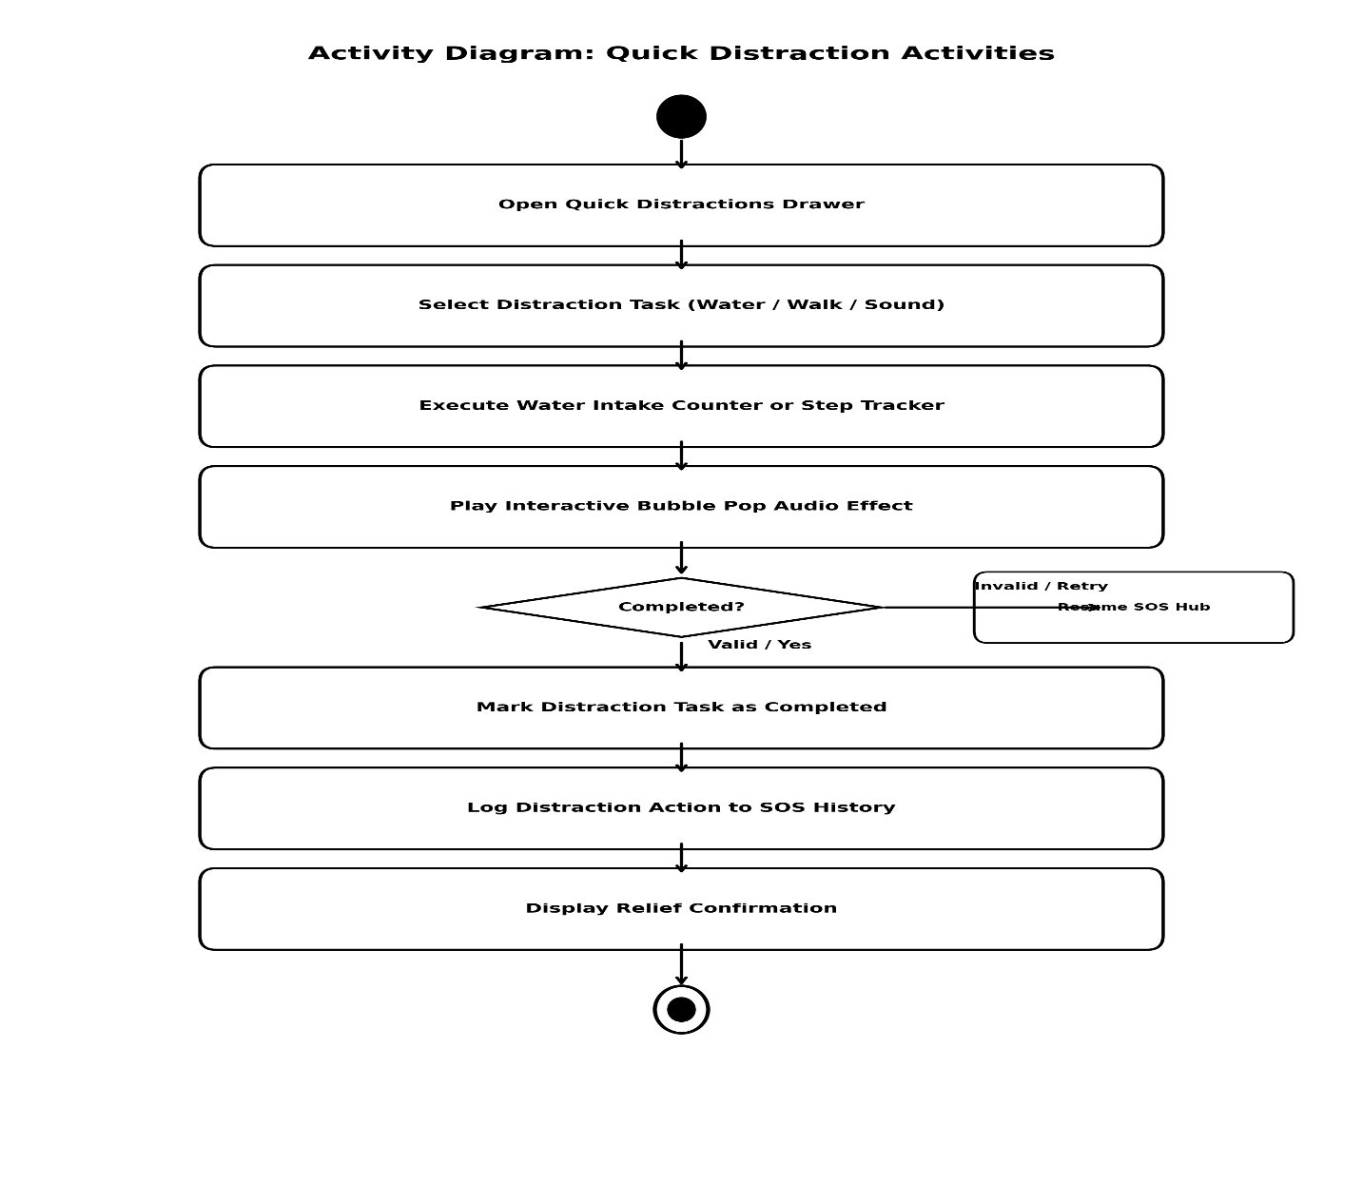
Figure 10: Activity Diagram for Quick Distraction

7.10 Activity Diagram for Access Peer Support Group
Figure 11: Activity Diagram for Access Peer Support Group

8. Sequence Diagram

8.1 Sequence Diagram for Manage Profile

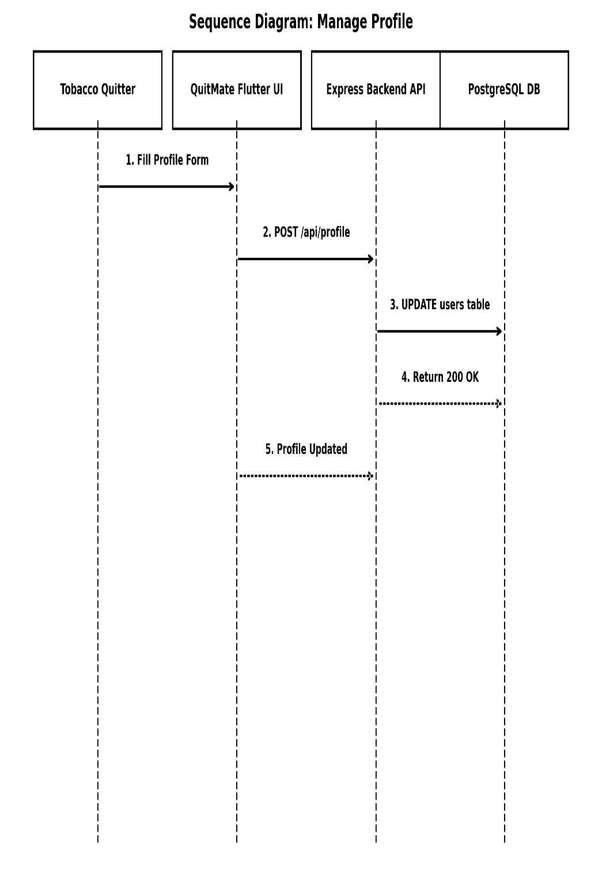
Figure 12: Sequence Diagram for Manage Profile

8.2 Sequence Diagram for Set Quit Date

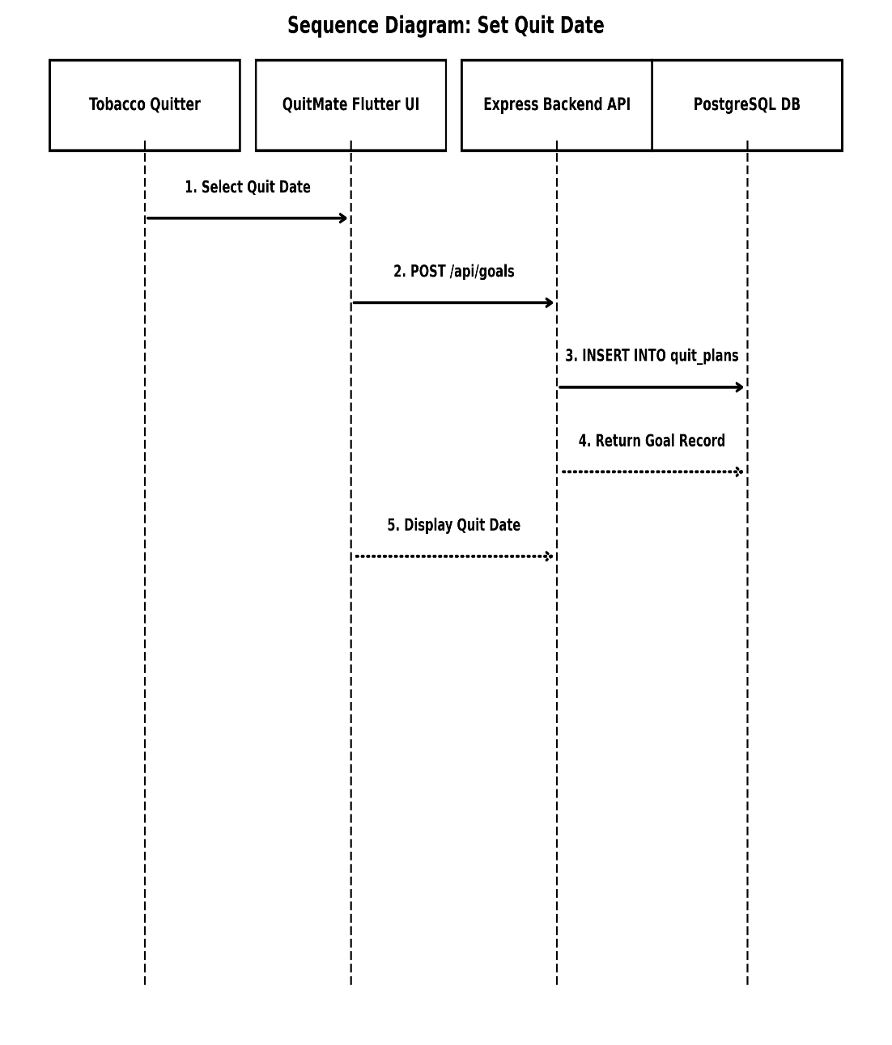
Figure 13: Sequence Diagram for Set Quit Date

8.3 Sequence Diagram for View Quit Plan

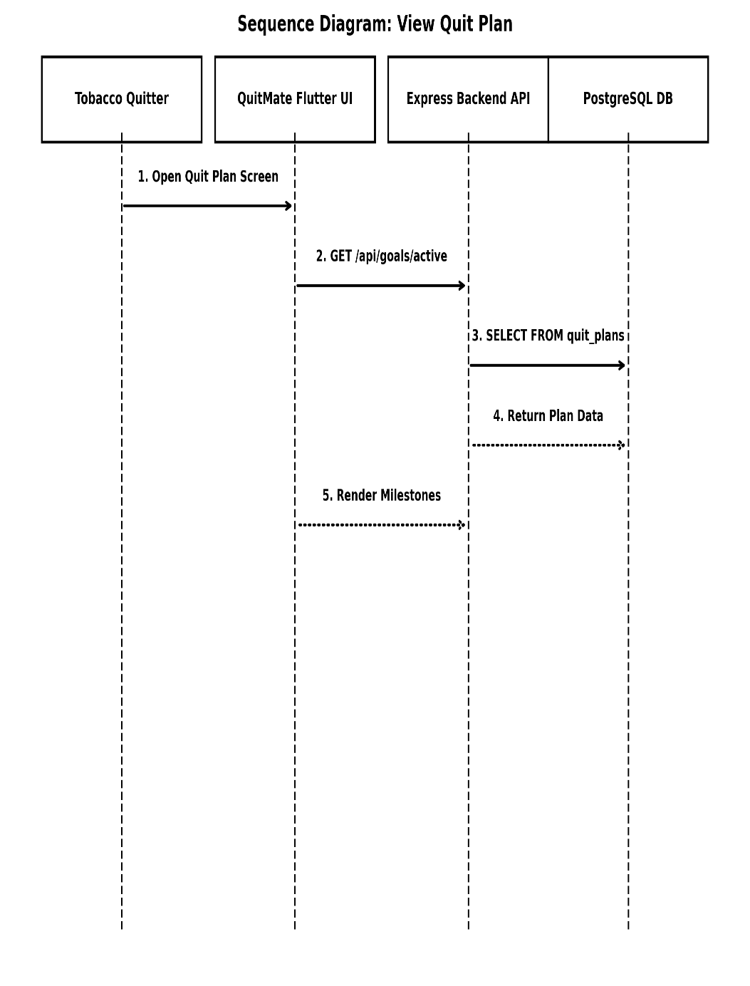
Figure 14: Sequence Diagram for View Quit Plan

8.4 Sequence Diagram for Daily Check-in

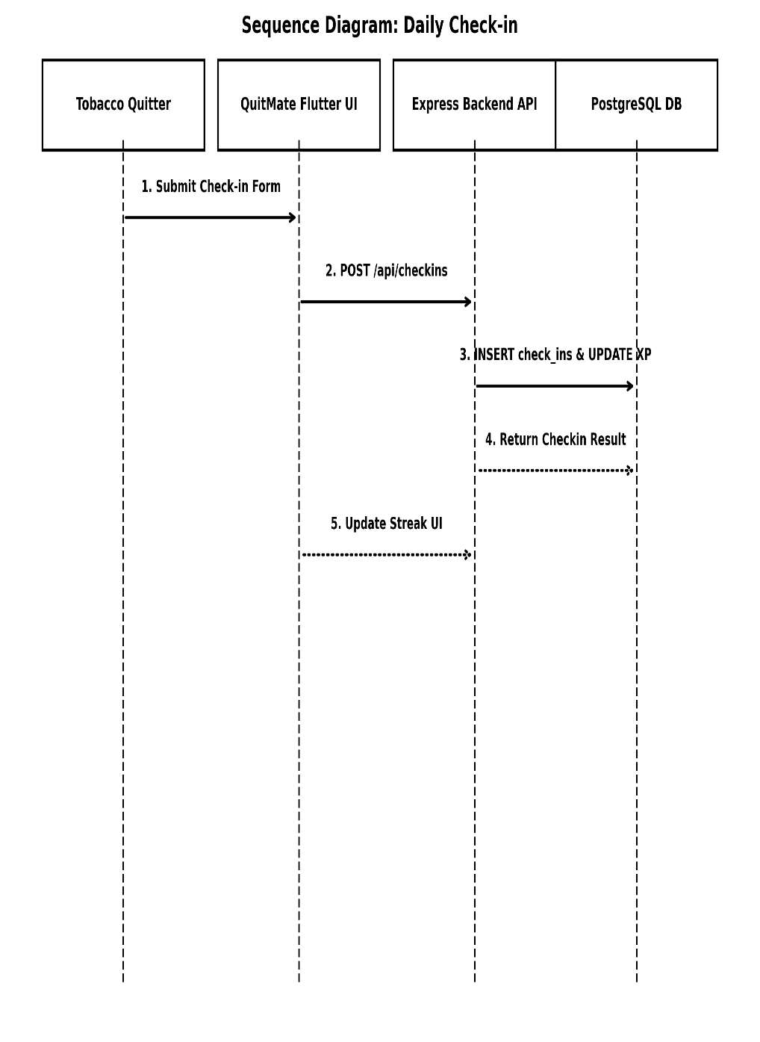
Figure 15: Sequence Diagram for Daily Check-in

8.5 Sequence Diagram for Track Saving

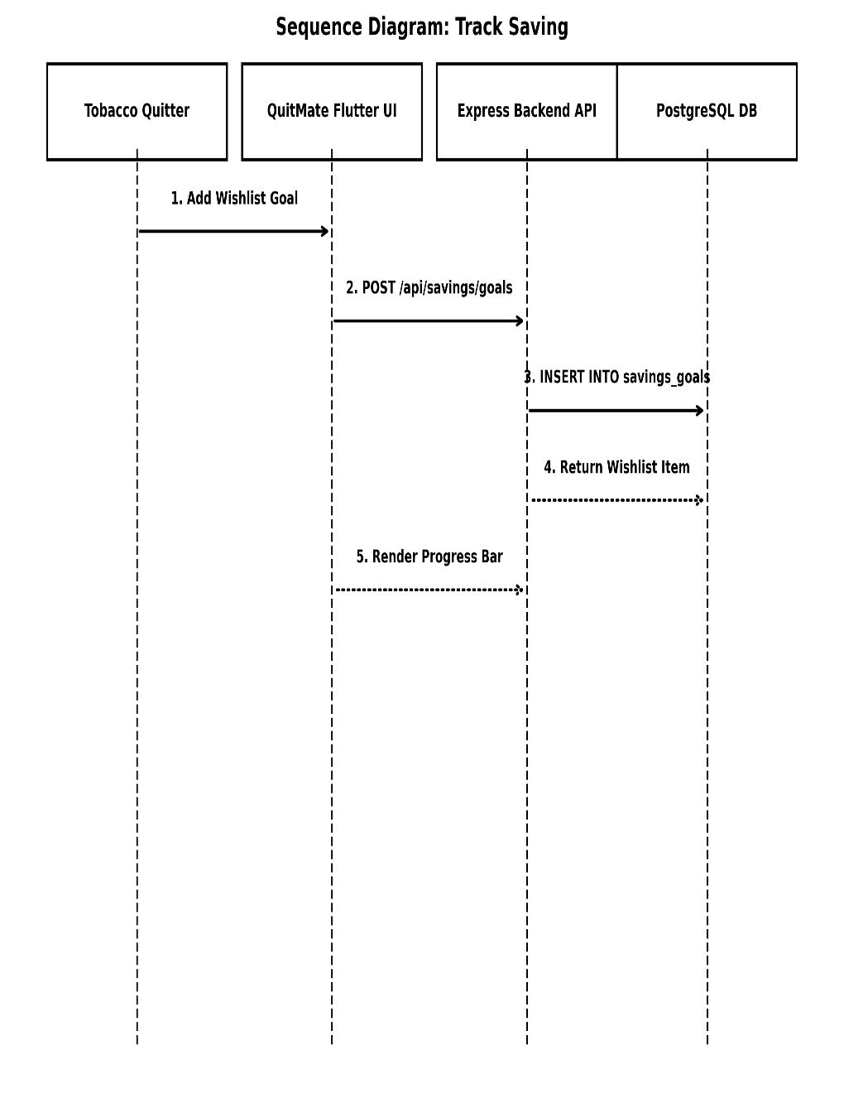
Figure 16: Sequence Diagram for Track Saving

8.6 Sequence Diagram for Craving Support

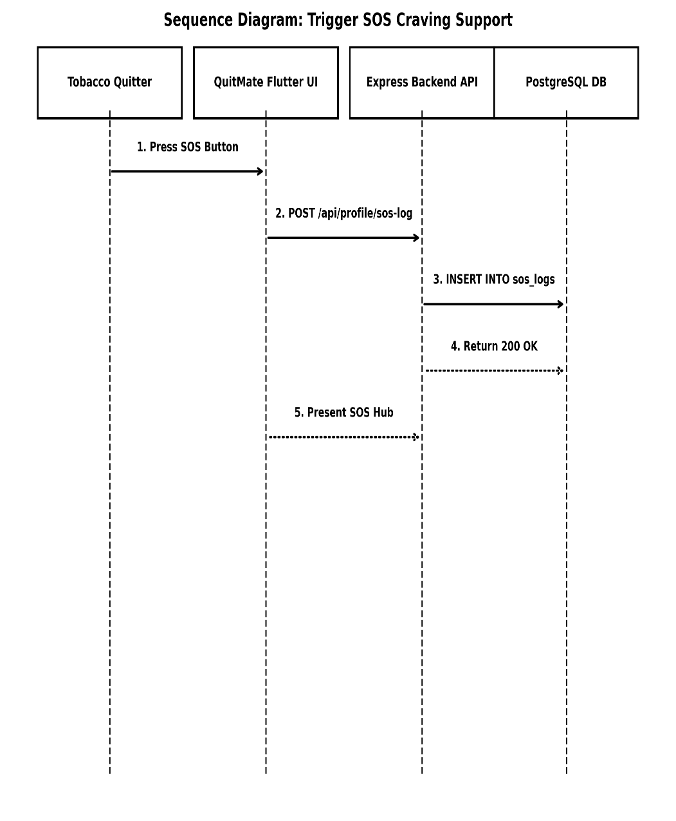
Figure 17: Sequence Diagram for Craving Support

8.7 Sequence Diagram for Start Survival Timer

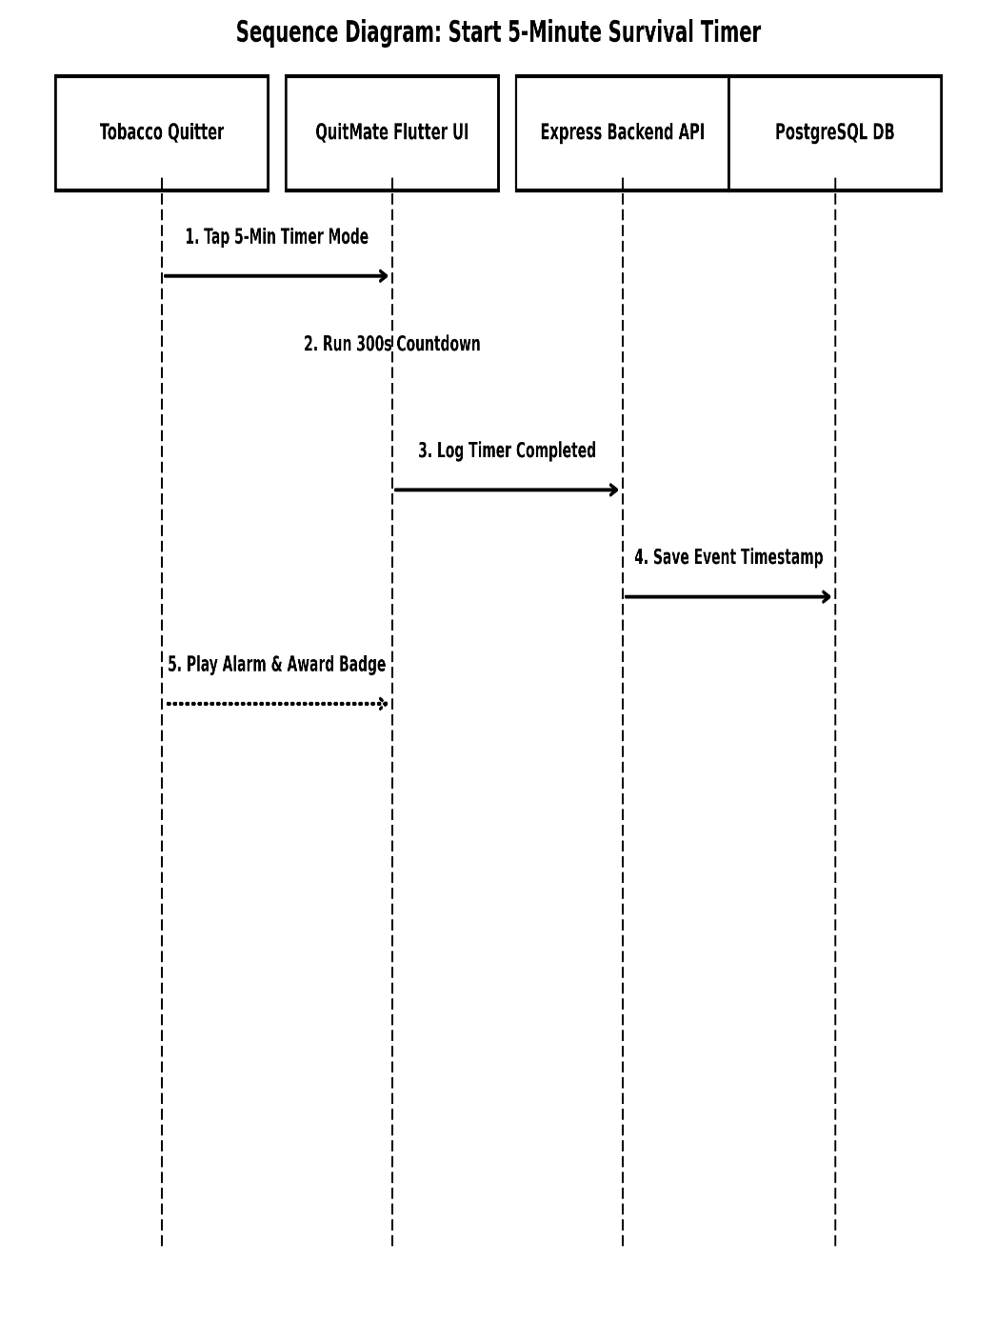
Figure 18: Sequence Diagram for Start Survival Timer

8.8 Sequence Diagram for Breathing Exercise

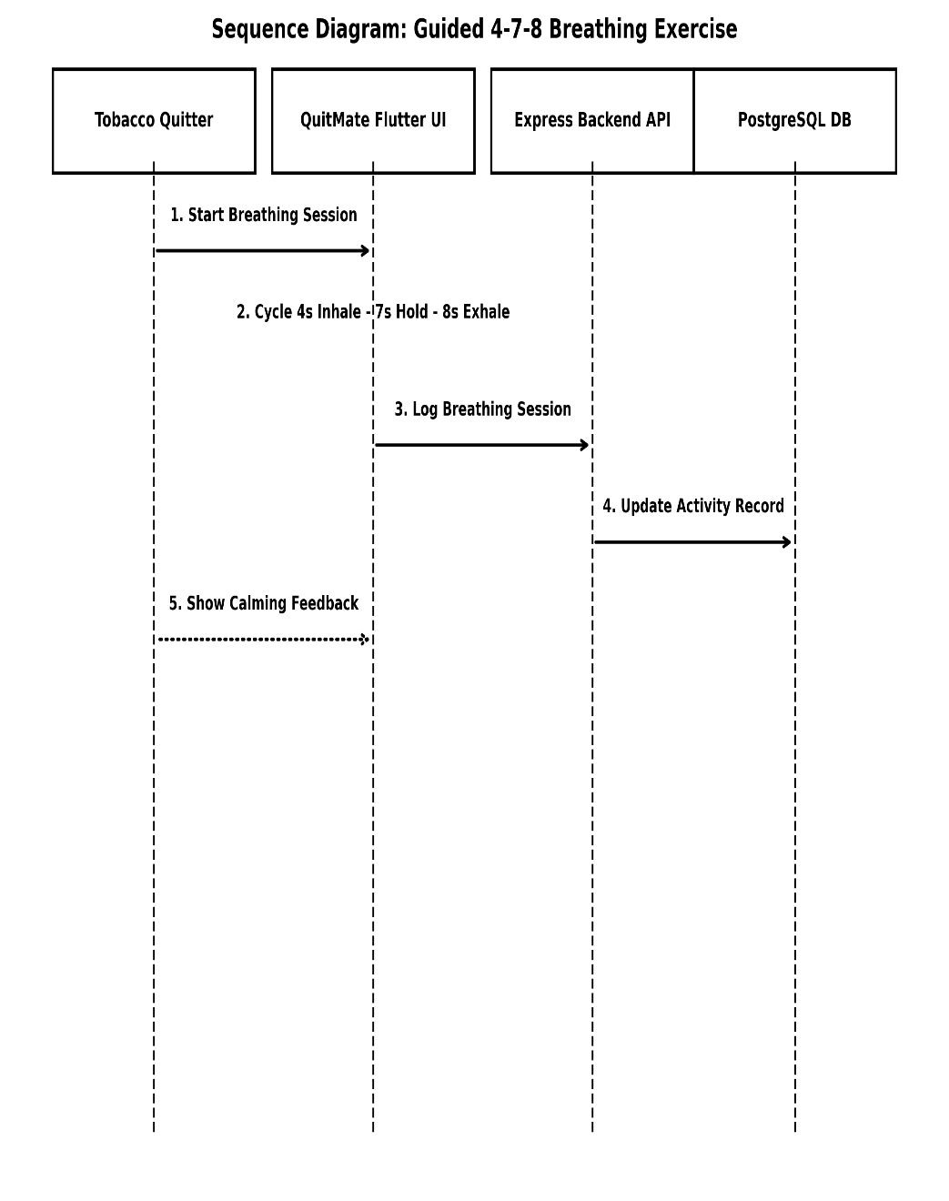
Figure 19: Sequence Diagram for Breathing Exercise

8.9 Sequence Diagram for Quick Distraction

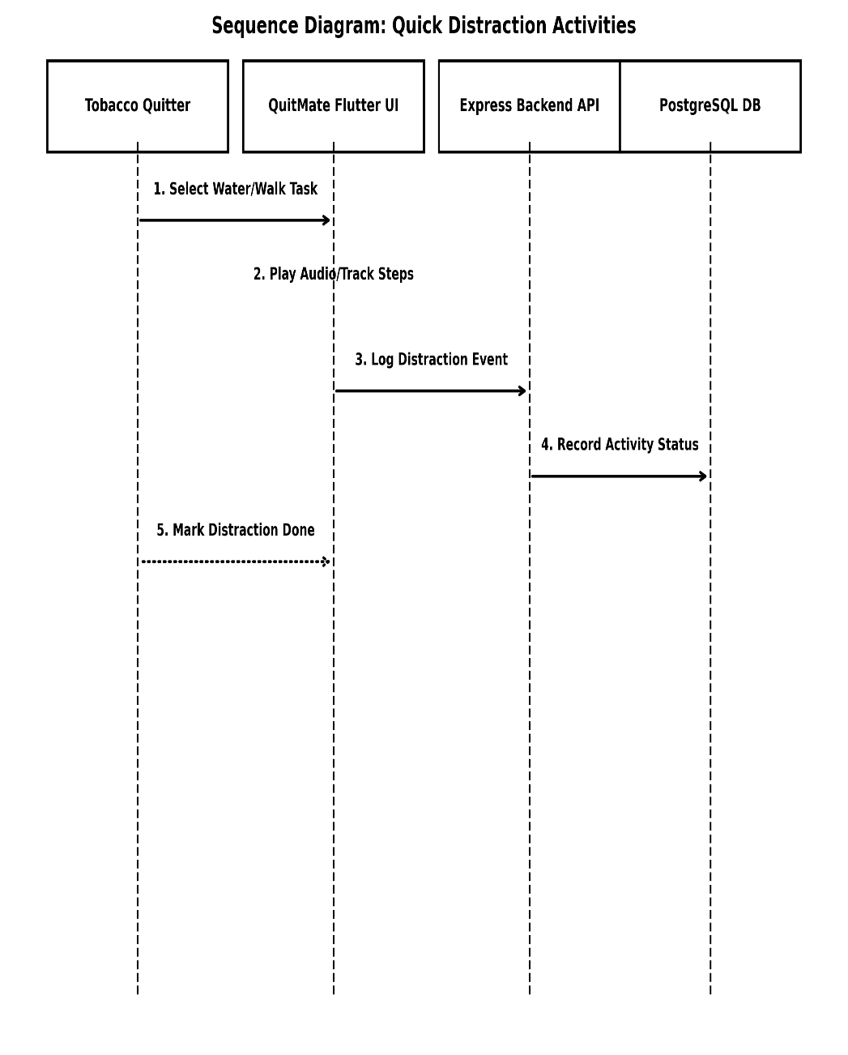
Figure 20: Sequence Diagram for Quick Distraction

8.10 Sequence Diagram for Access Peer Support Group

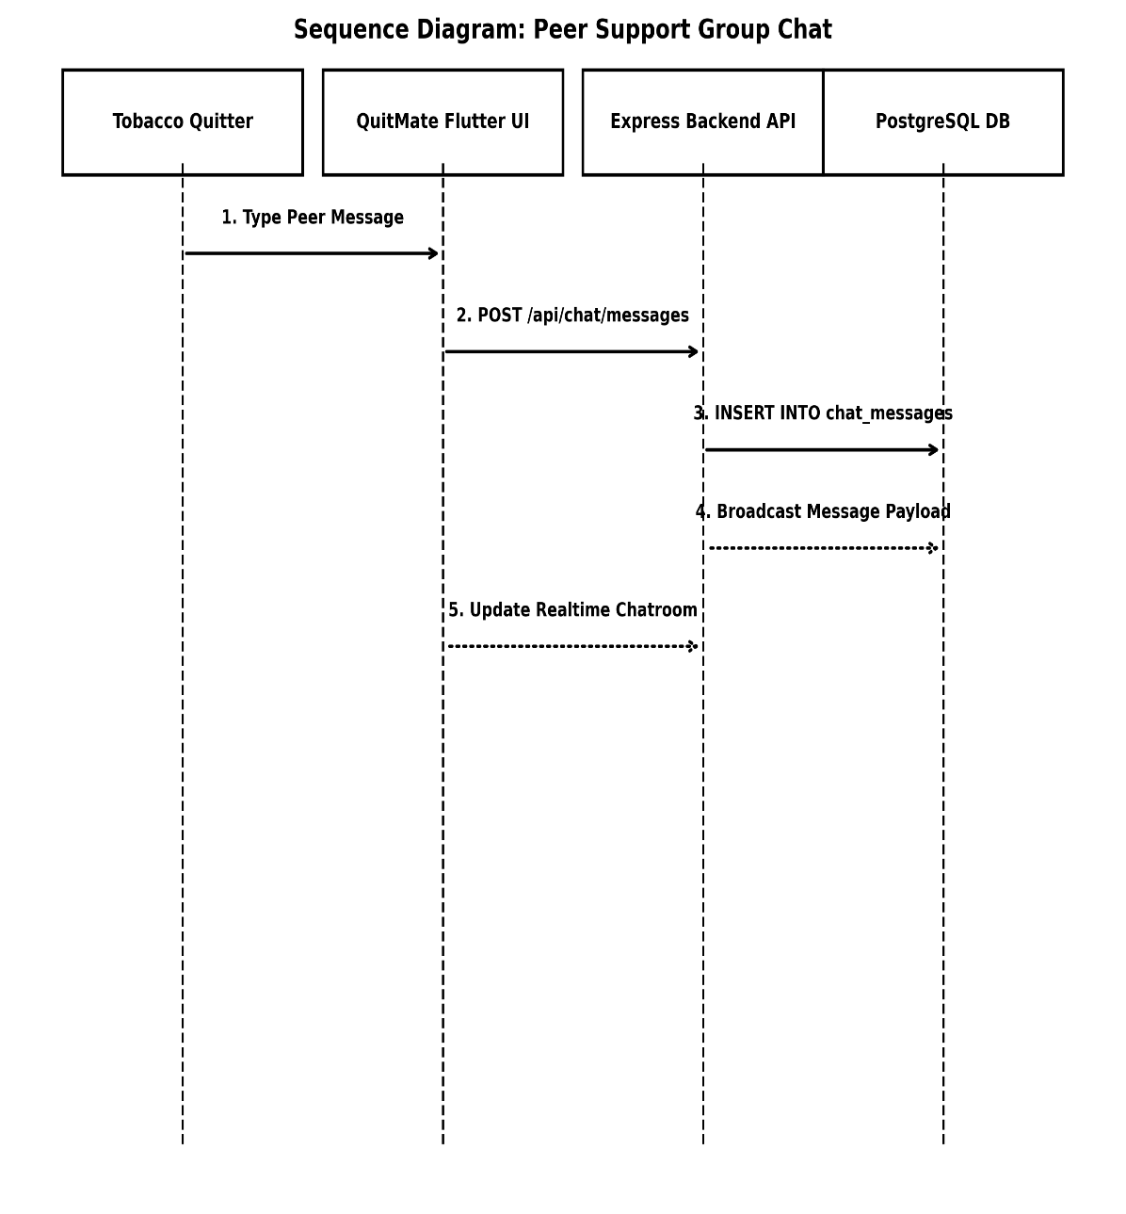
Figure 21: Sequence Diagram for Access Peer Support Group

9 Swimlane Diagram

9.1 Swimlane Diagram for Manage Profile

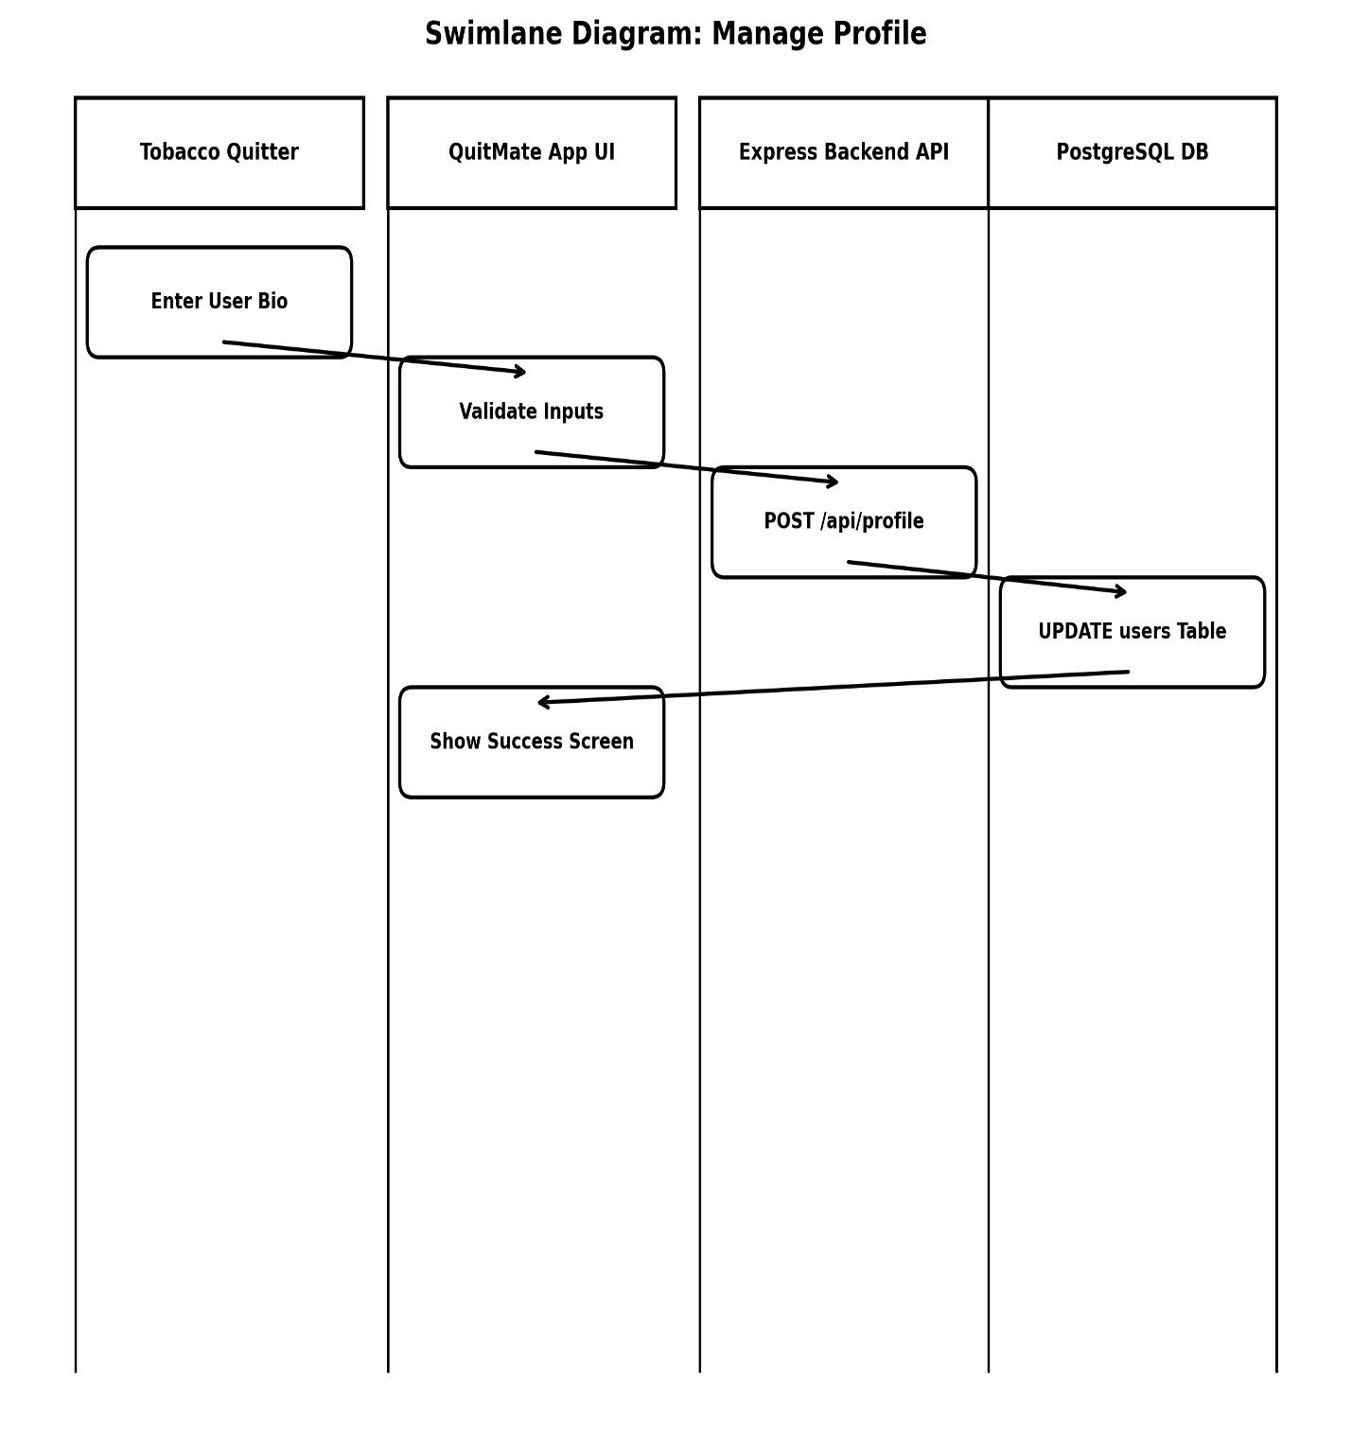
Figure 22: Swimlane Diagram for Manage Profile

9.2 Swimlane Diagram for Set Quit Date

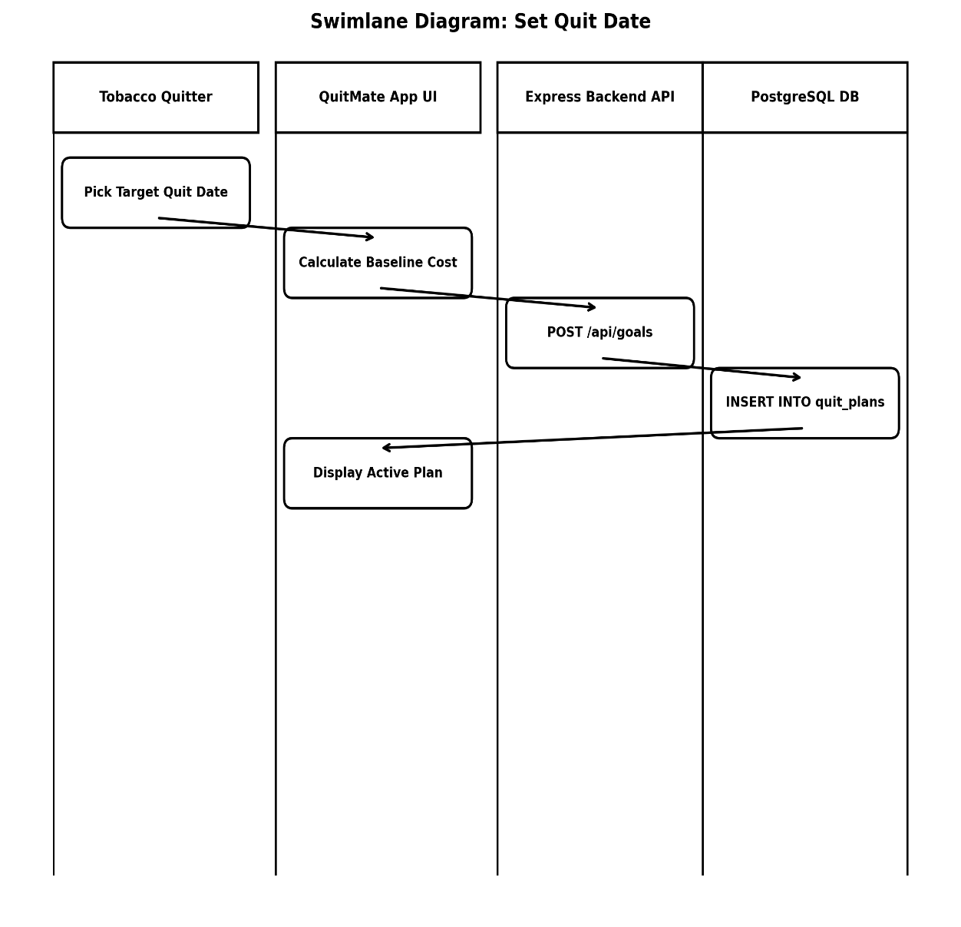
Figure 23: Swimlane Diagram for Set Quit Date

9.3 Swimlane Diagram for View Quit Plan

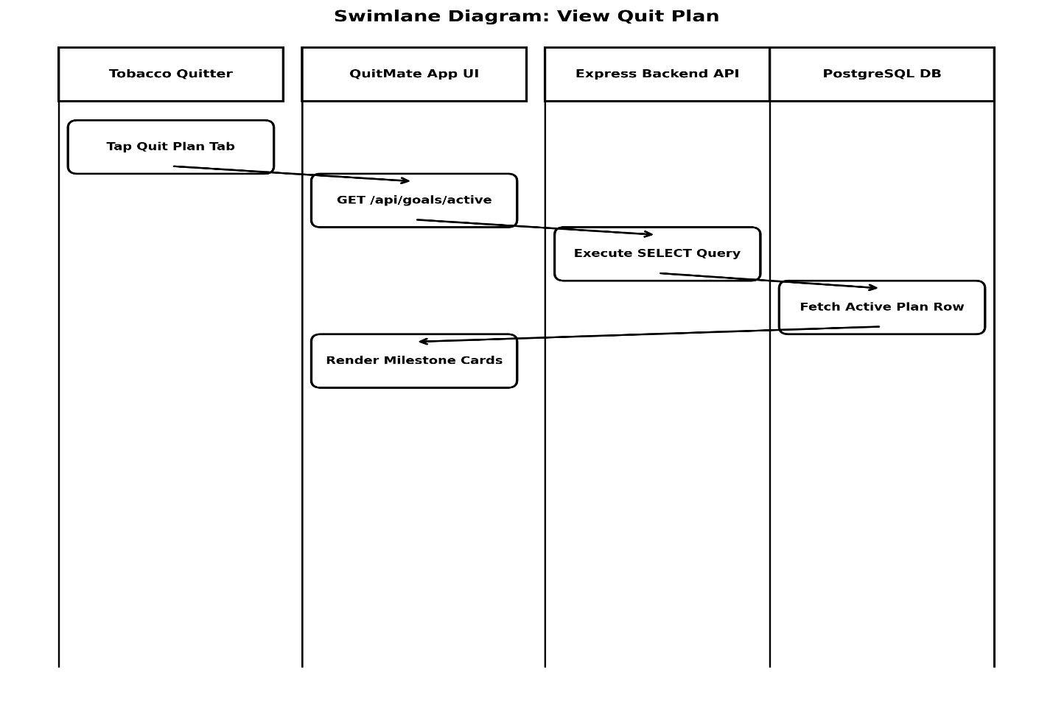
Figure 24: Swimlane Diagram for View Quit Plan

9.4 Swimlane Diagram for Daily Check-in

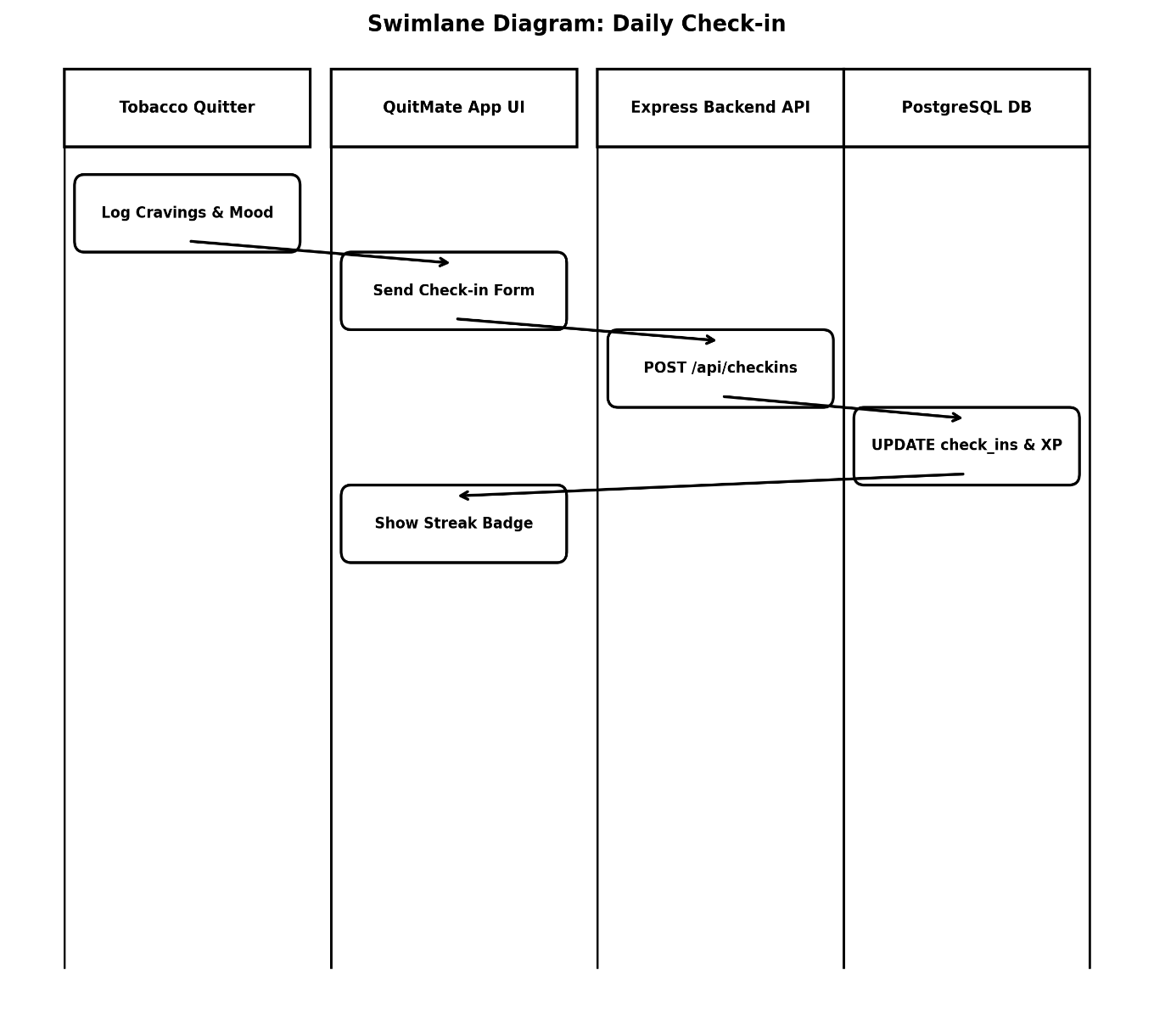
Figure 25: Swimlane Diagram for Daily Check-in

9.5 Swimlane Diagram for Track Saving

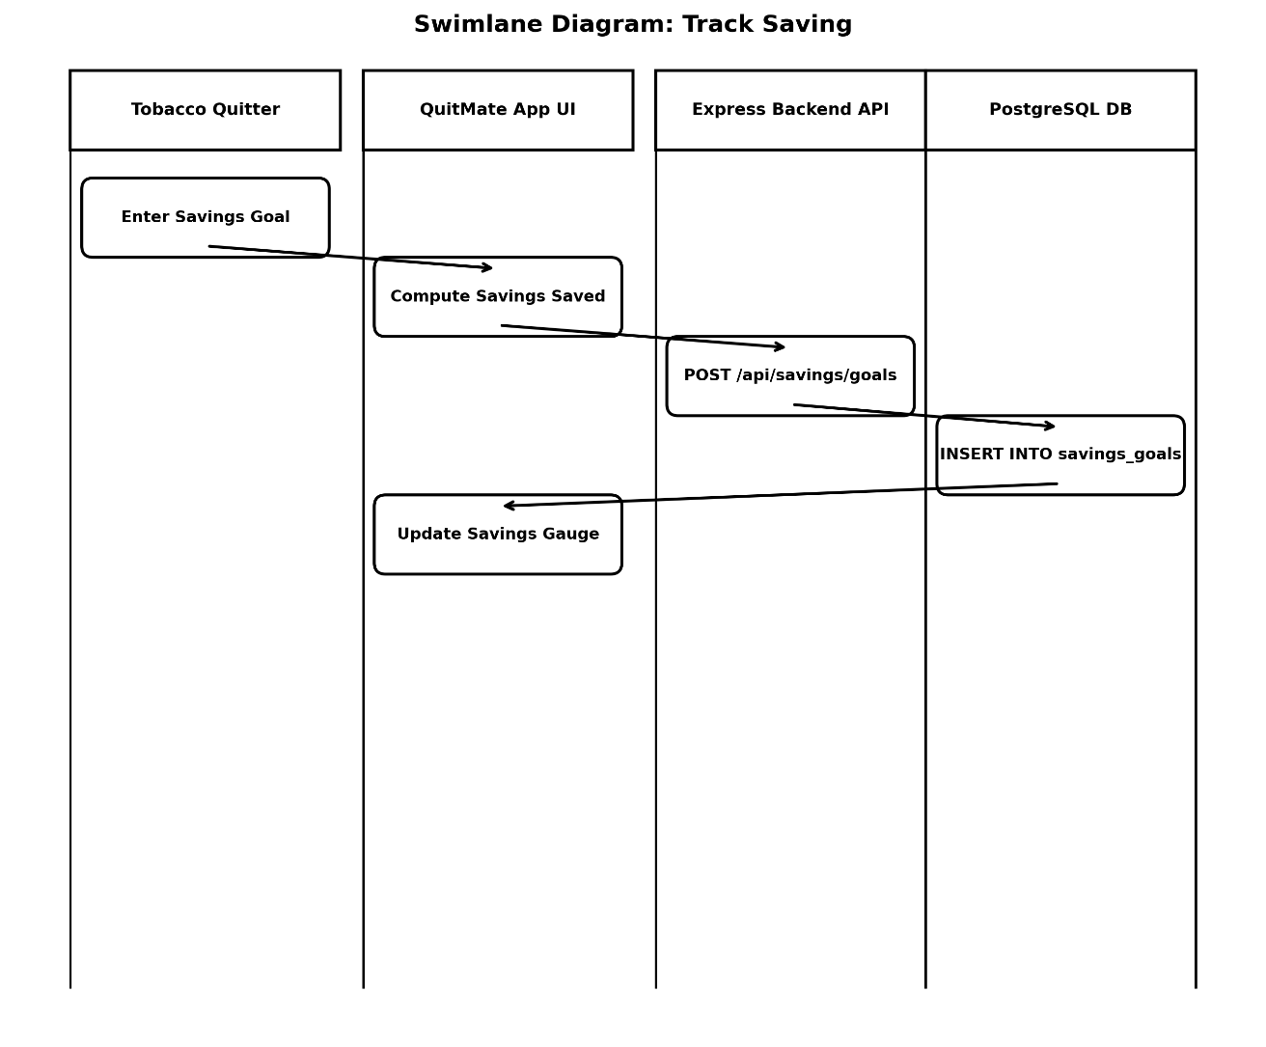
Figure 26: Swimlane Diagram for Track Saving

9.6 Swimlane Diagram for Craving Support

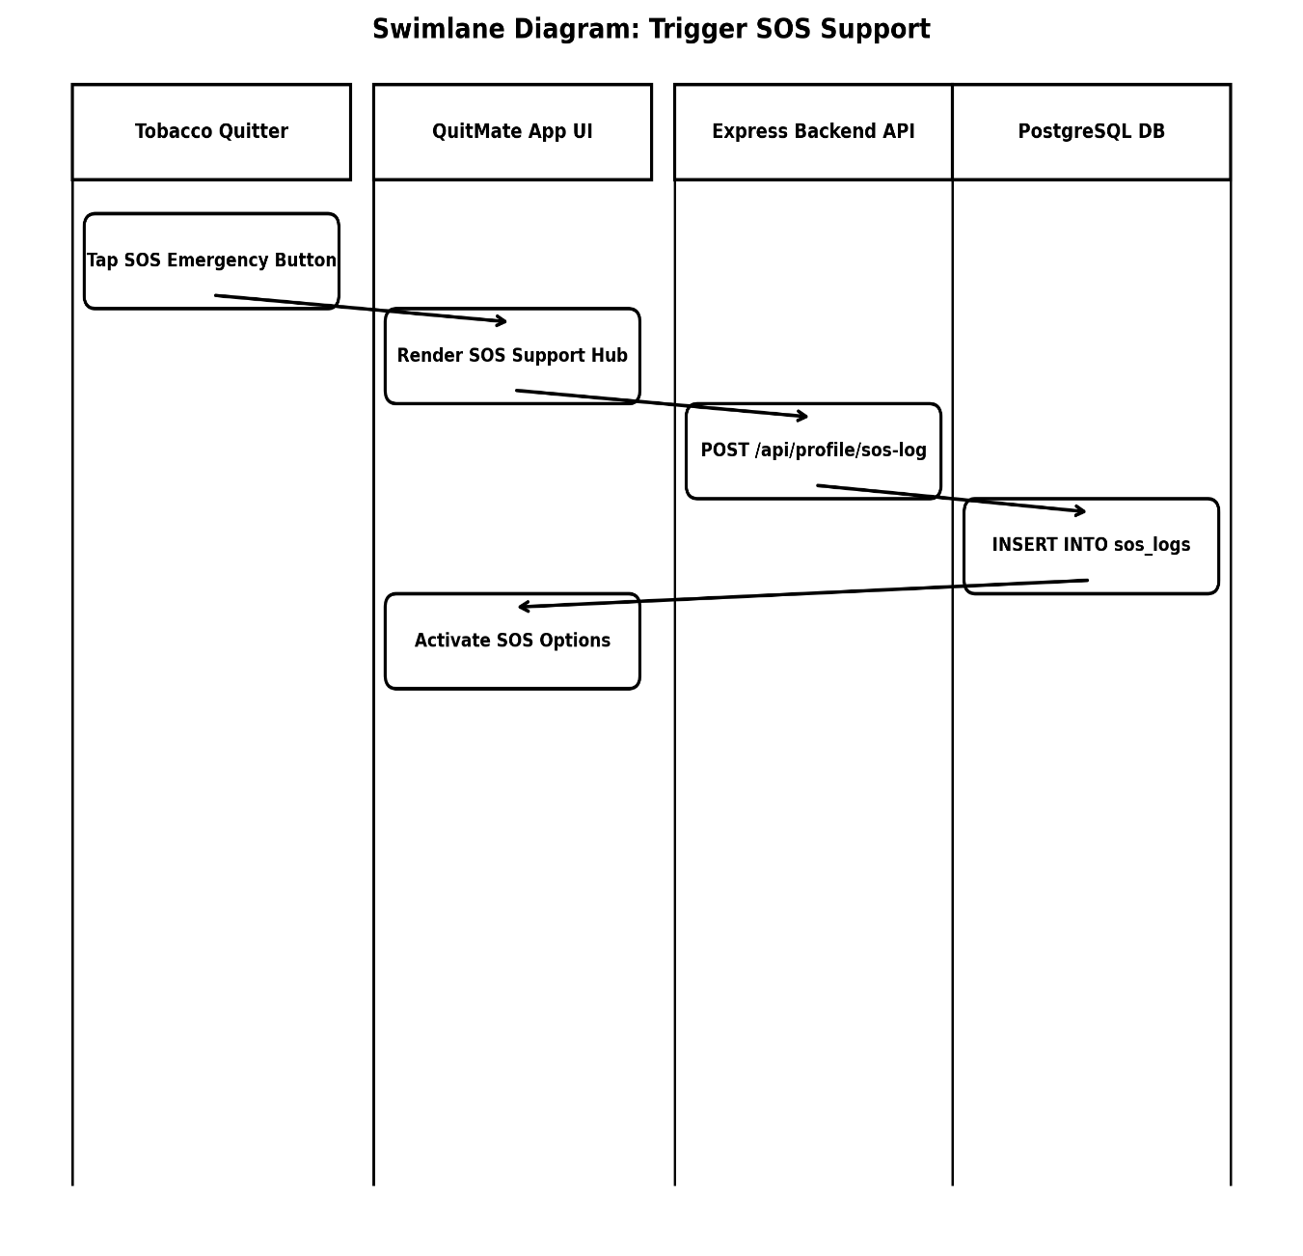
Figure 27: Swimlane Diagram for Craving Support

9.7 Swimlane Diagram for Start Survival Timer

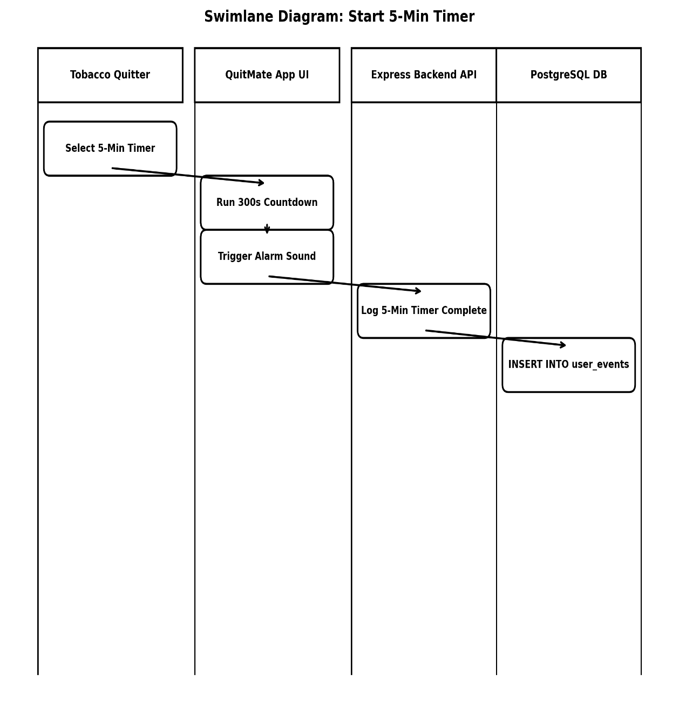
Figure 28: Swimlane Diagram for Start Survival Timer

9.8 Swimlane Diagram for Breathing Exercise

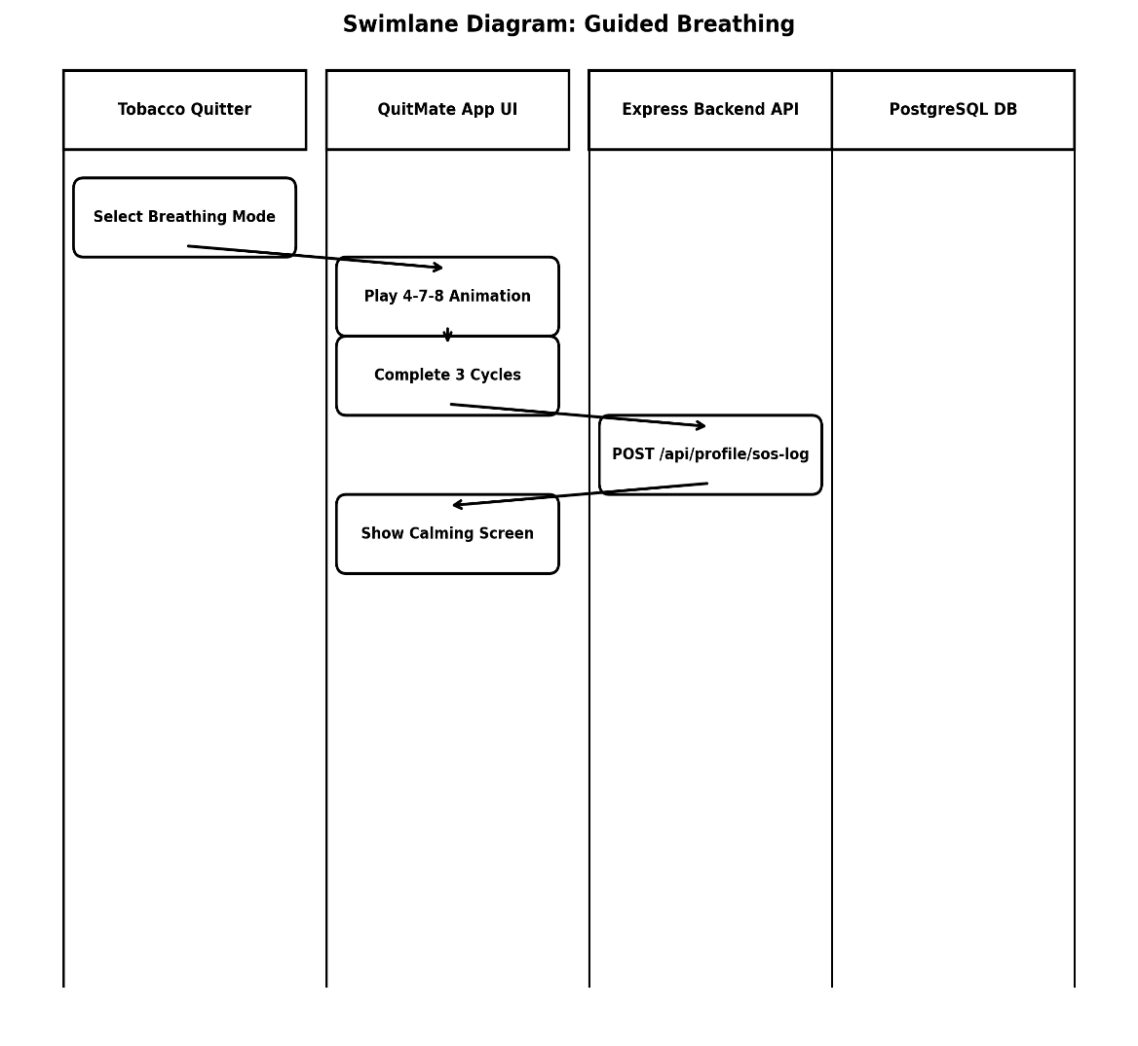
Figure 29: Swimlane Diagram for Breathing Exercise

9.9 Swimlane Diagram for Quick Distraction

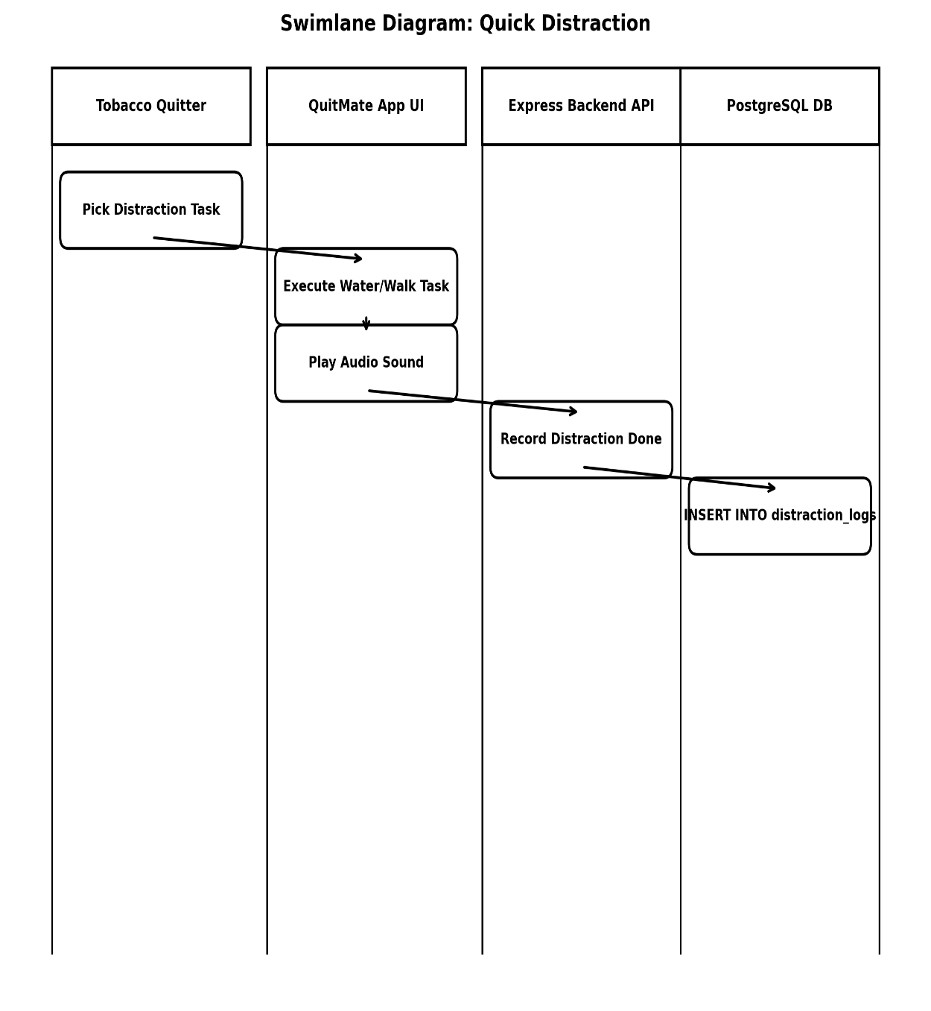
Figure 30: Swimlane Diagram for Quick Distraction

9.10 Swimlane Diagram for Access Peer Support Group

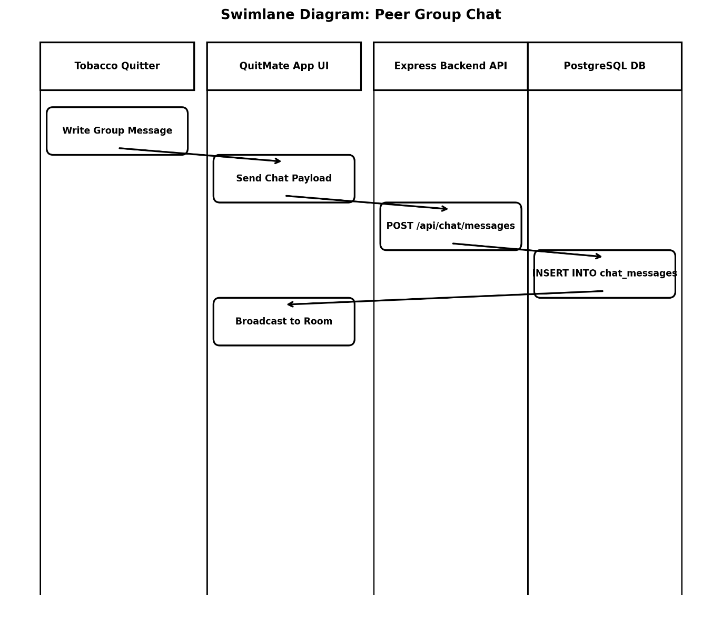
Figure 31: Swimlane Diagram for Access Peer Support Group

10. Requirement Traceability Matrix
Use Case IDs
U1 – Manage Profile
U2 – Set Quit Date
U3 – View Quit Plan
U4 – Daily Check-in
U5 – Track Saving
U6 – Craving Support
U7 – Start Survival Timer
U8 – Breathing Exercise
U9 – Quick Distraction
U10 – Access Peer Support Group
U11 - View Tobacco Awareness
U12 - View Gamification Progress
U13 - Interact with AI Craving Companion (Groq AI)
U14 - Receive Peer Support Group Messages
U15 - Offline Data Caching & Auto-Synchronization
U16 - Receive Local & Push Notifications
U17 - Educational Content Management
U18 – System Administration & Community Moderation
Functional Requirements ID:
FR1 – Secure user authentication and account management.
FR2 – Profile details updating and quit date scheduling.
FR3 – Emergency survival timer and SOS triggering mechanism.
FR4 – Guided breathing exercise session playback.
FR5 – Financial savings calculation and wishlist milestone tracker.
FR6 – Peer chatroom functionality and direct peer support messaging.
FR7 – Push notifications and motivational alert scheduling.
FR8 – Experience points (Streak Badges) and gamification logic calculations.
FR9 – Offline Data Caching & Auto-Synchronization: The system shall locally cache user entries in Hive offline storage, auto-syncing with the PostgreSQL backend when internet connectivity is restored.

RTM
Req ID | U1 | U2 | U3 | U4 | U5 | U6 | U7 | U8 | U9 | U10 | U11 | U12 | U13 | U14 | U15 | U16 | U17 | U18
FR1 | ✔
FR2 |  | ✔ | ✔
FR3 |  |  |  |  |  | ✔ | ✔
FR4 |  |  |  |  |  |  |  | ✔
FR5 |  |  |  |  | ✔
FR6 |  |  |  |  |  |  |  |  |  | ✔ | ✔ |  |  |  |  |  |  | ✔
FR7 |  |  |  |  |  |  |  |  |  |  |  |  |  | ✔
FR8 |  |  |  |  |  |  |  |  |  |  |  |  | ✔
FR9 |  |  |  |  |  |  |  |  |  |  |  |  |  |  |  | ✔ | ✔ | ✔

Figure 32: Requirement Traceability Matrix

11. Database Design

11.1 Entity Relationship Diagram
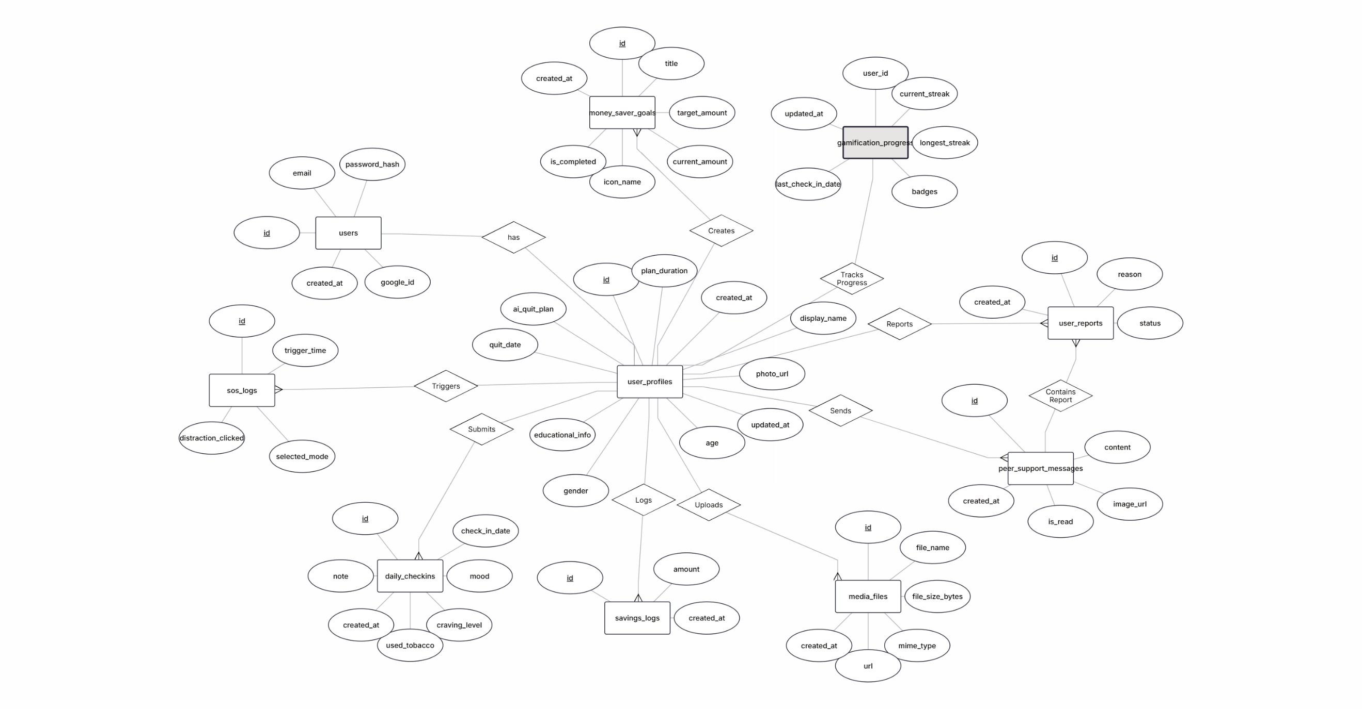
Figure 33: Entity Relationship Diagram

11.2 ER Diagram to Relational Schema:
- 1. users(id[PK], email, password_hash, google_id, created_at)
- 2. user_profiles(id[PK, FK -> users.id], display_name, photo_url, age, gender, educational_info, plan_duration, quit_date, ai_quit_plan, created_at, updated_at)
- 3. daily_checkins(id[PK], user_id[FK -> user_profiles.id], check_in_date, mood, craving_level, used_tobacco, note, created_at)
- 4. gamification_progress(user_id[PK, FK -> user_profiles.id], longest_streak, current_streak, badges[TEXT[]], last_check_in_date, updated_at)
- 5. money_saver_goals(id[PK], user_id[FK -> user_profiles.id], title, target_amount, current_amount, icon_name, is_completed, created_at)
- 6. savings_logs(id[PK], user_id[FK -> user_profiles.id], amount, created_at)
- 7. peer_support_messages(id[PK], sender_id[FK -> user_profiles.id], content, image_url, is_read, created_at)
- 8. media_files(id[PK], user_id[FK -> user_profiles.id], file_name, file_size_bytes, mime_type, url, created_at)

- 9. sos_logs(id[PK], user_id[FK -> user_profiles.id], trigger_time, selected_mode, distraction_clicked)
- 10. user_reports(id[PK], reporter_id[FK -> user_profiles.id], reported_user_id[FK], message_id[FK], reason, status, created_at)

12 Conclusion
The Software Requirements Specification (SRS) for the QuitMate - Tobacco Awareness mobile application provides a detailed roadmap for the development and implementation of a comprehensive tobacco cessation platform. By identifying the specific needs of tobacco quitters, peer group members, and medical advisors, this document ensures that the system is built to address the physical, psychological, and financial challenges of overcoming addiction.
The integration of features such as personalized quit plans, emergency craving support tools, financial tracking, and gamification creates a supportive environment for long-term behavior change. Furthermore, by maintaining high standards for data security, system performance, and user privacy, the application is positioned to be a reliable tool in public health management. This specification serves as the foundation for the development phase, ensuring that all stakeholders have a shared understanding of the system's goals to successfully help users achieve a tobacco-free lifestyle.

13 Reference
[1] World Health Organization (WHO), "WHO report on the global tobacco epidemic, 2023: Protect people from tobacco smoke," World Health Organization, Geneva, 2023. [Online]. Available: https://www.who.int/teams/health-promotion/tobacco-control/global-tobacco-report-2023. [Accessed: May 20, 2024].
[2] U.S. Department of Health and Human Services, "The Health Consequences of Smoking—50 Years of Progress: A Report of the Surgeon General," Centers for Disease Control and Prevention, 2014.
[3] R. Whittaker, H. McRobbie, C. Bullen, A. Rodgers, and Y. Gu, "Mobile phone-based interventions for smoking cessation," Cochrane Database of Systematic Reviews, no. 4, 2016.
[4] IEEE, "IEEE Standard for Software and Systems Requirements Specification (SRS)," IEEE Std 29148-2018, pp. 1-52, 2018.
[5] American Lung Association, "How to Quit Smoking," [Online]. Available: https://www.lung.org/quit-smoking. [Accessed: May 20, 2024].
[6] J. L. F. P. C. N. L. C. S. H. K. P. P. C. L. C. S. H. K. P., "The impact of digital interventions on smoking cessation: A systematic review," Journal of Medical Internet Research, vol. 22, no. 5, 2020.

14 Appendix
Term | Meaning
Tobacco Awareness | The tobacco quitting mobile application.
Tobacco Quitter | A person trying to quit tobacco products.
Quit Date | The selected date to stop using tobacco.
Craving | A strong psychological or physical urge to use tobacco.
Daily Check-in | A daily feature where users record their tobacco usage status and mood.
SOS Button | An emergency support feature used during intense cravings.
Survival Timer | A 5-minute countdown timer used during cravings to distract the user.
Breathing Exercise | The 4-7-8 guided breathing method to reduce stress and anxiety.
Money Saver Tracker | A feature that calculates the money saved by avoiding tobacco.
Wishlist | An item or goal the tobacco quitter wants to achieve using their saved money.
Streak Badges | Experience points earned by completing daily activities and milestones.
Peer Group Member | A support person who provides emotional guidance to tobacco quitters.
Moderator | A person who monitors group discussions to ensure safety and policy compliance.
Medical Advisor | A professional who verifies quitting guidelines and awareness content.
System Administrator | A person responsible for managing and maintaining the entire application system.
Stakeholder | Any individual or organization involved in or affected by the project.
SRS | Software Requirements Specification – the documentation of system requirements.

