Table of Contents
Introduction: 2
Stakeholder 2
Functional Requirement 2
Non-functional Requirement 3
1. Products requirements 3
2. Organizational requirements 3
Diagrams for this project 3
Use case Diagram 4
Activity diagram 8
Activity diagram for students: 8
Activity diagram for administrator 9
Sequence diagram 10
Sequence diagram for students 10
Sequence diagram for administrator 11
Class diagram 12
ER-diagram 13
Project Description 14
Implementation 14
Conclusion 14
Reference 15

Online College Admission Predictor

Introduction: Collage admission is an important part in education for ensuring good teaching and good learning. Our project is web based application in which students can register with their personal as well as marks details for prediction the admission in colleges and the administrator can allot the seats for the students. Administrator can add the college details and the batch details. Using this software, the entrance seat allotment became easier and can be implemented using system. Online admission predictor system can save the time effectively. Instead of going to the collages, they can choose their appropriate college and can apply for admission. Thus it saves a lot of time as well as money [1].

Stakeholder:
- Any person or organization who is affected by the system in some way and so who has a legitimate interest.
The stakeholders of the online college admission predictor system:
- Students
- Teachers
- Online student enquiry management
- Admission Management
- Fees Management
- Hostel Management
- Transport Management
- IT staff

Functional Requirement:
  - Statements of services the system should provide, how the system should react to particular inputs and how the system should behave in particular situations.
  - May state what the system should not do.
The basic service that the online college admission system includes:
- Students can properly choose their college.
- Entry of new student to the college.
- Update any information of the college.
- Send notification.

Non-functional Requirement:
- Constraints on the services or functions offered by the system such as timing constraints, constraints on the development process, standards, etc.
- Often apply to the system as a whole rather than individual features or services.

Products requirements

- Performance requirements
- The system should be easy to handle.
- System should give expected performance result.
- The response time should be small.
- Security requirements
- We are going to develop a secured database. There categories of the users namely administrator, restricted users who will viewing either all or some specific information from the database.
- Safety requirements
- The database may get crashed at any time certain time due to virus or OS failure. Therefore, it is required to take the database backup.

Organizational requirements

Organizational requirements can be included environmental, operational and development requirements. We are going to develop this software in efficient environment, our operation also good.

Diagrams for this project:

Use case Diagram

Level 0

Level 1

Level 1.1
Level 1.2

level 1.3
Level 1.4
Level 1.5
Level 1.6

Activity diagram

Activity diagram for students:

Activity diagram for administrator:

Sequence diagram

Sequence diagram for students:
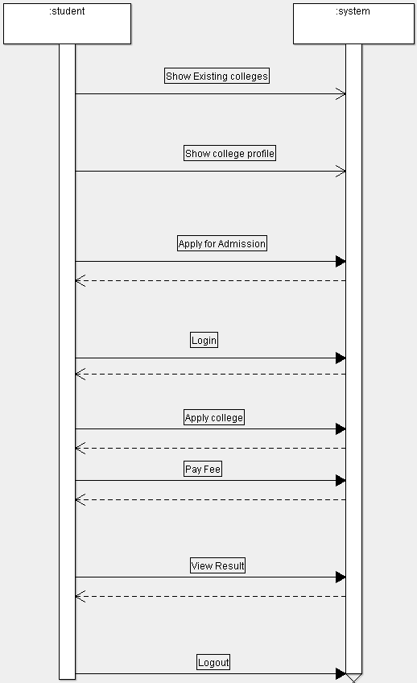

Sequence diagram for administrator:
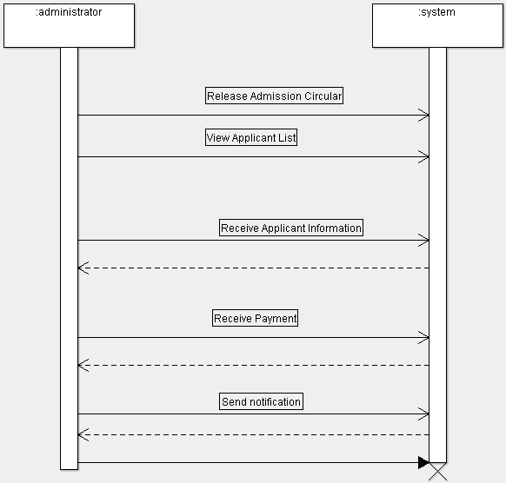

Class diagram

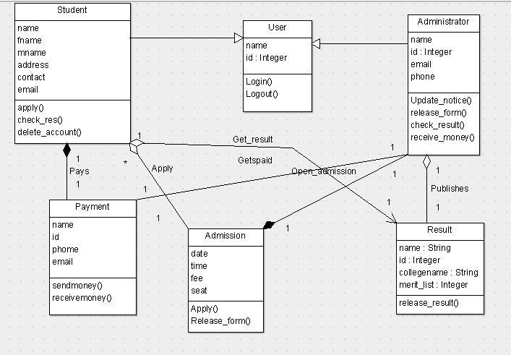

ER-diagram

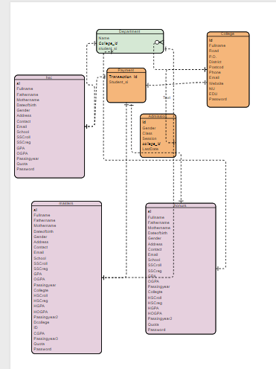

Project Description:
Our software will have two interfaces, one for the administer and another for the students.
Admin panel will have the following features:
- Add College: Provide details for college like name, address, streams provided etc.
- Add Cut Off: Select College from database and provide cut off for previous years.
- Manage / View Colleges: Update details for college and delete them if require.
- View Students: View list of students registered into the system.
- View Feedback: View feedback sent by user (student).
Student panel will have the following features:
- Register: Student will register themselves to the system by providing name, email ID, marks etc.
- View College: Student will be provided an option to show colleges near him and will show all the colleges based on his score.
- View Profile: Can view their own profile details.
    - Feedback: Student can send the feedback to notify the admin about the system.

Implementation:
System is designed to implement using html, css, php and also with other tools and languages when needed. The system investigation and analysis part will take a week. The design of the software is going to need more time. The system development is mainly for checking any bugs, adding more features etc. Finally, after the testing part is done this software will be ready for the customers.

Conclusion:
In this way we are going to develop admission predictor system, which is helpful for reduction in manual work and time. Students can apply within few seconds. Our system primarily focuses on building an efficient and user frindly communication system for the online admission predictor system.

Reference:
1.https://nevonprojects.com/college-admission-predictor-php/Accessed:02/02/2019
2.http://synopsis.nevemtech.com/index.aspx?Id=P063.doc/Accessed:02/02/2019

