Table

|  |  |  |  |  |  |  |  |  |  |  |  |  |
| --- | --- | --- | --- | --- | --- | --- | --- | --- | --- | --- | --- | --- |
| 1 |  |  |  |  | | | |  |  |  |  |  |
|  |  |
|  |  |
| 2 |  |  | |  |  |  |  |  |  |  |  |  |
| 3 |  |  | |  | | | |  |  |  |  |  |

Style 1

Style 2

|  |  |  |  |  |
| --- | --- | --- | --- | --- |
|  |  |  |  |  |
|  |  |  |  |  |
|  |  |  |  |  |
|  |  |  |  |  |

Style 3

|  |  |  |  |  |
| --- | --- | --- | --- | --- |
|  |  |  |  |  |
|  |  |  |  |  |

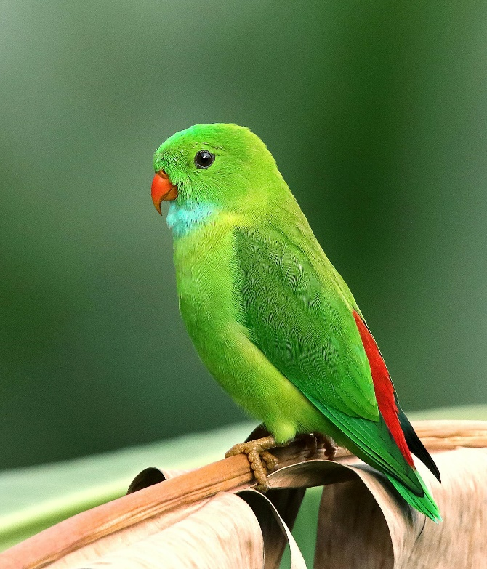Figure

Shape

graph