Solution to Question -01

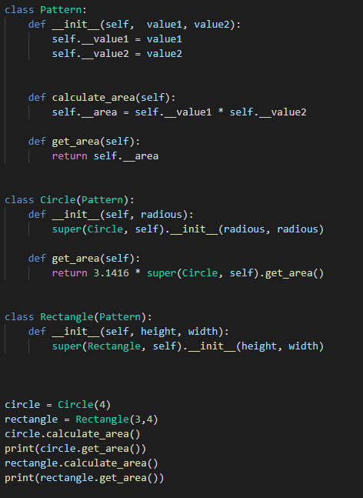I tried to explain the concept of OOP using a python code sample attached below:

I have implemented a **Pattern** class which is the template or blueprint for Circle and Rectangle class. All the attributes and methods are already constructed in this class. The variables with “__” are private variable which cannot be accessible from outside the class limit.

The Circle and Rectangle class inherited the Pattern class for accessing all the functionalities and attributes of this parent class.

The constructor for Circle class accepts only a single value but Pattern class takes two arguments for which we override the constructor and rewrite the code template for this portion. In the same way we override the get_area() method in order to execute some changes in the method which is known as **polymorphism.** I have used concepts like Inheritance, encapsulation, polymorphism/method overriding which are core parts of OOP.

Finally, in the driver code, I have created circle and rectangular classes to test all the functionalities of Object Oriented Programming.