

**Department of CIS**

**Name: Arman Hosen**

**ID NO: 193-16-486 Spring 2022**

**Course Title: Advance Database**

**Assignment**

**Submitted to**

**Nayeema Rahman**

**Senior Lecturer & Research Coordinator**

**Daffodil International University**

**Task-1:(b)**

|  |  |  |  |  |
| --- | --- | --- | --- | --- |
| 0NF/UNF | Level | 1NF | 2NF | 3NF |
| CustomerNumber  CustomerName  Adress  CustomerTelephone  ReturningCustomer  Notes  ProductCode  ProductName  ProductTypeCode  ProductTypeName  LocationCode  LocationName  PackageDuration | 1  1  1  1  1  1  2  2  2  2  2  2  2 | CustomerNumber  CustomerName  Adress  CustomerTelephone  ReturningCustomer  Notes  CustomerNumber*  ProductCode  ProductName  ProductTypeCode  ProductTypeName  LocationCode  LocationName  PackageDuration | **Customer**  CustomerNumber  CustomerName  Adress  CustomerTelephone  ReturningCustomer  Notes  **Product**  ProductCode  ProductName  ProductTypeCode*  **Product Type**  ProductTypeCode  ProductTypeName  **Product Location**  productCode*  LocationCode*  **Location**  LocationCode  LocationName  **CustomerProduct**  CustomerNumber*  ProductCode*  PackageDuration | **Customer**  CustomerNumber  CustomerName  Adress  CustomerTelephone  ReturningCustomer  Notes  **Product**  ProductCode  ProductName  ProductTypeCode*  **Product_Type**  ProductTypeCode  ProductTypeName  **Product_Location**  productCode*  LocationCode*  **Location**  LocationCode  LocationName  **CustomerProduct**  CustomerProductID  CustomerNumber*  ProductCode*  PackageDuration  locationCode* |

**Task-1(a):**

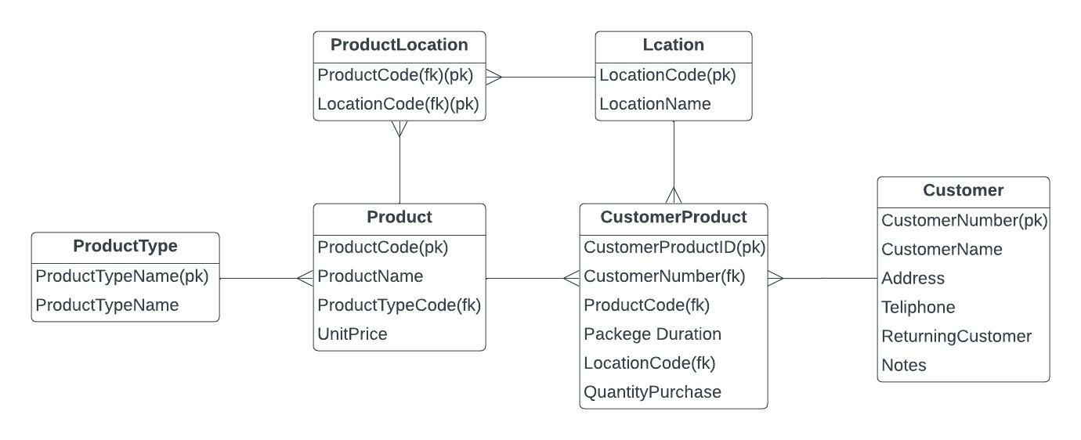

**Task-1(c):**

**Product Type:**

|  |  |  |  |  |  |
| --- | --- | --- | --- | --- | --- |
| Attribute | Datatype | Length | Primary key | Foreign key | Reference table |
| ProductTypeCode | Varchar | 3 | Yes |  |  |
| ProductTypeName | Varchar | 30 |  |  |  |

**Customer:**

|  |  |  |  |  |  |
| --- | --- | --- | --- | --- | --- |
| Attribute | datatype | Length | Primary key | Foreign key | Reference table |
| CustomerNo | varchar | 10 | yes |  |  |
| CustomerName | varchar | 50 |  |  |  |
| Address | varchar | 60 |  |  |  |
| Telephone no | varchar | 15 |  |  |  |
| Returning customer | Char | 3 |  |  |  |
| Note | varchar | 30 |  |  |  |

**Location**:

|  |  |  |  |  |  |
| --- | --- | --- | --- | --- | --- |
| Attribute | Datatype | Length | Primary key | Foreign key | Reference table |
| LocationCode | varchar | 5 | yes |  |  |
| LocationName | varchar | 20 |  |  |  |

**Product**:

|  |  |  |  |  |  |
| --- | --- | --- | --- | --- | --- |
| Attribute | Datatype | Length | Primary key | Foreign key | Reference table |
| ProductCode | varchar | 10 | yes |  |  |
| ProductName | varchar | 50 |  |  |  |
| ProductTypeCode | varchar | 3 |  | yes | Product type |
| UnitCost | float | 5 |  |  |  |

**Customer Product:**

|  |  |  |  |  |  |
| --- | --- | --- | --- | --- | --- |
| Attribute | Datatype | Length | Primary key | Foreign key | Reference table |
| CustomerProductID | int | 2 | yes |  |  |
| CustomerNo | varchar | 10 |  | yes | Customer |
| ProductCode | varchar | 10 |  | yes | Product |
| PackageDuration | varchar | 40 |  |  |  |
| LocationCode | varchar | 5 |  | yes | Location |
| QuantityPurchase | int | 3 |  |  |  |

**Product Location**

|  |  |  |  |  |  |
| --- | --- | --- | --- | --- | --- |
| Attribute | Datatype | Length | Primary key | Foreign key | Reference table |
| productCode | varchar | 10 | yes | yes | Product |
| LocationCode | varchar | 5 | yes | yes | Location |

**Task-2(a): Created Table**

**Product_Type**

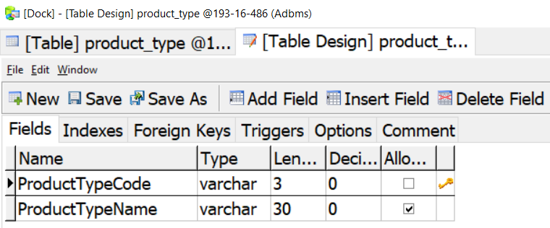

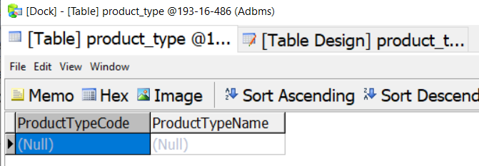

**Customer**

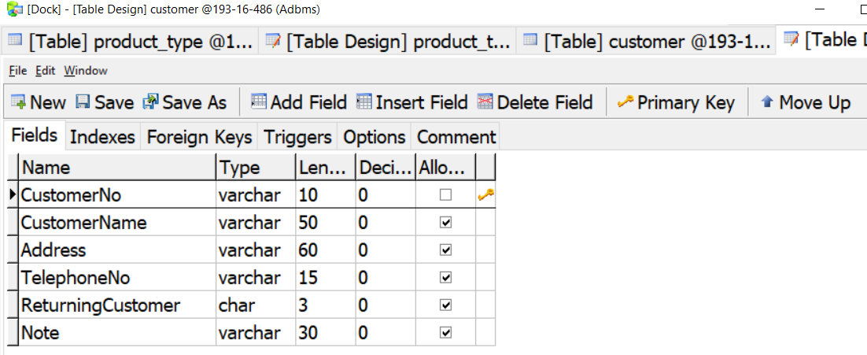

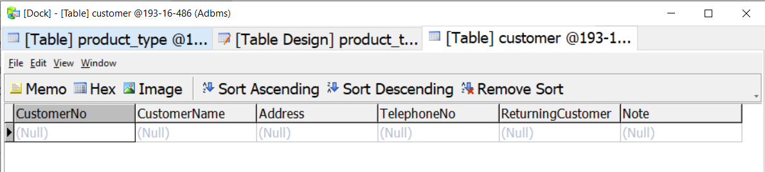

**Location**

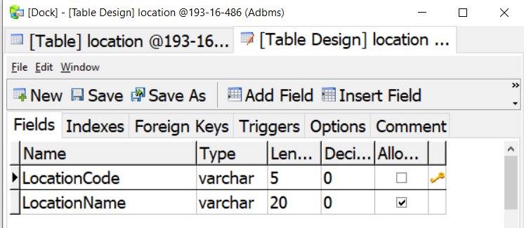

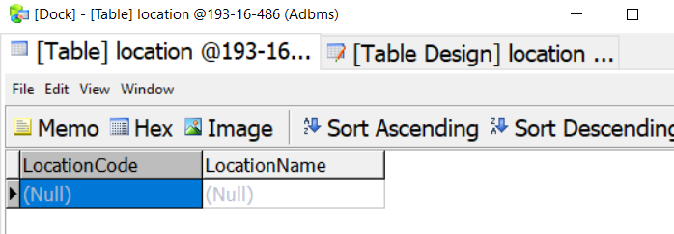

**Product**

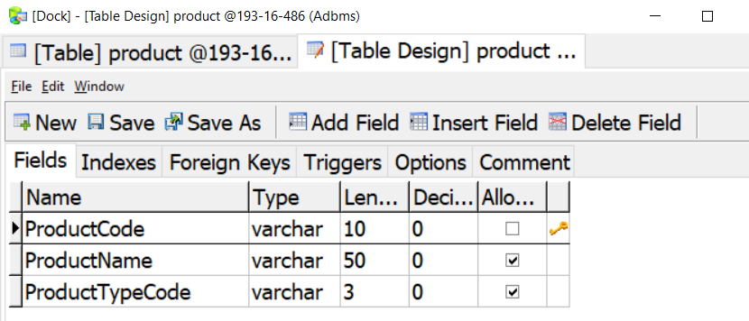

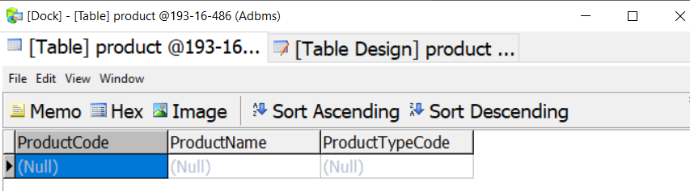

**Customer_Product:**

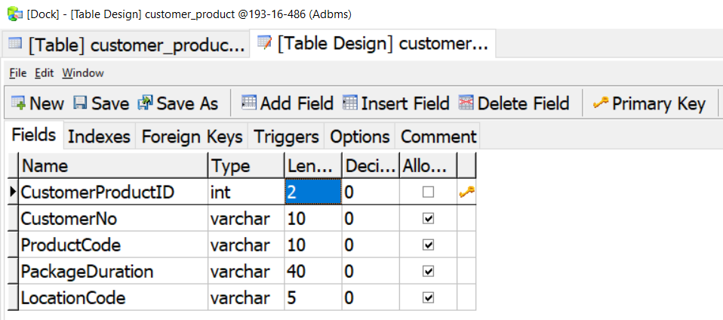

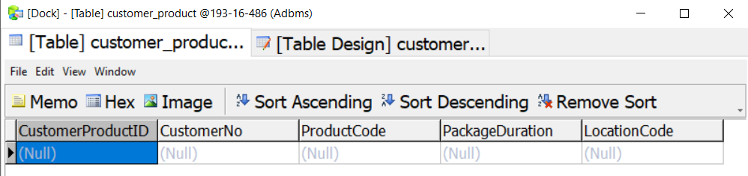

**Propduct_Location:**

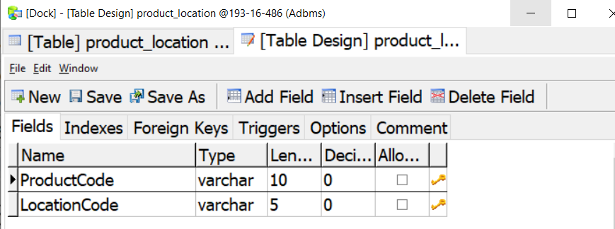

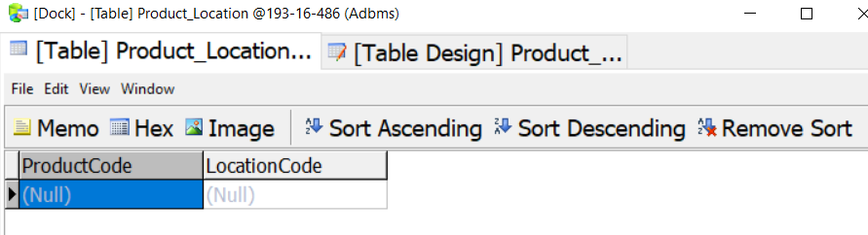

**Task-2(b): Insert Data**

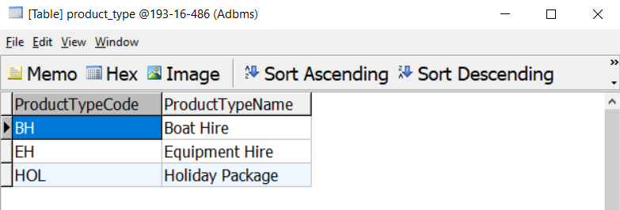

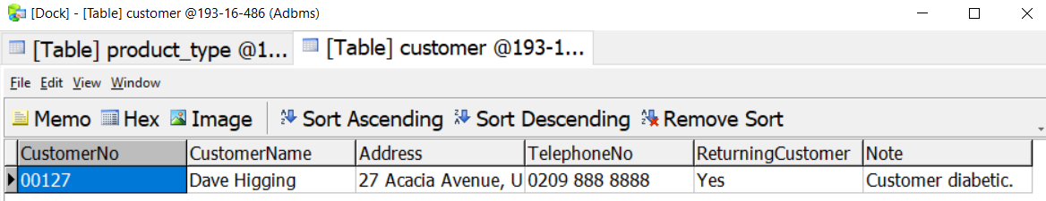

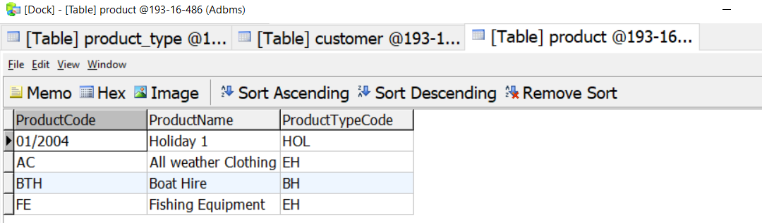

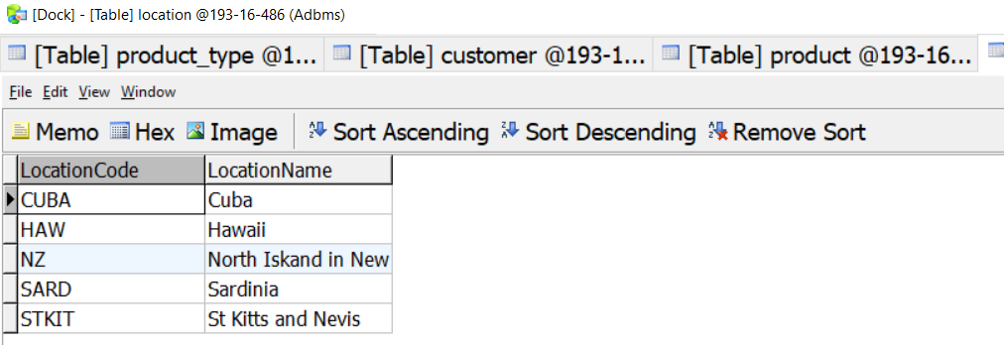

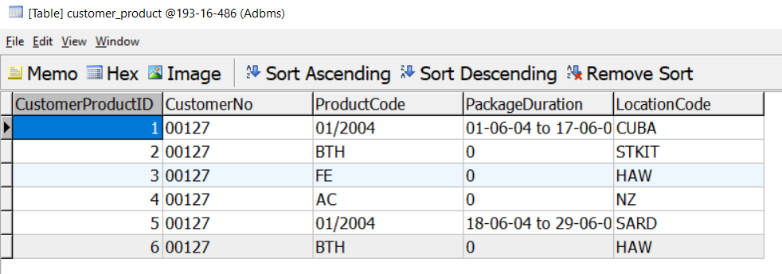

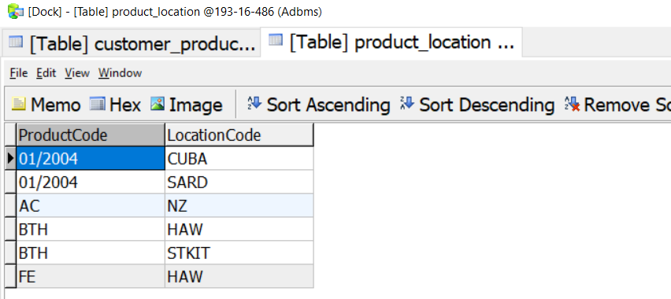

**Task-2©**

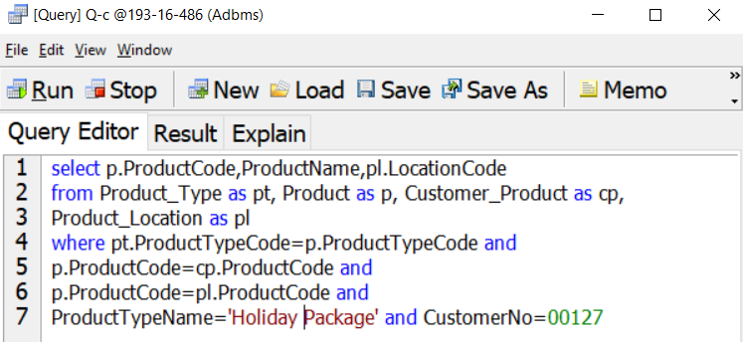

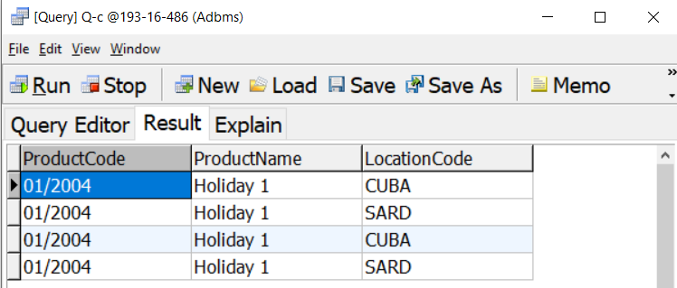

**Task-2(d):**

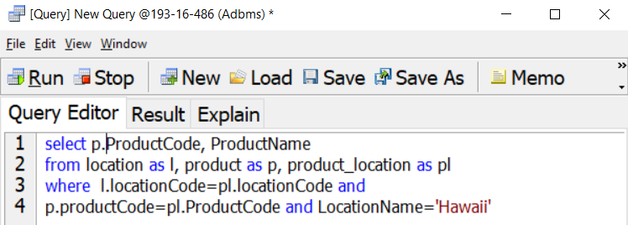

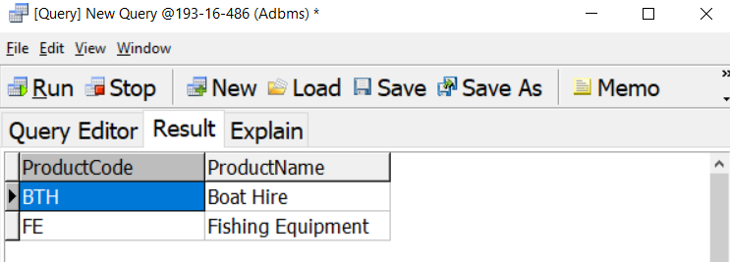

**Task-2(e):**

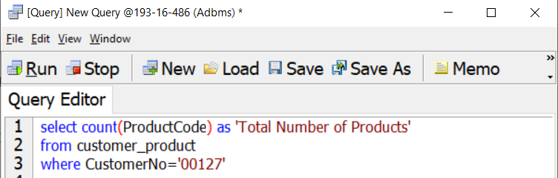

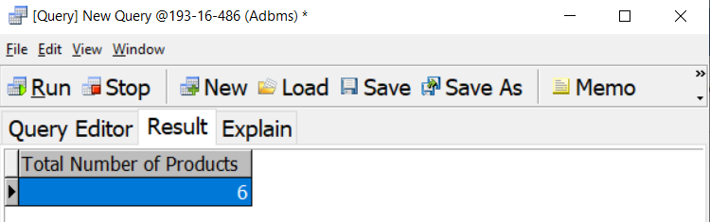

**Task-2(f):**

**Add attribute**

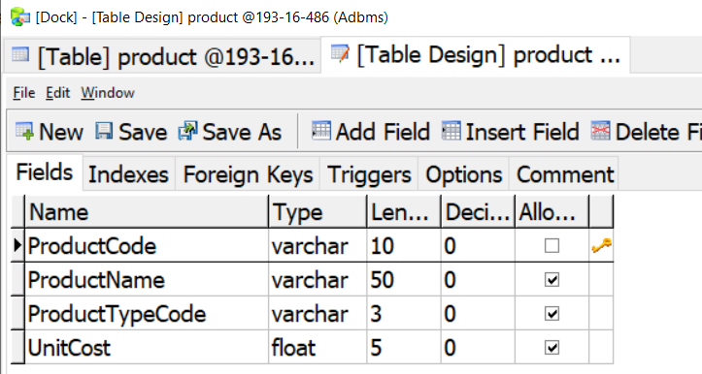

**Insert UnitCost Data**

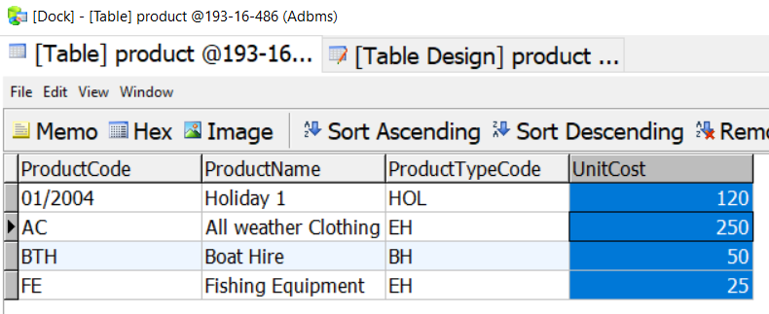

**Add Quantity Purchase attribute**

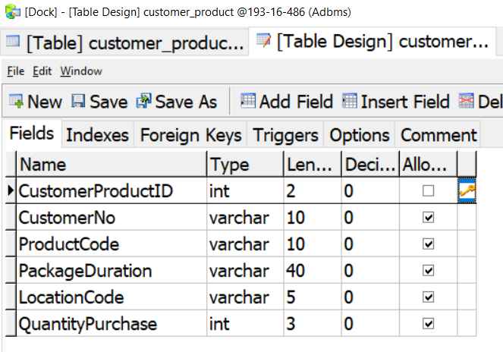

**Insert Quantity Purchase Data**

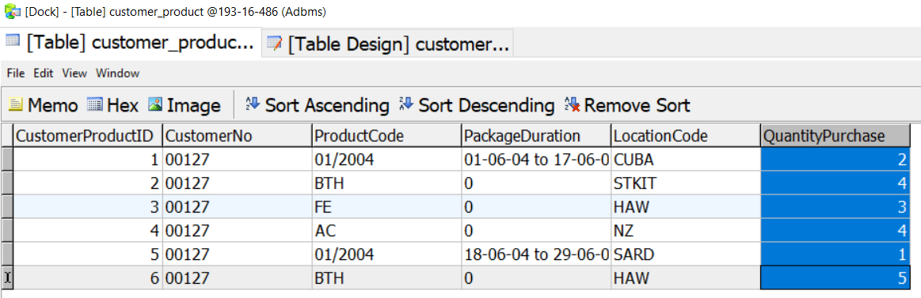

**Query**

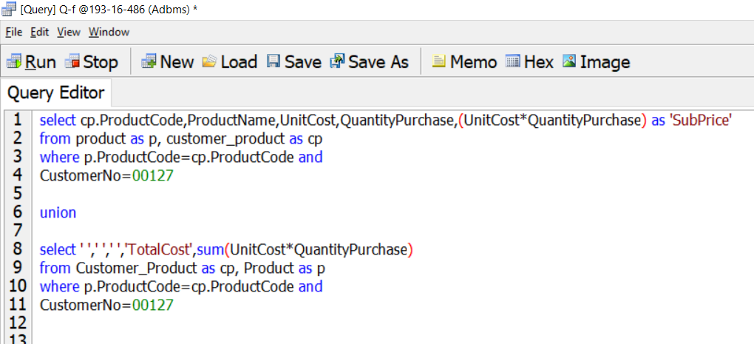

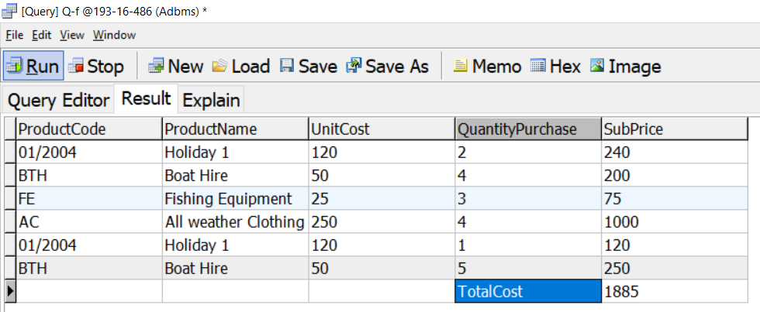

**Task-3:**

In this assignment The Island Dreams Company want to see a Customer details and the purchases for that Customer by a Customer Purchase Sheet in Database.

Firstly, I have to complete 3rd normalization to find the entity relationship and draw the ERD diagram.

Secondly, I create a Data dictionary table for the proposed database system to define the attributes input details. According to this information I have to create database table and insert all the data.

Finally, I write query for searching desired data. And including Unite cost and Quantity Purchased. At last write a query for showing relevant data for a customer with total cost of purchased product.

In this database I suggest to add staff information and product sell time and date. This is modify the Island Dreams company.