Simulation Output Waveform
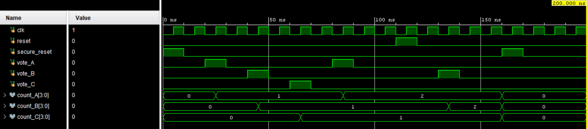
RTL Schematic
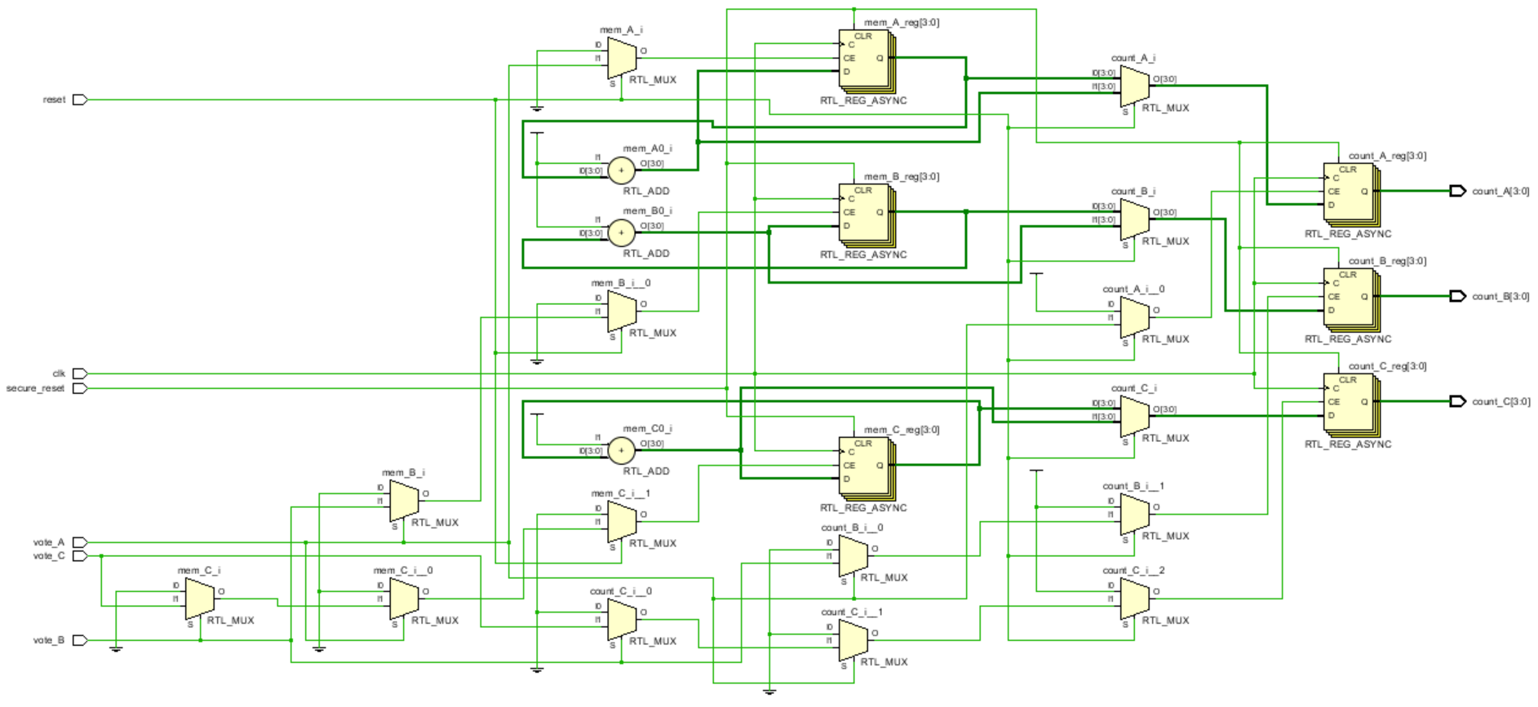
Synthesized Design
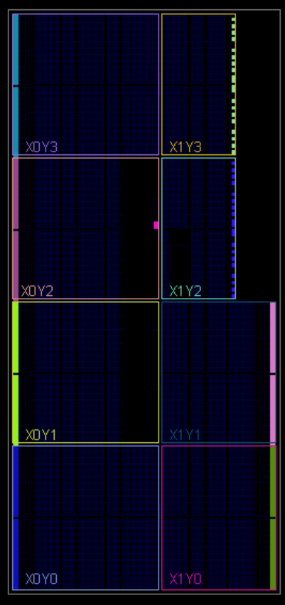
Output

T=0 | A= 0 | B= 0 | C= 0
T=25000 | A= 1 | B= 0 | C= 0
T=45000 | A= 1 | B= 1 | C= 0
T=65000 | A= 1 | B= 1 | C= 1
T=85000 | A= 2 | B= 1 | C= 1
T=135000 | A= 2 | B= 2 | C= 1
T=160000 | A= 0 | B= 0 | C= 0

