Project : Read-Analysis and Book Recommendation System

Step-1 Importing the necessary libraries.

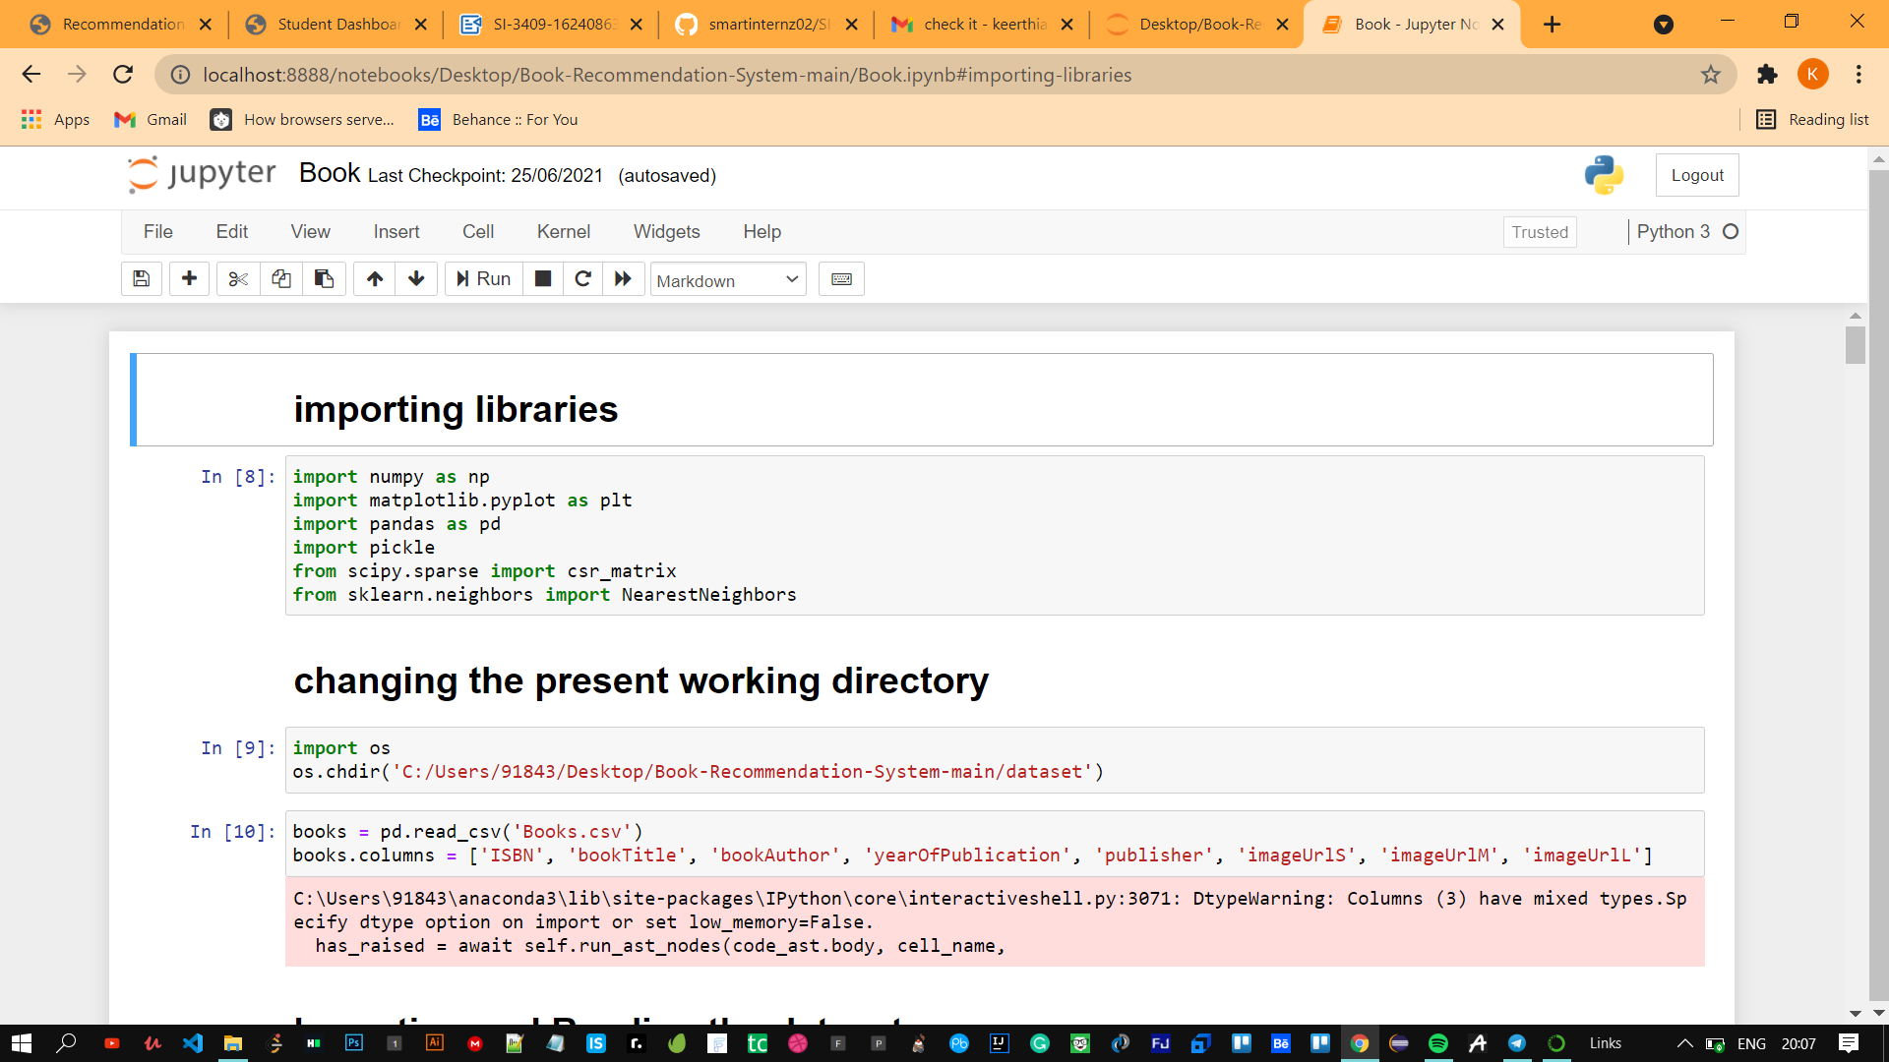

Step:2 Reading the user dataset,ratings dataset,books dataset.

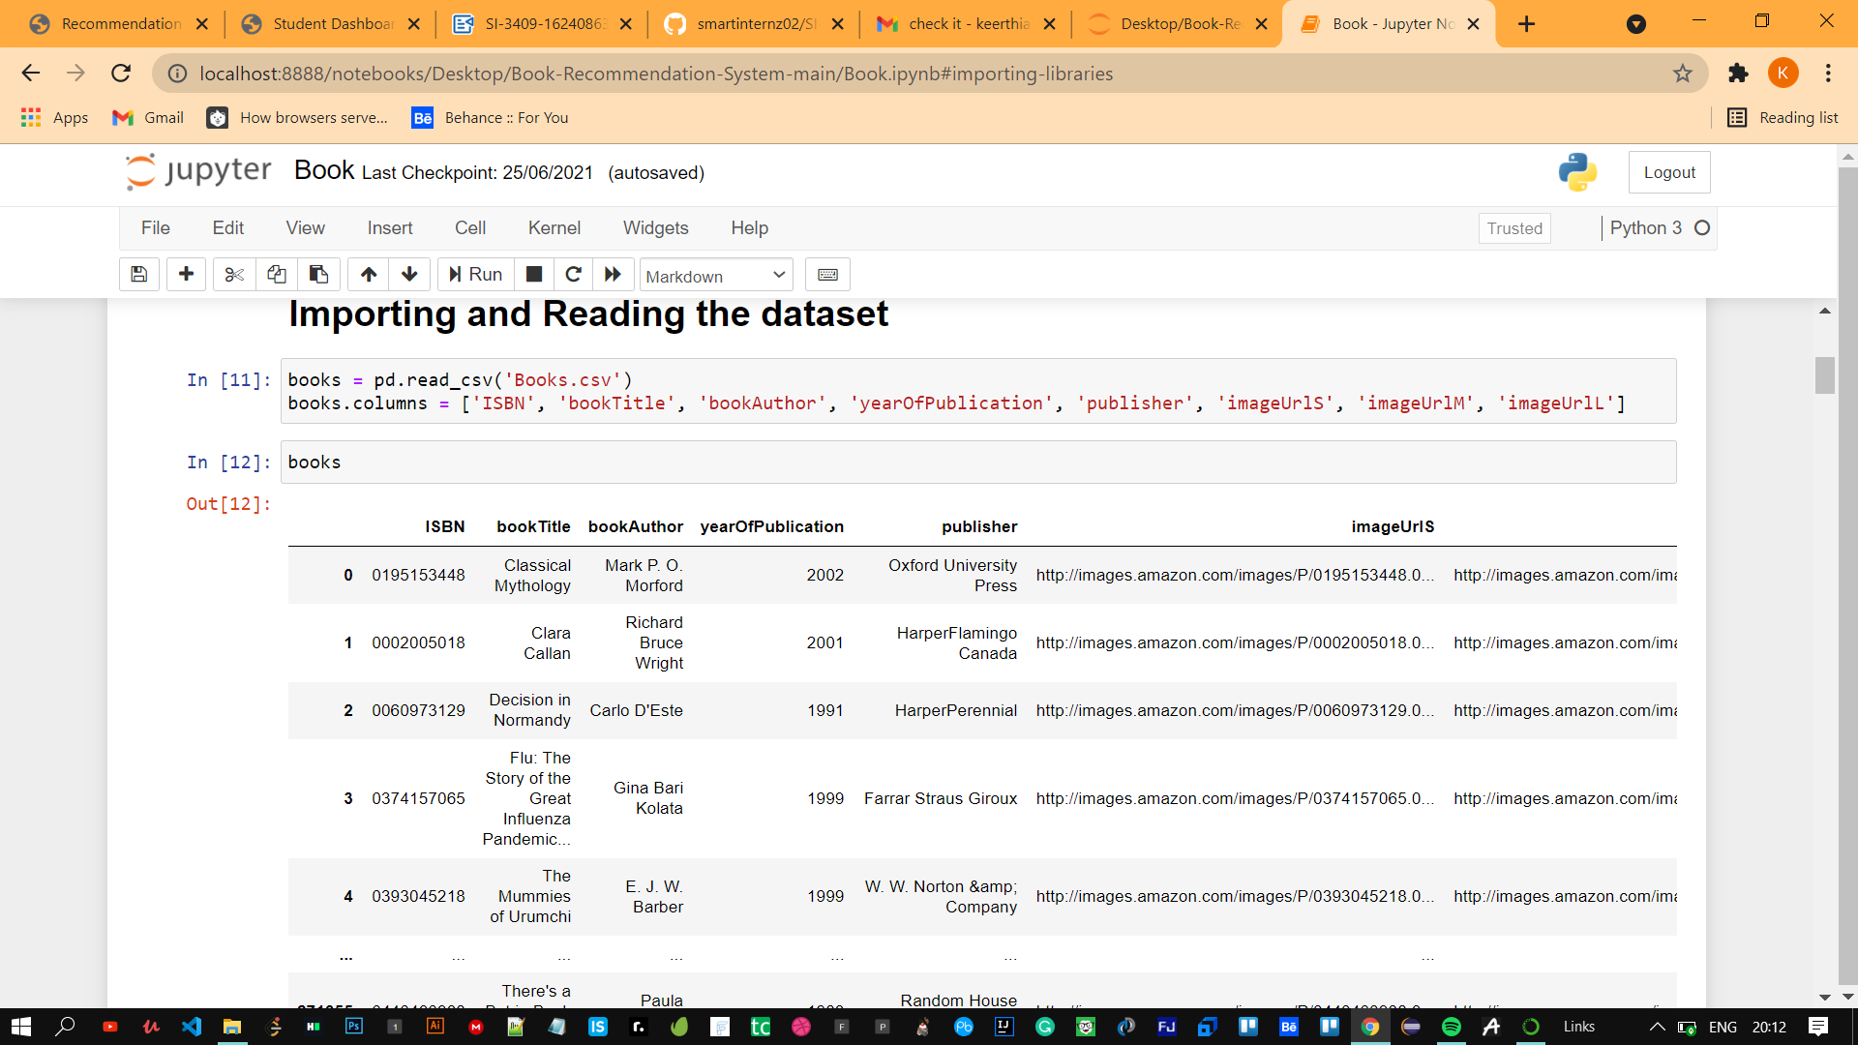

Step 3: Visualizing the data through graphs and methods

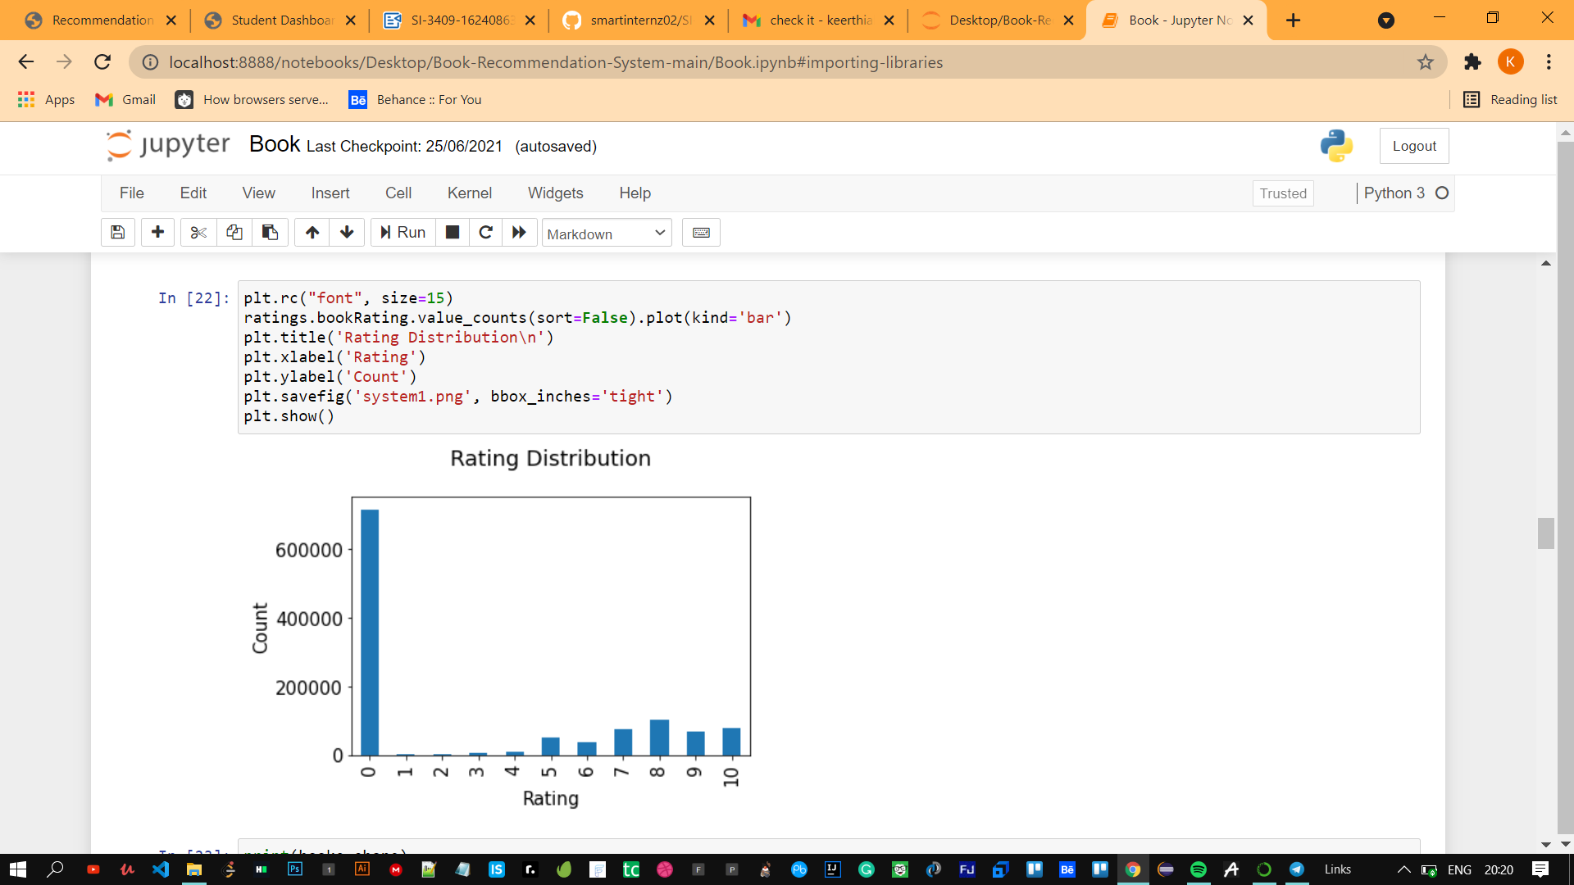

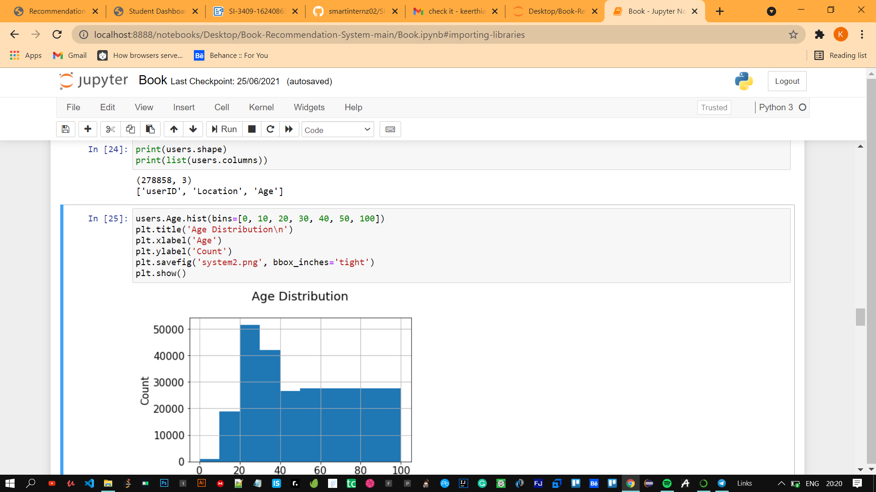

Step 4: Performing Collborative filtering over data ,In the more general sense, collaborative filtering is the process of filtering for information or patterns using techniques involving collaboration among multiple agents, viewpoints, data sources, etc. Applications of collaborative filtering typically involve very large data sets.

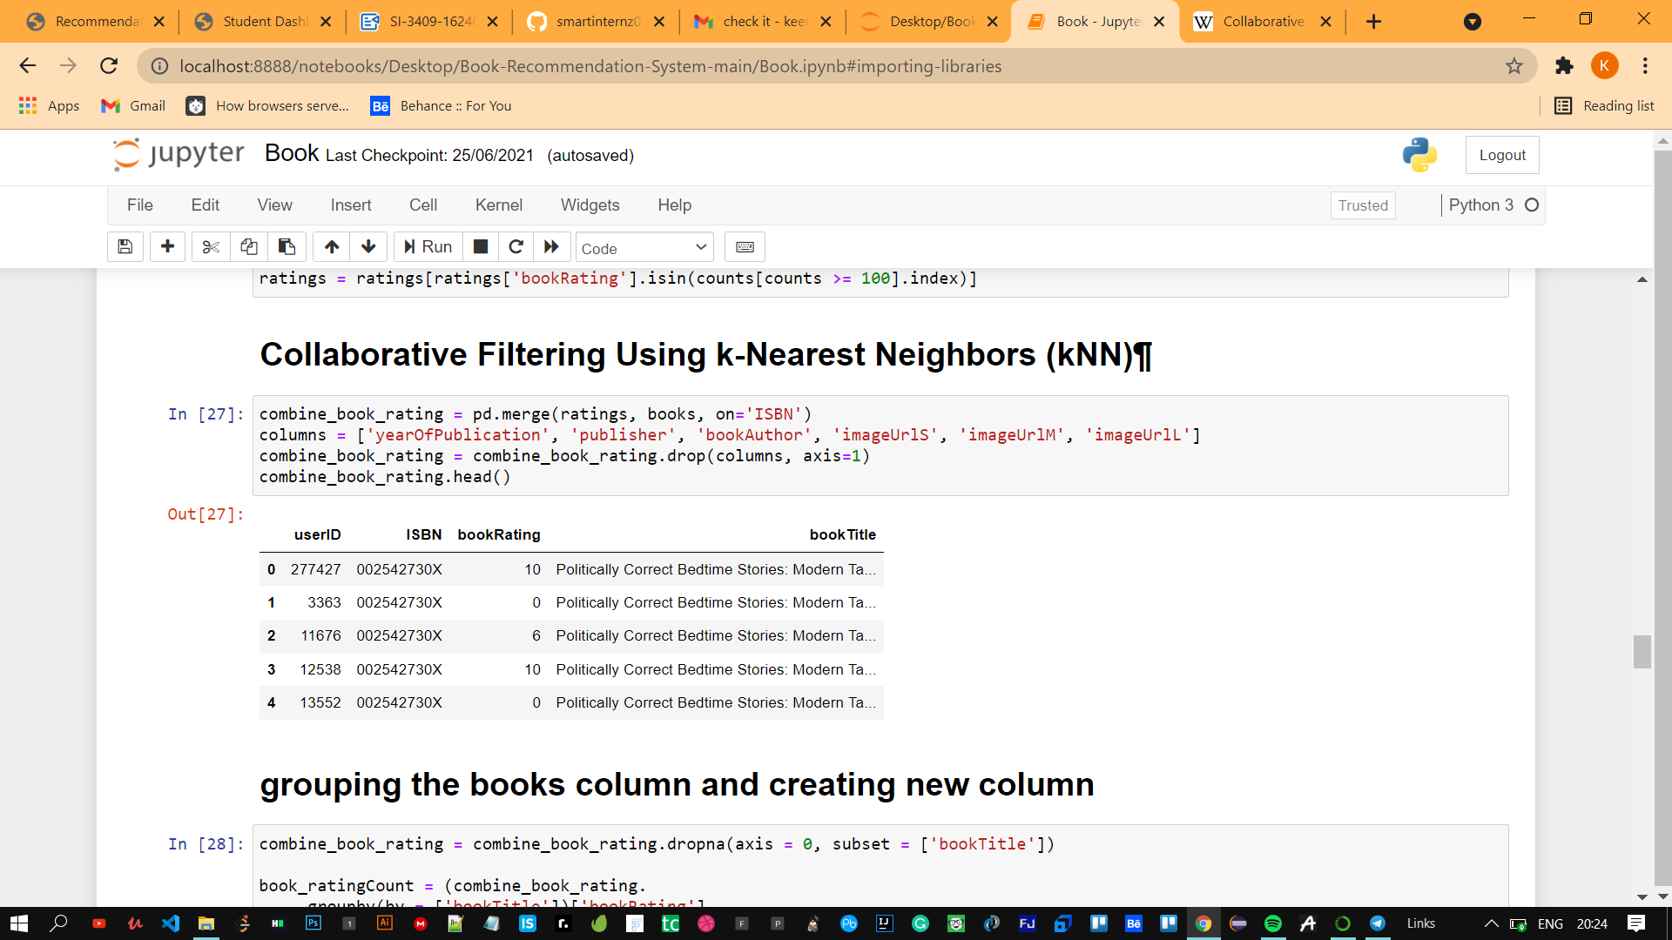

Step-5: Gropuing the books column and creating new column

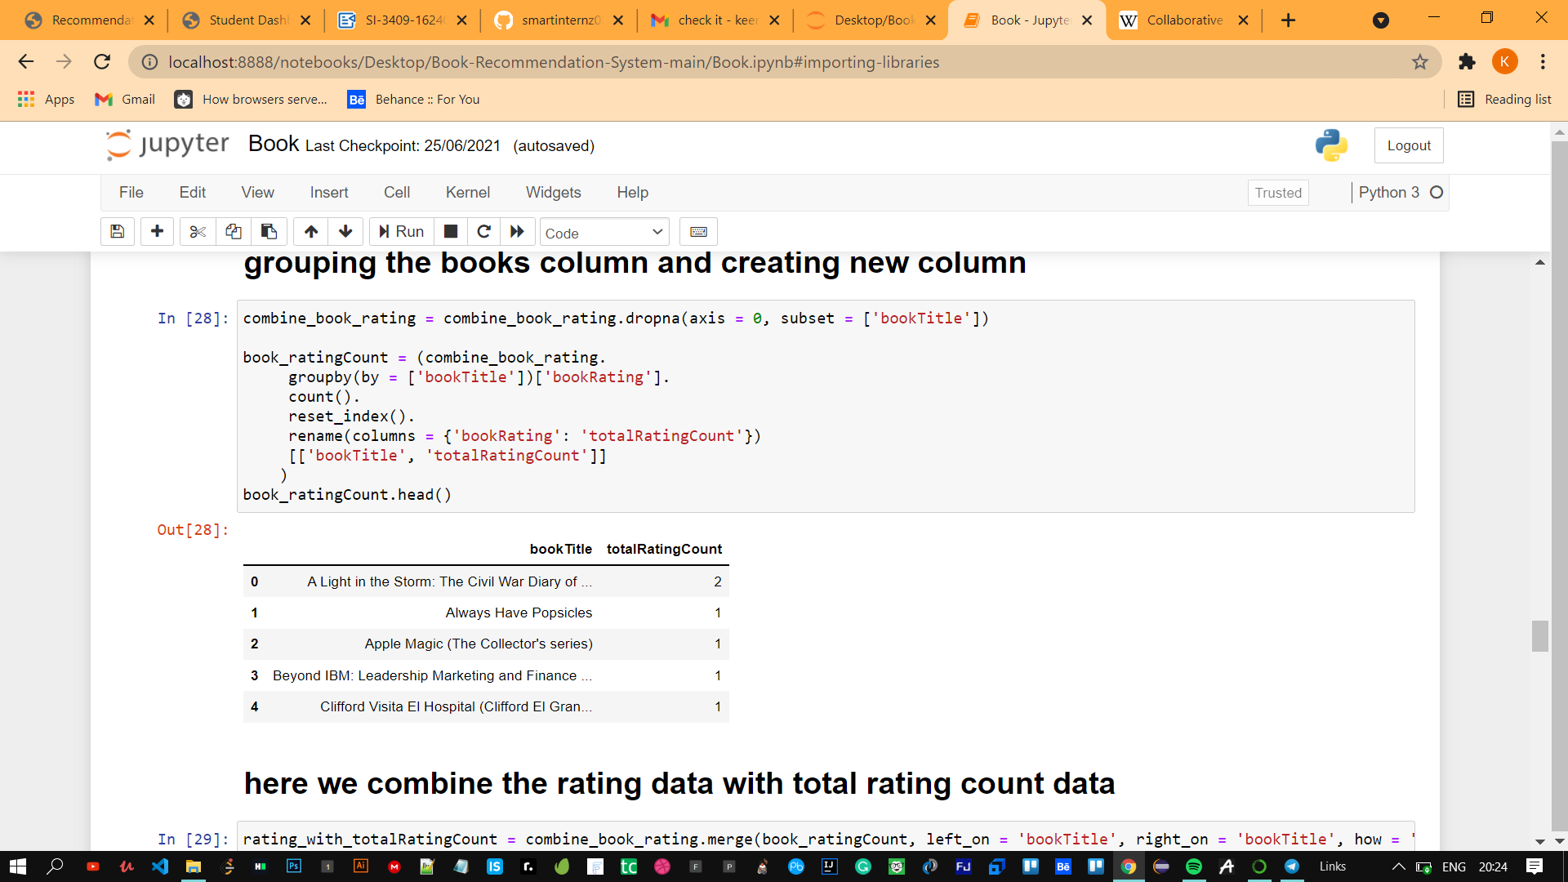

Step: 6 filtering the data and selecting users present in US and Canada.

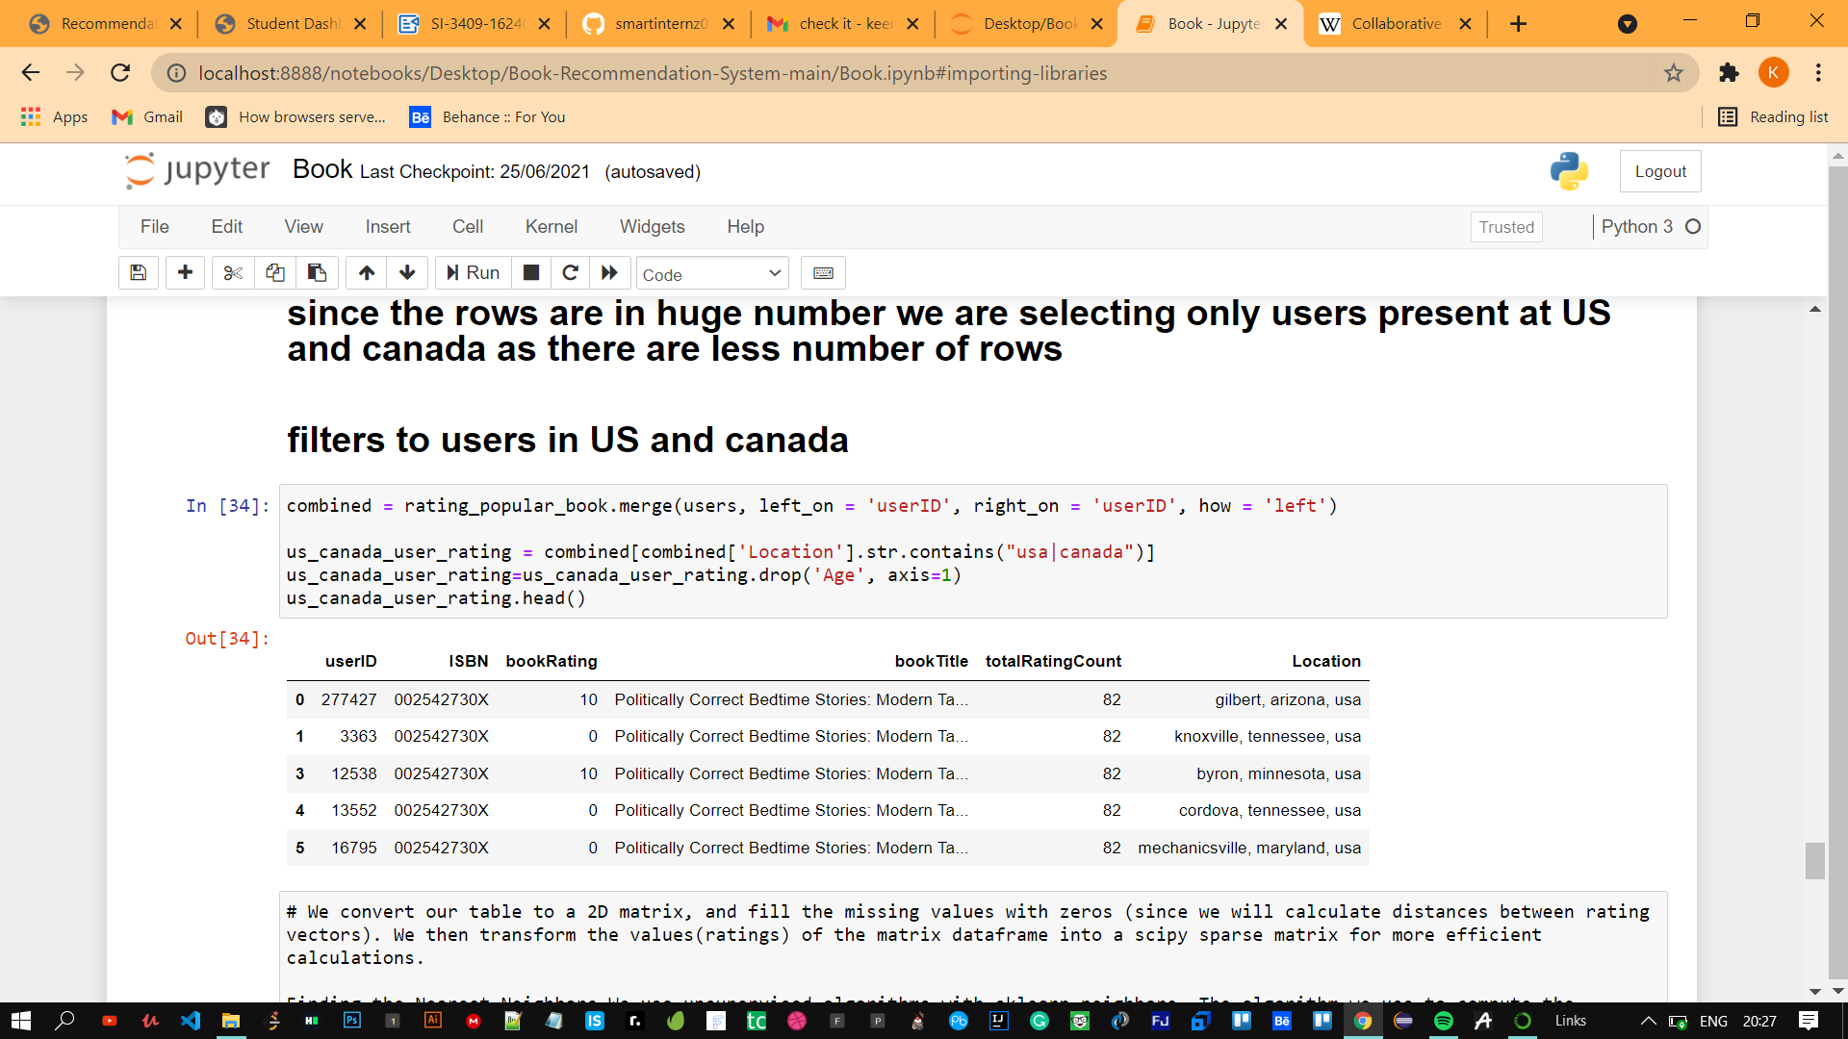

Step : 7 Implenting K-Nearest Neighbour Clustering Technique.

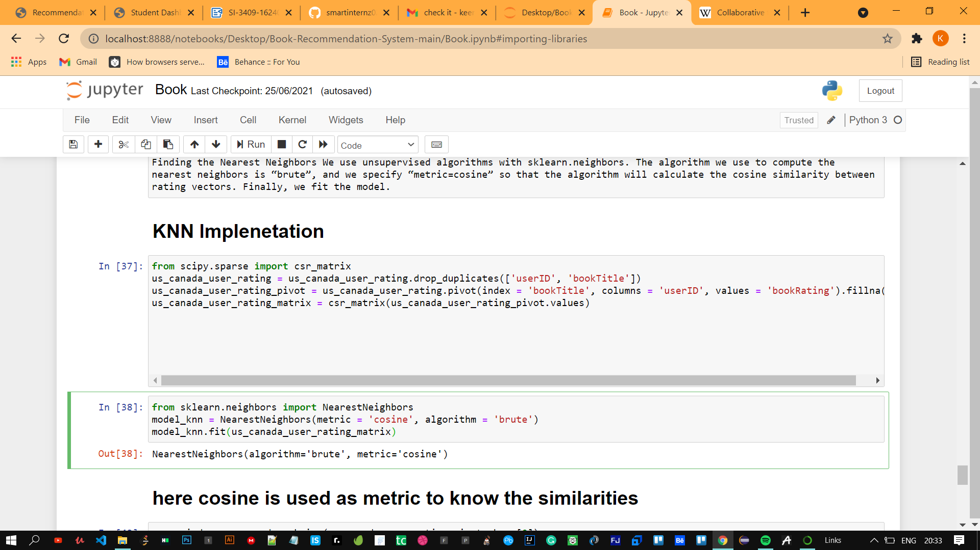

Step:8 Applying the cosine metric and it is used to find similarities

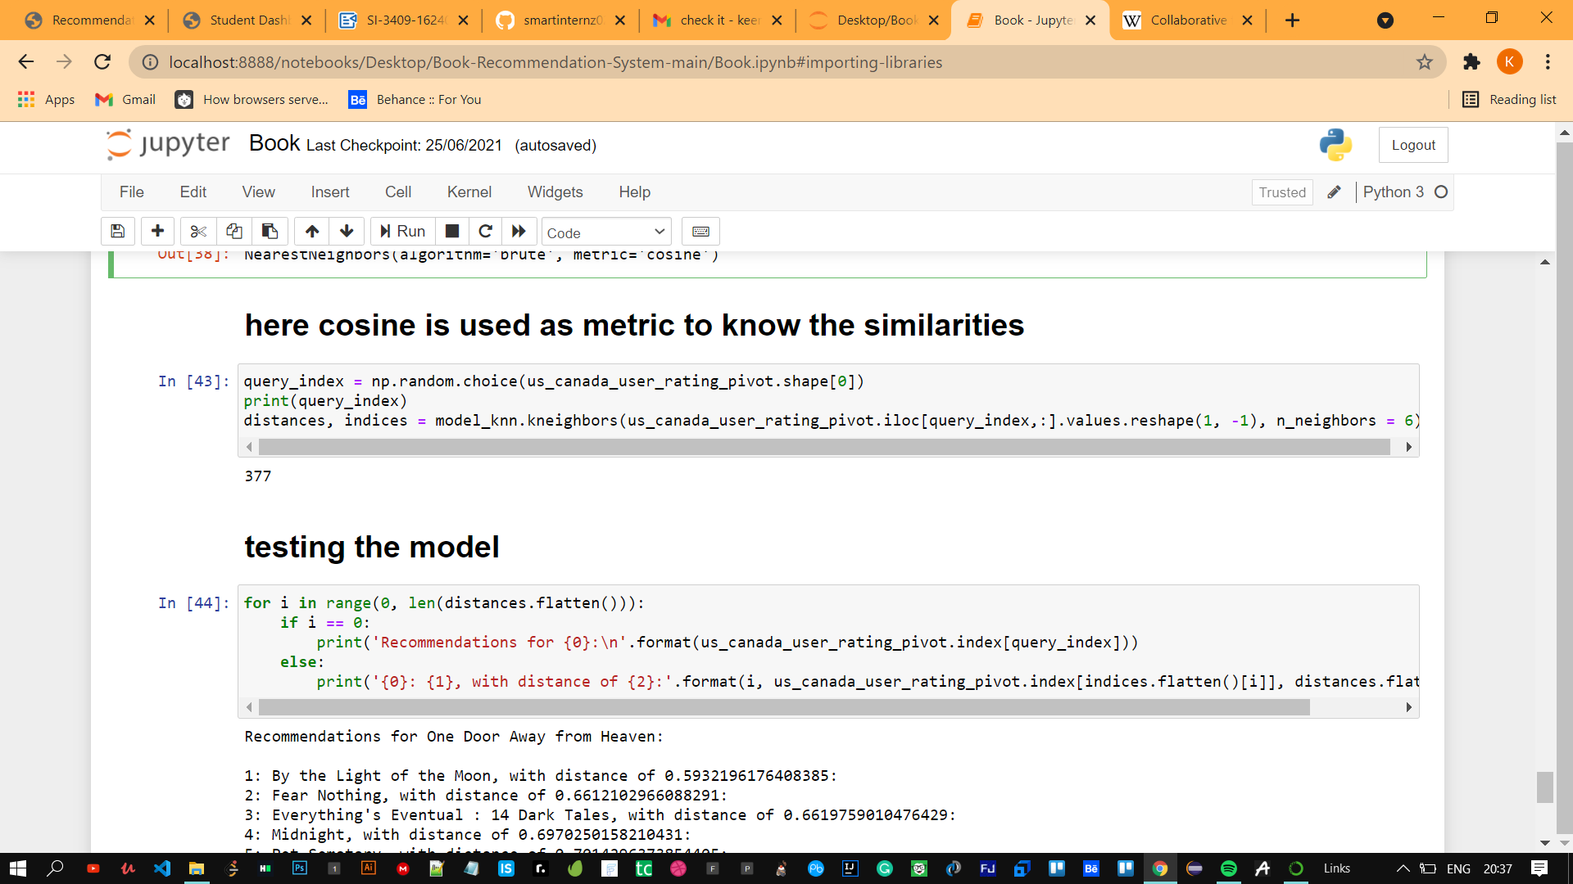

Step:8 Testing the model

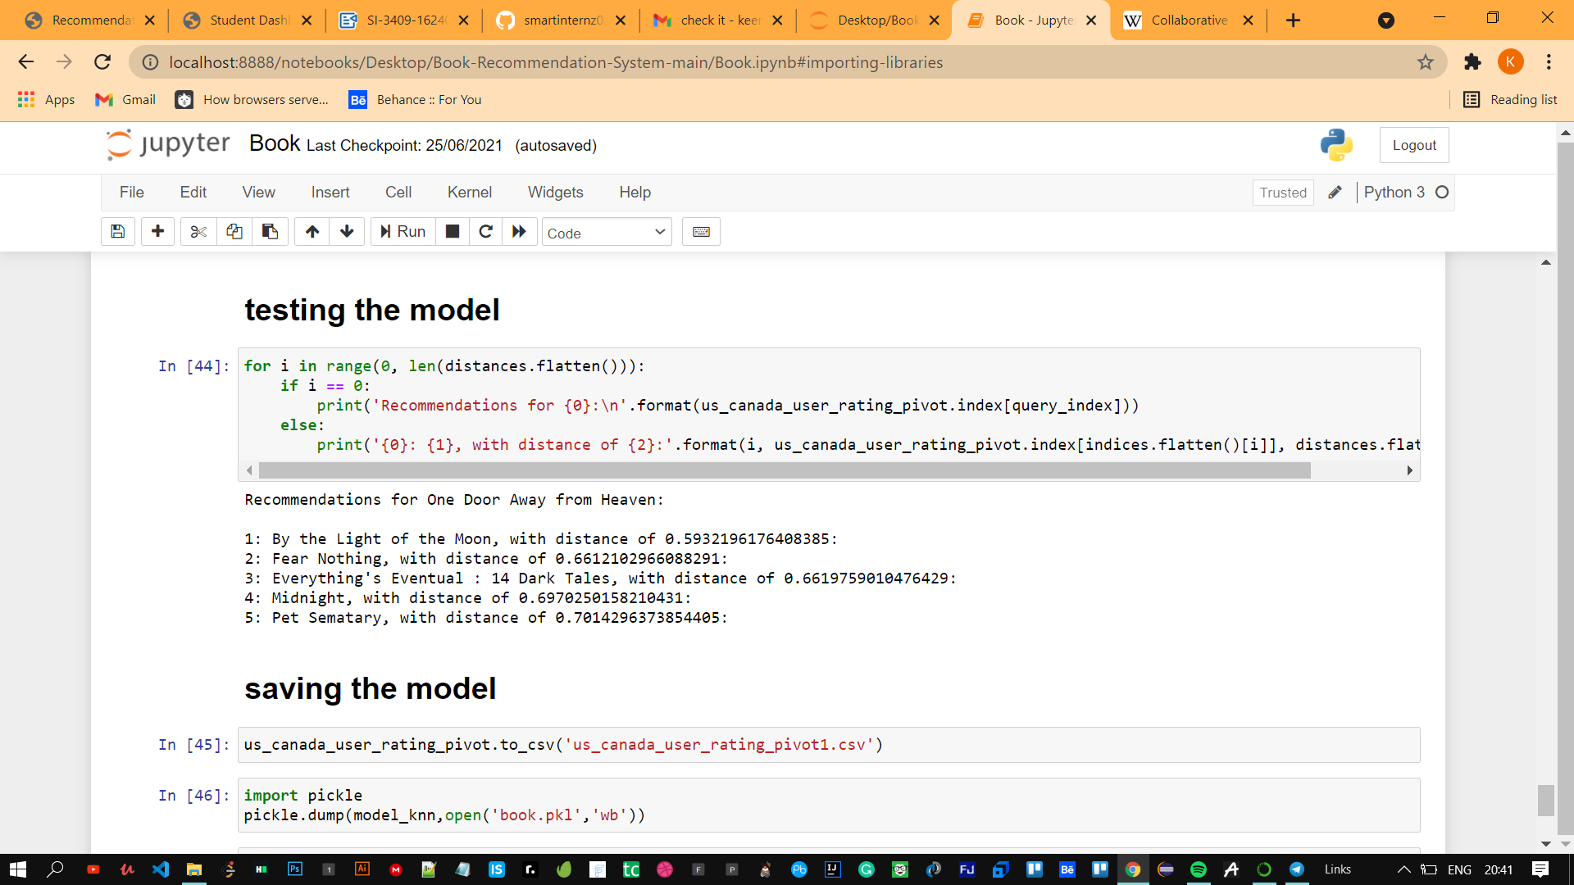

Step:9 Saving the Model

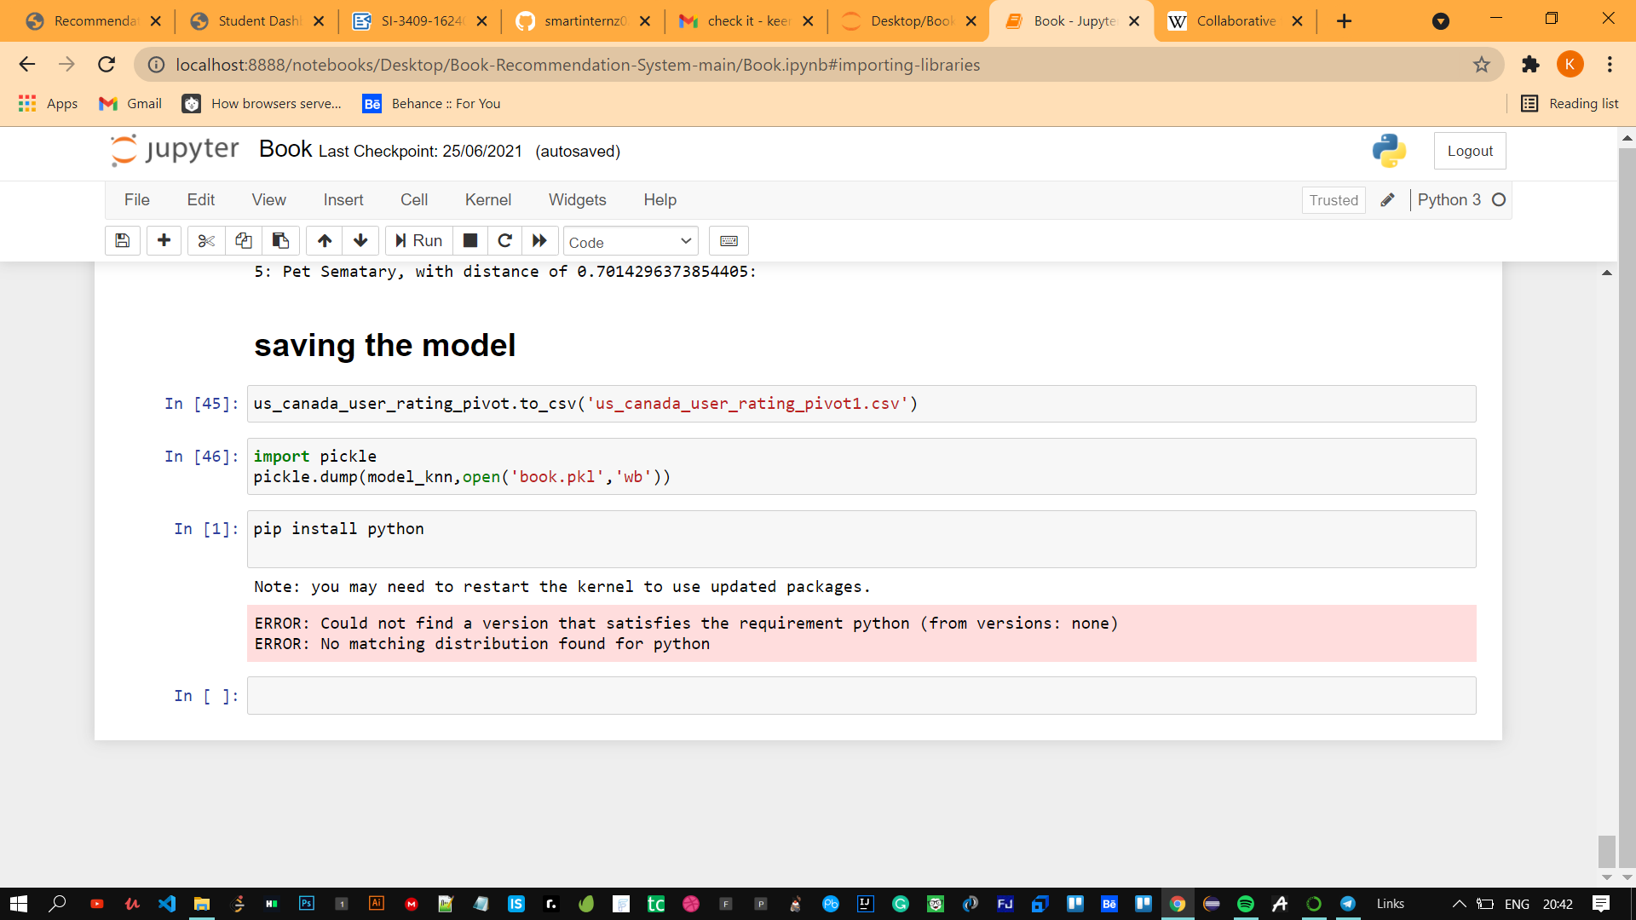

Step:10 Working with Flask

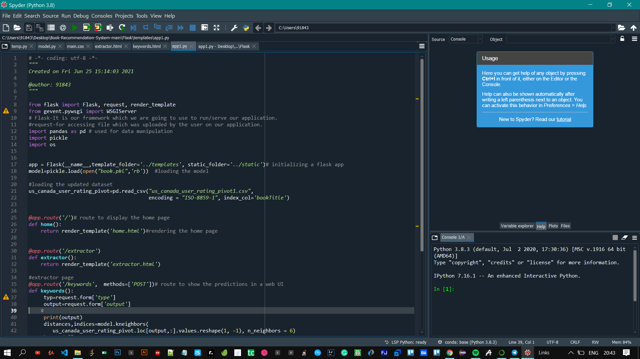

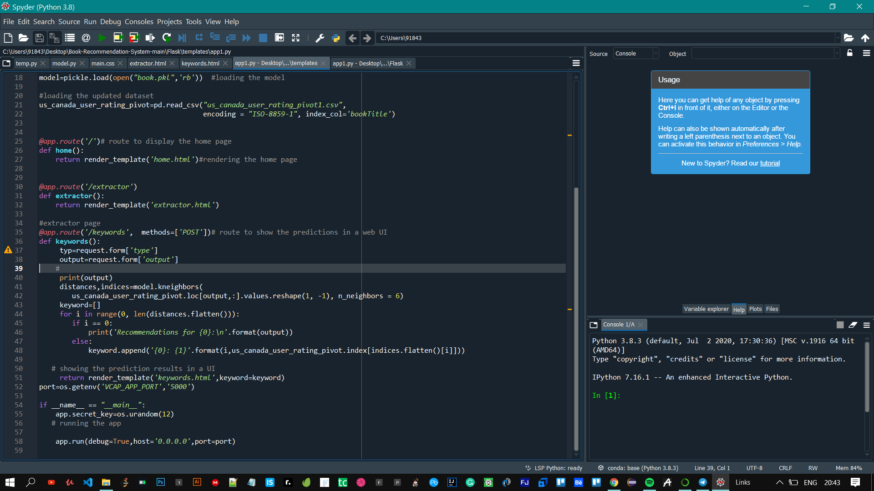

Results:

Step1: Home Page

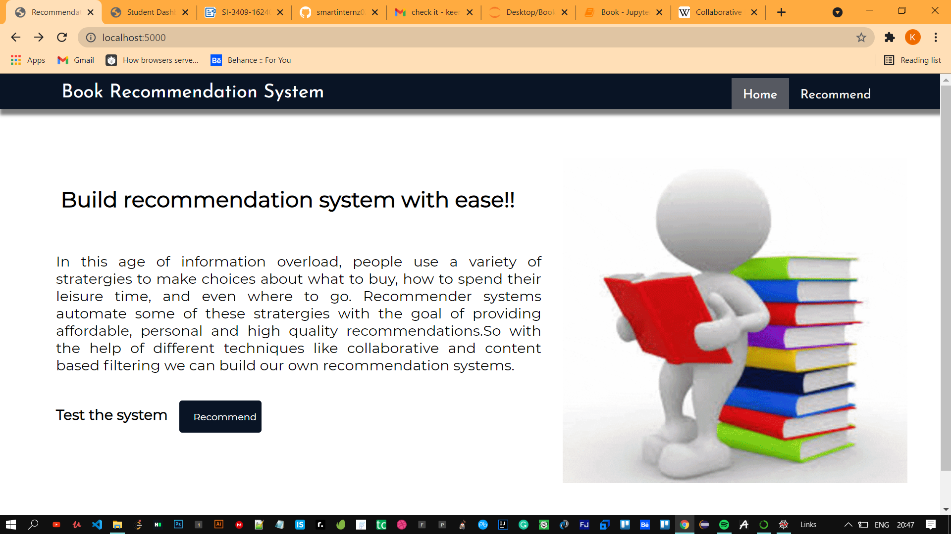

Step2: User Input

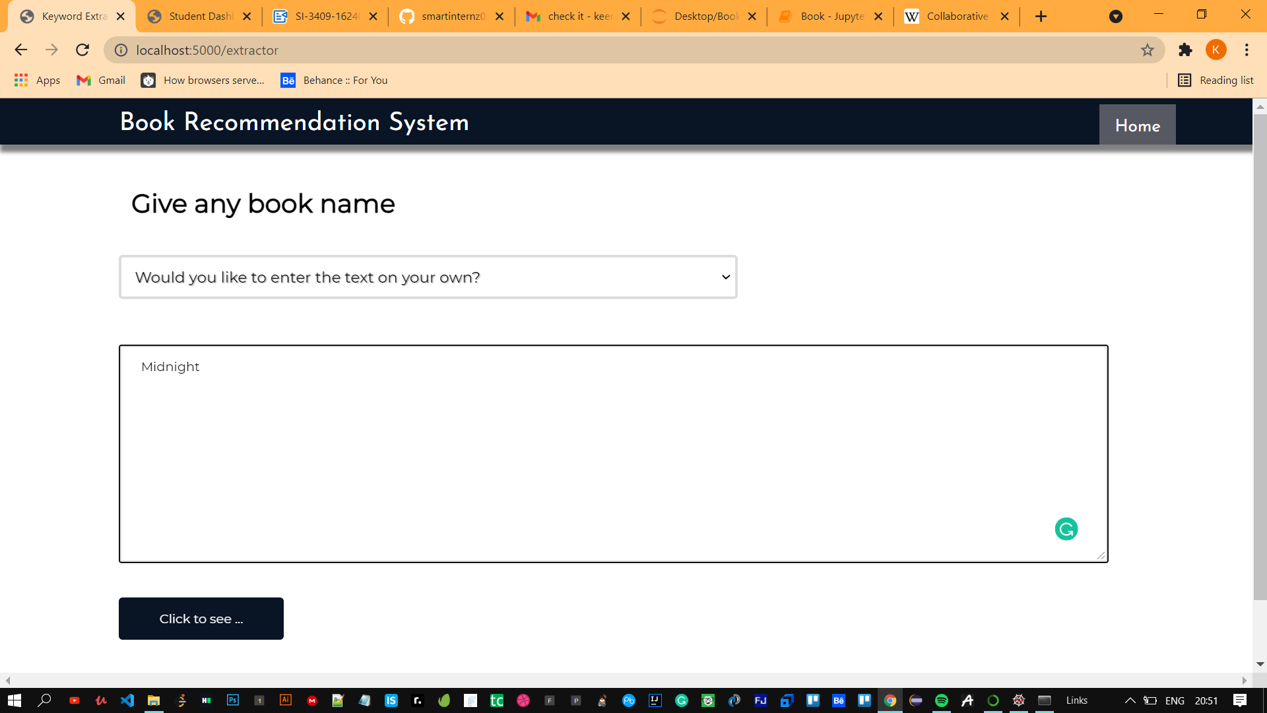

Step 3: Recommendation based on user input

