REST API Implementation & Database Relationship Verification
Patient Resource Management (CRUD Operations)
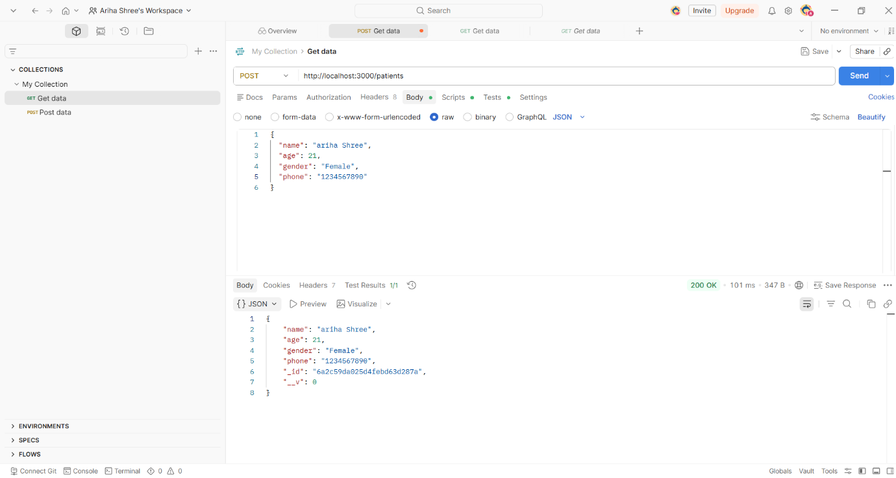
3.1.1 Patient Registration (POST /patients)
- Figure 3.1: API Endpoint for Creating a New Patient Record
- Technical Description: Demonstrates the successful validation and persistence of an incoming JSON patient payload. The Express server processes the request, commits it to the database, and returns the stored document alongside an auto-generated MongoDB _id with a standard 200 OK status code.
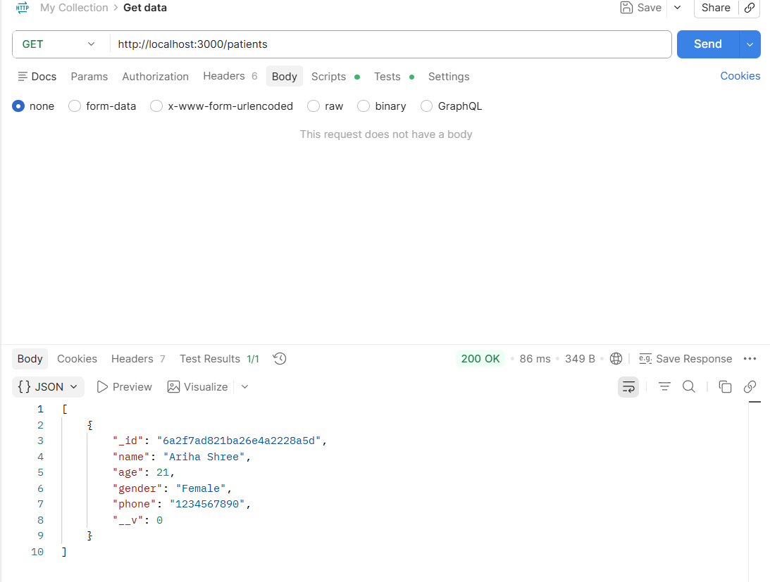
3.1.2 Fetching Active Patient Data (GET /patients)
- Figure 3.2: Retrieving All Patients from the Collection
- Technical Description: Illustrates the read operation targeting the entire patients collection. The response payload returns an indexed JSON array containing all active, structurally valid patient profiles.
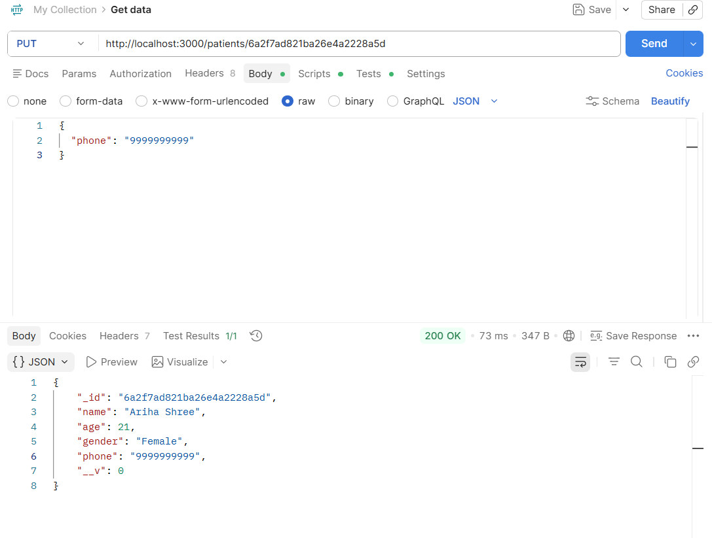
3.1.3 Modifying Existing Patient Attributes (PUT /patients/:id)
- Figure 3.3: Patient Record Update via Path Parameters
- Technical Description: Verifies the modification layer of the API. By supplying a specific patient _id as a path variable, the controller updates selective schema fields (such as changing the contact phone number to "9999999999") and safely returns the freshly mutated document.
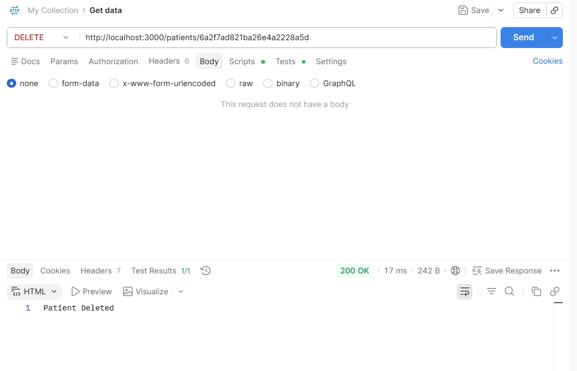
3.1.4 Data Lifecycle Termination (DELETE /patients/:id)
- Figure 3.4: Destructive Patient Deletion Operation
- Technical Description: Displays data lifecycle removal. Passing a target resource ID completely drops the corresponding entry from the database collection and returns an explicit string acknowledgment ("Patient Deleted"), leaving the subsequent retrieval array empty [].

3.2 Department Resource Management (CRUD Operations)
3.2.1 Department Generation (POST /departments)
- Figure 3.5: Administrative Creation of a Medical Department
- Technical Description: Validates the administrative routing layer. A JSON payload defining a clinical division (e.g., "Cardiology" in "Block A") is successfully instantiated and mapped to a distinct primary key.
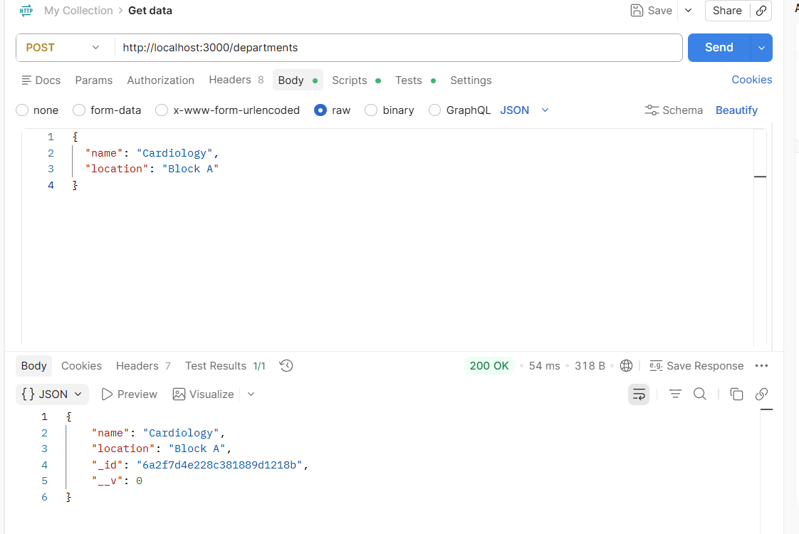
3.2.2 Fetching Active Department Data (GET /departments)
- Figure 3.6: Structured Array Retrieval of Medical Departments
- Technical Description: Shows the collective readout of all institutional departments. It confirms that newly generated organizational segments are being compiled smoothly into a queryable dataset.
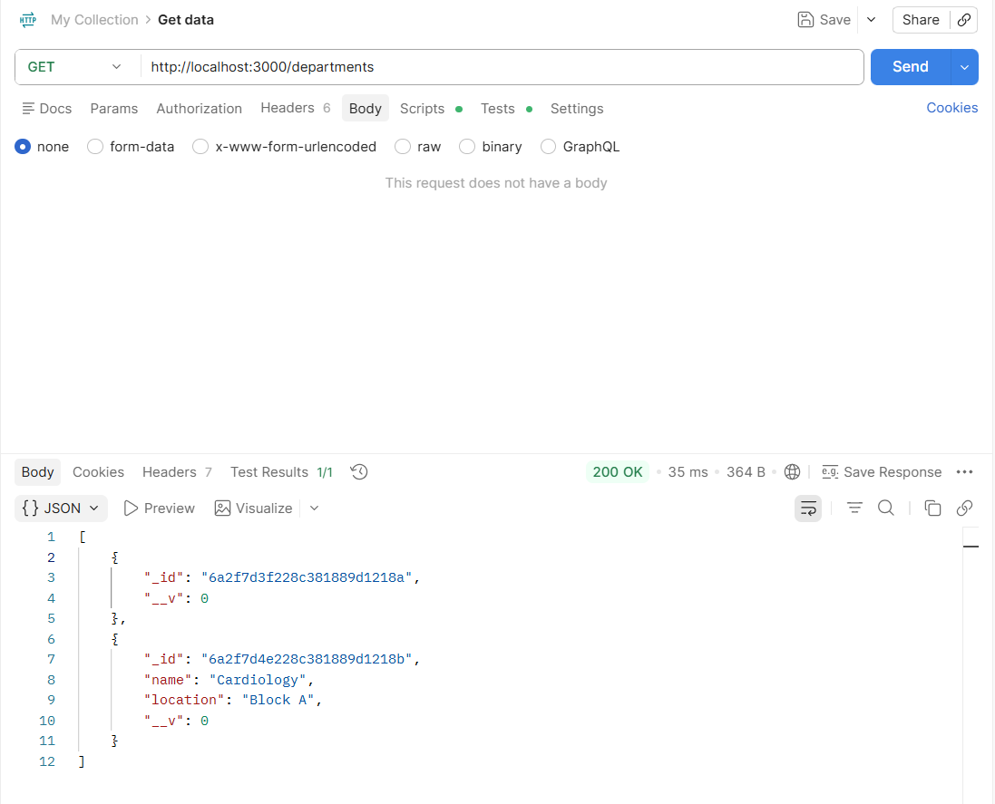
3.2.3 Modifying Department Metrics (PUT /departments/:id)
- Figure 3.7: Department Update Operation
- Technical Description: Demonstrates the structural flexibility of the API by modifying a department asset's physical coordinates (e.g., relocating Cardiology from "Block A" to "Block B").
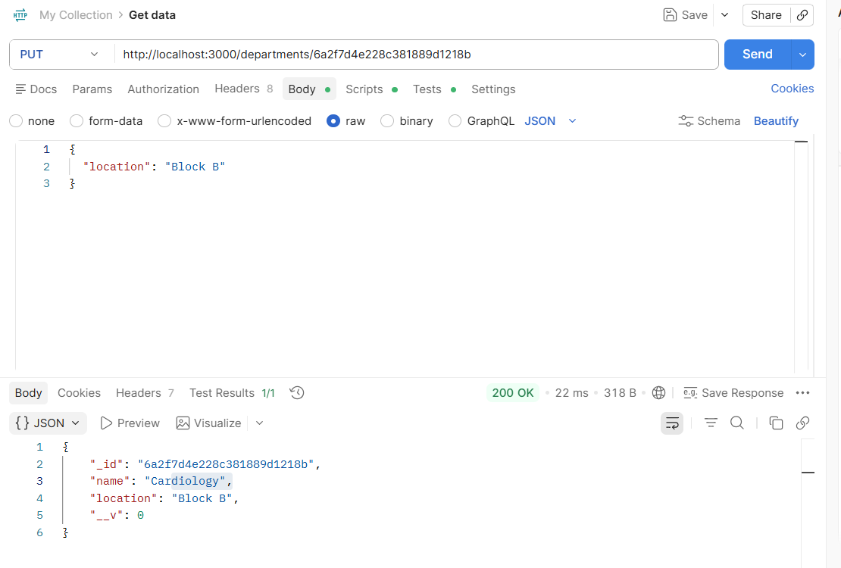
3.2.4 Department Removal (DELETE /departments/:id)
- Figure 3.8: Cascading/Standalone Department Deletion
- Technical Description: Confirms the deletion routine for structural collections, purging the target department payload and providing a safe endpoint exit flag ("Department Deleted").
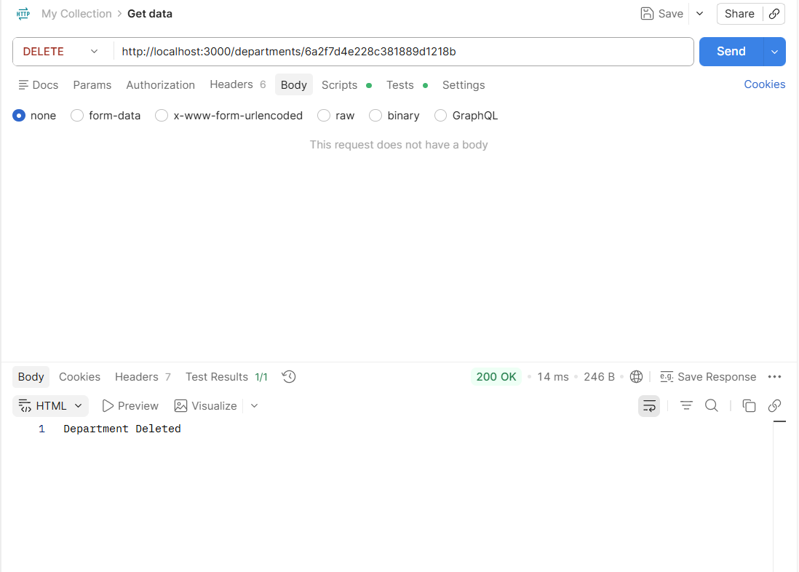
3.3 Relational Schema & Integrity Verification

3.3.1 Enforcing One-to-Many Mappings (POST /doctors)
- Figure 3.9: Doctor Creation with a Referential Department Key
- Technical Description: Crucial Relationship Proof. This screenshot demonstrates a functional One-to-Many mapping. When registering a new physician entity, a valid, pre-existing Mongoose ObjectId string is passed inside the departmentId field, establishing a rigid database relationship back to its parent department asset.
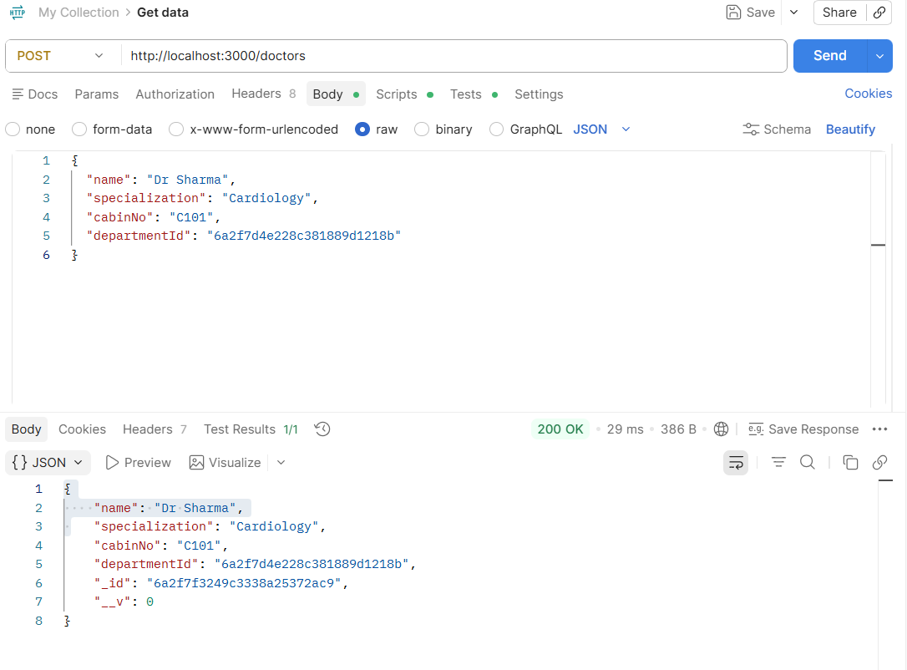
3.3.2 Bridge Collection Patterns for Many-to-Many Contracts (POST /appointments)
- Figure 3.10: Appointment Creation Bridging Patients and Doctors
- Technical Description: Crucial Relationship Proof. This snapshot validates the Many-to-Many bridge logic. The transactional Appointments collection serves as an associative entity. It takes an active, unique patientId and matches it securely with an independent doctorId to authorize a specific appointment date event.
- Independent doctorId to authorize a specific appointment date event.
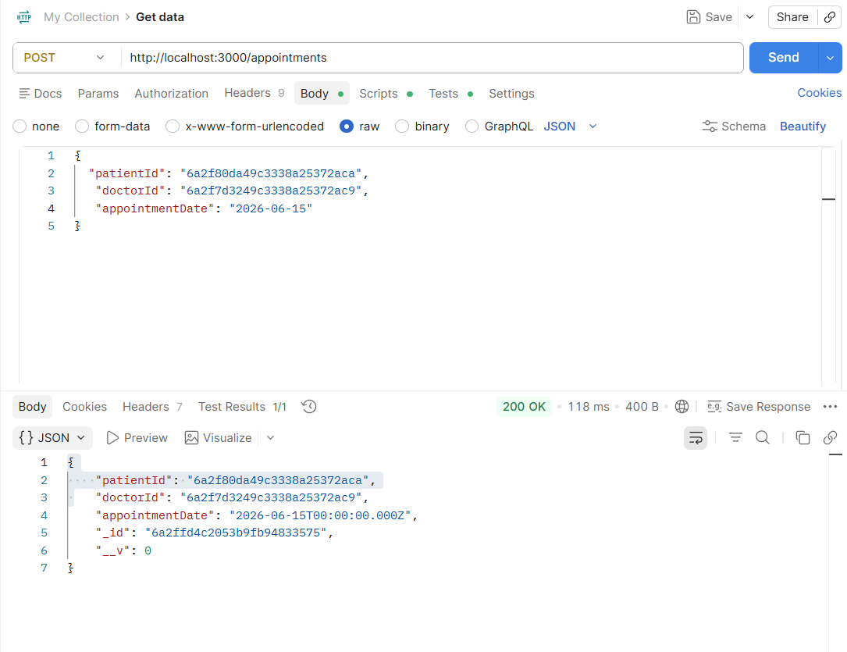

3.3.3 Consolidated Sub-Object Aggregate Fetching (GET /appointments)
- Figure 3.11: Advanced Mongoose Reference Query Population (.populate())
- Technical Description: This is the terminal evidence of database integrity. Instead of merely echoing unreadable 24-character hexadecimal reference strings, the route controller executes the Mongoose .populate() pattern. The system traverses the graph relationship to dynamically pull the actual fields (names, ages, specializations, cabin numbers) out of separate collections, compiling them into a singular, deeply-nested JSON document structure.

