Hospital Management System NoSQL Database Project Report
1. Objective
To design and implement a NoSQL database using MongoDB for a Hospital Management System. The project demonstrates collection creation, document insertion, CRUD operations, and API testing using Postman.

2. Software & Tools Used
- Database Server: MongoDB Server
- Database CLI: MongoDB Shell (mongosh)
- Backend Environment: Node.js / Express API
- API Testing Client: Postman
- Operating System: Windows OS

3. Database Design
The database contains collections designed to store institutional hospital records as document-oriented JSON payloads. The architecture consists of the following key collections:
- patients
- doctors
- departments
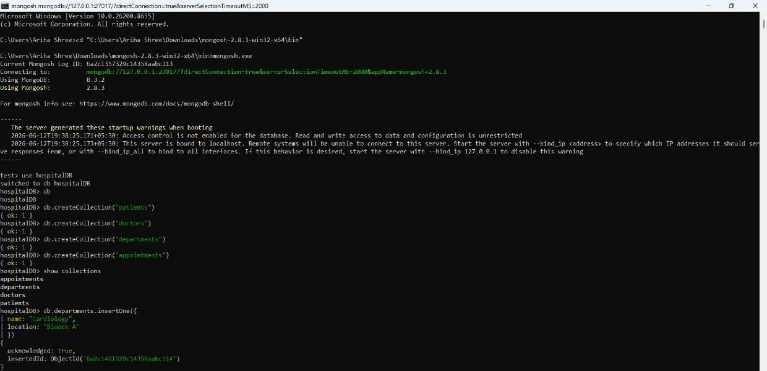
- appointments

4. Database Implementation & Setup
- Database Initialization: Created a local MongoDB database instance named hospitalDB.
- Collection Setup: Instantiated the primary structural collections: patients, doctors, departments, and appointments.
- Seed Data Insertion: Populated sample records directly into the collections using the MongoDB shell to establish a baseline for data testing.

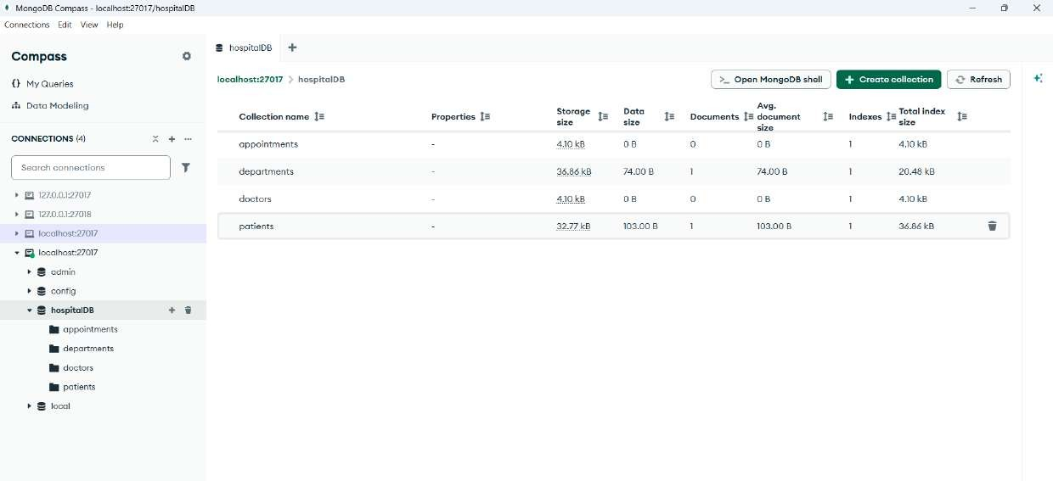

5. Patient Resource Management (CRUD Operations)
5.1 Patient Registration (POST /patients)
- Description: Demonstrates the successful validation and persistence of an incoming JSON patient payload. The Express server processes the application request, commits it to the underlying collection, and returns the stored document alongside an auto-generated MongoDB _id with a standard 200 OK status code.
5.2 Fetching Active Patient Data (GET /patients)
- Description: Illustrates the read operation targeting the entire patients collection. The response payload returns an indexed JSON array containing all active, structurally valid patient profiles currently stored in the database.
5.3 Modifying Existing Patient Attributes (PUT /patients/:id)
- Description: Verifies the modification layer of the API. By supplying a specific patient _id as a path variable, the controller updates selective schema fields (such as changing the contact phone number) and safely returns the freshly mutated document.
5.4 Data Lifecycle Termination (DELETE /patients/:id)
Description: Displays data lifecycle removal. Passing a target resource ID completely drops the corresponding entry from the database collection and returns an explicit string acknowledgment confirming the deletion, leaving the subsequent
REST API Implementation & Database Relationship Verification
Patient Resource Management (CRUD Operations)
