Customer Intelligence System for Strategic Business
Decision Making

1. Problem Statement
Companies collect large volumes of customer data but often lack labeled information about customer behavior. Without segmentation, businesses cannot identify high-value customers, predict churn risk, or target marketing campaigns effectively.
This project aims to build an AI-driven customer segmentation system using unsupervised machine learning algorithms. The system identifies hidden patterns in customer purchasing behavior and groups customers into meaningful segments.
These segments can then be used to design personalized marketing strategies, improve customer retention, and maximize revenue.

2. Dataset Description
The dataset used in this project contains customer transaction and behavioral data. The dataset includes attributes related to purchasing behavior and customer engagement.
Key features used for segmentation include:
- Recency (R): Number of days since the last purchase
- Frequency (F): Number of purchases made by the customer
- Monetary Value (M): Total amount spent by the customer
These RFM features provide a strong representation of customer behavior and are widely used in marketing analytics.

3. Data Preprocessing
Before applying clustering algorithms, the dataset was cleaned and preprocessed.
Steps performed:
- Handling Missing Values
Missing values were checked and handled appropriately.
- Outlier Detection
Extreme values were analyzed to ensure clustering stability.
- Feature Engineering
RFM metrics were created to capture customer purchasing behavior.
- Feature Scaling
Since clustering algorithms rely on distance metrics, all features were standardized using StandardScaler.

4. Exploratory Data Analysis (EDA)
Exploratory Data Analysis was conducted to understand the distribution and relationships within the dataset.
The following analyses were performed:
- Distribution of Recency, Frequency, and Monetary values
- Correlation analysis between customer features
- Identification of potential patterns in purchasing behavior
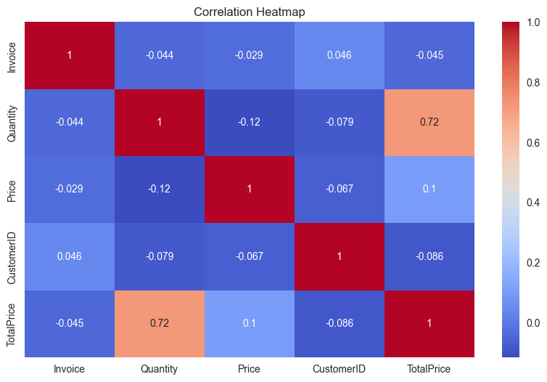
Figure 4.1 Correlation Heatm

5. Clustering Algorithms
To identify meaningful customer segments, multiple unsupervised clustering algorithms were implemented and compared.
Algorithms used:
- K-Means Clustering
- Hierarchical Clustering
- DBSCAN
- Gaussian Mixture Model (GMM)
Each algorithm groups customers based on similarity in RFM features.
Using multiple algorithms allows comparison of clustering performance and robustness.

6. Optimal Cluster Selection
Selecting the optimal number of clusters is a critical step in clustering analysis.
Two evaluation techniques were used:
- Elbow Method
- Silhouette Score
- Davies-Bouldin Index
The elbow method suggested that 4 clusters provide the best balance between model complexity and cluster separation.

7. Dimensionality Reduction (PCA)
Since clustering occurs in high-dimensional space, Principal Component Analysis (PCA) was used to reduce the data to two dimensions for visualization.
PCA transforms the original features into principal components that capture the maximum variance in the data.
This enables clear visualization of customer clusters.

7.1 KMeans PCA clusters
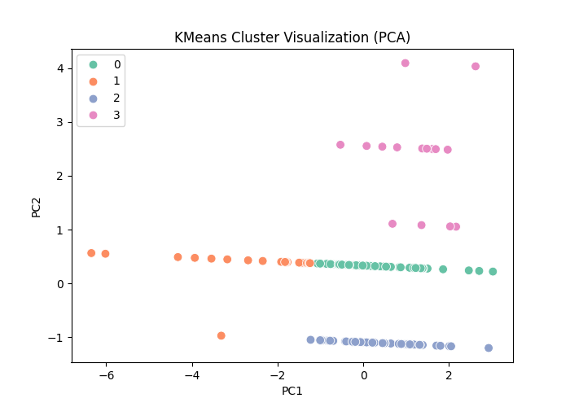

7.2 Hierarchical clusters
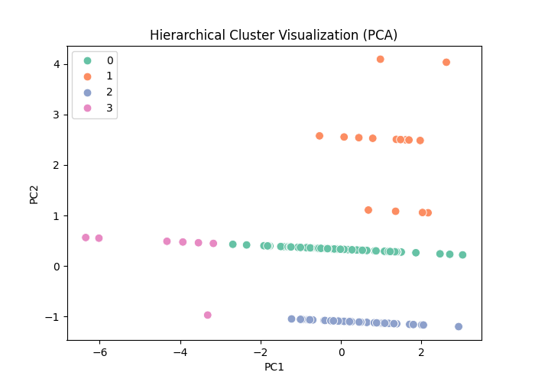

7.3 DBSCAN clusters
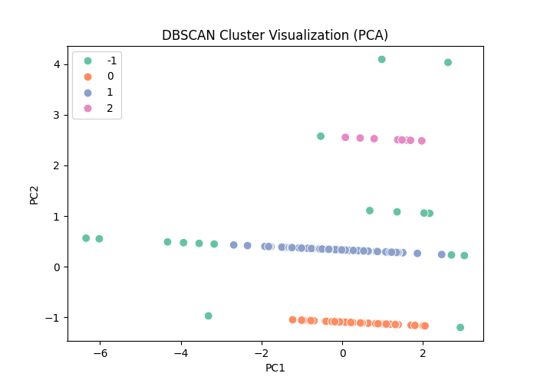

7.4 GMM clusters
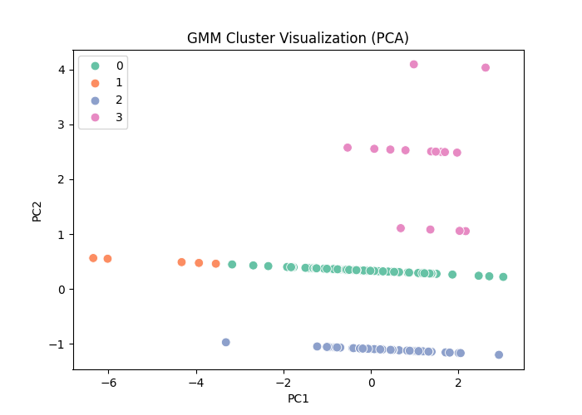

8. t-SNE Visualization
To further analyze cluster separation, t-SNE was applied as an advanced dimensionality reduction technique. t-SNE is particularly effective for visualizing high-dimensional data in two dimensions.

8.1 t-SNE Graph
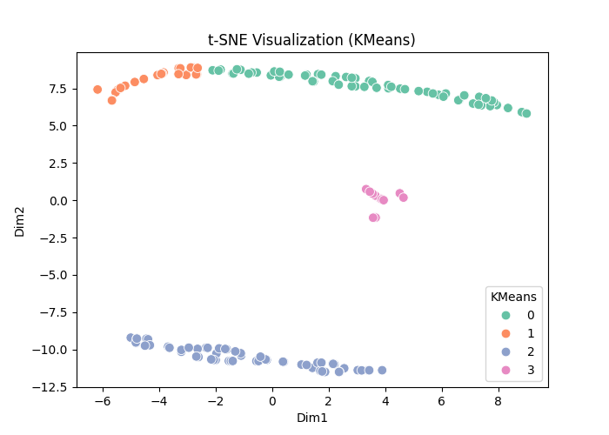

9. Cluster Interpretation
Cluster | Customer Type | Behavior
Cluster 0 | High Value Customers | High spending and frequent purchases
Cluster 1 | Budget Customers | Low spending but frequent visits
Cluster 2 | Occasional Buyers | Low frequency purchases
Cluster 3 | At-Risk Customers | Long time since last purchase

10. Business Insights
Based on the segmentation results, several actionable insights were discovered.
Key findings:
- Cluster 0 represents high-value customers who generate the largest revenue.
- Cluster 1 includes price-sensitive buyers who respond well to discounts.
- Cluster 2 represents occasional shoppers who require engagement strategies.
- Cluster 3 represents at-risk customers who have not purchased recently.

11. Marketing Strategy Recommendations
Customer Segment | Strategy
High Value Customers | Loyalty programs and premium offers
Budget Customers | Discount campaigns
Occasional Buyers | Personalized recommendations
At-Risk Customers | Retention campaigns

12. Conclusion
This project successfully implemented an end-to-end customer segmentation system using unsupervised learning techniques.
By applying clustering algorithms and dimensionality reduction techniques, meaningful customer segments were identified.
These insights can help businesses design targeted marketing strategies, improve customer retention, and maximize revenue.

