SVKM’s NMIMS MPSTME, SHIRPUR DBMS PROJECT

Course: - BTech CS 4th SEM Submitted To: - Varsha Nemade

|  |  |  |
| --- | --- | --- |
| **Name** | **Roll No.** | **SAP ID** |
| Arihant Jain | B220 | 70021119023 |

**Topic: -** Blood Bank Management System

Project Scenario: -

Following Database Management System allows Blood Bank to see all details about:

* Donors
* Blood
* Employees
* Hospitals

Database Design: -

The Entity-Relationship Model was used to create the database most efficiently and logically.

**Mapping Cardinality:** Mapping cardinalities express the number of entities to which another entity can be associated via a relationship set. Cardinality can be-

* One-to-one
* One-to-many
* Many-to-one
* Many-to-many

**E-R diagram:** It can express the overall logical structure of a database graphically. A diagram consists of some major components—

* Rectangles: represent entity set.
* Ellipses: represent attributes.
* Diamonds: represent relationships.
* Lines: which link attributes to entity sets and entity sets to relationship sets.

ER Diagram: -

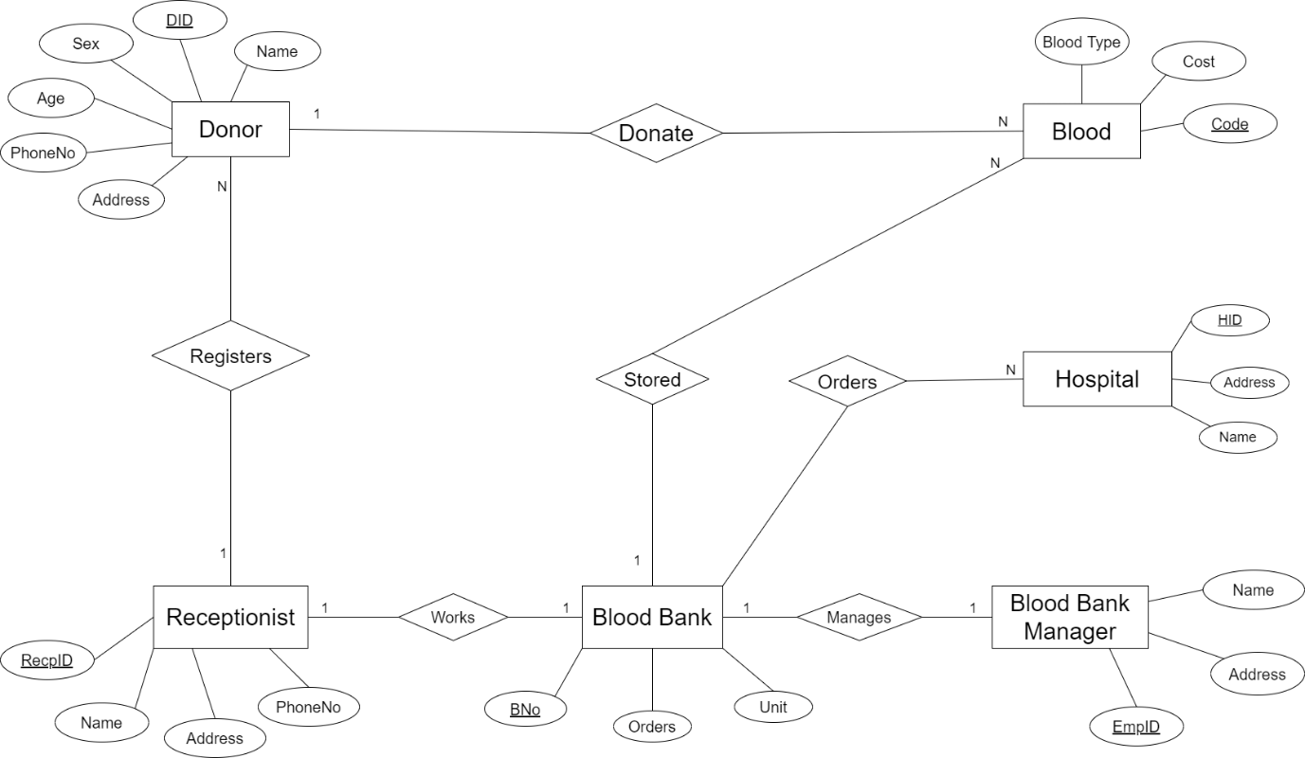

Relational Schema: -

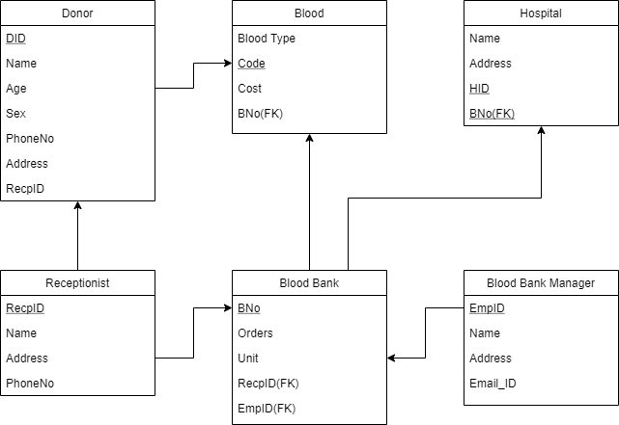

Description of Tables: -

1. **Receptionist – This table has four attributes i.e. RecpID , Name, Address, PhoneNo. (RecpID is primary key)**
2. **BloodBankManager – This table has four attributes i.e. EmpId, Name, Address,Email_ID. (EmpID is primary key)**
3. **Donor – This table has seven attributes i.e. DID, Name, Age, Sex, PhoneNo, Address, RecpID.(DID is primary key and RecpID is foreign key)**
4. **BloodBank – This table has five attributes i.e. BNo, Orders, Unit, RecpID. (BNo is primary key and RecpID,EmpID are foreign key)**
5. **Blood – This table has four attributes i.e. BloodType, Code, Cost, BNo.(Code is primary key and BNo is foreign key)**
6. **Hospital – This has four attributes i.e. Name, Address, HID, BNo.(HID is primary key and BNo is foreign key)**

MySQL Implementation: -





niyscj l > desc B l oodB ankt•1anager ;

F#e4d

| Type

xu4l | Key | Default | Extra

3 rows #n set (0.01 sec)

niysql> create

Receptionist(RecpID int pr nary key, Kanye varchar(Z0), Address varchar(20), PhoneKo int);

Query OK, 0 rows affectec| C0.12 sec)

nlysql> desc Receptionist ;

F el d | Type null | Key | Default | Extra

I RecpID I int I \O I PRI I NULL

dante | \zarchar(20} | 1‘ES |

*Address* | varchar (20) | 1‘ES |

Phoneho | Int | 1‘ES |

| FULL

| FULL

| FULL

4 rows in set CO.01 sec)

|  |  |  |  |  |  |  |  |
| --- | --- | --- | --- | --- | --- | --- | --- |
| EnipID | | | Int | | TO | | | PRI | | | FULL |
| Name | | | archar¿20) | | \’ES | | |  | | | FULL |
| Address | | | archar¿20) | | \’ES | | |  | | | FULL |

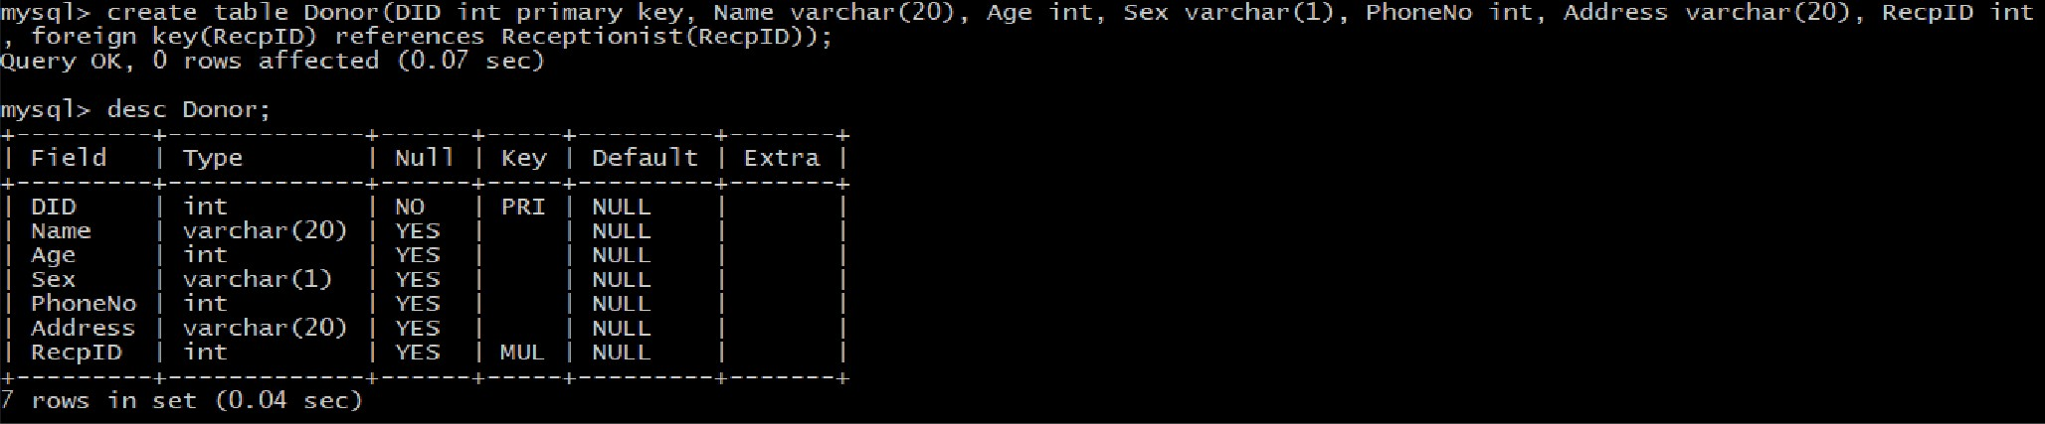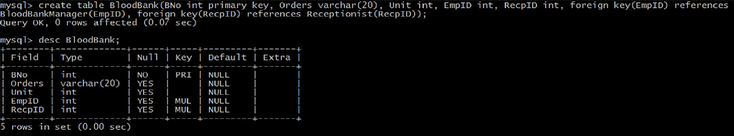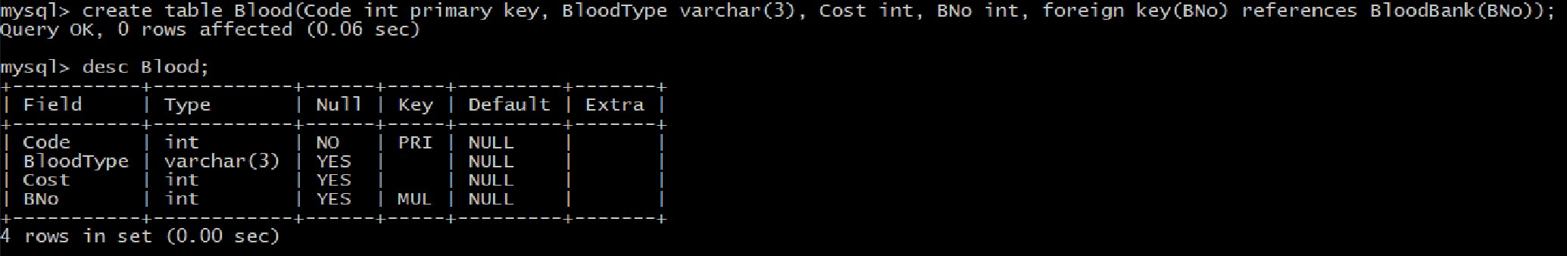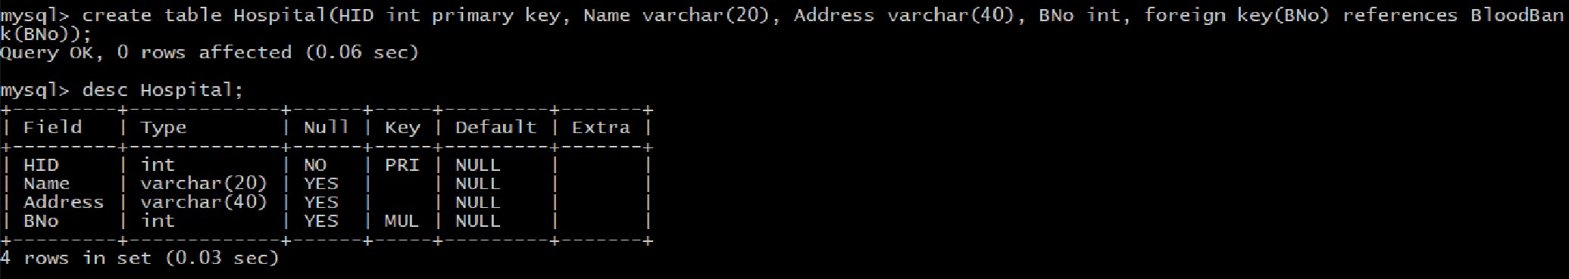

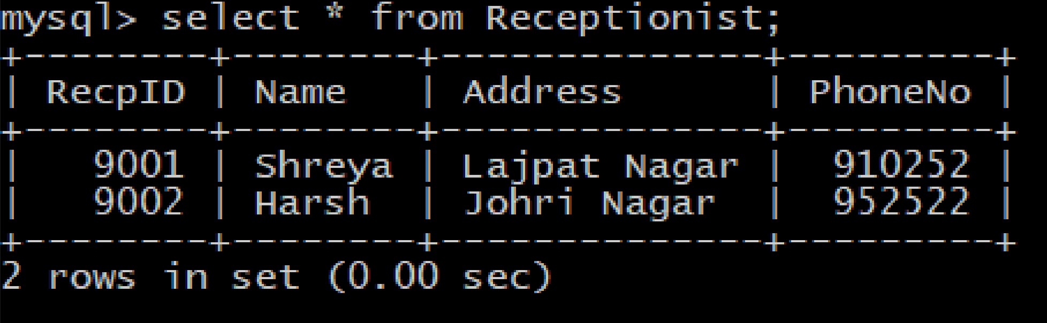

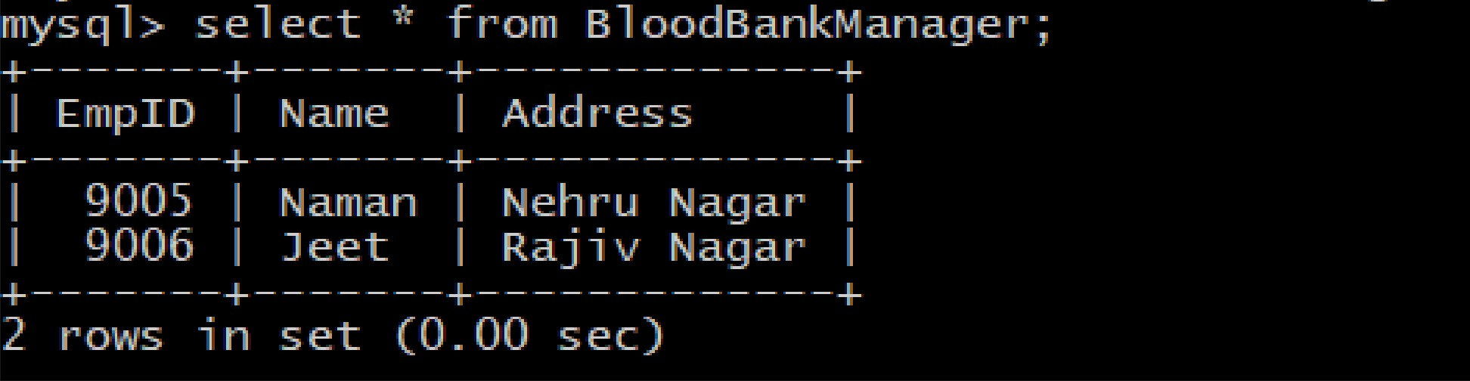

nlysql> select * fron Donor;



DID | hanle | Age | Sex | PhoneKo

1 101 l Ar4hant | 19 l M l 2101089 l

10/ | Pr4ya | 21 | F | 2458974

l 111 l Adit I 30 l u l 2689754 l 115 | Mohit | 25 | M | 2145789

l 119 | Sanlyak | 20 l M l 2397Z05 l

Rec plD

Rajat Path l 9001 l Bor4val 4 | 9001

KeruJ | 9001 Airport Road | 9002 Gotr4 Road | 9002 l

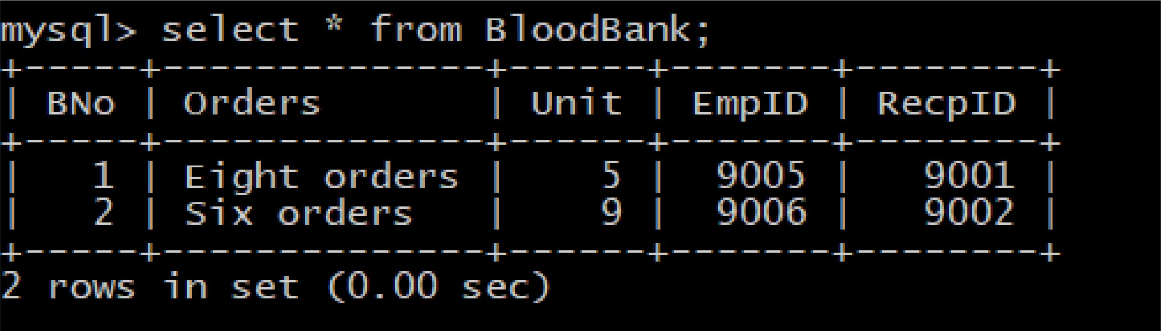

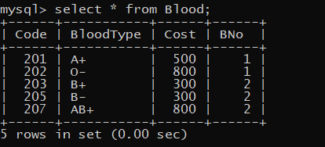

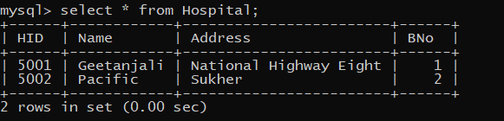

Query :-

**Q.** Pacifice hospital received how many O +ve blood from blood bank 1

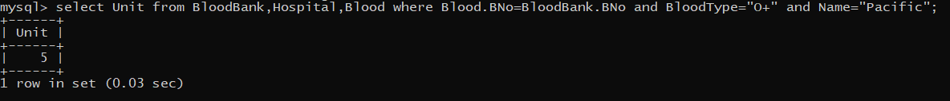

Python Integration:

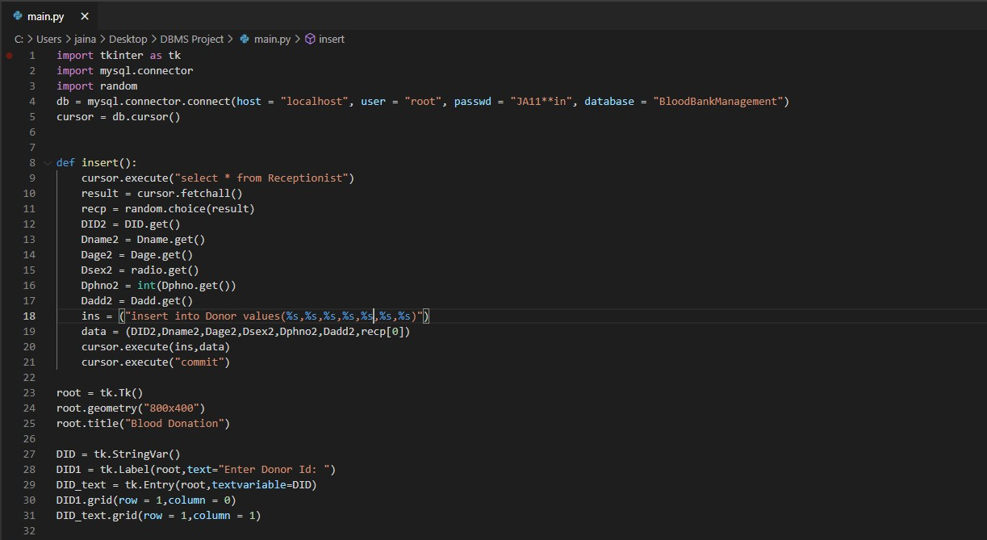

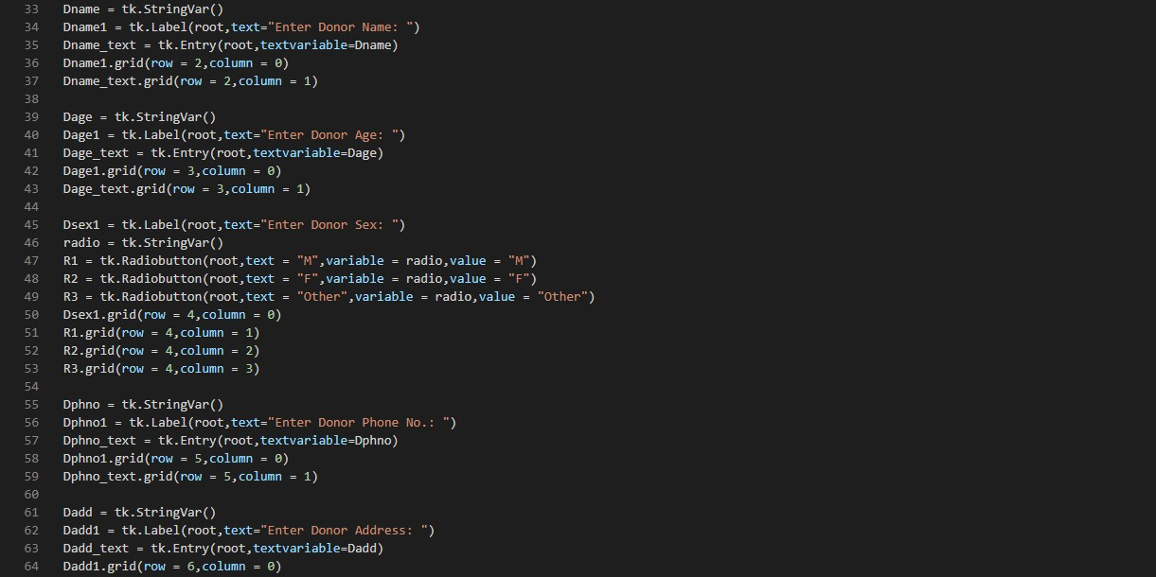

Blood Donation

Enter Donor Id: 120

Enter Donor Name: Arnav Enter Donor Age: 19

Enter Donor Sa:  Enter Donor Phone No.: 820993

Enter Donor Address: Swami Nag• I



F Other



Enter