Name: AKSHAY M DALAWAI

Div: A

Usn: 01FE23BEC432

Wireshark Lab:

WiFi

802.11

v

8

.0

Supplement to

*Computer Networking: A Top*

*-*

*Down*

*Approach,*

*8*

*th*

*ed.*

*,*

J.F. Kurose and K.W. Ross

*“Tell me and I forget. Show me and I remember. Involve me*

*and I understand.”*

Chinese proverb

©

2005

-

20

20

, J.F Kurose and K.W. Ro

ss, Al

l Rights Reserved



In this lab, we’ll investigate the 802.11 wireless network protocol. Before beginning this lab, you might want to re-read Section 7.3 in the text[1]. Since we’ll be delving a bit deeper into 802.11 than is covered in the text, you might want to check out “A Technical Tutorial on the 802.11Protocol,” by Pablo Brenner (Breezecom Communications), http://www.sss-mag.com/pdf/802_11tut.pdf, and “Understanding 802.11 Frame Types,” by Jim Geier, http://www.wi-fiplanet.com/tutorials/article.php/1447501. And, of course, there is the “bible” of 802.11 - the standard itself, “ANSI/IEEE Std 802.11, 1999 Edition (R2003),” http://gaia.cs.umass.edu/wireshark-labs/802.11-1999.pdf. In particular, you may find Table 1 on page 36 of the standard particularly useful when looking through the wireless trace.

In all of the Wireshark labs thus far, we’ve captured frames on a wired Ethernet connection. Here, since 802.11 is a wireless link-layer protocol, we’ll be capturing frames “in the air.” Unfortunately, some device drivers for wireless 802.11 NICs still don’t provide the hooks to capture/copy received 802.11 frames for use in Wireshark (see Figure 1 in Lab 1 for an overview of packet capture). Thus, in this lab, we’ll provide a trace of captured 802.11 frames for you to analyze and assume in the questions below that you are using this trace. If you’re able to capture 802.11 frames using your version of Wireshark, you’re welcome to do so.

# 1. Getting Started

Download the zip file http://gaia.cs.umass.edu/wireshark-labs/wireshark-traces.zip and extract the file Wireshark_802_11.pcap. This trace was collected using AirPcap and Wireshark running on a computer in the home network of one of the authors, consisting of a Linksys 802.11g combined access point/router, with two wired PCs and one wireless host PC attached to the access point/router. The author is fortunate to have other access points in neighboring houses available as well. In this trace file, we’ll see frames

captured on channel 6. Since the host and AP that we are interested in are not the only devices using channel 6, we’ll see a lot of frames that we’re not interested in for this lab, such as beacon frames advertised by a neighbor’s AP also operating on channel 6. The wireless host activities taken in the trace file are:

* The host is already associated with the *30 Munroe St* AP when the trace begins.
* At *t = 24.82*, the host makes an HTTP request to http://gaia.cs.umass.edu/wireshark-labs/alice.txt. The IP address of gaia.cs.umass.edu is 128.119.245.12.
* At *t=32.82, t*he host makes an HTTP request to http://www.cs.umass.edu, whose IP address is 128.119.240.19.
* At *t = 49.58,* the host disconnects from the *30 Munroe St* AP and attempts to connect to the *linksys_ses_24086*. This is not an open access point, and so the host is eventually unable to connect to this AP.
* At *t=63.0* the host gives up trying to associate with the *linksys_ses_24086 AP,* and associates again with the *30 Munroe St* access point.

Once you have downloaded the trace, you can load it into Wireshark and view the trace using the *File* pull down menu, choosing *Open*, and then selecting the

Wireshark_802_11.pcap trace file. The resulting display should look just like Figure 1.

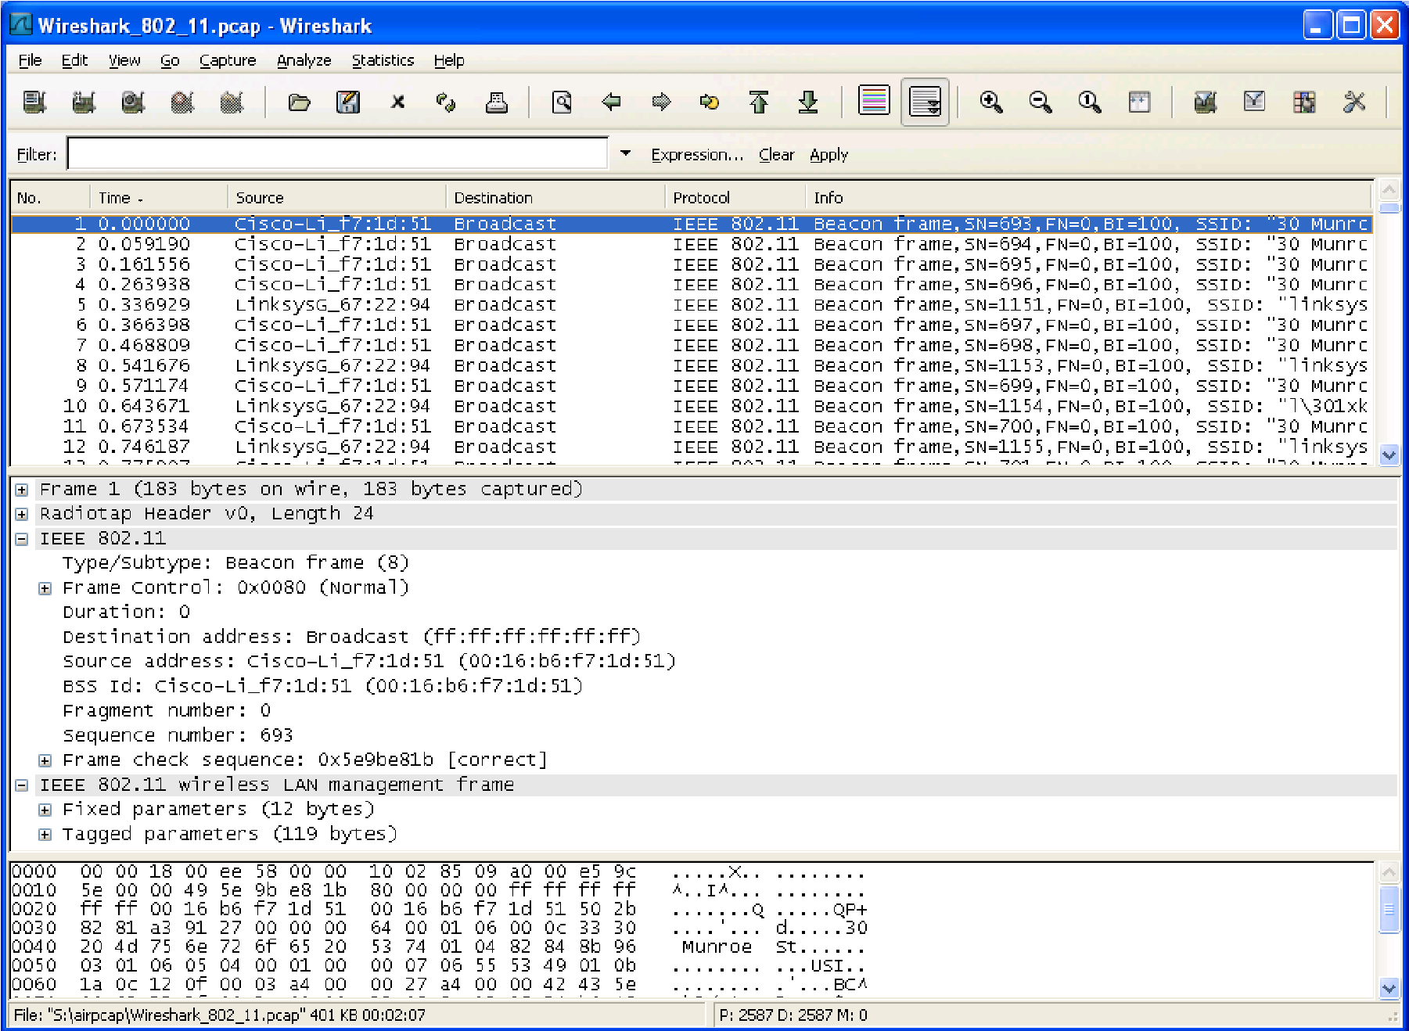

**Figure 1:** Wireshark window, after opening the Wireshark_802_11.pcap file

# 2. Beacon Frames

Recall that beacon frames are used by an 802.11 AP to advertise its existence. To answer some of the questions below, you’ll want to look at the details of the “IEEE 802.11” frame and subfields in the middle Wireshark window. Whenever possible, when answering a question below, you should hand in a printout of the packet(s) within the trace that you used to answer the question asked. Annotate the printout[2] to explain your answer. To print a packet, use *File->Print*, choose *Selected packet only*, choose *Packet summary line,* and select the minimum amount of packet detail that you need to answer the question.

1. What are the SSIDs of the two access points that are issuing most of the beacon frames in this trace?

ANS: SSID="30 Munroe St"

SSID="linksys12"

1. What are the intervals of time between the transmissions of the beacon frames the *linksys_ses_24086* access point? From the *30 Munroe St*. access point? (Hint: this interval of time is contained in the beacon frame itself).

ANS: Beacon Interval: 0.102400 [Seconds]

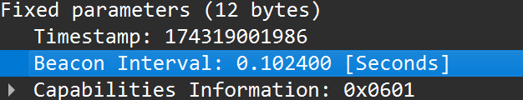

1. What (in hexadecimal notation) is the source MAC address on the beacon frame from *30 Munroe St*? Recall from Figure 7.13 in the text that the source, destination, and BSS are three addresses used in an 802.11 frame. For a detailed discussion of the 802.11 frame structure, see section 7 in the IEEE 802.11 standards document (cited above).

ANS: Source address: CiscoLinksys_f7:1d:51 (00:16:b6:f7:1d:51)

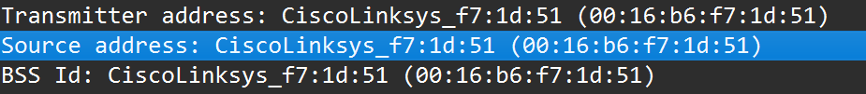

1. What (in hexadecimal notation) is the destination MAC address on the beacon frame from *30 Munroe St*??

ANS: Destination address: Broadcast (ff:ff:ff:ff:ff:ff)

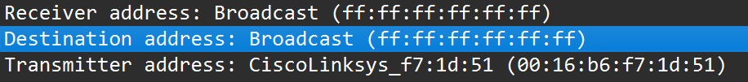

1. What (in hexadecimal notation) is the MAC BSS id on the beacon frame from *30 Munroe St*?

ANS: BSS Id: CiscoLinksys_f7:1d:51 (00:16:b6:f7:1d:51)



1. The beacon frames from the *30 Munroe St* access point advertise that the access point can support four data rates and eight additional “extended supported rates.” What are these rates?

ANS: 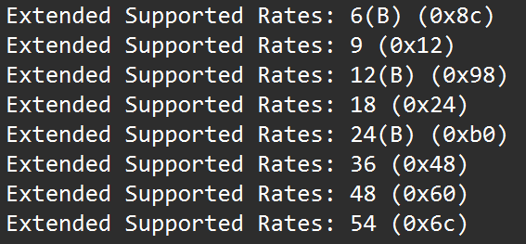

# 3. Data Transfer

Since the trace starts with the host already associated with the AP, let first look at data transfer over an 802.11 association before looking at AP association/disassociation. Recall that in this trace, at *t = 24.82*, the host makes an HTTP request to

http://gaia.cs.umass.edu/wireshark-labs/alice.txt. The IP address of gaia.cs.umass.edu is

128.119.245.12. Then, at *t=32.82,* the host makes an HTTP request to http://www.cs.umass.edu.

1. Find the 802.11 frame containing the SYN TCP segment for this first TCP session

(that downloads alice.txt). What are three MAC address fields in the 802.11

frame? Which MAC address in this frame corresponds to the wireless host (give the hexadecimal representation of the MAC address for the host)? To the access point? To the first-hop router? What is the IP address of the wireless host sending this TCP segment? What is the destination IP address? Does this destination IP address correspond to the host, access point, first-hop router, or some other network-attached device? Explain.

ANS: 1)**Three MAC address fields in the 802.11 frame** (hex):

ANS: Receiver address: CiscoLinksys_f7:1d:51 (00:16:b6:f7:1d:51)

Transmitter address: Intel_d1:b6:4f (00:13:02:d1:b6:4f)

BSS Id: CiscoLinksys_f7:1d:51 (00:16:b6:f7:1d:51)

2)Which MAC corresponds to the wireless host?

ANS: Transmitter address: Intel_d1:b6:4f (00:13:02:d1:b6:4f)

3)Which MAC corresponds to the access point?

ANS: BSS Id: CiscoLinksys_f7:1d:51 (00:16:b6:f7:1d:51) or

Receiver address: CiscoLinksys_f7:1d:51 (00:16:b6:f7:1d:51)

4)Which MAC corresponds to the first-hop router?

ANS: BSS Id: CiscoLinksys_f7:1d:51 (00:16:b6:f7:1d:51)

5) IP address of the wireless host sending the TCP SYN: 192.168.1.109

6) Destination IP address: 128.119.245.12

7) no

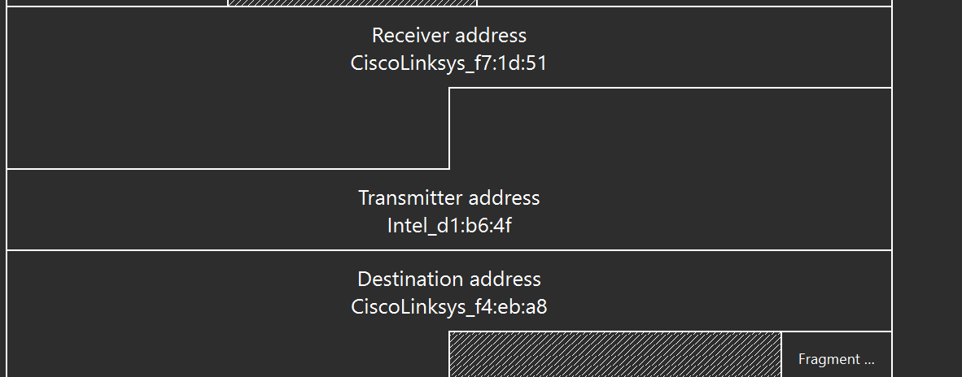

1. Find the 802.11 frame containing the SYNACK segment for this TCP session. What are three MAC address fields in the 802.11 frame? Which MAC address in this frame corresponds to the host? To the access point? To the first-hop router? Does the sender MAC address in the frame correspond to the IP address of the device that sent the TCP segment encapsulated within this datagram? (Hint: review Figure 6.19 in the text if you are unsure of how to answer this question, or the corresponding part of the previous question. It’s particularly important that you understand this).

ANS: i) What are three MAC address fields in the 802.11 frame?

--Receiver address: 91:2a:b0:49:b6:4f (91:2a:b0:49:b6:4f)

--Transmitter address: CiscoLinksys_f7:1d:51 (00:16:b6:f7:1d:51)

--BSS Id: CiscoLinksys_f7:1d:51 (00:16:b6:f7:1d:51)

ii) Which MAC address in this frame corresponds to the host?

ANS: Receiver address: 91:2a:b0:49:b6:4f (91:2a:b0:49:b6:4f) = Corresponds to the host

Transmitter address: CiscoLinksys_f7:1d:51 (00:16:b6:f7:1d:51)= to access point.

Source address: CiscoLinksys_f4:eb:a8 (00:16:b6:f4:eb:a8)= the first- hop router.

iii) Does the sender MAC address in the frame correspond to the IP address of the device that sent the TCP segment encapsulated within this datagram?

ANS: NO

# 3. Association/Disassociation

Recall from Section 7.3.1 in the text that a host must first *associate* with an access point before sending data. Association in 802.11 is performed using the ASSOCIATE REQUEST frame (sent from host to AP, with a frame type 0 and subtype 0, see Section 7.3.3 in the text) and the ASSOCIATE RESPONSE frame (sent by the AP to a host with a frame type 0 and subtype of 1, in response to a received ASSOCIATE REQUEST). For a detailed explanation of each field in the 802.11 frame, see page 34 (Section 7) of the 802.11 spec at http://gaia.cs.umass.edu/wireshark-labs/802.11-1999.pdf.

1. What two actions are taken (i.e., frames are sent) by the host in the trace just after *t=49*, to end the association with the *30 Munroe St* AP that was initially in place when trace collection began? (Hint: one is an IP-layer action, and one is an 802.11-layer action). Looking at the 802.11 specification, is there another frame that you might have expected to see, but don’t see here?

ANS: i) **At the IP layer:**

The host sends a **DHCP Release** message to give up its IP address.

ii)**At the 802.11 (Wi-Fi) layer:**  
 The host sends a **Disassociation frame** to the AP (30 Munroe St).

* The host releases its IP (DHCP Release) and disconnects from the AP (Disassociation). A Deauthentication frame would usually follow, but we don’t see it here.

1. Examine the trace file and look for AUTHENICATION frames sent from the host to an AP and vice versa. How many AUTHENTICATION messages are sent from the wireless host to the *linksys_ses_24086* AP (which has a MAC address of Cisco_Li_f5:ba:bb) starting at around *t=49?* .

ANS: Seventeen AUTHENTICATION messages.

1. Does the host want the authentication to require a key or be open?

ANS: The host wants the authentication to be **open (no key required)**.

1. Do you see a reply AUTHENTICATION from the *linksys_ses_24086* AP in the trace?

ANS: NO

1. Now let’s consider what happens as the host gives up trying to associate with the *linksys_ses_24086* AP and now tries to associate with the *30 Munroe St* AP. Look for AUTHENICATION frames sent from the host to and AP and vice versa. At what times are there an AUTHENTICATION frame from the host to the *30 Munroe St.* AP, and when is there a reply AUTHENTICATION sent from that AP to the host in reply? (Note that you can use the filter expression “wlan.fc.subtype == 11and wlan.fc.type == 0 and wlan.addr == IntelCor_d1:b6:4f” to display only the AUTHENTICATION frames in this trace for this wireless host.)

ANS: At t = 63.168087 there is a AUTHENTICATION frame sent from 00:13:02:d1:b6:4f (the wireless host) to 00:16:b7:f7:1d:51 (the BSS).

At t = 63.169071 there is an AUTHENTICATION from sent in the reverse direction from the BSS to the wireless host





1. An ASSOCIATE REQUEST from host to AP, and a corresponding ASSOCIATE RESPONSE frame from AP to host are used for the host to associated with an AP.

At what time is there an ASSOCIATE REQUEST from host to the *30 Munroe St* AP? When is the corresponding ASSOCIATE REPLY sent? (Note that you can use the filter expression “wlan.fc.subtype < 2 and wlan.fc.type == 0 and wlan.addr == IntelCor_d1:b6:4f” to display only the ASSOCIATE REQUEST and ASSOCIATE RESPONSE frames for this trace.)

ANS: At t = 63.169910 there is a ASSOCIATE REQUEST frame sent from 00:13:02:d1:b6:4f (the wireless host) to 00:16:b7:f7:1d:51 (the BSS).

At t = 63.192101 there is an ASSOCIATE RESPONSE from sent in the reverse direction from the BSS to the wireless host







1. What transmission rates is the host willing to use? The AP? To answer this question, you will need to look into the parameters fields of the 802.11 wireless LAN management frame.

ANS: In the ASSOCIATION REQUEST frame the supported rates are advertised as 1, 2, 5.5, 11, 6, 9, 12, 18, 24, 32, 48, and 54 Mbps.

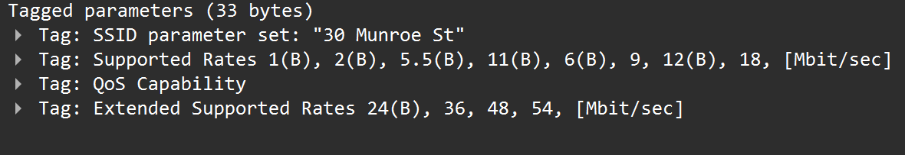

# 4. Other Frame types

Our trace contains a number of PROBE REQUEST and PROBE RESPONSE frames.

1. What are the sender, receiver and BSS ID MAC addresses in these frames? What is the purpose of these two types of frames? (To answer this last question, you’ll need to dig into the online references cited earlier in this lab).

ANS: At t = 2.297613 there is a PROBE REQUEST sent with source 00:12:f0:1f:57:13, destination: ff:ff:ff:ff:ff:ff, and a BSSID of ff:ff:ff:ff:ff:ff.

At t = 2.300697 there is a PROBE RESPONSE sent with source: 00:16:b6:f7:1d:51, destination and a BSSID of 00:16:b6:f7:1d:51.

A PROBE REQUEST is used by a host in active scanning to find an Access Point.

A PROBE RESPONSE is sent by the access point to the host sending the request.



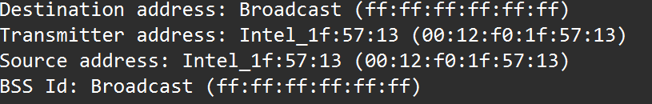

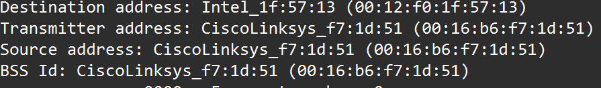

1. References to figures and sections are for the 8th edition of our text, Computer Networks, A Top-down Approach, 8th ed., J.F. Kurose and K.W. Ross, Addison-Wesley/Pearson, 2020.
2.