Name: AKSHAY M DALAWAI
Div: A
Usn: 01FE23BEC432

Wireshark Lab:  SSL v8.0  Supplement to Computer Networking: A Top-Down Approach, 8th ed., J.F. Kurose and K.W. Ross  “Tell me and I forget. Show me and I remember. Involve me and I understand.” Chinese proverb  © 2005-2020, J.F Kurose and K.W. Ross, All Rights Reserved | 

In this lab, we’ll investigate the Secure Sockets Layer (SSL) protocol, focusing on the SSL records sent over a TCP connection. We’ll do so by analyzing a trace of the SSL records sent between your host and an e-commerce server. We’ll investigate the various SSL record types as well as the fields in the SSL messages. You may want to review Section 8.6 in the text. We are currently developing a Wireshark Lab that will cover TLS – whose treatment in the 8th edition of our text replaces the coverage of SSL.

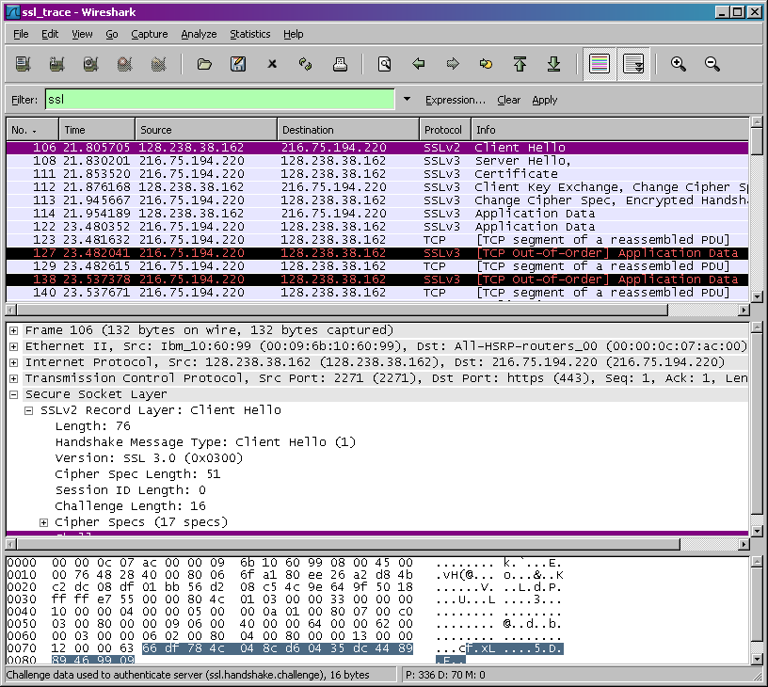

1. Capturing packets in an SSL session

The first step is to capture the packets in an SSL session. To do this, you should go to your favorite e-commerce site and begin the process of purchasing an item (but terminating before making the actual purpose!). After capturing the packets with Wireshark, you should set the filter so that it displays only the Ethernet frames that contain SSL records sent from and received by your host. (An SSL record is the same thing as an SSL message.) You should obtain something like screenshot on the previous page.

If you have difficulty creating a trace, you should download the zip file http://gaia.cs.umass.edu/wireshark-labs/wireshark-traces.zip and extract the ssl-ethereal-trace-1 packet trace.

2. A look at the captured trace

Your Wireshark GUI should be displaying only the Ethernet frames that have SSL records. It is important to keep in mind that an Ethernet frame may contain one or more SSL records. (This is very different from HTTP, for which each frame contains either one complete HTTP message or a portion of a HTTP message.) Also, an SSL record may not completely fit into an Ethernet frame, in which case multiple frames will be needed to carry the record.
Whenever possible, when answering a question below, you should hand in a printout of the packet(s) within the trace that you used to answer the question asked. Annotate the printout to explain your answer. To print a packet, use File->Print, choose Selected packet only, choose Packet summary line, and select the minimum amount of packet detail that you need to answer the question

- For each of the first 8 Ethernet frames, specify the source of the frame (client or server), determine the number of SSL records that are included in the frame, and list the SSL record types that are included in the frame. Draw a timing diagram between client and server, with one arrow for each SSL record.
ANS:
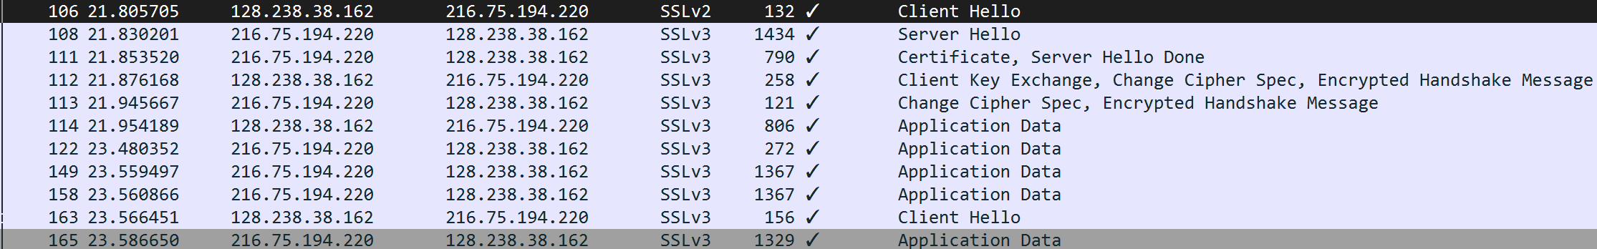
Each SSL record starts with three standard fields, although the values inside them may vary.
- The first field is the Content Type, which is 1 byte long.
- The second field is the Version, which is 2 bytes long.
- The third field is the Length, which occupies 2 bytes and indicates the size of the record payload.
- Each of the SSL records begins with the same three fields (with possibly different values). One of these fields is “content type” and has length of one byte. List all three fields and their lengths.
ANS:
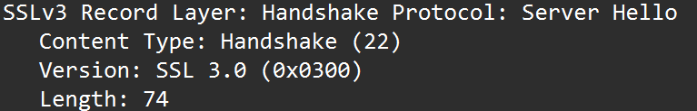
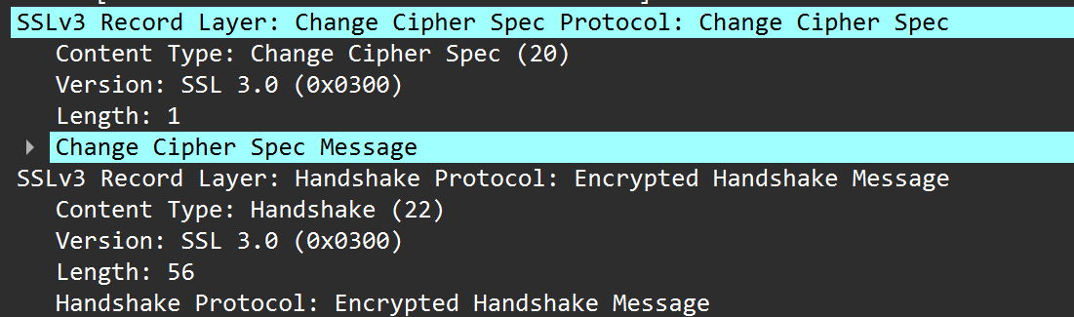

ClientHello Record:

- Expand the ClientHello record. (If your trace contains multiple ClientHello records, expand the frame that contains the first one.) What is the value of the content type?
ANS: SSLv2 does not need content value.
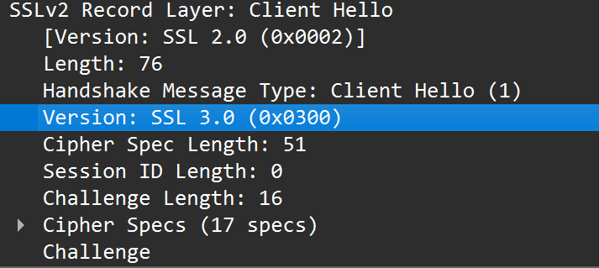
- Does the ClientHello record contain a nonce (also known as a “challenge”)? If so, what is the value of the challenge in hexadecimal notation?
ANS:ANS: challenge 0000 f5 df
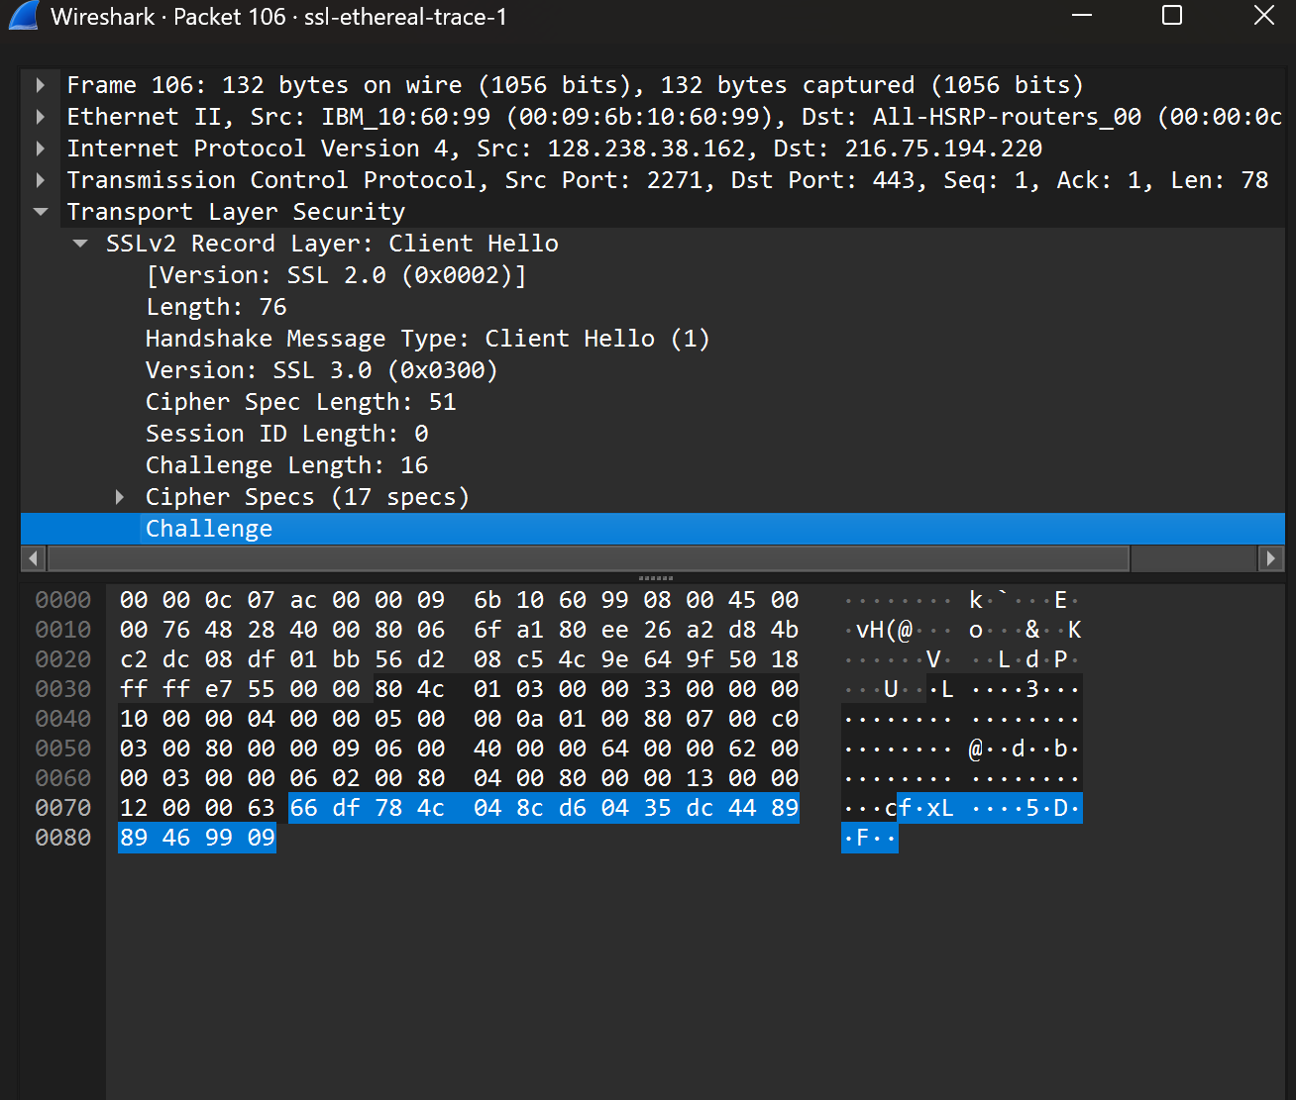
- Does the ClientHello record advertise the cyber suites it supports? If so, in the first listed suite, what are the public-key algorithm, the symmetric-key algorithm, and the hash algorithm?
- ANS:Public-key algorithm: RSA (used for the key exchange / encrypting pre-master secret).
- Symmetric cipher: 3DES_EDE_CBC (3DES in CBC mode).
- Hash / MAC algorithm: SHA (HMAC-SHA used for the MAC).
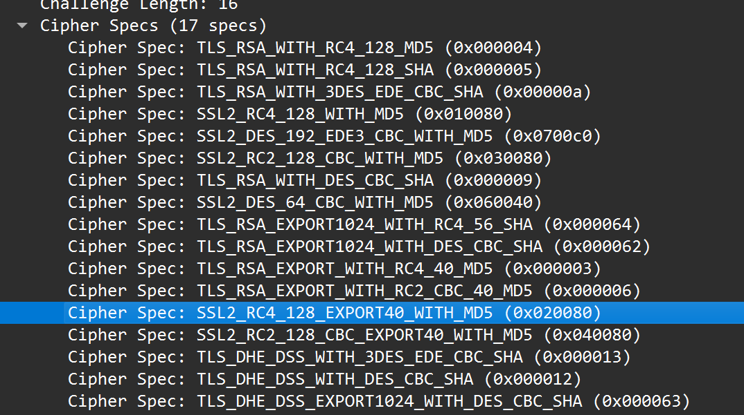

ServerHello Record:

- Locate the ServerHello SSL record. Does this record specify a chosen cipher suite? What are the algorithms in the chosen cipher suite?
ANS:
- Does this record include a nonce? If so, how long is it? What is the purpose of the client and server nonces in SSL?
ANS: Each SSL record starts with three fields: the Content Type (1 byte), theVersion (2 bytes), and the Length (2 bytes).
In the Server Hello message, the size is usually around 70–74 bytes and it includes a Server Random (nonce) of 32 bytes.
Both the Client Random and Server Random values are used in the key derivation process.
This ensures that every session is unique and protects against replay attacks.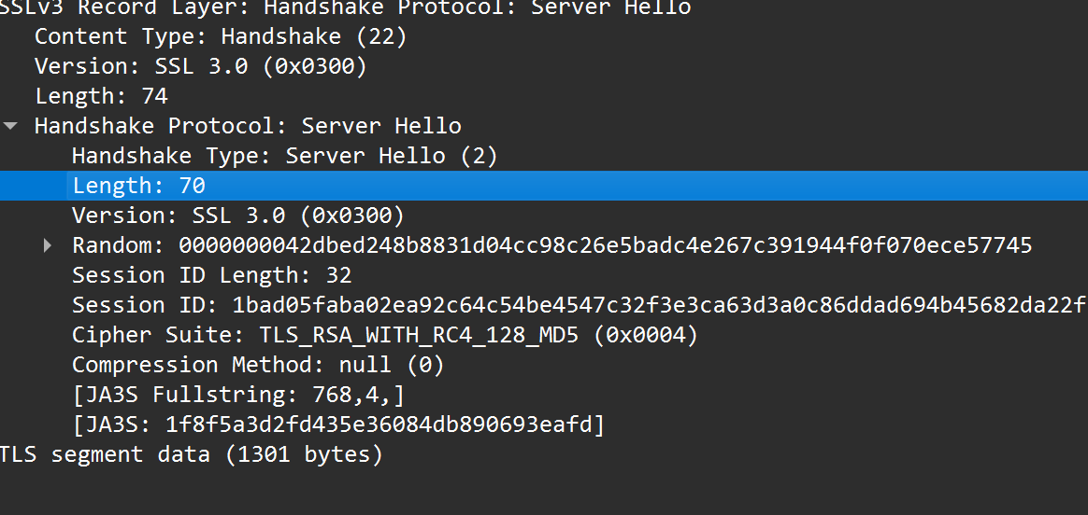
- Does this record include a session ID? What is the purpose of the session ID?
ANS: The Session ID is used for session resumption.
When the client reconnects, it can present the same Session ID to the server.
If the server still remembers it, both sides can reuse the same master secret.
This allows them to skip the full handshake and makes future connections faster.

- Does this record contain a certificate, or is the certificate included in a separate record. Does the certificate fit into a single Ethernet frame?
ANS: When we use the filter ssl.handshake.type == 2, we see only the Server Hello message. The Certificate is not in the same packet but comes in a separate record.
With the filter ssl.handshake.type == 11, we can see the Certificate message. It is in a separate record because certificates are usually larger than 1 KB and cannot fit in a single Ethernet frame, so they get split across multiple packets.
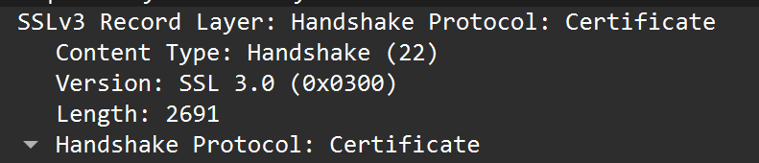

Client Key Exchange Record:

- Locate the client key exchange record. Does this record contain a pre-master secret? What is this secret used for? Is the secret encrypted? If so, how? How long is the encrypted secret?

Change Cipher Spec Record (sent by client) and Encrypted Handshake Record:
ANS: 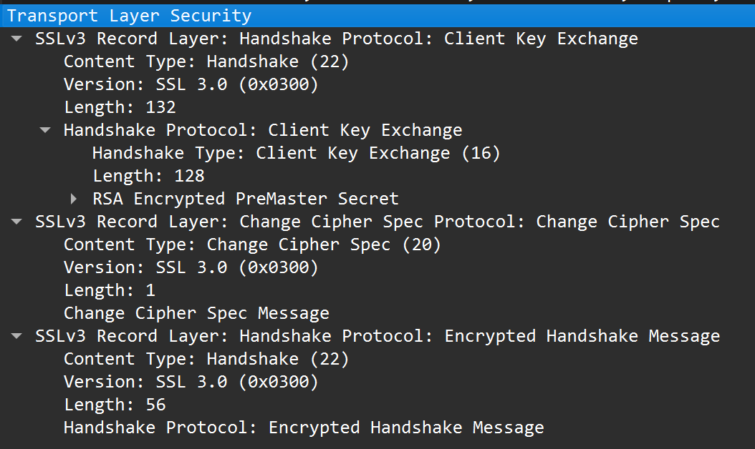
- What is the purpose of the Change Cipher Spec record? How many bytes is the record in your trace?
ANS: The Change Cipher Spec message tells both client and server to start using the negotiated keys and algorithms.
It marks the point where communication switches from plaintext handshake to encrypted messages.
- In the encrypted handshake record, what is being encrypted? How?
ANS: The Finished handshake message (contains verify_data) is encrypted.
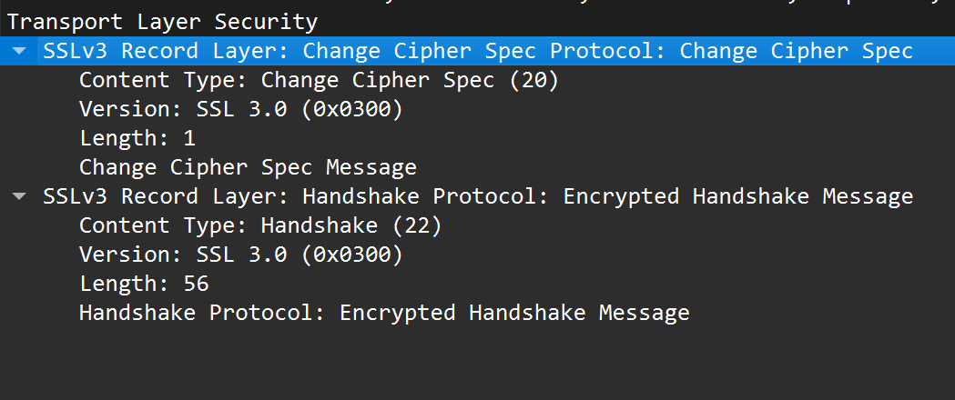
- Does the server also send a change cipher record and an encrypted handshake record to the client? How are those records different from those sent by the client?
ANS: Yes, the server also sends a Change Cipher Spec followed by an encrypted Finished message to the client.
These messages serve the same purpose as the client’s: they signal the switch to encrypted communication and confirm the integrity of the handshake.
The only difference lies in the content, such as the verify_data and ciphertext, and sometimes the length because of padding. The encryption method and structure remain the same.

Application Data

- How is the application data being encrypted? Do the records containing application data include a MAC? Does Wireshark distinguish between the encrypted application data and the MAC?
ANS: Encryption is done using the symmetric cipher chosen in the handshake, for example AES-128-CBC with HMAC-SHA1.
A MAC is added for integrity if CBC/HMAC is used, while in AEAD ciphers like AES-GCM the MAC is built in.
In Wireshark, without decryption, you only see an encrypted block of data. It cannot separate the application data from the MAC inside the record.
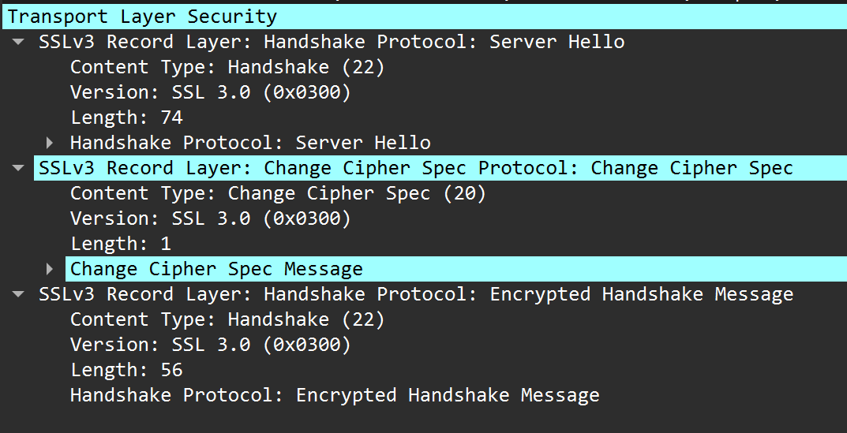
- Comment on and explain anything else that you found interesting in the trace.
ANS:1. SSLv2-compatible ClientHello
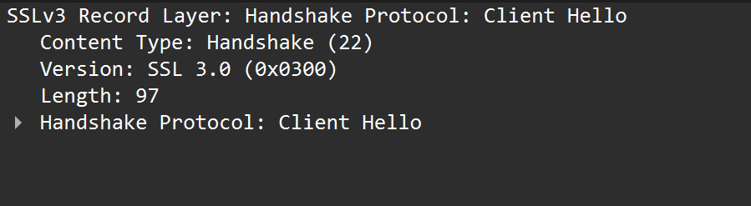
2. Cipher suite is outdated/strong: Cipher Suite: TLS_RSA_WITH_RC4_128_MD5 (0x0004)

3. Certificate was fragmented into multiple packets:
[3 Reassembled TCP Segments (2696 bytes): #108(1301), #109(668), #111(727)]

References to figures and sections for this SSL lab are for the 7th edition of our text, Computer Networks, A Top-down Approach, 7th ed., J.F. Kurose and K.W. Ross, Addison-Wesley/Pearson, 2016.
What do we mean by “annotate”? If you hand in a paper copy, please highlight where in the printout you’ve found the answer and add some text (preferably with a colored pen) noting what you found in what you ‘ve highlight. If you hand in an electronic copy, it would be great if you could also highlight and annotate.

