**Tugas Pertemuan Ke – 6**

**Bab 6 : ALARM MANAGER**

|  |  |
| --- | --- |
| **Nama** | Shohibul Maarif |
| **Nim** | 2018066 |
| **Kelas** | C |
| **Pemberi Tugas** | Yahezkiel Rogandi Lorenzo Sibarani (2018110) |

1. **Menambahkan alarm manager pada project sebelumnya.**
2. **Langkah – langkah pengerjaan**
3. Buka Android Studio kemudian buka *project* pada bab sebelumnya.

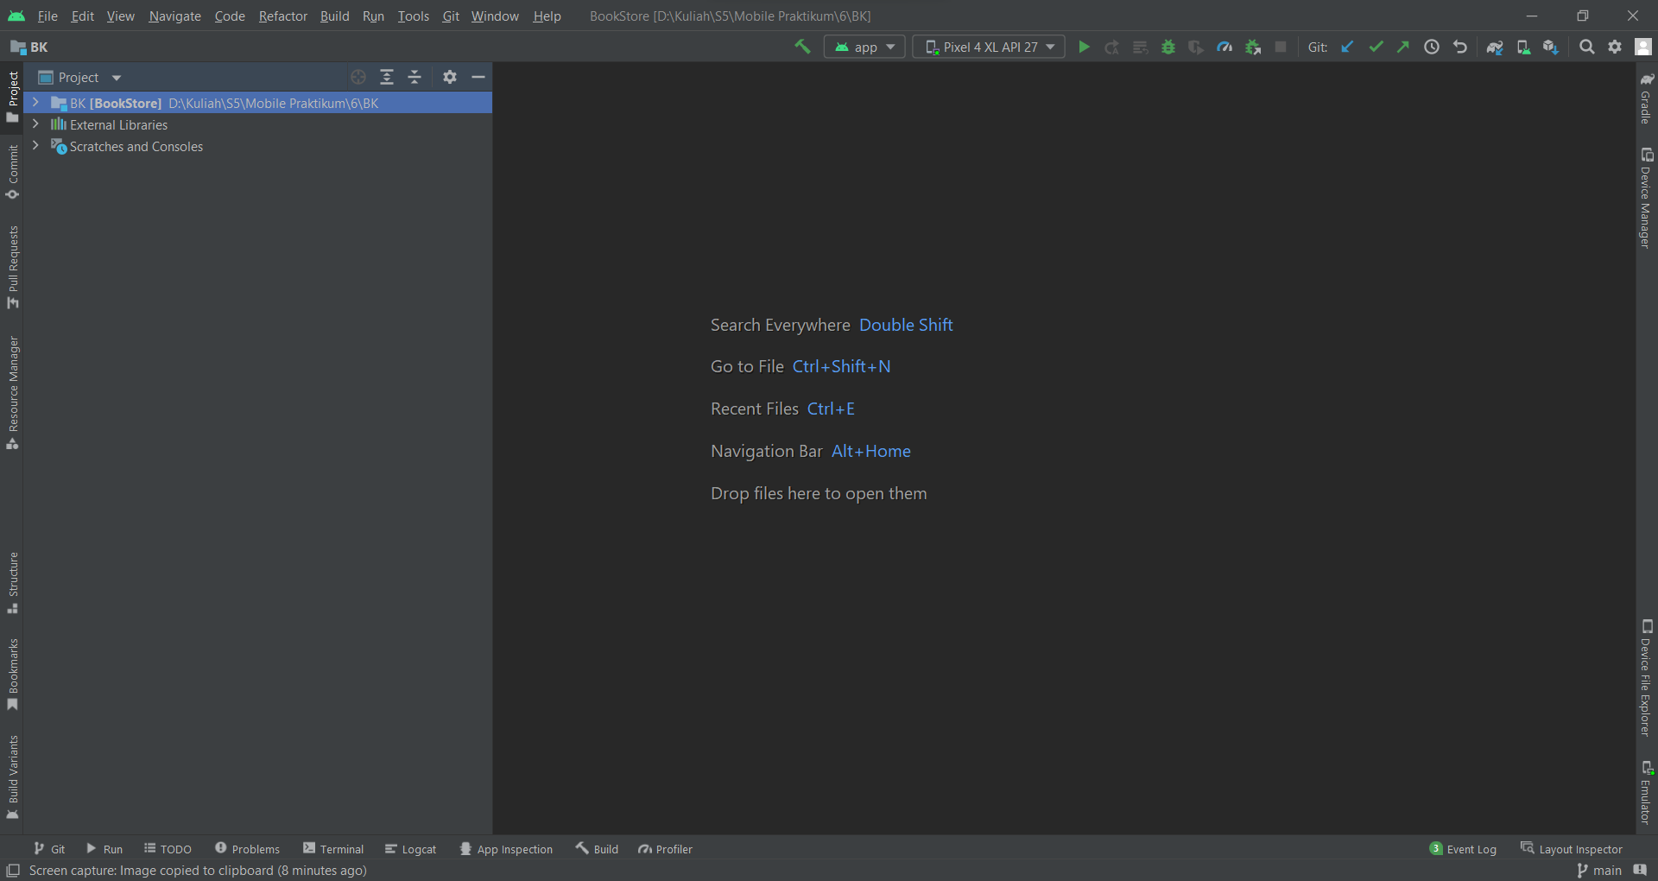

#### Membuka *project*

1. Selanjutnya buat java *class* baru dengan cara klik kanan pada com.*example* pilih *new* kemudian *java* *class,* kemudian berikan nama *AlarmReceiver*.



#### Membuat *java* *class* *baru*

1. Selanjutnya berikan *source* *code* pada *AlarmReceiver*.java seperti dibawah.

|  |
| --- |
| package com.example.bookstore;  import android.app.PendingIntent;  import android.content.BroadcastReceiver;  import android.content.Context;  import android.content.Intent;  import androidx.core.app.NotificationCompat;  import androidx.core.app.NotificationManagerCompat;  public class AlarmReceiver extends BroadcastReceiver {  @Override  public void onReceive(Context context, Intent intent) {  Intent i = new Intent(context, MainActivity.class);  intent.setFlags(Intent.FLAG_ACTIVITY_NEW_TASK | Intent.FLAG_ACTIVITY_CLEAR_TASK);  //builder yang akan membuat notifikasi tampil  PendingIntent pendingIntent = PendingIntent.getActivity(context, 0 ,i, 0);  NotificationCompat.Builder builder = new NotificationCompat.Builder(context, "AlarmManager").setSmallIcon(R.drawable.ic_baseline_circle_notifications_24)  .setContentTitle("ini Alarm Manager")  .setContentText("Praktikum BAB 6 Alarm Manager")  .setAutoCancel(true)  .setDefaults(NotificationCompat.DEFAULT_ALL)  .setPriority(NotificationCompat.PRIORITY_HIGH)  .setContentIntent(pendingIntent);  NotificationManagerCompat notificationManagerCompat = NotificationManagerCompat.from(context);  notificationManagerCompat.notify(123, builder.build());  }  } |

*Source* *code* diatas terdapat pada file.java. *Source* *code* diatas digunakan untuk memunculkan notifikasi yang akan di tampilkan pada bagian notifikasi yang ada pada android.

1. Kemudian pergi ke *AndroidManifest* dengan cara klik folder *manifest* kemudian *double* klik pada *AndroidManifest*.java. Lalu tambahkan source code berikut.

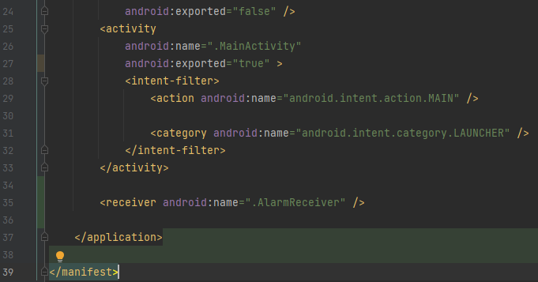

#### Menambahkan *source* *code* pada *androidmanifest*.java

|  |
| --- |
| <receiver android:name=".AlarmReceiver" /> |

*Source* *code* diatas terdapat pada *androidmanifest*.java. *Source* *code* diatas digunakan untuk mengambil data pada *file* yang bernama *AlarmReceiver*.java

1. Jika sudah, pergi ke *build*.*gradle* dengan cara pilih *folder* *Gradle* *Script* kemudian *double* klik pada *build*.*gradle*. Selanjutnya tambahkan *source* *code* seperti dibawah.

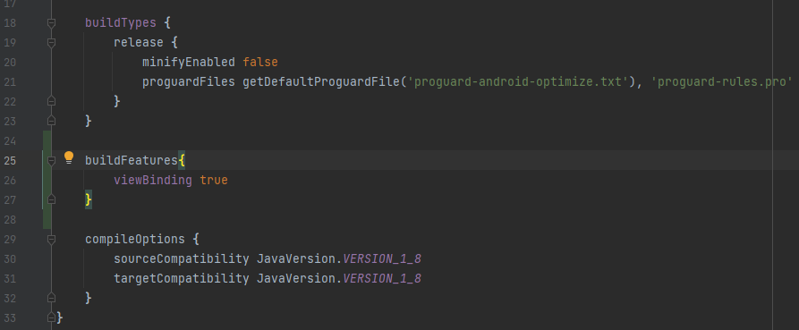

#### Menambahkan *source* *code* pada *build*.*gradle*

1. Selanjutnya pergi ke *activity*_*main3*.xml tambahkan *source* *code* seperti dibawah.

|  |
| --- |
| <?xml version="1.0" encoding="utf-8"?>  <androidx.constraintlayout.widget.ConstraintLayout  xmlns:android="http://schemas.android.com/apk/res/android"  xmlns:app="http://schemas.android.com/apk/res-auto"  xmlns:tools="http://schemas.android.com/tools"  android:layout_width="match_parent"  android:layout_height="match_parent"  android:orientation="vertical"  tools:context=".MainActivity3">  <androidx.drawerlayout.widget.DrawerLayout xmlns:android="http://schemas.android.com/apk/res/android"  xmlns:app="http://schemas.android.com/apk/res-auto"  xmlns:tools="http://schemas.android.com/tools"  android:id="@+id/dl"  android:layout_width="match_parent"  android:layout_height="match_parent">  <LinearLayout xmlns:android="http://schemas.android.com/apk/res/android"  xmlns:app="http://schemas.android.com/apk/res-auto"  xmlns:tools="http://schemas.android.com/tools"  android:layout_width="match_parent"  android:layout_height="match_parent"  android:orientation="vertical">  <TextClock  android:id="@+id/selectedTime"  android:layout_width="match_parent"  android:layout_height="wrap_content"  android:layout_marginTop="200dp"  android:text=""  android:format24Hour="hh : mm"  android:textAlignment="center"  android:textColor="@color/black"  android:textSize="46dp" />  <Button  android:id="@+id/selectedTimeBtn"  android:layout_width="match_parent"  android:layout_height="70dp"  android:layout_marginHorizontal="26dp"  android:layout_marginTop="36dp"  android:text="Selected Time"  android:textSize="26dp"/>  <Button  android:id="@+id/setAlarmBtn"  android:layout_width="match_parent"  android:layout_height="70dp"  android:layout_marginTop="36dp"  android:layout_marginHorizontal="26dp"  android:text="Set Alarm"  android:textSize="26dp"/>  <Button  android:id="@+id/cancelAlarmBtn"  android:layout_width="match_parent"  android:layout_height="70dp"  android:layout_marginTop="36dp"  android:layout_marginHorizontal="26dp"  android:text="Cancel Alarm"  android:textSize="26dp"/>  </LinearLayout>  <com.google.android.material.navigation.NavigationView  android:id="@+id/nav_view"  android:layout_width="wrap_content"  android:layout_height="match_parent"  android:layout_gravity="start"  app:headerLayout="@layout/navigation_header"  app:menu="@menu/navigation_menu">  </com.google.android.material.navigation.NavigationView>  </androidx.drawerlayout.widget.DrawerLayout>  </androidx.constraintlayout.widget.ConstraintLayout> |

### Komponen *activity*_*main3*.xml

|  |  |  |  |
| --- | --- | --- | --- |
| **No** | **Object** | **Property** | **Value** |
|  | TextClock | Id  Text | @+id/selectedTime  - |
|  | Button1 | Id  text | @+id/selectedTimeBtn  Selected Time |
|  | Button2 | Id  text | @+id/setAlarmBtn  Set Alarm |
|  | Button3 | Id  text | @+id/cancelAlarmBtn  Cancel Alarm |

Hasil Tampilan :

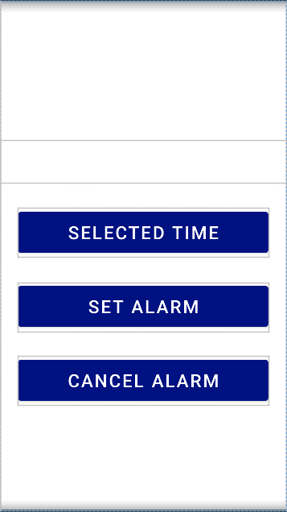

#### Hasil Tampilan *activity*_*main3*.xml

1. Kemudian ubahlah *source* *code* pada *MainActivity3*.java.

|  |
| --- |
| package com.example.bookstore;  import androidx.annotation.NonNull;  import androidx.appcompat.app.ActionBarDrawerToggle;  import androidx.appcompat.app.AppCompatActivity;  import androidx.drawerlayout.widget.DrawerLayout;  import android.content.Intent;  import android.os.Bundle;  import android.view.MenuItem;  import com.google.android.material.navigation.NavigationView;  import android.app.AlarmManager;  import android.app.NotificationChannel;  import android.app.NotificationManager;  import android.app.PendingIntent;  import android.content.Context;  import android.view.View;  import android.widget.Toast;  import com.example.bookstore.databinding.ActivityMain3Binding;  import com.google.android.material.timepicker.MaterialTimePicker;  import com.google.android.material.timepicker.TimeFormat;  import java.util.Calendar;  public class MainActivity3 extends AppCompatActivity {  private ActivityMain3Binding binding;  private MaterialTimePicker picker;  private Calendar calendar;  private AlarmManager alarmManager;  private PendingIntent pendingIntent;  private DrawerLayout dl;  private ActionBarDrawerToggle abcd;  @Override  protected void onCreate(Bundle savedInstanceState) {  super.onCreate(savedInstanceState);  binding = ActivityMain3Binding.inflate(getLayoutInflater());  setContentView(R.layout.activity_main3);  setContentView(binding.getRoot());  createNotificationChannel();  binding.selectedTimeBtn.setOnClickListener(new View.OnClickListener() {  @Override  public void onClick(View view) {  showTimePicker();  }  });  binding.setAlarmBtn.setOnClickListener(new View.OnClickListener() {  @Override  public void onClick(View view) {  setAlarm();  }  });  binding.cancelAlarmBtn.setOnClickListener(new View.OnClickListener() {  @Override  public void onClick(View view) {  cancelAlarm();  }  });  dl = (DrawerLayout)findViewById(R.id.dl);  abcd = new  ActionBarDrawerToggle(this,dl,R.string.Open,R.string.Close);  abcd.setDrawerIndicatorEnabled(true);  dl.addDrawerListener(abcd);  abcd.syncState();  getSupportActionBar().setDisplayHomeAsUpEnabled(true);  NavigationView nav_view = (NavigationView)findViewById(R.id.nav_view);  nav_view.setNavigationItemSelectedListener(new NavigationView.OnNavigationItemSelectedListener() {  @Override  public boolean onNavigationItemSelected(@NonNull MenuItem item) {  int id = item.getItemId();  if (id == R.id.nav_novel){  Intent a = new Intent(MainActivity3.this, MainActivity.class);  startActivity(a);  }else if (id == R.id.nav_anak){  Intent a = new Intent(MainActivity3.this, MainActivity2.class);  startActivity(a);  }else if (id == R.id.nav_notif){  Intent a = new Intent(MainActivity3.this, MainActivity3.class);  startActivity(a);  }  return true;  }  });  }  private void cancelAlarm() {  //untuk menggagalkan alarm yang sudah disetel  Intent intent = new Intent(this, AlarmReceiver.class);  pendingIntent = PendingIntent.getBroadcast(this, 0, intent, 0);  if (alarmManager == null) {  alarmManager = (AlarmManager) getSystemService(Context.ALARM_SERVICE);  }  alarmManager.cancel(pendingIntent);  Toast.makeText(this, "Alarm Cancelled", Toast.LENGTH_SHORT).show();  }  private void setAlarm() {  //untuk menjalankan alarm yang sudah disetel  alarmManager = (AlarmManager) getSystemService(Context.ALARM_SERVICE);  Intent intent = new Intent(this, AlarmReceiver.class);  pendingIntent = PendingIntent.getBroadcast(this, 0, intent, 0); alarmManager.setInexactRepeating(AlarmManager.RTC_WAKEUP, calendar.getTimeInMillis(), AlarmManager.INTERVAL_DAY, pendingIntent);  Toast.makeText(this, "Alarm Set Successfully", Toast.LENGTH_SHORT).show();  }  private void showTimePicker() {  //memunculkan dialog timepicker menggunakan library dariandroid  picker = new MaterialTimePicker.Builder()  .setTimeFormat(TimeFormat.CLOCK_24H)  .setHour(12)  .setMinute(0)  .setTitleText("Select Alarm Time")  .build();  picker.show(getSupportFragmentManager(), "AlarmManager");  //mengeset waktu didalam view  picker.addOnPositiveButtonClickListener(new View.OnClickListener() {  @Override  public void onClick(View view) {  if (picker.getHour() > 12) { binding.selectedTime.setText(String.format("%02d : %02d", picker.getHour(), picker.getMinute()));  } else {  binding.selectedTime.setText(picker.getHour() + " : " + picker.getMinute() + " ");  }  //menangkap inputan jam kalian lalu memulai alarm  calendar = Calendar.getInstance();  calendar.set(Calendar.HOUR_OF_DAY, picker.getHour());  calendar.set(Calendar.MINUTE, picker.getMinute());  calendar.set(Calendar.SECOND, 0);  calendar.set(Calendar.MILLISECOND, 0);  }  });  }  private void createNotificationChannel() {  //mendeskripsikan channel notifikasi yang akan dibangun  CharSequence name = "INI ALARM MANAGER";  String description = "Alarm untuk service motor";  //tingkat importance = high ( penting sekali )  int importance = NotificationManager.IMPORTANCE_HIGH;  NotificationChannel channel = new NotificationChannel("AlarmManager", name, importance);  channel.setDescription(description);  //membuka izin pengaturan dari aplikasi untuk memulai ervice notifikasi  NotificationManager notificationManager = getSystemService(NotificationManager.class);  notificationManager.createNotificationChannel(channel);  }  @Override  public boolean onOptionsItemSelected(@NonNull MenuItem item) {  return abcd.onOptionsItemSelected(item) || super.onOptionsItemSelected(item);  }  } |

Analisa :

*Source* *code* diatas terdapat pada *MainActivity3*.java, *source* *code* diatas digunakan untuk mengatur dari tampilan yang berada pada *activity*_*main*.xml. terdapat beberapa fungsi *void*. Salah satunya adalah *void* *cancelAlarm* yang digunakan untuk menggagalkan *alarm* yang sudah disetel.

1. Tampilan hasil program ketika dijalankan.

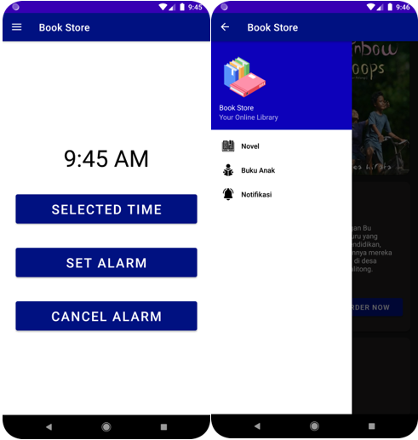

#### Tampilan Hasil *Running*

Analisa :

Program diatas adalah aplikasi menggunakan *alarm*. Saat pengguna menekan tombol *selected* *time*, maka pengguna bisa mengatur jam. Jika pengguna menekan tombol *set* *alarm* maka alarm akan mengatur sesuai jam yang sudah ditetapkan pengguna.

1. **Link repository github**

https://github.com/Arii789/Tugas6_2018066.git