
GRADUATION PROJECT
Academic Year 2025–2026

MediFollow
Intelligent Post-Hospitalization Monitoring Web Platform
Remote monitoring, generative AI, and blockchain security

Presented by:  Walaeddine Riahi  Arij Mahjoub  Eya Nefzi  Ons Jaouadi  Nizar Chaieb | Supervised by:  Mrs. Asma Ayari  Institution:  ESPRIT  Private Higher School of Engineering and Technology

Table of Contents
General Introduction | 4
Chapter 1 — General Context | 6
1.1 Introduction | 6
1.2 Problem Statement | 7
1.3 Study of Existing Solutions | 8
1.5 Proposed Solution – MediFollow | 10
1.6 Functional and Non-Functional Requirements | 12
1.7 System Actors | 14
1.8 Use Case Diagram | 15
1.9 Data Model | 16
1.10 Technical Architecture | 18
1.11 Software Environment | 20
1.12 Product Backlog | 21
1.13 Agile Scrum Methodology | 23
Chapter 2 — Realization and Implementation | 25
2.1 Authentication and Onboarding | 26
2.2 Super Administrator Interface | 27
2.3 Auditor Interface (Audit & Security) | 29
2.4 Coordinator Interface | 32
2.5 Doctor Interface | 34
2.6 Nurse Interface | 38
2.7 Patient Interface | 39
2.8 Artificial Intelligence Features | 42
Chapter 3 — CI/CD Pipeline and Software Quality | 45
3.1 CI/CD Pipeline Architecture | 46
3.2 Jenkins Pipeline | 47
3.3 SonarQube Quality Analysis | 48
3.4 Monitoring and Observability | 50
General Conclusion | 52

INTRODUCTION
General Introduction
Context, challenges, and objectives of the MediFollow project

Post-hospitalization follow-up represents a critical phase of patient recovery. Studies show that up to 20% of patients experience complications or require readmission within 30 days of discharge. Most of these complications could be avoided through early detection of warning signs and prompt medical intervention.

Traditional follow-up methods rely on scheduled visits and subjective patient reports, creating gaps in the continuity of care. The digital transformation of healthcare offers new opportunities to address these challenges.

Project Objectives
This project introduces MediFollow, a comprehensive web platform specifically designed for remote monitoring of post-hospitalized patients. The platform aims to:

🎯 Key Objectives of MediFollow
● Ensure continuous monitoring of vital signs (temperature, blood pressure, heart rate, weight, SpO₂)
● Generate automated alerts for abnormal vital sign values
● Support multi-role healthcare teams with Role-Based Access Control (RBAC)
● Provide interactive dashboards for real-time visualization of patient data
● Guarantee complete traceability and security of medical information via Aptos blockchain
● Integrate an AI voice assistant (Jarvis-3B) for 24/7 support

Report Structure
CHAPTER | CONTENT
Chapter 1 – General Context | Problem statement, study of existing solutions, proposed solution, requirements, actors, data model, technical architecture and methodology
Chapter 2 – Realization | Interfaces of all roles: SuperAdmin, Auditor, Coordinator, Doctor, Nurse, Patient and AI features
Chapter 3 – CI/CD & Quality | DevOps Pipeline (GitHub Actions, Jenkins), SonarQube analysis, Prometheus/Grafana/Alertmanager monitoring

CHAPTER 1
General Context
Problem statement · Existing solutions · Architecture · Methodology

1.1 Introduction
Post-hospitalization monitoring is a critical phase where inadequate surveillance can lead to preventable complications, readmissions, and increased healthcare costs. MediFollow is a comprehensive web platform designed to bridge the gap between hospital discharge and full patient recovery through intelligent remote monitoring.

🏗️ Six Core Components
● Vital Signs Monitoring – Recording and tracking of vital signs
● Automated Alert System – Real-time detection of anomalies
● Multi-Role Management – 6 distinct roles with tailored permissions
● Interactive Dashboards – Real-time visualization of clinical data
● Questionnaire Management – AI-personalized follow-up questionnaires
● Complete Audit Trail – Full traceability via Aptos blockchain

1.2 Problem Statement
Post-hospitalization monitoring presents a major challenge: many complications occur because patients are not sufficiently monitored after discharge. Traditional methods rely on infrequent scheduled visits, creating significant gaps in continuity of care.

How can we design a comprehensive, intelligent, and secure web platform allowing healthcare professionals to effectively monitor post-hospitalized patients, detect abnormal health indicators in real-time, and reduce complications through automated alerts and continuous data tracking?

1.3 Study and Critique of Existing Solutions
SOLUTION | STRENGTHS | KEY LIMITATIONS
Epic EMR | Regulatory compliance, records management, reporting | No AI, no remote alerts, no chatbot, single-entity architecture, high costs
Teladoc | Video consultations, KPIs, modular ecosystem | Configuration complexity, high cost, not tailored for post-hospital monitoring, no AI chatbot

1.5 Proposed Solution – MediFollow
MediFollow is a modern, intelligent, and secure platform for monitoring post-hospitalized patients. It relies on a multi-role architecture supporting 6 distinct profiles, ensuring data isolation and security via Aptos blockchain, and integrating AI at every operational level.

💡 Global Vision of the Solution
● Reduce time spent on manual patient monitoring tasks
● Decrease medical management costs for healthcare facilities
● Provide 24/7 intelligent assistance via Jarvis (Voice AI)
● Enable effective coordination within multi-role healthcare teams
● Provide control over medical data access via Aptos blockchain

1.6 Functional and Non-Functional Requirements

Functional Requirements
REQUIREMENT | DESCRIPTION
Questionnaire Mgmt | Create, assign, and manage health questionnaires with configurable frequency
Alert System | Real-time detection of abnormal values with instant notifications to the care team
Vital Signs Monitoring | Recording and monitoring vital signs with configurable alert thresholds per patient
Dashboards | Real-time data visualization, trends, alert history per role
Multi-Role Mgmt | Support for 6 roles (Patient, Doctor, Nurse, Coordinator, Admin, Auditor)
Audit Trail | Complete traceability of all platform actions for regulatory compliance
Aptos Blockchain | Decentralized and secure medical access control, revocable by the patient
Generative AI | AI clinical summary, questionnaire generation, automatic triage, predictive analysis

Non-Functional Requirements
CRITERION | SPECIFICATION
Security | AES-256 encryption, Role-Based Access Control (RBAC), data isolation per entity
Legal Compliance | Compliance with health data protection regulations, Privacy-by-Design
Performance | Response time < 2s, support for 1,000+ concurrent users, Redis cache
Availability | 99.9% guaranteed uptime, Kubernetes, Prometheus/Grafana monitoring system
Scalability | Horizontal scaling, Docker containers, load-based auto-scaling

1.7 System Actors
ROLE | RESPONSIBILITIES | PERMISSIONS
Super Admin | Global platform ownership, management of all accounts | Full access – Audit Log – System settings
Platform Admin | Technical and operational platform management | Accounts, security, logs, licenses
Doctor | Comprehensive monitoring of assigned patients, clinical decisions | Vital signs, questionnaires, AI analysis, alerts
Nurse | Data entry assistance, patient assignment to doctors | Patient data, assignments, reminders
Coordinator | Compliance supervision, escalation of critical alerts | Alerts, reports, protocol tracking
Patient | Record consultation, vital signs entry, questionnaires | Read record, measure entry, blockchain
Auditor | Security monitoring, logs, incidents, audit reports | Read-only + report generation
AI Agent | Automated analysis of medical data, anomalies | Analysis module, KPIs, predictions

1.8 Use Case Diagram
The use case diagram provides a comprehensive overview of the interactions between system actors and the main functional modules of the platform.

1.9 Data Model
The data model defines the core entities of the system, their attributes, and relationships. It ensures data consistency, supports multi-organization, and enables the platform's various modules.

1.10 Technical Architecture

1.10.1 Logical Architecture
LAYER | TECHNOLOGY | ROLE
Presentation | Web Browser | User interface accessible via HTTPS
Frontend | Next.js / React / Tailwind CSS | Responsive and optimized user interfaces
Application | NestJS (Node.js) | RESTful APIs, business logic, RBAC
AI | OpenAI GPT-4 / Hugging Face / Jarvis-3B | Medical analysis, voice chatbot, anomalies
Data | PostgreSQL / MongoDB / Redis | Persistent storage, caching, high availability
Blockchain | Aptos (Move) | Decentralized and immutable medical access control

1.10.2 Physical Architecture
The platform follows a distributed deployment model based on cloud services: frontend on Vercel (global CDN), backend and AI services on a separate cloud environment, managed database (high availability), and Aptos blockchain nodes.

1.11 Software Environment
TECHNOLOGY | ROLE | CATEGORY
NestJS | Node.js backend framework, modular architecture | Backend
Next.js / React | React frontend framework with optimized rendering | Frontend
Tailwind CSS | Utility-first CSS framework for design | UI
OpenAI GPT-4 | AI models for NLP, questionnaire generation | AI
Jarvis-3B | Specialized healthcare AI voice assistant | Voice AI
Hugging Face / BiomedBERT | Clinical triage, biomedical analysis | Medical AI
Pusher | Real-time communication, push notifications | Real-time
PostgreSQL / MongoDB | Relational and NoSQL databases | Data
Redis | In-memory cache, sessions, message queues | Performance
Aptos Blockchain | Decentralized medical access control (Move) | Security
GitHub Actions | Automated CI/CD, testing, deployment | DevOps
Jenkins | Local CI/CD pipeline, Docker, SonarQube | DevOps
Docker / Kubernetes | Containerization, orchestration, scaling | Infrastructure
Vercel | Frontend deployment, global CDN | Hosting
Prometheus / Grafana | Monitoring, alerting, dashboards | Observability

1.12 Product Backlog
ID | USER STORY | PRIORITY
US-01 | As a user, I want to create an account and log in | High
US-02 | As an admin, I want to manage roles and permissions | High
US-03 | As an admin, I want to manage user accounts | High
US-04 | As a doctor, I want to view vital sign trends | High
US-05 | As a patient, I want to enter my vital signs | High
US-06 | As a patient, I want to report my symptoms | High
US-07 | As a patient, I want to consult my medical records | High
US-08 | As a doctor, I want to receive alerts for abnormal values | High
US-09 | As a nurse, I want to assign patients to doctors | High
US-10 | As a coordinator, I want to send reminders to patients | Medium
US-11 | As an auditor, I want to view logs and generate reports | High

1.13 Agile Scrum Methodology
For the development of this project, we adopted an agile approach inspired by the Scrum methodology, adapted to the academic context. Scrum supports iterative and incremental development, well suited to evolving requirements.
SPRINT | OBJECTIVE | MODULES DEVELOPED
Sprint 1 | Multi-role architecture | User management, RBAC, JWT authentication
Sprint 2 | Clinical monitoring | Patient management, vital signs, alert configuration
Sprint 3 | Questionnaires & Alerts | AI questionnaires, automated alert system
Sprint 4 | AI & DevOps | AI integration, analytics, dashboards, CI/CD pipeline

CHAPTER 2
Realization and Implementation
User interfaces · Features · Screenshots

This chapter presents the graphical interfaces of the MediFollow platform and the main implemented features. The platform was developed with Next.js for the frontend and NestJS for the backend, following a multi-role web architecture integrating Aptos blockchain and generative AI.

2.1 Authentication and Onboarding
The platform offers a secure registration and login system based on JWT tokens with Role-Based Access Control. An innovative biometric facial recognition feature is available for secure passwordless login.

🔐 Authentication Security
● JWT Tokens with automatic refresh and RBAC control
● Biometric facial recognition (Jarvis-3B) – passwordless login
● Demo accounts per role with quick password copy
● AES-256 encryption of all transmitted data
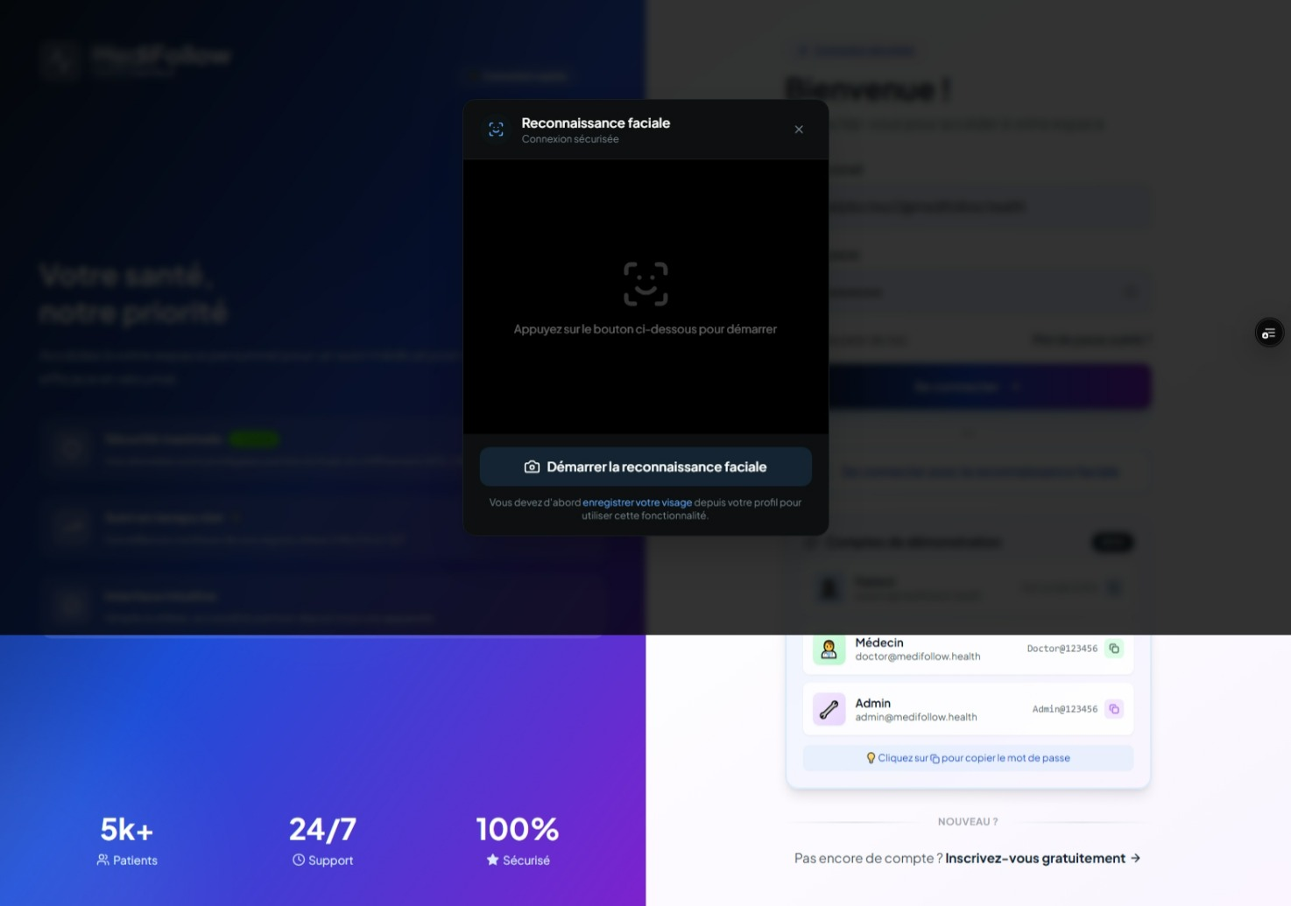
Fig. Facial Recognition – Secure Biometric Authentication (Jarvis-3B)

2.2 Super Administrator Interface
SUPER ADMIN
The Super Administrator has a real-time global view of the entire user ecosystem of the MediFollow platform. The dashboard centralizes key metrics and recent audit events with severity level indications.

INDICATOR | VALUE | DESCRIPTION
Admins | 4 | Platform administrators
Doctors | 5 | Registered doctors
Patients | 8 | Patients under monitoring
Nurses | 4 | Nursing staff
Coordinators | 2 | Care coordinators
Auditors | 2 | Security auditors
New (7d) | 4 | New users this week
Failed logins (24h) | 0 | No suspicious attempts
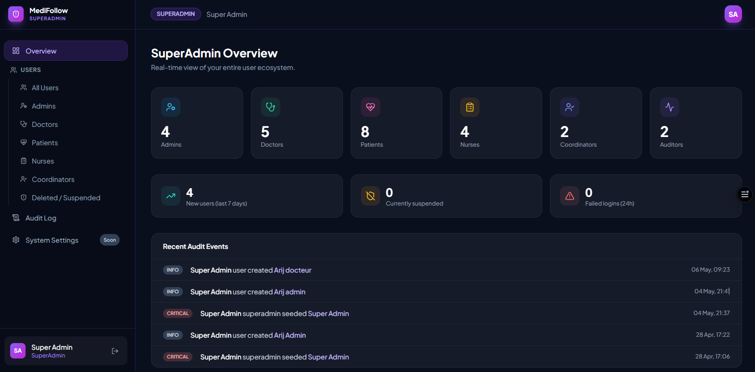
Fig. SuperAdmin Overview – Real-time dashboard of the user ecosystem

2.2.1 Immutable Audit Log
The Super Admin's audit log records every critical action immutably: user creation, super-admin initialization, with precise timestamp, actor, target, action, and severity level (INFO / CRITICAL). 9 total entries recorded.

2.3 Auditor Interface (Audit & Security)
SECURITY AUDITOR
The security auditor has a comprehensive suite of tools to oversee system security, consult logs, manage incidents, and generate audit reports. The Aptos blockchain is integrated to ensure log immutability.

2.3.1 Auditor Dashboard
INDICATOR | VALUE | VARIATION
Total Logs | 2,543 | +12% this month
Incidents | 8 | -3% this month
Active Users | 142 | +5% this month
Modifications | 1,247 | +8% this month
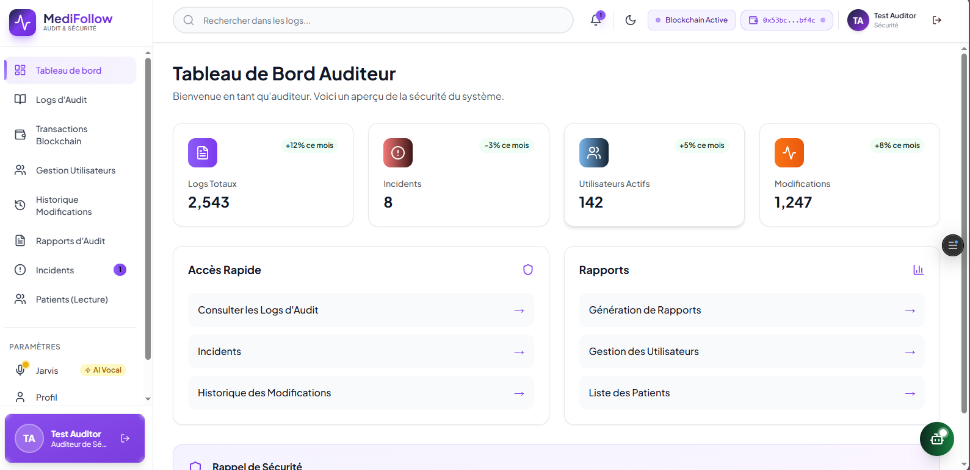
Fig. Auditor Dashboard – System security view with active blockchain

2.3.2 Audit Logs
The Audit Logs module allows consultation of all system events and actions. Each entry includes: timestamp, user, action type (LOGIN, LOGIN_FAILED...), affected resource, JSON details, and status. Export available in CSV and JSON.
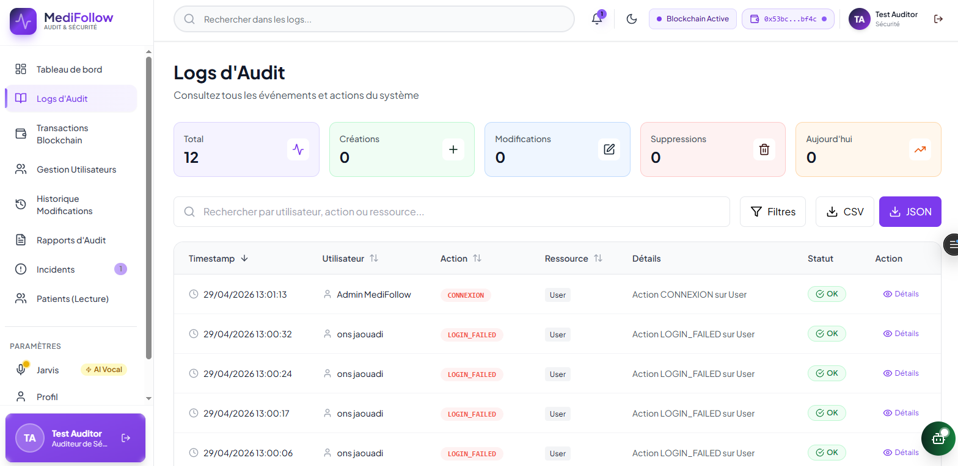
Fig. Audit Logs – Multi-criteria filtering (CSV / JSON)

2.3.3 Audit Reports
The auditor can generate custom reports or download pre-generated reports: Monthly Report (2.5 MB), Q1 Security Report (3.8 MB), Active Users Report (1.2 MB). Each report is timestamped and available in PDF format.
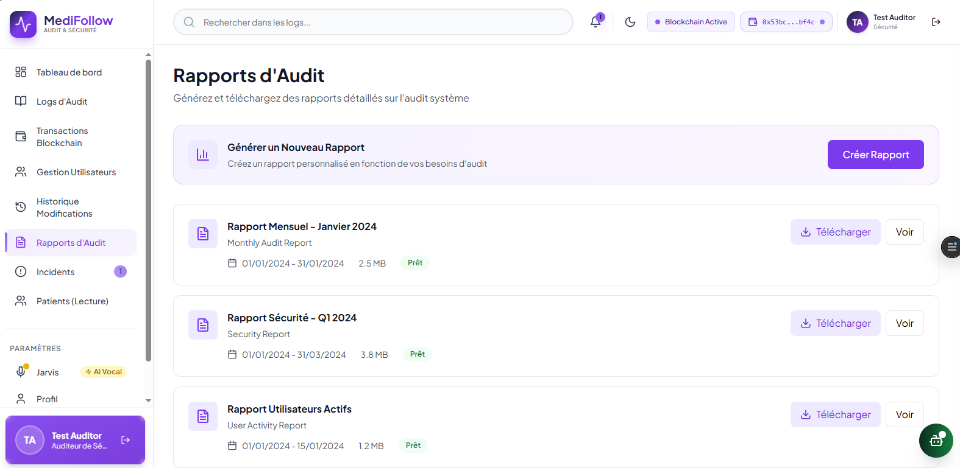
Fig. Audit Reports – Generation and download of detailed system reports

2.3.4 Security Incident Management
The Incidents module detects and manages critical security alerts. A VITAL Alert incident was detected: abnormal temperature + oxygen saturation, requiring immediate medical intervention. Status: Resolved.
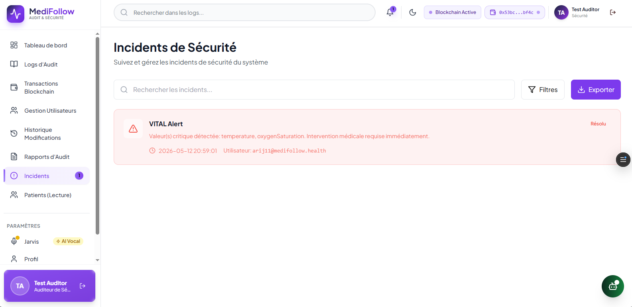
Fig. Security Incidents – Critical VITAL Alert (Temp + SpO₂) – Status Resolved

2.4 Coordinator Interface
CARE COORDINATOR
The coordinator supervises patient compliance over 7 days, manages active alerts, and reports. They can manually escalate critical situations to doctors and rely on the Clinical Triage AI Assistant.

2.4.1 Patient Compliance Monitoring
The assigned list displays for each patient: medical record number (MRN), department, assigned doctor(s), compliance score (%), number of completed/pending questionnaires, and daily status (OK / Missing).
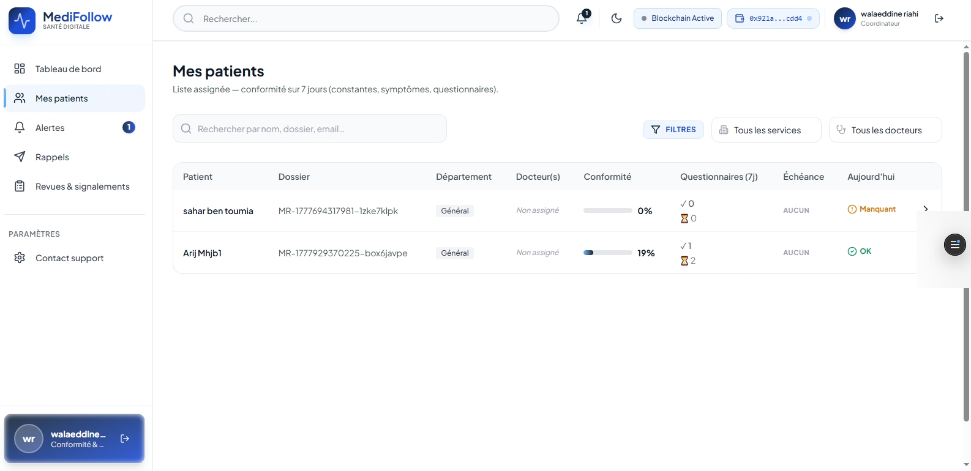
Fig. My Patients – 7-day compliance with questionnaires and vital signs

2.4.2 Active Alerts Management – AI Triage
The Active Alerts Monitoring allows tracking untreated alerts, following doctor interventions, and escalating critical situations. The Clinical Triage AI Assistant analyzes clinical summaries to assess urgency.
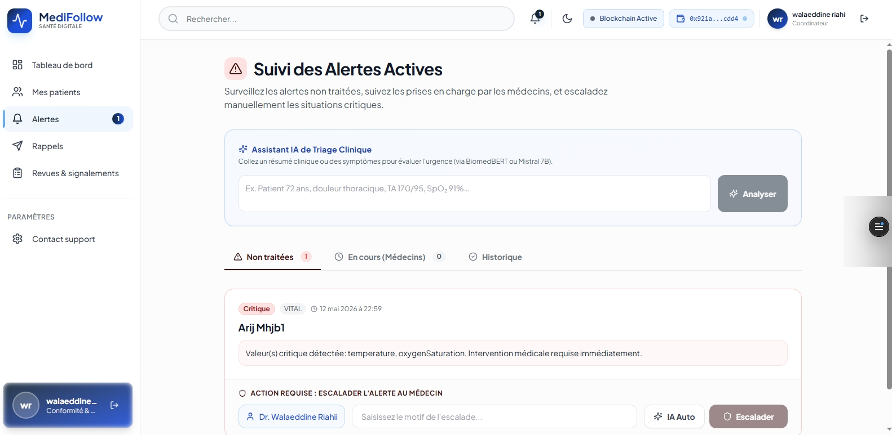
Fig. Active Alerts Monitoring – Clinical AI Triage + Manual escalation

2.4.3 Reviews & Reports – Critical Alerts
The Reviews & Reports module displays critical alerts with measured vital values and assigned doctor's contact info. CRITICAL Alert detected. Actions: Request re-measurement · Send notification · Acknowledge.
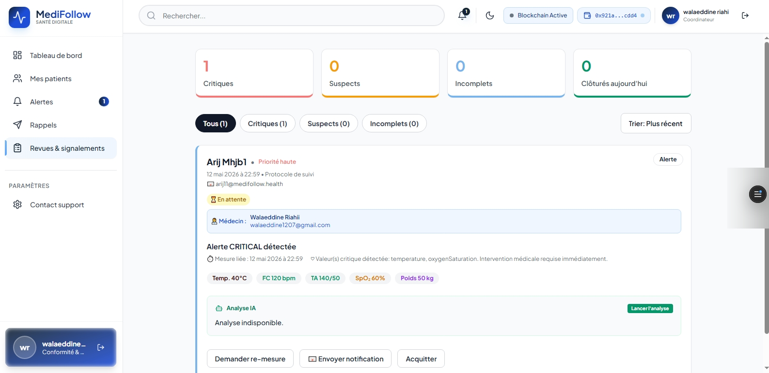
Fig. Reviews & Reports – CRITICAL Alert with critical vital values and AI analysis

2.5 Doctor Interface
DOCTOR
The doctor has a comprehensive workspace to manage their assigned patients, monitor vital signs in real-time, create analysis requests, and generate questionnaires via AI. The platform integrates an AI clinical summary for each patient.

2.5.1 Patient List
The doctor views the list of their patients with basic medical information. The Aptos blockchain guarantees the security of access to medical records.
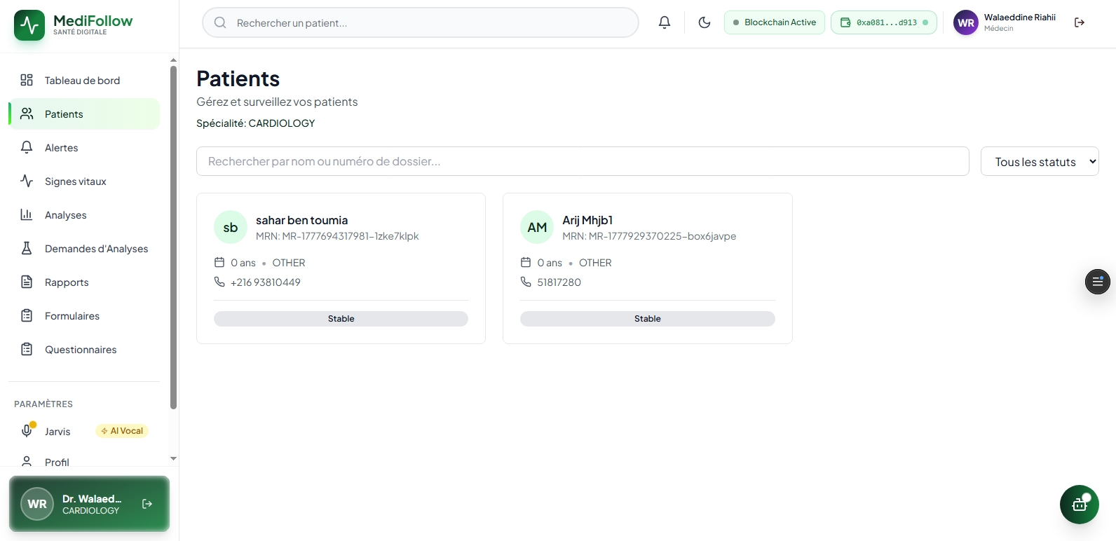
Fig. Patients – List of assigned patients

2.5.2 AI Clinical Summary
The patient profile automatically generates a Comprehensive AI Clinical Summary: patient information, current vital signs with normality assessment, trends from the last 5 measurements, and predictive analysis.
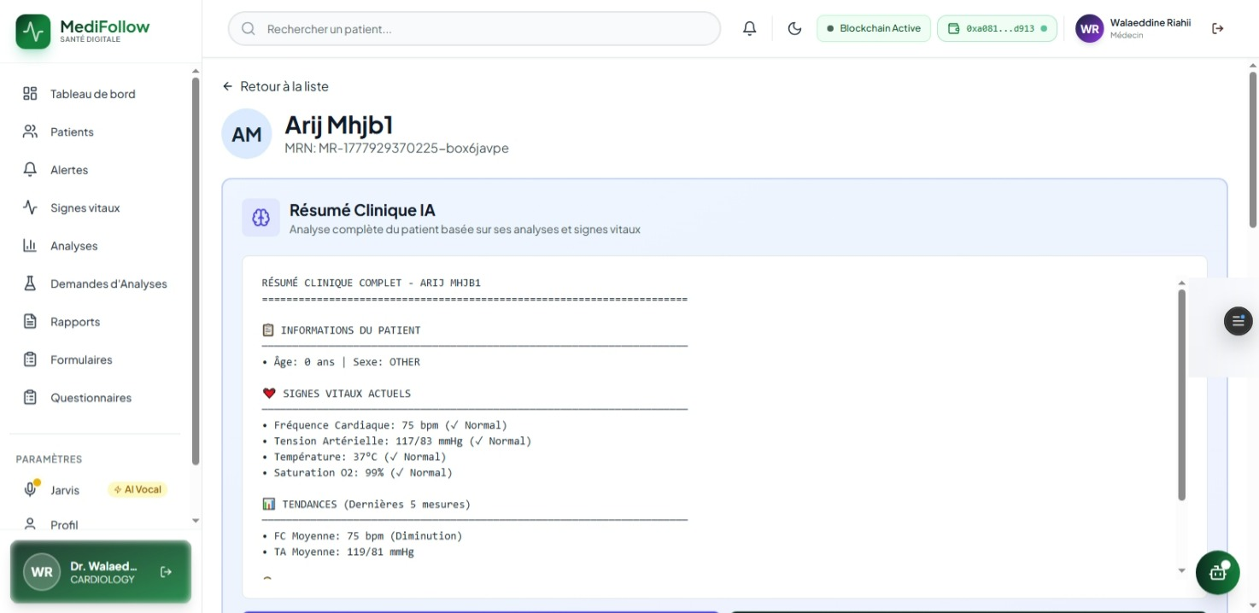
Fig. AI Clinical Summary – Comprehensive analysis of the patient

2.5.3 Real-Time Vital Signs Monitoring
The vital signs dashboard displays averages of all patients and the complete history of measurements. Abnormal values are highlighted. Critical notifications appear in real-time.
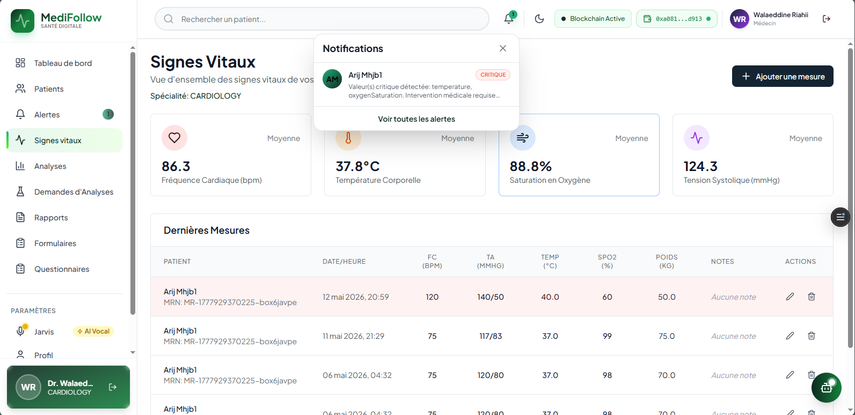
Fig. Vital Signs – Real-time monitoring + CRITICAL notification

2.5.4 Medical Analysis Requests
The doctor creates analysis requests for their patients: clinical reason, deadline, attached document, and selection of the target patient from the assigned list. This feature facilitates post-hospitalization clinical follow-up.
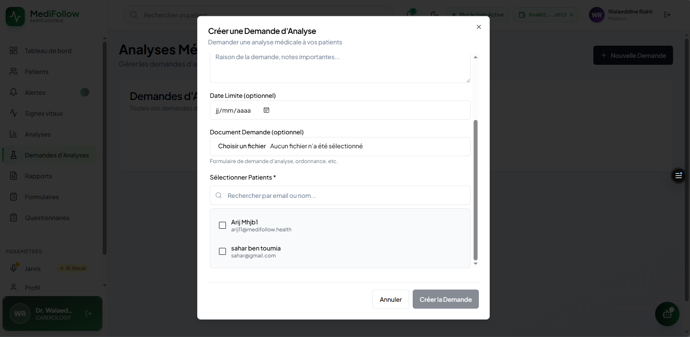
Fig. Analysis Requests – Creation form for assigned patient

2.5.5 AI Questionnaire Generation
The doctor automatically generates clinical questionnaires by specifying the medical specialty, title, and custom instructions. The AI instantly produces relevant questions adapted to the clinical context.
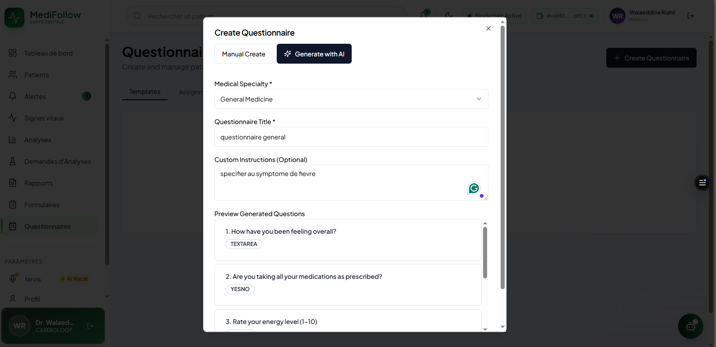
Fig. AI Questionnaire Generation – Specialty + instructions → Automatic clinical questions

2.6 Nurse Interface
NURSE
The nurse has a dedicated interface to assign patients to available doctors, enter medical data, and manage reminders. The 'Assign to Doctor' interface allows quick assignment with instant confirmation.
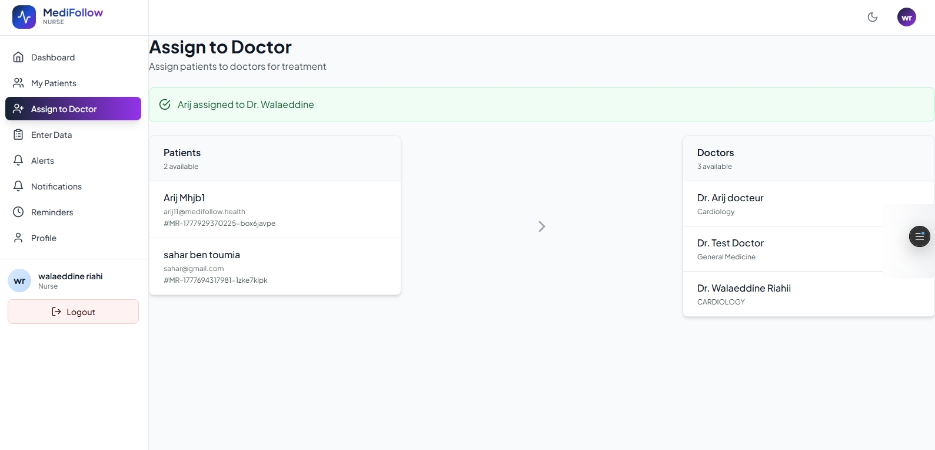
Fig. Assign to Doctor – Patient-doctor assignment

2.7 Patient Interface
PATIENT
The patient has a comprehensive personal space to track their post-hospitalization health: dashboard with real-time vital signs, interactive questionnaires with voice assistance, and total control of their medical data via Aptos blockchain.

2.7.1 Patient Dashboard
The dashboard displays real-time most recent vital signs, active alerts, and an interactive user guide to help the patient navigate the platform.
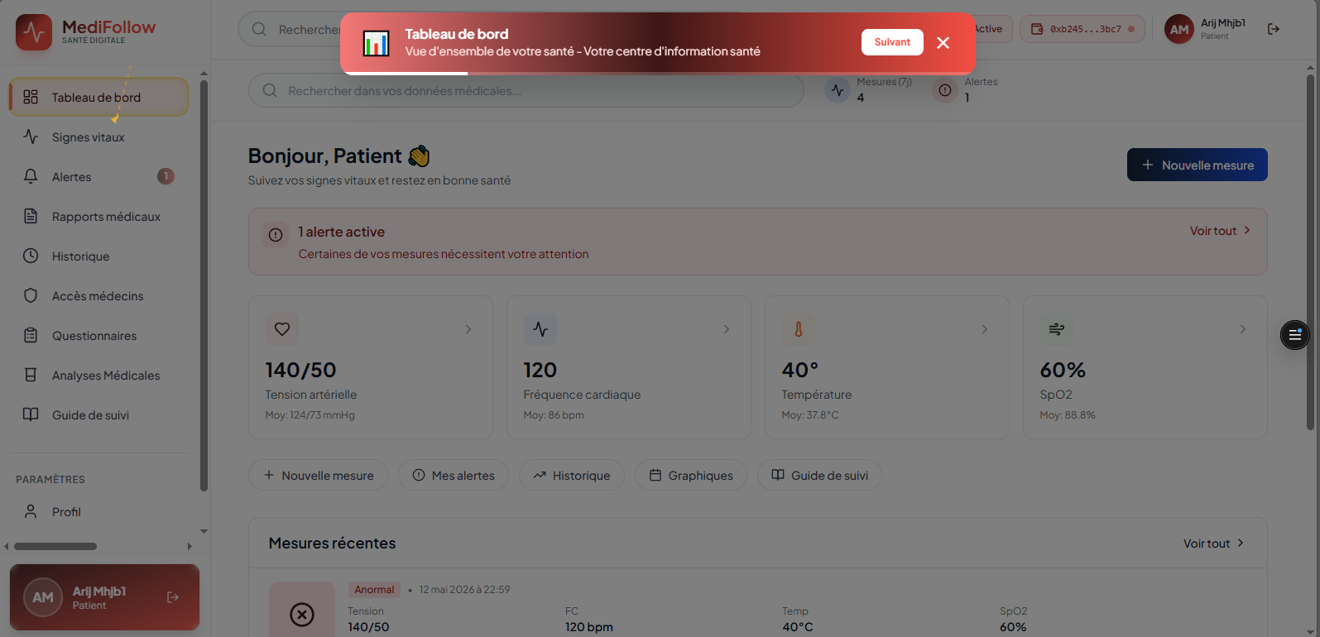
Fig. Patient Dashboard – Real-time vital signs + interactive user guide

2.7.2 Questionnaire with AI Voice Assistance
The patient answers their follow-up questionnaires via an intuitive interface with a progress bar. The Jarvis voice mode allows answering clinical questions aloud. Question types: free text, binary Yes/No, 1-10 numerical scale.
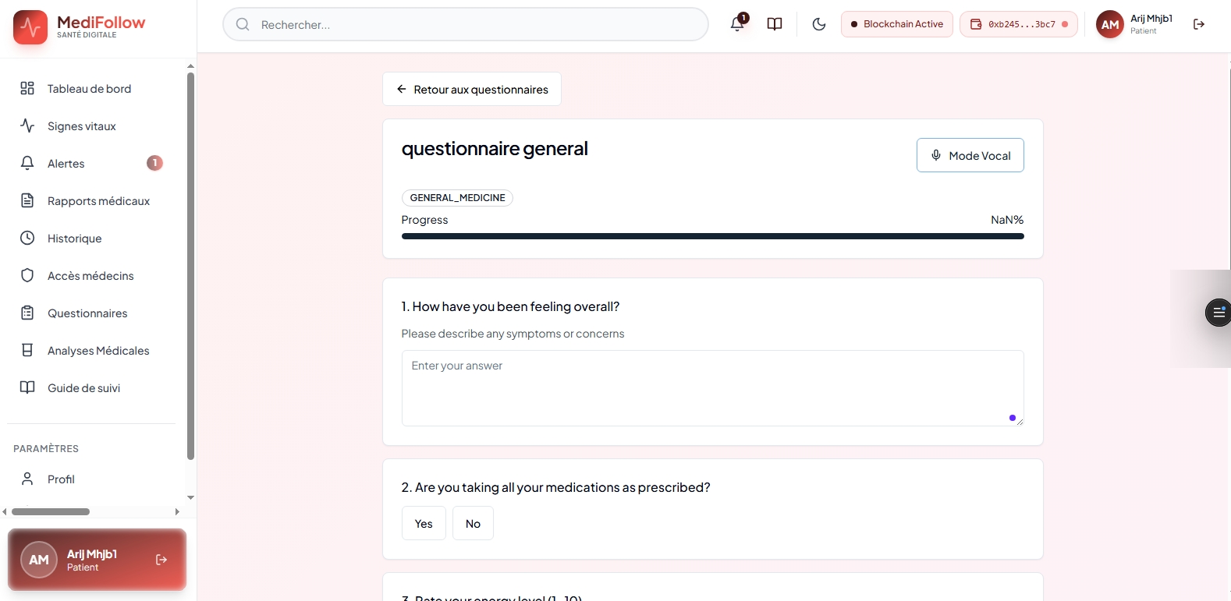
Fig. Patient Questionnaire – AI Voice Mode (Jarvis) for spoken responses to clinical questions

2.7.3 Medical Access Control via Aptos Blockchain
The patient precisely controls which doctors can access their health data via the Aptos blockchain. They can grant or revoke access with configurable duration (30d, 3 months, 6 months, 1 year) and view the blockchain wallet addresses of each doctor.
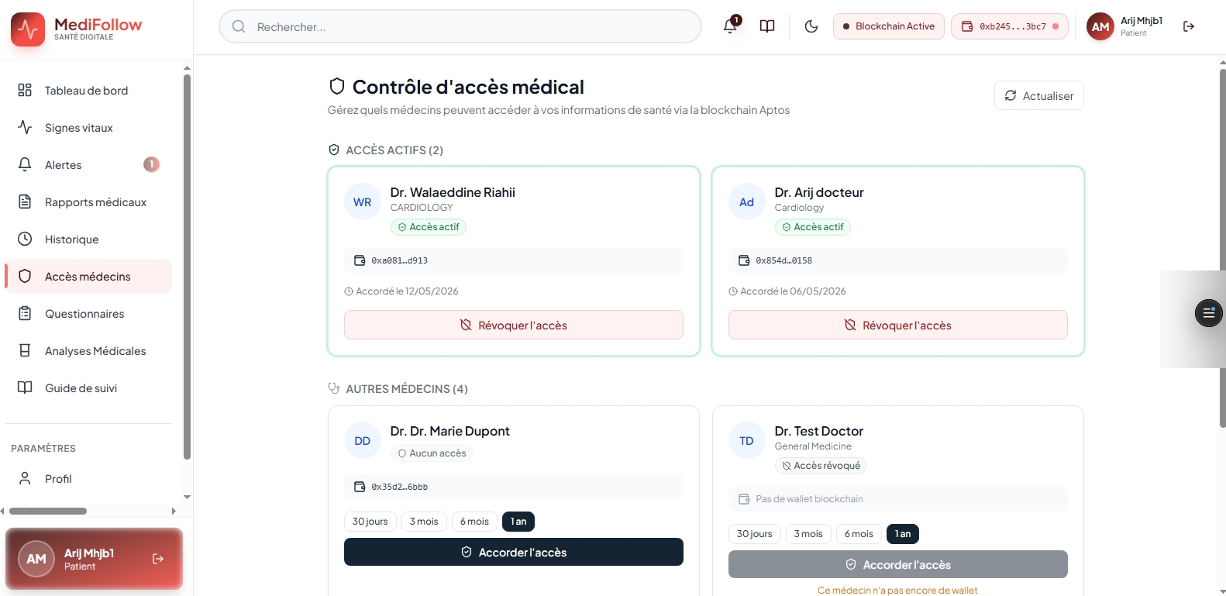
Fig. Aptos Blockchain Medical Access Control – Active accesses, revocation possible

2.8 Artificial Intelligence Features
MediFollow integrates artificial intelligence at all operational levels of the platform, distinguishing the solution from existing systems on the market.

AI FEATURE | TECHNOLOGY | TARGET USERS
Jarvis Voice Assistant | Jarvis-3B (Healthcare LLM) | All roles
AI Clinical Summary | GPT-4 / OpenAI | Doctors
Questionnaire Generation | GPT-4 + contextual instructions | Doctors
Clinical Triage | BiomedBERT / Mistral 7B | Coordinators
Vital Anomaly Detection | Configurable thresholds + ML | Automated system
Facial Recognition | Computer Vision (Jarvis-3B) | All roles
Predictive Analysis | Trends + forecasting | Doctors, Coordinators

2.8.1 Jarvis – AI Voice Assistant
Jarvis is the AI voice assistant integrated into MediFollow, based on the Jarvis-3B model. Accessible to all roles via an interactive voice orb, it provides immediate contextual assistance 24/7. In Auto mode, it listens and responds continuously; in Push-to-Talk mode, the user triggers voice recognition manually.
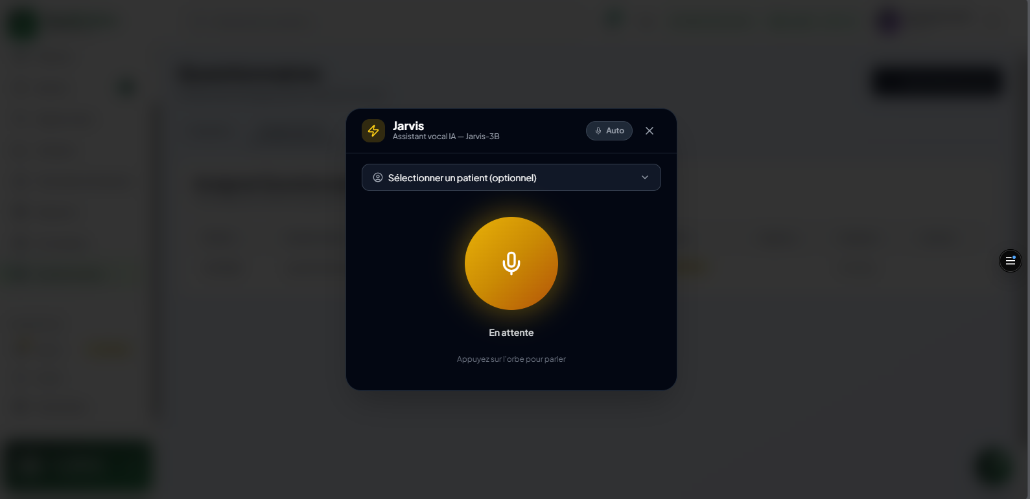
Fig. Jarvis – AI Voice Assistant (Jarvis-3B) in standby mode

CHAPTER 3
CI/CD Pipeline and Software Quality
DevOps · Testing · SonarQube · Monitoring

To ensure the reliability, security, and maintainability of the MediFollow platform, we implemented a comprehensive DevOps workflow based on Continuous Integration and Continuous Deployment (CI/CD). This workflow automates code validation, testing, quality analysis, containerization, and deployment.

3.1 CI/CD Pipeline Architecture
The CI/CD workflow is organized into four independent pipelines – two for the frontend (medifollow-web) and two for the backend API (medifollow-api) – following the principle of separation between Continuous Integration (CI) and Continuous Delivery (CD).

PIPELINE | TRIGGER | MAIN ACTIONS
Frontend CI | Push / Pull Request | ESLint (static analysis) · Vitest (unit tests)
Frontend CD | After successful CI | Next.js Build · Artifact storage (GitHub Actions)
Backend CI | Branch push | Mock PostgreSQL/MongoDB · Jest (tests)
Backend CD | After successful CI | TypeScript compilation → JS · dist/ Artifact stored

3.2 Jenkins Pipeline – Full Automation
For local automation and complete lifecycle management, we implemented a dedicated CI/CD pipeline with Jenkins, ensuring that every code modification is automatically validated, analyzed, containerized, and deployed.

⚙️ Jenkins Pipeline Steps (Jenkinsfile)
● Preparation: Workspace cleanup and secure build environment configuration
● Installation: Dependency installation with npm install
● Static Analysis: ESLint execution – code style violation detection
● Unit Tests: Execution with Vitest – validation of all features
● SonarQube Analysis: Comprehensive report on security, reliability, and maintainability
● Docker Build: Construction of the production container image
● Deployment: Automatic restart via Docker Compose with the latest image

3.3 Software Quality Analysis – SonarQube
SonarQube was integrated into the pipeline as a Quality Gate tool. It performs deep static code analysis across four key dimensions: Reliability, Security, Maintainability, and Test Coverage. A build is only validated if it passes all Quality Gate conditions.

METRIC | BEFORE | AFTER | IMPROVEMENT
Frontend Reliability | D (520 bugs) | A (2 bugs) | -99.9%
Frontend Security | C (2 issues) | A (0 issues) | ✓ Resolved
Frontend Coverage | 0.3% | 81.4% | +747.9%
Duplication | 7.3% | 0.0% | ✓ Eliminated
Backend Maintainability | A (stable) | A (stable) | Maintained
Quality Gate | FAILED | PASSED ✓ | ✓ Validated

3.4 Monitoring and Observability
A comprehensive monitoring and observability stack was deployed to supervise the platform in production and detect anomalies in real-time, based on Prometheus, Grafana, and Alertmanager.

📊 MediFollow Monitoring Stack
● Prometheus: Collection and storage of metrics for frontend and backend API
● Grafana: Interactive dashboards for real-time visualization of platform performance
● Alertmanager: Automated alerts with configurable rules – InstanceDown Critical Alert

CONCLUSION
General Conclusion
Summary · Limitations · Future Perspectives

Summary of Achievements
This project presented the design, development, and deployment of MediFollow, a remote monitoring platform for post-hospitalized patients. The three chapters addressed the challenges related to automation, intelligent assistance, multi-role management, and software quality.

DOMAIN | ACHIEVEMENT
Multi-Role Architecture | 6 distinct roles with dedicated interfaces
Real-Time Alert System | Automatic detection of vital anomalies with instant notifications
AI Integration | Jarvis-3B voice, GPT-4 clinical summary, BiomedBERT triage, questionnaire generation
Aptos Blockchain | Decentralized medical access control, immutable audit logs
Software Quality | SonarQube Quality Gate PASSED: Reliability A, Security A, Coverage 81.4%

Future Perspectives
DIRECTION | DESCRIPTION
Advanced AI | Deep Learning models for vital trend prediction and early detection
Mobile Application | Native iOS and Android app to extend platform accessibility
External Integrations | Connection to wearable device APIs, HIS systems, and third-party software
Advanced Analytics | BI dashboards with industry benchmarking and predictive cohort analysis

MediFollow demonstrates that a modern, intelligent, and scalable web platform can be designed and implemented to meet the real needs of post-hospitalization monitoring. By combining robust multi-role architecture, AI automation, blockchain security, and a comprehensive DevOps pipeline, this project provides a solid and extensible foundation for a next-generation medical management solution.

