**LIVER TUMOR SEGMENTAION**

A Capstone Project Report

Submitted to the Faculty

of the

Bennett University

By

Arijeet Sinha

E16CSE121

In Partial Fulfillment of the Requirements

for the Degree of

Bachelor of Technology

Major Department: Computer Science Engineering

October 2019

Greater Noida-201310, Uttar Pradesh, India

# CERTIFICATE

I hereby certify that the work which is being presented in the B.Tech. Capstone Project Report entitled **“Project Title”,** in partial fulfillment of the requirements for the award of the **Bachelor of Technology in Computer Science & Engineering** and submitted to the Department of Computer Science & Engineering of Bennett University Greater Noida UP is an authentic record of my own work carried out during a period from July 2019 to November 2019.

The matter presented in this thesis has not been submitted by me for the award of any other degree elsewhere.

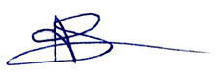

Signature of Candidate

Arijeet Sinha

E6CSE121

This is to certify that the above statement made by the candidate is correct to the best of my knowledge.

Head

Computer Science Engineering Department

Bennett University Greater Noida UP

ABSTRACT

Liver cancer has been as the second most fatal cancer to cause death for men and sixth

for women. Early diagnosis by Computed Tomography could lead to high recovery rate,

however going through all the CT slices for thousands or even millions of patients manually by professionals is hard, tiresome, expensive, time-consuming and prone to errors. Therefore, we needed a reliable, simple and accurate method to automate this process. In this thesis we used CNNs to overcome all the aforementioned obstacles, we used a Re-sUNet model on the 3D-IRCADb01 dataset which contains CT slices for patients along with masks for liver, tumors and other body organs. ResUNet is a hybrid between the U- Net and ResNet models where it uses Residual blocks rather than traditional convolution blocks. We used 2 Cascaded CNNs one for segmenting the liver and extracting the ROI and the second one use the extracted ROI from the first CNN and segment the tumors. The primary treatment methods include surgical resection, therapy etc. These treatment methods requires the detailed information of tumors, such as the size and shape of tumor and location of the tumor, before therapy in order to develop a fine treatment program. The segmentation of liver cancer can be done manually by radiologists with good expertise and experience. However, its time consuming, error-prone and also requires an experts study

ACKNOWLEDGEMENTS

I would like to thank my Supervisor **Dr. Sridhar Swaminathan**, Assistant Professor- Department of Computer Science Engineering, Bennett University, for providing me the opportunity to work alongside him under his guidance to complete my Capstone Project.

#### I also wish to acknowledge and thank Dean-School of Engineering and Applied Sciences, Bennett University and Dr. Deepak Garg-Head, Department of Computer Science & Engineering

Last but not the least, I express my gratitude to all my departmental Professors, Staff Members and Colleagues who have been instrumental in making this project culminate successfully.



Arijeet Sinha

Admn. No: E16CSE121

(Semester: 7, B.Tech. CSE)

TABLE OF CONTENTS

ABSTRACT iii

ACKNOWLEDGEMENTS iv

LIST OF TABLES vii

LIST OF FIGURES viiii

1. INTRODUCTION 1

1.1. Problem Statement 1

2. Background Research 2

2.1. Proposed System 3

2.2. Goals and Objectives 3

3. Project Planning 4

3.1. Project Lifecycle 4

3.2. Project Setup 7

3.3. Stakeholders 8

3.4. Project Resources 8

3.5. Assumptions 8

4. Project Tracking 9

4.1. Tracking 9

4.2. Communication Plan 9

4.3. Deliverables 10

5. SYSTEM ANALYSIS AND DESIGN 11

5.1. Overall Description 11

5.2. Users and Roles 11

5.3. Design diagrams/ UML diagrams/ Flow Charts/ E-R diagrams 12

5.3.1. Class Diagram 12

5.3.2. Activity Diagrams 12

5.3.3. Sequence Diagram 13

5.3.4. Data Architecture 13

6. User Interface 14

6.1. UI Description 14

6.2. UI Mockup 15

7. Algorithms/Pseudo Code 15

8. Project Closure 17

8.1. Goals / Vision 17

8.2. Delivered Solution 17

8.3. Remaining Work 17

REFERENCES 18

LIST OF TABLES

Table Page

Table 1: Goal and Objectives 3

Table 2: Sample 2 7

Table 3: Sample 3 8

Table 4: Sample 4 8

Table 5: Sample 4 8

Table 6: Sample 6 9

Table 7: Regularly Scheduled Meetings 9

Table 8: Information To Be Shared Within Our Group 10

Table 9: Information To Be Provided To Other Groups 10

Table 10: Information Needed From Other Groups 10

Table 11: Deliverables 10

Table 12: Sample 12 11

LIST OF FIGURES

Figure Page

Figure 1: sample 1 12

Figure 2: sample 2 12

Figure 3: Sample 3 13

Figure 4: Sample 4 14

Figure 5: Sample 5 12

1. INTRODUCTION

Liver cancer has been as most fatal cancer to cause death for people. Early diagnosis by Computed Tomography could lead to high recovery rate, however going through all the CT slices for thousands or even millions of patients manually by professionals is hard, tiresome, expensive, time-consuming and prone to errors.Therefore, we needed a reliable, simple and accurate method to automate this process. In this thesis we used CNNs to overcome all the aforementioned obstacles, we used a Re-sUNet model on the 3D-IRCADb01 dataset which contains CT slices for patients along with masks for liver, tumors and other body organs. ResUNet is a hybrid between the U- Net and ResNet models where it uses Residual blocks rather than traditional convolution blocks.

Since the introduction of Computer Tomography, CT scanning cause a revolution in diagnostics. It led to improved cancer diagnosis and treatment, surgery, cardiac conditions monitoring and injury treatment. It eliminated the need for exploratory surgeries.

* 1. Problem Statement

Healthcare Segment is the important sector compared to other business segments. Progressively, large number of individuals needs abnormal state of consideration and administrations. Liver sickness is a worry for huge chunk of human population. There is an immense number of tumor patients expanding day by day. One of the new technologies that showed great results and great promise in Image Classification, Object Detection, Face Recognition, Obstacle Avoidance, Material Inspection, Natural Language. Processing and many other applications is Convolutional Neural Networks (CNNs). Ourtarget is to build a CNN model to segment the Liver and detect the Region Of Interest (ROI) from neighbouring organs using a CNN then use the ROI and detect liver

tumors using another CNN.

1. Background Research

**ResNet**

ResNet is a CNN architecture but it introduces a little modification to the normal architecture called Residual Blocks. Residual Blocks are the main building

unit of ResNets and they utilize a very important concept called Skip Connections. The

main idea behind Skip Connections is to connect a layer with a successor layer of its

successor layer .Skipping layers simplify the network by using fewer layer in the initial training stages and also accelerate learning by reducing the effect of the Vanishing Gradient problem due to the fact that there are fewer layers to propagate through. Residual blocks reuse the activation function from previous layers to learn the weight and then adapts to amplify he skipped layer and mute the upstream layer.

**Batch Normalisation**

Batch Normalization is used for improving the overall speed, performance and stability

of an CNN by normalizing the input layers and scaling the activation functions. It was

initially proposed to solve the Internal Covariate Shift problem, which occurs in networks

where the change of parameters in the input of the preceding layer lead to change of

distribution of the current layer and so on, so in deep networks the small changes are

amplified as they propagate along the networks layers resulting in a huge shift in the

deeper layers. Beside solving the Covariate Shift problem Batch Normalization leads

to better training rate without exploding gradients and it regularizes the network and

overcomes the need of using dropouts to avoid overfitting.

* 1. Proposed System

**Batch Normalisation:** Batch Normalization is used for improving the overall speed, performance and stability of an CNN by normalizing the input layers and scaling the activation functions.

**ResNet:** ResNet is a CNN but it introduces a little modification to the normal architecture called Residual Blocks. Residual Blocks are the main building unit of ResNets and they utilize a very important concept called Skip Connections. The main idea behind Skip Connections is to connect a layer with a successor layer of its successor layer.

* 1. Goals and Objectives

The objective of our work in this task is to:

1. Augment the 3D-IRCADb01 Dataset.

2. Build and Train CNN model to segment the Liver.

3. Build and Train a CNN model to segment the Tumors.

In this work we used the ResUNet model for pixel-wise automatic liver and liver tumors

segmentation using CT scans.

Table 1: Goal and Objectives

|  |  |
| --- | --- |
| **#** | **Goal or Objective** |
| 1 | By identifying the early stages of liver disease because of upgrade of innovation, which has adequately improved in the field of healthcare, as it enables doctors to pinpoint at an early stage and analyze effectively. |
| 2 | Collecting Images and to identify tumor |
| 3 | Can be done by differentiating liver and tumor |
| 4 | Make a working prototype with a good accuracy with the use of CNN architectures |

1. Project Planning
   1. Project Lifecycle

**Week 1**

I Spent Identifying the Project and finally narrowed down to one on Health Care- Segmentation of Liver Tumour. My mentor for the Project helped me in the project identification.

**Week 2**

I have read and conceptualized about the topic. Python based Computer Vision and Deep Learning libraries were used for the advancement and experimentation of the task. For that, distinctive CNN architectures was conceptualized and utilized. This experiment was carried out and assessed by utilizing the Liver Tumor Segmentation Dataset and division of CT Scan pictures and images. Automatic segmentation of liver tumor is the speediest way and it is increasingly applied for finding exact location and size, thus reducing confusions during resections of tumors. Yet, this system is challenging due to heterogeneous and diffusive shape.

**Week 3**

Liver Tumor Segmentation Dataset is collected from <https://www.ircad.fr/research/3d-ircadb-01/>. **RCADb-01** database is composed of the 3D CT-scans of 10 women and 10 men with hepatic tumours in 75% of cases. The 20 folders correspond to 20 different patients, which can be downloaded individually or conjointly. The table below provides information on the image, such as liver size (width, depth, height) or the location of tumours according to Couninaud’s segmentation. It also indicates the major difficulties liver segmentation software may encounter due to the contact with neighbouring organs, an atypical shape or density of the liver, or even artefacts in the image.

**Week 4**

Parallel to the ongoing project, it was time for 1st Milestone- Checks and Evaluation. Spent on documentation of the milestone, which was evaluated by the HOD Of CSE. This evaluation took stock of the topic and also evaluated on plans for the rest of 7-8 Weeks. Resources were already arranged and in place for this project and training and testing of images were planned for the following weeks.

**Week 5**

Resources required for this project are just the dataset, which was shared by the mentor. Programming and creating of model using google colab and a personal PC is what was required. Tools used for the purposes were -Apparatuses (for example, Anaconda Python), and Libraries (for example, OpenCV, Tensorflow, numpy, pandas, cv2, os and Keras used for this procedure). I had started with the preprocessing of dataset . It took around a whole day to preprocess.

**Week 6**

In this week, for this segmentation task, I used ResUNet which makes the image segmentation process. And its successfully showing accuracy of 90%.

**Week 7**

Discussed with my mentor regarding the I asked him what are the alternate and best ways of improving the confusion Matrix .He suggested me to do training with remaining images .

**Week 8**

While continuing further from Week 7, it was time for 2nd Milestone documentation and evaluation (LinkedIn post, GitHub code.). Midterm assessment was around and hence limited progress. Progress was evaluated further plans for rest of the 3-4 Weeks shared. User Interface Design, Training and testing of images were continued in the following weeks.

**Week 9**

Worked on Graphical User Interface(GUI) of this Project. GUI had four functionalities, namely **Training Samples, Test Images, Classification and then Segmentation.**

**Week 10**

I attempted and continued with ongoing Testing and continuous checking on Accuracy and coordinate it with our activity acknowledgment framework.

**Week 11**

In this week, took a true accuracy of 98 % and tested it with a few test information. I will chip away at concluding our Project. I checked for mistakes and troubleshooted them. I attempted to add more images to the model and continued testing of information with remaining data and request that our guide tell any more headways if any be finished.

**Week 12**

This is the final week and by this time all final checks and changes are to be made. It was time for 3rd Milestone documentation. This milestone includes final report, presentation, YouTube Video and blog.

* 1. Project Setup

Table 2: Decision Description

|  |  |
| --- | --- |
| **#** | **Decision Description** |
| 1 | Windows 10, python, Tkinter for GUI |
| 2 | Datasets from <https://www.ircad.fr/research/3d-ircadb-01/> |
| 3 | Libraries (for example, OpenCV, Tensorflow, numpy, pandas, cv2, os and Keras used for this procedure |
| 4 | A virtual server image will be set up at NDSU that matches the customer environment (image provided by customer) |

* 1. Stakeholders

Table 3: Stakeholders

|  |  |
| --- | --- |
| **Stakeholder** | **Role** |
| CSE_Bennett | Sponsor |
| Dr. Sridhar Swaminathan | Mentor |
| Dr. Deepak Garg | Instructor |
| Arijeet Sinha | Team member |

* 1. Project Resources

Table 4: Sample 4

|  |  |  |
| --- | --- | --- |
| **Resource** | **Resource Description** | **Quantity** |
| Capstone Team | Student who will be the primary developers of the project. | 1 |
| Dr. Sridhar Swaminathan | The mentor who will be able to provide us with technical assistance. | 1 |
| Models | CNN Architectures-ResU-net | 2 |
| Anaconda Python | Coding of augmentation, Coding for Liver and Tumor Segmentation | 2 |

* 1. Assumptions

Table 5: Assumptions

|  |  |
| --- | --- |
| **#** | **Assumption** |
| A1 | The capstone team and mentors will be able to meet face to face once a week. |
| A2 | Student will be able to familiarize themselves with their part |
| A3 | Team will have sufficient time to complete a working model to present by mid-semester |
| A4 | Liver Tumor Segmentation will be completed on time so that proper testing of the system is done |

1. Project Tracking
   1. Tracking

Table 6: Tracking

|  |  |  |
| --- | --- | --- |
| **Information** | **Description** | **Link** |
| Code Storage | Project code will be stored in GitHub repository. | <https://github.com/Arijeet1/Liver-Tumor-Segmentation> |
| Project Documents and Assignments | Weekly reports, specification and design documents, etc. will be stored in GitHub repository. | <https://github.com/Arijeet1/Liver-Tumor-Segmentation> |
| Project Documentation | Final report, documents, etc. will be stored in our Github repository.  . | <https://github.com/Arijeet1/Liver-Tumor-Segmentation> |
| Continuous Integration | Continuous integration will be done with **RCADb-01** database | <https://www.ircad.fr/research/3d-ircadb-01/> |

* 1. Communication Plan

Table 7: Regularly Scheduled Meetings

|  |  |  |
| --- | --- | --- |
| Meeting Type | Frequency/Schedule | Who Attends |
| Short Meeting | Weekly in class | Project member |
| Sprint Planning Meeting | Start of each sprint | Project member and mentor |
| Sprint Retrospective Meeting | End of each sprint | Project member |
| Sprint Review Meeting | End of each sprint | Project member, ***mentor*** |

Table 8: Information To Be Shared Within Our Group

|  |  |  |  |
| --- | --- | --- | --- |
| Who? | What Information? | When? | How? |
| Project individual | Task assignments, General scrum information milestones and resources required for Project | Weekly | Mentor meeting, listing in Project Specification. |

Table 9: Information To Be Provided To Other Groups

|  |  |  |  |
| --- | --- | --- | --- |
| Who? | What Information? | When? | How? |
| Sponsor and mentor | Final deliverables | At completion of project | Project specification doc., code, Power Point presentation |
| Sponsor and mentor | Weekly report | Weekly | Email and Trac site access |
| Sponsor and mentor | Project baselines ***(optional)*** | At the end of each sprint | Onsite customer demo, access to repository |

Table 10: Information Needed From Other Groups

|  |  |  |  |
| --- | --- | --- | --- |
| Who? | What Information? | When? | How? |
| Sponsor and mentor | Requirement changes | Start of each sprint | Conference call or meeting with sponsor and mentor. |
| Nathan Olson | Availability of Database | Start of second sprint | Email |

* 1. Deliverables

Table 11: Deliverables

|  |  |
| --- | --- |
| **#** | **Deliverable** |
| 1 | Working with models |
| 2 | Code |
| 3 | Test and test results |
| 4 | Build process documents |
| 5 | Administrator or user manual |
| 6 | Final report |

1. SYSTEM ANALYSIS AND DESIGN
   1. Overall Description

This project is an attempt to apply machine learning and deep learning techniques which will be beneficial for doctors to identify early stages of tumor by using 3D-IRCADb01 Dataset. First this data must be cleaned by Augmenting the 3D-IRCADb01 Dataset. Then graph visualizations of the data (initially pertaining to the navigation path through the application) will be generated to allow us to view the dominant paths to specific modules and forms in the product, and give us an idea of where to start with machine learning. The confusion matrix will be compiled Build and Train CNN model to segment the LiverBuild and to segment the Tumors for easy documentation. The statistics functions will provide basic insight into the data for any identification of tumors

* 1. Users and Roles

Table 12: User Roles

|  |  |
| --- | --- |
| **User** | **Description** |
| Arijeet Sinha | 1.Code for augmentation  2.Code for batch normalisation  3.Code for segmentation of liver and tumor  4.Finalise the result through Confusion Matrix |

* 1. Design diagrams/ UML diagrams/ Flow Charts/ E-R diagrams
     1. Class Diagram

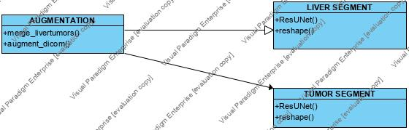

Figure 1: Class Digram

* + 1. Activity Diagrams

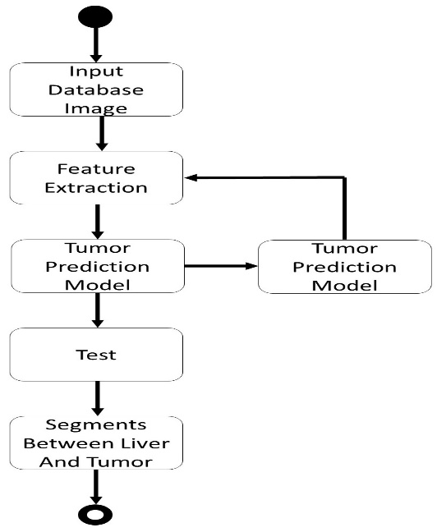

Figure 2: Activity Diagram

* + 1. Sequence Diagram

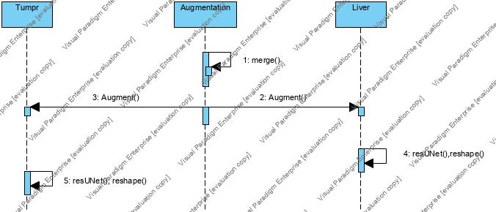

Figure 3: Sequence Diagram

* + 1. Data Architecture

The ResUNet is constructed from three paths Encoding which encodes the input to a

compact representation, Decoding which is the opposite of Encoding and categorizes

the representation in a pixel-wise fashion and the Bridge which connects the two paths

together.

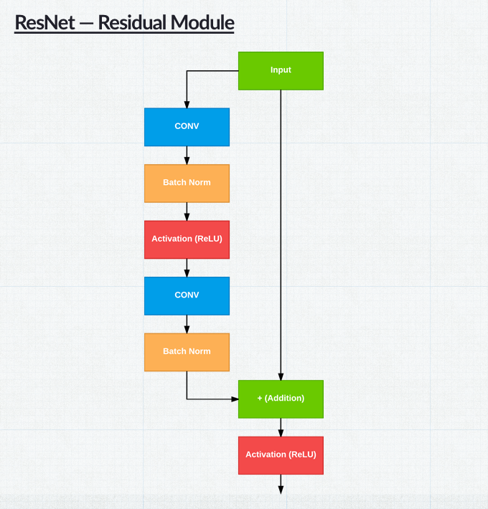

Figure 4: Sample 4

1. User Interface
   1. UI Description

Here the GUI  takes input from 3 ways.  
1. By taking The Training Sample which are in images

2. By allowing User to test images while inputing and extracting features. These will also convert test numpy array files to .bmp files.  
 3.Then classification part is there which includes learning, classify and then segmenting livers and tumor.  
Here K-means clustering is used for this segmentation The GUI is basic as of now but there are some factors which are considered while building this GUI such as while maximizing/minimizing the element locations does not lose position. There are some dynamic elements which can adjust their size according to the window. Proper padding is provided between different element.

* 1. UI Mockup

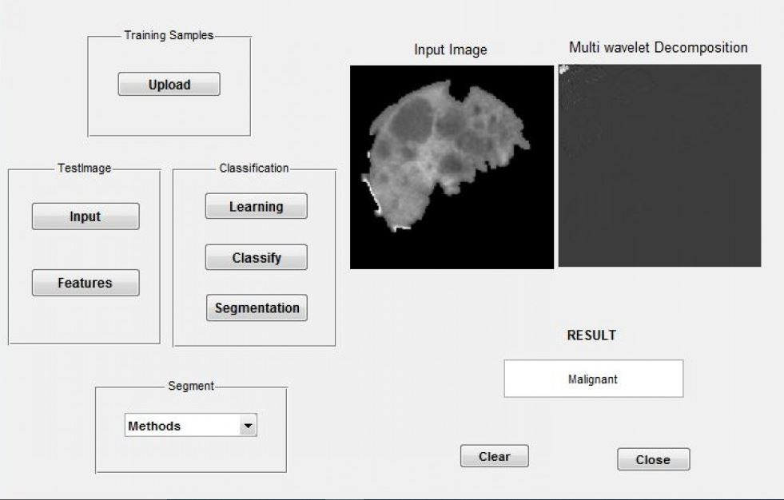

Figure 5: Sample 5

1. Pseudo Code OF RESUNET

def ResUNet():

f = [16, 32, 64, 128, 256]

inputs = keras.layers.Input((image_size, image_size, 3))

## Encoder

e0 = inputs

e1 = stem(e0, f[0])

e2 = residual_block(e1, f[1], strides=2)

e3 = residual_block(e2, f[2], strides=2)

e4 = residual_block(e3, f[3], strides=2)

e5 = residual_block(e4, f[4], strides=2)

## Bridge

b0 = conv_block(e5, f[4], strides=1)

b1 = conv_block(b0, f[4], strides=1)

## Decoder

u1 = upsample_concat_block(b1, e4)

d1 = residual_block(u1, f[4])

u2 = upsample_concat_block(d1, e3)

d2 = residual_block(u2, f[3])

u3 = upsample_concat_block(d2, e2)

d3 = residual_block(u3, f[2])

u4 = upsample_concat_block(d3, e1)

d4 = residual_block(u4, f[1])

outputs = keras.layers.Conv2D(1, (1, 1), padding="same", activation="sigmoid")(d4)

model = keras.models.Model(inputs, outputs)

return model

1. Project Closure
   1. Goals / Vision

The goal for this project were to Classify the Liver and TumorLiver Image using Neural Network Classifiers . Here Liver and Tumor are divided by segmentation process. Through the course of the project, these goals were altered so that the primary goal became creating a well-identified output by using CNN architectures-ResU-net.

* 1. Delivered Solution

There is a solution to control over the illness by identifying the early stages of liver disease because of upgrade of innovation, which has adequately improved in the field of healthcare, as it enables doctors to pinpoint at an early stage and analyze effectively. Will get to know the best RMS value for segmentation of liver and tumor by using CNN architectures- ResU-net.

* 1. Remaining Work

GUI part is required in this task. As the system is already identifying the early stages, so it helps doctors to identify the early stage and analyse effectively. I already done with the segmentation of liver and tumor from CT images.

REFERENCES

1. Abdel-massieh NH, Hadhoud MM, Amin KM (2010) Fully automatic liver tumor segmentation from abdominal CT scans. In: Computer engineering and systems (ICCES) international conference. IEEE, pp 197–202
2. Adcock A, Rubin D, Carlsson G (2014) Classification of hepatic tumors using the matching metric. Comput Vis Image Underst 121:36–42
3. Alahmer H, Ahmed A (2015) Computer-aided classification of liver tumors using contrasting features difference. In: ICMISC 2015 : 17th international conference on medical image and signal computing, pp 27–28
4. Albain KS, Swann RS, Rusch VW, Turrisi AT, Shepherd FA, Smith C, Chen Y, Livingston RB, Feins RH, Gandara DR, Fry WA (2009) Radiotherapy plus chemotherapy with or without surgical resection for stage III non-small-cell lung cancer: a phase III randomised controlled trial. Lancet 374:379–386
5. Al-Nahhas A, Szyszko T, Tait P, Damrah O, Canelo R (2006) Selective internal radiation therapy. In: Liver and biliary tract surgery. Springer, Vienna, pp 409–418
6. Al-Shaikhli SDS, Yang MY, Rosenhahn B (2015) Automatic 3D liver segmentation using sparse representation of global and local image information via level set formulation.
7. Anter AM, Azar AT, Hassanien AE, El-Bendary N, ElSoud MA (2013) Automatic computer aided segmentation for liver and hepatic tumors using hybrid segmentations techniques. In: Computer science and information systems (FedCSIS), 2013 federated conference on, 2013. IEEE, pp 193–198
8. Bauknecht HC, Romano VC, Rogalla P, Klingebiel R, Wolf C, Bornemann L, Hamm B, Hein PA (2010) Intra-and interobserver variability of linear and volumetric measurements of brain metastases using contrast-enhanced magnetic resonance imaging. Investig Radiol 45:49–56
9. Beck A, Aurich V (2007) HepaTux-a semiautomatic liver segmentation system 3D segmentation. In: Proceedings of 3D segmentation in the clinic: a grand challenge, pp 225–233