Vrinda Store Sales Analysis Report - 2025

# 1. Sample Questions

• Compare the sales and orders using a single chart

• Which month got the highest sales and orders?

• Who purchased more – men or women in 2022?

• What are the different order statuses in 2022?

• List the top 10 states contributing to the sales

• Relation between age and gender based on number of orders

• Which channel is contributing to maximum sales?

• What is the highest selling category?

# 2. Sample Insights

✔ Women are more likely to buy compared to men (~65%)

✔ Maharashtra, Karnataka, and Uttar Pradesh are the top 3 states (~35%)

✔ Adult age group (30–49 yrs) is the highest contributing (~50%)

✔ Amazon, Flipkart, and Myntra channels are the major contributors (~80%)

# 3. Final Conclusion to Improve Vrinda Store Sales

✔ Target women customers of age group (30–49 yrs) living in Maharashtra, Karnataka, and Uttar Pradesh by showing ads/offers/coupons available on Amazon, Flipkart, and Myntra.

# 4. Dashboard-Based Visual Insights

The following visuals represent the analysis derived from the Vrinda Store 2025 sales data:

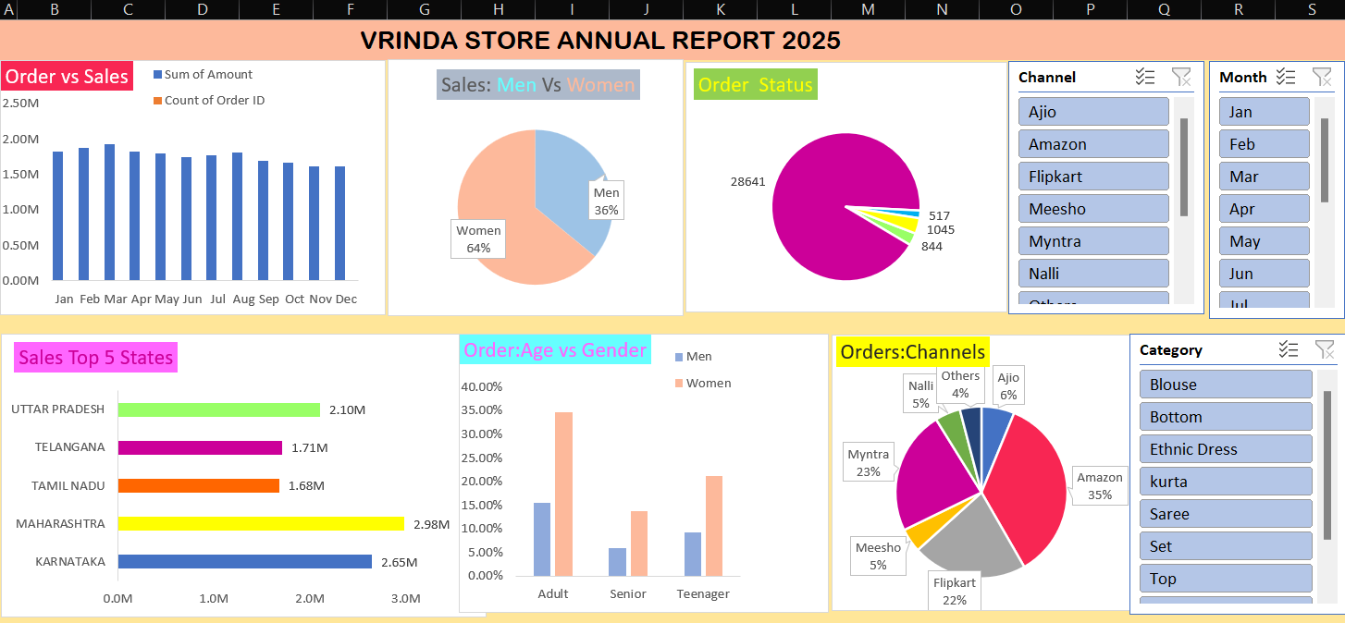

Figure: Dashboard Overview of Sales, Orders, Channels, Categories, and Customer Segments.