

Computer Sciences/Software Engineering

**Agile Software Development**

**Integration of interfaces for public payment services**

**Students name:**

Florentina Syla - fs28378

Naim Ahmetaj – na28325

Arijeta Izeiri- ai18748

**Submission Date:** 04.01.2020

1. **Introduction**

Currently, we have a lot of online services, where citizens are able to check balances for taxes, for electricity, water, heating . For any public services payment, user is able to made in any commercial bank in Kosova, but always user should have document payment for the electricity, water, heating bill. In every payment document there are data about costumer, and public c services provider.

For some payment, we are able just to see balance, and to print payment document and then to go to bank and pay, which means that for some payments we are not able to pay online. For some services, user should be registered and will have username and password, for some services there is no, need for username and password, user can access to his/her balance with ID card number, and name and surname, which is not corrected, because another user can have access to another user, if he knows ID card number and name and surname.

Because of millions of transaction, there are a lot of payments received from banks with no valid tax payer data. For this category of payments it is problem to insert payment because automatic system will not be able to validate tax payer data in order to insert payment to specific tax payer and specific tax account. In this case public organization should contact bank and/or client to validate payment.

This is current process, but idea is to minimize number of payments with no validate data. We will initiate project that will Integrate public payment services and validate payment.

Our idea is all this services to standardized, integrate and to create unique interface with unique login page, which means that:

* User needs only one username and password to access all public services
* No access to any public services for payment, without username and password
* User will see on one screen all balances, separated by public services
* User will be able to pay for any public services using any online payment methods

Public organization, every day prints different payment documents. Clients use this payment document, to pay taxes or another obligation. For any payment done through bank or through any online services, it very important that payment as soon as possible to transfer to specific bank account selected by client.

**TASK 1: Logs, Requirements, Tasks**

For working in this project, we needed to have a direct contact with the customer and with the requested requirements from the users that will be using this application.

Gathering all the information from the users and the customer was part of the process for creating and bringing the idea as a prototype and present the same to the customer.

**TEAM MEMEBERS tasks:**

**Naim Ahmetaj-** took care for interviewing and gathering all the information from the Administration Fee department members of Kosovo which will bring users needs in the same time for using the application. It will be an ease for having a complete overview how the app should look like and which requirements are ample for satisfying users needs as Naim is one of IT Administrators of this department .

This task took Naim 2 hours per day for one week in total 10 hours

**Florentina Syla-** took care for analyses, questions and remarks of the users. Previous experience with such application, what should be different, relation and other requests from the users. How the database should be linked in order to gain correct dataset of linked entities. In correlation with Naim which will be direct communication bridge with the customers and the users.

This task took Florentina 1,5 hours per day for 3 days in total 4,5 hours

**Arijeta Izeiri-** took care for brining the idea as a prototype (low fidelity) with all previous requirements from the users gathered from the team members. In coordination with the team first low fidelity prototype will look like as described in the pictures.

This task took Arijeta 1,5 hours per day for 3 days in total 4,5

**Note:** This is first faze of prototyping the application as a low fidelity prototype which will be part of the Appendix !

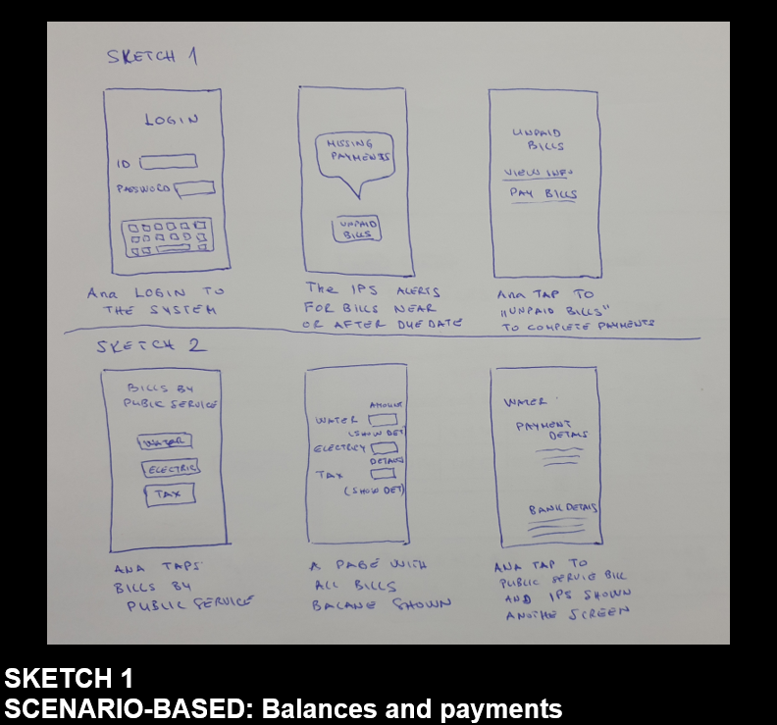

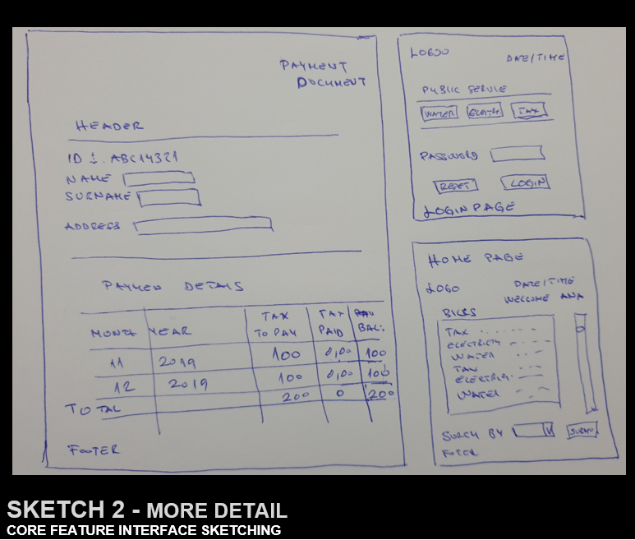

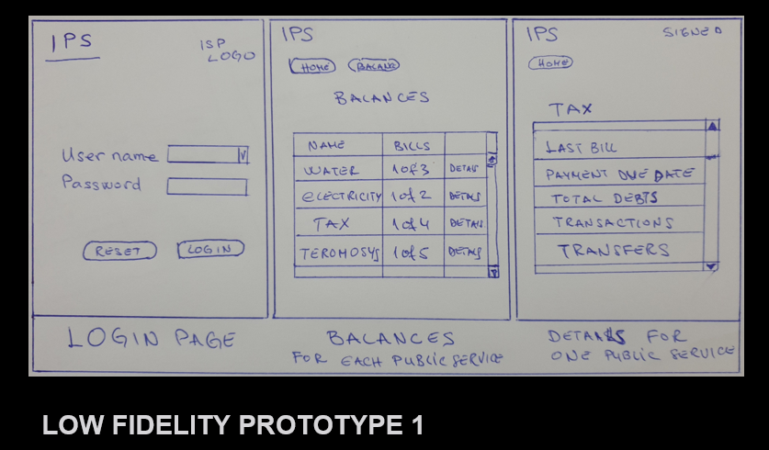

**TASK2 : SCRUM**

Each day, scrum meeting was held with team members: Naim, Florentina, Arijeta via Teams call. Each issue was documented and discussed in this meetings.

Naim got few remarks and requirements from the client. Issue was transferred to the team for which, few backlog issues were created in PivotalTracker.

There is an issue detected which will need to be changed. Scrum members decided to create an issue and to assign it to a developer.

Users did not find very practical the login form, which is very simple. They requested, for each login there to be sent an notification to the mobile phone of the user. Mobile phone should be added when the first time account is created for using this application.

Second issue: there is not an option which will allow user to change the password.

There were few scrum meeting held before giving the entire test scenarios that need to be developed. Developer assigned for this issue is Arijeta.

In the next meeting held a bug was detected, the issue was analyzed by Naim, and a task was assigned. In this meeting was decide a table with issues to be created in order work in pairs to be done.

|  |  |  |  |  |
| --- | --- | --- | --- | --- |
| **Issue List** | **Product Backlog** | **Time** | **Assigned to** | **Tupe of the issue** |
| 1.) Change login form , give opportunity to change password and add mobile phone | project_20200111_2102  project_20200111_2108 | 3 hours  1.5 hours | Arijeta | Add in , new feature |
| 2.) Validation of email address | project_20200116_2107  project_20200121_2122 | 1 hour analysis, 2hours development | Florentina, Arijeta , Naim | Bug |
| 3.) Identity the problem within balances - In the balance screen, should be highlight in red balances with not completed payments. | project_20200120_1928 | In progress | Arijeta , Naim | Chore/Performance improvement |
| 4.) Report Show Transactions between Start Date and End Date | **project_20200120_1935** | In progress | Florentina, Naim | Bug |

For task 1, with requirements of the Client few improvements were done in the Login form, for which Arijeta took care the task to be analyzed and developed. This feature took Arijeta 4.5 hours for analysis and development.

Task 2, a bug was detected, for which work in pair was included .

Task 3, this task is in progress and handled by Naim and Arijeta.

Task 4, this task is in progress, currently on it are working Naim and Florentina, a bug will need to be fixed.