## **Introduction**

Every year, millions of children die before reaching their fifth birthday due to preventable causes. UNICEF, the United Nations Children's Fund, is working to improve child survival rates by providing healthcare, nutrition, and education to children and their families around the world. In this report, we will explore the relationship between child mortality rates and health indicators in different countries.\

## **Data**

We will be using two datasets provided by UNICEF: unicef_indicator_1.csv and unicef_indicator_2.csv. These datasets contain information on child mortality rates and health indicators for different countries. We will also be using the metadata file unicef_metadata.csv to help us understand the variables in our datasets.

# **Diarrhea**

Diarrhea is a common and potentially dangerous illness in children, particularly those under the age of five. It is a condition in which stools become loose and watery, and it can lead to dehydration if not properly treated. One solution to treating diarrhea in children is the use of zinc supplements. Zinc is a mineral that is essential for the immune system and plays a role in digestive function. Studies have shown that zinc supplementation can reduce the duration and severity of diarrhea in children, as well as decrease the likelihood of future episodes.

Other solutions for treating diarrhea in children include rehydration therapy, which involves giving the child oral rehydration solution (ORS) or intravenous fluids to replace lost fluids and electrolytes. Additionally, it is important to continue feeding the child during and after the episode of diarrhea, as malnutrition can exacerbate the condition.

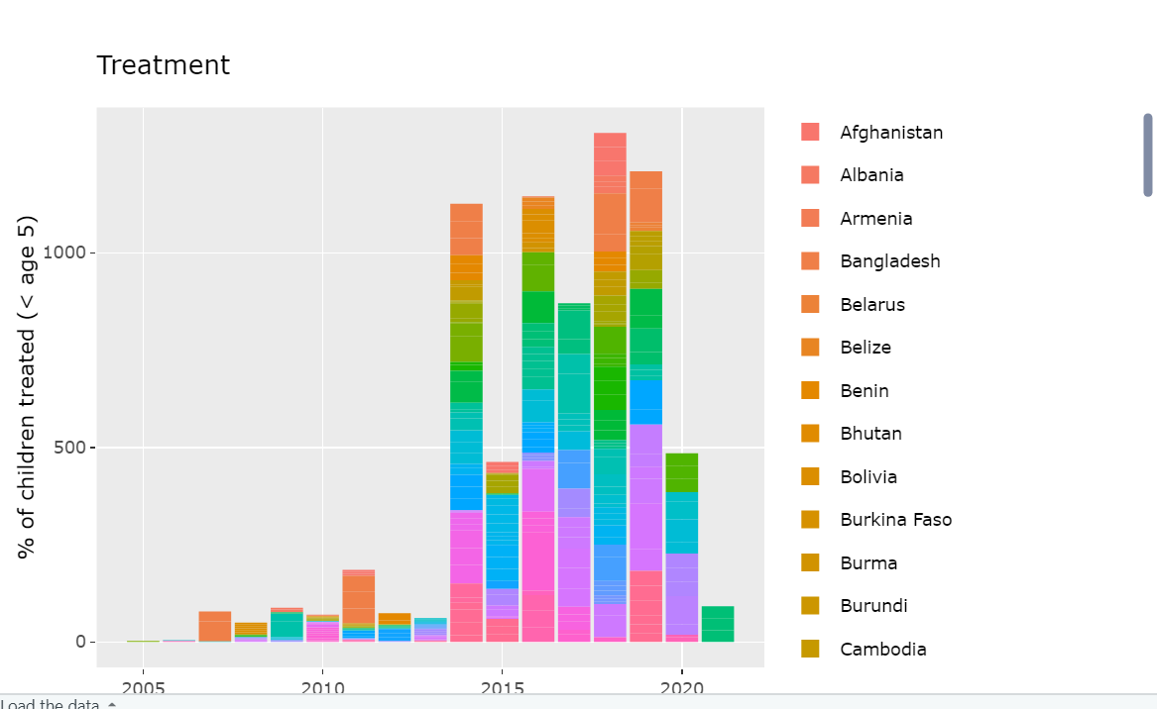

# **Increase in life expectancy**

Advancements in medical technology and healthcare have led to significant increases in life expectancy over the past century. Early detection and treatment of diseases and illnesses have played a crucial role in improving life expectancy. When an illness or disease is detected and treated early, the chances of a successful recovery increase, which can lead to a longer and healthier life.

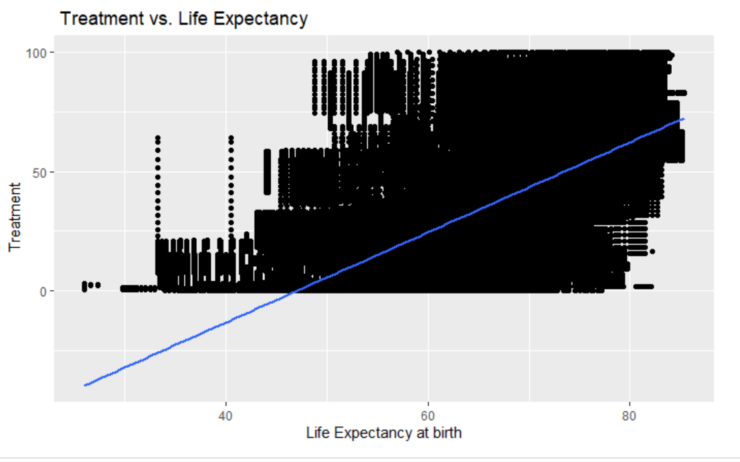

The treatment coverage of the percentage of the children has been grown over the years, and it is increasing rapidly.

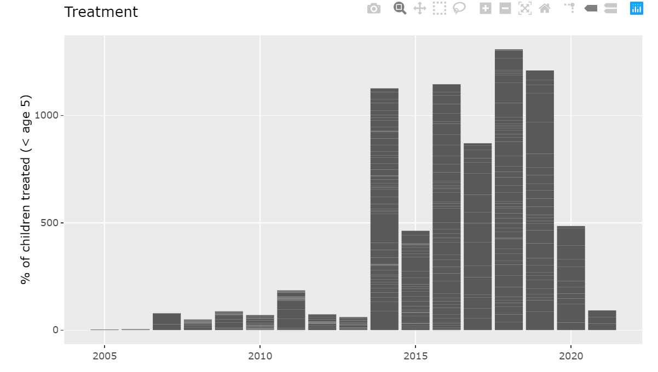

**Countries with their diarrhea treatment**

India, China, Africa are some of the countries that has made great strides in reducing childhood mortality due to diarrhea by implementing a national program that includes the use of oral rehydration therapy and zinc supplementation. According to the World Health Organization (WHO), zinc supplementation is an effective treatment for diarrhea in children under five years old. Zinc supplements can reduce the severity and duration of diarrhea episodes, and can also help prevent future episodes.

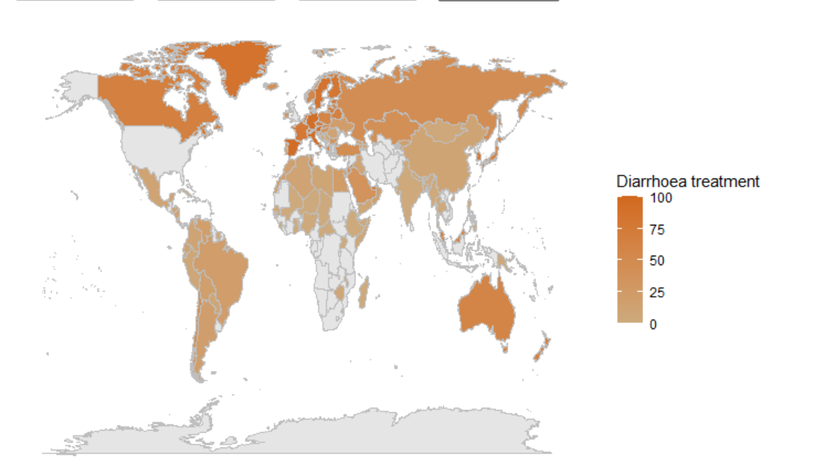

Preventative measures play a crucial role in preventing disease transmission and reducing the risk of children falling ill due to diarrhoea. One such measure is the use of rotavirus vaccines, which can offer protection against one of the primary causes of infant mortality from diarrhoea. Additionally, poor hygiene practices, unsafe drinking water, and inadequate sanitation contribute to approximately 60% of diarrhoeal disease deaths worldwide. Hence, simple interventions such as washing hands with soap can reduce the risk of diarrhoea by at least 40% and significantly decrease the risk of respiratory infections. Ensuring access to safe drinking water and proper sanitation facilities is also critical in preventing the spread of diarrhoeal diseases.