v0.1

INFO:tensorflow:/content/tflearn-v0.1.tfl is not in all_model_checkpoint_paths. Manually adding it.

Network trained and saved as tflearn-v0.1.tfl.

training time taken: 1297.76501489

validation accuracy : 0.625

v0.3 CONVNET

Network trained and saved as conv_nn_v03

training time taken: 666.7988185882568

validation accuracy : 0.6792452830188679

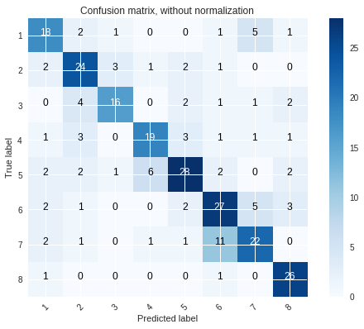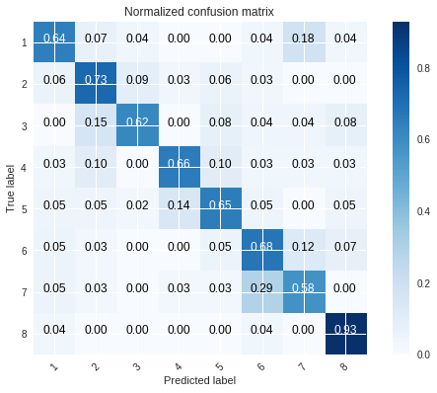

v0.63 RESNET32

Network trained and saved as tflearn-v0.63.tfl. time taken: 2105.63618016243

validation accuracy : 0.8339622641509434

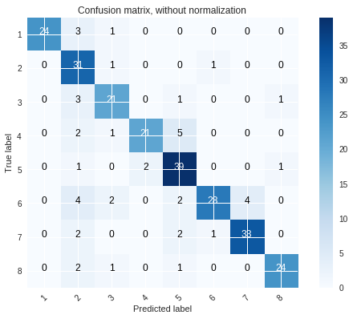

v0.63.2 RESNET56

Network trained and saved as resnet56_skeletal_insights time taken: 10837.087109804153

Validation accuracy : 0.8150943396226416

Total Prediction Time :3.4846651554107666

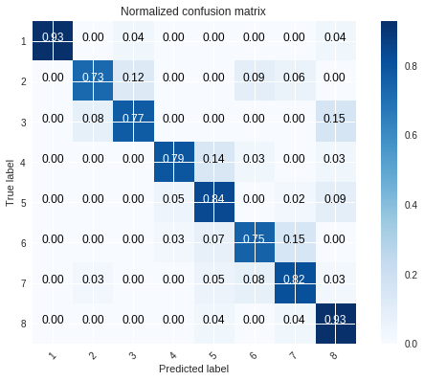

RESNET56 50 epochs

Network trained and saved as resnet56_skeletal_insights

time taken: 3565.104131937027

validation acccuracy :0.8264150943396227

Total Prediction Time :3.1241347789764404

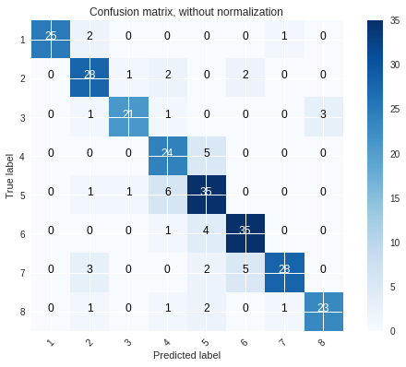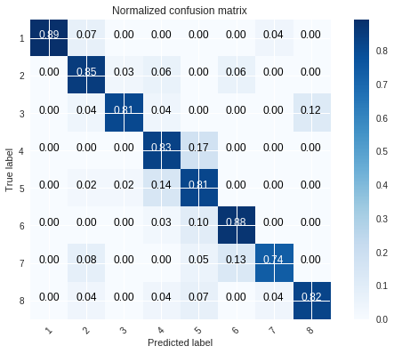

v0.70 ResNEXT

Network trained and saved as tflearn-v0.70.tfl.

time taken: 10189.454042196274

validation accuracy : 0.45

