**v0.1 CONVNET**

INFO:tensorflow:/content/tflearn-v0.1.tfl is not in all_model_checkpoint_paths. Manually adding it.

Network trained and saved as tflearn-v0.1.tfl.

training time taken: 1297.76501489

validation accuracy : 0.625

**v0.3 CONVNET NO POOLING**

Network trained and saved as conv_nn_v03

training time taken: 666.7988185882568

validation accuracy : 0.6792452830188679

Total Prediction Time :0.9562594890594482

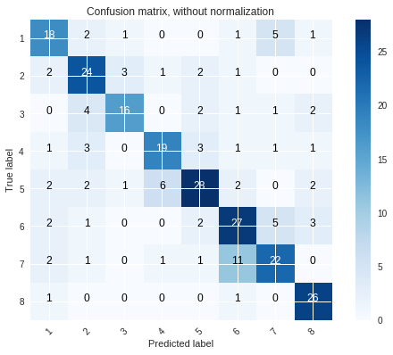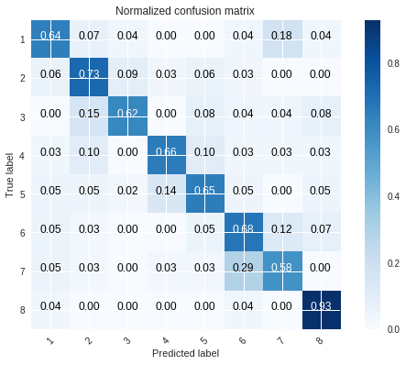

**v0.5 CONVNET ADDITIONAL CONVOLUTIONAL LAYERS**

Network trained and saved as conv_nn_v05

training time taken: 4566.336027622223

validation accuracy :0.6452830188679245  
Total Prediction Time :6.371569633483887



**v0.63 RESNET32**

Network trained and saved as resnet32_skeletal_insights. time taken:

time taken: 1962.2850286960602

validation accuracy : 0.8528301886792453

Total Prediction Time :2.316279172897339

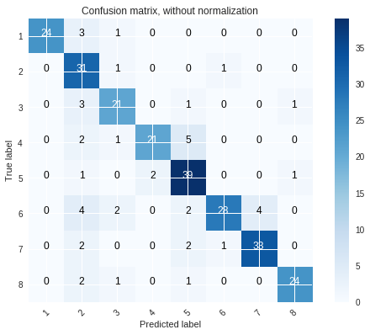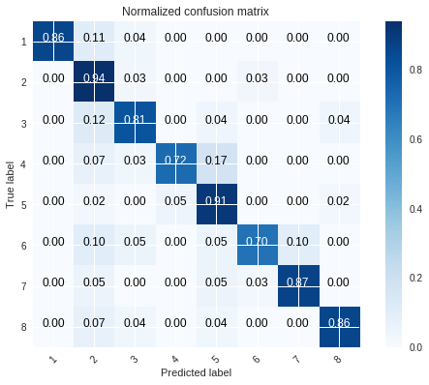

**RESNET56 50 epochs**

Network trained and saved as resnet56_skeletal_insights

time taken: 3427.387045621872

validation acccuracy :0.8301886792452831

Total Prediction Time :3.004533052444458

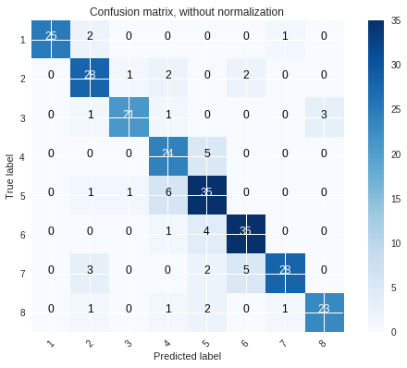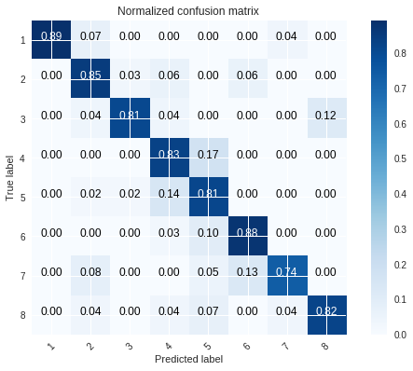

**v0.63.2 RESNET56 150 epoch**

Network trained and saved as resnet56_skeletal_insights time taken: 10837.087109804153

Validation accuracy : 0.8150943396226416

Total Prediction Time :3.4846651554107666

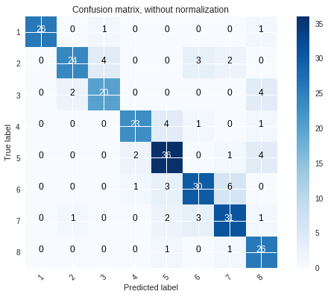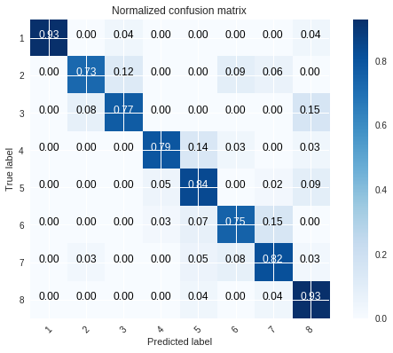

**v0.70 ResNEXT 50 epochs**

Network trained and saved as tflearn-v0.70.tfl.

time taken: 10189.454042196274

validation accuracy : 0.45

