PixelPendant - Wearable Camera System

Full Connection Schematics

Component | Connected To
XIAO ESP32-S3 Sense GND | Common GND
XIAO ESP32-S3 Sense 3V3 | Slide SPDT Switch (OUT)
XIAO ESP32-S3 Sense GPIO4 (Motor Control Pin) | MOSFET Gate
MOSFET Source | GND
MOSFET Drain | Vibration Motor −
Vibration Motor + | 3V3
10kΩ Resistor | MOSFET Gate → GND (Pull-down)
Slide SPDT Switch (Input) | Battery +
Battery + (3.7V 400mAh) | Slide SPDT Switch
Battery − | GND
OV2640 Camera Module | Onboard Connector (XIAO ESP32-S3 Sense)

Connection Diagram
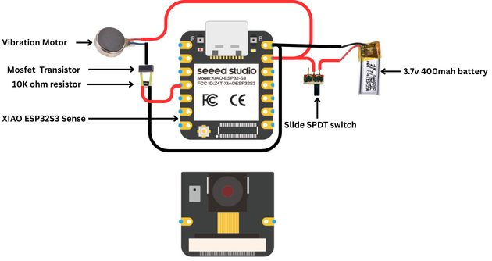
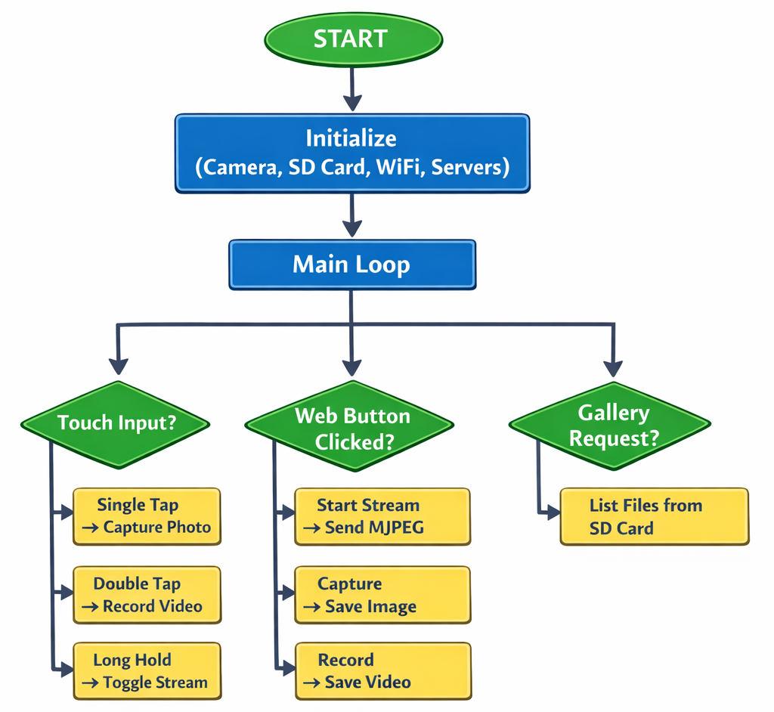
Flowchart

