KisanNiti: An AI- and IoT-Based Framework for Cooperative Post-Harvest Selling in Farmer Producer Organizations
Arijit Singh, Tushar Garg, Hitesh Mehandiratta, Namya Gautam, and Harkiran Kaur
Thapar Institute of Engineering and Technology, Patiala, Punjab, India
asingh28_be23@thapar.edu
tgarg3_be23@thapar.edu
hhitesh_be23@thapar.edu
ngautam_23@thapar.edu
harkiran.kaur@thapar.edu
Abstract. Even after harvest, a Farmer Producer Organization (FPO) has to settle where, when and how much of its members' produce is sold. KisanNiti, a decision-support framework for this task, is presented. Mandi price forecasting, storage sensing and a cooperative allocation model are combined in it. Mandi prices from AGMARKNET are treated as a network of markets and forecast with an attention temporal graph convolutional network (A3T-GCN). Storage conditions are to be recorded by a low-cost node made of an ESP32 board and an SHT30 temperature and humidity probe placed in the grain. An integer program assigns every farmer lot to a mandi, a day and a quantity, and all lots share the daily limit of each mandi. The forecasting and allocation parts were tested on real Paddy (Common) prices from 20 Punjab mandis for the 2020–2025 seasons. In every season, more than 96% of the reported prices were equal to the minimum support price (MSP). A simple MSP rule therefore gave the lowest forecast error (mean absolute error of Rs. 1.26 per quintal), and no learned model beat it. In a synthetic 40-lot FPO scenario, the cooperative plan respected every daily limit, whereas independent choices exceeded a limit in every run. The gain of the plan over a nearest-mandi rule was small (Rs. 0.79 per quintal) when limits were loose and rose to Rs. 3.5–13.9 per quintal when they were tight.
Keywords: Farmer Producer Organizations · Mandi price forecasting · Graph neural networks · Minimum support price · Integer programming · Internet of Things

1 Introduction
Farmer Producer Organizations (FPOs) are producer organizations whose members are farmers. Produce can be pooled, marketed and sold by them on behalf of the members, which gives small farmers a way to act together in the market [1]. Selling after harvest remains difficult, and the losses after harvest are large. A 2024 ICRIER policy brief reports that India loses food worth about Rs. 1.53 trillion every year, based on a national study carried out by NABCONS during 2020–2022, and storage is discussed in it as one part of the problem [2].
For an FPO, selling after harvest is not a single decision. Where to sell, when to sell and how much to send have to be settled together, and the three choices affect one another. A mandi with a better price may be farther away, and waiting for a later date keeps the produce in storage for longer. If many farmers send produce in the same few days, one mandi can receive more than it can handle. Daily wholesale prices are published on the AGMARKNET portal, and recent Indian work has used these data from 165 markets for forecasting [3]. For crops that are bought at the minimum support price (MSP), a fixed price is also announced by the government before each season [4][5].
Agricultural price forecasting has improved with modern time-series models. Statistical, machine-learning and deep-learning methods were compared by Manogna et al. on 23 commodities from 165 Indian markets, and the LSTM and GRU models performed best [3]. Tomato, onion and potato prices in India were studied by Nayak et al., who showed that adding temperature and rainfall helped deep-learning models [6]. Data-driven forecasting is supported by these studies, but the full selling problem of an FPO is not solved by them.
Another line of research models several price series together. A spectral temporal graph neural network was applied by Özden and Bulut to daily vegetable prices and trade volumes in Turkey [7]. Prices of four South Korean crops were combined with weather variables by Min et al., and graph-based models did better than a stacked LSTM [8]. Storage research has grown in parallel. Temperature and relative humidity inside hermetic paddy storage were monitored for 125 days by Islam et al. [9], and a recent review covers the use of AI, IoT and smart sensors in grain storage [10].
Each of these studies solves one part of the problem, and forecasting, storage monitoring and logistics are mostly treated as separate tasks. In KisanNiti, they are connected for cooperative selling. Four contributions are made in this paper. First, a framework is described in which mandi forecasts, farmer lot records and storage readings feed one selling plan. Second, a mandi network is built from map coordinates, and an A3T-GCN forecaster is compared with simple baselines on real AGMARKNET data over three test seasons. Third, the selling decision is written as an integer program in which farmers share the daily limit of each mandi, and the program is compared with simple selling rules. Fourth, the circuit of a low-cost storage-sensing node is presented. The results are reported as they came out, including the finding that the learned forecasters did not beat simple rules for an MSP crop.
Related work is reviewed in Section 2. The architecture and methods are described in Section 3. The experiments are reported and discussed in Section 4, and the paper is concluded in Section 5.

2 Related Work
Agricultural price forecasting has moved from classical time-series models toward machine learning and deep learning. Daily AGMARKNET wholesale data from 2010 to 2024 for 23 commodities and 165 Indian markets were used by Manogna et al. ARIMA, support vector regression, XGBoost and several neural networks were compared, and the lowest errors were obtained with the LSTM and GRU models [3]. Price data for tomato, onion and potato from major Indian markets were combined with temperature and precipitation by Nayak et al., and deep-learning models with these external variables were found to do better than statistical and machine-learning models [6].
A different idea is added by graph-based models: related series are learned together instead of one at a time. StemGNN was applied by Özden and Bulut to 1,791 days of Turkish vegetable price and trade-volume data and compared with CNN, LSTM and Random Forest models [7]. A stacked LSTM was compared by Min et al. with two graph models, StemGNN and the temporal graph convolutional network (T-GCN). In their multivariate setting, the graph models outperformed the LSTM, and the largest improvement came from smoothing out short-term fluctuations [8]. T-GCN combines a graph convolution with a gated recurrent unit (GRU) [11], and A3T-GCN adds an attention step over past time points [12]. Both were first proposed for traffic forecasting, not for agricultural markets.
Grain-storage research shows that continuous monitoring can support post-harvest management. A low-cost remote system for hermetic paddy storage was built in Bangladesh by Islam et al. Over 125 days, the temperature inside the bags stayed between 16.7 °C and 29.2 °C, and no insect or mould growth was seen [9]. AI and IoT methods for grain storage, including smart sensors and anomaly detection, were reviewed by Anukiruthika and Jayas [10].
The value of formal optimization in agricultural logistics has been shown in several studies. A mixed-integer linear programming model for harvesting, processing and transport for small olive growers in Chile was built by Urra-Calfuñir et al. [13]. First-mile transport for an agricultural cooperative in Greece was organized with a mixed-integer model by Gámez-Albán et al. [14]. A three-objective freight-allocation problem for a food-grain organization in India, with inventory- and warehouse-related penalty factors, was formulated by Anoop et al. [15]. For farmer-facing advice, an explainable crop-recommendation system was developed by Shams et al., so that the reason for a suggested crop can be understood [16].
In Table 1, these studies are compared with KisanNiti on five points. Only what each paper reports is marked. Market forecasting, storage sensing and cooperative allocation are not joined in one system by any of the reviewed studies, and this is the gap addressed here.
Table 1. Comparison of KisanNiti with related studies (Yes = reported in the paper).
Study | Price forecast | Graph of series | Storage sensing | Allocation / transport | Indian data
Manogna et al. [3] | Yes | – | – | – | Yes
Nayak et al. [6] | Yes | – | – | – | Yes
Özden and Bulut [7] | Yes | Yes | – | – | –
Min et al. [8] | Yes | Yes | – | – | –
Islam et al. [9] | – | – | Yes | – | –
Urra-Calfuñir et al. [13] | – | – | – | Yes | –
Gámez-Albán et al. [14] | – | – | – | Yes | –
Anoop et al. [15] | – | – | – | Yes | Yes
KisanNiti (this paper) | Yes | Yes | Yes* | Yes | Yes
* Circuit designed and simulated; field readings are not yet used in the experiments.

3 Proposed System Architecture and Methodology
KisanNiti is built around one question: how can market and storage information be used by an FPO to prepare a better selling plan for its members? The overall design is shown in Fig. 1. Three inputs are used. The first is the mandi price history from AGMARKNET, the second is the FPO's record of member lots with the quantity and location of each lot, and the third is the storage readings from a sensor node. The price history goes to a forecasting model, and the lot records are used to work out transport costs. Storage readings are meant to feed the plan once the node has been calibrated. A cooperative allocation model combines the inputs and produces a selling plan, which states which lot goes to which mandi, on which day and in what quantity.
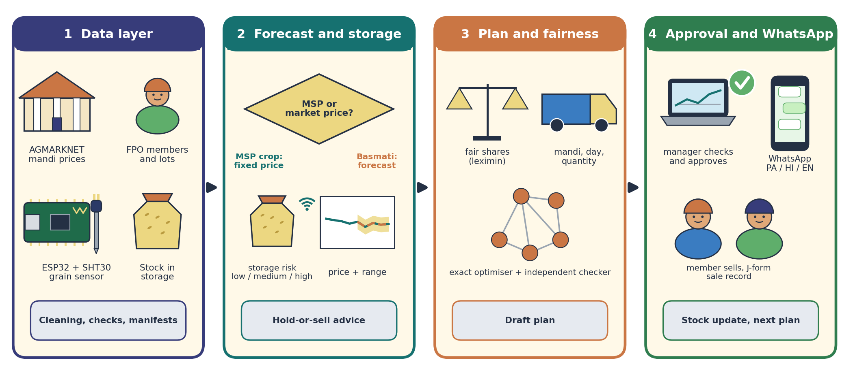
Fig. 1. Overall architecture of KisanNiti: (1) data layer, (2) forecasting and storage risk, (3) fair allocation, (4) manager approval and WhatsApp messages.

3.1 Market Data and Mandi Network
AGMARKNET data for Paddy (Common) in Punjab for September to December of 2020–2025 were used. The data were downloaded from the official AGMARKNET API in April 2026 [17]. The raw file had 16,284 rows. After 81 exact duplicate rows were removed, 19 rows with zero minimum or maximum prices were repaired and 2 duplicate market-date-variety groups were merged, 16,201 records from 176 mandis remained. When a mandi reported more than one variety on a day, the arrival-weighted average of the modal prices was used.
Most mandis report only on some days. The 20 mandis that reported in all six seasons and had the most trading dates (195 to 288 dates each) were therefore kept. Each mandi is one node of a graph. The location of each mandi was found with the OpenStreetMap Nominatim service [18], and every mandi was connected to its k nearest mandis by straight-line distance. The value of k was chosen from {2, 3, 5} on a separate validation season. The graph in this way has a clear meaning based on geography, and no price relationship is assumed before it is tested. The network is shown in Fig. 2; the five mandis marked in red are used in the allocation experiment.
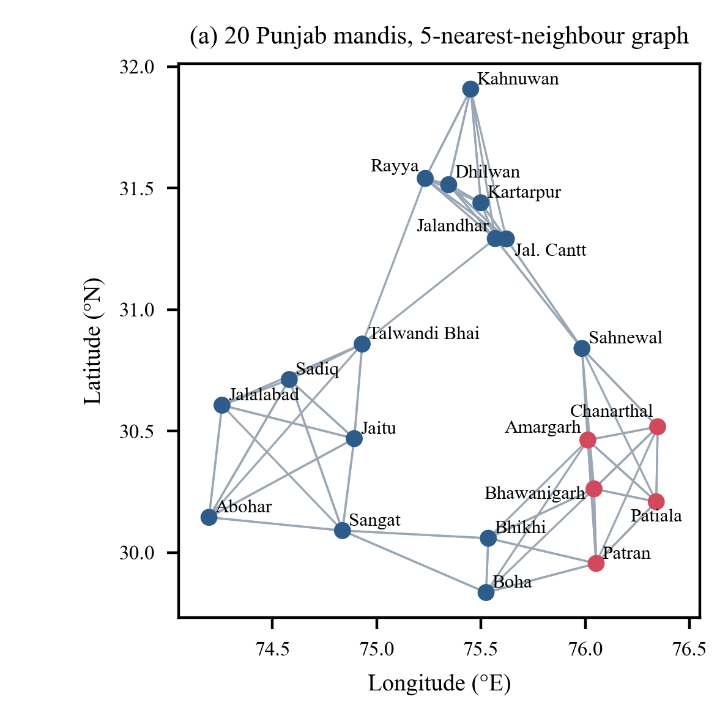
Fig. 2. Mandi network used for forecasting: 20 Punjab mandis and the five-nearest-neighbour graph (red: candidate mandis for the allocation test).

3.2 Graph-Based Price Forecasting
A3T-GCN [12] is used as the main forecaster, and its flow is shown in Fig. 3. It has three parts. Each mandi's values are mixed with those of its neighbours by a graph convolution. How these values change over time is learned by a GRU. A weight is then given to each past time step by an attention layer before the forecast is made. Let A be the adjacency matrix of the mandi graph and I the identity matrix. The graph is normalized as
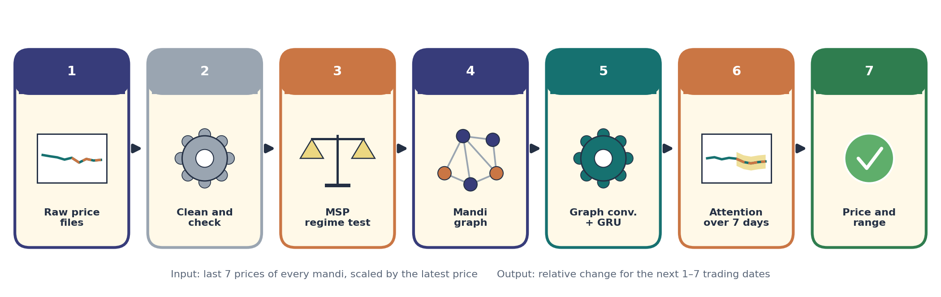
Fig. 3. Methodology: from raw price files, cleaning and the MSP regime test to the A3T-GCN forecast with a range.
Â = D̃^{−1/2} (A + I) D̃^{−1/2}, (1)
where D̃ is the degree matrix of A + I. For input x_{t} at step t and hidden state h_{t−1}, the update gate u_{t}, reset gate r_{t} and new state h_{t} are
u_{t} = σ(Â[x_{t}, h_{t−1}]W_{u} + b_{u}), r_{t} = σ(Â[x_{t}, h_{t−1}]W_{r} + b_{r}), (2)
c_{t} = tanh(Â[x_{t}, r_{t} ⊙ h_{t−1}]W_{c} + b_{c}), h_{t} = u_{t} ⊙ h_{t−1} + (1 − u_{t}) ⊙ c_{t}. (3)
A weight is given to each hidden state by a small scoring network, and the weighted states are combined before the output layer:
α_{t} = softmax_{t}(w₂⊤ tanh(W₁h_{t} + b₁) + b₂), z = Σ_{t} α_{t}h_{t}, ŷ = W_{o}z + b_{o}. (4)
The input is the last 7 trading-date prices of all 20 mandis, and the output is the price of every mandi for the next 7 trading dates. Because the MSP rises every season, each input window is divided by its latest price, and the relative change from that price is predicted. The scale is thereby kept the same across seasons. The model is trained to reduce the mean absolute error, and only prices that were actually reported are used as targets. Gaps in the inputs are filled with the last price reported by the same mandi in that season. Before the first report of a mandi in a season, the mean price reported by the other mandis on that date is used, so that no future value enters the input.

3.3 Storage-Sensing Node
Storage conditions matter when waiting for a later selling date is considered. Regular checking of probes in stored grain is advised in grain-storage guidance, because hot spots may indicate insects [19]. A low-cost node was therefore designed, as shown in Fig. 4. An ESP32 development board with built-in 2.4 GHz Wi-Fi (802.11 b/g/n) is used [20]. A protected SHT30 probe is pushed into the grain, and temperature and relative humidity are read over the I²C bus (GPIO 21 and 22). A typical tolerance of ±2% RH between 20 and 80% RH and ±0.2 °C between 0 and 65 °C is stated for this sensor [21]. The relative humidity of the air between the kernels is in equilibrium with the grain, and divided by 100 it gives the water activity of the grain. Storage fungi need a relative humidity of at least 65% [22], and grain kept in air below 65–70% relative humidity degrades slowly [23]. A reading is taken every 5 minutes, and a simple rule maps the 24-hour median to a low, medium or high risk level at 65% and 70% RH.
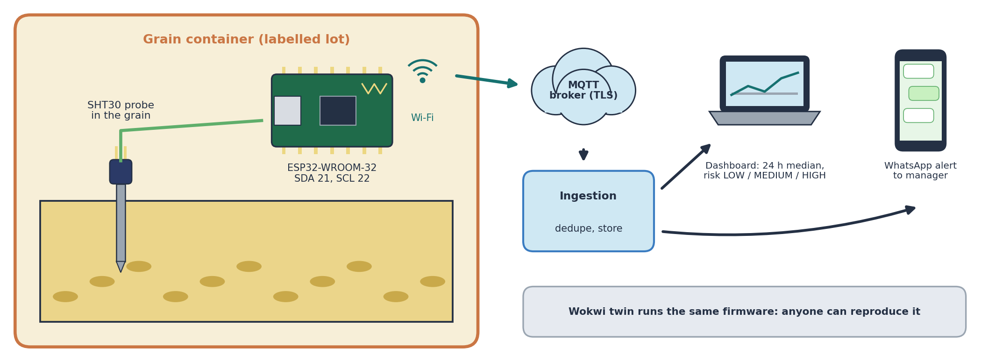
Fig. 4. Storage-sensing node: SHT30 probe in the grain, ESP32 board, Wi-Fi link to an MQTT broker with TLS, and the dashboard and WhatsApp alert for the manager.
The same firmware was run in the Wokwi ESP32 simulator [24], so that the node can be reproduced without hardware. In this version, the node has not yet been placed in real storage, and its readings are not used in the experiments of Section 4. Temperature and humidity do not measure grain moisture or spoilage directly, so a storage-condition term is to be added to the allocation model only after the node has been calibrated against measured grain samples.

3.4 Cooperative Selling Allocation Model
The selling decision is written as an integer program. Let f be a farmer lot, m a candidate mandi and d = 0, 1, …, D − 1 a trading day in the planning period. Q_{f} is the quantity of lot f, p̂_{md} the forecast price at mandi m on day d, κ_{fm} the road distance from lot f to mandi m, r the transport cost per quintal per kilometre, and w a small waiting cost per quintal per day. The net value of sending one quintal is
v_{fmd} = p̂_{md} − r κ_{fm} − w d. (5)
The decision variable x_{fmd} is the quantity of lot f sent to mandi m on day d. The model is
maximize Σ_{f} Σ_{m} Σ_{d} v_{fmd} x_{fmd} (6)
subject to Σ_{m} Σ_{d} x_{fmd} = Q_{f} for every lot f, (7)
Σ_{f} x_{fmd} ≤ C_{md} for every mandi m and day d, (8)
x_{fmd} ∈ {0, 10, 20, …} quintals. (9)
By constraint (7), every lot in the planning run is sold exactly once. Constraint (8) makes the model cooperative: C_{md} is the quantity the FPO can deliver to mandi m on day d, and this limit is shared by all lots. Without (8), each lot would simply go to its own best mandi and day, and the problem would split into separate farmer decisions. Quantities are planned in 10-quintal units, which is close to how loads are sent. The model is solved with the HiGHS solver [25] through SciPy [26]. Storage and market-arrival terms are not included yet. They are to be added once the storage node is calibrated and the effect of arrivals on price has been measured for the selected mandis.

3.5 Recommendation Output
The output of the model is a table with one row for each part of a lot: the lot, the mandi, the selling day and the quantity, together with the forecast price and the transport cost used. This structured output can later be shown on an FPO dashboard or sent to farmers as messages. If explanations are added, they should say why a plan was chosen, in the spirit of explainable recommendation systems [16].

4 Experimental Evaluation and Discussion

4.1 Data and Setup
The price data for the 20 selected mandis are described in Table 2. Across the six seasons there were 382 trading dates, and a price was reported by the mandis on 4,626 of the 7,640 possible mandi-days (60.5%). The main feature of this crop is shown by the table: in every season, more than 96% of the reported prices were equal to the MSP for Grade A paddy of that season (to the nearest rupee) [4][5]. Prices also varied very little from one mandi to another on the same day.
Table 2. Paddy (Common) prices in the 20 selected Punjab mandis. SD = standard deviation (Rs. per quintal).
Season | MSP Grade A (Rs./q) | Trading dates | Prices equal to MSP (%) | SD of all prices | Mean daily SD across mandis
2020 | 1888 | 70 | 98.3 | 44.3 | 7.1
2021 | 1960 | 55 | 99.1 | 80.5 | 29.6
2022 | 2060 | 60 | 98.5 | 16.5 | 0.8
2023 | 2203 | 70 | 96.1 | 45.5 | 12.8
2024 | 2320 | 66 | 98.8 | 29.5 | 0.4
2025 | 2389 | 61 | 99.0 | 21.6 | 3.0

Forward-chaining evaluation was used. Each test season was forecast with models trained on all earlier seasons except the one just before it, which was kept for validation. Three test seasons result: 2023 (trained on 2020–2021, validated on 2022), 2024 and 2025. Seasons were never mixed inside one input window. Seven models were compared: (i) a naive forecast that repeats the last price; (ii) the mean of the last 7 prices; (iii) an MSP rule that always predicts the Grade A MSP of the season, which is announced before the season; (iv) ridge regression on the relative changes, with its penalty chosen on validation; (v) a GRU without a graph; (vi) T-GCN, which is the graph model without attention; and (vii) A3T-GCN. The neural models had a hidden size of 32 and were trained with the Adam optimizer (learning rate 0.001, batch size 32) for up to 400 epochs, and training was stopped when the validation error had not improved for 40 epochs. Each neural model was trained with five random seeds. The mean absolute error (MAE), the root mean squared error (RMSE) and the mean absolute percentage error (MAPE) are reported over forecast horizons of 1 to 7 trading dates, scored only on prices that were actually reported. The experiments were run with Python 3.13, PyTorch 2.9.1 and SciPy 1.15.2.

4.2 Forecasting Results
Table 3 gives the results. Validation selected k = 5 for the 2023 season and k = 3 for 2024 and 2025. All errors are small, below Rs. 7 per quintal on average, because the prices hardly move. The lowest MAE in all three seasons came from the MSP rule (mean Rs. 1.26 per quintal), which also had the lowest RMSE. The naive forecast was second (Rs. 1.77). Among the learned models, the most accurate was A3T-GCN (Rs. 2.36), followed by the GRU (Rs. 2.51), T-GCN (Rs. 2.54) and ridge regression (Rs. 4.09). The graph alone (T-GCN) gave nothing over a plain GRU, and the small edge of A3T-GCN is about the size of the variation between random seeds. No learned model beat the two simplest rules.
Table 3. Forecast errors over horizons of 1–7 trading dates (Rs. per quintal). Neural models: mean ± SD over five seeds.
Model | MAE 2023 | MAE 2024 | MAE 2025 | Mean MAE | Mean RMSE | Mean MAPE (%)
Naive (last price) | 3.46 | 0.25 | 1.59 | 1.77 | 29.65 | 0.067
Moving average (7 dates) | 3.98 | 3.32 | 2.09 | 3.13 | 30.08 | 0.125
MSP rule | 2.68 | 0.17 | 0.94 | 1.26 | 24.67 | 0.044
Ridge regression | 6.54 | 2.39 | 3.33 | 4.09 | 29.73 | 0.168
GRU (no graph) | 4.12 ± 0.08 | 1.00 ± 0.29 | 2.42 ± 0.20 | 2.51 | 29.60 | 0.099
T-GCN | 4.29 ± 0.22 | 0.99 ± 0.20 | 2.33 ± 0.15 | 2.54 | 29.68 | 0.100
A3T-GCN | 4.10 ± 0.11 | 0.81 ± 0.06 | 2.16 ± 0.13 | 2.36 | 29.68 | 0.092

A date-by-date comparison at a horizon of one trading date was also made. On each of the 158 test dates, the error of A3T-GCN was higher than that of the naive forecast. The naive forecast is exactly right whenever a mandi stays at the MSP, which is almost always, while a change of exactly zero is rarely predicted by a neural model. The MSP rule tied with the naive forecast on 126 dates, was better on 13 and worse on 19, but its misses were smaller, which gave it the lower average error. For an MSP crop such as Paddy (Common), the price is therefore almost fixed by policy, and the announced MSP was the best forecast found.

4.3 Cooperative Allocation Results
Real member records were not available, so a synthetic FPO was built to test the allocation model. It has 40 lots placed at random in an area of about 30 km × 30 km between Patiala and Bhawanigarh, with lot sizes from 20 to 120 quintals (2,815 quintals per FPO on average). The candidate mandis are the five marked in red in Fig. 2: Patiala (New Anaj Mandi), Patran, Bhawanigarh, Chanarthal and Amargarh. The settings below are assumptions for this test and not measured values. Road distance is taken as 1.3 times the straight-line distance, transport costs Rs. 2 per quintal per kilometre, waiting costs Rs. 2 per quintal per day, and at most 300 quintals can be delivered by the FPO to each mandi per day. Each plan covers the next 5 trading dates. Plans were made from 16 starting dates in the 2025 season for 10 random FPOs (160 runs per policy), and every plan was scored with the actual 2025 prices. When a mandi did not report on a date, its last reported price was used.
Four policies were compared. In P1, each lot is sent to its nearest mandi on the first day that still has room, and lots are served in random order. In P2, every lot chooses its own best mandi and day without looking at the others. P3 is the KisanNiti model of Sect. 3.4, run once with the MSP rule as the price forecast and once with the A3T-GCN forecast. P4 is the same model given the actual prices, which is an upper bound that no real system can reach. A separate check confirmed that every plan sold each lot exactly once, and any day on which the limit of a mandi was exceeded was counted. Each run of the model, with 1,000 integer variables, was solved in about 0.25 s on a laptop.
Table 4. Allocation results, averaged over 160 runs (Rs. per quintal unless stated).
Policy | Net return | Transport cost | Distance (km) | Runs over a daily limit (%) | Gain over P1
P1 Nearest mandi, first free day | 2355.38 | 30.40 | 15.16 | 0 | –
P2 Independent best choice | 2359.32* | 29.68 | 14.81 | 100 | 3.92*
P3 KisanNiti (MSP-rule price) | 2356.18 | 30.07 | 15.00 | 0 | 0.79 ± 1.05
P3 KisanNiti (A3T-GCN price) | 2356.19 | 30.06 | 15.00 | 0 | 0.79 ± 1.05
P4 Perfect foresight (bound) | 2356.19 | 30.06 | 15.00 | 0 | 0.80 ± 1.04
* Not achievable: P2 sent on average 2,017 quintals more than the daily limits allowed in each run.
Table 4 shows three things. Independent choices (P2) do not suit a cooperative: when every lot goes to its own best option, almost all produce reaches the nearest mandis on the first day, and the daily limits were exceeded in all 160 runs (on two mandi-days per run on average). The cooperative model (P3) respected every limit and earned Rs. 0.79 per quintal more than the nearest-mandi rule, mostly through less travel and waiting. That gain is small and varies between runs (standard deviation Rs. 1.05). The forecast, finally, hardly changed the plan: P3 with the MSP rule, P3 with A3T-GCN and the perfect-foresight bound were within Rs. 0.01 per quintal of each other, because the prices at the five mandis were nearly the same.
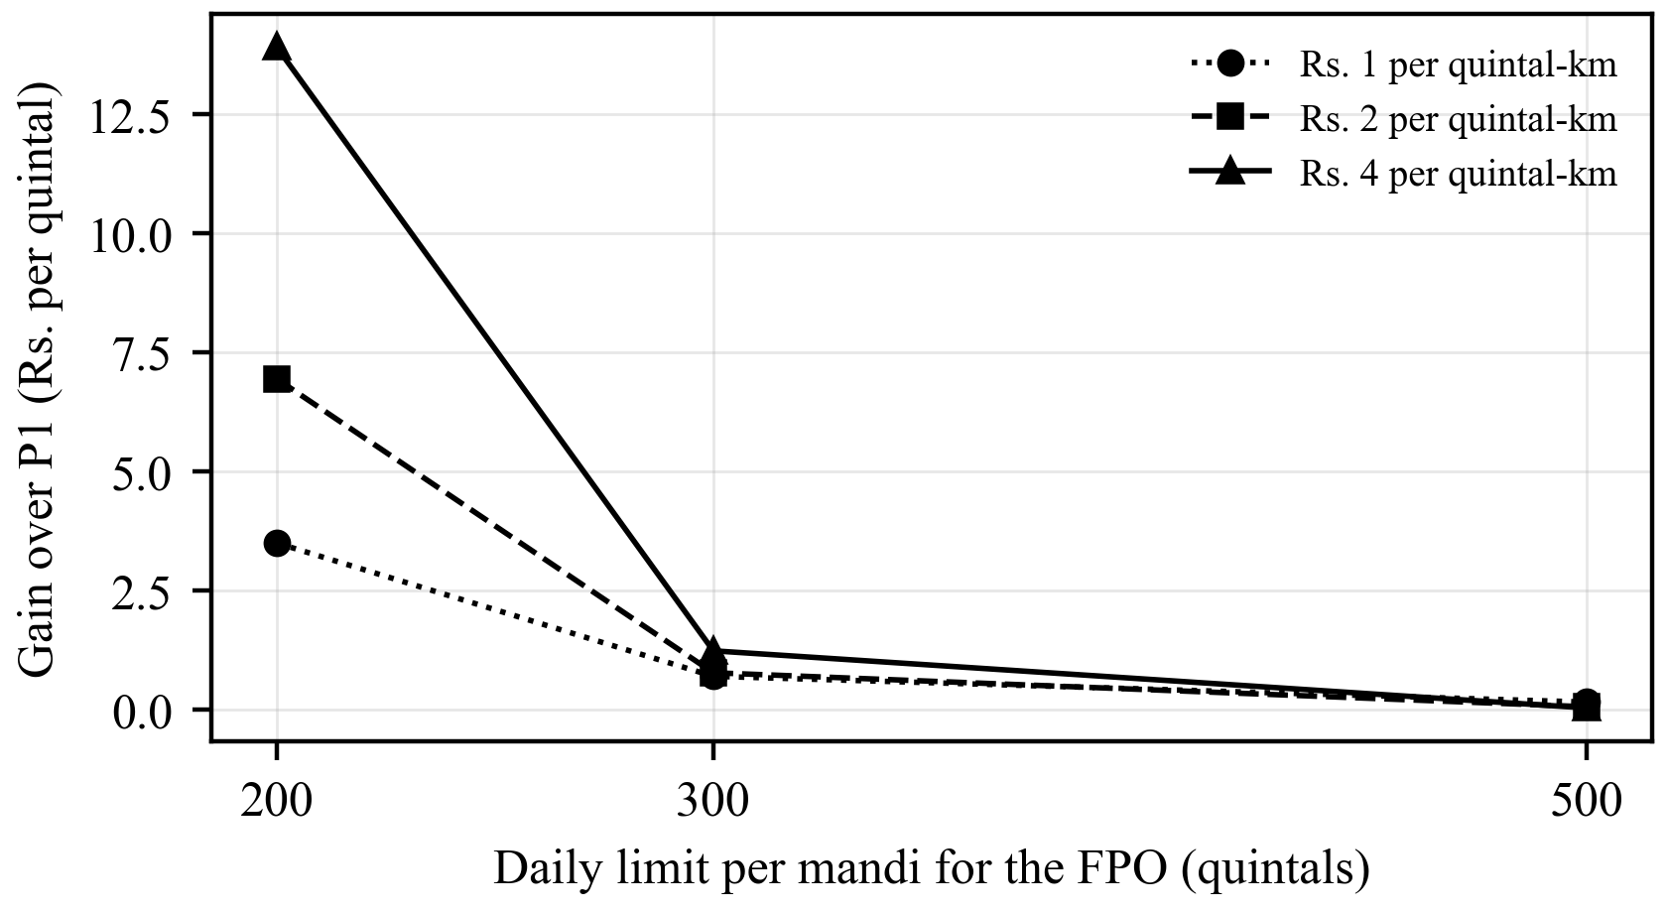
Fig. 5. Gain of the cooperative model (P3) over the nearest-mandi rule (P1) for different daily limits and transport costs (80 runs per point).
The settings above are assumptions, so the test was repeated with transport costs of Rs. 1, 2 and 4 per quintal per kilometre and daily limits of 200, 300 and 500 quintals (Fig. 5). The gain depends mainly on how tight the daily limit is. With a limit of 500 quintals, the nearest-mandi rule was already almost optimal (gain of Rs. 0.15 per quintal or less). With a limit of 200 quintals, the gain was Rs. 3.49, 6.94 and 13.91 per quintal at the three transport costs, and the average distance fell from 19.9 km to about 16.5 km.

4.4 Discussion and Limitations
The first version teaches one clear lesson. Mandi prices of an MSP crop such as Paddy (Common) in Punjab are almost fixed by policy, so a complex forecaster adds nothing and the announced MSP can serve as the price. What remains useful for such crops is coordination: deliveries are spread over mandis and days, limits are kept, and travel is reduced. The forecasting branch is more likely to matter for crops with market-set prices, such as basmati paddy or wheat held on the farm after harvest, and testing it on those crops is the next step.
The study has clear limits. Only one crop, one state and the September to December period of six seasons are covered by the price data. The modal price published for a mandi is not the exact price that a given farmer receives. The FPO, its lots, the transport rate, the road factor, the waiting cost and the daily limits are synthetic, so the allocation gains show what the model can do under these settings and not what a real FPO will earn. The storage node has been tested only in simulation. Finally, the way in which traders or mandis would react if many farmers followed the plan cannot be shown by a historical test.

5 Conclusion and Future Work
KisanNiti has been presented as a framework that helps an FPO decide where, when and how much of its members' produce is to be sold. Three parts are joined in it: a mandi-network price forecaster based on A3T-GCN, a low-cost storage-sensing node built around an ESP32 and an SHT30 probe, and an integer program that assigns farmer lots to mandis and days while the daily limit of each mandi is shared. The forecasting and allocation parts were tested on real AGMARKNET prices for Paddy (Common) from 20 Punjab mandis over 2020–2025.
Two results were obtained. The price of this crop is set almost entirely by the MSP: in every season, more than 96% of the reported prices were equal to it, and the announced MSP forecast better than every learned model, A3T-GCN included. A forecasting system for FPOs should check whether a crop is sold at the MSP before any learned model is used, and the announced MSP should be taken as the price if it is. The cooperative allocation model, in turn, respected the shared daily limits every time, while independent choices broke them in every run. Its gain over the nearest-mandi rule was small with loose limits (Rs. 0.79 per quintal) and grew to Rs. 3.5–13.9 per quintal with tight ones. For MSP crops, KisanNiti therefore helps through coordination, not through price prediction.
Several steps remain. The most important is to test the forecaster on crops whose prices are set by the market, such as basmati paddy and wheat held after harvest, where timing and mandi choice can matter more; a longer and wider AGMARKNET extract than the one available for this study is needed for it. Next, the storage node is to be assembled and calibrated against measured grain samples, so that a storage-condition term can be added to the allocation model in a tested way. The effect of market arrivals on price should also be included once it has been measured for the selected mandis. The synthetic FPO should be replaced with real member records, transport quotes and mandi handling limits from a partner FPO, and the plan should be checked against what farmers actually earn. Finally, the selling plan is to be delivered to farmers as short messages in their own language, with a simple explanation of each recommendation [16], and its usefulness is to be studied with FPO staff and members.
Declarations
Use of AI tools. An AI language model was used to help prepare and revise the text and the figures of this manuscript. All content, numbers and references were checked by the authors, who take full responsibility for the paper.
References
1. Small Farmers' Agribusiness Consortium (SFAC): Frequently Asked Questions: Farmer Producer Organisations. https://sfacindia.com/fpofaq.aspx, last accessed 2026/10/15
2. Gulati, A., Das, R., Winter-Nelson, A.: Reducing Post-Harvest Losses in Indian Agriculture: A Case Study of Selected Crops. Policy brief, ICRIER, New Delhi (2024). https://icrier.org/publications/reducing-post-harvest-losses-in-indian-agriculture-a-case-study-of-selected-crops/, last accessed 2026/10/15
3. Manogna, R.L., Dharmaji, V., Sarang, S.: Enhancing agricultural commodity price forecasting with deep learning. Sci. Rep. 15, 20903 (2025). https://doi.org/10.1038/s41598-025-05103-z
4. Directorate of Economics and Statistics, Ministry of Agriculture and Farmers Welfare: Minimum Support Prices (According to Crop Year), as on 22.01.2025. https://desagri.gov.in/wp-content/uploads/2025/02/MSP_for-website_English-version.pdf, last accessed 2026/10/15
5. Directorate of Economics and Statistics, Ministry of Agriculture and Farmers Welfare: Minimum Support Price (Marketing Season-wise), as on 28.05.2025. https://desagri.gov.in/wp-content/uploads/2025/08/MSP-Statement_English.pdf, last accessed 2026/10/15
6. Nayak, G.H.H., Alam, M.W., Singh, K.N., Avinash, G., Kumar, R.R., Ray, M., Deb, C.K.: Exogenous variable driven deep learning models for improved price forecasting of TOP crops in India. Sci. Rep. 14, 17203 (2024). https://doi.org/10.1038/s41598-024-68040-3
7. Özden, C., Bulut, M.: Spectral temporal graph neural network for multivariate agricultural price forecasting. Ciênc. Rural 54(1), e20220677 (2024). https://doi.org/10.1590/0103-8478cr20220677
8. Min, Y., Kim, Y.R., Hyon, Y., Ha, T., Lee, S., Hyun, J., Lee, M.R.: RNN and GNN based prediction of agricultural prices with multivariate time series and its short-term fluctuations smoothing effect. Sci. Rep. 15, 13681 (2025). https://doi.org/10.1038/s41598-025-97724-7
9. Islam, M.S., Sadmani, S., Ali, M.R., Sayem, N.S., Islam, M.H., Hanif, M.A., Alam, M.M.: Remotely controlled smart monitoring system of hermetic paddy storage to reduce postharvest losses in Bangladesh. Smart Agric. Technol. 8, 100468 (2024). https://doi.org/10.1016/j.atech.2024.100468
10. Anukiruthika, T., Jayas, D.S.: AI-driven grain storage solutions: exploring current technologies, applications, and future trends. J. Stored Prod. Res. 111, 102588 (2025). https://doi.org/10.1016/j.jspr.2025.102588
11. Zhao, L., Song, Y., Zhang, C., Liu, Y., Wang, P., Lin, T., Deng, M., Li, H.: T-GCN: a temporal graph convolutional network for traffic prediction. IEEE Trans. Intell. Transp. Syst. 21(9), 3848–3858 (2020). https://doi.org/10.1109/TITS.2019.2935152
12. Bai, J., Zhu, J., Song, Y., Zhao, L., Hou, Z., Du, R., Li, H.: A3T-GCN: attention temporal graph convolutional network for traffic forecasting. ISPRS Int. J. Geo-Inf. 10(7), 485 (2021). https://doi.org/10.3390/ijgi10070485
13. Urra-Calfuñir, B.A., Monardes-Concha, C.A., Miranda-González, P.A.: Agri-food supply chain optimization through a decentralized production process in the olive oil industry. Comput. Ind. Eng. 192, 110185 (2024). https://doi.org/10.1016/j.cie.2024.110185
14. Gámez-Albán, H.M., Guisson, R., De Meyer, A.: Optimizing the organization of the first mile in agri-food supply chains with a heterogeneous fleet using a mixed-integer linear model. Intell. Syst. Appl. 23, 200426 (2024). https://doi.org/10.1016/j.iswa.2024.200426
15. Anoop, K.P., Panicker, V.V., Siby, J., Aryadutt, C.S.: Multi-objective optimization algorithms for freight allocation in a food grain supply chain. Appl. Soft Comput. 171, 112729 (2025). https://doi.org/10.1016/j.asoc.2025.112729
16. Shams, M.Y., Gamel, S.A., Talaat, F.M.: Enhancing crop recommendation systems with explainable artificial intelligence: a study on agricultural decision-making. Neural Comput. Appl. 36(11), 5695–5714 (2024). https://doi.org/10.1007/s00521-023-09391-2
17. Directorate of Marketing and Inspection, Ministry of Agriculture and Farmers Welfare: AGMARKNET – Agricultural Marketing Information Network. https://agmarknet.gov.in, last accessed 2026/10/15
18. OpenStreetMap contributors: Nominatim geocoding service. https://nominatim.openstreetmap.org, last accessed 2026/10/15
19. Canadian Grain Commission: Protect the quality of your stored grain from insect infestations and mould. News release (13 September 2017). https://www.canada.ca/en/grain-commission/news/2017/09/protect_the_qualityofyourstoredgrainfrominsectinfestationsandmou.html, last accessed 2026/10/15
20. Espressif Systems: ESP32 Series Datasheet, Version 5.3. https://www.espressif.com/sites/default/files/documentation/esp32_datasheet_en.pdf, last accessed 2026/10/22
21. Sensirion AG: Datasheet SHT3x-DIS: Humidity and Temperature Sensor, Version 7. https://sensirion.com/media/documents/213E6A3B/63A5A569/Datasheet_SHT3x_DIS.pdf (2022), last accessed 2026/10/22
22. Gwinner, J., Harnisch, R., Mück, O.: Manual of the Prevention of Post-Harvest Grain Losses, 2nd edn. GTZ, Eschborn (1996). https://www.fao.org/4/x5065e/x5065E00.htm, last accessed 2026/10/22
23. de Lucia, M., Assennato, D.: Agricultural Engineering in Development: Post-Harvest Operations and Management of Foodgrains. FAO Agricultural Services Bulletin 93. FAO, Rome (1994). https://www.fao.org/4/t0522e/T0522E00.htm
24. Wokwi: ESP32 simulator. https://wokwi.com, last accessed 2026/10/22
25. Huangfu, Q., Hall, J.A.J.: Parallelizing the dual revised simplex method. Math. Program. Comput. 10(1), 119–142 (2018). https://doi.org/10.1007/s12532-017-0130-5
26. Virtanen, P., Gommers, R., Oliphant, T.E., et al.: SciPy 1.0: fundamental algorithms for scientific computing in Python. Nat. Methods 17(3), 261–272 (2020). https://doi.org/10.1038/s41592-019-0686-2

