KisanNiti: An AI- and IoT-Based Framework for
Cooperative Post-Harvest Selling in
Farmer Producer Organizations
Harkiran Kaur, Arijit Singh, Tushar Garg,
Hitesh Mehandiratta, and Namya Gautam
{asingh28_be23, tgarg3_be23, hhitesh_be23, ngautam_23}@thapar.edu
Abstract. Farmer Producer Organizations (FPOs) can market produce collectively, but post-harvest selling still requires linked decisions about where, when, and how much to sell. KisanNiti is proposed as a decision-support framework that connects market forecasting, storage information, and cooperative allocation. Historical mandi price data are used to estimate future market conditions. A graph-based forecasting branch represents selected mandis as a network so that information from related markets can be used together. A storage branch is included to provide environmental information after the sensing setup has been validated. These inputs feed an allocation model that is intended to choose a mandi, selling day, and quantity for each farmer or lot while considering expected sale value and transport cost. The final output is a structured selling plan that can later be delivered through an FPO-facing interface. The paper therefore defines the research basis and the proposed system design without reporting results for components that have not yet been tested.
Keywords: Farmer Producer Organizations · Cooperative Selling · Agricultural Price Forecasting · Graph Neural Networks · Internet of Things · Decision Support
1 Introduction
Farmer Producer Organizations (FPOs) are producer organizations whose members are farmers. Their activities can include pooling, marketing, and selling the produce of their members. This structure gives farmers a way to act collectively in the market. Post-harvest management still remains important, however. A 2024 ICRIER policy brief reports that India loses about Rs. 1.53 trillion worth of food each year, based on the NABCONs 2020-2022 national study, and it identifies storage and movement of grain as important parts of the post-harvest problem. [1,2]
For an FPO, selling after harvest is not one decision. The organization must decide where to sell, when to sell, and how much produce to send. These choices affect one another. A mandi with a higher expected price may be farther away, while waiting for a later date keeps produce in storage for longer. Recent Indian forecasting work has used daily wholesale price data from the AGMARKNET portal across 165 markets, showing that the portal can provide a broad market-price series for modelling. [3]
Recent studies show that agricultural price forecasting can benefit from modern time-series models. Manogna et al. compared statistical, machine-learning, and deep-learning methods on 23 commodities from 165 Indian markets and found that LSTM and GRU models were strong performers across many series. Nayak et al. studied tomato, onion, and potato prices in India and showed that exogenous variables such as temperature and precipitation can also be useful when they are added to price history. These studies support the use of data-driven forecasting, but they do not by themselves solve the full selling problem faced by an FPO. [3,4]
Another useful line of research models several agricultural price series together. Özden and Bulut applied a spectral temporal graph neural network to daily vegetable prices and trade volumes in Turkey. Min et al. later compared recurrent and graph-based models using agricultural prices and weather variables in South Korea. Storage research has developed in parallel: Islam et al. demonstrated remote monitoring of temperature and relative humidity in hermetic paddy storage over a 125-day period, while a recent review describes wider use of AI, IoT, and smart sensors in grain-storage management. [5,6,8,9]
The studies above provide useful building blocks, but the papers reviewed here mainly treat forecasting, storage monitoring, and logistics as separate tasks. KisanNiti is proposed to connect these tasks for cooperative post-harvest selling. Its first contribution is a mandi-network forecasting design in which related markets can be modelled together. Its second contribution is a clear interface through which validated storage information can later affect selling decisions. Its third contribution is a farmer-mandi-day allocation model that combines predicted prices with farmer quantity and transport information. The next sections review the research behind these choices and then describe the proposed architecture.
2 Related Work
Agricultural price forecasting has moved from classical time-series models toward machine learning and deep learning. Manogna et al. used daily wholesale data from January 2010 to June 2024 and compared several methods across 23 commodities and 165 Indian markets. Nayak et al. focused on tomato, onion, and potato prices and evaluated models that also used temperature and precipitation. Together, these studies show that both temporal patterns and carefully chosen external variables can improve agricultural price forecasts. [3,4]
Graph-based models add a different idea: several related series can be learned together instead of being treated as completely separate. Özden and Bulut used StemGNN on 1,791 days of Turkish vegetable price and trade-volume data and compared it with CNN, LSTM, and Random Forest models. Min et al. compared stacked LSTM, StemGNN, and T-GCN on South Korean agricultural data. They found that the graph-based models captured short-term fluctuations more effectively in their experiments, although performance depended on the evaluation measure. A3T-GCN is relevant as a possible architecture because it combines graph convolution, GRU-based temporal learning, and attention over historical time points. Its original study, however, was conducted on traffic networks, not agricultural markets. [5-7]
Grain-storage research shows that continuous environmental monitoring can support post-harvest management. Islam et al. built a low-cost remote system for hermetic paddy storage and monitored temperature and relative humidity for 125 days. Anukiruthika and Jayas reviewed recent work on AI and IoT for grain storage and highlighted applications such as smart sensing, quality management, and anomaly detection. These studies justify a storage-information branch in KisanNiti, but they do not justify a specific spoilage model for our project before a storage prototype has been calibrated. [8,9]
Agricultural logistics studies also show the value of formal optimization. Urra-Calfuñir et al. proposed a mixed-integer linear programming model that combines harvesting, processing, allocation, and transport decisions for small olive growers. Gámez-Albán et al. used mixed-integer programming to organize first-mile transport for an agricultural cooperative. In India, Anoop et al. formulated a multi-objective food-grain freight allocation problem using inventory and warehouse-related penalty factors. These studies are not the same as the KisanNiti selling problem, but they show that allocation and transport decisions can be stated as explicit optimization models rather than informal rules. [10-12]
Farmer-facing decision support also benefits from explanations that are easy to understand. Shams et al. developed an explainable crop-recommendation system and used interpretable explanations to make recommendations clearer to users. This supports the long-term goal of explaining a KisanNiti recommendation, but the present manuscript does not include an untested dashboard or chatbot. The papers reviewed in this section therefore motivate separate parts of KisanNiti; Section 3 shows how those parts are connected in the proposed framework. [13]
3 Proposed System Architecture and Methodology
KisanNiti is designed around one question: how can an FPO use market information and available post-harvest information to prepare a better selling plan? The proposed system has three input groups. The first contains mandi price history. The second contains farmer or lot information, including available quantity and location. The third is reserved for storage information after the sensing setup has been validated. These inputs are connected to a forecasting module and a cooperative allocation model, as shown in Fig. 1.
3.1 Overall KisanNiti Architecture
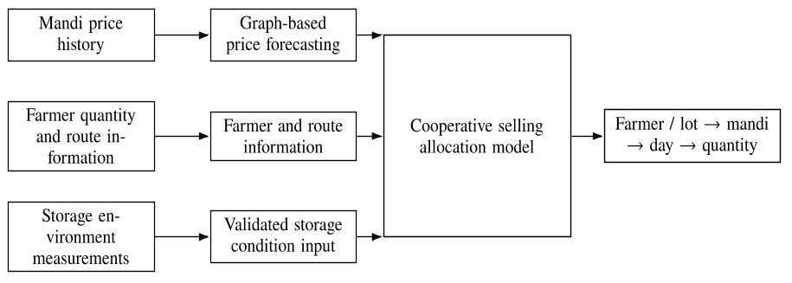
Fig. 1. Proposed high-level architecture of KisanNiti.
The market branch estimates future prices for candidate mandis. Farmer and route information are used to estimate which selling choices are feasible and what transport may cost. The storage branch is shown as an input interface rather than a completed risk model. This is deliberate: storage measurements should influence a selling decision only after the sensing setup and its interpretation have been tested. The allocation model combines the validated inputs and produces a structured farmer-or-lot to mandi, day, and quantity plan.
3.2 Market Data and Mandi Representation
AGMARKNET is the source of the market-price series used in KisanNiti. Manogna et al. used daily wholesale AGMARKNET price data from 165 Indian markets in a recent forecasting study [3]. For the first KisanNiti forecasting experiment, the modal-price field in the project dataset is used as the target. Additional market variables, including arrivals, will be added only after the exact dataset extract and field definitions are frozen and documented.
Each selected mandi is represented as one graph node. A simple and reproducible starting graph is proposed: every mandi is connected to its k geographically nearest candidate mandis. The value of k is treated as a validation choice rather than a fixed fact. This construction gives the graph a clear meaning and avoids claiming a price-based relationship before it has been tested. Agricultural graph-forecasting studies show that learning relationships across several price series can be useful, while A3T-GCN provides a general graph-and-time architecture that accepts an adjacency structure as input. [5-7]
3.3 Graph-Based Price Forecasting
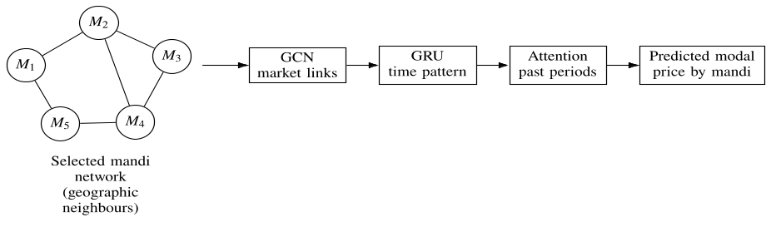
Fig. 2. Proposed mandi graph and A3T-GCN forecasting flow.
A3T-GCN is proposed as one candidate forecasting model. It combines three ideas. The graph convolutional network (GCN) passes information between connected nodes. The gated recurrent unit (GRU) learns how those node values change over time. The attention layer then gives different weights to historical time points before the forecast is produced. This structure was originally proposed for traffic forecasting. KisanNiti therefore does not assume that it will be the best model for Indian mandi data; it must be compared with simpler baselines during evaluation. [7]
For a selected historical window, the model input contains recent price observations for all mandis in the graph. The output is a future modal-price estimate for each candidate mandi. Additional market variables, including arrivals or weather, may be evaluated later after their exact sources and field definitions are fixed. This keeps the first graph experiment focused on whether modelling the mandi network adds useful information beyond ordinary time-series forecasting. [4-6]
3.4 Storage-Condition Input
Storage conditions can affect whether waiting for a later selling date is sensible. Recent paddy-storage research has shown that temperature and relative humidity can be monitored remotely over long storage periods, and current grain-storage reviews describe wider use of connected sensors and AI-based monitoring. These findings support including storage information in the architecture. [8,9]
The present manuscript does not assign a sensor model, a spoilage threshold, or an anomaly-detection algorithm to KisanNiti. Those choices require a real prototype and calibration data. After validation, the storage branch can supply a clearly defined condition or urgency variable to the allocation model. Until that work is complete, no storage-risk accuracy or grain-quality claim is reported.
3.5 Cooperative Selling Allocation Model
The core selling problem is written as an allocation problem. Let x denote the quantity assigned from farmer or lot f to mandi m on day d. Let Q be the available quantity for farmer or lot f, p-hat be the predicted modal price for mandi m on day d, and c be the estimated transport cost per unit from farmer f to mandi m. The simplest baseline objective is to maximize expected sale value after transport cost.
maximize Σ_{f,m,d} x_{fmd} (p̂_{md} - c_{fm}) | (1)
The first required constraint is quantity conservation: a farmer or lot cannot sell more produce than is available. In the baseline model, all quantity included in the planning run is assigned exactly once.
Σ_{m,d} x_{fmd} = Q_{f} for each f | (2)
This baseline is intentionally small. A market-arrival pressure term should only be added after the relationship between historical arrivals and price has been estimated for the selected mandis. A storage-delay term should only be added after the storage branch has been calibrated. Leaving these coefficients unspecified now is safer than assigning arbitrary penalties. Recent agri-food studies support the use of mixed-integer and multi-objective models for allocation and transport planning, including an Indian food-grain allocation study, so these methods provide suitable comparison points once the KisanNiti model is implemented. [10-12]
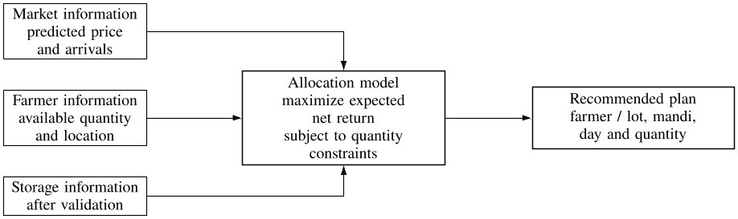
Fig. 3. Core allocation structure. Storage-specific terms are added only after validation.
3.6 Recommendation Output
The model output is defined independently of any user-interface design. Each recommendation should identify the farmer or lot, the suggested mandi, the selling day, and the assigned quantity. It can also include the predicted modal price and the transport-cost estimate used by the model. A dashboard or multilingual messaging interface can consume this structured output later, but no interface screenshot is included before that interface has been built and tested. If model explanations are added in a later version, they should explain the model output rather than present a feature as proof of market causation. [13]
References
[1] Small Farmers' Agribusiness Consortium (SFAC). Frequently Asked Questions: Farmer Producer Organisations. https://sfacindia.com/fpofaq.aspx (accessed 8 Aug 2026).
[2] Gulati, A., Das, R., Winter-Nelson, A.: Reducing Post-Harvest Losses in Indian Agriculture - A Case Study of Selected Crops. ICRIER Policy Brief 20 (2024). https://icrier.org/publications/reducing-post-harvest-losses-in-indian-agriculture-a-case-study-of-selected-crops/ (accessed 8 Aug 2026).
[3] Manogna, R.L., Dharmaji, V., Sarang, S.: Enhancing agricultural commodity price forecasting with deep learning. Scientific Reports 15, 20903 (2025). https://doi.org/10.1038/s41598-025-05103-z.
[4] Nayak, G.H.H., Alam, M.W., Singh, K.N., Avinash, G., Kumar, R.R., Ray, M., Deb, C.K.: Exogenous variable driven deep learning models for improved price forecasting of TOP crops in India. Scientific Reports 14, 17203 (2024). https://doi.org/10.1038/s41598-024-68040-3.
[5] Özden, C., Bulut, M.: Spectral temporal graph neural network for multivariate agricultural price forecasting. Ciência Rural 54(1), e20220677 (2024). https://doi.org/10.1590/0103-8478cr20220677.
[6] Min, Y., Kim, Y.R., Hyon, Y., Ha, T., Lee, S., Hyun, J., Lee, M.R.: RNN and GNN based prediction of agricultural prices with multivariate time series and its short-term fluctuations smoothing effect. Scientific Reports 15, 13681 (2025). https://doi.org/10.1038/s41598-025-97724-7.
[7] Bai, J., Zhu, J., Song, Y., Zhao, L., Hou, Z., Du, R., Li, H.: A3T-GCN: Attention Temporal Graph Convolutional Network for Traffic Forecasting. ISPRS International Journal of Geo-Information 10(7), 485 (2021). https://doi.org/10.3390/ijgi10070485.
[8] Islam, M.S., Sadmani, S., Ali, M.R., Sayem, N.S., Islam, M.H., Hanif, M.A., Alam, M.M.: Remotely controlled smart monitoring system of hermetic paddy storage to reduce postharvest losses in Bangladesh. Smart Agricultural Technology 8, 100468 (2024). https://doi.org/10.1016/j.atech.2024.100468.
[9] Anukiruthika, T., Jayas, D.S.: AI-driven grain storage solutions: Exploring current technologies, applications, and future trends. Journal of Stored Products Research 111, 102588 (2025). https://doi.org/10.1016/j.jspr.2025.102588.
[10] Urra-Calfuñir, B.A., Monardes-Concha, C.A., Miranda-González, P.A.: Agri-food supply chain optimization through a decentralized production process in the olive oil industry. Computers & Industrial Engineering 192, 110185 (2024). https://doi.org/10.1016/j.cie.2024.110185.
[11] Gámez-Albán, H.M., Guisson, R., De Meyer, A.: Optimizing the organization of the first mile in agri-food supply chains with a heterogeneous fleet using a mixed-integer linear model. Intelligent Systems with Applications 23, 200426 (2024). https://doi.org/10.1016/j.iswa.2024.200426.
[12] Anoop, K.P., Panicker, V.V., Siby, J., Aryadutt, C.S.: Multi-objective optimization algorithms for freight allocation in a food grain supply chain. Applied Soft Computing 171, 112729 (2025). https://doi.org/10.1016/j.asoc.2025.112729.
[13] Shams, M.Y., Gamel, S.A., Talaat, F.M.: Enhancing crop recommendation systems with explainable artificial intelligence: a study on agricultural decision-making. Neural Computing and Applications 36, 5695-5714 (2024). https://doi.org/10.1007/s00521-023-09391-2.

