KisanNiti: An AI- and IoT-Based Framework for Cooperative Post-Harvest Selling in Farmer Producer Organizations
Harkiran Kaur, Arijit Singh, Tushar Garg, Hitesh Mehandiratta, and Namya Gautam
Thapar Institute of Engineering and Technology, Patiala, Punjab, India
{asingh28_be23,tgarg3_be23,hhitesh_be23,ngautam_23}@thapar.edu
Abstract. Farmer Producer Organizations (FPOs) sell the produce of many members together, but after harvest they still have to decide where, when and how much to sell. This paper presents KisanNiti, a decision-support framework that links mandi price forecasting, storage sensing and a cooperative allocation model. Mandi prices from AGMARKNET are treated as a network of markets and forecast with an attention temporal graph convolutional network (A3T-GCN). A low-cost storage node built from an ESP32 board, a DHT22 sensor and two DS18B20 probes is designed to record storage conditions. An integer program then assigns each farmer lot to a mandi, a day and a quantity while respecting a shared daily limit at each mandi. We tested the forecasting and allocation parts on real Paddy (Common) prices from 20 Punjab mandis for the 2020–2025 seasons. In every season, more than 96% of the reported prices were equal to the minimum support price (MSP). As a result, a simple MSP rule gave the lowest forecast error (mean absolute error of Rs. 1.26 per quintal), and none of the learned models beat it. In a synthetic 40-lot FPO scenario, the cooperative plan respected every daily limit, while independent choices exceeded a limit in every run. Its gain over a nearest-mandi rule was small (Rs. 0.79 per quintal) when the limits were loose and rose to Rs. 3.5–13.9 per quintal when they were tight.
Keywords: Farmer Producer Organizations · Mandi price forecasting · Graph neural networks · Minimum support price · Integer programming · Internet of Things

1 Introduction
Farmer Producer Organizations (FPOs) are producer organizations whose members are farmers. They can pool, market and sell the produce of their members, which gives small farmers a way to act together in the market [1]. Selling after harvest is still hard, and losses after harvest are large. A 2024 ICRIER policy brief reports that India loses about Rs. 1.53 trillion worth of food every year, based on a national study carried out by NABCONS during 2020–2022, and it discusses storage as one part of the problem [2].
For an FPO, selling after harvest is not one decision. The organization must decide where to sell, when to sell and how much produce to send. These choices affect one another. A mandi with a better price may be farther away, and waiting for a later date keeps produce in storage for longer. If many farmers send produce in the same few days, one mandi can receive more than it can handle. Daily wholesale price data are published on the AGMARKNET portal, and recent Indian work has used these data from 165 markets for forecasting [3]. For crops bought at the minimum support price (MSP), the government also announces a fixed price before each season [4, 5].
Agricultural price forecasting has improved with modern time-series models. Manogna et al. compared statistical, machine-learning and deep-learning methods on 23 commodities from 165 Indian markets and found that LSTM and GRU models performed best [3]. Nayak et al. studied tomato, onion and potato prices in India and showed that adding temperature and rainfall helped deep-learning models [6]. These studies support data-driven forecasting, but they do not solve the full selling problem of an FPO.
Another line of research models several price series together. Özden and Bulut applied a spectral temporal graph neural network to daily vegetable prices and trade volumes in Turkey [7]. Min et al. combined prices of four South Korean crops with weather variables and found that graph-based models did better than a stacked LSTM [8]. Storage research has grown in parallel. Islam et al. monitored temperature and relative humidity inside hermetic paddy storage for 125 days [9], and a recent review describes the use of AI, IoT and smart sensors in grain storage [10].
These studies each solve part of the problem, but they mostly treat forecasting, storage monitoring and logistics as separate tasks. KisanNiti connects them for cooperative selling. This paper makes four contributions. First, it describes a framework in which mandi forecasts, farmer lot records and storage readings feed one selling plan. Second, it builds a mandi network from map coordinates and compares an A3T-GCN forecaster with simple baselines on real AGMARKNET data over three test seasons. Third, it writes the selling decision as an integer program in which farmers share each mandi's daily limit, and compares it with simple selling rules. Fourth, it presents the circuit of a low-cost storage-sensing node. The results are reported as they came out, including the finding that the learned forecasters did not beat simple rules for an MSP crop.
Section 2 reviews related work. Section 3 describes the architecture and methods. Section 4 reports the experiments and discusses what they show, and Section 5 concludes the paper.

2 Related Work
Agricultural price forecasting has moved from classical time-series models toward machine learning and deep learning. Manogna et al. used daily AGMARKNET wholesale data from 2010 to 2024 for 23 commodities and 165 Indian markets. They compared ARIMA, support vector regression, XGBoost and several neural networks, and the LSTM and GRU models gave the lowest errors [3]. Nayak et al. used price data for tomato, onion and potato from major Indian markets together with temperature and precipitation, and found that deep-learning models with these external variables did better than statistical and machine-learning models [6].
Graph-based models add a different idea: related series are learned together instead of one at a time. Özden and Bulut used StemGNN on 1,791 days of Turkish vegetable price and trade-volume data and compared it with CNN, LSTM and Random Forest models [7]. Min et al. compared a stacked LSTM with two graph models, StemGNN and the temporal graph convolutional network (T-GCN). In their multivariate setting the graph models outperformed the LSTM, and smoothing out short-term fluctuations improved the multivariate models the most [8]. T-GCN combines a graph convolution with a gated recurrent unit (GRU) [11]. A3T-GCN adds an attention step over past time points [12]. Both were first proposed for traffic forecasting, not for agricultural markets.
Grain-storage research shows that continuous monitoring can support post-harvest management. Islam et al. built a low-cost remote system for hermetic paddy storage in Bangladesh. Over 125 days, the temperature inside the bags stayed between 16.7 °C and 29.2 °C, and no insect or mould growth was seen [9]. Anukiruthika and Jayas reviewed AI and IoT methods for grain storage, including smart sensors and anomaly detection [10].
Agricultural logistics studies show the value of formal optimization. Urra-Calfuñir et al. built a mixed-integer linear programming model that plans harvesting, processing and transport for small olive growers in Chile [13]. Gámez-Albán et al. used a mixed-integer model to organize first-mile transport for an agricultural cooperative in Greece [14]. In India, Anoop et al. formulated a three-objective freight-allocation problem for a food-grain organization, using inventory- and warehouse-related penalty factors [15]. For farmer-facing advice, Shams et al. developed an explainable crop-recommendation system so that users can understand why a crop is suggested [16].
Table 1 compares these studies with KisanNiti on five points. It marks only what each paper reports. None of the reviewed studies joins market forecasting, storage sensing and cooperative allocation in one system, which is the gap this work addresses.
Table 1. Comparison of KisanNiti with related studies (Yes = reported in the paper).
Study | Price forecast | Graph of series | Storage sensing | Allocation / transport | Indian data
Manogna et al. [3] | Yes | – | – | – | Yes
Nayak et al. [6] | Yes | – | – | – | Yes
Özden and Bulut [7] | Yes | Yes | – | – | –
Min et al. [8] | Yes | Yes | – | – | –
Islam et al. [9] | – | – | Yes | – | –
Urra-Calfuñir et al. [13] | – | – | – | Yes | –
Gámez-Albán et al. [14] | – | – | – | Yes | –
Anoop et al. [15] | – | – | – | Yes | Yes
KisanNiti (this paper) | Yes | Yes | Yes* | Yes | Yes
* Circuit designed and simulated; field readings are not yet used in the experiments.

3 Proposed System Architecture and Methodology
KisanNiti is built around one question: how can an FPO use market and storage information to prepare a better selling plan for its members? Figure 1 shows the overall design. There are three inputs. The first is mandi price history from AGMARKNET. The second is the FPO's record of member lots, with the quantity and location of each lot. The third is storage readings from a sensor node. The price history goes to a forecasting model. The lot records are used to work out transport costs. Storage readings are meant to feed the plan once the node has been calibrated. A cooperative allocation model combines these inputs and produces a selling plan that says which lot goes to which mandi, on which day and in what quantity.
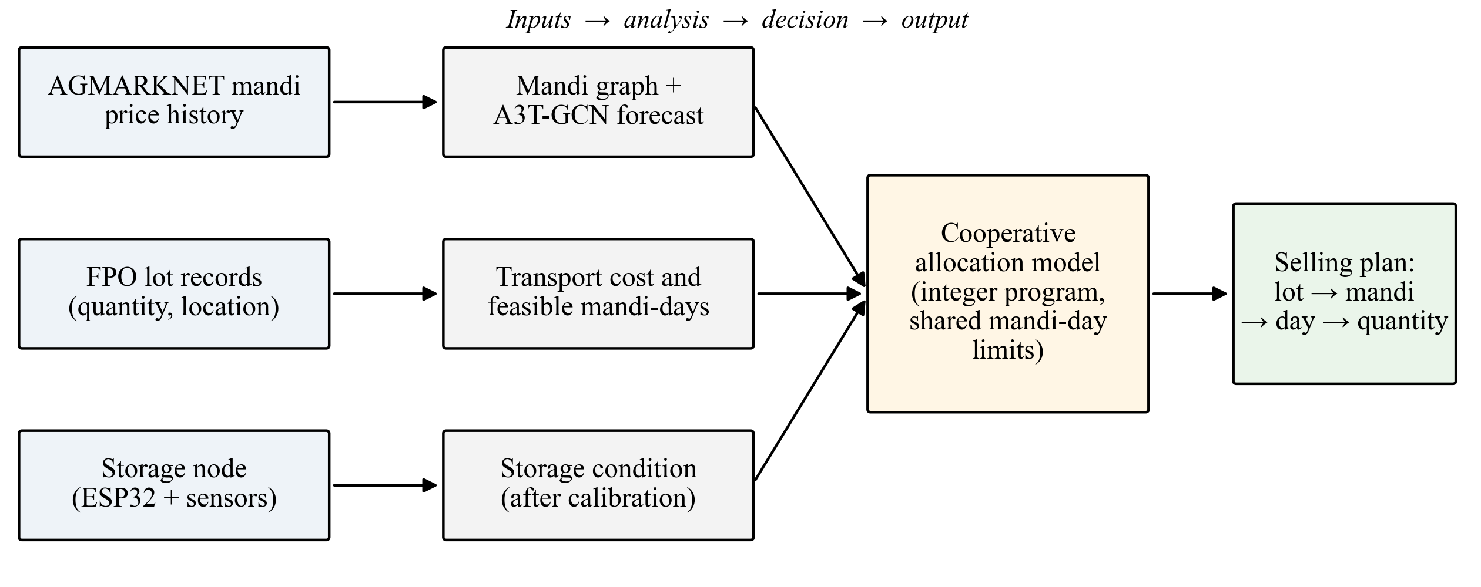
Fig. 1. Overall architecture of KisanNiti.

3.1 Market Data and Mandi Network
We used AGMARKNET data for Paddy (Common) in Punjab for September to December of 2020–2025, downloaded from the official AGMARKNET API in April 2026 [17]. The raw file had 16,284 rows. We removed 81 exact duplicate rows, repaired 19 rows that had zero minimum or maximum prices, and merged 2 duplicate market-date-variety groups. This left 16,201 records from 176 mandis. When a mandi reported more than one variety on a day, we used the arrival-weighted average of the modal prices.
Most mandis report only on some days, so we kept the 20 mandis that reported in all six seasons and had the most trading dates (195 to 288 dates each). Each mandi is one node of a graph. We found the location of each mandi with the OpenStreetMap Nominatim service [18] and connected every mandi to its k nearest mandis by straight-line distance. The value of k was chosen from {2, 3, 5} using a separate validation season. This gives the graph a clear meaning based on geography and does not assume any price relationship before it is tested. Figure 2(a) shows the network; the five mandis marked in red are used in the allocation experiment.
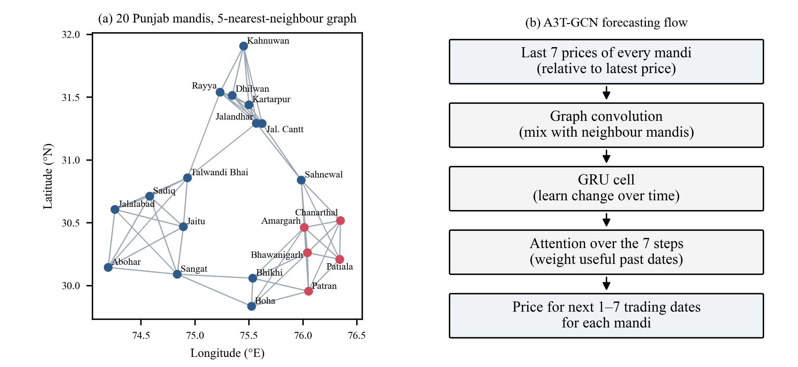
Fig. 2. (a) Mandi network used for forecasting (red: candidate mandis for the allocation test). (b) Steps of the A3T-GCN forecaster.

3.2 Graph-Based Price Forecasting
We use A3T-GCN [12] as the main forecaster. It has three parts. A graph convolution mixes each mandi's values with those of its neighbours. A GRU learns how these values change over time. An attention layer then gives a weight to each past time step before the forecast is made. Let A be the adjacency matrix of the mandi graph and I the identity matrix. The graph is normalized as
Â = D̃^{−1/2} (A + I) D̃^{−1/2}, (1)
where D̃ is the degree matrix of A + I. For input x_{t} at step t and hidden state h_{t−1}, the update gate u_{t}, reset gate r_{t} and new state h_{t} are
u_{t} = σ(Â[x_{t}, h_{t−1}]W_{u} + b_{u}), r_{t} = σ(Â[x_{t}, h_{t−1}]W_{r} + b_{r}), (2)
c_{t} = tanh(Â[x_{t}, r_{t} ⊙ h_{t−1}]W_{c} + b_{c}), h_{t} = u_{t} ⊙ h_{t−1} + (1 − u_{t}) ⊙ c_{t}. (3)
A small scoring network gives each hidden state a weight, and the weighted states are combined before the output layer:
α_{t} = softmax_{t}(w₂⊤ tanh(W₁h_{t} + b₁) + b₂), z = Σ_{t} α_{t}h_{t}, ŷ = W_{o}z + b_{o}. (4)
The input is the last 7 trading-date prices of all 20 mandis, and the output is the price of every mandi for the next 7 trading dates. Because the MSP rises every season, each input window is divided by its latest price, and the model predicts the relative change from that price. This keeps the scale the same across seasons. The model is trained to reduce the mean absolute error, and only prices that were actually reported are used as targets. Gaps in the inputs are filled with the last price the same mandi reported in that season; before a mandi's first report of a season, the mean price reported by the other mandis on that date is used, so no future value enters the input.

3.3 Storage-Sensing Node
Storage conditions matter when an FPO considers waiting for a later selling date. Grain-storage guidance advises checking temperature probes in stored grain regularly, because hot spots may indicate insects [19]. We therefore designed a low-cost node, shown in Fig. 3. It uses an ESP32 development board, which has built-in 2.4 GHz Wi-Fi (802.11 b/g/n) [20]. A DHT22 sensor measures air temperature and relative humidity near the bags; its stated accuracy is ±2% RH (at most ±5% RH) and better than ±0.5 °C [21]. Two DS18B20 digital thermometers measure grain temperature at two points, for example near the top and in the middle of a bag; each is accurate to ±0.5 °C between −10 °C and +85 °C [22]. The sensors are connected to GPIO 4, 16 and 17 and powered from the 3.3 V pin, and each DS18B20 data line has a 4.7 kΩ pull-up resistor, as in the manufacturer's reference circuit [22].
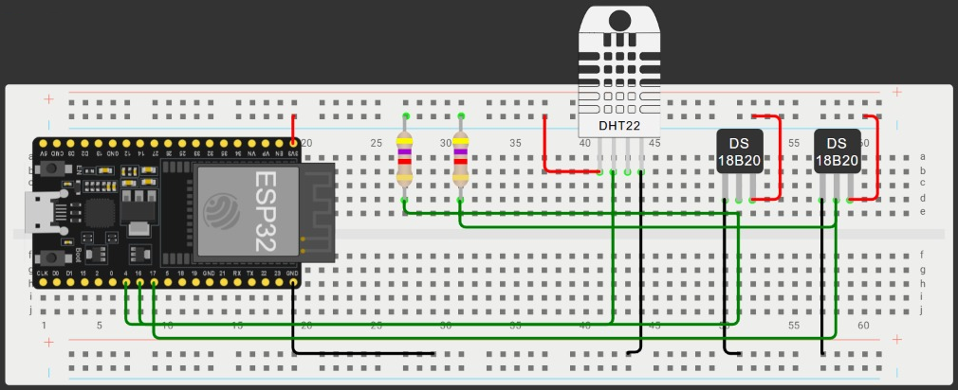
Fig. 3. Circuit of the storage-sensing node: ESP32, DHT22 and two DS18B20 sensors with 4.7 kΩ pull-up resistors (Wokwi simulation).
The circuit was built and checked in the Wokwi ESP32 simulator [23]. In this version, the node has not yet been placed in real storage, and its readings are not used in the experiments of Section 4. Temperature and humidity do not measure grain moisture or spoilage directly, so a storage-condition rule will be added to the allocation model only after the node has been calibrated against measured grain samples.

3.4 Cooperative Selling Allocation Model
The selling decision is written as an integer program. Let f be a farmer lot, m a candidate mandi and d = 0, 1, …, D − 1 a trading day in the planning period. Q_{f} is the quantity of lot f, p̂_{md} the forecast price at mandi m on day d, κ_{fm} the road distance from lot f to mandi m, r the transport cost per quintal per kilometre, and w a small waiting cost per quintal per day. The net value of sending one quintal is
v_{fmd} = p̂_{md} − r κ_{fm} − w d. (5)
The decision variable x_{fmd} is the quantity of lot f sent to mandi m on day d. The model is
maximize Σ_{f} Σ_{m} Σ_{d} v_{fmd} x_{fmd} (6)
subject to Σ_{m} Σ_{d} x_{fmd} = Q_{f} for every lot f, (7)
Σ_{f} x_{fmd} ≤ C_{md} for every mandi m and day d, (8)
x_{fmd} ∈ {0, 10, 20, …} quintals. (9)
Constraint (7) makes sure that every lot in the planning run is sold exactly once. Constraint (8) is what makes the model cooperative: C_{md} is the quantity the FPO can deliver to mandi m on day d, and all lots share it. Without (8), each lot would simply go to its own best mandi and day, and the problem would split into separate farmer decisions. Quantities are planned in 10-quintal units, which is close to how loads are sent. We solve the model with the HiGHS solver [24] through SciPy [25]. Storage and market-arrival terms are not added yet. They will be added once the storage node is calibrated and the effect of arrivals on price has been measured for the selected mandis.

3.5 Recommendation Output
The output of the model is a table with one row for each part of a lot: the lot, the mandi, the selling day and the quantity, along with the forecast price and the transport cost used. This structured output can later be shown on an FPO dashboard or sent to farmers as messages. If explanations are added, they should explain why the model chose a plan, in the spirit of explainable recommendation systems [16].

4 Experimental Evaluation and Discussion

4.1 Data and Setup
Table 2 describes the price data for the 20 selected mandis. Across the six seasons there were 382 trading dates, and the mandis reported a price on 4,626 of the 7,640 possible mandi-days (60.5%). The table shows the main feature of this crop: in every season, more than 96% of the reported prices were equal to that season's MSP for Grade A paddy (to the nearest rupee) [4, 5]. Prices also varied very little from one mandi to another on the same day.
Table 2. Paddy (Common) prices in the 20 selected Punjab mandis. SD = standard deviation (Rs. per quintal).
Season | MSP Grade A (Rs./q) | Trading dates | Prices equal to MSP (%) | SD of all prices | Mean daily SD across mandis
2020 | 1888 | 70 | 98.3 | 44.3 | 7.1
2021 | 1960 | 55 | 99.1 | 80.5 | 29.6
2022 | 2060 | 60 | 98.5 | 16.5 | 0.8
2023 | 2203 | 70 | 96.1 | 45.5 | 12.8
2024 | 2320 | 66 | 98.8 | 29.5 | 0.4
2025 | 2389 | 61 | 99.0 | 21.6 | 3.0

We used forward-chaining evaluation. Each test season was forecast with models trained on all earlier seasons except the one just before it, which was kept for validation. This gives three test seasons: 2023 (trained on 2020–2021, validated on 2022), 2024 and 2025. Seasons were never mixed inside one input window. We compared seven models: (i) a naive forecast that repeats the last price; (ii) the mean of the last 7 prices; (iii) an MSP rule that always predicts the season's Grade A MSP, which is announced before the season; (iv) ridge regression on the relative changes, with its penalty chosen on validation; (v) a GRU without a graph; (vi) T-GCN, which is the graph model without attention; and (vii) A3T-GCN. The neural models had a hidden size of 32 and were trained with the Adam optimizer (learning rate 0.001, batch size 32) for up to 400 epochs, stopping when the validation error had not improved for 40 epochs. Each neural model was trained with five random seeds. We report the mean absolute error (MAE), the root mean squared error (RMSE) and the mean absolute percentage error (MAPE) over forecast horizons of 1 to 7 trading dates, scored only on prices that were actually reported. The experiments used Python 3.13, PyTorch 2.9.1 and SciPy 1.15.2.

4.2 Forecasting Results
Table 3 gives the results. Validation chose k = 5 for the 2023 season and k = 3 for 2024 and 2025. All errors are small, below Rs. 7 per quintal on average, because the prices hardly move. The MSP rule had the lowest MAE in all three seasons (mean Rs. 1.26 per quintal) and also the lowest RMSE. The naive forecast came second (Rs. 1.77). Among the learned models, A3T-GCN was the most accurate (Rs. 2.36), ahead of the GRU (Rs. 2.51), T-GCN (Rs. 2.54) and ridge regression (Rs. 4.09). The graph alone (T-GCN) did not help compared with a plain GRU, and the small edge of A3T-GCN is of the same size as the variation between random seeds. No learned model beat the two simplest rules.
Table 3. Forecast errors over horizons of 1–7 trading dates (Rs. per quintal). Neural models: mean ± SD over five seeds.
Model | MAE 2023 | MAE 2024 | MAE 2025 | Mean MAE | Mean RMSE | Mean MAPE (%)
Naive (last price) | 3.46 | 0.25 | 1.59 | 1.77 | 29.65 | 0.067
Moving average (7 dates) | 3.98 | 3.32 | 2.09 | 3.13 | 30.08 | 0.125
MSP rule | 2.68 | 0.17 | 0.94 | 1.26 | 24.67 | 0.044
Ridge regression | 6.54 | 2.39 | 3.33 | 4.09 | 29.73 | 0.168
GRU (no graph) | 4.12 ± 0.08 | 1.00 ± 0.29 | 2.42 ± 0.20 | 2.51 | 29.60 | 0.099
T-GCN | 4.29 ± 0.22 | 0.99 ± 0.20 | 2.33 ± 0.15 | 2.54 | 29.68 | 0.100
A3T-GCN | 4.10 ± 0.11 | 0.81 ± 0.06 | 2.16 ± 0.13 | 2.36 | 29.68 | 0.092

We also compared the models date by date at a horizon of one trading date. Over the 158 test dates, A3T-GCN had a higher error than the naive forecast on every date. The reason is that the naive forecast is exactly right whenever a mandi stays at the MSP, which is almost always, while a neural model rarely predicts a change of exactly zero. The MSP rule tied with the naive forecast on 126 dates, was better on 13 and worse on 19, but its misses were smaller, so its average error was lower. For an MSP crop like Paddy (Common), then, the price is almost fixed by policy, and the announced MSP was the best forecast we found.

4.3 Cooperative Allocation Results
To test the allocation model, we built a synthetic FPO, because real member records were not available. It has 40 lots placed at random in an area of about 30 km × 30 km between Patiala and Bhawanigarh, with lot sizes from 20 to 120 quintals (2,815 quintals per FPO on average). The candidate mandis are the five marked in red in Fig. 2(a): Patiala (New Anaj Mandi), Patran, Bhawanigarh, Chanarthal and Amargarh. The settings below are assumptions for this test, not measured values. Road distance is taken as 1.3 times the straight-line distance. Transport costs Rs. 2 per quintal per kilometre, waiting costs Rs. 2 per quintal per day, and the FPO can deliver at most 300 quintals to each mandi per day. Each plan covers the next 5 trading dates. We made plans from 16 starting dates in the 2025 season for 10 random FPOs (160 runs per policy) and scored every plan with the actual 2025 prices. When a mandi did not report on a date, its last reported price was used.
We compared four policies. P1 sends each lot to its nearest mandi on the first day that still has room, serving lots in random order. P2 lets every lot choose its own best mandi and day without looking at the others. P3 is the KisanNiti model of Sect. 3.4, run once with the MSP rule as the price forecast and once with the A3T-GCN forecast. P4 is the same model given the actual prices, which is an upper bound that no real system can reach. A separate check confirmed that every plan sold each lot exactly once, and it counted any day on which a mandi's limit was exceeded. Each run of the model, with 1,000 integer variables, was solved in about 0.25 s on a laptop.
Table 4. Allocation results, averaged over 160 runs (Rs. per quintal unless stated).
Policy | Net return | Transport cost | Distance (km) | Runs over a daily limit (%) | Gain over P1
P1 Nearest mandi, first free day | 2355.38 | 30.40 | 15.16 | 0 | –
P2 Independent best choice | 2359.32* | 29.68 | 14.81 | 100 | 3.92*
P3 KisanNiti (MSP-rule price) | 2356.18 | 30.07 | 15.00 | 0 | 0.79 ± 1.05
P3 KisanNiti (A3T-GCN price) | 2356.19 | 30.06 | 15.00 | 0 | 0.79 ± 1.05
P4 Perfect foresight (bound) | 2356.19 | 30.06 | 15.00 | 0 | 0.80 ± 1.04
* Not achievable: P2 sent on average 2,017 quintals more than the daily limits allowed in each run.
Table 4 shows three results. First, independent choices (P2) do not work for a cooperative: when every lot goes to its own best option, almost all of the produce reaches the nearest mandis on the first day, and the daily limits were exceeded in all 160 runs (on two mandi-days per run on average). Second, the cooperative model (P3) respected every limit and earned Rs. 0.79 per quintal more than the nearest-mandi rule, mostly by reducing travel and waiting. This gain is small and varies between runs (standard deviation Rs. 1.05). Third, the forecast made almost no difference to the plan: P3 with the MSP rule, P3 with A3T-GCN and the perfect-foresight bound were within Rs. 0.01 per quintal of each other, because the prices at the five mandis were nearly the same.
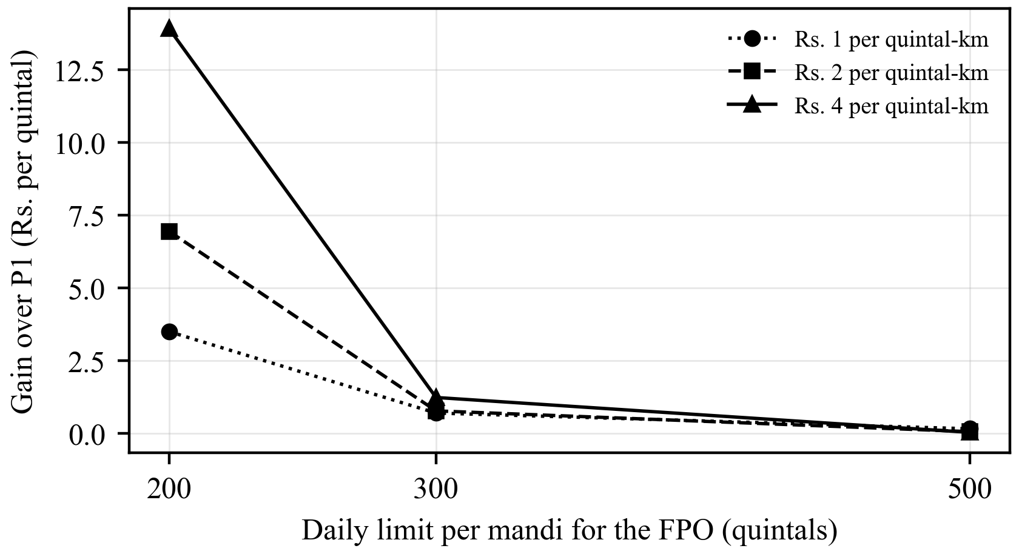
Fig. 4. Gain of the cooperative model (P3) over the nearest-mandi rule (P1) for different daily limits and transport costs (80 runs per point).
Because the settings above are assumptions, we repeated the test with transport costs of Rs. 1, 2 and 4 per quintal per kilometre and daily limits of 200, 300 and 500 quintals (Fig. 4). The gain depends mainly on how tight the daily limit is. With a limit of 500 quintals, the nearest-mandi rule was already almost optimal (gain of Rs. 0.15 per quintal or less). With a limit of 200 quintals, the cooperative model gained Rs. 3.49, 6.94 and 13.91 per quintal at the three transport costs, and it cut the average distance from 19.9 km to about 16.5 km.

4.4 Discussion and Limitations
For this first version, the main lesson is simple. For an MSP crop such as Paddy (Common) in Punjab, mandi prices are almost fixed by policy, so a complex forecaster adds nothing, and the announced MSP should be used as the price. The value of KisanNiti for such crops lies in coordination: spreading deliveries across mandis and days so that limits are respected and travel is reduced. The forecasting branch is more likely to matter for crops whose prices are set by the market, such as basmati paddy or wheat that farmers hold after harvest, and testing it on those crops is the next step.
The study has clear limits. The price data cover one crop, one state and only the September to December period of six seasons. The modal price published for a mandi is not the exact price a given farmer receives. The FPO, its lots, the transport rate, the road factor, the waiting cost and the daily limits are synthetic, so the allocation gains show what the model can do under these settings, not what a real FPO will earn. The storage node has been tested only in simulation. Finally, the historical test cannot show how traders or mandis would react if many farmers followed the plan.

5 Conclusion and Future Work
This paper presented KisanNiti, a framework that helps an FPO decide where, when and how much of its members' produce to sell. It joins three parts: a mandi-network price forecaster based on A3T-GCN, a low-cost storage-sensing node built around an ESP32, and an integer program that assigns farmer lots to mandis and days while sharing each mandi's daily limit. We tested the forecasting and allocation parts on real AGMARKNET prices for Paddy (Common) from 20 Punjab mandis over 2020–2025.
Two findings stand out. First, for this crop the MSP fixes the price almost completely: more than 96% of the reported prices were equal to the MSP in every season, and the announced MSP was a better forecast than every learned model, including A3T-GCN. A forecasting system for FPOs should therefore check whether a crop is sold at the MSP before it uses a learned model, and use the announced MSP when it is. Second, the cooperative allocation model always respected the shared daily limits, while independent choices broke them in every run. Its gain over sending each lot to the nearest mandi was small when the limits were loose (Rs. 0.79 per quintal) and grew to Rs. 3.5–13.9 per quintal when they were tight. For MSP crops, then, the main value of KisanNiti is coordination rather than price prediction.
Several steps remain. The most important is to test the forecaster on crops whose prices are set by the market, such as basmati paddy and wheat held after harvest, where timing and mandi choice can matter more; this needs a longer and wider AGMARKNET extract than we could obtain for this study. Next, the storage node will be assembled and calibrated against measured grain samples, so that a storage-condition term can be added to the allocation model in a tested way. The model should also include the effect of market arrivals on price once that effect has been measured for the selected mandis. The synthetic FPO used here should be replaced with real member records, transport quotes and mandi handling limits from a partner FPO, and the plan should be checked against what farmers actually earn. Finally, the selling plan will be delivered to farmers as short messages in their own language, with a simple explanation of each recommendation [16], and its usefulness will be studied with FPO staff and members.
References
1. Small Farmers' Agribusiness Consortium (SFAC): Frequently Asked Questions: Farmer Producer Organisations. https://sfacindia.com/fpofaq.aspx, last accessed 2026/10/15
2. Gulati, A., Das, R., Winter-Nelson, A.: Reducing Post-Harvest Losses in Indian Agriculture: A Case Study of Selected Crops. Policy brief, ICRIER, New Delhi (2024). https://icrier.org/publications/reducing-post-harvest-losses-in-indian-agriculture-a-case-study-of-selected-crops/, last accessed 2026/10/15
3. Manogna, R.L., Dharmaji, V., Sarang, S.: Enhancing agricultural commodity price forecasting with deep learning. Sci. Rep. 15, 20903 (2025). https://doi.org/10.1038/s41598-025-05103-z
4. Directorate of Economics and Statistics, Ministry of Agriculture and Farmers Welfare: Minimum Support Prices (According to Crop Year), as on 22.01.2025. https://desagri.gov.in/wp-content/uploads/2025/02/MSP_for-website_English-version.pdf, last accessed 2026/10/15
5. Directorate of Economics and Statistics, Ministry of Agriculture and Farmers Welfare: Minimum Support Price (Marketing Season-wise), as on 28.05.2025. https://desagri.gov.in/wp-content/uploads/2025/08/MSP-Statement_English.pdf, last accessed 2026/10/15
6. Nayak, G.H.H., Alam, M.W., Singh, K.N., Avinash, G., Kumar, R.R., Ray, M., Deb, C.K.: Exogenous variable driven deep learning models for improved price forecasting of TOP crops in India. Sci. Rep. 14, 17203 (2024). https://doi.org/10.1038/s41598-024-68040-3
7. Özden, C., Bulut, M.: Spectral temporal graph neural network for multivariate agricultural price forecasting. Ciênc. Rural 54(1), e20220677 (2024). https://doi.org/10.1590/0103-8478cr20220677
8. Min, Y., Kim, Y.R., Hyon, Y., Ha, T., Lee, S., Hyun, J., Lee, M.R.: RNN and GNN based prediction of agricultural prices with multivariate time series and its short-term fluctuations smoothing effect. Sci. Rep. 15, 13681 (2025). https://doi.org/10.1038/s41598-025-97724-7
9. Islam, M.S., Sadmani, S., Ali, M.R., Sayem, N.S., Islam, M.H., Hanif, M.A., Alam, M.M.: Remotely controlled smart monitoring system of hermetic paddy storage to reduce postharvest losses in Bangladesh. Smart Agric. Technol. 8, 100468 (2024). https://doi.org/10.1016/j.atech.2024.100468
10. Anukiruthika, T., Jayas, D.S.: AI-driven grain storage solutions: exploring current technologies, applications, and future trends. J. Stored Prod. Res. 111, 102588 (2025). https://doi.org/10.1016/j.jspr.2025.102588
11. Zhao, L., Song, Y., Zhang, C., Liu, Y., Wang, P., Lin, T., Deng, M., Li, H.: T-GCN: a temporal graph convolutional network for traffic prediction. IEEE Trans. Intell. Transp. Syst. 21(9), 3848–3858 (2020). https://doi.org/10.1109/TITS.2019.2935152
12. Bai, J., Zhu, J., Song, Y., Zhao, L., Hou, Z., Du, R., Li, H.: A3T-GCN: attention temporal graph convolutional network for traffic forecasting. ISPRS Int. J. Geo-Inf. 10(7), 485 (2021). https://doi.org/10.3390/ijgi10070485
13. Urra-Calfuñir, B.A., Monardes-Concha, C.A., Miranda-González, P.A.: Agri-food supply chain optimization through a decentralized production process in the olive oil industry. Comput. Ind. Eng. 192, 110185 (2024). https://doi.org/10.1016/j.cie.2024.110185
14. Gámez-Albán, H.M., Guisson, R., De Meyer, A.: Optimizing the organization of the first mile in agri-food supply chains with a heterogeneous fleet using a mixed-integer linear model. Intell. Syst. Appl. 23, 200426 (2024). https://doi.org/10.1016/j.iswa.2024.200426
15. Anoop, K.P., Panicker, V.V., Siby, J., Aryadutt, C.S.: Multi-objective optimization algorithms for freight allocation in a food grain supply chain. Appl. Soft Comput. 171, 112729 (2025). https://doi.org/10.1016/j.asoc.2025.112729
16. Shams, M.Y., Gamel, S.A., Talaat, F.M.: Enhancing crop recommendation systems with explainable artificial intelligence: a study on agricultural decision-making. Neural Comput. Appl. 36, 5695–5714 (2024). https://doi.org/10.1007/s00521-023-09391-2
17. Directorate of Marketing and Inspection, Ministry of Agriculture and Farmers Welfare: AGMARKNET – Agricultural Marketing Information Network. https://agmarknet.gov.in, last accessed 2026/10/15
18. OpenStreetMap contributors: Nominatim geocoding service. https://nominatim.openstreetmap.org, last accessed 2026/10/15
19. Canadian Grain Commission: Protect the quality of your stored grain from insect infestations and mould. News release (13 September 2017). https://www.canada.ca/en/grain-commission/news/2017/09/protect_the_qualityofyourstoredgrainfrominsectinfestationsandmou.html, last accessed 2026/10/15
20. Espressif Systems: ESP32 Series Datasheet, Version 5.3. https://www.espressif.com/sites/default/files/documentation/esp32_datasheet_en.pdf, last accessed 2026/10/15
21. Aosong Electronics: Digital-output relative humidity & temperature sensor/module DHT22 (AM2302). Datasheet. https://cdn.sparkfun.com/assets/f/7/d/9/c/DHT22.pdf, last accessed 2026/10/15
22. Maxim Integrated: DS18B20 Programmable Resolution 1-Wire Digital Thermometer. Datasheet. https://cdn.sparkfun.com/datasheets/Sensors/Temp/DS18B20.pdf, last accessed 2026/10/15
23. Wokwi: ESP32 simulator. https://wokwi.com, last accessed 2026/10/15
24. Huangfu, Q., Hall, J.A.J.: Parallelizing the dual revised simplex method. Math. Program. Comput. 10(1), 119–142 (2018). https://doi.org/10.1007/s12532-017-0130-5
25. Virtanen, P., Gommers, R., Oliphant, T.E., et al.: SciPy 1.0: fundamental algorithms for scientific computing in Python. Nat. Methods 17(3), 261–272 (2020). https://doi.org/10.1038/s41592-019-0686-2

