KisanNiti: Cooperative Post-Harvest Selling for Farmer-Producer Organisations with Mandi Price Forecasting, Storage Sensing, and Fair Allocation
Arijit Singh, Tushar Garg, Hitesh Mehandiratta, Namya Gautam, and Harkiran Kaur
Thapar Institute of Engineering and Technology, Patiala, Punjab, India
{asingh28_be23,tgarg3_be23,hhitesh_be23,ngautam_be23}@thapar.edu
harkiran.kaur88@gmail.com
Abstract
A Farmer-Producer Organisation must decide where, when, and how much of its members’ produce to sell, yet price forecasting, storage monitoring, and logistics are usually handled by separate tools. KisanNiti brings them together in the order a manager works: prices and farmer records are collected and cleaned, a selling plan is proposed and reviewed, each farmer is told in their own language, and the actual sales are recorded. In Punjab, at least 96.1% of the Paddy (Common) prices reported in every season from 2020 to 2025 were exactly the minimum support price, and simply predicting that price gave the lowest error (1.26 Indian Rupees per quintal). Basmati has no support price. Eight forecasting methods were compared on it under a protocol frozen before testing, and on the held-out season none of them beat the naive forecast at 1, 7, or 14 days once multiple comparisons were accounted for. An exact fair-allocation model raised the smallest share sold by any farmer from 0.0% under the nearest-mandi rule to 68.6%, across 60 synthetic plans priced with real market data, at a cost of 5.70 Indian Rupees per quintal. The complete system passed 1,373 automated tests and a 14-step end-to-end run on fictional organisation data.
Keywords: Farmer-Producer Organisations $⋅$ Mandi price forecasting $⋅$ Minimum support price $⋅$ Fair allocation $⋅$ Integer programming

1 Introduction
A Farmer-Producer Organisation (FPO) is a registered body of farmers that can pool, market, and sell its members’ produce [28]. Selling for the group means choosing a mandi, a day, and a quantity for each member’s lot, and these choices are linked. The best-paying mandi may be the farthest one. Waiting for a better price keeps grain in storage longer. When many members bring grain in the same week, a single mandi can receive more than it can handle in a day. Storage is also one of the causes of India’s post-harvest losses, which a 2024 estimate of the Indian Council for Research on International Economic Relations put at about 1.53 trillion Indian Rupees (Rs) of food a year [13].
Most of the price information an FPO needs is public. The Agricultural Marketing Information Network (AGMARKNET) [9] publishes the daily arrivals and the minimum, maximum, and modal price reported by each mandi. The government announces a minimum support price (MSP) for paddy and wheat before each season [8][7]. How much prices move depends on the crop. In the 20 Punjab mandis studied here, at least 96.1% of the Paddy (Common) prices reported in every season from 2020 to 2025 were exactly the Grade-A MSP. Basmati paddy has no MSP. It sells at market prices that differ by variety, so for a basmati farmer the choice of mandi and day changes what the crop earns.
KisanNiti is a decision-support system for FPO staff around Patiala. It reads AGMARKNET prices [9], the FPO’s lot records, and a grain-storage sensor, proposes a selling plan, lets a manager review it, and tells each farmer in their own language. The paper makes five contributions. A simple regime test, the share of reported prices equal to the MSP, separates price-bound crops from market crops (Section 4.1). For basmati, eight forecasting methods were compared under a protocol fixed in advance and evaluated once on a held-out season (Section 4.2). An exact allocation model shares the daily mandi limits fairly among members and is compared with simpler rules (Section 4.3). A storage-sensing rule is evaluated on simulated scenarios (Section 4.5). Finally, the five stages from data to recorded sales are built and tested as a single system (Section 4.6). Section 5 concludes the paper and outlines future work.

2 Related Work
Price forecasting. Most Indian studies take daily or monthly AGMARKNET prices [9] and compare one model family with autoregressive integrated moving average (ARIMA) models. The largest comparison covers 23 commodities in 165 markets from 2010 to 2024. In it, long short-term memory (LSTM) and gated recurrent unit (GRU) networks had the lowest errors [21]. Incorporating rainfall and temperature improved deep learning forecasts of tomato, onion, and potato prices [23]. Two studies are closer to the crops here. Bhoi et al. fitted six time-series models to monthly basmati prices from 74 Punjab markets and reported the forecasts as probability bands [5]. Balantrapu et al. studied prices anchored to the MSP and found that for wheat a naive forecast was almost as good as their best model [4]. Closest in user context, Ladhar et al. built a system for Indian farmer collectives that uses forecast ranges to recommend when to sell a pooled lot, and field officers tracked it in 16 cooperatives over five months [19]. It does not allocate sales across members or apply a fairness rule. Graph models forecast many related series at once [26][22]; the temporal graph convolutional network (T-GCN) and the attention temporal graph convolutional network (A3T-GCN) were built this way for traffic [31][3].
Storage and sensing. Measured farm storage losses in North India are small in the first months after harvest. They were 0.39 to 0.50% for wheat in Madhya Pradesh and zero for paddy in Punjab, where farmers sell soon after harvest, and they are expected to rise after about three months [12]. Low-cost monitors log temperature and humidity and raise alarms [17]. None of these systems passes its readings on to a selling decision.
Allocation and fairness. Mixed-integer models already plan agricultural logistics for small growers, cooperatives, and food-grain freight [29][1]. They minimise cost or maximise profit and do not consider how the gains are shared. Leximin (lexicographic max-min) methods address exactly that [24][6], and they have been used to allocate school classrooms with real data [18]. None of the agricultural allocation papers read for this study used a fairness criterion.
Advice to farmers. Evidence on phone-based advice is mixed. In 100 Maharashtra villages, Short Message Service (SMS) price and weather messages produced no significant change in the prices farmers received [11].
Table 1 lists only what each paper reports. Across the studies reviewed, price forecasting, storage monitoring, and allocation were studied separately. No study fed a forecast into a plan that shares mandi capacity among the members of an FPO, and none combined such a plan with a fairness rule or with a manager’s approval before farmers are told. KisanNiti targets this combination in Punjab, where basmati is the main crop sold at market prices and nearly all reported prices of common paddy equal the MSP.
Table 1. Features reported by representative studies and built in KisanNiti (Y: reported; –: not reported in what was read). D: Indian mandi data; M: MSP check; R: forecast ranges; H: hold-or-sell with storage cost; S: storage sensing in the decision; C: shared mandi capacity; F: fairness criterion; A: manager approval; W: farmer messages. KisanNiti ranges come from baseline forecasts.
Study | D | M | R | H | S | C | F | A | W
Manogna et al. [21] | Y | – | – | – | – | – | – | – | –
Bhoi et al. [5] | Y | – | Y | – | – | – | – | – | –
Balantrapu et al. [4] | Y | Y | – | – | – | – | – | – | –
Anoop et al. [1] | – | – | – | – | – | Y | – | – | –
Kurokawa et al. [18] | – | – | – | – | – | – | Y | – | –
Fafchamps and Minten [11] | – | – | – | – | – | – | – | – | Y
KisanNiti (Proposed) | Y | Y | Y | – | Y | Y | Y | Y | Y

3 System Design and Methods
Figure 1 shows the KisanNiti architecture. It follows the order in which an FPO manager works. (1) Farmer records, mandi prices, and storage readings are collected and cleaned. (2) A forecast, a storage assessment, and a fair allocation produce a proposed plan. (3) The manager reviews the plan, edits it, and approves or rejects it. (4) Each farmer is told about the plan in their own language. (5) Replies and actual sales are recorded and compared with the plan.
Five design rules apply at every stage. Raw facts, derived values, proposals, human decisions, and actual outcomes are stored separately. Quantities and money are kept exact, in grams and paise, and never as floating-point numbers. Each FPO sees only its own data, which is enforced both in the queries and in the database. Every change is an append-only record that names its author. Every failure is explicit: a missing contact, consent, or language blocks a message with a stated reason, and nothing is guessed.
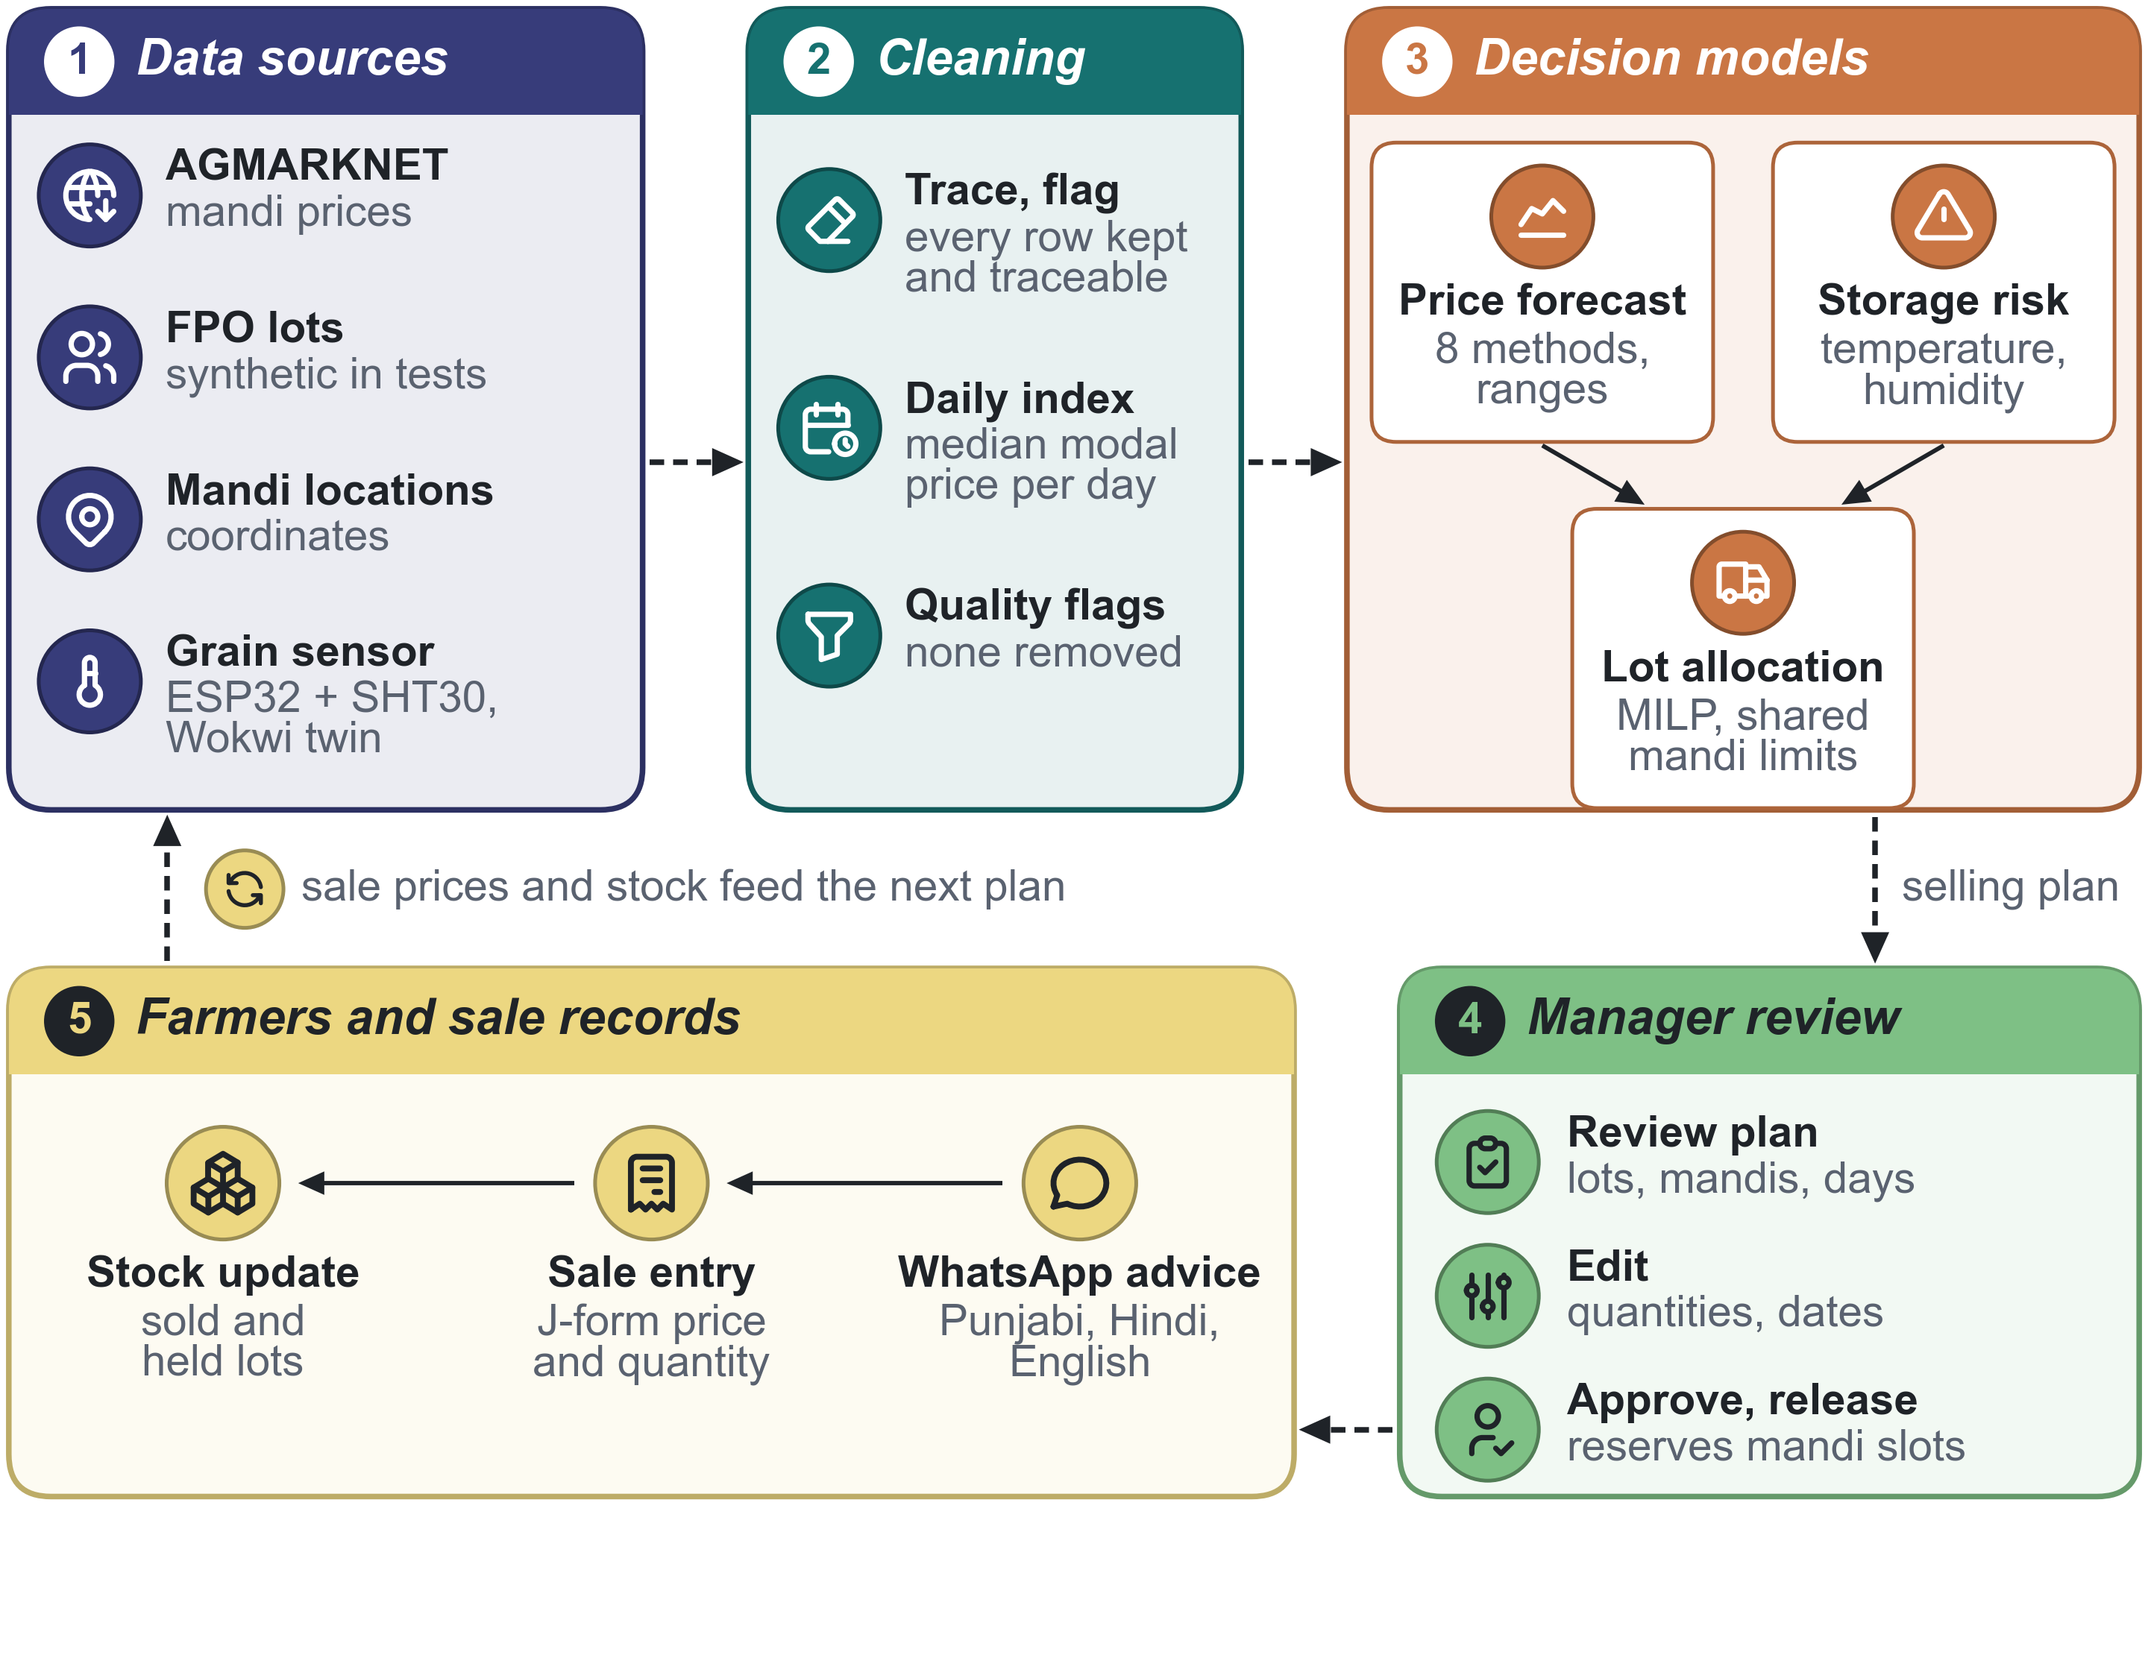
Fig. 1. KisanNiti architecture. Data sources (1), including AGMARKNET prices [9] and mandi coordinates [25], are cleaned into a daily price panel (2). Decision models (3) turn prices, storage readings, and lot records into a plan that the FPO manager reviews (4). Farmers receive the approved plan on WhatsApp, and recorded sales update stock for the next plan (5). MILP: mixed-integer linear program.

3.1 Stage 1: Data and Cleaning
Prices come from the AGMARKNET report Date Wise Prices for Specified Commodity [9]. The portal asks for a Completely Automated Public Turing test to tell Computers and Humans Apart (CAPTCHA), so the files were downloaded by hand, one month at a time, and 29 monthly files of Paddy (Basmati) for Punjab are stored with checksums. The parser records the source file and line of every row, so each cleaned row can be traced back to the portal. The files hold 6,678 rows, 6,098 with a date and 580 without one, and every row is accounted for. Automatic checks flag suspicious rows but remove none. Where the portal lists a variety under the date of the row above, the date is inferred and flagged.
For each variety, the daily index is the median modal price over the mandis that reported the variety that day. At least three mandis are needed, and missing days are not filled in. The index summarises the market; it is not the price that any one farmer received. Farmer records, namely members, lots with exact quantities, and an append-only stock ledger, are entered by FPO staff. Sensor readings are assessed every hour (Section 3.3).
The cleaned data enter the system marked as pending. They are marked as validated only after the authors sign off a hand check against the portal. For this check, 56 stratified rows were read on the live portal by automated browser scripts, with the CAPTCHAs entered by the authors. All 56 modal prices agreed. In 33 rows every field agreed, 20 rows differed only in arrivals, and 4 showed a missing bound as 0.00. An independent second pass re-read 26 rows and found 26 of them identical. The sample was chosen on purpose, so it does not estimate an error rate. The portal splits the total arrivals of a date over the variety rows, not always equally, which makes exported arrivals hard to interpret; for this reason the index uses modal prices only. Of the 22 rows with an inferred date, 21 appear on the portal beneath the preceding date with the same prices, and the page markup contains no merged cells.

3.2 Stage 2: Forecasting, Storage Risk, and Fair Allocation
Regime test. For each crop and season, the share of reported prices equal to the announced MSP is computed. A high share marks a price-bound crop. For such a crop the MSP is used as the price, and no forecaster is trained.
Pre-registered forecast comparison. Basmati is studied through two varieties, Pusa Basmati 1121 and Pusa Basmati 1509 (called 1121 and 1509 below). Their index is forecast 1, 7, and 14 calendar days ahead. A 28-day horizon is a secondary outcome, and 60 days is reported only descriptively. The seasons are used in time order: 2021–22 to 2023–24 for initial training, 2024–25 for tuning and calibration, and 2025–26 as the held-out season, evaluated once. September and October 2026 form a separate, partial check. Each forecast uses only data up to its origin day, and an origin needs ten index days of its season.
The eight methods were fixed beforehand. Three are simple: the last value (the naive forecast), a seasonal naive value, and a five-day average. The other five are exponential smoothing (ETS), ARIMA, the light gradient-boosting machine (LightGBM), a small GRU, and the pretrained Chronos-2 model [2] used zero-shot. Every method also gives 80% and 95% ranges, taken from analytic intervals, quantile objectives, split-conformal residuals, or the model’s own quantiles.
Accuracy is measured by the mean absolute error (MAE) in Rs per quintal and by the mean absolute scaled error (MASE). Each method is compared with the naive forecast by a Diebold–Mariano test with the Harvey–Leybourne–Newbold (HLN) correction. The $p$-values are Holm-corrected over all 42 comparisons, and a block bootstrap gives an interval for the relative change in MAE. A method counts as better only if three conditions hold: the adjusted $p<0.05$, the interval excludes zero, and the gain is larger than the smallest gain the sample can detect (13.3% for 1121 and 17.2% for 1509). Otherwise the system keeps the naive forecast. The protocol was frozen before the run, and the code was first tested on synthetic series. The runner refuses to start before the freeze, after any change to the code or data, or for a second test run. Figure 2 summarises the protocol from the price files to the decision rule.
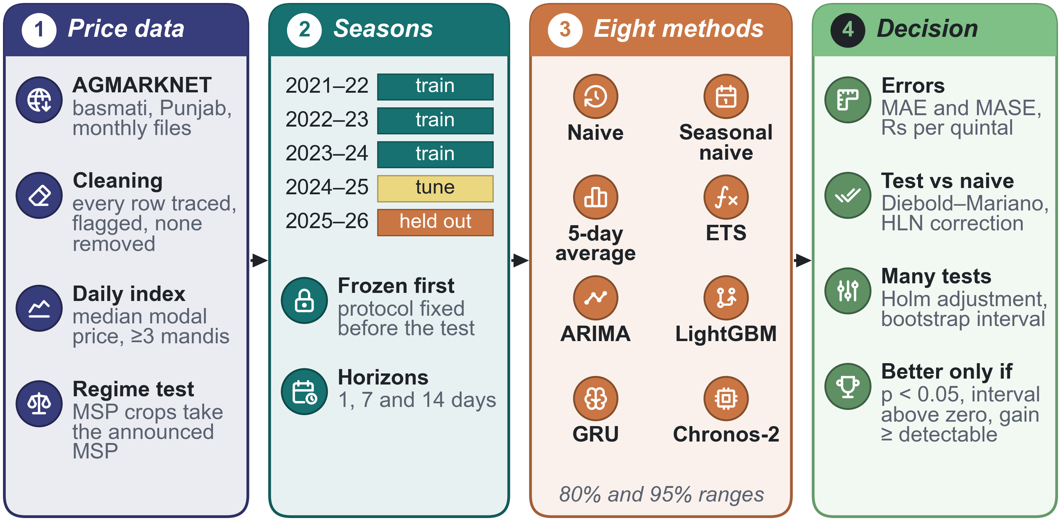
Fig. 2. Pre-registered basmati forecast comparison. AGMARKNET price files [9] are cleaned into a daily index (1); seasons are split in time order and the 2025–26 season is held out and run once, after the protocol is frozen (2); eight methods forecast 1, 7, and 14 days ahead with 80% and 95% ranges (3); and a method replaces the naive forecast only if it passes every part of the decision rule (4).
Fair allocation. A plan gives each lot a mandi, a day, and a quantity. Each mandi has a daily limit that all members share. An exact mixed-integer program works through a fixed order of goals. It first sells as much as possible. It then raises the smallest share sold by any farmer, then the next smallest, and so on, in leximin order. After that, lots at risk of spoilage get the earliest dates, net return is maximised, and any remaining ties are broken deterministically. An independent checker re-validates every plan, and on small cases a brute-force search confirms the solver’s answer.

3.3 Storage Sensing and Risk Rule
Figure 3 shows the storage node design and its data path. A protected SHT30 temperature and humidity probe [27] sits in a bag of grain and is read every five minutes by an ESP32 board [10]. Readings travel to the server over Message Queuing Telemetry Transport (MQTT) with Transport Layer Security (TLS). The board keeps a 24-hour buffer and drops a reading only after the server confirms that it has stored it once. The server assesses the readings every hour.
The rule rests on a simple physical fact. Grain exchanges moisture with the air between its kernels, and the relative humidity (RH) of that air, divided by 100, is the water activity $a_{w}$ of the grain. Storage fungi need at least 65 % RH [14], and grain kept below 65 to 70 % degrades slowly [20]. The rule takes the median humidity and temperature of the last 24 h. It returns LOW for $a_{w}<0.65$, MEDIUM for $0.65≤a_{w}<0.70$, and HIGH from $0.70$. The level rises at once, but it falls only after 48 h at least 2 points below the limit. The rule returns UNKNOWN, with its reasons, when the probe hangs in shed air, during the first 6 h, or when readings are old or missing. It tells whether the air in a bag favours mould and insects; it does not measure moisture content or detect spoilage. The same firmware runs unchanged on a Wokwi twin with an emulated SHT3x sensor [30], and the planner gives at-risk lots the earliest dates.
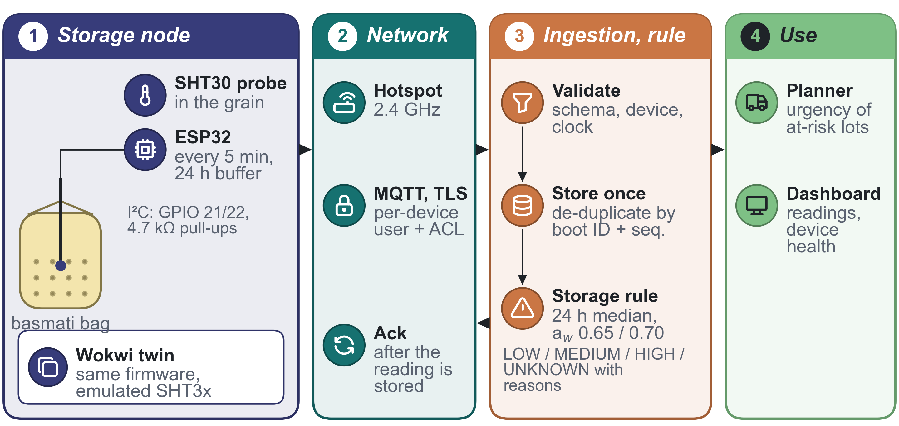
Fig. 3. Storage node and data path. The ESP32 reads the probe in the grain (1) and sends each reading over MQTT with TLS (2); the server validates it, stores it once, and applies the storage rule (3); and the planner and the manager app use the result (4). The same firmware runs on a Wokwi twin with an emulated SHT3x sensor [30]. ACL: access control list; I²C: inter-integrated circuit bus; GPIO: general-purpose input/output.

3.4 Stages 3 to 5: Review, Messages, Sales
A proposed plan is stored unchanged. When the manager edits it, the edit becomes a new revision, which is accepted only if the independent validator finds no violation. Approval needs the approve permission and an acknowledgement of every warning. It runs in a single database transaction that records the decision and reserves the exact quantities in the stock ledger. A reservation cannot exceed free stock, a plan cannot be approved twice, and when two plans compete for the same lot only one can succeed. These guarantees were tested with parallel requests on PostgreSQL.
After approval, one message per farmer is built from a versioned template in the farmer’s language (Punjabi, Hindi, or English). It contains only the approved facts, with no price and no promise. A message is prepared only for an active farmer with a phone number and consent to WhatsApp messages, and consent is checked again at sending. A preview channel shows the exact text without sending anything. Because the FPO has no messaging-platform account, sending is handed to the manager. The manager presses “Send to farmers”, confirms, and receives one link per farmer. Each link opens the manager’s own WhatsApp with the text already written; the manager sends it there and reports it as sent or not sent. The system cannot see delivery, so this report is stored as the manager’s statement and not as a delivery. Farmers’ replies are entered by staff and are never read as acceptance.
Sales are entered from the paper J-form, the sale receipt issued in Punjab mandis, with exact amounts rounded half to even. Duplicate form numbers are refused, and mistakes are voided by compensating records. A sale that follows the plan consumes its reservation. For an off-plan sale, the person entering it must choose which reservation to give up. The system then reports planned against actual quantity, price, and share for each farmer.

4 Results and Discussion

4.1 Paddy (Common): Prices Stay at the MSP
Table 2 describes the AGMARKNET prices [9] of the 20 Punjab mandis that reported in all six seasons. Together they give 4,626 mandi-days over 382 trading dates, or 60.5% of those possible. In 2024, 98.8% of the reported prices were exactly the Grade-A MSP of Rs 2,320 per quintal, and the mean daily standard deviation (SD) across mandis was only Rs 0.4. Even in the weakest season, 2023, the share was 96.1%.
Table 2. Paddy (Common) prices from AGMARKNET [9] in the 20 selected Punjab mandis, September to December of each season.
Season | MSP Grade A | Trading | Prices equal | SD of
 | (Rs per quintal) | dates | to MSP (%) | prices (Rs per quintal)
2020 | 1,888 | 70 | 98.3 | 44.3
2021 | 1,960 | 55 | 99.1 | 80.5
2022 | 2,060 | 60 | 98.5 | 16.5
2023 | 2,203 | 70 | 96.1 | 45.5
2024 | 2,320 | 66 | 98.8 | 29.5
2025 | 2,389 | 61 | 99.0 | 21.6
Seven forecasters were compared on the three latest seasons, 1 to 7 trading dates ahead. They were the MSP rule, which predicts the announced Grade-A MSP, the last reported price, a seven-date average, ridge regression, a GRU, T-GCN, and A3T-GCN. The MSP rule had the lowest MAE, Rs 1.26 per quintal, followed by the last price at Rs 1.77. A3T-GCN was the best learned model at Rs 2.36, slightly ahead of the GRU (Rs 2.51) and T-GCN (Rs 2.54).
One trading date ahead, A3T-GCN was worse than the last price on 158 of 158 dates. The reason is simple. When a mandi stays at the MSP, the last price is exactly right, and a neural network almost never predicts a change of exactly zero. The MSP rule and the last price were close: the MSP rule was better on 13 dates, worse on 19, and equal on 126. This comparison is descriptive and has no significance test. For Paddy (Common), KisanNiti therefore uses the announced MSP as the price and trains no forecaster.

4.2 Basmati Paddy: the Pre-Registered Forecast Comparison
The comparison was run once on the held-out season, after the protocol and its configuration had been frozen. Both freezes are timestamped in the version history of the public repository. The run uses the index built from dated rows only, so the portal inspection (Section 3.1) cannot change the primary result. Index days exist only from September to January, giving 433 index days for 1121 and 369 for 1509. With the ten-day rule for origins, the held-out season yields 68, 64, and 60 forecast pairs at 1, 7, and 14 days for 1121, and 62, 57, and 51 for 1509. For 1509 this is fewer than the 60 pairs first planned. At 28 days only 38 pairs remain, below the 40 needed for a coverage claim. An exploratory power check on earlier seasons put the smallest detectable improvement at 11 to 17% of the naive error.
The effect of cleaning was measured before any forecast was run. Four outlier screens were tried: a past-only median absolute deviation rule with $k=3$ and with $k=5$, a Hampel filter, and an interquartile rule. They flag between 2.2% and 8.8% of the dated rows. Removing the flagged rows would change 27 to 110 of the 433 index days of 1121, by up to Rs 770 per quintal, and the portal inspection cannot tell which flagged rows are real errors. The rows with inferred dates look plausible. For 486 same-day pairs of 1121 and 1509 in one market, where the second row has an inferred date, the median price ratio is 1.18. For 211 control pairs with their own dates, one day apart, it is 1.17, and the interquartile ranges are 0.14 and 0.17. Only 2 of the 519 inferred rows share their key with another row.
Table 3 gives the held-out MAE of each method and its change against the naive forecast.
Table 3. Held-out season 2025–26: MAE (Rs per quintal) at 1, 7, and 14 days for 1121 and 1509, and change in MAE against the naive forecast (%). No change was judged better by the pre-registered rule.
MAE | 1121 |  |  | 1509
Method | 1 d | 7 d | 14 d | 1 d | 7 d | 14 d
Naive | 107 | 107 | 144 | 62 | 112 | 148
Seasonal naive | 225 | 209 | 194 | 247 | 240 | 223
Five-day average | 87 | 111 | 160 | 81 | 98 | 160
ETS | 95 | 108 | 159 | 62 | 111 | 148
ARIMA | 100 | 122 | 178 | 65 | 115 | 162
LightGBM | 100 | 141 | 264 | 71 | 123 | 147
GRU | 80 | 106 | 168 | 76 | 104 | 167
Chronos-2 | 89 | 123 | 186 | 65 | 125 | 170
Change vs naive (%)
Seasonal naive | +110.7 | +100.4 | +34.8 | +296.7 | +113.5 | +50.6
Five-day average | -18.7 | +3.3 | +11.2 | +30.5 | -12.7 | +7.6
ETS | -10.7 | +1.1 | +10.3 | -1.0 | -1.7 | -0.2
ARIMA | -6.2 | +13.7 | +23.6 | +3.9 | +2.3 | +9.1
LightGBM | -5.9 | +31.5 | +83.7 | +14.3 | +9.4 | -0.8
GRU | -25.3 | -1.0 | +17.0 | +22.7 | -7.3 | +12.4
Chronos-2 | -16.7 | +14.6 | +29.2 | +4.6 | +11.4 | +14.8
Under the pre-registered rule, 0 of the 42 comparisons found a method better than the naive forecast. The largest raw improvement came from the GRU one day ahead for 1121, a change in MAE of -25.3% (Rs 80 against Rs 107). Its bootstrap interval excluded zero, but its Holm-adjusted $p$ was 0.252, so it does not count as better. Where a method did differ significantly from the naive forecast, it was worse. The seasonal naive forecast was significantly worse in 3 comparisons; for 1509 one day ahead its MAE changed by +296.7% (adjusted $p$ 0.000).
This does not mean that all methods are equal. In 30 of the 42 comparisons, the interval rules out an improvement as large as the smallest detectable gain. The other 12 are inconclusive rather than negative. They include all 6 non-seasonal methods one day ahead for 1121, where improvements of up to about a quarter are still consistent with the data (median interval width 33 points). For prices that move this little, the naive forecast is hard to beat. The system therefore uses it, together with ranges, and states that the baseline is sufficient.
The protocol also declared 5 variants of the index: with inferred dates included, with sub-yards merged, and with at least 2 or 4 mandis a day. Repeating the comparisons on all of them, with the configuration already chosen, gave the same picture. Across the 210 comparisons, 0 found a better method, and apart from the seasonal naive forecast no method differed significantly (0 cases).
The secondary and descriptive horizons are reported without tests. At 28 days, the GRU and LightGBM had a lower MAE than the naive forecast for 1121 (Rs 173 for the GRU against Rs 278). Both models use the day of the season as an input, so this is a hypothesis to test in later seasons, not a finding. The partly observed season 2026–27 was run separately and is reported descriptively. It gives only 6 pairs one day ahead for 1121 and 39 for 1509, falling to 26 at 14 days, which is too few for a test. For 1509 the naive forecast had the lowest MAE at 7 and 14 days (Rs 90 and Rs 137).
The 80% and 95% ranges were checked at the three primary horizons. The models’ own ranges, from ETS, ARIMA, LightGBM quantiles, and Chronos-2, were well calibrated in 37 of 48 cases, too wide in 7, and too narrow in 4. The split-conformal ranges did worse. They were calibrated on the residuals of a single, more volatile validation season, and they were well calibrated in only 13 of 60 cases and too wide in 47. One season is not enough to calibrate a range.

4.3 Allocation: Fair Plans Against Simple Rules
Before any comparison, the solver was checked against brute-force enumeration, which shares only the input types and the exact objective with it. On 324 random small instances, three solver back ends were run with two leximin methods: HiGHS [15], the Solving Constraint Integer Programs (SCIP) solver, and the constraint programming and Boolean satisfiability (CP-SAT) solver of Google OR-Tools. In 1,728 of 1,728 runs the solver reached exactly the objective found by enumeration.
The method was then compared with simpler rules on 60 weekly plans. The plans come from ten draws of a synthetic FPO with 300 members whose lots become ready over six weeks. They are scored with real 2025 AGMARKNET prices [9] of Paddy (Common) and real mandi coordinates [25], with road distance taken as 1.3 times the straight-line distance. Every plan is re-checked by the independent validator. Table 4 compares seven policies: the nearest mandi; each farmer’s independent best choice; a plan that maximises only total net return (utilitarian); a plan that maximises only the smallest share; a greedy water-filling heuristic; the KisanNiti hierarchy; and, as a bound, the same hierarchy run with actual rather than forecast prices.
Table 4. Selling policies on 60 synthetic plans at real 2025 prices. Valid: plans accepted by the independent validator (a plan is invalid if it exceeds a mandi’s daily limit). Net: mean net return (Rs per quintal). Min. share: smallest share of a lot sold, averaged over plans. Fairness price: net return given up against the utilitarian plan.
Policy | Valid (%) | Net | Min. share (%) | Gini | Fairness price | Solve (s)
Nearest mandi | 100 | 2,329.69 | 0.0 | 0.3125 | 14.99 | 0.00
Independent best | 0 | 2,360.49 | 100.0 | 0.0000 | – | 0.00
Utilitarian | 100 | 2,344.68 | 0.0 | 0.3087 | 0.00 | 0.07
Max-min only | 100 | 2,339.87 | 68.6 | 0.0019 | 4.81 | 0.57
Greedy | 100 | 2,330.60 | 68.6 | 0.0019 | 14.08 | 0.07
KisanNiti | 100 | 2,338.98 | 68.6 | 0.0019 | 5.70 | 4.94
Actual-price bound | 100 | 2,338.98 | 68.6 | 0.0019 | 5.70 | 5.07
When each farmer chose independently, a mandi’s daily limit was broken in 100% of the plans, so none of these plans was valid. The nearest-mandi rule respects the limits, but its least-served farmer sold only 0.0% of their lot. The utilitarian plan did no better (0.0%), because maximising the total ignores who is left out. The KisanNiti hierarchy raised the smallest share to 68.6%, the most that the mandi limits allow, with a Gini coefficient of 0.0019. This fairness cost Rs 5.70 per quintal against the utilitarian plan. The greedy rule reached the same smallest share but gave up Rs 14.08 per quintal.
Using actual rather than forecast prices changed nothing. This was expected, because prices of Paddy (Common) hardly differ between mandis (Section 4.1); distance, limits, and fairness decide the plan. Of the 240 exact solves, 240 were proven optimal. Three weighted-sum alternatives hit the 300-second limit without proving optimality in a six-plan pilot, so they are left out of Table 4. Because the FPO is synthetic, these results describe how the method behaves, not a gain for any real farmer.
The transport rate and the daily limit are assumed values, so the comparison was repeated for 9 combinations of three rates (Rs 1, 2, and 4 per quintal-km) and three limits (200, 300, and 500 quintals per mandi-day). Figure 4 shows the results. The KisanNiti plan was valid in every setting. The smallest share it secures rises with the limit, from 45.67% to 98.17%, because no plan can sell more than the mandis can take, and it does not depend on the rate. Compared with the nearest-mandi rule, the KisanNiti plan gains Rs 3.81 to Rs 19.19 per quintal, and its price of fairness ranges from Rs 0.74 to Rs 17.15. The price of fairness grows with the transport rate. The greedy heuristic gave up more net return than the exact plan in 9 of 9 settings. The nearest-mandi rule left at least one farmer with no sale whenever the limit was 300 quintals or less.
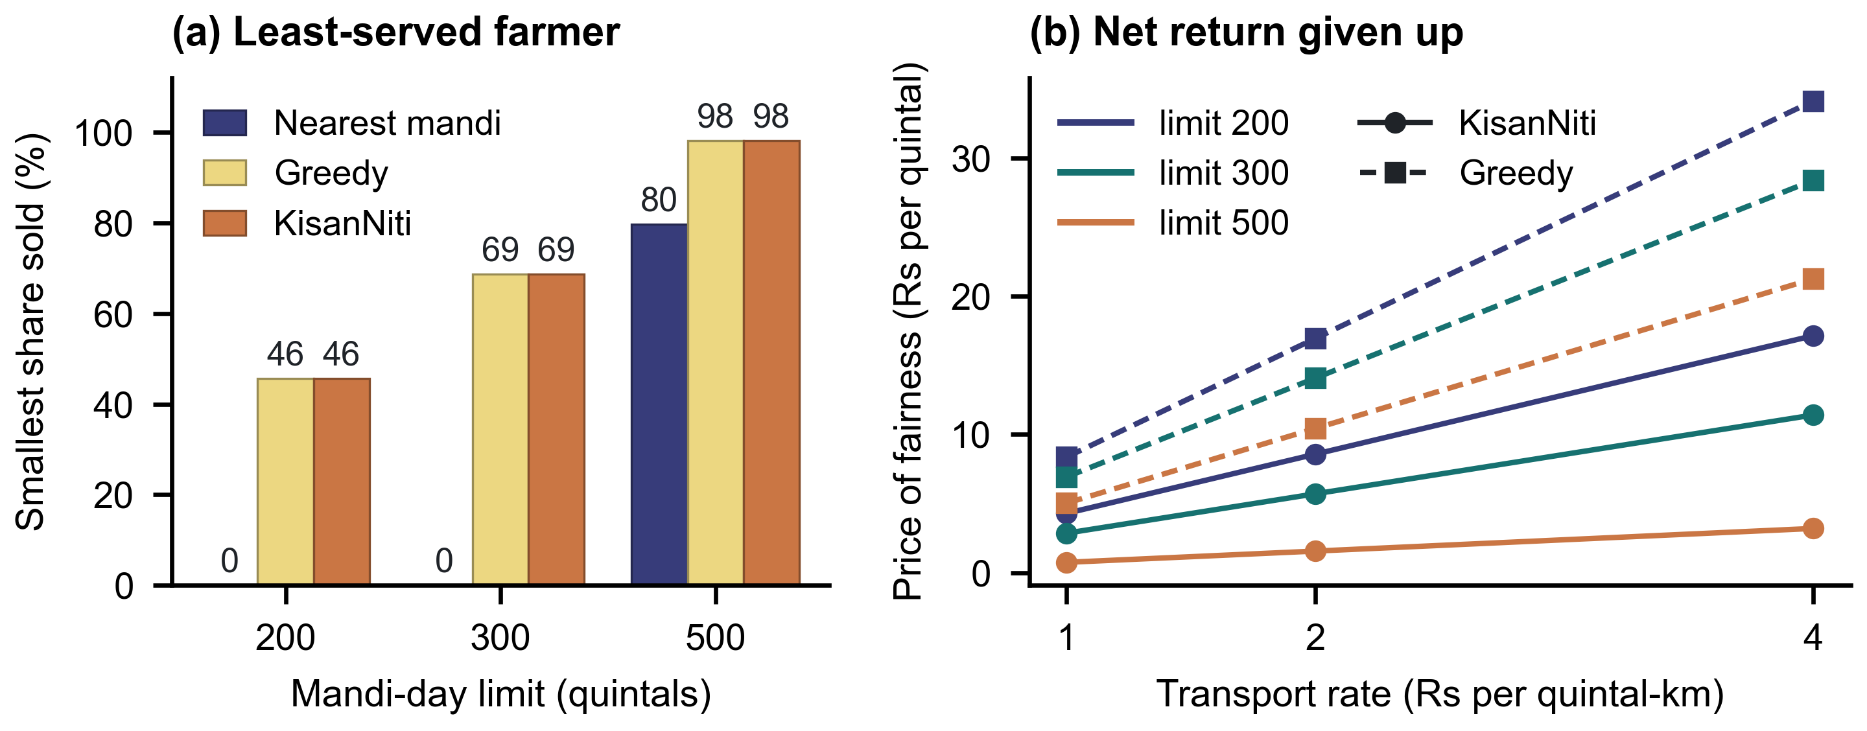
Fig. 4. Allocation under nine settings of transport rate and mandi-day limit, 60 synthetic plans each. (a) Smallest share of a lot sold; it is the same for every transport rate. (b) Net return given up against the utilitarian plan (price of fairness) by the exact KisanNiti plan (solid) and the greedy heuristic (dashed).
Solve times were measured on random instances with 10 to 1,000 farmers, 5 to 25 mandis, and 3 to 14 days, with a 60-second limit and three seeds each. HiGHS and SCIP proved optimality on every instance with up to 100 farmers; at 100 farmers their median times were 22.14 and 36.85 seconds. At 300 and 1,000 farmers they reached the time limit with a feasible plan. CP-SAT proved optimality only at 10 farmers, because its integer scaling grows too large beyond that. The greedy heuristic needed under 0.23 seconds even at 1,000 farmers, and every plan a solver returned was valid. The 300-member synthetic FPO above was solved exactly in 4.94 seconds on average (maximum 37.6). Instance structure clearly matters, so larger or less regular FPOs should be solved with a time limit and the greedy plan as a fallback.

4.4 Checking the Manager’s Edits
A manager’s edit should be accepted exactly when it keeps the plan valid. To test this, a second checker was written directly from the rules: choices must be admissible, lines must not repeat, quantities must come in whole increments, no lot may be over-allocated (or left over when the whole lot must be sold), and no mandi may exceed its limit. The edits were made at random on 500 solved instances and ranged from harmless changes to a single broken rule; 1,052 were valid and 3,379 invalid. The second checker gave the same verdict as the independent validator on 4,431 of the 4,431 edits.

4.5 Storage Rule on Simulated Scenarios
The rule was evaluated on 6 simulated scenarios built from the monthly climate normals of the India Meteorological Department station at Patiala [16]. Each scenario was run with 20 noise seeds and with sensor biases of $±2$ %RH. Without bias, the rule agreed with the intended category in 88–100 % of known hours in the four in-grain scenarios, and it changed category at most 0.7 times a week. A rule that uses only the latest reading changed category 1.4–19.1 times a week, and shed-air humidity was a poor stand-in for the grain. The 24-hour median has two costs. It is slower, reporting HIGH about 12 h late, and it returns UNKNOWN more often. A sensor error of $±2$ %RH mattered as much as the choice of rule and caused up to 29 % false HIGH hours, so every sensor needs a salt calibration before its readings are used. These tests measure how far noise and shortcuts move the rule away from its definition. The definition itself rests on the storage literature [14][20].

4.6 The Built System
The system has 1,373 automated tests. Among other things, they cover parallel approvals on PostgreSQL, isolation between FPOs, append-only records, and the exact text of every message. The system also has 12 versioned contracts with 137 valid and 223 invalid examples.
A single command runs 14 steps on two new fictional FPOs through the same interface that the website uses. The steps cover data, stock, a simulated sensor, the plan, an edit, approval, messages, the manager’s hand-over to WhatsApp, sales, release, a ledger audit, and isolation. Each step is checked against an independent recomputation, and the run stops at the first deviation. It passed all 14 steps in about 11 seconds. Faults planted on purpose were each detected: a corrupted ledger entry, rounding down, a wrong weighted price, and a message missing its last character. All farmers, lots, and sales in this run are fictional, and no message went to a real farmer. The English, Punjabi, and Hindi message texts were checked by independent reviewers. Figure 5 shows three screens of the manager app after this run: the approved revision of a plan, the approved plan as a Punjabi message to one farmer, and the planned against the actual sale.
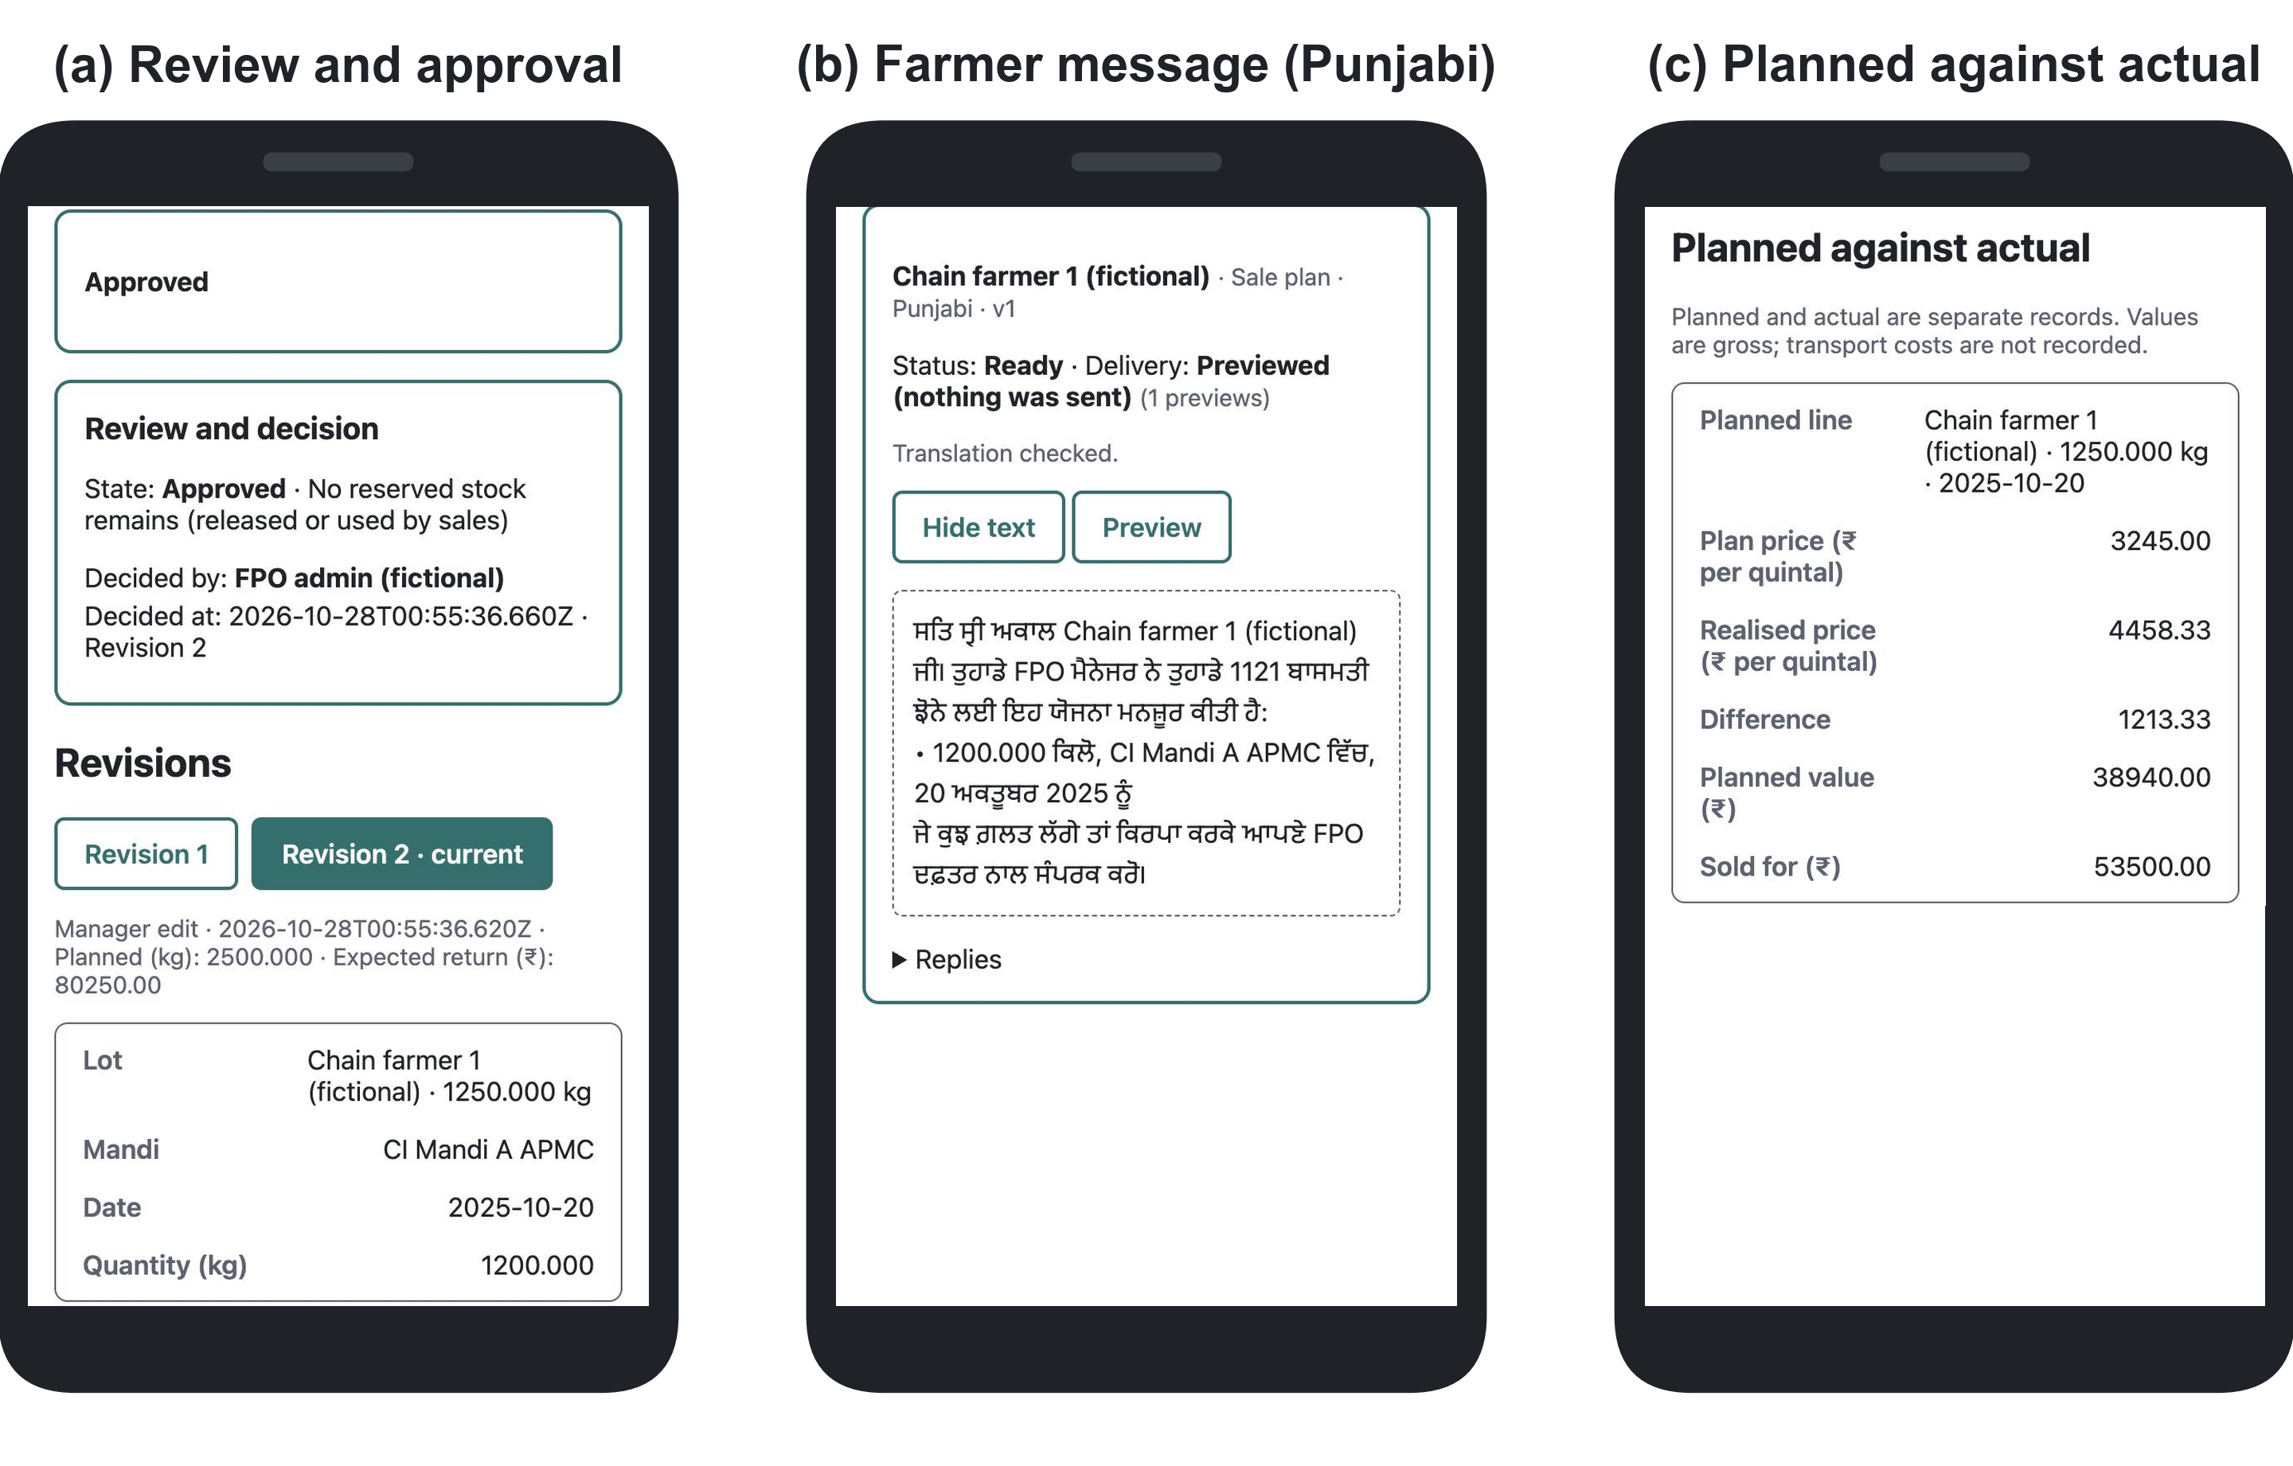
Fig. 5. Manager app on a phone after the end-to-end run on a fictional FPO. (a) The manager’s edit is stored as revision 2 and approved. (b) The approved plan written in Punjabi for one farmer, built from a reviewed template. (c) The sale recorded from the J-form, compared with the plan.

5 Conclusion and Future Work
Whether an FPO gains from price forecasting depends on who sets the price. For Paddy (Common) in Punjab, the price is set by policy. The announced support price was the most accurate forecast, no learned model beat the last price, and the useful work is to share mandi limits fairly. In the synthetic experiment, the exact allocation raised the smallest share sold by any farmer from 0.0% to 68.6%, and it gave up less net return than a greedy rule. Basmati is sold at market prices, and for basmati the forecast comparison was fixed in advance. Its result is negative: on the held-out season, none of the eight methods beat the naive forecast at 1, 7, or 14 days once multiple comparisons were accounted for (Section 4.2). The naive forecast is therefore enough for the system, although a short-horizon gain for 1121 cannot be ruled out. All five stages, from data to recorded sales, were built as a single system and tested end to end.
Scope. The price index is a market summary rather than the price a farmer received. It covers September to January over five seasons, so only large forecast gains can be detected. The portal check covers 56 stratified rows, and there is no second source against which the portal itself could be checked. The allocation experiment uses a synthetic FPO, so it shows how the method behaves rather than how much a real farmer would gain, and the storage rule and node firmware were evaluated on simulated scenarios and the Wokwi twin rather than in stored grain. Wheat held after procurement is outside the scope, because Punjab mandis report too few wheat prices outside the procurement season.
Future work. The system can be extended with a one-week sensor run in stored grain, hold-or-sell advice that uses the forecast ranges, and the allocation comparison with basmati prices and measured transport costs. A deployment with one FPO, subject to ethics approval, can add a comprehension test of the messages with farmers, delivery tracking through a messaging-platform account, a review of the off-plan sale rule with FPO staff, and a legal review of privacy.
Acknowledgments. No funding is declared for this work.
Use of Artificial Intelligence Tools. Claude (Anthropic), a large language model, was used to draft and revise the text from the result files, to write the analysis, figure, and table code, and to run consistency checks. Every number in the text is generated by a script from a results file, and the scripts that re-check the stated numbers and the bibliography are in the public repository. The authors are responsible for the content of this paper.
Data and Code Availability. The research code, result files, and the pre-registered protocol with its timestamped version history are available at https://github.com/Arijit2772-dev/kisaniti_research_paper. AGMARKNET prices are public [9]; all farmers, lots, and sales in the system experiments are synthetic.
Disclosure of Interests. No competing interests are declared that are relevant to the content of this article.

References
- Anoop, K.P., Panicker, V.V., Siby, J., Aryadutt, C.S.: Multi-objective optimization algorithms for freight allocation in a food grain supply chain. Applied Soft Computing 171, 112729 (2025). https://doi.org/10.1016/j.asoc.2025.112729
- Ansari, A.F., Shchur, O., Küken, J., Auer, A., Han, B., Mercado, P., Rangapuram, S.S., Shen, H., Stella, L., Zhang, X., Goswami, M., Kapoor, S., Maddix, D.C., Guerron, P., Hu, T., Yin, J., Erickson, N., Desai, P.M., Wang, H., Rangwala, H., Karypis, G., Wang, Y., Bohlke-Schneider, M.: Chronos-2: from univariate to universal forecasting. arXiv preprint arXiv:2510.15821 (2025). https://doi.org/10.48550/arXiv.2510.15821
- Bai, J., Zhu, J., Song, Y., Zhao, L., Hou, Z., Du, R., Li, H.: A3T-GCN: attention temporal graph convolutional network for traffic forecasting. ISPRS International Journal of Geo-Information 10(7), 485 (2021). https://doi.org/10.3390/ijgi10070485
- Balantrapu, S.P., Raju, G.R., Mudigonda, S.S., Kalur, L.A.: Forecasting minimum support price-anchored mandi prices for wheat and maize in India: a comparative machine-learning and time-series framework. Agricultural Science Digest (2026). https://doi.org/10.18805/ag.D-6567
- Bhoi, P.B., Vatta, K., Kumar, S., Arora, K., Adhale, P., Vani, G.K.: Probability analysis for forecasting basmati prices in Punjab: application of advanced forecasting models. Journal of Agricultural Development and Policy 33(2), 157–164 (2023). https://doi.org/10.63066/23220457.33.2.005
- Chen, V.X., Hooker, J.N.: A guide to formulating fairness in an optimization model. Annals of Operations Research 326(1), 581–619 (2023). https://doi.org/10.1007/s10479-023-05264-y
- Directorate of Economics and Statistics, Ministry of Agriculture and Farmers Welfare: Minimum support price (marketing season-wise), as on 28.05.2025, https://desagri.gov.in/wp-content/uploads/2025/08/MSP-Statement_English.pdf, last accessed 2026/10/22
- Directorate of Economics and Statistics, Ministry of Agriculture and Farmers Welfare: Minimum support prices (according to crop year), as on 22.01.2025, https://desagri.gov.in/wp-content/uploads/2025/02/MSP_for-website_English-version.pdf, last accessed 2026/10/22
- Directorate of Marketing and Inspection, Ministry of Agriculture and Farmers Welfare: AGMARKNET – agricultural marketing information network, https://agmarknet.gov.in, last accessed 2026/10/22
- Espressif Systems: ESP32 series datasheet, version 5.3, https://www.espressif.com/sites/default/files/documentation/esp32_datasheet_en.pdf, last accessed 2026/10/22
- Fafchamps, M., Minten, B.: Impact of SMS-based agricultural information on Indian farmers. The World Bank Economic Review 26(3), 383–414 (2012). https://doi.org/10.1093/wber/lhr056
- Gulati, A., Das, R., Winter-Nelson, A.: Reducing Post-Harvest Losses in India: Farmer-Level Interventions and Grain Management Strategies. Indian Council for Research on International Economic Relations (ICRIER), New Delhi (2024), https://icrier.org/pdf/Reducing_Post-Harvest_Losses_in_India.pdf, last accessed 2026/10/22
- Gulati, A., Das, R., Winter-Nelson, A.: Reducing post-harvest losses in Indian agriculture: A case study of selected crops. Policy Brief 20, Indian Council for Research on International Economic Relations (ICRIER), New Delhi (2024), https://icrier.org/pdf/Policy_Brief_20.pdf, last accessed 2026/10/22
- Gwinner, J., Harnisch, R., Mück, O.: Manual of the Prevention of Post-Harvest Grain Losses. Deutsche Gesellschaft für Technische Zusammenarbeit (GTZ) GmbH, Post-Harvest Project, Eschborn, 2 edn. (1996), https://www.fao.org/4/x5065e/x5065E00.htm, chapter 6, Fungi and mycotoxins. Last accessed 2026/10/22
- Huangfu, Q., Hall, J.A.J.: Parallelizing the dual revised simplex method. Mathematical Programming Computation 10(1), 119–142 (2018). https://doi.org/10.1007/s12532-017-0130-5
- India Meteorological Department: Climatological tables of observatories in India 1991–2020. Tech. rep., Climate Research and Services, India Meteorological Department, Pune (2022), https://imdpune.gov.in/library/public/Climatological%20Tables%201991-2020.pdf, ninth edition. Station Patiala (42101), PDF pages 635–636. Last accessed 2026/10/28
- Islam, M.S., Sadmani, S., Ali, M.R., Sayem, N.S., Islam, M.H., Hanif, M.A., Alam, M.M.: Remotely controlled smart monitoring system of hermetic paddy storage to reduce postharvest losses in Bangladesh. Smart Agricultural Technology 8, 100468 (2024). https://doi.org/10.1016/j.atech.2024.100468
- Kurokawa, D., Procaccia, A.D., Shah, N.: Leximin allocations in the real world. ACM Transactions on Economics and Computation 6(3–4), 1–24 (2018). https://doi.org/10.1145/3274641
- Ladhar, R., Sharma, S., Tangirala, S., Gupta, N., Azeem, A., Jain, A., Katakam, B.C., Bommakanti, A., Sankaraiah, C., Piridi, H.P., Yadav, K., Vittalrao, K., Rahman, M., Chutani, R., Shah, R., Katepallewar, R., Chakraborty, D., Seth, A.: AI-based market intelligence systems for farmer collectives: a case study from India. ACM Journal on Computing and Sustainable Societies 1(1), Article 6 (2023). https://doi.org/10.1145/3609262
- de Lucia, M., Assennato, D.: Agricultural Engineering in Development: Post-Harvest Operations and Management of Foodgrains. No. 93 in FAO Agricultural Services Bulletin, Food and Agriculture Organization of the United Nations, Rome (1994), https://www.fao.org/4/t0522e/T0522E00.htm, last accessed 2026/10/22
- Manogna, R.L., Dharmaji, V., Sarang, S.: Enhancing agricultural commodity price forecasting with deep learning. Scientific Reports 15, 20903 (2025). https://doi.org/10.1038/s41598-025-05103-z
- Min, Y., Kim, Y.R., Hyon, Y., Ha, T., Lee, S., Hyun, J., Lee, M.R.: RNN and GNN based prediction of agricultural prices with multivariate time series and its short-term fluctuations smoothing effect. Scientific Reports 15, 13681 (2025). https://doi.org/10.1038/s41598-025-97724-7
- Nayak, G.H.H., Alam, M.W., Singh, K.N., Avinash, G., Kumar, R.R., Ray, M., Deb, C.K.: Exogenous variable driven deep learning models for improved price forecasting of TOP crops in India. Scientific Reports 14, 17203 (2024). https://doi.org/10.1038/s41598-024-68040-3
- Ogryczak, W., Luss, H., Pióro, M., Nace, D., Tomaszewski, A.: Fair optimization and networks: a survey. Journal of Applied Mathematics 2014, 612018 (2014). https://doi.org/10.1155/2014/612018
- OpenStreetMap contributors: Nominatim geocoding service, https://nominatim.openstreetmap.org, last accessed 2026/11/02
- Özden, C., Bulut, M.: Spectral temporal graph neural network for multivariate agricultural price forecasting. Ciência Rural 54(1), e20220677 (2024). https://doi.org/10.1590/0103-8478cr20220677
- Sensirion AG: Datasheet SHT3x-DIS: Humidity and temperature sensor, version 7 (Dec 2022), https://sensirion.com/media/documents/213E6A3B/63A5A569/Datasheet_SHT3x_DIS.pdf, last accessed 2026/10/22
- Small Farmers’ Agribusiness Consortium: Frequently asked questions: Farmer producer organisations, https://sfacindia.com/fpofaq.aspx, last accessed 2026/10/22
- Urra-Calfuñir, B.A., Monardes-Concha, C.A., Miranda-González, P.A.: Agri-food supply chain optimization through a decentralized production process in the olive oil industry. Computers & Industrial Engineering 192, 110185 (2024). https://doi.org/10.1016/j.cie.2024.110185
- Wokwi: ESP32 simulator, https://wokwi.com, last accessed 2026/10/22
- Zhao, L., Song, Y., Zhang, C., Liu, Y., Wang, P., Lin, T., Deng, M., Li, H.: T-GCN: a temporal graph convolutional network for traffic prediction. IEEE Transactions on Intelligent Transportation Systems 21(9), 3848–3858 (2020). https://doi.org/10.1109/TITS.2019.2935152

