KisanNiti: An AI- and IoT-Based Framework for Cooperative Post-Harvest Selling in Farmer Producer Organisations
Arijit Singh, Tushar Garg, Hitesh Mehandiratta, Namya Gautam, and Harkiran Kaur
Thapar Institute of Engineering and Technology, Patiala, Punjab, India
asingh28_be23@thapar.edu
tgarg3_be23@thapar.edu
hhitesh_be23@thapar.edu
ngautam_23@thapar.edu
harkiran.kaur88@gmail.com
Abstract. Even after harvest, a farmer producer organisation has to settle where, when and how much of its members' produce is sold. KisanNiti, a decision-support framework for this task, is presented. It combines mandi price forecasting, storage sensing, and a cooperative allocation model. Mandi prices from the Agricultural Marketing Information Network are treated as a market network and forecast using an attention temporal graph convolutional network. Storage conditions are monitored by a low-cost node made of an ESP32 board and an SHT30 temperature and humidity probe placed in the grain. An integer program assigns every farmer lot to a mandi, a day and a quantity, and all lots share the daily limit of each mandi. The forecasting and allocation parts were tested on real Paddy (Common) prices from 20 Punjab mandis for the 2020–2025 seasons. In every season, more than 96% of the reported prices were equal to the minimum support price. A simple minimum support price rule, therefore, gave the lowest forecast error (mean absolute error of 1.26 Indian rupees per quintal), and no learned model beat it. In a synthetic 40-lot farmer producer organisation scenario, the cooperative plan respected every daily limit, whereas independent choices exceeded a limit in every run. The gain of the plan over a nearest-mandi rule was small (0.79 rupees per quintal) when the limits were loose and rose to 3.5–13.9 rupees per quintal when the limits were tight.
Keywords: Farmer Producer Organisations · Mandi price forecasting · Graph neural networks · Minimum support price · Integer programming · Internet of Things

1 Introduction
Farmer Producer Organisations (FPOs) are producer organisations whose members are farmers. They can pool, market, and sell produce on behalf of the members, giving small farmers a way to act together in the market [1]. Selling after harvest remains difficult, and post-harvest losses are large. A 2024 policy brief of the Indian Council for Research on International Economic Relations (ICRIER) reports that India loses food worth about 1.53 trillion Indian Rupees (Rs.) every year, based on a national study carried out during 2020–2022 by the consultancy subsidiary of the National Bank for Agriculture and Rural Development, and identifies storage as one part of the problem [2].
For an FPO, selling after harvest is not a single decision. Where to sell, when to sell, and how much to send must be settled together, and the three choices affect one another. A mandi with a better price may be farther away, and waiting for a later date keeps the produce in storage for longer. If many farmers send produce in the same few days, one mandi can receive more than it can handle. Daily wholesale prices are published on the Agricultural Marketing Information Network (AGMARKNET) portal [3], and recent Indian work has used these data from 165 markets for forecasting [4]. For crops bought at the Minimum Support Price (MSP), the government also announces a fixed price before each season [5][6].
Agricultural price forecasting has improved with modern time-series models. Statistical, Machine Learning (ML), and Deep Learning (DL) methods were compared by Manogna et al. across 23 commodities from 165 Indian markets, and the Long Short-Term Memory (LSTM) and Gated Recurrent Unit (GRU) models performed best [4]. Tomato, onion, and potato prices in India were studied by Nayak et al., who showed that incorporating temperature and rainfall improved DL models [7]. These studies support data-driven forecasting, but they do not solve the full selling problem for an FPO.
Another line of research models several price series together. A Spectral Temporal Graph Neural Network (StemGNN) was applied to daily vegetable prices and trade volumes in Turkey by Özden and Bulut [8]. Min et al. combined prices of four South Korean crops with weather variables, and graph-based models outperformed a stacked LSTM [9]. Storage research has grown in parallel. Temperature and Relative Humidity (RH) inside hermetic paddy storage were monitored for 125 days by Islam et al. [10], and a recent review covers the use of Artificial Intelligence (AI), the Internet of Things (IoT) and smart sensors in grain storage [11].
Each of these studies solves one part of the problem, and forecasting, storage monitoring and logistics are mostly treated as separate tasks. In KisanNiti, they are connected for cooperative selling. Four contributions are made in this paper. First, a framework is described in which mandi forecasts, farmer lot records, and storage readings feed into a single selling plan. Second, a mandi network is built from map coordinates, and an Attention Temporal Graph Convolutional Network (A3T-GCN) forecaster is compared with simple baselines on real AGMARKNET data [3] over three test seasons. Third, the selling decision is written as an integer program in which farmers share the daily limit of each mandi, and the program is compared with simple selling rules. Fourth, a low-cost storage-sensing node is designed and verified in simulation. All results are reported, including the finding that the learned forecasters did not beat simple rules for an MSP crop.
Related work is reviewed in Section 2. The architecture and methods are described in Section 3. The experiments are reported and discussed in Section 4, and the paper is concluded in Section 5.

2 Related Work
Agricultural price forecasting has moved from classical time-series models toward ML and DL. Daily AGMARKNET [3] wholesale data from 2010 to 2024 for 23 commodities and 165 Indian markets were used by Manogna et al. AutoRegressive Integrated Moving Average (ARIMA), support vector regression, Extreme Gradient Boosting (XGBoost) and several neural networks were compared, and the lowest errors were obtained with the LSTM and GRU models [4]. Price data for tomato, onion, and potato from major Indian markets were combined with temperature and precipitation by Nayak et al., and DL models incorporating these external variables performed better than statistical and ML models [7].
A different idea introduced by graph-based models is that related series are learned together rather than one at a time. StemGNN was applied by Özden and Bulut to 1,791 days of Turkish vegetable price and trade volume data and compared with Convolutional Neural Network (CNN), LSTM, and Random Forest models [8]. A stacked LSTM was compared by Min et al. with two graph models, StemGNN and the Temporal Graph Convolutional Network (T-GCN). In their multivariate setting, the graph models outperformed the LSTM, with the largest improvement coming from smoothing short-term fluctuations [9]. T-GCN combines a graph convolution with a GRU [12], and A3T-GCN adds an attention step over past time points [13]. Both were first proposed for traffic forecasting, not for agricultural markets.
Grain-storage research shows that continuous monitoring can support post-harvest management. A low-cost remote system for hermetic paddy storage was built in Bangladesh by Islam et al. Over 125 days, the temperature inside the bags stayed between 16.7 °C and 29.2 °C, and no insect or mould growth was seen [10]. AI and IoT methods for grain storage, including smart sensors and anomaly detection, were reviewed by Anukiruthika and Jayas [11].
The value of formal optimisation in agricultural logistics has been shown in several studies. A mixed-integer linear programming model for harvesting, processing and transport for small olive growers in Chile was built by Urra-Calfuñir et al. [14]. First-mile transport for an agricultural cooperative in Greece was organised with a mixed-integer model by Gámez-Albán et al. [15]. A three-objective freight allocation problem for a food-grain organisation in India, with inventory- and warehouse-related penalty factors, was formulated by Anoop et al. [16]. For farmer-facing advice, Shams et al. developed an explainable crop-recommendation system so that the rationale for a suggested crop can be understood [17].
Table 1 compares these studies with KisanNiti on five points. Only what each paper reports is marked. Market forecasting, storage sensing, and cooperative allocation are not integrated into a single system in any of the reviewed studies, and this is the gap addressed here.
Table 1. Comparison of KisanNiti with related studies (Yes = reported in the paper).
Study | Price forecast | Graph of series | Storage sensing | Allocation/transport | Indian data
Manogna et al. [4] | Yes | – | – | – | Yes
Nayak et al. [7] | Yes | – | – | – | Yes
Özden and Bulut [8] | Yes | Yes | – | – | –
Min et al. [9] | Yes | Yes | – | – | –
Islam et al. [10] | – | – | Yes | – | –
Urra-Calfuñir et al. [14] | – | – | – | Yes | –
Gámez-Albán et al. [15] | – | – | – | Yes | –
Anoop et al. [16] | – | – | – | Yes | Yes
KisanNiti (Proposed) | Yes | Yes | Yes | Yes | Yes

3 Proposed System Architecture and Methodology
KisanNiti is built around one question: how can an FPO use market and storage information to prepare a better sales plan for its members? Figure 1 shows the overall design. Three inputs are used. The first is the mandi price history from AGMARKNET [3]; the second is the FPO's record of member lots, including the quantity and location of each lot; and the third is the storage readings from a sensor node. The price history is fed into a forecasting model, the lot records are used to calculate transport costs, and the storage readings are turned into a storage-risk level that supports the hold-or-sell decision. A cooperative allocation model combines the inputs and produces a selling plan that specifies which lot goes to which mandi, on which day, and in what quantity.
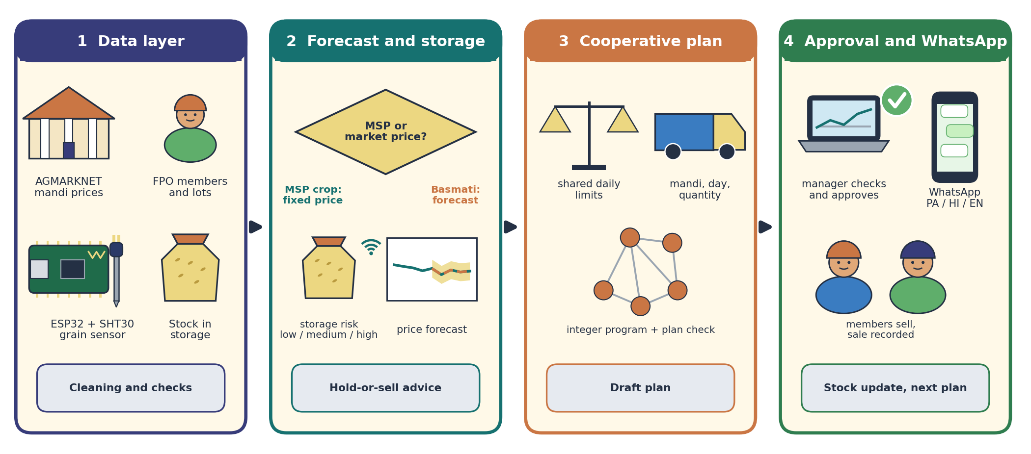
Fig. 1. Overall architecture of KisanNiti: (1) data layer, (2) forecasting and storage risk, (3) cooperative allocation, (4) manager approval and WhatsApp messages.

3.1 Market Data and Mandi Network
AGMARKNET data [3] for Paddy (Common) in Punjab for September to December of 2020–2025 were used. The data were downloaded from the official AGMARKNET Application Programming Interface (API) in April 2026 [3]. The raw file had 16,284 rows. After 81 exact duplicate rows were removed, 19 rows with zero minimum or maximum prices were repaired, and 2 duplicate market-date-variety groups were merged, 16,201 records from 176 mandis remained. When a mandi reported more than one variety on a day, the arrival-weighted average of the modal prices was used.
Most mandis report only on some days. The 20 mandis that reported across all six seasons and had the most trading dates (195 to 288 each) were therefore retained. Each mandi is one node of a graph. The location of each mandi was obtained from the OpenStreetMap Nominatim service [18], and each mandi was connected to its k nearest mandis based on straight-line distance. The value of k was chosen from {2, 3, 5} on a separate validation season. In this way, the graph has a clear geographic meaning, and no price relationship is assumed before it is tested. Figure 2 shows the resulting mandi network; the five mandis marked in red are used in the allocation experiment.
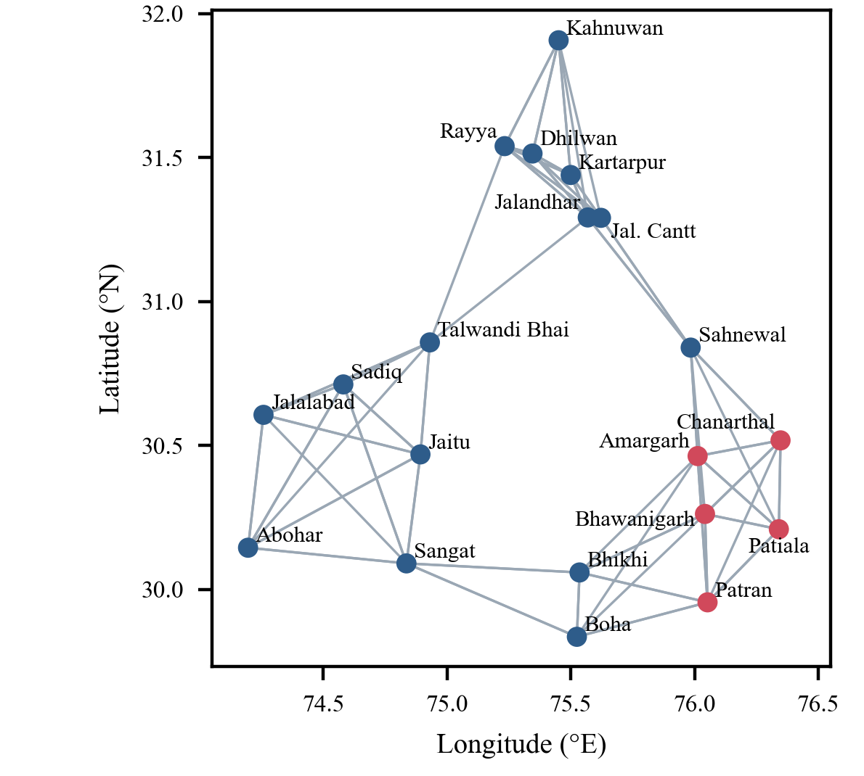
Fig. 2. Mandi network used for forecasting: 20 Punjab mandis and the five-nearest-neighbour graph (red: candidate mandis for the allocation test).

3.2 Graph-Based Price Forecasting
Figure 3 shows the forecasting flow, from the raw price files to the final price forecast. After cleaning, the share of reported prices that equal the announced MSP is checked for each crop and season, because for a crop sold almost entirely at the MSP the announced MSP itself is a strong forecast (Section 4.2). A3T-GCN [13] is used as the main learned forecaster. It has three parts. Each mandi's values are mixed with those of its neighbours by a graph convolution. How these values change over time is learned by a GRU. A weight is then given to each past time step by an attention layer before the forecast is made.
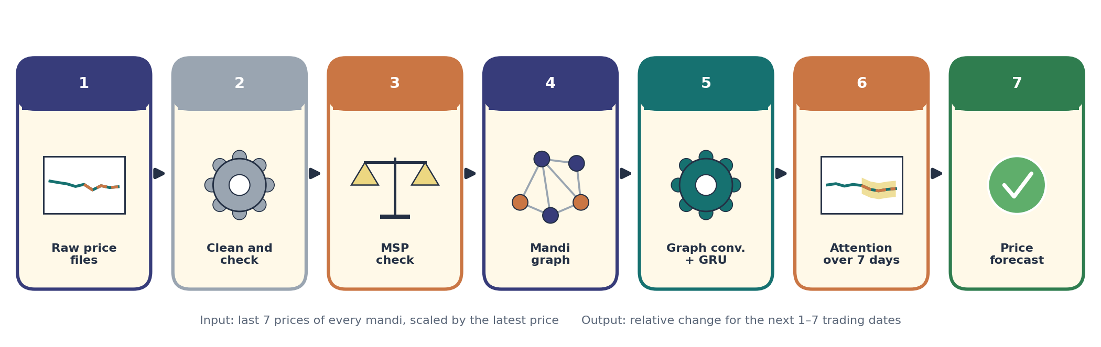
Fig. 3. Methodology: from raw price files, cleaning, and the MSP check to the A3T-GCN price forecast.
Let A be the adjacency matrix of the mandi graph and I the identity matrix. The graph is normalised as
Â = D̃^{−1/2} (A + I) D̃^{−1/2}, (1)
where D̃ is the degree matrix of A + I. For input x_{t} at step t and hidden state h_{t−1}, the update gate u_{t}, reset gate r_{t} and new state h_{t} are
u_{t} = σ(Â[x_{t}, h_{t−1}]W_{u} + b_{u}), r_{t} = σ(Â[x_{t}, h_{t−1}]W_{r} + b_{r}), (2)
c_{t} = tanh(Â[x_{t}, r_{t} ⊙ h_{t−1}]W_{c} + b_{c}), h_{t} = u_{t} ⊙ h_{t−1} + (1 − u_{t}) ⊙ c_{t}. (3)
A weight is given to each hidden state by a small scoring network, and the weighted states are combined before the output layer:
α_{t} = softmax_{t}(w₂⊤ tanh(W₁h_{t} + b₁) + b₂), z = Σ_{t} α_{t}h_{t}, ŷ = W_{o}z + b_{o}. (4)
The input is the last 7 trading-date prices of all 20 mandis, and the output is the price of every mandi for the next 7 trading dates. Because the MSP rises every season, each input window is divided by its latest price, and the relative change from that price is predicted. The scale is thereby kept the same across seasons. The model is trained to reduce the Mean Absolute Error (MAE), and only prices that were actually reported are used as targets. Gaps in the inputs are filled with the last reported price from the same mandi for that season. Before the first report of a mandi in a season, the mean price reported by the other mandis on that date is used, so that no future value enters the input.

3.3 Storage-Sensing Node
Storage conditions matter when waiting for a later selling date is considered. Regularly checking probes in stored grain is advised in grain storage guidance because hot spots may indicate insects [19]. A low-cost node was therefore designed, and Figure 4 shows its layout. An ESP32 development board with built-in 2.4 GHz Wi-Fi (802.11 b/g/n) is used [20]. A protected SHT30 probe is pushed into the grain, and temperature and RH are read over the Inter-Integrated Circuit (I²C) bus, on General-Purpose Input/Output (GPIO) pins 21 and 22. A typical tolerance of ±2% RH between 20 and 80% RH and ±0.2 °C between 0 and 65 °C is stated for this sensor [21]. The RH of the air between the kernels is in equilibrium with the grain, and divided by 100 it gives the water activity of the grain. Storage fungi need an RH of at least 65% [22], and grain kept in air below 65–70% RH degrades slowly [23]. A reading is taken every 5 minutes, and a simple rule maps the 24-hour median to a low, medium or high risk level at 65% and 70% RH. The readings are sent over Wi-Fi to a Message Queuing Telemetry Transport (MQTT) broker secured with Transport Layer Security (TLS), and the risk level is shown on the dashboard and sent to the manager as a WhatsApp alert.
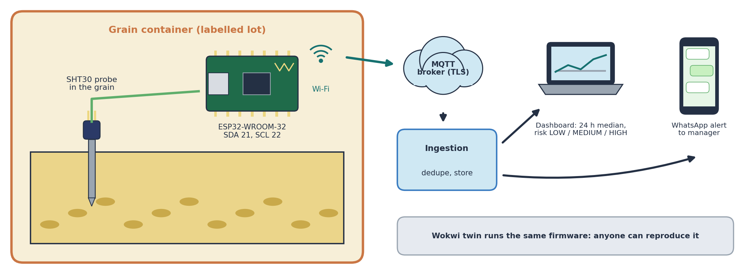
Fig. 4. Storage-sensing node: SHT30 probe in the grain, ESP32 board, Wi-Fi link to an MQTT broker with TLS, and the dashboard and WhatsApp alert for the manager.
The same firmware was run in the Wokwi ESP32 simulator [24], so that the node can be reproduced without hardware. Because temperature and RH describe the air in the store rather than grain moisture or spoilage directly, the node reports a storage-risk level to the manager, and the experiments of Section 4 evaluate the forecasting and allocation parts on historical market data.

3.4 Cooperative Selling Allocation Model
The selling decision is written as an integer program. Let f be a farmer lot, m a candidate mandi and d = 0, 1, …, D − 1 a trading day in the planning period. Q_{f} is the quantity of lot f, p̂_{md} the forecast price at mandi m on day d, κ_{fm} the road distance from lot f to mandi m, r the transport cost per quintal per kilometre, and w a small waiting cost per quintal per day. The net value of sending one quintal is
v_{fmd} = p̂_{md} − r κ_{fm} − w d. (5)
The decision variable x_{fmd} is the quantity of lot f sent to mandi m on day d. The model is
maximise Σ_{f} Σ_{m} Σ_{d} v_{fmd} x_{fmd} (6)
subject to Σ_{m} Σ_{d} x_{fmd} = Q_{f} for every lot f, (7)
Σ_{f} x_{fmd} ≤ C_{md} for every mandi m and day d, (8)
x_{fmd} ∈ {0, 10, 20, …} quintals. (9)
By constraint (7), every lot in the planning run is sold exactly once. Constraint (8) makes the model cooperative: C_{md} is the quantity the FPO can deliver to mandi m on day d, and this limit is shared by all lots. Without (8), each lot would go to its own best mandi and day, and the problem would split into separate farmer decisions. Quantities are planned in 10-quintal units, which is close to how loads are sent. The model is solved with the HiGHS solver [25] through SciPy [26]. Because the value in (5) is a sum of price and cost terms, further costs such as storage or market-arrival effects can be added to it without changing the structure of the model.

3.5 Recommendation Output
The output of the model is a table with one row for each part of a lot: the lot, the mandi, the selling day and the quantity, together with the forecast price and the transport cost used. As Figure 1 shows, this structured output is checked and approved by the FPO manager on a dashboard and then sent to farmers as WhatsApp messages. Each recommendation can carry a short explanation of why the plan was chosen, in the spirit of explainable recommendation systems [17].

4 Results and Discussion

4.1 Data and Setup
Table 2 describes the AGMARKNET price data [3] for the 20 selected mandis. Across the six seasons, there were 382 trading dates, and prices were reported by the mandis on 4,626 of the 7,640 possible mandi-days (60.5%). Table 2 also shows the main feature of this crop: in every season, more than 96% of the reported prices were equal to the MSP for Grade A paddy of that season (to the nearest rupee) [5][6]. Prices also varied very little from one mandi to another on the same day, as the small Standard Deviation (SD) values in the last column show.
Table 2. Paddy (Common) prices in the 20 selected Punjab mandis from AGMARKNET [3] (SD in Rs. per quintal).
Season | MSP Grade A (Rs. per quintal) | Trading dates | Prices equal to MSP (%) | SD of all prices | Mean daily SD across mandis
2020 | 1888 | 70 | 98.3 | 44.3 | 7.1
2021 | 1960 | 55 | 99.1 | 80.5 | 29.6
2022 | 2060 | 60 | 98.5 | 16.5 | 0.8
2023 | 2203 | 70 | 96.1 | 45.5 | 12.8
2024 | 2320 | 66 | 98.8 | 29.5 | 0.4
2025 | 2389 | 61 | 99.0 | 21.6 | 3.0

Forward-chaining evaluation was used. Each test season was forecast using models trained on all earlier seasons except the one immediately preceding it, which was reserved for validation. This gives three test seasons: 2023 (trained on 2020–2021, validated on 2022), 2024, and 2025. Seasons were never mixed in a single input window. Seven models were compared: (i) a naive forecast that repeats the last price; (ii) the mean of the last 7 prices; (iii) an MSP rule that always predicts the Grade A MSP of the season, which is announced before the season; (iv) ridge regression [27] on the relative changes, with its penalty chosen on validation; (v) a GRU without a graph; (vi) T-GCN, which is the graph model without attention; and (vii) A3T-GCN. The neural models had a hidden size of 32 and were trained with the Adam optimiser [28] (learning rate 0.001, batch size 32) for up to 400 epochs, and training was stopped when the validation error had not improved for 40 epochs. Each neural model was trained with five random seeds. The MAE, the Root Mean Squared Error (RMSE) and the Mean Absolute Percentage Error (MAPE) are reported over forecast horizons of 1 to 7 trading dates, scored only on prices that were actually reported. The experiments were run with Python 3.13, PyTorch 2.9.1 [29] and SciPy 1.15.2 [26].

4.2 Forecasting Results
Table 3 presents the forecast errors of the seven models. Validation selected k = 5 for the 2023 season and k = 3 for 2024 and 2025. All errors are small, below Rs. 7 per quintal on average, because the prices hardly move. The lowest MAE in all three seasons came from the MSP rule (mean Rs. 1.26 per quintal), which also had the lowest RMSE. The naive forecast was second (Rs. 1.77). Among the learned models, the most accurate was A3T-GCN (Rs. 2.36), followed by the GRU (Rs. 2.51), T-GCN (Rs. 2.54) and ridge regression (Rs. 4.09). The graph alone (T-GCN) gave nothing over a plain GRU, and the small edge of A3T-GCN is about the size of the variation between random seeds. No learned model beat the two simplest rules.
Table 3. Forecast errors over horizons of 1–7 trading dates (Rs. per quintal). Neural models: mean ± SD over five seeds.
Model | MAE 2023 | MAE 2024 | MAE 2025 | Mean MAE | Mean RMSE | Mean MAPE (%)
Naive (last price) | 3.46 | 0.25 | 1.59 | 1.77 | 29.65 | 0.067
Moving average (7 dates) | 3.98 | 3.32 | 2.09 | 3.13 | 30.08 | 0.125
MSP rule | 2.68 | 0.17 | 0.94 | 1.26 | 24.67 | 0.044
Ridge regression | 6.54 | 2.39 | 3.33 | 4.09 | 29.73 | 0.168
GRU (no graph) | 4.12 ± 0.08 | 1.00 ± 0.29 | 2.42 ± 0.20 | 2.51 | 29.60 | 0.099
T-GCN | 4.29 ± 0.22 | 0.99 ± 0.20 | 2.33 ± 0.15 | 2.54 | 29.68 | 0.100
A3T-GCN | 4.10 ± 0.11 | 0.81 ± 0.06 | 2.16 ± 0.13 | 2.36 | 29.68 | 0.092

A date-by-date comparison at a horizon of one trading date was also made. On each of the 158 test dates, the error of A3T-GCN was higher than that of the naive forecast. The naive forecast is exactly right whenever a mandi stays at the MSP, which is almost always, while a change of exactly zero is rarely predicted by a neural model. The MSP rule tied with the naive forecast on 126 dates, was better on 13 and worse on 19, but its misses were smaller, which gave it the lower average error. For an MSP crop such as Paddy (Common), the price is therefore almost fixed by policy, and the announced MSP was the best forecast found.

4.3 Cooperative Allocation Results
Real member records were not available, so a synthetic FPO was built to test the allocation model. It has 40 lots placed at random in an area of about 30 km × 30 km between Patiala and Bhawanigarh, with lot sizes from 20 to 120 quintals (2,815 quintals per FPO on average). The candidate mandis are the five marked in red in Figure 2: Patiala (New Anaj Mandi), Patran, Bhawanigarh, Chanarthal and Amargarh. The settings below are assumptions for this test and not measured values. Road distance is taken as 1.3 times the straight-line distance, transport costs Rs. 2 per quintal per kilometre, waiting costs Rs. 2 per quintal per day, and at most 300 quintals can be delivered by the FPO to each mandi per day. Each plan covers the next 5 trading dates. Plans were made from 16 starting dates in the 2025 season for 10 random FPOs (160 runs per policy), and every plan was scored with the actual 2025 AGMARKNET prices [3]. When a mandi did not report on a date, its last reported price was used.
Four policies were compared. In P1, each lot is sent to its nearest mandi on the first day that still has room, and lots are served in random order. In P2, every lot chooses its own best mandi and day without looking at the others. P3 is the KisanNiti model of Section 3.4, run once with the MSP rule as the price forecast and once with the A3T-GCN forecast. P4 is the same model given the actual prices, which is an upper bound that no real system can reach. A separate check confirmed that every plan sold each lot exactly once, and any day on which the limit of a mandi was exceeded was counted. Each run of the model, with 1,000 integer variables, was solved in about 0.25 s on a laptop. Table 4 reports the average results of the four policies.
Table 4. Allocation results, averaged over 160 runs (Rs. per quintal unless stated).
Policy | Net return | Transport cost | Distance (km) | Runs over a daily limit (%) | Gain over P1
P1 Nearest mandi, first free day | 2355.38 | 30.40 | 15.16 | 0 | –
P2 Independent best choice | 2359.32* | 29.68 | 14.81 | 100 | 3.92*
P3 KisanNiti (MSP-rule price) | 2356.18 | 30.07 | 15.00 | 0 | 0.79 ± 1.05
P3 KisanNiti (A3T-GCN price) | 2356.19 | 30.06 | 15.00 | 0 | 0.79 ± 1.05
P4 Perfect foresight (bound) | 2356.19 | 30.06 | 15.00 | 0 | 0.80 ± 1.04
* Not achievable: P2 sent on average 2,017 quintals more than the daily limits allowed in each run.
Table 4 shows three things. Independent choices (P2) do not suit a cooperative: when every lot goes to its own best option, almost all produce reaches the nearest mandis on the first day, and the daily limits were exceeded in all 160 runs (on two mandi-days per run on average). The cooperative model (P3) respected every limit and earned Rs. 0.79 per quintal more than the nearest-mandi rule, mostly through less travel and waiting. That gain is small and varies between runs (SD Rs. 1.05). The forecast, finally, hardly changed the plan: P3 with the MSP rule, P3 with A3T-GCN and the perfect-foresight bound were within Rs. 0.01 per quintal of each other, because the prices at the five mandis were nearly the same.
The settings above are assumptions, so the test was repeated with transport costs of Rs. 1, 2 and 4 per quintal per kilometre and daily limits of 200, 300 and 500 quintals. Figure 5 plots the gain of P3 over P1 for each of these settings. The gain depends mainly on how tight the daily limit is. With a limit of 500 quintals, the nearest-mandi rule was already almost optimal (gain of Rs. 0.15 per quintal or less). With a limit of 200 quintals, the gain was Rs. 3.49, 6.94 and 13.91 per quintal at the three transport costs, and the average distance fell from 19.9 km to about 16.5 km.
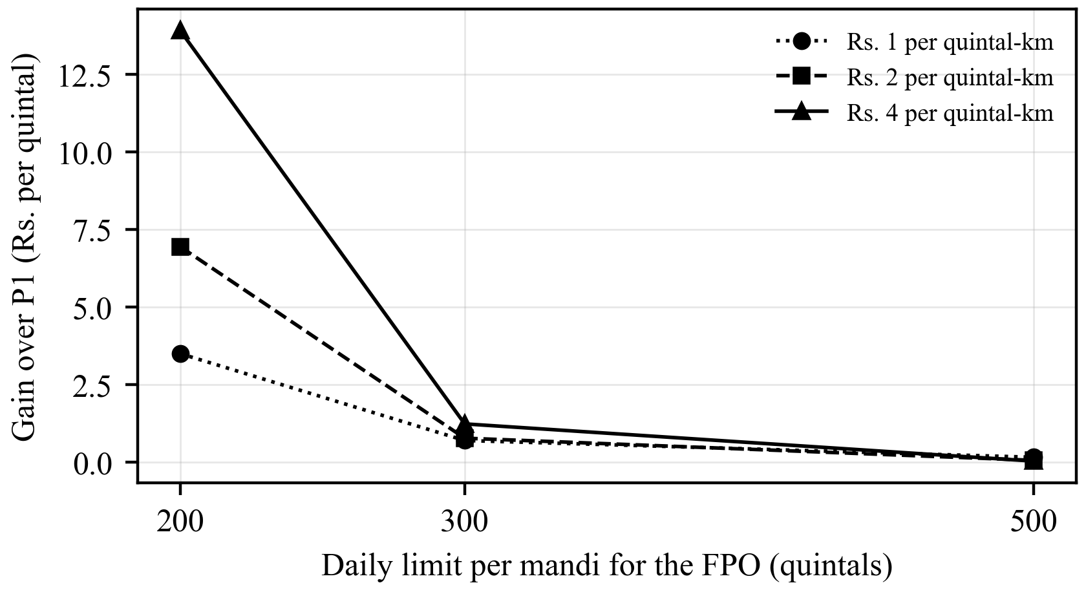
Fig. 5. Gain of the cooperative model (P3) over the nearest-mandi rule (P1) for different daily limits and transport costs (80 runs per point).

4.4 Discussion and Limitations
The study teaches one clear lesson. Mandi prices of an MSP crop such as Paddy (Common) in Punjab are almost fixed by policy, so a complex forecaster adds nothing and the announced MSP can serve as the price. What remains useful for such crops is coordination: deliveries are spread over mandis and days, limits are kept, and travel is reduced. The forecasting branch is more likely to matter for crops with market-set prices, such as basmati paddy or wheat held on the farm after harvest, where the same framework applies without change.
The scope of the study should be kept in mind when the results are read. The price data cover one crop, one state and the September to December period of six seasons. The modal price published for a mandi is not the exact price that a given farmer receives. The FPO, its lots, the transport rate, the road factor, the waiting cost and the daily limits are synthetic, so the allocation gains show what the model can do under these settings and not what a particular FPO will earn. The storage node was evaluated in simulation. Finally, the way in which traders or mandis would react if many farmers followed the plan cannot be shown by a historical test.

5 Conclusion and Future Work
KisanNiti has been presented as a framework that helps an FPO decide where, when and how much of its members' produce is to be sold. Three parts are joined in it: a mandi-network price forecaster based on A3T-GCN, a low-cost storage-sensing node built around an ESP32 and an SHT30 probe, and an integer program that assigns farmer lots to mandis and days while the daily limit of each mandi is shared. The forecasting and allocation parts were tested on real AGMARKNET prices [3] for Paddy (Common) from 20 Punjab mandis over 2020–2025.
Two results were obtained. The price of this crop is set almost entirely by the MSP: in every season, more than 96% of the reported prices were equal to it, and the announced MSP forecast better than every learned model, A3T-GCN included. A forecasting system for FPOs should check whether a crop is sold at the MSP before any learned model is used, and the announced MSP should be taken as the price if it is. The cooperative allocation model, in turn, respected the shared daily limits every time, while independent choices broke them in every run. Its gain over the nearest-mandi rule was small with loose limits (Rs. 0.79 per quintal) and grew to Rs. 3.5–13.9 per quintal with tight ones. For MSP crops, KisanNiti therefore helps through coordination, not through price prediction.
Future work will extend KisanNiti in four directions. The forecaster will be applied to crops whose prices are set by the market, such as basmati paddy and wheat held after harvest, where timing and mandi choice can matter more, using a longer and wider AGMARKNET extract [3]. The storage node will be deployed in FPO storage and calibrated against measured grain samples, so that a storage-condition term and the measured effect of market arrivals on price can be added to the allocation model. The synthetic FPO will be replaced with member records, transport quotes and mandi handling limits from a partner FPO, so that the plan can be compared with what farmers actually earn. Finally, the delivery of the selling plan to farmers as short messages in their own language, with a simple explanation of each recommendation [17], will be studied with FPO staff and members.

Disclosure of Interests. The authors have no competing interests to declare that are relevant to the content of this article.
References
1. Small Farmers' Agribusiness Consortium (SFAC): Frequently Asked Questions: Farmer Producer Organisations. https://sfacindia.com/fpofaq.aspx, last accessed 2026/10/27
2. Gulati, A., Das, R., Winter-Nelson, A.: Reducing Post-Harvest Losses in Indian Agriculture: A Case Study of Selected Crops. Policy brief, ICRIER, New Delhi (2024). https://icrier.org/publications/reducing-post-harvest-losses-in-indian-agriculture-a-case-study-of-selected-crops/, last accessed 2026/10/27
3. Directorate of Marketing and Inspection, Ministry of Agriculture and Farmers Welfare: AGMARKNET – Agricultural Marketing Information Network. https://agmarknet.gov.in, last accessed 2026/10/27
4. Manogna, R.L., Dharmaji, V., Sarang, S.: Enhancing agricultural commodity price forecasting with deep learning. Sci. Rep. 15, 20903 (2025). https://doi.org/10.1038/s41598-025-05103-z
5. Directorate of Economics and Statistics, Ministry of Agriculture and Farmers Welfare: Minimum Support Prices (According to Crop Year), as on 22.01.2025. https://desagri.gov.in/wp-content/uploads/2025/02/MSP_for-website_English-version.pdf, last accessed 2026/10/27
6. Directorate of Economics and Statistics, Ministry of Agriculture and Farmers Welfare: Minimum Support Price (Marketing Season-wise), as on 28.05.2025. https://desagri.gov.in/wp-content/uploads/2025/08/MSP-Statement_English.pdf, last accessed 2026/10/27
7. Nayak, G.H.H., Alam, M.W., Singh, K.N., Avinash, G., Kumar, R.R., Ray, M., Deb, C.K.: Exogenous variable driven deep learning models for improved price forecasting of TOP crops in India. Sci. Rep. 14, 17203 (2024). https://doi.org/10.1038/s41598-024-68040-3
8. Özden, C., Bulut, M.: Spectral temporal graph neural network for multivariate agricultural price forecasting. Ciênc. Rural 54(1), e20220677 (2024). https://doi.org/10.1590/0103-8478cr20220677
9. Min, Y., Kim, Y.R., Hyon, Y., Ha, T., Lee, S., Hyun, J., Lee, M.R.: RNN and GNN based prediction of agricultural prices with multivariate time series and its short-term fluctuations smoothing effect. Sci. Rep. 15, 13681 (2025). https://doi.org/10.1038/s41598-025-97724-7
10. Islam, M.S., Sadmani, S., Ali, M.R., Sayem, N.S., Islam, M.H., Hanif, M.A., Alam, M.M.: Remotely controlled smart monitoring system of hermetic paddy storage to reduce postharvest losses in Bangladesh. Smart Agric. Technol. 8, 100468 (2024). https://doi.org/10.1016/j.atech.2024.100468
11. Anukiruthika, T., Jayas, D.S.: AI-driven grain storage solutions: exploring current technologies, applications, and future trends. J. Stored Prod. Res. 111, 102588 (2025). https://doi.org/10.1016/j.jspr.2025.102588
12. Zhao, L., Song, Y., Zhang, C., Liu, Y., Wang, P., Lin, T., Deng, M., Li, H.: T-GCN: a temporal graph convolutional network for traffic prediction. IEEE Trans. Intell. Transp. Syst. 21(9), 3848–3858 (2020). https://doi.org/10.1109/TITS.2019.2935152
13. Bai, J., Zhu, J., Song, Y., Zhao, L., Hou, Z., Du, R., Li, H.: A3T-GCN: attention temporal graph convolutional network for traffic forecasting. ISPRS Int. J. Geo-Inf. 10(7), 485 (2021). https://doi.org/10.3390/ijgi10070485
14. Urra-Calfuñir, B.A., Monardes-Concha, C.A., Miranda-González, P.A.: Agri-food supply chain optimization through a decentralized production process in the olive oil industry. Comput. Ind. Eng. 192, 110185 (2024). https://doi.org/10.1016/j.cie.2024.110185
15. Gámez-Albán, H.M., Guisson, R., De Meyer, A.: Optimizing the organization of the first mile in agri-food supply chains with a heterogeneous fleet using a mixed-integer linear model. Intell. Syst. Appl. 23, 200426 (2024). https://doi.org/10.1016/j.iswa.2024.200426
16. Anoop, K.P., Panicker, V.V., Siby, J., Aryadutt, C.S.: Multi-objective optimization algorithms for freight allocation in a food grain supply chain. Appl. Soft Comput. 171, 112729 (2025). https://doi.org/10.1016/j.asoc.2025.112729
17. Shams, M.Y., Gamel, S.A., Talaat, F.M.: Enhancing crop recommendation systems with explainable artificial intelligence: a study on agricultural decision-making. Neural Comput. Appl. 36(11), 5695–5714 (2024). https://doi.org/10.1007/s00521-023-09391-2
18. OpenStreetMap contributors: Nominatim geocoding service. https://nominatim.openstreetmap.org, last accessed 2026/10/27
19. Canadian Grain Commission: Protect the quality of your stored grain from insect infestations and mould. News release (13 September 2017). https://www.canada.ca/en/grain-commission/news/2017/09/protect_the_qualityofyourstoredgrainfrominsectinfestationsandmou.html, last accessed 2026/10/27
20. Espressif Systems: ESP32 Series Datasheet, Version 5.3. https://www.espressif.com/sites/default/files/documentation/esp32_datasheet_en.pdf, last accessed 2026/10/27
21. Sensirion AG: Datasheet SHT3x-DIS: Humidity and Temperature Sensor, Version 7. https://sensirion.com/media/documents/213E6A3B/63A5A569/Datasheet_SHT3x_DIS.pdf (2022), last accessed 2026/10/27
22. Gwinner, J., Harnisch, R., Mück, O.: Manual of the Prevention of Post-Harvest Grain Losses, 2nd edn. GTZ, Eschborn (1996). https://www.fao.org/4/x5065e/x5065E00.htm, last accessed 2026/10/27
23. de Lucia, M., Assennato, D.: Agricultural Engineering in Development: Post-Harvest Operations and Management of Foodgrains. FAO Agricultural Services Bulletin 93. FAO, Rome (1994). https://www.fao.org/4/t0522e/T0522E00.htm, last accessed 2026/10/27
24. Wokwi: ESP32 simulator. https://wokwi.com, last accessed 2026/10/27
25. Huangfu, Q., Hall, J.A.J.: Parallelizing the dual revised simplex method. Math. Program. Comput. 10(1), 119–142 (2018). https://doi.org/10.1007/s12532-017-0130-5
26. Virtanen, P., Gommers, R., Oliphant, T.E., et al.: SciPy 1.0: fundamental algorithms for scientific computing in Python. Nat. Methods 17(3), 261–272 (2020). https://doi.org/10.1038/s41592-019-0686-2
27. Hoerl, A.E., Kennard, R.W.: Ridge regression: biased estimation for nonorthogonal problems. Technometrics 12(1), 55–67 (1970). https://doi.org/10.1080/00401706.1970.10488634
28. Kingma, D.P., Ba, J.: Adam: a method for stochastic optimization. In: 3rd International Conference on Learning Representations (ICLR) (2015). https://doi.org/10.48550/arXiv.1412.6980
29. Paszke, A., Gross, S., Massa, F., et al.: PyTorch: an imperative style, high-performance deep learning library. In: Advances in Neural Information Processing Systems 32, pp. 8024–8035 (2019). https://doi.org/10.48550/arXiv.1912.01703

