**EFFECTIVITY OF MULTI-ROBOT PLATOON FORMATION AND COORDINATION**

This report is submitted for requirements pertaining to Term Paper for Second Semester

**MASTERS IN CONTROL SYSTEMS ENGINEERING**

Submitted by

**Arijit Kumar Haldar**

MCSE, 1st Year, 2nd Semester

Roll Number: 002010804015

Department of Electrical Engineering

JADAVPUR UNIVERSITY

KOLKATA-700032

September, 2021

**CONTENTS**

|  |  |
| --- | --- |
| **List of figures** | iii |
| **Chapter 1: Introduction** | 1 |
| * 1. Introduction | 1 |
| * 1. Multi-Robot vs Swarm Robot | 2 |
| * 1. Platoon Formation | 3 |
| * 1. Coordinated Control | 3 |
| **Chapter 2: Literature Survey** | 5 |
| * 1. Primary hypothesis for formation flight in birds      1. Probable needs of flocking      2. Advantages gained      3. Implication | 5  6  6 |
| * 1. Aerodynamic advantage hypothesis | 7 |
| * 1. Visual communication advantage hypothesis | 8 |
| **Chapter 3: Problem Identification** | 9 |
| * 1. Desired goal | 9 |
| * 1. Size of formation consideration | 9 |
| * 1. Types of formation consideration | 9 |
| * 1. Mathematical Modelling      1. Formation model      2. Individual bird model | 11  12 |
| * 1. Linearization | 13 |
| **Chapter 4: Conclusion** | 15 |
| * 1. Work done so far | 15 |
| * 1. Scope of future work | 15 |
| **References** | 16 |

**List of figures**

1. Simulated Robotic Agents Maintaining a Formation 1
2. Some formation configurations 2
3. Birds flying in V-formation 5
4. Representation of distances to be maintained during V-formation 7
5. Figure visualizing a V-formation 9
6. Figure visualizing a J-Formation 10
7. Figure representing Echelon formation 10
8. Figure to demonstrate number of agents in each arm of V 11

**CHAPTER 1**

**Introduction**

Formation or Platoon-formation is a very well-known group behaviour that we notice in nature. From formation flying or birds to ants forming a platoon to carry some object much bigger than their own size, we notice different reasons for formation during movement among social organisms.

The same and/or different advantages can also be harnessed by multi-robot systems, which extends the domain of swarm robotics to platoon formation and maintenance during actuation, and the study of its advantage for the said system.

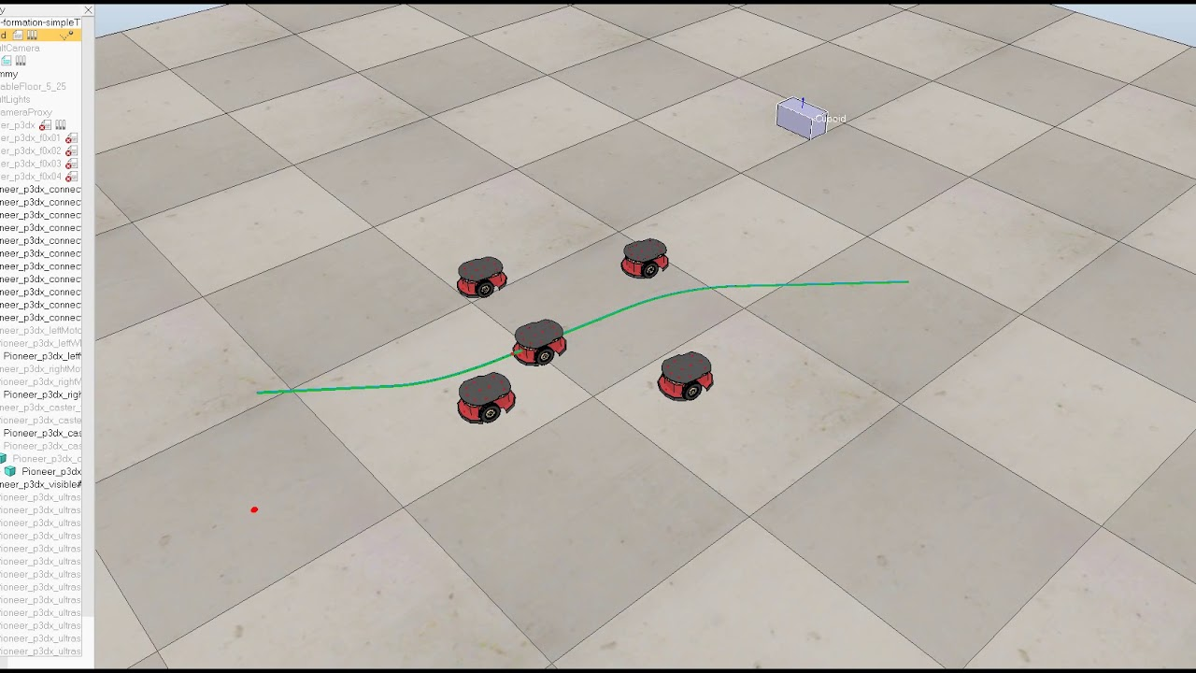

Fig 1: Simulated Robotic Agents Maintaining a Formation [8]

* 1. **Introduction**

My topic for seminar during the odd and even semesters of First year comprised of Swarm Robotics, in which I studied and discussed on the mathematical modelling, formation and path planning of a swarm robotic system; particularly, a terrestrial swarm robot system with homogeneous agents which form a swarm and traverse through a resource profile to a pre-determined goal, while avoiding obstacles.

Now, for the present work, I am writing on platoon formation and control of a homogeneous, multi-robot system. For this term paper, I would try to give emphasis on understanding the recent works done on the study of advantages or effectivity of platoon formation in nature, i.e., biological agents, and discuss on the same.

Before going into the topic of effectivity, it’s worth mentioning some types of formation we can form with any homogeneous agents –

* Maintaining a spatial trajectory while actuation [3].
* Maintaining a desired special pattern while actuation [3].
* Maintaining topology or hierarchy based on minimum energy wastage or minimum damage incurred as a whole on the system during actuation.
* Formation of caging for restricting an area into some desired blocks.
* Maintain a formation so as to maximise the force or thrust on an object for efficient actuation.

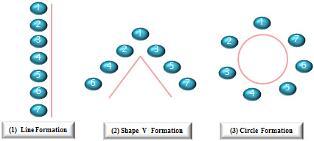

Fig 2: Some formation configurations [7]

* 1. **Multi-Robot vs Swarm Robot**

When mentioning about multi-robot or swarm robot systems, we are dealing with multiple, often identical robotic agents working together. So, what exactly is the difference between a multi-robot system and a swarm robot system? Then answer lies in the implementation of the system.

For swarm robotic system, the lower limit of the swarm size is around 3, i.e., swarm systems can be composed of minimum 3 to a maximum of say 100 or 1000 or even more agents, based on the scale of the swarm, the useability of the agents as a function of inter-agent distance, and each agent’s size. A swarm formation would only mean that the agents would maintain a congregation and actuate as a whole through a defined region while avoiding obstacles (or any other mission goal).

But a multi-robot system is usually small in size [1]. Maintaining a formation using a multi-robot system means that the system has to occupy some certain area or volume spatially. This means, if the system is too big, we won’t have enough space for actuation of the system. Thus, formation using multi-robot systems typically have sizes in the range of 5 to few multiples of 10 [1], beyond which, any formation becomes a hindrance than an advantage.

* 1. **Platoon Formation**

Platoon formation is the joining of two or more autonomous mobile robots in a formation or a convoy-like motion by using connectivity techniques between each agents and actuating control algorithms [3][5]. The agents automatically retain a close distance between each other based on the mission needs and control algorithm designed. A virtual agent at the head of the platoon may be defined as the leader, while the subsequent other agents follow the leader while maintaining the platoon formation.

* 1. **Coordinated Control**

Coordination is required for multiple reasons in a multi-robot system. For a swarm robotic system, coordination ranges from inter-agent communication and actuation while avoiding colliding with any agent. Also, if we take into account some heuristic search algorithms, or particle swarm optimization, or similar control algorithms, where we need to feedback individual agent’s data among other agents, and form a “bigger picture” about the resource profile or goal for faster convergence of agents.

In other words, coordinated control makes it possible to make a swarm robotic or a multi-robot system to work as a group entity, rather than individual, independent agents. Not only does coordination help in formation, controlled actuation and knowledge about the system and its surroundings, but it also helps to use available resources intelligently, and develop faster and more robust convergence algorithms.

**CHAPTER 2**

**Literature Survey**

For the purpose of this term paper, I selected the topic of formation flight of birds in nature, and its probable advantages, as the basis for my study on multi-robot platoon formation. Since swarm or formation of agents are very common in the animal kingdom, so, understanding the behaviours that have been selected from countless evolution phases through which the species have gone through

* 1. **Primary Hypothesis for Formation Flight in birds**

One of the most common form of platoon formation among living organisms, that we notice in our day-to-day life is formation flight of birds. We notice birds flying in flocks, maintaining an arrow-head or V formation and variations of it, etc. Based on this behaviour, we can draw some conclusions which might give us an insight into the characteristics of formation flight, that is chosen by birds due to some form of obvious advantage.

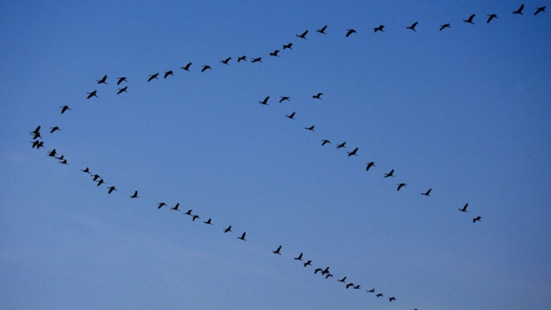

Fig 3: Birds flying in V-formation [9]

* + 1. **Probable Needs of Flocking**

The first question that we can think of is, why do birds need flocking, or maintaining a recognisable formation while flying? There are two possible explanations –

1. Natural social behaviour – It might be the that the birds display a social behaviour by flocking as a means of displaying itself as a part of the flock or to portray friendly or social nature with other birds in the flock [1].
2. Need to detect, avoid and defend against predators – It may be possible that the flocking together helps in better coordination for detecting predators, and prevent blind spots. Also, being together in groups may make the birds look intimidating to the predators, or they can attack together more effectively, if required [1].

In this context, we come upon two hypotheses for linear formation, that might be the obvious advantage to the birds due to formation flight [4].

* + 1. **Advantages Gained**

The two hypothesis that explains the advantages to the birds due to platoon formation during flight are –

1. Offers aerodynamic advantage – The formation might physically help the birds to fly over long distances [1].
2. Used to improve visual communication – The formation might allow the birds to see clearly around while flying in a flock without being obstructed by other birds [1].
   * 1. **Implication**

Observing the flight of birds and drawing some hypothesis on the advantages that the birds can gain from the platoon formation during flight, and also the various shape and inter-agent distances in the formation lets us develop coordinated control of unmanned aerial vehicles, drawing conclusions from natural choice of formation and distances that are most suitable for the type of vehicle, i.e., size, wingspan etc., being implemented [1][3].

* 1. **Aerodynamic Advantage Hypothesis**

According to this hypothesis, the V-formation flight makes the birds get more aerodynamic lift by flying in the upwash produced by the other birds [5].

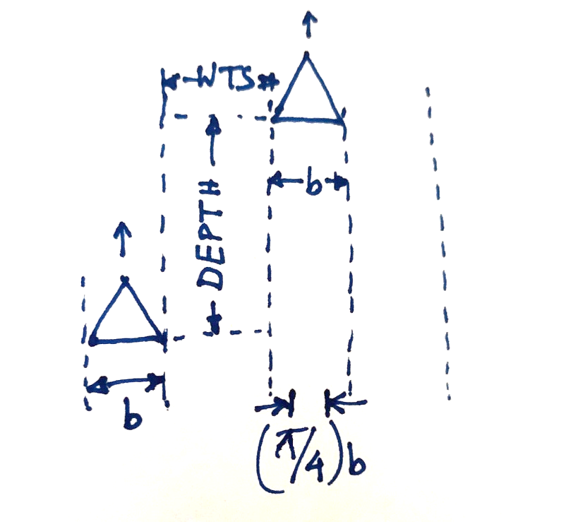

Fig 4: Representation of distances to be maintained during V-formation

where, b = wingspan of each bird,

d = depth between two wingtips,

WTS = Wing Tip Spacing

= $\left(\frac{π}{4}-1\right)\frac{b}{2}$, if WTS = WTSopt  [5][1]

= $-\left(\frac{4-π}{4}\right)\frac{b}{2}$; which is < 0, so wingtips overlap [5][1]

According to P. Seiler et. al., WTS $≥ {WTS}_{opt}$, WTS is not related to depth.

Assuming that the wingspan ‘b’ is fixed for every bird, or the wingbeat frequency is low, $\frac{π}{4}b$ is the distance between two wingtip vortices, then, within the area of trailing vortices is the area of downwash (drag). Outside the vertices is the area of upwash (lift).

The maximum aerodynamic advantage is achieved when –

${WTS}_{optimal}=\left(\frac{π}{4}b-b\right)×\frac{1}{2}=\left(\frac{π}{4}-1\right)×\frac{b}{2}$, which is < 0. So, wingtips have to overlap, while maintaining depth, for maximum aerodynamic advantage [1]. We can summarise this hypothesis as –

* Advantage is strongly dependant on lateral position [1].
* According to Munk’s Displacement Theorem, aerodynamic advantage is independent of longitudinal position, so, we can distribute load evenly by staggering, without affecting total induced drag [1].
  1. **Visual Communication Advantage Hypothesis**

Visual communication hypothesis is based on the probable eyesight and field of view of the birds, that has to be optimally coordinated for maximum advantage of sight for the birds.

1. Location of eye on the head restricts field of vision, if not flying in a staggered formation [1].
2. Enhanced visual communication may help migratory navigation by averaging the desired direction of all birds [1].
3. May also help increased probability that flocks are maintained during flight between roosting and foraging areas [1].
4. May enable younger birds to learn about migratory paths and/or traditional roosting and feeding areas [1].

So, in this hypothesis, WTS and depth are positively correlated.

**CHAPTER 3**

**Problem Identification**

* 1. **Desired Goal**

The desired goal of this formation control strategy is to form a specific shape of platoon by the robotic agents, as drawn inspiration from birds, and maintain the lateral and longitudinal distances between each agent for maximum advantages, as discussed earlier [6].

In this regard, we first create a mathematical model to create an identical simulation as we observe in birds, and form and maintain the V-formation, as the goal of the simulation, during actuation.

* 1. **Size of Formation consideration**

We observe, that the size of formation flight in birds is usually small [1]. On close inspection of the underlying mechanisms, we notice that if the size of a formation is large, the localized disturbances in any area of the formation is amplified, as we go further away from the point of disturbance, since the disturbances propagate down the chain. This is known as string instability [1].

Thus, the size of our desired multi-agent platoon formation will be small.

* 1. **Types of Formation consideration**

Since we are taking the V formation in birds, we notice, that by changing the lengths of the arms of the V, we get different variations of the V formation, all of which are governed by the same underlying principles –

1. V – Formation [1]

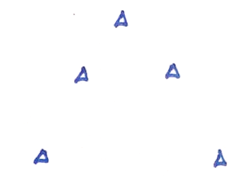

Fig 5: Figure visualizing a V-formation

In this formation, the two arms of the V are composed of equal number of agents.

1. J – Formation [1]

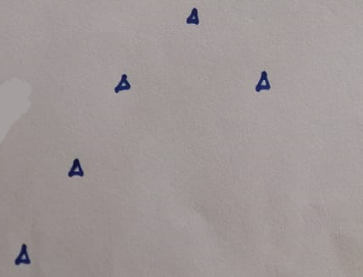

Fig 6: Figure visualizing a J-Formation

In this type of formation, one arm of the V is composed of a greater number of agents than the other.

1. Echelon Formation [1]

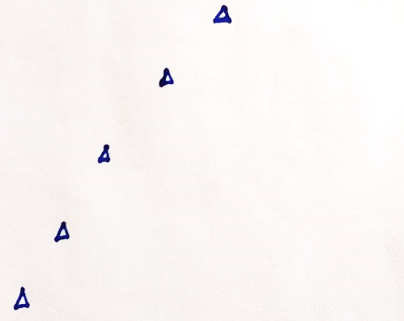

Fig 7: Figure representing Echelon formation

In this type of formation, one arm of the V does not have any agents, apart from the leading, vertex agent.

* 1. **Mathematical Modelling**

Mathematical modelling of the bird V-formation allows us to express the formation criteria in a mathematical equation, which we can easily translate later into a simulation, and then into a physical multi-robot system, thus mimicking the formation of birds in an actual multi-robot platoon formation.

For the mathematical model, we actually need to model one bird, assuming that all birds are identical, then use the bird model to form the mathematical model of the formation the birds are supposed to form, which, in our case, is a V-formation.

* + 1. **Formation Model**

For the formation modelling, let us define a V - formation system, where the leading bird’s position is defined by $P_{0}(t)$, while the two arms of the V are composed of N+1 number of birds [5] each, 1 being the first bird that is common for each arm.

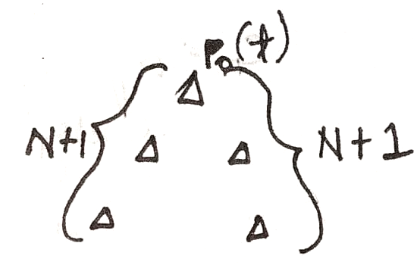

Fig 8: Figure to demonstrate number of agents in each arm of V

Position of the first bird, $P_{0}\left(t\right)∈R^{3}$

Position of $i$-th follower bird, $P_{i}\left(t\right)∈R^{3}, (1≤i≤N)$

Tracking error $e_{i}\left(t\right)=\left(P_{i-1}\left(t\right)+δ\right)-P_{i}\left(t\right), (1≤i≤N)$ where $δ$ is spacing vector.

If desired condition = Lateral $→$ optimum wingtip spacing

Longitudinal $→$ $2b$ behind

Then, $δ=\left[\begin{matrix}-2b & \frac{πb}{2} & 0\end{matrix}\right]$. The goal is that the follower birds try to make the spacing error = 0 [1].

* + 1. **Individual Bird Model**

Forces on a bird:

1. Parasitic Drag [5][1]: $-C_{D}\left\|v\right\|v$ (forces exerted by air on the bird’s body) where $C_{D}$ is the drag coefficient,

$v$ is the velocity vector of the bird.

1. Weight [5][1]: $-mg\overline{k}$,

where $m$ is mass of the bird,

$g$ is gravitational constant and

$\overline{k}$ is the unit vector in z-direction.

1. Profile Drag [5][1]: $-\frac{C_{P}}{{\left\|v\right\|}^{2}}v$ (drag exerted by air on wings when flapped)

Where $C_{P}$ is Profile drag coefficient,

$v$ is velocity vector of the bird.

1. Lift & Thrust [1]: Force generated by bird to fly by flapping its wings, denoted as $F$.

Now, the cartesian position of bird, $p={\left[\begin{matrix}x & y & z\end{matrix}\right]}^{T}$

$∴$ Equation of motion of bird [1]:

$$m\ddot{p}=-C_{D}\left\|v\right\|v-mg\overline{k}-\frac{C_{P}}{{\left\|v\right\|}^{2}}v+F$$

For steady state velocity [1],

$$v=v_{ss}$$

$$∴F_{SS}=C_{D}\left\|v_{ss}\right\|v_{ss}+mg\overline{k}+\frac{C_{P}}{{\left\|v_{ss}\right\|}^{2}}v_{ss}$$

Here, lift and thrust balance all other forces.

* 1. **Linearization**

Approximating the finite dimensional non-linear dynamical system [1],

$$\dot{z}=h_{1}(z,e)$$

$$F=h_{2}(z,e)$$

$z∈R^{n}$ is the state of the system,

$e∈R^{3}$ is tracking error.

Assuming no tracking error, the necessary force for steady velocity –

$$h_{1}\left(0,0\right)=0$$

$$h_{2}\left(0,0\right)=F_{SS}$$

Linearizing around this condition, [1]

$$∆\dot{z}={\left(\frac{∂h_{1}}{∂z}\right)}_{\left(0,0\right)}.∆z+{\left(\frac{∂h_{1}}{∂e}\right)}_{\left(0,0\right)}.e$$

$$F=F_{SS}+{\left(\frac{∂h_{2}}{∂z}\right)}_{\left(0,0\right)}.∆z+{\left(\frac{∂h_{2}}{∂e}\right)}_{\left(0,0\right)}.e$$

Now, let us define A, B, C, D as [1] –

$${A=\left(\frac{∂h_{1}}{∂z}\right)}_{\left(0,0\right)}.∆z$$

$$B={\left(\frac{∂h_{1}}{∂e}\right)}_{\left(0,0\right)}.e$$

$$C={\left(\frac{∂h_{2}}{∂z}\right)}_{\left(0,0\right)}.∆z$$

$$D={\left(\frac{∂h_{2}}{∂e}\right)}_{\left(0,0\right)}.e$$

So, overall linearized system, [5][1]

$$\ddot{P}=\frac{1}{m}∆F$$

$$∆\dot{z}=A∆z+Be$$

$$∆F=C∆z+De$$

**CHAPTER 4**

**Conclusion**

* 1. **Work done so far**

I started my work on multi-robot platoon formation with the literature survey of few papers that have delved into the biomimicry aspect of formation control. In this term paper, I emphasised on probable advantages, types and size of formation flight done by birds. Later, I discussed on the mathematical modelling of a similar bird V-formation, as discussed, based on some papers that I referenced.

On the basis of this understanding, I am trying to develop a simulation of the mathematical model, being discussed, to obtain a formation flight on some virtual birds, the creation and maintenance of the V-formation being my target.

* 1. **Scope of future work**

Extending on the simulation that I am designing, the workflow that I have decided so far is –

* + 1. Make the simulation to work with any N number of agents, since I am working only with fixed number of agents (5 agents) in the simulation now.
    2. Develop the formation using a triangle formation, rather than grid formation that I am trying to do now, which would help with computation time.
    3. Define obstacles, and implement obstacle avoidance on the formation of agents.
    4. Implement path planning methodology with the obstacles and a resource profile, since I am only focusing on straight line path to a specific coordinate now.
    5. Lastly, I will try to define power levels for each agent during actuation, and automatically rearrange agent positions based on a total energy minimization approach, which would harness the aerodynamic advantage as discussed in birds; and would be useful for implementing in a hardware-based robot formation through any fluid medium.

**References**

1. P. Seiler, A. Pant and J.K. Hedrick, "Analysis of bird formations", Proceedings of the 41st IEEE Conference on Decision and Control, vol. 1, pp. 118-123. IEEE, 2002.
2. J. Gao, C. Gu, H. Yang and M. Wang, "A flight formation mechanism: The weight of repulsive force", Communications in Nonlinear Science and Numerical Simulation, vol. 95, pp. 105648, 2021.
3. Y.Q. Chen and Z. Wang, "Formation control: a review and a new consideration", IEEE/RSJ International conference on intelligent robots and systems, pp. 3181-3186, 2005.
4. I.L. Bajec and F. H. Heppner, "Organized flight in birds", Animal Behaviour, vol. 78, no. 4, pp. 777-789, 2009.
5. P. Seiler, A. Pant and J.K. Hedrick, "A systems interpretation for observations of bird V-formations", Journal of theoretical biology, vol. 221, no. 2, pp. 279-287, 2003.
6. A. Nathan and V. C. Barbosa, "V-like Formations in Flocks of Artificial Birds", Artificial Life, vol. 14, no. 2, pp. 179-188, 2008.
7. Y.H. Joo, “Robot Formations”, https://www.researchgate.net/figure/Swarm-robot-formation-move_fig1_263649795
8. N. Lashkari, “Formation Control in Autonomous vehicles”, https://www.youtube.com/watch?v=D-vrNZJ4QBE
9. P. Ross, “Birds V-formation”, https://www.ibtimes.com/why-do-birds-fly-v-formations-new-research-points-remarkable-awareness-aerodynamics-1541880