- Revenue per Region:
East Asia emerged as the highest revenue-generating region, followed closely by South America and Europe, indicating strong pharmaceutical demand in densely populated and healthcare-active markets. Revenue trends closely aligned with units sold, suggesting that business performance is largely volume-driven rather than price-driven. Emerging regions such as Oceania and the Middle East may offer future expansion opportunities through targeted distribution and product strategies.
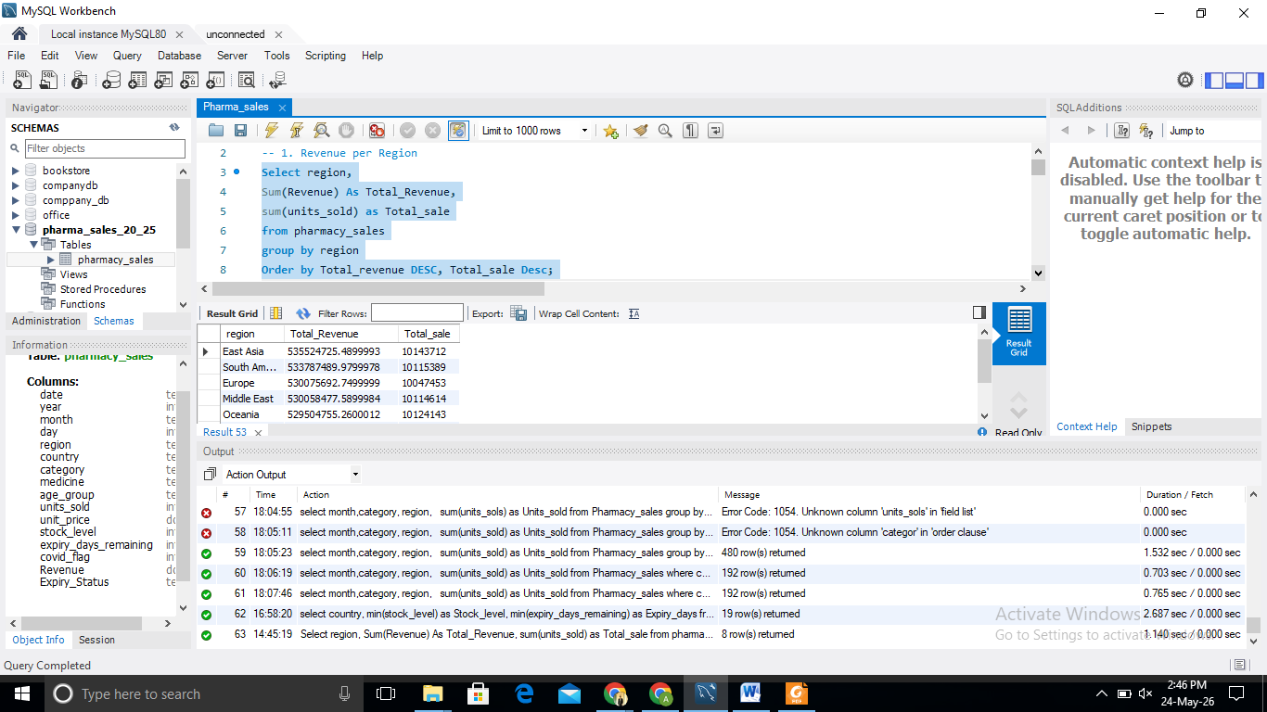

- Revenue Per medicine per region:
Analysis showed that medicines like Cough Syrup, Ibuprofen, and Paracetamol consistently ranked among the top revenue-generating products across multiple regions. Africa and South Asia demonstrated particularly strong OTC medicine demand, indicating high dependency on essential and symptomatic treatments.
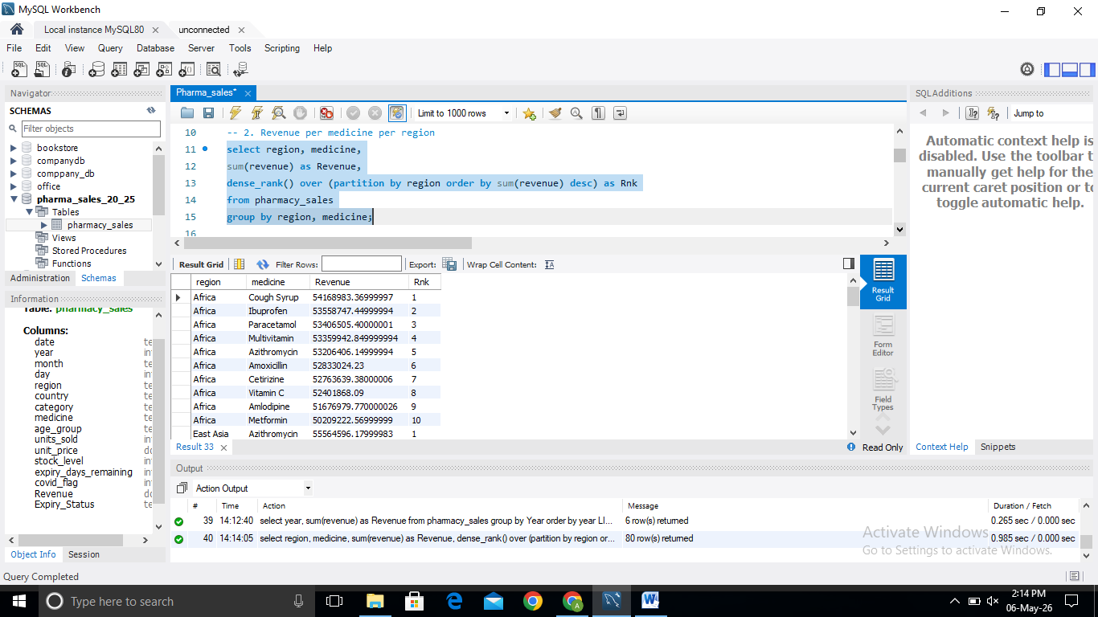

3.Top three Medicine Per Category:
The analysis identified Azithromycin, Ibuprofen, Metformin, Cough Syrup, and Multivitamin as the highest revenue-generating medicines across their respective categories. The relatively balanced revenue distribution suggests a diversified and stable pharmaceutical portfolio, while strong performance in chronic, respiratory, and wellness medicines highlights evolving healthcare demand patterns and long-term growth opportunities.
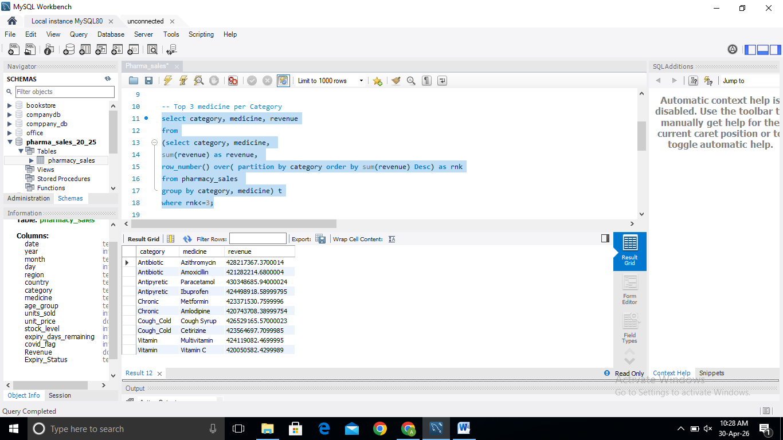

- Supply crisis country:
The supply crisis analysis identified multiple country-medicine combinations where stock levels dropped to zero, indicating complete stockout events. Critical medicines such as Metformin, Amlodipine, Vitamin C, and Amoxicillin were affected across several regions, highlighting weaknesses in inventory planning and demand forecasting. These shortages may result in lost revenue, reduced customer satisfaction, and potential treatment disruptions, emphasizing the need for stronger inventory control and proactive replenishment strategies.
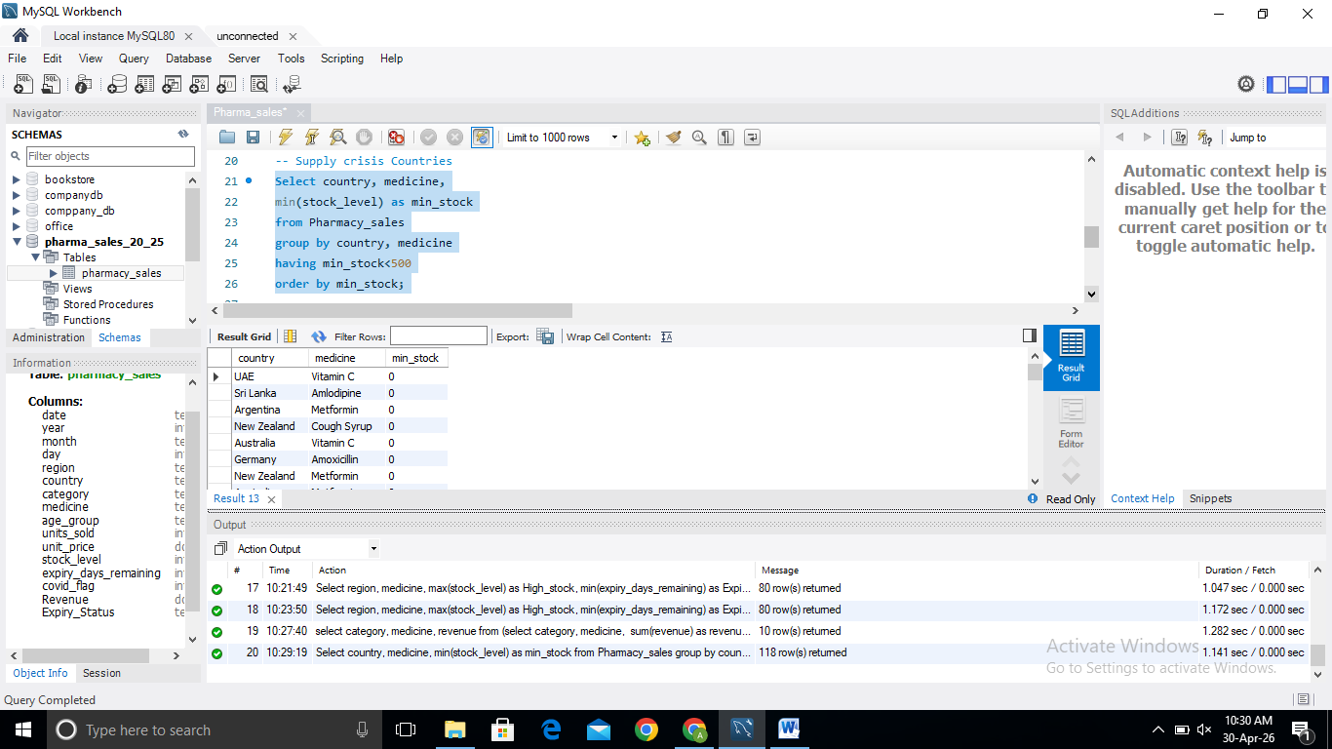

- High Stock but Near Expiry Risk Analysis:
The analysis identified multiple medicines across regions with inventory levels exceeding 5,000 units while having less than 100 days of shelf life remaining. This combination of high stock and low expiry days creates significant financial risk through potential write-offs, inventory holding costs, and lost revenue. Chronic medicines, antibiotics, and OTC products are all affected, indicating the need for stronger demand forecasting, inventory redistribution, and proactive expiry management strategies.

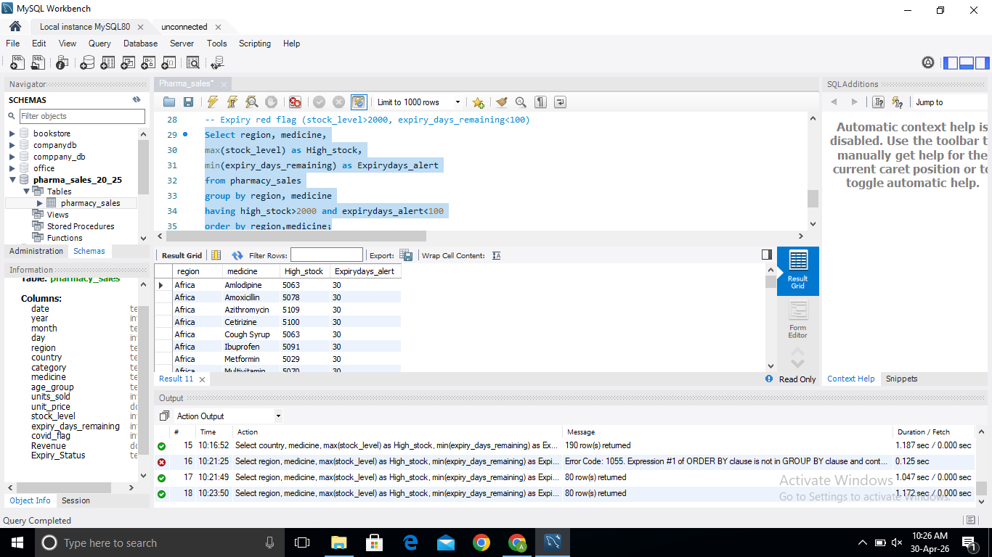

- Revenue driving Age group:
The analysis reveals that the 46–65 age group is the strongest revenue contributor across multiple medicine categories, particularly Chronic, Antibiotic, and Vitamin products. Chronic therapies emerged as the highest revenue-generating category overall, highlighting the growing burden of lifestyle diseases. Additionally, strong Cough_Cold demand among seniors and significant Antibiotic revenue from children indicate distinct age-specific healthcare needs. These findings support targeted marketing, optimized inventory planning, and demographic-focused healthcare strategies.

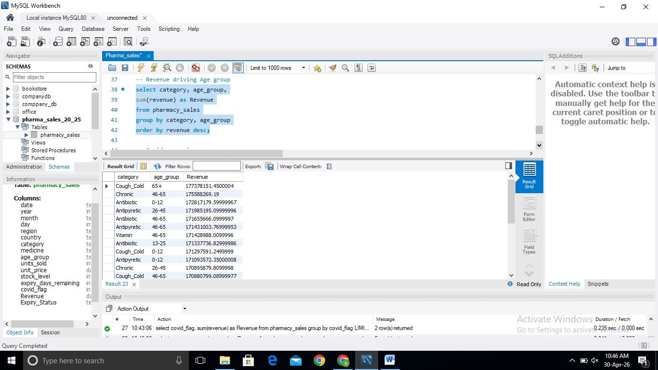

7. COVID period and Post-COVID analysis:
COVID period and Post-COVID analysis revealed sustained demand across all pharmaceutical categories, with Antipyretics generating the highest revenue (~471.4M), followed closely by Chronic and Antibiotic medicines. Vitamin products maintained strong performance, indicating a lasting consumer shift toward preventive healthcare. The minimal revenue variation across categories demonstrates a well-diversified product portfolio, reducing dependence on any single therapeutic segment and supporting long-term business stability.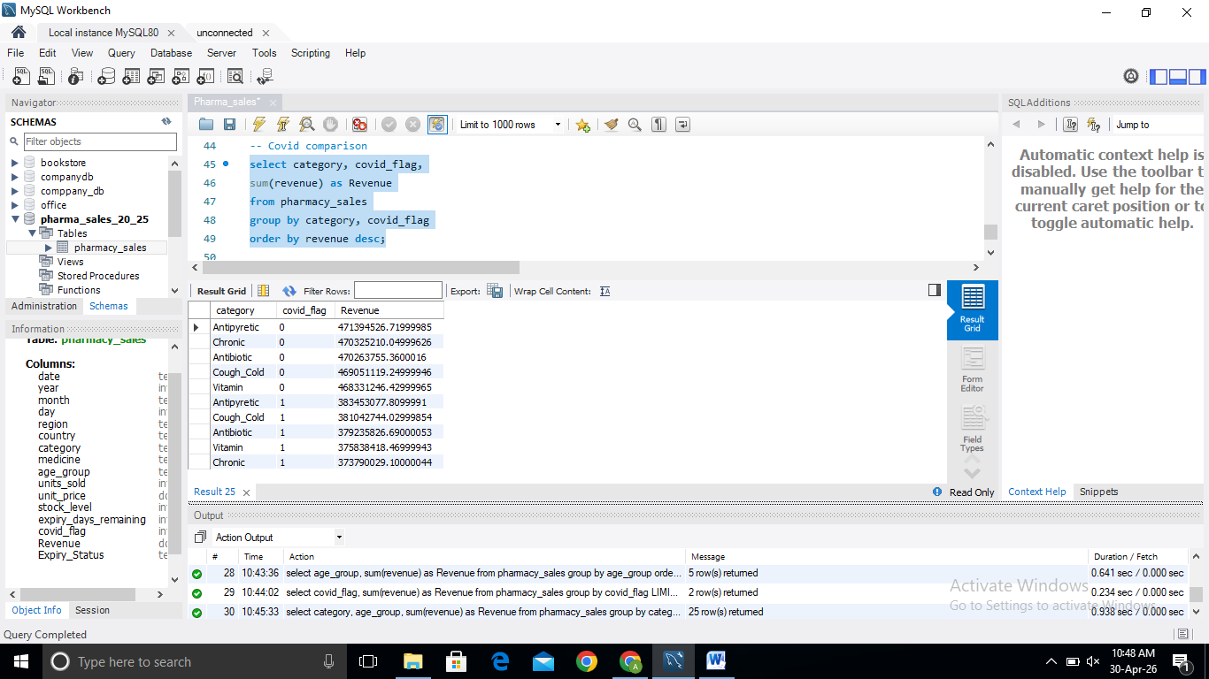

- Yearly Revenue Trend Analysis (2020–2025):
Yearly revenue analysis revealed that pharmaceutical sales peaked during the COVID period, with 2020 and 2021 each generating approximately 947M in revenue. Following the pandemic, revenue declined as emergency healthcare demand normalized but stabilized between 582M–591M from 2022 onwards. This pattern highlights the significant impact of COVID on pharmaceutical consumption while demonstrating the business’s ability to maintain strong and consistent revenue through a diversified product portfolio and sustained demand for chronic, wellness, and essential medicines.

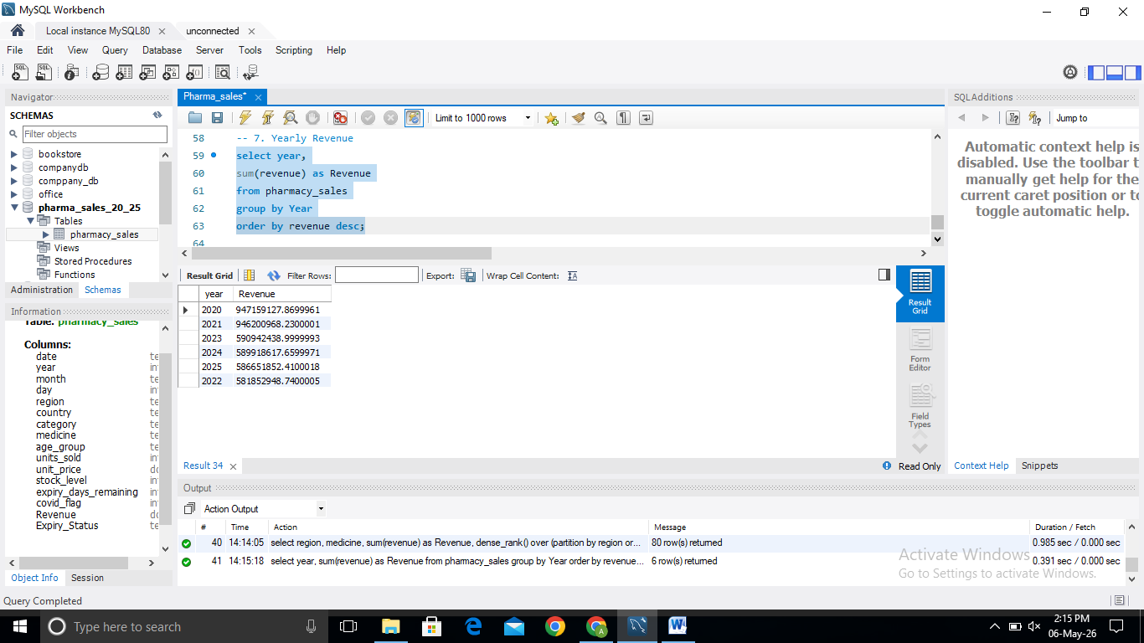

- Year-over-Year (YoY) Revenue Growth Analysis:
Year-over-Year revenue analysis revealed stable performance during the COVID period, with only a 0.1% decline between 2020 and 2021. Revenue experienced a significant correction of 38.5% in 2022 as pandemic-driven demand normalized. However, the business recovered in 2023 with positive growth and maintained a stable revenue range above 580M through 2025. These trends indicate a resilient pharmaceutical portfolio capable of sustaining long-term performance beyond temporary pandemic-related demand spikes.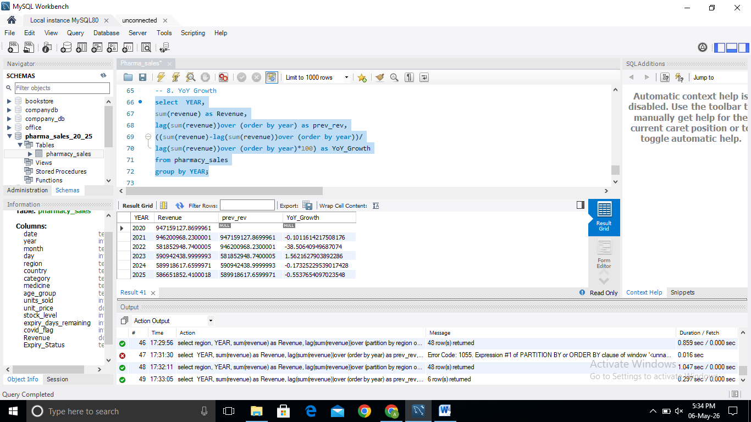

- COVID Impact on Antipyretic Sales:
Analysis of Antipyretic sales revealed that demand remained strong beyond the COVID period. Unit sales increased from 7.28 million during COVID to 8.96 million post-COVID, representing approximately 23% growth. This trend suggests that consumer awareness of health management and OTC medication usage continued after the pandemic, transforming Antipyretics from a temporary high-demand category into a sustained revenue driver. The findings highlight the importance of maintaining robust inventory levels and leveraging cross-selling opportunities within the OTC portfolio

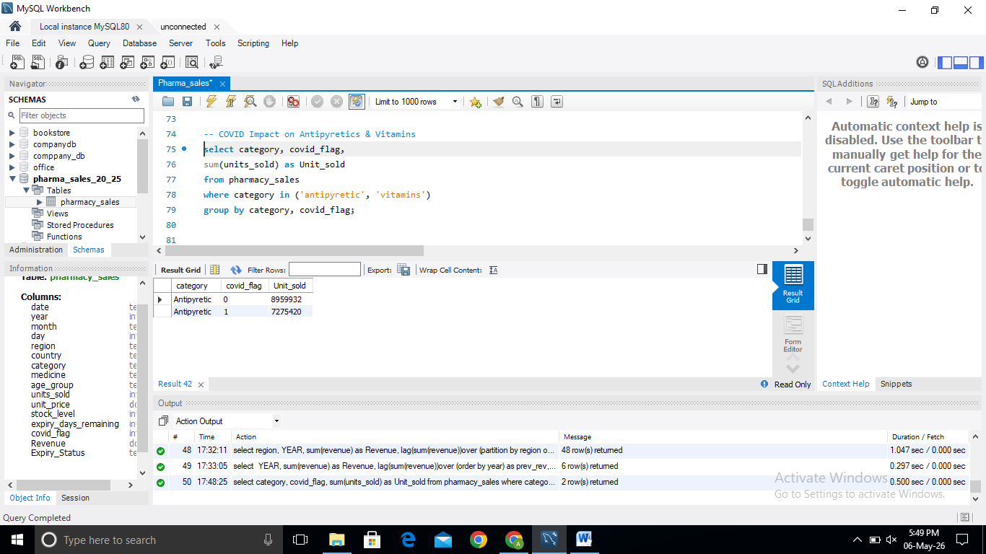

- Chronic Medicine Revenue by Age Group:
Chronic medicine revenue analysis revealed that the 46–65 age group was the largest contributor, generating approximately 175.6M in revenue. However, the 26–45 segment closely followed, highlighting the growing prevalence of lifestyle-related chronic diseases among working-age adults. Revenue remained strong across all age groups, indicating broad demand for long-term therapies such as diabetes and cardiovascular medications. These findings emphasize the importance of patient adherence programs, preventive healthcare initiatives, and targeted chronic disease management strategies.
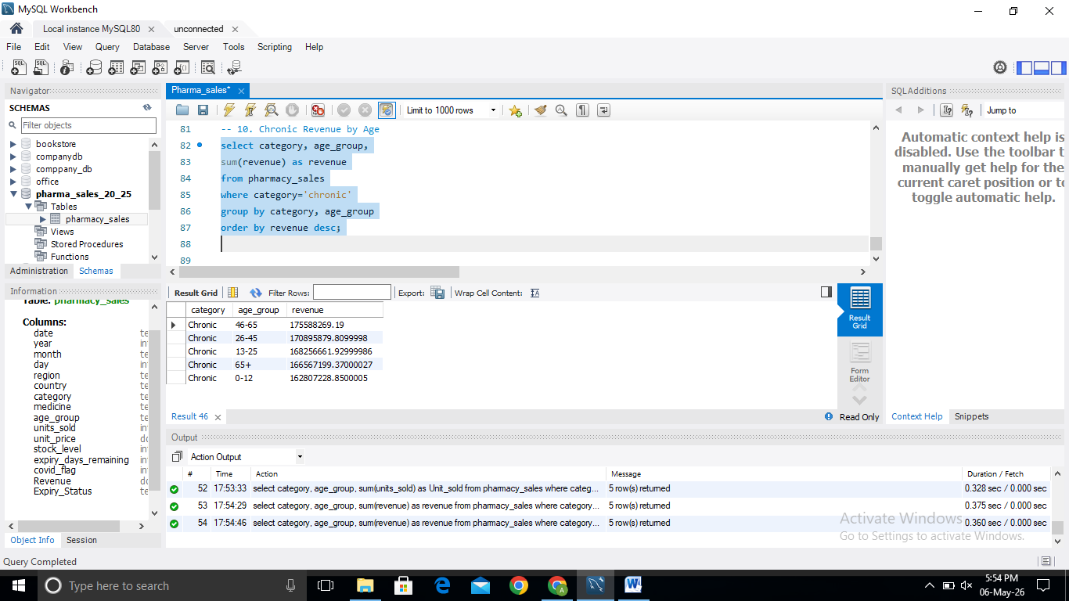

- Worst Inventory Health Countries Analysis:
Inventory health analysis identified several countries, including India, UAE, Canada, Australia, and Argentina, experiencing critical inventory conditions characterized by both stockouts (stock level = 0) and near-expiry inventory (30 days remaining). This combination highlights inefficiencies in inventory allocation and demand forecasting, creating risks of lost sales, product wastage, and reduced customer satisfaction. The findings emphasize the need for centralized inventory monitoring, proactive replenishment planning, and cross-region inventory optimization to improve supply chain performance

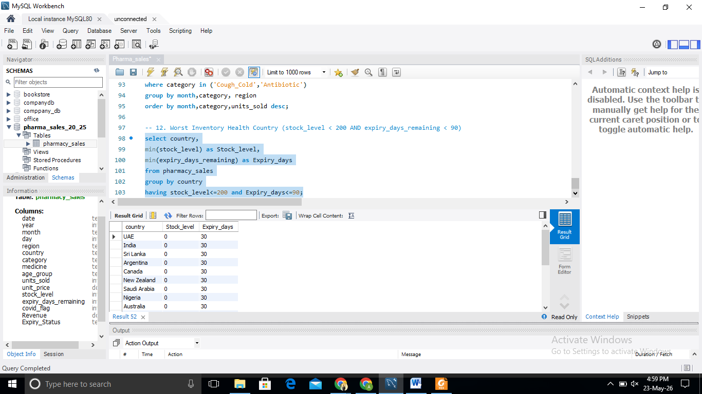

- Seasonality Analysis of Cough_Cold & Antibiotic Sales:
Seasonality analysis revealed clear demand cycles for Cough_Cold and Antibiotic medicines. Sales peaked during Q1, with March recording the highest volumes across most regions, while demand declined significantly during August–October before recovering in November–December. East Asia and South Asia consistently ranked among the highest-demand markets, while Africa recorded the strongest Cough_Cold sales peak. These findings highlight the importance of seasonal forecasting, proactive inventory planning, and region-specific supply chain optimization to ensure product availability during peak illness periods while minimizing expiry-related losses during low-demand months
