HANDWRITTEN AND PRINTED BENGALI SCRIPT CHARACTER SEGMENTATION USING MORPHOLOGICAL ANALYSIS

A Thesis Submitted
By
Pritilata Biswas
ID: 1103017
Sumaia Afrin Prity
ID: 1103057
Parvez Abedin Siddique
ID: 1103094

Under the Supervision of
Arifa Islam Champa
Lecturer
Department of Computer Science and Engineering
Bangladesh Army International University of Science and Technology


Bachelor of Science in Computer Science and Engineering
Bangladesh Army International University of Science and Technology
Fall, 2019 Semester

HANDWRITTEN AND PRINTED BENGALI SCRIPT CHARACTER SEGMENTATION USING MORPHOLOGICAL ANALYSIS

A Thesis submitted to the Department of Computer Science and Engineering Faculty, Bangladesh Army International University of Science and Technology in partial fulfillment of the requirements for the degree of Bachelor of Science in Computer Science and Engineering.

Pritilata Biswas  Sumaia Afrin Prity  Parvez Abedin Siddique | ID: 1103017  ID: 1103057  ID: 1103094
Department of
Computer Science and Engineering
Bangladesh Army International University of Science and Technology


Fall Semester 2019
July, 2020

Declaration
This is to certify that this thesis is my original work. No part of this work has been submitted elsewhere partially or fully for the award of any other degree or diploma. Any material reproduced in this project has been properly acknowledged.

Student’s name & signature

Approval

The Thesis titled “HANDWRITTEN AND PRINTED BENGALI SCRIPT CHARACTER SEGMENTATION USING MORPHOLOGICAL ANALYSIS” has been submitted to the following respected members of the Board of Examiners in partial fulfillment of the requirements for the degree of Bachelor of Science in Computer Science and Engineering on June 2020 by the following student and has been accepted as satisfactory.
Pritilata Biswas  Sumaia Afrin Prity  Parvez Abedin Siddique | ID: 1103017  ID: 1103057  ID: 1103094

_ _ _ _ _ _ _ _ _ _ _ _ _ _ _ _ _ _  Supervisor  Arifa Islam Champa  Lecturer  Department of CSE  Bangladesh Army International University of Science and Technology | _ _ _ _ _ _ _ _ _ _ _ _ _ _ _ _ _  External Supervisor  [Faculty Name]  Choose an item.  Department of ___  Bangladesh Army International University of Science and Technology
_ _ _ _ _ _ _ _ _ _ _ _ _ _ _ _ _ _
Mohammad Asaduzzaman Khan
Head, Department of CSE
Bangladesh Army International University of Science and Technology

Acknowledgement

In this section, express your gratitude to the people who have helped you throughout the work. Give thanks to different people for valuable discussions, their suggestions, ideas and encouragements.
This section should not be more than one page. But if you cannot confine your gratitude in one page, you can use two pages.
Remember, Font will be 12, Times New Roman here.

Pritilata Biswas
Sumaia Afrin Prity
Parvez Abedin Siddique

TABLE OF CONTENTS
Declaration i
Approval ii
Acknowledgement iii
ABSTRACT viii
Chapter 1 1
Introduction 1
1.1. Introduction 1
1.2. Historical Background 3
1.2.1. Earlier Research 4
1.2.2. Recent Research 6
1.2.3. State of the art technology 7
1.3. Future Scope of This Study 8
1.3.1. Future Scopes 8
1.3.2. Recommendations 9
1.4. Limitation of the Study 9
1.5. Advantage over Traditional Method 10
1.6. Objective of this Work 10
1.6.1. Primary objectives 10
1.6.2. Secondary Objectives 10
1.7. Introduction to this Thesis 11
Chapter 2 12
HOW TO USE THIS TEMPLATE 12
2.1. Introduction 12
2.2. From Declaration to Abstract 12
2.3. Entering the Text 12
2.3.1. Using Bold, Italic or Underline and use of Bullets 12
2.3.2. Text Justification 13
2.3.3. Spacing Option 13
2.3.4. How to use Numbering 13
2.3.5. Using Color 13
2.4. Table of Content 15
2.4.1. How to Update Table of content Automatically 15
2.4.1.1. Mark your text according to Table 2.1 15
2.4.1.2. Update the Table 15
2.5. List of Figures 16
2.6. Use of Table 16
2.7. Use of Figures 16
2.8. Writing Equations 18
2.9. Using Symbols 18
2.10. Appendices 18
2.11. References 19
2.12. Error Correction 20
2.13. Summary 20
Chapter 3 21
Title of Chapter 3 21
3.1. Introduction 21
3.2. Headings 21
3.2.1. Subheading 21
3.2.2. Subheading 21
3.3. Novelty of Our Work 21
3.4. Summary 21
Chapter 4 22
Title of Chapter 4 22
4.1. Introduction 22
4.2. Headings 22
4.2.1. Subheading 22
4.2.2. Subheading 22
4.3. Summary 22
Chapter 5 23
Discussions and Conclusions 23
5.1. Discussions 23
5.2. Suggestion for future Work 23
5.2.1. Subheading 23
5.2.2. Subheading 23
5.3. Conclusions 23
REFERENCES 24
Appendix A 26
Detailed Explanation 26

LIST OF FIGURES

LIST OF TABLES

ABSTRACT

Bengali script segmentation is the most challenging and also an essential key task for any Bangla Optical Character Recognition system. With the help of script segmentation, a big image of some written document is fragmented into several small pieces which are then used for pattern matching to visualize the desired sequence of characters. For implementing the Bangla OCR, the script segmentation may also play a vital role. But, for accurate and proper segmentation it is essential to mark out the properties of Bangla script as well as the exceptions. In this paper, we have tried to present a perfect and robust segmentation process for handwritten and printed Bengali script. This term is important for Bangla language as resources of this language are not easily available. In the Bangla OCR system, one of the major challenges is character segmentation. Appropriate segmentation raises the validity of the recognition process. Proper segmentation is hard as there are more than 300 basics, modified and compound characters in the Bengali script as they are topologically connected. Some characters are also overlapped. Here we have also used connected component analysis that can trace all the problems of character segmentation of Bangla script with less attempt. In the system, we have tried to identify the Matra line rightly. Then by using this information, connected components can be tear apart. Using some morphological operations for segmentation lead us to proper recognition. The proposed method solves the problems of character segmentation in Bangla script and thereby increases the accuracy of a segmentation phase that leads to greater accuracy of an entire optical character recognition system.

Chapter 1

Introduction

Introduction

Historical Background

Earlier Research

Recent Research

State of the art technology

Future Scope of This Study
From 1950s character recognition is an active area of research. Many techniques for recognition of Characters have been suggested. But still, an efficient OCR for the recognition of handwritten Bengali characters does not exist. Few steps have been taken for Handwritten and printed character recognition. Various challenges are identified which may provide more lively interest to the researchers. These challenges are difficult to identify the diverse human writing styles, different angles of letters, different shapes and sizes of letters, pure input quality, low accuracy rate in recognition, etc. Hence, a lot of research work is to be done to solve these difficulties. In the future, the area of recognition of constrained print is expected to decrease. In the case of handwritten text, our segmentation process can give better output if there exists enough space between characters. In the future, we will try to develop our work in the area of the handwritten script more accurately.

Future Scopes
Our proposed strategy can help to increase the segmentation and recognition accuracy for Bangla printed text. Though as the proposed method failed to give better results for character segmentation, we have a plan to use HMM (Hidden Markov model) for character segmentation. In that case, the system will take the word as input and will give characters as output. Though we need a large data set as we have to train each character with all possible modifiers, yet we think the system will give better results.

Recommendations
Bangla is one of the most widely spoken languages in the world. Though Bangla is a very rich and old language, the matter of regret is that its computerization has not yet gone much far. Dedicated research and development for Bangla computerization have just been started from the last decade. In the computerization of any language, one of the vital tasks is to develop an efficient and effective Optical Character Recognition (OCR) system for the respected language. To store a million pages of paper documents into electronic form, OCR is the key tool. Otherwise, if those are entered by typing manually, the efficiency, effectiveness, and correctness will drastically fall. As a result, all the effort will go in vain.
For Bangla, there is no good OCR solution until now. But, our government and private organizations have huge quantities of Bangla paper documents that are so important that those should be stored for a long period. To do so, making electronic copies of those documents are unparalleled and it can be done by using a high-quality Bangla OCR system. But, to implement an OCR the foremost step in the recognition process is the script segmentation of the document image. Since the written form of Bangla documents is more complex than that of many other languages, Bangla script segmentation is of great importance for creating a Bangla OCR system.

Limitation of the Study
The main obstacle of our method is distorted image, not aligned image as we have scanned the script horizontally, vertically but not in slop. The result has a few limitations in the case of line, word, and character segmentation. For line segmentation, the system will not be able to give correct results if the line is skewed more than 30 degrees clockwise or anti-clockwise. The system has a limitation of segmenting connected lines as well. That means it will not be able to segment a line correctly if the line collides with the upper or lower line of the text. For word segmentation, the system fails to segment a word correctly if the inter-word gap gets equal to the inter-character gap of a line. For character segmentation, the system has a few limitations. Firstly, our proposed method will not be able to segment overlapped characters. Secondly, it will not be able to segment a character if it overlaps with another character. Finally, since we’re unable to detect baseline the system fails to separate the modifiers from the characters.

Advantage over Traditional Method

Objective of this Work
To accomplish thesis work we make a list of some objectives that we must achieve during the work. Our primary and secondary objectives are stated below-

Primary objectives
The primary and main objective of this research is to develop an effective strategy for segmenting printed Bengali scripts using morphological analysis which can help to build an efficient optical character recognition (OCR) system.

Secondary Objectives
To obtain this primary objective the following sub-objectives must also be achieved:
- Reduce the segmentation error and time.
- Define the structuring element properly.
- Determine the matra line by the morphological opening operation.
- Remove connectedness of character using morphological closing operation.
- Comparative analysis between existing and proposed methods.

Introduction to this Thesis
Bangla character recognition has become a vital issue in the last few years but it is a huge challenge to get good performance due to the segmentation and many of them are similar. It remains largely unsolved due to the presence of many ambiguous characters and excessively swigs Bangla handwriting. Even many flourished existing methods do not lead to satisfactory performance in practice that related to Bangla character recognition. We mainly focused on the segmentation process which is the backbone of the recognition phase. At the preprocessing part, the input image is processed by using various filters like the grayscale filter, bilateral filter, skew angle correction, and binarization. Then for segmentation purposes, the lines of Bengali script are segmented by horizontal projection profile (HPP) and then words for each line are segmented by vertical projection profile (VPP). Here HPP and VPP are part of structural analysis. This Structural analysis is the process of breaking words down into their basic parts to determine word meaning. Finally, for character segmentation, we used basic operations like opening and closing of Morphological Image Processing. In our system, we mainly tried to identify the lines, words, and also the characters properly for the Bengali script that solves the problem of making a good Optical Character Recognition system and thereby increases the accuracy of the segmentation process.

Chapter 2

Methodology

2.1. Introduction

In this thesis, we have tried to complete the segmentation processes properly for Bengali scripts that help to build a robust Optical Character Recognition (OCR) system. As proper segmentation is the most challenging part for building the OCR system, here the overall methods of segmentation processes are described completely.

2.2. Optical Character Recognition (OCR)
Optical Character Recognition deals with the problem of recognizing optically processed characters. Optical recognition is performed off-line after the writing or printing has been completed, as opposed to on-line recognition where the computer recognizes the characters as they are drawn. Both handwritten and printed characters may be recognized, but the performance is directly dependent upon the quality of the input documents.

Character recognition
On-line
Off-line

Single characters
Handwritten script
Printed
Handwritten
Recognition
Verification

Figure 1: The different areas of character recognition.

In Figure 1, the different fields of character recognition like off-line and on-line fields are visualized. For off-line single characters, the documents can be printed and handwritten. Besides, for the handwritten script, recognition and verification are the most important stages. The more constrained the input is, the better will the performance of the OCR system be. However, when it comes to totally unconstrained handwriting, OCR machines are still a long way from reading as well as humans. However, the computer reads fast and technical advances are continually bringing the technology closer to its ideal.

2.2.1. The History of OCR
Methodically, character recognition is a subset of the pattern recognition area. However, it was character recognition that gave the incentives for making pattern recognition and image analysis matured fields of science. The overall OCR chronology from the 1870s to 1986s is shown by the following Table 1:

Table 1: A short OCR chronology

1870
The very first attempts
1940
The modern version of OCR
1950
The first OCR machines appear
1960 - 1965
First generation OCR
1965 - 1975
Second generation OCR
1975 - 1985
Third generation OCR
1986 ->
OCR to the people

Here, Table 1 indicates the short chronology of OCR from the earlier periods to today’s generation. Although OCR machines became commercially available already in the 1950s, only a few thousand systems had been sold worldwide up to 1986. The main reason for this was the cost of the systems. However, as hardware was getting cheaper, and OCR systems started to become available as software packages, the sale increased considerably. Today a few thousand is the number of systems sold every week, and the cost of an omnipotent OCR has dropped with a factor of ten every other year for the last 6 years.

2.2.2. Components of an OCR system
A typical OCR system consists of several components. The complete OCR system consists of a scanner, the recognition component, and OCR software that interacts with the other components to store the computerized document on the computer. The process of inputting the material into the computer begins with the scanner taking a picture of the printed material. The components of an OCR system are illustrated by the following Figure 2:

Location segmentation
Optical Scanning
Preprocessing


Feature Extraction


Figure 2: Components of an OCR-system

In Figure 2, a common setup of OCR is visualized. The first step in the process is to digitize the analog document using an optical scanner. When the regions containing text are located, each symbol is extracted through a segmentation process which is the most important task. The extracted symbols may then be preprocessed and eliminate noise to facilitate the extraction of features in the next step. The identity of each symbol is found by comparing the extracted features with descriptions of the symbol classes obtained through a previous learning phase. Finally, contextual information is used to reconstruct the words and numbers of the original text.

System Overview
In our system, we completed our tasks by the following steps:
- Taking image as input from the Bengali Scripts.
- Processing the input image by applying various filters.
- Segmenting the lines by following Horizontal Projection Profile (HPP).
- Segmenting the words by following Vertical Projection Profile (VPP).
- Finally, segmenting the characters properly by using the operations of Morphological image processing.

Bengali Script
Bangla scripts are moderately complex patterns. The alphabet of Bangla script consists of 50 characters with 11 vowels and 39 consonants. They are the basic characters of the Bangla language. each word in Bangla scripts is composed of several characters joined by a horizontal line (called ‘Matra’ or head-line) at the top. Often there may be different composite characters and vowel and consonant signs(‘Kaar’ and ‘Falla’ symbols). This makes the development of an OCR for Bangla printed scripts a highly challenging task. In Bangla, the writing style is from left to right. The upper case / lower case concept is absent in Bangla. Most of the characters have a line in the upper zone. When they form a word by sitting side by side they are connected through this line. This line is called “Matra” or “Head-line”. Those characters have “Matra” on them are connected with another character in the upper zone through their “Matra”. Some connected components are seen to be connected in the lower zone (modified vowels and consonants).

Image filtering
Filtering is a technique for modifying or enhancing an image. For example, we can filter an image to emphasize certain features or remove other features. Image processing operations implemented with filtering include smoothing, sharpening, and edge enhancement. Filtering is a neighborhood operation, in which the value of any given pixel in the output image is determined by applying some algorithm to the values of the pixels in the neighborhood of the corresponding input pixel. A pixel's neighborhood is some set of pixels, defined by their locations relative to that pixel.

Grayscale filtering:
A grayscale (or gray level) image is simply one in which the only colors are shades of gray. The reason for differentiating such images from any other sort of color image is that less information needs to be provided for each pixel. ‘Gray’ color is one in which the red, green, and blue components all have equal intensity in RGB space, and so it is only necessary to specify a single intensity value for each pixel, as opposed to the three intensities needed to specify each pixel in a full-color image. Often, the grayscale intensity is stored as an 8-bit integer giving 256 possible different shades of gray from black to white. If the levels are evenly spaced then the difference between successive gray levels is significantly better than the gray level resolving power of the human eye. Grayscale images are very common, in part because much of today's display and image capture hardware can only support 8-bit images. Besides, grayscale images are entirely sufficient for many tasks and so there is no need to use more complicated and harder-to-process color images. OpenCV provides us some tools to generate a grayscale image by grayscale filtering. This simply generates the average of RGB channel and put it between 0-255 so that only black and white image remains.

- Bilateral filtering:
The main aim of image smoothing is to remove noise in digital images. It is a classical matter in digital image processing to smooth image. And it has been widely used in many fields, such as image display, image transmission, and image analysis, etc. Image smoothing has been a basic module in almost all the image processing software. So, it is worth studying more deeply. Image smoothing is a method of improving the quality of images. The image quality is an important factor for the human vision point of view. The image usually has noise which is not easily eliminated in image processing. The quality of the image is affected by the presence of noise. Many methods are there for removing noise from images. Many image processing algorithms can’t work well in a noisy environment, so the image filter is adopted as a preprocessing module. However; the capability of conventional filters based on pure numerical computation is broken down rapidly when they are put in a heavily noisy environment. The median filter is the most used method, but it will not work efficiently when the noise rate is above 0.5. So, here we used the bilateral filtering to smoothing our image. A bilateral filter is a non-linear, edge-preserving, and noise-reducing smoothing filter for images. It replaces the intensity of each pixel with a weighted average of intensity values from nearby pixels. This weight can be based on a Gaussian distribution. Crucially, the weights depend not only on Euclidean distance of pixels but also on the radiometric differences. This preserves sharp edges.

Image Binarization
Image binarization is the process of taking a grayscale image and converting it to black-and-white, essentially reducing the information contained within the image from 256 shades of gray to 2: black and white, a binary image. This is sometimes known as image thresholding, although thresholding may produce images with more than 2 levels of gray. It is a form of segmentation, whereby an image is divided into constituent objects. This is a task commonly performed when trying to extract an object from an image. The process of binarization works by finding a threshold value in the histogram – a value that effectively divides the histogram into two parts, each representing one of two objects (or the object and the background). It is known as global thresholding. Most thresholding algorithms work by using some type of information to decide where the threshold is. Sometimes the information is statistical and uses the mean, median, entropy, other times information is in the form of shape characteristics of the histogram. Otsu’s algorithm is one of the classical thresholding algorithms introduced by Nobuyuki Otsu in 1979. The algorithm works by exhaustively searching for the threshold that minimizes the weighted within-class variance, or put another way maximizes the between-class variance. Here, we used Otsu’s algorithm.

Skew angle correction
The skew angle is the angle in which the elements of an image are skewed from the horizontal or vertical line. To correct this skewness, it needs to find the angel of skewed element and find its rotation matrix. If we can get the rotation matrix we can easily deskew the angle and remove the skewness of the image element.

Horizontal Projection Profile( HPP)

Vertical Projection Profile(VPP)

Morphological image processing
Morphology is a broad set of image processing operations that process images based on shapes. In a morphological operation, each pixel in the image is adjusted based on the value of other pixels in its neighborhood.

- Opening and closing:
Opening and closing are the operations of morphological image processing. Opening removes small objects from the foreground (usually taken as the bright pixels) of an image, placing them in the background, while closing removes small holes in the foreground, changing small islands of background into the foreground. These techniques can also be used to find specific shapes in an image. In image processing, closing is, together with opening, the basic workhorse of morphological noise removal. Opening removes small objects, while closing removes small holes.

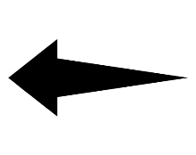
ই
ই

(a) opening


এ
এ
(b) closing

Figure 3: (a) Opening and (b) Closing operations
In Figure 3, the morphological operations are shown. Here (a) indicates the output of opening and (b) indicates the output of closing operations. The operations are applied upon the full character element. The deepness of the image element depends on the attribute that is used in the time of the operation. For opening operation, if a big attribute is used then it will be completely removed. On the other side, the closing operation simply opposite of opening. That means by using a big attribute it will be bolder.

Summary
A detailed overview of our system has been given in this chapter. The overview also includes the explanation of the different methods that are applied to make a strong OCR system.

Chapter 3

Implementation

Introduction

Implementation Tools
To perform the segmentation processes completely several development environments, and packages are used. Here is a list of tools used in the total research process-

Environments
- Anaconda Environment: This the main python environment that has been used to develop our deep convolutional neural network architecture.

Anaconda is a free and open-source distribution of the Python and R programming languages for scientific computing that aims to simplify package management and deployment. Package versions are managed by the package management system conda. The Anaconda distribution includes data-science packages suitable for Windows, Linux, and macOS. Anaconda distribution comes with 1,500 packages selected from PyPI as well as the conda package and virtual environment manager. It also includes a GUI, Anaconda Navigator, as a graphical alternative to the command-line interface. The big difference between conda and the pip package manager is how to package dependencies are managed, which is a significant challenge for Python data science and the reason conda exists [1].

Packages
- OpenCV: Our RGB images need to be processed for the deep convolutional neural network architecture so we use this OpenCV to do that.

OpenCV (Open source computer vision) is a library of programming functions mainly aimed at real-time computer vision. Originally developed by Intel, it was later supported by Willow Garage then Itseez which was later acquired by Intel. The library is cross-platform and free for use under the open-source BSD license. OpenCV supports some models from deep learning frameworks like TensorFlow, Torch, PyTorch after converting to an ONNX model and Caffe according to a defined list of supported layers [2].

- Numpy: For manipulating the images as arrays we Numpy package of python. It is a popular Python library used for performing array-based numerical computations. The canonical implementation of NumPy used by most programmers runs on a single CPU core and is parallelized to use multiple cores for some operations. This restriction to a single-node CPU-only execution limits both the size of data that can be handled and the potential speed of NumPy code [3].

- Matplotlib: Matplotlib is a plotting library for the Python programming language and its numerical mathematics extension NumPy. It provides an object-oriented API for embedding plots into applications using general-purpose GUI toolkits like Tkinter, wxPython, Qt, or GTK+. There is also a procedural "pylab" interface based on a state machine (like OpenGL), designed to closely resemble that of MATLAB, though its use is discouraged. SciPy makes use of Matplotlib. Matplotlib was originally written by John D. Hunter, since then it has an active development community, and is distributed under a BSD-style license. Michael Droettboom was nominated as matplotlib's lead developer shortly before John Hunter's death in August 2012, and further joined by Thomas Caswell. Matplotlib 2.0.x supports Python versions 2.7 through 3.6. Python 3 support started with Matplotlib 1.2. Matplotlib 1.4 is the last version to support Python 2.6. Matplotlib has pledged to not support Python 2 past 2020 by signing the Python 3 Statement [4].

  - Tesseract Engine
We used the most popular Tesseract OCR engine to benchmark our methodology. Tesseract is an open-source OCR engine that was developed at HP between 1984 and 1994. Tesseract began as a Ph.D. research project [5] in HP Labs, Bristol, and gained momentum as a possible software and/or hardware add-on for HP’s line of flatbed scanners. The motivation was provided by the fact that the commercial OCR engines of the day were in their infancy, and failed miserably on anything but the best quality print.
Since HP had independently-developed page layout analysis technology that was used in products, (and therefore not released for open-source) Tesseract never needed its page layout analysis. Tesseract, therefore assumes that its input is a binary image with optional polygonal text regions defined. Processing follows a traditional step-by-step pipeline, but some of the stages were unusual in their day, and possibly remain so even now. The first step is a connected component analysis in which outlines of the components are stored. This was a computationally expensive design decision at the time but had a significant advantage: by inspection of the nesting of outlines, and the number of child and grandchild outlines, it is simple to detect inverse text and recognize it as easily as black-on-white text. Tesseract was probably the first OCR engine able to handle white-on-black text so trivially. At this stage, outlines are gathered together, purely by nesting, into Blobs. Blobs are organized into text lines, and the lines and regions are analyzed for fixed pitch or proportional text. Text lines are broken into words differently according to the kind of character spacing. Fixed pitch text is chopped immediately by character cells. Proportional text is broken into words using definite spaces and fuzzy spaces. Recognition then proceeds as a two-pass process. In the first pass, an attempt is made to recognize each word in turn. Each satisfactory word is passed to an adaptive classifier as training data. The adaptive classifier then gets a chance to more accurately recognize the text lower down the page. Since the adaptive classifier may have learned something useful too late to contribute top of the page, a second pass is run over the page, in which words that were not recognized well enough are recognized again. A final phase resolves fuzzy spaces and checks alternative hypotheses for the x-height to locate small cap text.
Tesseract is an OCR engine with support for Unicode and the ability to recognize more than 100 languages out of the box. It can be trained to recognize other languages. It is also a popular OCR for the Bengali script. In our thesis will evaluate our result corresponding to the result of the Tesseract OCR engine.

Implementation Details
The implementation of our system had done in five stages:

- Taking image input from the Bengali scripts.
- Preprocessing the input image by using several filters, correcting skew angles, and binarization.
- Segmenting lines by following Horizontal Projection Profile (HPP).
- Segmenting words by following Vertical Projection Profile (VPP).
- Eventually, segmenting characters by using Morphological Image Processing operations.

The steps are illustrated by the following figure 4:

- Gray Scale filtering
- Bilateral filtering
- Binarization & Skew Angle correction
Preprocessing



Line Segmentation
Horizontal Projection Profile

Bengali Script


Word Segmentation

Vertical Projection Profile




Character Segmentation
Figure 4: The proposed system
Character Segmented Bengali Script
Morphological Image Processing

In Figure 4, our full system is demonstrated. Now the implementation steps of our system are described below:

Taking Input of Bengali Script
Bangla is one of the most widely spoken languages in the world. More than 180 million people
across the globe use this language. In Bangla script, there are 11 vowels and 39 consonant s(total
of 50) characters, which are called basic characters. Bangla scripts are moderately complex patterns. Each word in Bangla scripts is composed of several characters joined by a horizontal line (called ‘Matra’ or head-line) at the top. In our system, the text digitization of the Bengali script is done by a flatbed scanner having a resolution of 100 to 300 dpi. Then the image will go for the preprocessing stage.

Preprocessing
The image resulting from the scanning process may contain a certain amount of noise. Depending on the resolution on the scanner and the success of the applied technique for
thresholding, the characters may be smeared or broken. Some of these defects, which may
later cause poor recognition rates, can be eliminated by preprocessing the image to smooth
the digitized characters.
In this preprocessing step, a general image is taken as input at a minimum resolution of 100 dpi and a maximum resolution of 300 dpi. Then the input image is passed into several filters like grayscale and bilateral filters. Finally, we will go for image binarization and skew angle correction. The processing of these steps are described below:

- Grayscale filter:
At first, the input image is converted into a grayscale image by using the grayscale filter. This filter gradually converts all the colors in our images to some shade of gray. The input image which was 3 channel RGB image will be converted into a 1 channel grayscale image.
- Bilateral filter:
Then we will apply the bilateral filter on that image. A bilateral filter is a non-linear, edge-preserving, and noise-reducing smoothing filter for images. It replaces the intensity of each pixel with a weighted average of intensity values from nearby pixels. This preserves sharp edges. Thus, using this filtered noise will be removed and the image will be more smooth.

- Binarization:
After that, we will go for image binarization. Through binarization, the image is converted to a two-tone image. This image binarization converts an image of up to 256 gray levels to a black and white image. Here we have used Otsu's threshold technique. In Otsu’s threshold technique it converted the 256 gray level into 2 color levels by simply dividing them by 256. If the quotient is between 0-.5 then the pixel will be 0 means in the range of white or if the quotient between .5-1 then the pixel will be 1 means it will be in the range of black.

- Skew angle correction:
The presence of a skew angle can adversely affect the overall process of recognition and
significantly complicate the segmentation of the document. Hence, it is required to detect and correct the skew angle before proceeding to further steps in OCR. Once the skew angle is identified, the document is simply rotated in the opposite direction by the estimated angle. The skew can be identified by using the horizontal direction. After that, a rotation matrix can be produced from that horizontal direction. By multiplying the rotation matrix and the image matrix the element inside the image can be deskewed.

Line Segmentation

Word Segmentation

Character Segmentation

Character segmentation is the most difficult part of the overall segmentation process. Two major
characteristics of Bangla script which make it more difficult and erroneous in case of character
level segmentation are – Matra line and Character overlap. Bangla words are connected through
matra (head) line. In our approach, we tried to detect the matra line then by removing it, we can find the characters. The overall accuracy of the segmentation process is very much dependent on the proper detection of the matra line as it is the core component of character segmentation. If we take the horizontal projection profile (used inline separation) of a line or a word, then the highest number of black pixels denotes the matra line. But it may take more than one iterations. But this technique is not so feasible. So, we tried to find a structural element corresponding to the matra line. With that structural element, we apply the morphological image processing operations. How these operations worked are described below:
- Opening:
This opening operation removes the matra line more efficiently and for that, we need a structural element. Because structural elements can easily find matra lines more efficiently than the HPP because matra lines do not continue and HPP works better when the target element is continued. Structural element nothing but a 2D matrix that contains a special shape of the target element. We know the shape of the matra line is a rectangle. So, we need a structural element that is a rectangle and also we must not remove the matra line completely. Because completely removing the matra line can be a very bad decision for further feature extraction for the OCR. Because in Bengali script some characters cannot be identified without the matra line. So, we take a structural element that will leave at least 1 row of the pixel, and from that pixel, we can get back our matra line.
ন ণ
Figure 5: Bangla characters

In Figure 5, two Bangla characters are shown. Hereby using opening operation, if we remove the matra line then there will arise a conflict whether it is ন or ণ. So, we need to get back the matra line.

So, after identifying the matra line we simply do the opening operation and get the characters separated from each other. Now, we can simply use the VPP operation to find every individual character.

- Closing:
Form Figure 5 we come to learn that the matra line is an important part of the Bengali script. So, without the matra line, the feature extraction will be inaccurate. The matra line can be get backed by using the closing of the morphological image processing operation. For that, we need the same structural element that we used before for opening morphological image processing operation. By simply applying a closing morphological image processing operation on the image with the structural element our matra lines will be backed.

Novelty of Our Work

Summary
This chapter gives the implementation details of our entire system. It gradually implies how the system acts with its processes with the help of several methods and their applications. In this way, the segmentation processes that are lines, words, and characters are described here completely.

Chapter 4

Experimental Results

Introduction
In our system, there are five steps. In this chapter, we are going to explain the details of the output of every step in brief.

Evaluation
In this thesis, we have tried to take two types of Bengali documents like the handwritten and printed document. These two documents are taken as the input image. Then for the first stage, these images are filtered using the grayscale filter, bilateral filter, image binarization, and checking for skew angle correction. After getting a binary image we proceed for the segmentation process. For segmentation, the text line is extracted by applying HPP, and as a result, words are also separated by using the VPP procedure. Finally, we have done the character segmentation using Morphological Image Processing operations that are opening and closing. Thus, the text lines, words, and characters of our scanned images are segmented.

Preprocessing
When the input image is passed into the preprocessing stage, then the output of both handwritten and printed image of Bengali scripts are:

- Handwritten script results:

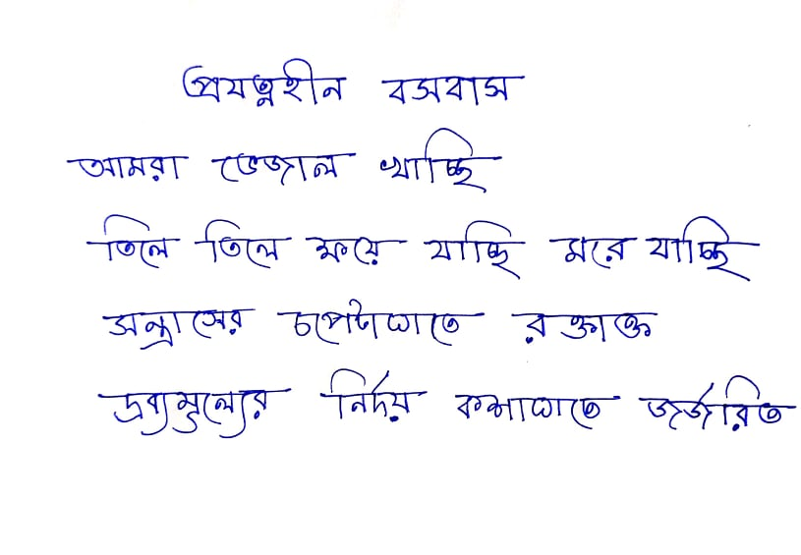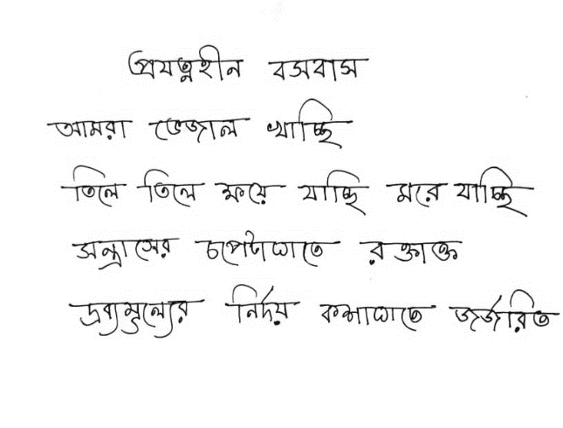
- Input image (b) Applying Grayscale filter
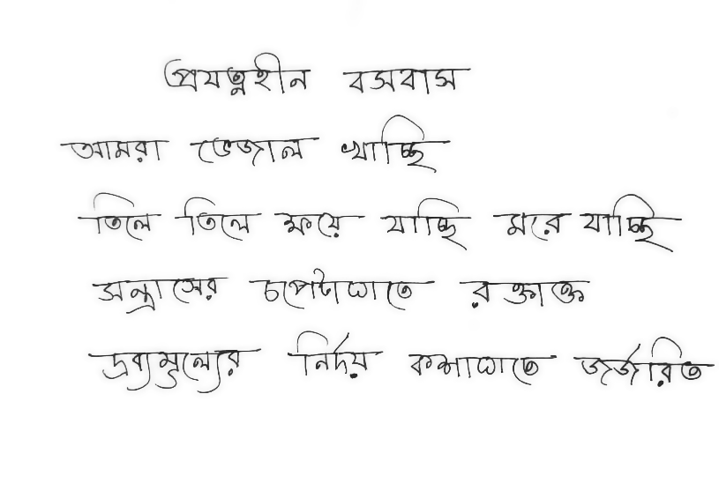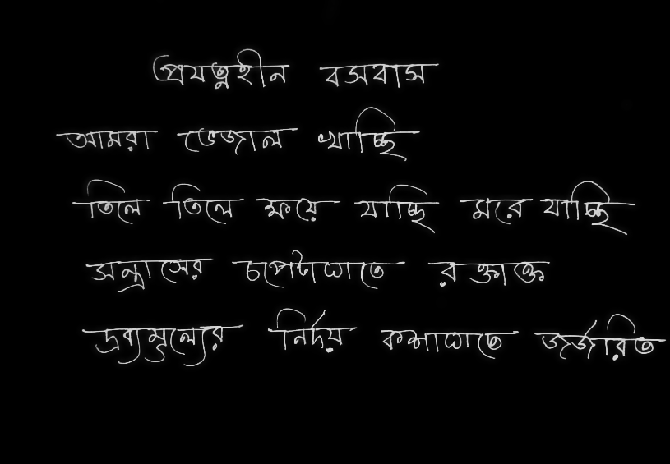
- Applying Bilateral filter (d) Image Binarization & Skew Angle Correction

Figure 6: Preprocessing for Bengali handwritten script

- Printed Script Result:

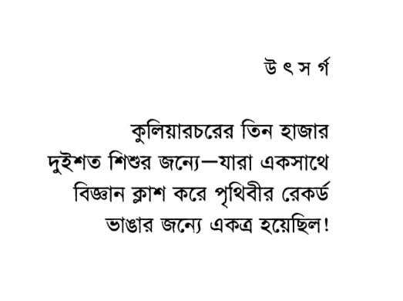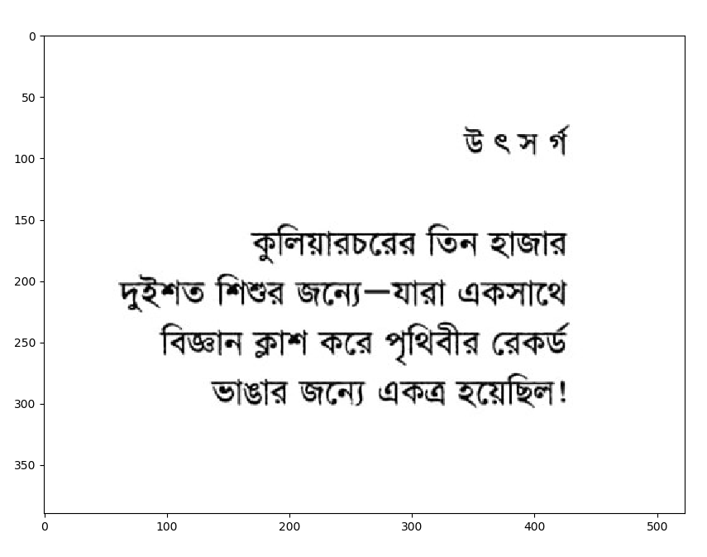

- Input image (b) Applying Grayscale filter
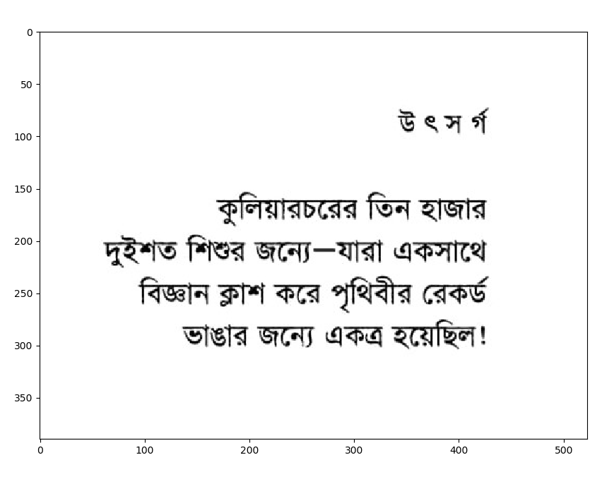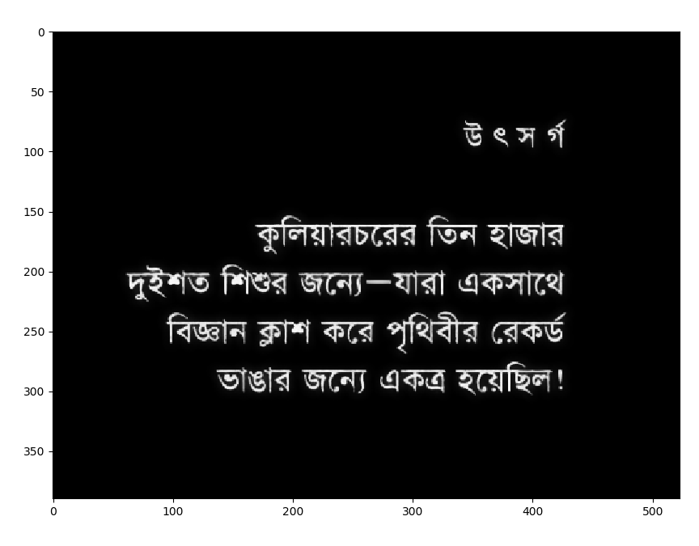

- Applying Bilateral filter (d) Image Binarization & Skew Angle Correction

Figure 7: Preprocessing for Bengali printed script

In Figure 6 and Figure 7, the preprocessing of the handwritten script and the printed script is shown. Here (a) indicates an RGB image or general image of the Bengali script as input. (b) is the result of applying the grayscale filter which turns the RGB input image into a grayscale image. Then (c) indicates the result of applying a bilateral filter which removes the noise of the image and smoothes it. The final stage of preprocessing is shown in (d), where if any skewness is present it will correct it and finally we get the binary image after image binarization, and thus the image is ready for segmentation stage.

Line Segmentation
After the preprocessing stage, the binary image will go for segmenting its line by applying the horizontal projection profile. The outputs are:

- Handwritten script results:
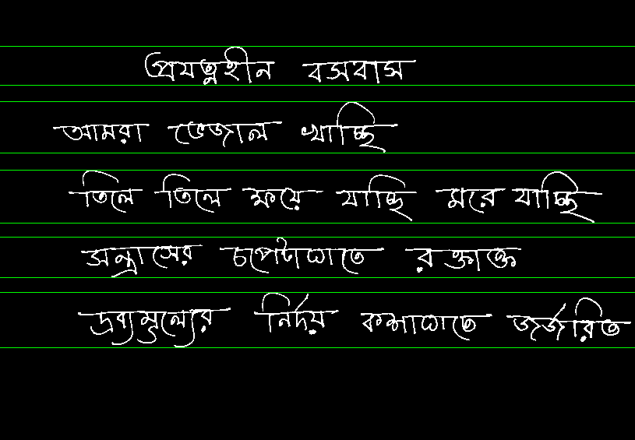

Figure 8: Line segmentation of Bengali handwritten script using HPP

- Printed Script Result:
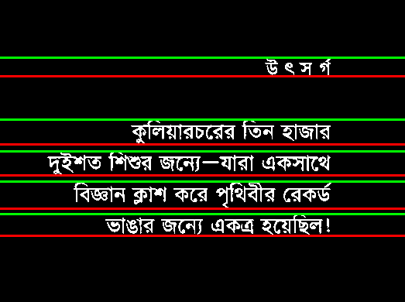

Figure 9: Line segmentation of Bengali Printed script using HPP
Here for line segmentation, we used Horizontal Projection Profile (HPP). The outputs of applying HPP on the handwritten and printed script are displayed in Figure 8 and Figure 9.

    - Word Segmentation
After line segmentation, the image is turned into word segmentation. The outputs are:

- Handwritten script results:
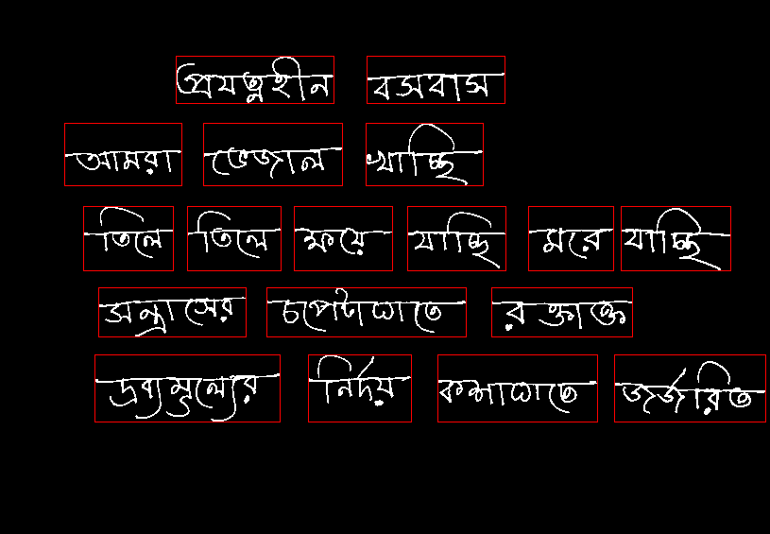
Figure 10: Word segmentation of handwritten Bengali script using VPP
- Printed Script Result:
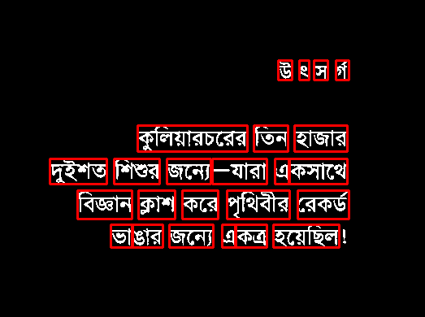

Figure 11: Word segmentation of printed Bengali script using VPP
Here, for word segmentation, Vertical Projection Profile (VPP) is used. Figure 10 and Figure 11 depicts the result of applying VPP for both handwritten and printed Bengali script.

    - Character Segmentation
The final stage of our system is the character segmentation. The outputs are:
- Handwritten script results:
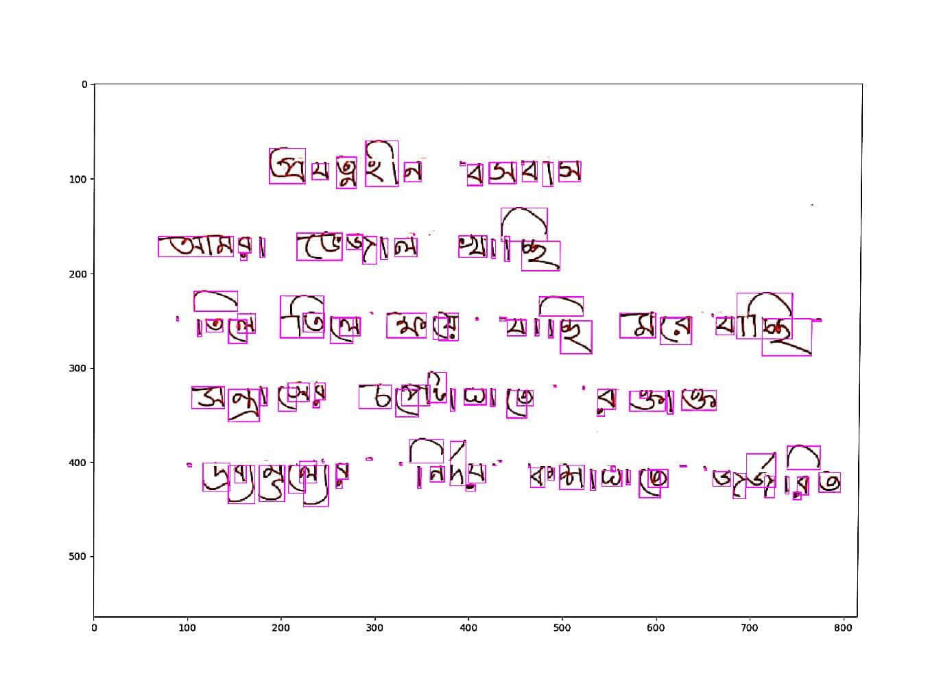
Figure 12: Character segmentation of handwritten Bengali script using Morphological image processing
- Printed Script Result:
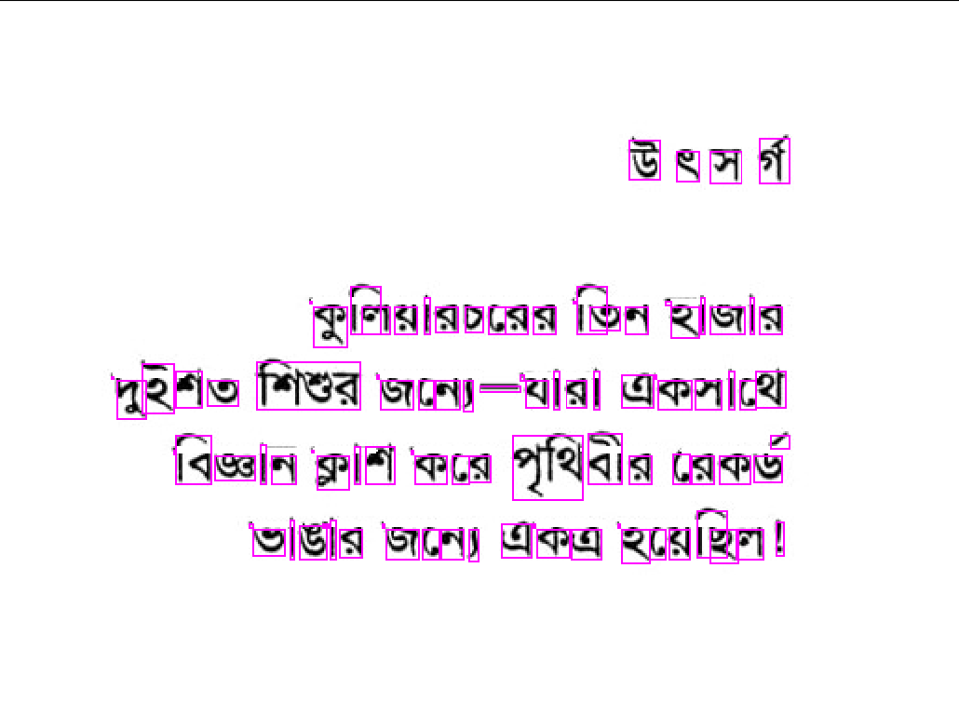
Figure 13: Character segmentation of printed Bengali script using Morphological image processing
Character segmentation is the final step of the segmentation process. Here, Figure 12 and Figure 13 depict the result of character segmentation where for segmenting characters we used morphological opening and closing operations.
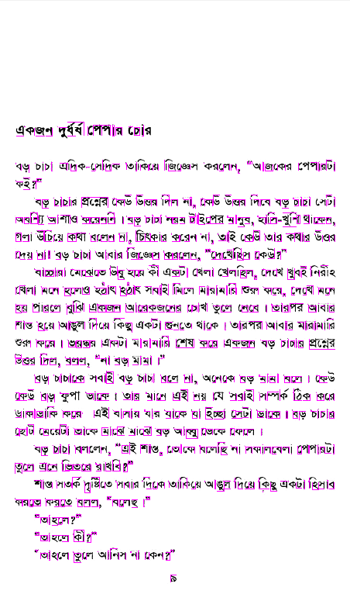
  - Evaluation with tesseract

- Segmentation result form our methodology

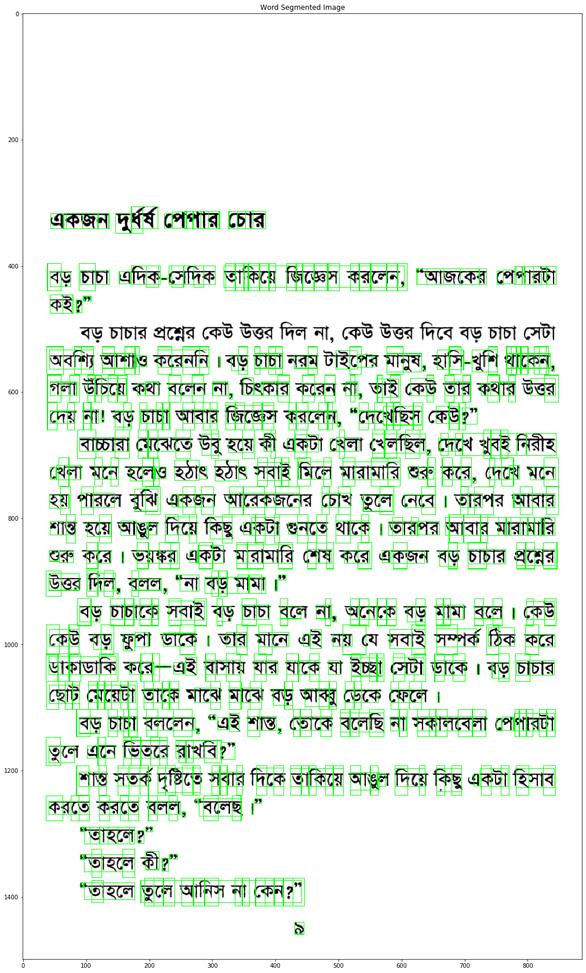
- segmentation result from tesseract

Figure 14: Comparing the result with tesseract

In Figure 14, we compared the result of our methodology with the result of the tesseract OCR engine. Here, we can see that the Tesseract OCR is not capable of recognizing the characters of 4th row at all. But our methodology can recognize that part.

Summary

We have mainly focused on the segmentation procedure. For this segmentation, we use two types of Bengali script like the handwritten and printed script as input. As segmentation is the key task for building a good optical character recognition system so the main challenging processes of handwritten and printed scripts segmentation results are gradually displayed in this chapter.

Chapter 5

Discussions and Conclusions

Discussions

Suggestion for future Work

Conclusions

REFERENCES

- D. Christine, “Conda works with Linux, OSX, and Windows, and is language agnostic, which allows us to use it with any programming language or even multi-language projects.”, (21 May 2015). "Conda for Data Science". Archived from the original on 16 June 2015. Retrieved 16 Jun 2015.
- Marangoni, Maurício, and Denise Stringhini. “High-Level Computer Vision Using OpenCV.” 2011 24th SIBGRAPI Conference on Graphics, Patterns, and Images Tutorials (2011): 11-24.
- M. Bauer, M. Garland. 2019. “Legate NumPy: accelerated and distributed array computing”. In Proceedings of the International Conference for High-Performance Computing, Networking, Storage and Analysis (SC ’19). Association for Computing Machinery, New York, NY, USA, Article 23, 1–23. DOI: https://doi.org/10.1145/3295500.3356175.
- J. D. Hunter, "Matplotlib: A 2D Graphics Environment," in Computing in Science & Engineering, vol. 9, no. 3, pp. 90-95, May-June 2007, DOI: 10.1109/MCSE.2007.55.
- R.W. Smith, The Extraction and Recognition of Text from Multimedia Document Images, Ph.D. Thesis, University of Bristol, November 1987.

Appendix A

Detailed Explanation

Provide any additional material that have been used in this thesis/project here.

