[SEGMENTATION OF BENGALI CHARACTERS FROM TEXT IMAGE]

A Choose an item. Submitted
By
Author
ID: 1103017
ID: 1103057
ID: 1103094

Under the Supervision of
Arifa Islam Champa
Choose an item.
Department of Computer Science and Engineering
Bangladesh Army International University of Science and Technology


Bachelor of Science in Computer Science and Engineering
Bangladesh Army International University of Science and Technology
Choose an item., Choose an item.Semester

[THESIS TITLE]

A Choose an item. submitted to the Department of Computer Science and Engineering Faculty, Bangladesh Army International University of Science and Technology in partial fulfillment of the requirements for the degree of Bachelor of Science in Computer Science and Engineering.
Author | ID: 110xxxx

Department of
Computer Science and Engineering
Bangladesh Army International University of Science and Technology


Choose an item. Semester Choose an item.
June, 2020

Declaration
This is to certify that this Choose an item. is my original work. No part of this work has been submitted elsewhere partially or fully for the award of any other degree or diploma. Any material reproduced in this project has been properly acknowledged.

Student’s name &signature

Approval

The Thesis titled “Click here to enter text.” has been submitted to the following respected members of the Board of Examiners in partial fulfillment of the requirements for the degree of Bachelor of Science in Computer Science and Engineering on June 2020 by the following student and has been accepted as satisfactory.

Author | ID: 110xxxx

_ _ _ _ _ _ _ _ _ _ _ _ _ _ _ _ _ _  Supervisor  [Faculty Name]  Choose an item.  Department of CSE  Bangladesh Army International University of Science and Technology | _ _ _ _ _ _ _ _ _ _ _ _ _ _ _ _ _  External Supervisor  [Faculty Name]  Choose an item.  Department of ___  Bangladesh Army International University of Science and Technology
_ _ _ _ _ _ _ _ _ _ _ _ _ _ _ _ _ _
Mohammad Asaduzzaman Khan
Head, Department of CSE
Bangladesh Army International University of Science and Technology

Acknowledgement

In this section, express your gratitude to the people who have helped you throughout the work. Give thanks to different people for valuable discussions, their suggestions, ideas and encouragements.
This section should not be more than one page. But if you cannot confine your gratitude in one page, you can use two pages.
Remember, Font will be 12, Times New Romanhere.

Author

TABLE OF CONTENTS
Declaration i
Approval ii
Acknowledgement iii
ABSTRACT vii
Chapter 1 1
Introduction 1
1.1. Introduction 1
1.2. Historical Background 1
1.2.1. Earlier Research 1
1.2.2. Recent Research 1
1.2.3. State of the art technology 1
1.3. Future Scope of This Study 1
1.3.1. Future Scopes 1
1.3.2. Recommendations 2
1.4. Limitation of the Study 2
1.5. Advantage over Traditional Method 2
1.6. Objective of this Work 2
1.6.1. Primary objectives 2
1.6.2. Secondary Objectives 2
1.7. Introduction to this Thesis 2
Chapter 2 3
HOW TO USE THIS TEMPLATE 3
2.1. Introduction 3
2.2. From Declaration to Abstract 3
2.3. Entering the Text 3
2.3.1. Using Bold, Italic or Underline and use of Bullets 3
2.3.2. Text Justification 4
2.3.3. Spacing Option 4
2.3.4. How to use Numbering 4
2.3.5. Using Color 4
2.4. Table of Content 6
2.4.1. How to Update Table of content Automatically 6
2.4.1.1. Mark your text according to Table 2.1 6
2.4.1.2. Update the Table 6
2.5. List of Figures 7
2.6. Use of Table 7
2.7. Use of Figures 7
2.8. Writing Equations 9
2.9. Using Symbols 9
2.10. Appendices 9
2.11. References 10
2.12. Error Correction 11
2.13. Summary 11
Chapter 3 12
Title of Chapter 3 12
3.1. Introduction 12
3.2. Headings 12
3.2.1. Subheading 12
3.2.2. Subheading 12
3.3. Novelty of Our Work 12
3.4. Summary 12
Chapter 4 13
Title of Chapter 4 13
4.1. Introduction 13
4.2. Headings 13
4.2.1. Subheading 13
4.2.2. Subheading 13
4.3. Summary 13
Chapter 5 14
Discussions and Conclusions 14
5.1. Discussions 14
5.2. Suggestion for future Work 14
5.2.1. Subheading 14
5.2.2. Subheading 14
5.3. Conclusions 14
REFERENCES 15
Appendix A 16
Detailed Explanation 16

LIST OF FIGURES
Figure 2.1 Logo of BAIUST [1] 7
Figure 2.2 Example of an image with acceptable resolution (left one) and unacceptable resolution (right one). 8
Figure 2.3 An example of graph that uses color which can be easily distinguished even in black and white print; the graphs are properly labeled also. 9

ABSTRACT

In the abstract, you should present what you have done or developed or discovered or investigated in their work. You will say briefly the results of the investigation or experiment, whether the results are consistent with the predicted values and existing publications. You will mention your initial targets and whether you have achieved it or not.
The ‘Abstract’ is significantly important as a reader will try to get an idea about the work by reading it. In the abstract the novelty of the work or the contribution of the authors should be highlighted. The objective of the work shall not be presented in the abstract. No introduction should be presented in the abstract.

Chapter 1

Introduction

Introduction

Since 1950, Optical Character Recognition is a major research area. As we all know, Bengali is one of the richest language of the world ranking 5th as the most spoken native language and ranking 7th as the most spoken language. As a result, in recent years a digitized method for recognizing Bengali characters is started receive attention for OCR related work with the rapid growth and advertisement of the use of computer in Bangladesh.
In the field of OCR, segmentation is one of the most challenging tasks of Bengali character recognition. Many different methods have been proposed on this purpose and many methods have shown high performance. The structure of Bengali language is quite different. Bengali is written in Sanskrit script. Bengali script is consists of 50 basic characters including 11 vowels and 39 consonant characters. It is used for representing other language like Meithei and Manipuri, and there is time when it used to write Sanskrit within Bengal. Most of the Bengali characters are topologically connected [1]. Bengali language is ingenious. However, there have not been such a significant number of takes a shot at language preparing for Bengali as have been for some different language, for example, English and Spanish. There are numerous vital compositions that were practiced in Bengali at the last century. As innovation back then was not that much advanced, these works were not written in digital form. So it isn't workable for a publisher for print them again without composing the whole writings. For this situation an OCR will be an incredible assistance for the publisher. An OCR for Bengali would likewise empower users to cause editable records from images that to have been produced for particular purposes.

Historical Background
Segmentation of Bengali character is one of the most challenging tasks in making a Bengali Optical Character Recognition (OCR). Till now no such methods are discovered that has 100% accuracy. In comparison with other European language the structure of Bengali language is quite different. There are large amount of characters in Bengali. So we need a robust technique for our research. For segmentation of Bengali characters, the method that has been used are Horizontal Projection Profile (HPP), Vertical Projection Profile (VPP) and Morphology.

Earlier Research
In this section, we will review a couple of related work which was done previously based on segmentation of Bengali characters.
Numerous analysts have tended to the issue of character segmentation of Bengali content. Different strategies have been proposed by various authors. Some details of the previous research works on Bengali character segmentation are given bellow:

Chaudhuri & Pal [2] proposed the first complete Bangla OCR system for printed documents. Using horizontal and vertical projection profile analysis and headline removal technique they segmented the documents into lines, words and characters. They additionally partitioned the words into three zones utilizing headline and base line identification strategies.

Mahmud et al [3] proposed an acknowledgment procedure for confined just as consistent printed Bangla characters. This process additionally supports multi textual style of Bengali content acknowledgment. Preprocessing includes segmentation at different levels. They used piecewise linear scanning, greedy search algorithm and base line detection technique for character segmentation.

Mahmud et al [4] utilized projection profile based technique for segmenting Bengali content. For character segmentation they utilized vertical scanning technique. Depth First Search (DFS) algorithm likewise used for overlapped character segmentation.

Mehedi et al [5] proposed another methodology utilizing characteristic functions and hamming network for segmentation and acknowledgment of printed Bangla text. They utilized a lot of characteristic function for segmenting upper portion (above matra line) and characters that go under the base line (three zone approach). It additionally utilizes a combination of Flood-fill and Boundary-fill algorithm for segmenting a few characters that can't be segmented utilizing conventional approach.
Sattar et al [6] proposed a condition based methodology for overlapped character segmentation. They examine the width of a single character, on the off chance that it is sufficiently large, at that point checked for the overlapped character ‘ekar’ . They didn't discuss other sort of overlapping problems.
Rownak et al [7] utilized curved scanning for overlapped character segmentation.

Garain and Chaudhuri [8] proposed a statistical analysis based technique for segmenting contacting characters in printed Bengali content. They noticed that contacting characters happen for the most part at the center of the center zone and by assessing the pixel designs and their relative situation as for the anticipated center zone certain associated focuses with contacting were found. The geometric shape is cut at these focuses and the OCR scores are noted. The best score gives the ideal outcome.

In most the previously mentioned work, they separated the words into three zones, yet blunder in benchmark identification decreases the general precision of the division procedure. There are a lot of issues related with overlapped character segmentation what's more. Unfortunately none of the talked strategies resolve these issues totally.

Recent Research
There are a lot of research works done on Bengali characters in recent years. There are several studies which have focused on the segmentation of Bengali characters. These studies have been applied to different approaches to the different complicated cases and achieved high performance.
Some details of the recent year research works on Bengali characters segmentation are given bellow:
Zahan & Selim [1] proposed a complete and robust segmentation technique for printed Bengali script. They have noticed that segmentation is difficult as there are more than 300 basic, modified and compound characters in the content and they are topologically connected and some are overlapped. They have used analysis of connected component based on two zone approach. In their research work they tried to find out the matra line properly and they divided the script into two zone. Then they collected the connected components observing the matra line. Their proposed methods solve many problem of character segmentation of Bengali script and thereby increase the overall accuracy in the field of optical character recognition.
Gupta & Patel [9] proposed various methodologies to segment a text based image at various levels of segmentation. They tried to retrieve specific information from the entire image and discuss about various factors affecting the segmentation process. Then they reviewed available techniques of segmentation. Their special attention was given to the handwriting recognition.

Basu & Sarkar [10] utilized a fuzzy technique for segmentation of handwritten Bangla word images. They had worked in two steps. In first step they identified the black pixels constituting the matra in the target image by utilizing a fuzzy feature. In second step they identified some of the black pixels on the matra as segment points by using three fuzzy features. Their methods have certain limitations but it can be considered as a significant step for the development of a full-fledged Bangla OCR system.
Bishnu & Chaudhury [11] proposed a method for the segmentation of handwritten Bangla text into characters. In their system as they detected different zone across the height of the word, they have proposed a technique for recursive contour following in one of the zones across the height of the word to find out the boundary within which the main portion of the character lies. Their algorithm gives fairly good results if the sequent characters are not touching in the zone of contour following.
Mehedi & Alim [12] presented a new approach to segment and recognize printed Bangla text using characteristic functions and hamming network. In their system they have proposed a new algorithm to detect and separate text lines, words and characters from printed Bangla text. This algorithm uses a combination of Flood-fill and Boundary-fill algorithm to segment some characters that cannot be segmented using traditional approach. They have used hamming network for recognition scheme.
Bhowmik & Roy [13] proposed a segmentation scheme of Bangla handwritten words with some unconventional and east to implement technique. They have proposed an area based algorithm for the skew detection of the Bangla specimen skewed handwritten words from their self prepared database. Their analysis of directional chain code extracted the feature for segmentation. Finally Multilayer Perception (MLP) Neural networks recognize the segmenting points.
Ram & Das [14] designed a novel two stage approach for segmentation of isolated Bangla word images. In the first stage, they designed a feature based approach to classify the connected word segments into two classes. In the second stage, they designed fuzzy segmentation features to identify the matra region and the potential segmentation points.
Sarkar & Samir [15] proposed a new process for extraction and character segmentation from the handwritten Bangla document images. They have utilized Run Length Smoothing Algorithm (RLSA), called Spiral Run Length Smearing Algorithm (SRLSA), to extract words from the text lines of handwritten Bangla document image. In the second part of their work they have came out with the solution on how best word images of handwritten Bangla script can be segmented into components characters.
In most of the previously mentioned works, the researcher showed high performance and also high accuracy.

State of the art technology
Start writing here…

Future Scope of This Study
Start writing here…

Future Scopes
Start writing here…

Recommendations
Start writing here…

Limitation of the Study
Start writing here…

Advantage over Traditional Method
Segmentation has various methodologies to segment a Bengali text image. In this section we will discuss about it and will also discuss about the advantage of our method .The methods that are used to execute segmentation of text images are smearing approach, pixel counting approach, stochastic approach, water flow approach, histogram approach [9].
In smearing approach it will smeared all the continuous black pixels towards the horizontal axes for segmenting. Which means it will fill the white spaces between the black pixels with black pixels. This process will be valid for a predefined threshold value. The smeared area is called boundary growing area. This smeared area defines separate lines or words.

In pixel counting approach for line segmentation there is two way to execute segmentation, with and without guidelines. This algorithm is designed in such a way that it can tolerate a certain less number of black pixels in a white row when there is no guideline. When guideline is given then it arise problem when any character extends guideline boundary. This approach cannot be utilized when the image contains higher degree of skew, overlapped character and when there is irregular spacing between text lines.
In stochastic approach it verifies nonlinear line between overlapped text lines. It follows probabilistic algorithm. In this approach the image is partitioned into small cells. Then following hidden Markov modeling the segmentation paths will be searched. When there are less black pixels in the touching component then the path of higher probability will cross. However, this approach will not work when there is maximum black pixels in the contacting point.
In waterfall approach a suppositional flow of water will be given to the image from left to right and top to bottom. This is expected from this approach is that the flow of water will fill up the gaps between the lines. Now the area that is not wetted area of the image will indicate the text lines and the wetted area indicates the gap. Finally the image will be divided into two different stripes. One is for text line and another is for line spacing. And the angle of this process will be determined from some mathematical functions.
Our work is based on histogram approach. In histogram approach it will identify the text lines automatically and then will segment it. It can be elaborated to upper level of segmentation. This is a simple and fast method to characterize line segments. Histogram approach works in three or four steps. We will discuss in details of this approach in chapter 4 about how this approach works. In comparison with traditional approach this approach works very well. It identifies the location of the text lines and words. It reduces the excluded region from the text line of the image step by step. Some equation provides average height of the lines and length of the words.
The overall discussion provides a clear view of the advantage of our method over traditional method.

Objective of this Work
Start writing here…

Primary objectives
Start writing here…

Secondary Objectives
Start writing here…

Introduction to this Thesis
Start writing here…

Chapter 2

Methodology

Introduction
In this section, the methodology of segmentation will be described. Segmentation is a dormant part of an OCR system just like the domain of application of it. This is the most vital and important part for designing an efficient Bengali character recognition. Segmentation is the most important stage for all publishers to work with Bengali OCR. Our work is mostly about the segmentation of Bengali character in a text image. When the work is based on image the aim of segmentation is to facilitate the representation of an image into meaningful, efficient and easier to analyze. It is used to allocate contents, lines, curves etc in images. Segmentation process of a text image includes the following steps. They are – line segmentation, word segmentation and character segmentation. The given steps must be segmented properly for the successful recognition. There are various methodologies of segmentation. Here line segmentation and word segmentation is done using projection profile and character segmentation is done using morphology. Each of the segmentation process is difficult for executing a successful segment. Line segmentation is an operation that executes individual lines. Word segmentation is an operation that executes individual words. Character segmentation is an operation that quest to decompose an image of a sequence of characters into sub-images of individual symbols. To reach the expected result, various methods are needed for segmentation. The aim of this chapter is to introduce those methods.

Methodology
Methodology is a series of computational steps that takes some set of values. To achieve the expected result, firstly we need to apply some filters on the input image at preprocessing step and the step by step Horizontal Projection profile (HPP) Vertical Projection profile (VPP) and Morphology will be applied. Let us introduce with them.

Preprocessing

Horizontal Projection profile
Text line segmentation has been performed by filtering the input image horizontally. Recurrence of dark pixels in each line is counted in order to construct the row histogram which is shown in figure 2().The situation between two continuous lines, where the number of pixels in a row is zero then it is considered as a boundary between the lines. For detecting this gap or boundary between lines we have used horizontal projection profile (HPP). Horizontal Projection Profile (HPP) is the projection profile of an image along horizontal axis. HPP is determined for each line as entirety of all segment pixel esteems inside the line. The following two sample outputs are the result of applying HPP.

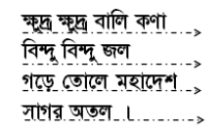
Figure 2(): Line Segmentation using HPP [16]

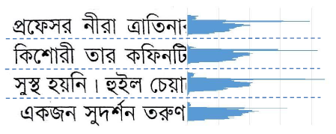
Figure 2(): Line Segmentation using HPP [1]

Vertical Projection profile
After a line has been identified, we need to identify words in each line for word segmentation. Number of dark pixels in each column is determined to build column histogram which is shown in figure 2(). The portion of the line with constant dark pixels is thought of to be a word in that line. On the other hand if no dark pixel is found in some vertical sweep that is considered as the separating between words. Along these lines various words in various lines are isolated. This separation or gap between words is calculated by vertical projection profile (VPP). Projection profile along vertical axis is called vertical projection profile. VPP is calculated for every column as sum of all row pixel values inside the column.
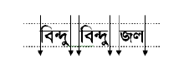
Figure 2(): Word Segmentation using VPP [16]

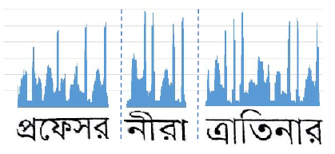
Figure 2(): Word Segmentation using VPP [1]

Morphology

Chapter 3
Implementation

Introduction
The entire segmentation of Bengali characters is done in three stages. To start with, we take a image of normal format as contribution of the framework and do some preprocessing to show better performance. This preprocessing includes conversion of image into gray image, after the gray conversion we will use bilateral filter. It will remove noise from the image and will make it smooth. Then we will convert the image up to 256 gray levels to a black and white image which is called binary image. Then skew angle correction will be applied. Then we send the prepared image as the input of the principal phase of the framework which is line segmentation. In this stage, we segment each line from the content and make individual line. This is the input of the second phase of the framework which is word segmentation. In this stage, we segment words from each line and creating individual word too. At that point this is the third stage as input which is character segmentation. Here, we segment characters from each word lastly the output is individual characters. In this chapter the reader will get a detail concept about the entire implementation process.

Implementation Tools

Implementation Details
There are several steps to follow for segmentation for a text image. We will describe these steps in details. The general framework of our proposed research is given in the following figure 3(a).

Figure 3(a): Step by step process of Segmentation of a text image

Further details of our work will be described in the following.

Input Preprocessing
Start writing here …

Line Segmentation
Histogram strategy can without much of a stretch be reached out to more significant levels of segmentation. In this section the detailed description of line segmentation will be given. A Y histogram is utilized to segment the text lines. After the preprocessing step is completed, we need to find the Y histogram of the image. The histogram contains two values, upper value and lower value. Each text line assembles to the upper value of the histogram. The histogram shows the added pixels for each y value. The space between the upper value and the lower value represents an area where the text lines exist. After obtaining all the text lines we need to execute a strategy to apply a limit to get line separation in the whole text. This limit is relative to the normal length of the lines in the text. This step identifies the location of the text lines.
For each line calculation, when the HPP gets continuous black pixels then counts it as the upper. Then it step forward horizontally and counts the white pixels. So far as it gets white pixels it step forward horizontally to the down. Then when it started getting continuous black pixels, HPP counts it as lower and draws a line. The process will continue doing the same thing and as a result we will get the text lines segmented within the whole image.

Word Segmentation
In this section the detailed description of word segmentation will be given. An X histogram is utilized to segment words. An X histogram projection that is applied to each line distinguished takes out potential words. X histogram is quite similar to the Y histogram. The histogram also contains two values, right value and left value. Here each text line is used to identify each word using right value and left value. When a line is drawn the value of each line will be sent to the function of word segmentation.
For each word calculation, when the VPP gets continuous black pixels then count it as left. Then it step forward vertically and counts the white pixels. So far as it gets white pixels it step forward vertically and go ahead. After getting continuous white pixels when it get any black pixels then consider it as space and count it as right. We have calculated each word by pixel wise. As we have checked each word vertically, the vertical projection profile counted continuous white pixel as a word and when it find out any space VPP counted it as another word.

Character Segmentation

Novelty of Our Work
The foremost objective of this work is to segment the Bengali characters from a text image. The result of this thesis paper will give a detail report of the line, word and character segmentation using two methods, histogram method and morphology. Our work will be helpful for further work of Bengali character recognition. To work with Bengali OCR principle task is to obtain the segmentation of Bengali characters which is the most complicated task. We tried our best to segment the Bengali characters. And we are thinking of working with this research work for further OCR related research work. There are several research work done on segmentation of Bengali characters. Among all of them the histogram based methods and the morphology based methods are very efficient because histogram requires only one pass through the pixels.

Summary
Start writing here …

Chapter 4

Experimental Result

Introduction
In this chapter, we will analyze that our proposed research is successful to achieve its objectives. The experimental result contains the output image of our segmentation process step by step. We have showed each of the steps result with details.

Input Preprocessing
Firstly, we have taken a normal format image as input shown in figure 4(a) for preprocessing.
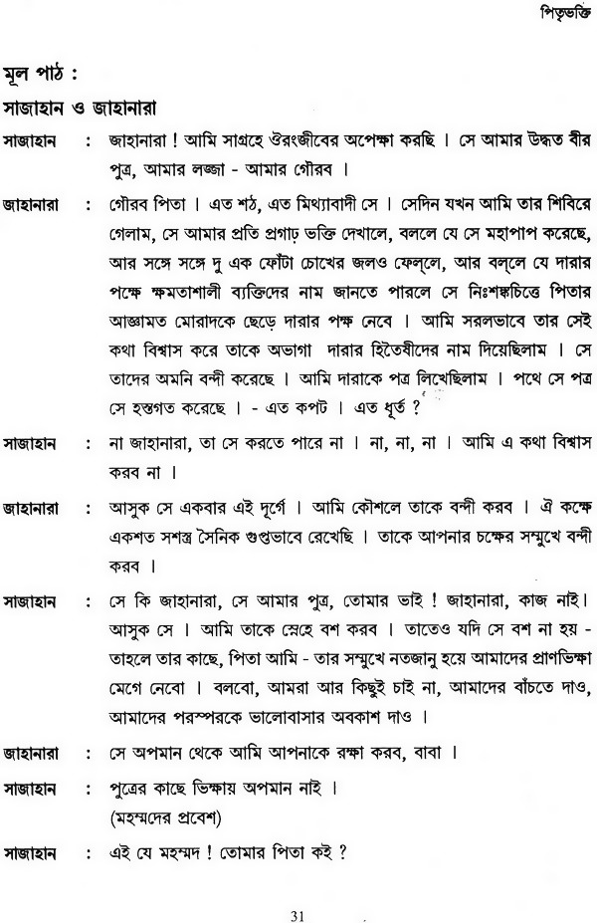
Figure 4(a): Input image []
This image is not smooth and it contains noise. So we applied bilateral filter to remove noise from the image and to make it smooth. Then we converted the image into gray scale. A threshold selection method (OTSU) has been used. Then we converted the image into binary image.
The resultant output of the preprocessing step is shown in figure 4(b).

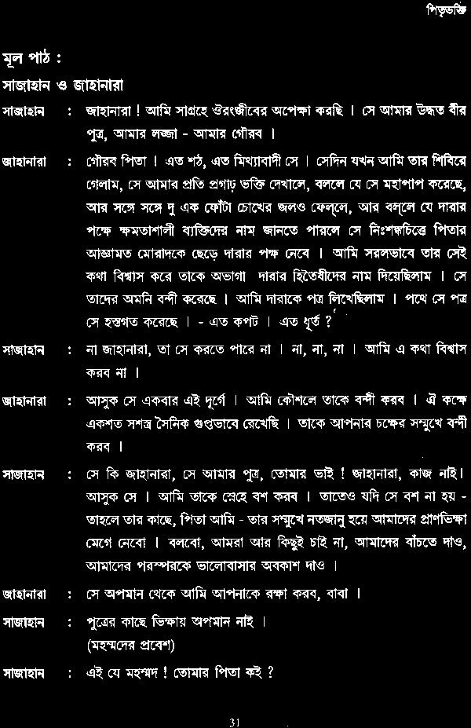
Figure 4(b): Filtered image

Line Segmentation
After completing the preprocessing step our first challenge was to segment each line of the text image properly. We have segmented each line properly shown in figure 4(c).

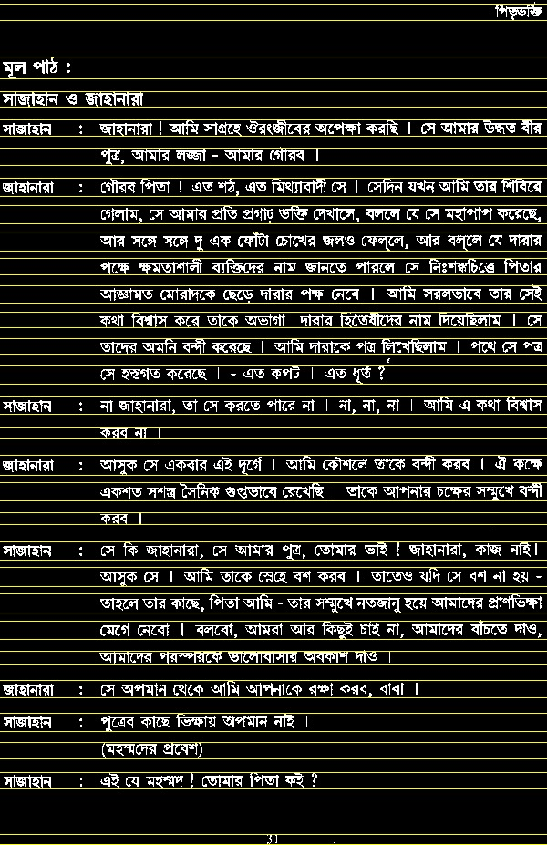
Figure 4(c): Resultant Line Segmentation

Our process of line segmentation worked very well. We can see from figure 4(c) that each line has been segmented properly. But our input image got a problem. There is a small length of black pixel in between the text line 12 and 13. We have a predefined value which is greater than 10 for the length of each line and for continuous white pixel each line has been calculated. And the problem does not fulfill the condition so it will remain as a gap.

Word Segmentation
Our second challenge was to segment each word from each text lines of the text image. We have segmented each word from each line properly that is shown in figure 4(d).

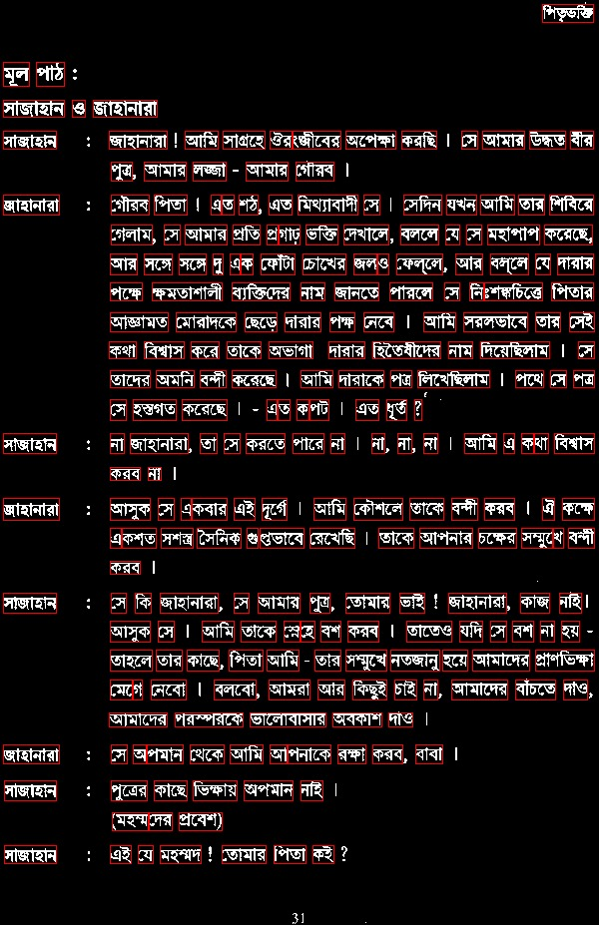
Figure 4(d): Resultant Word Segmentation

As we have said our text image have some problems. In some words there are missing white pixels where it is needed. There is another problem we faced during word segmentation. In Bengali script some alphabet has full matraline, some has half matraline and some does not contain any matraline. So the alphabet with half matraline and no matraline contain absent of white pixels between the characters in a word creating a space. In our process we have calculated each line and each word by pixel wise. As we have checked each word vertically, the vertical projection profile counted continuous white pixel as a word and when it find out any space VPP counted it as another word.
The combined output of line and word segmentation is shown in figure 4(e).
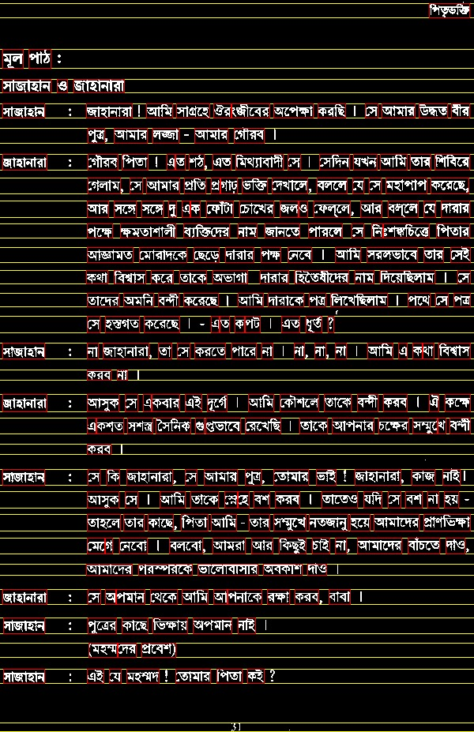
Figure 4(e): Combined output of Line and Word Segmentation.

Result Analysis
Results were considered for different images from different sites. We noted while word segmentation that the dataset has some problems. There are some missing pixels in certain words. As a result our system cannot recognize some words. As I also said before that the words those contain half matra and matraless character will also show missing pixels which is considered as gap in our system.

Chapter 5

Discussions and Conclusions

Discussions
A methodology for the segmentation of Bengali contents has been introduced in this paper. Approach proposed from the earliest starting point of checking a text image to convert it into binary image, noise removal, skew angle correction, line segmentation, word segmentation and character segmentation. It is the difficult task in the character segmentation part when two characters are in some joined together. Our main motive of this work is to segment Bengali characters from text image. To segment Bengali characters, we have performed line segmentation, word segmentation and character segmentation. Our line segmentation works almost properly, our word segmentation also works with very little errors and our character segmentation works with some errors. This chapter contains the overview of our work and the future recommendation of this work.

Suggestion for future Work
The future possibility is to actualize the rest of the calculation and lead an extensive correlation of the different strategies as talked about in the paper. This work will give straightforwardness to analysts, researchers and architects working with text image and gives them application explicit calculation determination information to grasp the need of accomplishing quicker and effective method to segment Bengali characters from a text image. In future many more work can be done with this research work.
- As sample more dataset need to be collected.
- We all know Bengali script has not only basic characters but also some compound characters and modifiers. So attention should be given there.
- Future works can also be on the overlapping characters.
- The segmentation approach can be concentrated on recognition based.

Conclusions
Segmentation is one of the most challenging tasks in the field of OCR. In our research work we tried to perform some methodology for segmenting Bengali characters from text images. It is quite difficult to achieve 100% accuracy for line, word and character segmentation. We have studied a lot in this purpose and learned a lot about segmentation. This field is quite interesting. We had to go through the Bengali script and had to classify them by their structure. Working with these was both difficult and interesting.
We have applied some filters as the preprocessing of this research work. After getting a preprocessed image we have applied some methodology for getting line, word and character segmentation respectively. We have gone through many difficulties to segment the Bengali contents by their line, word and character. Still our work was going on and on for getting better performance.

REFERENCES
- T. Zahan, M.R. Selim, M.S. Rahman, M.Z. Iqbal, (2018). “Connected Component Analysis Based Two Zone Approach for Bangla Character Segmentation.” 1-4. 10.1109/ICBSLP.2018.8554684.
- B. B. Chaudhuri and U. Pal, “A Complete Printed Bangla OCRSystem,” Pattern Recognition, Vol. 31, No. 5, pp. 531—549, 1998.
- J. U. Mahmud, M. F. Raihan and C. M. Rahman, “A complete OCR system for continuous Bengali characters,” In: Proceedings of the TENCON, 1372–1376, 2003.
- S.M. Milky Mahmud, Nazib Shahrier, A.S.M Delowar Hossain, Md.Tareque Mohmud Chowdhury, and Md.Abdus Sattar,“An EfficientSegmentation Scheme for the Recognition of Printed Bangla characters,” Proceedings of ICCIT, pp 283-286, 2003.
- Md. Al Mehedi Hasan, Md. Abdul Alim, and Md. Wahedul Islam “A New Approach to Bangla Text Extraction and Recognition from
Textual Image”, Proceedings of ICCIT, 2005.
- Md. Abdus Sattar, Khaled Mahmud, Humayun Arafat and A. F. M.Noor Uz Zaman, “Segmenting Bangla Text for Optical Recognition,”
ICCIT, 2007. ISBN: 978-1-4244-1550-2, pp. 1-6.
- Ahnaf Farhan Rownak, Md. Fazle Rabby, Sabir Ismail, and Md. Saiful Islam,‘’An Efficient Way for Segmentation of Bangla Characters in Printed Document Using Curved Scanning’’ 5th International Conference on Informatics, Electronics and Vision (ICIEV), 2016.
- U. Garain and B. B. Chaudhuri, “Segmentation of touching characters in printed Devnagari and Bangla scripts using fuzzy multifactorial analysis,” IEEE Trans. Syst. Man Cybern., Part C 32: 449–459, 2002.
- Gupta Mehula*, Patel Ankitab, Dave Namratac, Goradia Rahuld, and Saurin Shethe (2014) Text-Based Image Segmentation Methodology, ScienceDirect: Elsevier Ltd.
- Basu, S., Sarkar, R., Das, N., Kundu, M., Nasipuri, M., Basu, D.K. (2007) A Fuzzy Technique for Segmentation of Handwritten Bangla Word Images, 2007 International Conference on Computing: Theory and Applications (ICCTA'07) : IEEE.
- A. Bishnu, B.B. Chaudhuri (1999) Segmentation of Bangla handwritten text into characters by recursive contour following, Proceedings of the Fifth International Conference on Document Analysis and Recognition. ICDAR '99: IEEE.
- Md. Al Mehedi Hasan, Md. Abdul Alim, Md. Wahedul Islam (2005) A New Approach to Bangla Text Extraction and Recognition From Textual Image, Proceedings of the Fifth International Conference on Document Analysis and Recognition: ICCIT.
- T. K. Bhowmik, A. Roy and U. Roy, “Character Segmentation for Handwritten Bangla Words Using Artificial Neural Network,” Proceeding of the First IAPR TC3 NNLDAR Workshop, Seoul, 2005.
- Ram Sarkar, Nibaran Das, Subhadip Basu, Mahantapas Kundu, Mita Nasipuri, Dipak (2005) A two-stage approach for segmentation of handwritten Bangla word images, Proceedings of International Conference on Frontiers in Handwriting Recognitions, 403-408, 2008
- Ram Sarkar, Samir Malakar, Nibaran Das, Subhadip Basu, Mahantapas Kundu, Mita Nasipuri (2005) Word Extraction and Character Segmentation from Text Lines of Unconstrained Handwritten Bangla Document Images, Journal of Intelligent Systems 20 (3), 227-260, 2011.
- Md. Mahbub Alam, Dr. M. Abul Kashem (2010) 'A Complete Bangla OCR System for Printed Chracters', JCIT, 01(01)

www.wikipedia.org cannot be used as a reference

Appendix A

Detailed Explanation

Provide any additional material that have been used in this thesis/project here.

