INTERNSHIP PROGRAM OF SOFTWARE DEVELOPMENT (Laravel)
BAIUST’s ICT WING
Pritilata Biswas
ID: 1103017
Mohammad Mehedi Hasan Bhuiyan
ID: 1103023
Tafsir Haque Arnob
ID: 1103080

Department of Computer Science and Engineering
Bangladesh Army International University of Science and Technology


Bachelor of Science in Computer Science and Engineering
Bangladesh Army International University of Science and Technology
Fall Semester, 2019

Acknowledgement

At the very outset, we are very much thankful to almighty God for giving us strength, courage, and ability to accomplish the internship program as well as the internship report in a scheduled time despite various complications. The satisfaction that accompanies the successful completion of this internship would be incomplete without the mention of people whose ceaseless cooperation made it possible, whose constant guidance and encouragement crown all efforts with success.
We are deeply indebted to our respected faculty members who supervised the internship program with their whole-hearted supervision during our internship period. We are also grateful to the ICT WING members of BAIUST for their efforts to us during the whole program. It would have been very difficult to prepare this report up to this mark without their guidance.
Our gratitude goes to the entire CSE Department, of BAIUST for arranging an Internship Program that facilitates the integration of practical knowledge with real-life situations.
We also convey a very special thanks and gratitude to Mohammad Asaduzzaman Khan, honorable head of the Department of Computer Science and Engineering, Bangladesh Army International University of Science & Technology (BAIUST), for his kind advice, support and timely feedback regarding the guidelines and deadlines of internship completion.

Pritilata Biswas (ID:1103017)

Mohammad Mehedi Hasan Bhuiyan (ID:1103023)

Tafsir Haque Arnob (ID:1103080)

Executive Summary

This report is a reflection of the learning and experiences acquired through an opportunity to be associated with the one-month internship program at BAIUST’s ICT WING. This internship helped us in the software development program. In this way, we have learned about the practical scenario of web development by using the Laravel framework. As, for web designing, HTML, CSS, and JavaScript play a fundamental role, we required to be experts on these languages. In the front end, the developer’s most important languages are HTML, CSS, and JavaScript. Nowadays, CSS includes some frameworks such as Bootstrap, Foundation for readymade modules, designs, packages, and libraries that can be easily integrated into websites to create outstanding designs. We have learned how to find, download, and use these modules and packages with our model. Besides, for Backend Development, there is a need to learn server-side languages such as PHP, Ruby, and Python, SQL, etc. Through this program, we have learned the language like PHP and also find out the features and uses of Object-oriented programming language. This program helped us to create a project with the knowledge of the Laravel framework. Laravel is a web application framework with an expressive, elegant syntax. Laravel attempts to take the pain out of development by easing common tasks used in the majority of web projects, such as authentication, routing, sessions, and caching. Laravel aims to make the development process a pleasing one for the developer without sacrificing application functionality. Thus, this internship program helped us by providing a practical interpretation with Laravel. Finally, we have done with our project named “Hostel Meal Management Website” by applying the knowledge of this internship program using the Laravel framework version of 6(LTS).

TABLE OF CONTENTS

Acknowledgement 2
Executive Summary 3
Chapter 1 7
Introduction 7
1.1. Introduction 7
1.2. Motivation 7
1.3. Objective 8
1.3.1. General Objective 8
1.3.2. Specific Objective 8
Chapter 2 9
Overview of the Organization 9
2.1. Introduction of the Organization 9
2.2. Vision, Purpose and Principal of the Organization 9
2.3. BAIUST’s ICT WING 12
2.3.1. Vision, Purpose and Principal of the ICT Wing 12
2.3.1.1. Vision 12
2.3.1.2. Purpose 12
2.3.1.3. Principal 13
2.3.2. Members: 14
2.3.3. Courses: 14
2.3.3.1. Course Outline: 14
2.3.4. Internship: 15
2.4. Stakeholders 15
Chapter 3 17
Having good relation with the Laravel Framework 17
3.1. Introduction 17
3.2. Class wise description of your training 17
3.2.1. Class-1 17
3.2.2. Class-2 18
3.2.3. Class-3 18
3.2.4. Class-4 18
3.2.5. Class-5 19
3.2.6. Class-6 19
3.2.7. Class-7 20
3.3. Description of your assignment 20
Chapter 4 27
Observations, Recommendations and Conclusion 27
4.1. Introduction 27
4.2. Observations 27
4.3. Recommendations 27
4.4. Conclusion 28
REFERENCES 29

LIST OF FIGURES

Figure 2.1: Logo of Bangladesh Army.………………………………………….………………15
Figure 3.1: Assignment modal form……………………………………….…………………….21
Figure 3.2: Homepage…………………………….……………………………………………..22
Figure 3.3: Admin dashboard……………………………………………………………………23
Figure 3.4: student wise meal list………………………………………………………………..23
Figure 3.5: Student profile……………………………………………………………………….24
Figure 3.6: Meal searching option……………………………………………………………….25
Figure 3.7: Meal routine…………………………………………………………………………25

Chapter 1

Introduction

Introduction
An internship report provides the faculty with the information which qualifies the students for graded credit. It also provides the faculty with in-depth information about the student’s experience in specific fields. Furthermore, and of considerable importance, the internship report increases the student’s responsibility by requiring the student intern to gather information and plan the report throughout the working experience. The student then has an opportunity to demonstrate maturity as a technical writer by presenting, analyzing, and evaluating his or her work on the specific program. Being an intern, the main challenge was to translate the theoretical and also practical concepts into a real-life experience like creating a project.

This report is the result of one month’s long internship program conducted in BAIUST’s ICT WING and is prepared as a requirement for the completion of the CSE graduation of Bangladesh Army International University of Science and Technology. This report also depicts an overview of our assigned projects and assignments through this program.

Motivation
Internship Program of Bangladesh Army International University of Science and Technology is a Post-Graduation requirement for the CSE students. This report is a partial requirement of the Internship program of the CSE curriculum at the Bangladesh Army International University of Science and Technology. The main motivation of the internship is to get the student exposed to the job world by having the required knowledge.

The internship program and the study have the following purposes:
- To revitalize and strive with excellence into the future career field.
- To cope with the job field having pieces of knowledge.
- To be more confident with every step for developing sites by giving the best efforts and be patient.
- To fulfill the requirement of CSE graduation.
Thus, we can say internship experience helps with excellence in the career field. It helps to learn to overcome frustrations, to never stop trying until we are 100 percent happy with our work, and we have learned that we are perfectly capable of single-handedly producing professional, elegant designs. Although we still have much to learn, after our undergraduate internship experience, we feel much more prepared for our future career.

Objective
The objective can be viewed in two forms:
- General Objective
- Specific Objective

General Objective
This internship report is prepared primarily to fulfill the Bachelor of Science (B.Sc.) degree requirement under the CSE Faculty, Bangladesh Army International University of Science and Technology.

Specific Objective
More specifically, this study entails the following aspects:
- To give an overview of the program by which students gained theoretical and practical knowledge in Software Development.
- To familiar with the web development framework like Laravel by which students could be able to build their own websites.
- To help students focus on their career interests and potentials.
- To give the opportunity to learn, observe, and determine one’s goals and aims.

Chapter 2

Overview of the Organization

Introduction of the Organization
Bangladesh Army International University of Science and Technology (BAIUST), a pioneer university of Bangladesh Army, started its journey from 14 February 2015 with the motto of "Knowledge, Wisdom, and Technology". It is established temporarily at the serene and secured environment of Comilla Cantonment with the mission to provide State of the Art education and research in science, engineering, Business Administration, and other relevant programs. It expects to run its affairs in the permanent location from 2022. The University aims to provide innovative, multi-disciplinary courses and endeavors to make a hub of knowledge.

ICT WING of BAIUST is a major contributor for managing Campus-Wide IT infrastructure, including Computers, Networking (Wired / Wireless), and Internet facilities, Mail, Web and Application Servers, and so on. Recently it has been started to perform the works of student’s online registration procedures for each semester and also takes the internship courses like Networking & Server Management and Software Development Program for the outgoing batches of Computer Science and Engineering.

Vision, Purpose and Principal of the Organization
The Bangladesh Army International University of Science and Technology (BAIUST) has started its journey to provide better and quality education and research facilities in the field of Engineering, Science & Humanities, Business Administration, Law, English, and other relevant programs. BAIUST offering world-class facilities and its flexible programs will ensure exceptional experiences for its students.

- Vision:
The University aspires to transform into a center of excellence in Science, Engineering, and Technology programs by providing innovative, multi-disciplinary courses and extensive research facilities to the young generation of the country and beyond. Its endeavors to make the University a hub of knowledge and be recognized as a leading university of the country.

- Purpose:
- To offer need-based programs in important disciplines of Science, Technology, Social Science, and Business for both undergraduate and graduate students.
- To strive for excellence by providing quality teaching through a wide variety of instructional approaches.
- To produce highly competent, and global standard manpower in Science and Technology; who will be proficient in communication skills, critical thinking, and analytical abilities.
- To generate adequate resources to support the University’s instructions, research, and extension pursuits.
- To provide a timely, friendly, and accessible support system that promotes partnership and sense of shared responsibilities between students, faculty, alumni, and other stakeholders.
- To strive for the gradual expansion of faculties, departments, and programs following the need, and in abidance with the Private University Act 2010.
- To develop collaboration with similar universities, institutes, and organizations, both at home and abroad and sign agreements and memorandum of understandings (MOU) to this effect.
- To sensitize and infuse amongst the students and the graduates the core values of BAIUST i.e. Integrity, Openness, Intellectual Curiosity, Commitment to Excellence, Self-Discipline, Sense of Responsibility, Diversity, and Respect for Others.
- To carry out other necessary works of the University to meet the need of the time.

- Principal:
- Flexible programs, world-class facilities, and award-winning support services combinedly ensure a student’s university experience is exceptional and unique.
- Provide help and guidance on how to study most effectively.
- Invested efforts to enhance the student experience and provide support and guidance that are second to none.
- Develop the graduate attributes required for the student’s success at the university and beyond.
- Run the system of peer support in the form of student-run helpdesks, information points, academic families, buddying, and mentoring. This allows newer students to call on the help and advice of more experienced students as they progress through university life.
- Provide state of the art education and research in science, engineering, and other relevant programs to develop human resources for the socio-economic wellbeing of the society.

- Core Values:
- Integrity: It is a commitment to uphold the highest standard of moral, ethical, and professional conduct.
- Openness: One should think clearly, study freely with an open mind, willing to learn, and examine the complex problems with reasoning.
- Intellectual Curiosity: One must strive to broaden his/her knowledge, stretch intellectual horizon, and push beyond the comfort zones. As one gains knowledge, it will give him/her the power, authority, and confidence.
- Commitment to Excellence: The commitment to produce highly competent and global standard manpower on science and technology who will be proficient in communication skills, critical thinking, and analytical abilities. The aim is to search for truth and delivery of socially relevant, scientific, and technological contributions. This is a place where hard work will be rewarded and talents will be nurtured.
- Self-Discipline: One must impose self-discipline to abide by the rules, and regulations of the University and beyond.
- Sense of Responsibility: All must inculcate the sense of responsibility, and discharge the assigned duties judiciously.
- Diversity: In due course of time, the University aims to have students, faculty, and researchers from various disciplines, nationalities, and cultural backgrounds.
- Respect for others: As members are from devise culture, race, and religion, all must show respect for others.

BAIUST’s ICT WING
ICT WING of BAIUST handles Campus-Wide IT infrastructure with Computers, Networking and Internet facilities, Web and Application Servers, and so on. It also performs student’s academic needs like semester wise online registration procedures and also provides some professional courses to develop student’s skills on career sides. BAIUST ICT Wing was founded to boost the technological support for the university. It provides the primary management and support for computing, internet and technology services for Bangladesh Army international University of Science and Technology (BAIUST). It manages the wired and wireless network infrastructure, ICT related short courses to envision Digital Bangladesh, automation, and maintains University owned computer equipment and peripherals. ICT Wing also manages a number of Services, including the University's institutional Email, Video Conferencing, Official Websites, the Internet Connection service, and systems.

Vision, Purpose and Principal of the ICT Wing
Bangladesh Army international University of Science and Technology (BAIUST) launched ICT Wing with a view to bolstering the performance of the University’s on-going and envisioned academic, research, and administrative operations through innovative exploitation of the ICT products and services.

Vision
The vision of BAIUST ICT Wing is to support and maximize efficiency in Academics, Research and Administration through ICT.

Purpose
- To provide a platform for good practices in technology.
- To operate as effective software development center.
- To ensure maximum use of need based state-of-the-art of technology.
- To develop as a technology learning center and to streamline ICT activities.
- To implement a high-speed, reliable networking infrastructure that meets the current and future requirements for teaching, learning, research, and university administration.
- To establish a systems infrastructure in support of providing highly available and secure applications, web site, and data repositories.
- To increase the efficiency and effectiveness of administrative tasks and information retrieval at the university through implementation of technology and improved administrative processes. To work in partnership with academic computing and departmental support across campus to create a campus-wide support infrastructure for ICT that will deliver competitive support and services to faculty, staff, and students.

Principal
As to the core functions and procedures relating the operation and management of the University, the ICT Wing will strive for developing and rolling out innovative solutions to
- Enhance the quality of research, teaching and learning.
- Boost the University’s overall online visibility.
- Ease the delivery of frequent services sought after by the students and faculty members. Maximize productivity of the University staff.

In creating and regularly updating the University’s website and managing inside network and server, the BAIUST ICT Wing aims to deploy the insider knowledge so as to optimize the content and online visibility of the University at regional and international research and academia. Introduction of e-filing and automation of services provided through different offices will certainly move up the University’s performance with considerable saving in terms of physical labor and time, not to mention the associated mental stress. The success in installing automated systems in the offices of Accounts and Admission has motivated ICT Wing to undertake yet another endeavor – the automation of Examination Controller’s office, and will continue to motivate ICT Wing to gradually consider other offices apparently known as laggards for automation.

The ICT Wing, in addition to augment the ICT products and services, will emphasize maintenance and innovative use of the existing ICT facilities including but not limited to campus-wide network, web services, IP telephony service, and the CCTV network in developing an efficient IT infrastructure that will better provide services insofar as covering the entire University community.

Members:
- Director- Professor Brigadier General K M Salzar Hossain, ndc, psc (Retd)
- Asst. Server & Security Eng.- Mohammad Jahirul Hoque
- Assistant Software Engineer- Md Ebrahim Kholil
- Assistant Software Engineer- A.S.M Chafiullah
- Assistant Network Engineer- Kamrujjaman

Courses:
ICT WING is planning to arrange a professional web development course very soon.

Course Outline:
- Basics & Designing:
- HTML 5
- CSS 3
- Bootstrap 4
- JavaScript + jQuery
- Template Customization
- Basic PHP
- Development & Live Server Deployment
- Framework Introducing
- Folder Structure, Artisan command
- How web Works with Laravel
- Route, Blade Templating
- Creating Views
- Working with Database
- Defining Controllers
- Database Relationship
- Installing Laravel debugger
- Model & Provider Soft Delete
- CRUD Operation
- Authentication Middleware
- Security Mail and Caching
- Notification & Error Handling
- Project Development and live server upload

Internship:
Recently, ICT WING also provides internship opportunities for outgoing batches. It conducts the internship program in two divisions:
- Networking & Server Management
- Software Development (Laravel)

Stakeholders
BAIUST runs under the direct supervision of the Bangladesh Army. Its programs are approved by UGC. The Vice-Chancellor (VC) is selected and approved by the honorable President of Bangladesh.
The University is directly controlled by the Bangladesh Army and the members of the board of trustees are from Bangladesh Army. The Chief of Bangladesh Army is the chairman of the trustee board and other high officials of the Bangladesh Army placed on the board by their rank and posts.


Figure 2.1: Logo of Bangladesh Army.

As an education center, the students are given top priority. All the students have direct access to the VC for their educational, administrative & personal requirements. Besides, the VC interacts with all students regularly. The VC and faculties also interact with parents/guardians when required. The faculties and administration provide the utmost care to the students’ needs.

Chapter 3

Having good relation with the Laravel Framework

Introduction
Through this training, we have a good relationship with the Laravel framework. Our instructor helps us to go forward and motivated us to work with Laravel. Though it’s a very short time they gave their best effort to give us the knowledge of Laravel.

Laravel is a free, open-source PHP framework, created by Taylor Otwell and intended for the development of web applications following the model-view-controller (MVC) architectural pattern and based on Symfony. Some of the features of Laravel are a modular system with a dedicated dependency manager, different ways for accessing relational databases, utilities that aid in application deployment and maintenance, and it’s the orientation toward syntactic sugar.

Class wise description of your training
During the training, our instructors conduct a total of 7 classes. They taught us how to install the Laravel framework, some important functions of the Laravel framework, how to connect with the database, and so on. They gave us an assignment based on class which is COVID -19 report, where we make a form where we can give input like student ID, Name, Level, etc and it will generate an output based on input.

Class-1
In the first class, we are familiar with various types of new tools like VS Code, XAAMP, GIT, Composer, Node, etc. We know how to set up our environment to work with Laravel. At first, we install all the required software. Then we step by step open our software to run smoothly. First of all, we run the XAAMP software to run our database, for this we can open the server then start the Apache and MySQL on the XAMPP server. Then we run command and then check all the software versions. Then we install our desired Laravel project. We go to the htdocs folder and install the entire project in this folder. Then we run CMD and write the required code to run the project. Then we start the server with the code php artisan serve. Then we do some basic code and design some frontend and give direction between pages.

Class-2
In class 2, first, we open the previous project. For this we go to the htdocs folder then we run windows power shell then we write a command code ./, after this command, the project will open with the Visual Studio Code software automatically. Then we add some content in our project and also add some basic HTML tags to show something on our web page. Then we create a controller to load our project more effectively. To create controller, we go windows power shell then type php artisan make: controller WelcomeController. Then there’s automatically generate a class in our project. In the controller class, we say with the function to load the project from the controller class. We process all the data in the controller class.

Class-3
In class 3, we learned about how to install various types of plugin in our project, how to use it, and where we can use these types of plugin. One of the extension names is Laravel artisan Then we set up the connection between our project and database. We need to rewrite some code in the project to connect the project with our database. Then we go to our localhost server and according to our project name, we create a database in our localhost server. Then we need to do the migration process under the database folder. Migration creates the table on the database. Then we can learn various Laravel characteristics from the Laravel website. Then we create an authentication default sign-in page. Then we create a registration page with some HTML code. Then, at last, we can learn how to directory data from the database, and so on.

Class-4
In class four, we learned CRUD operations. CRUD means Create, Read, Update, Delete. We can learn how to use these four operations and when we use them from class 4. At first, we can create a modal from bootstrap to make a student info form to easily doing our operation. We made a student info form which includes Student Name, Student Id, Department, and Level/Term. Then we migrate the project after creating a controller. We set the route directory on our created controller. Then we return our data from the StudentController store function. After making the student info form, we give input and see the output on our database, then we can say that our task is complete. We set our string value depends on our requirement on the student controller class. Suppose in a form student name is required, Id is mandatory, etc.

Class-5
Introducing with Laravel 6. We make in this class Admin Panel Dashboard. First, we install the Laravel 6 package then we serve it server. After we make authentication using by command and connect the database in the server. we introduce some template and install the template package executing the command by power shell in this project, and then we check our package is installed successfully or not. After installation is complete then we reload the server and get the AdminLTE login page successfully. After we login then we see our home page but this isn’t the AdminLTE home page that’s why we extend our home.blade.php from the master file and then get the AdminLTE admin dashboard. And then fetch the data from the database and show our user data in homepage after that, we modify our homepage by using the name, email, and action (view, edit, delete).

Class-6
In this class, we added the previous controller and model from the student form. Then we modify the navigation sidebar of our project and add URL to return the view file, connect the model in the controller before returning the view file. Then we fetch the student data from the student table and show data in the view file. After that, we added some action methods like a previous method system and doing edit operation on data. In that case, we again the fetch data by primary key, so that we get the detailed information of particular data. After that show our particular data in view file that’s why we created a view file in the project. In the view file edited data and submitted in the requested file and return to request file. Then we validated our data and assigned the data in the previous variables and finally, we save the data and return data with the message of ‘data updated successfully’. Finally, we apply our delete operation that’s why we overwrite the route and create a new route. After that, we fetch the data from the data table by primary key and doing the delete operation with the message ‘data deleted successfully’.

Class-7
In last 7, we learned about image and file uploading. The process of image and file uploading are same. To upload image, we have to follow some steps:
- Create a symlink.
- Check if the image is present in request.
- get the image and validate it.
- Pass your request through validation rules. You might want to set a max size or file type restriction and that’s the place to do it.
- Store the image.
- Generate a URL and store it in DB if you have to display the image to the user later.

Description of your assignment
After conducting the classes instructors assigned us two works:
- One assignment
- A final Project
- Assignment Details:
Instructors assigned us to create a COVID -19 report, where we make a form and where we can give input like student ID, Name, Level, etc and it will generate an output based on input. We designed an input page by using the following steps:

- Creating a Controller by using his/her specific name
Example: (PujaCovidController)

- Creating a Model using a specific name
Example: (PujaCovid)

- Defining migration attributes:
- Name
- Area
- Symptoms (assigned to take a text area)
- Date

- Taking input from the user end by designing a form.

- Validating the data.

- Storing the data

- Showing a success message.

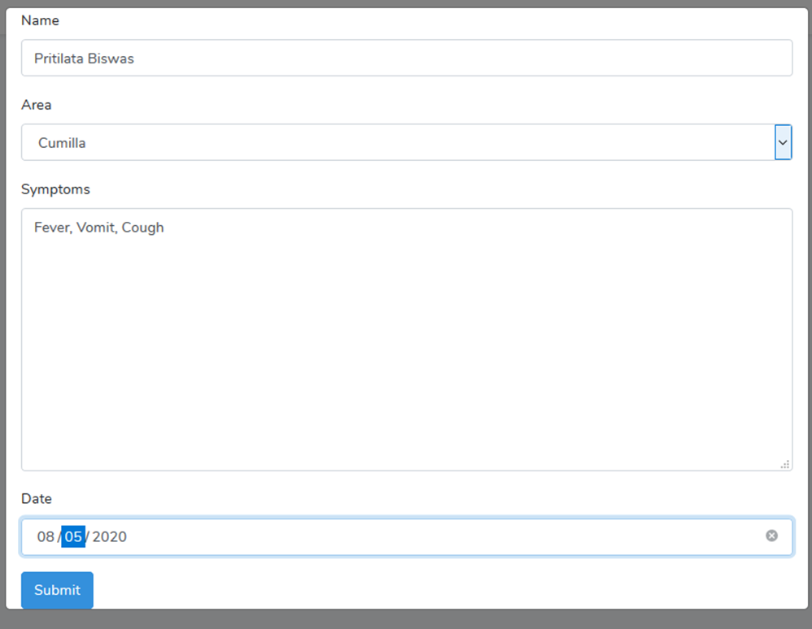
Figure 3.1: Assignment modal form.
- Project Details:
After completing the Laravel Framework we have done our project. Our project is based on our university requirement which is the Hostel meal system. We all know in our university hostel meal system is done manually all the time. Students gave their mail on the ground floor by written in the meal book. Then we realize that is a big hassle for our students in the modern era. So that’s why we generated meal system software which can control all the meal system facilities. We will show it step by step below:

This is the main front page of our project. That means if a person trying to hit our website then at first he will see this:

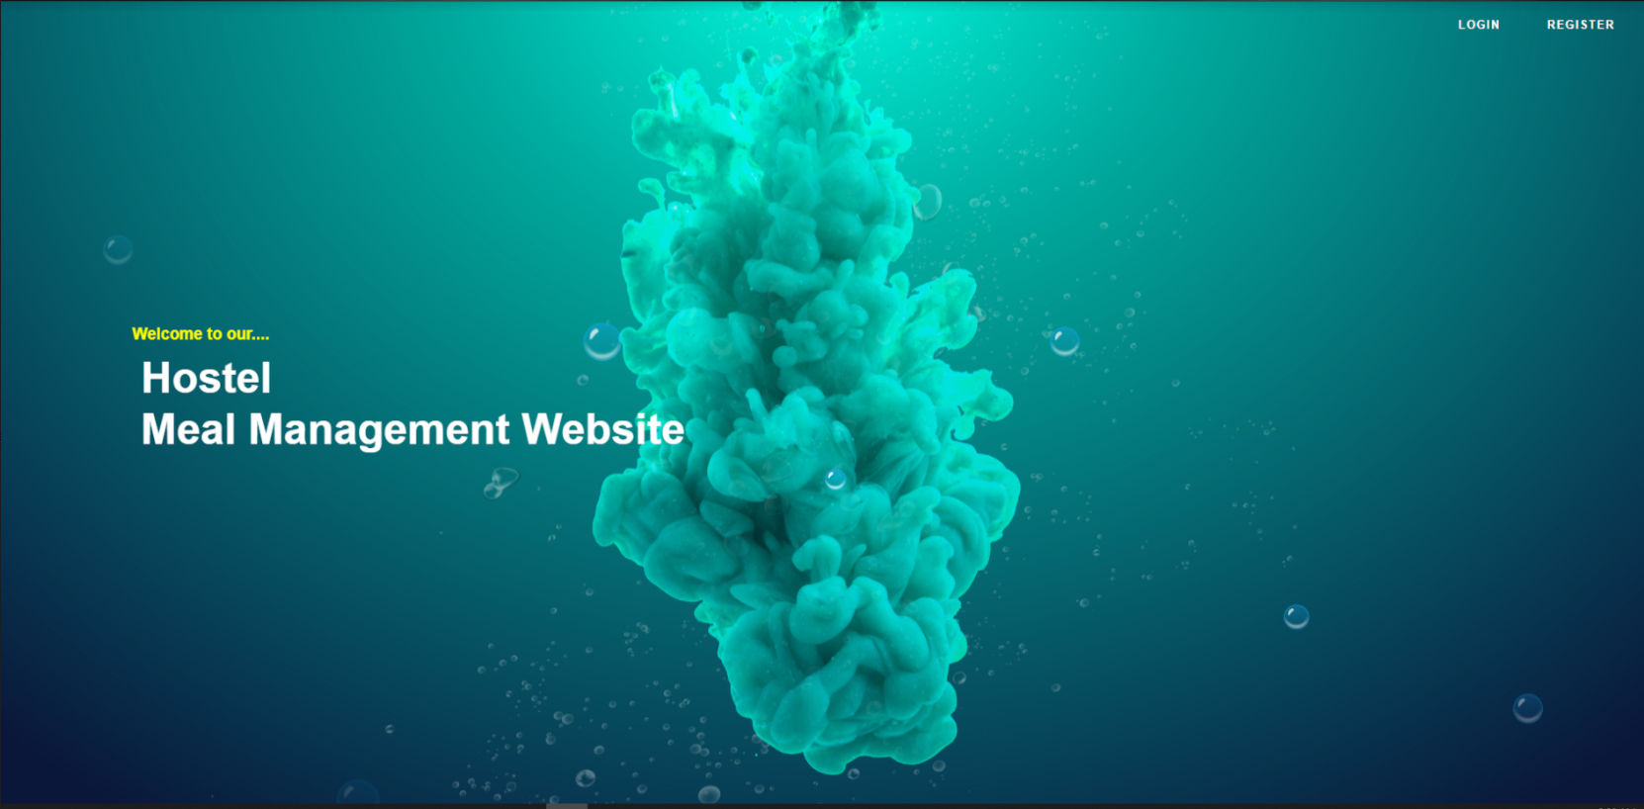
Figure 3.2: Homepage.
This is the first page. In the right upper corner, we can see two navigation menus. One is Login, the other is Register. Login is applicable for existing student and Register is applicable for new students.

There are two types of people who can access this web application.
- Admin
- Student
- Admin:
Admin can check and track all the activities of students. If a student registers in the meal system website then he can successfully register himself, but without the admin permission, he never been able to add a meal from his profile. An admin can add a student or delete a student from the system.
Here is the final dashboard of an admin after students giving one-day whole meal:

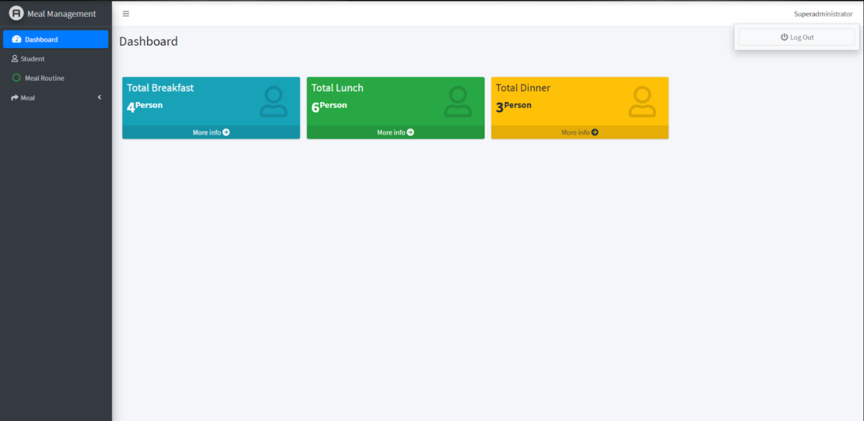
Figure 3.3: Admin dashboard.
Here admin can see how many orders have done for breakfast, lunch, and dinner for tomorrow.

Admin also can see the whole meal of a day like this:

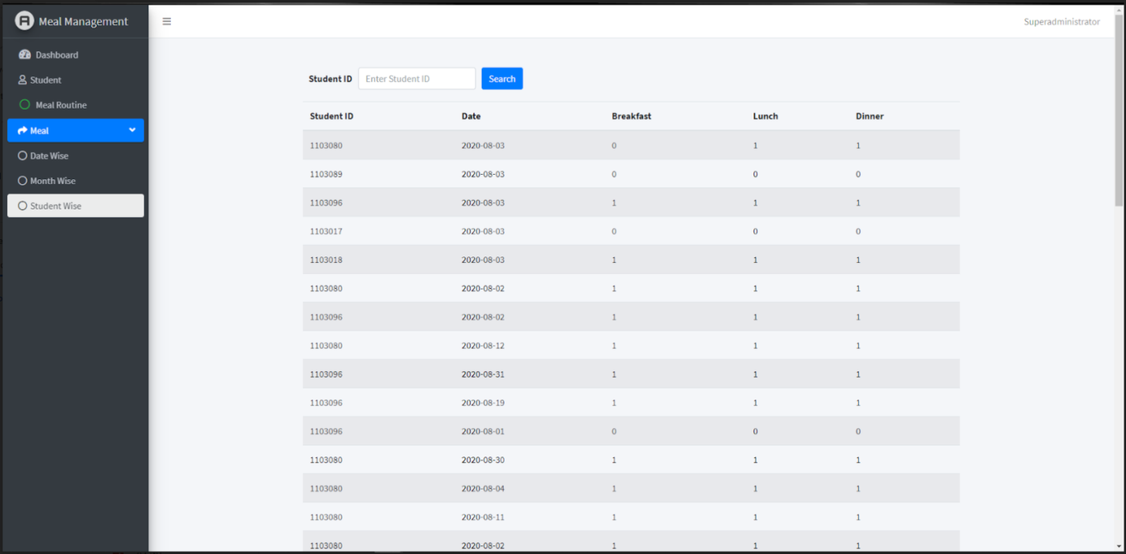
Figure 3.4: student wise meal list
- Student:
Student can add their meal if the admin approves them as a student. If an admin doesn’t approve the students then he never adds his meal. Students can edit their profile as well in this system. Students also track their whole month, year meal system in this web application.

This is the student profile:

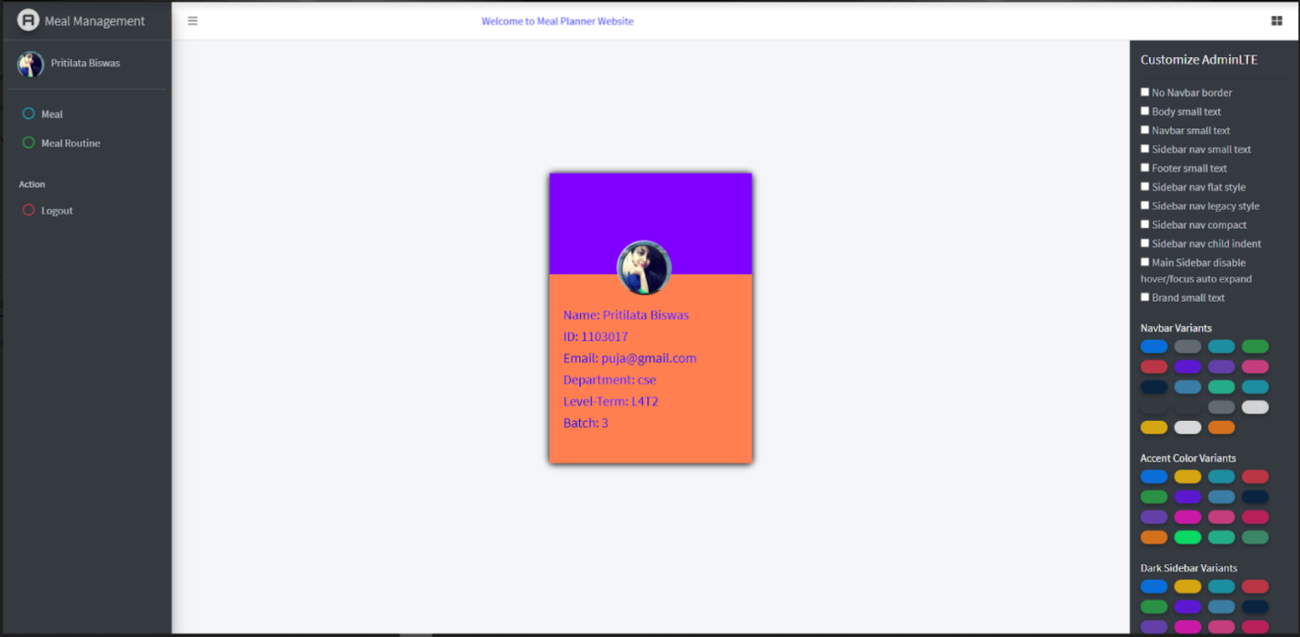
Figure 3.5: Student profile.

Here Student can see their meal record by date:

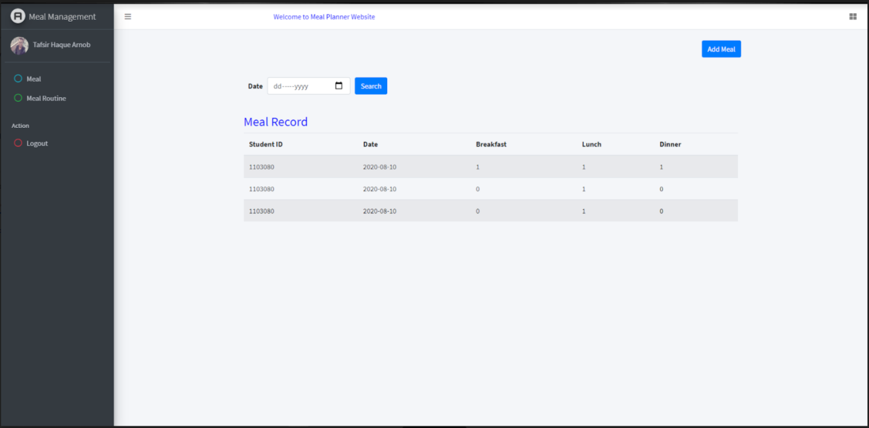
Figure 3.6: Meal searching option.
This is the meal routine, admin can able to change it:

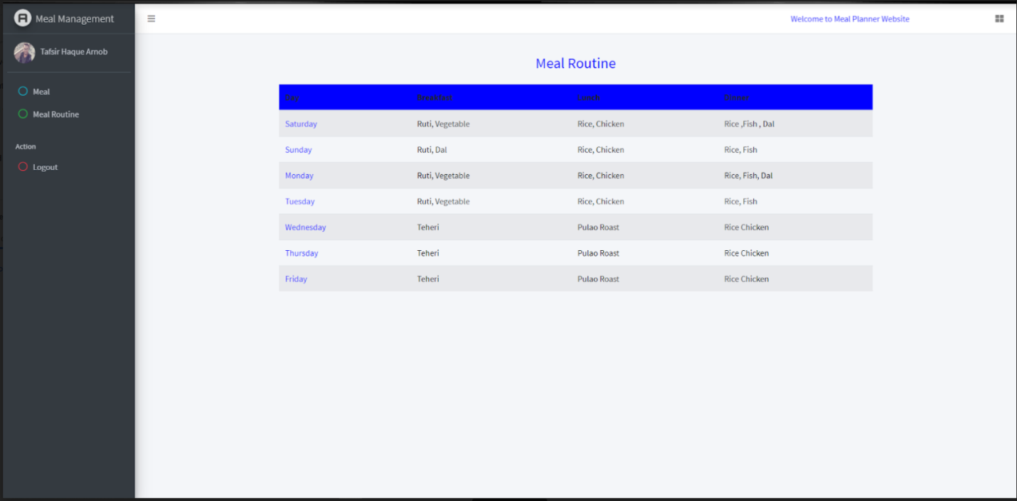
Figure 3.7: Meal routine.
This is our overall project description. We have done our best to do the project in a very short time. In the future, we will try to add additional features like meal budget and so on.

Chapter 4

Observations, Recommendations and Conclusion

Introduction
After doing one and a half months of internship we are familiar with web design & development and we gather the basic knowledge of the Laravel framework. Now we are capable of doing a short Laravel project which includes basic things like a form, registration page, etc.

Observations
Our instructors gave their best effort to learn as much as they can. We all realize if we get more time then we will learn more about Laravel, which will be very helpful for us. But the timing schedule is too tight that we have to finish our intern in a short period. But we all are satisfied that we at least learned the basic things which are very helpful if we are with Laravel in the future.
Our instructors make us able to do make a form like a registration form, information form, etc. With the help of this knowledge, we can do our project. So we can say we learned the basic things but we learned it efficiently.

Recommendations
We wish always the betterment of ICT WING. They have done a huge for our university administration system. Our two elder brothers have done lots of hard work to do our whole university management in a systematic way that reduces the hassle of the students because in the management system it covers all the criteria.
If the intern time is manageable for 3months it will be very helpful for us but unfortunately, time was very short for us.

Conclusion
That’s the last report of our university life. Due to the pandemic, our faculties have done a lot to finish our graduation on time. Though it’s a very tough time for our country, we have done all the things in a short time comparing others. If the intern will be physical then we will be more benefited but it’s all the activities that satisfy us.
Thank you again to all the respected faculties.

REFERENCES

- https://www.baiust.edu.bd/
- https://laravel.com/

