No of image | Total number of lines | Successfully Segmented | Accuracy (%)
1 | 30 | 30 | 100
2 | 31 | 31 | 100
3 | 28 | 28 | 100
4 | 32 | 32 | 100
5 | 26 | 26 | 100
6 | 27 | 27 | 100
7 | 29 | 29 | 100
8 | 31 | 31 | 100
9 | 29 | 29 | 100
10 | 28 | 28 | 100
11 | 28 | 28 | 100
12 | 30 | 30 | 100
13 | 29 | 29 | 100
14 | 31 | 31 | 100
15 | 29 | 29 | 100
16 | 24 | 24 | 100
17 | 34 | 34 | 100
18 | 30 | 30 | 100
19 | 29 | 29 | 100
20 | 30 | 30 | 100
21 | 29 | 29 | 100
22 | 29 | 29 | 100
23 | 29 | 29 | 100
24 | 29 | 29 | 100

Table 1: Line segmentation result

No of Image | Total number of word | Successfully segmented | Accuracy (%)
1 | 259 | 225 | 86.87
2 | 282 | 253 | 89.72
3 | 223 | 215 | 96.41
4 | 256 | 217 | 84.77
5 | 187 | 174 | 93.05
6 | 187 | 169 | 90.37
7 | 178 | 171 | 96.07
8 | 236 | 224 | 94.92
9 | 222 | 200 | 90.09
10 | 214 | 204 | 95.33
11 | 224 | 205 | 91.52
12 | 226 | 193 | 85.40
13 | 189 | 175 | 92.59
14 | 208 | 182 | 87.5
15 | 223 | 204 | 91.48
16 | 215 | 196 | 91.16
17 | 229 | 215 | 93.89
18 | 238 | 205 | 86.13
19 | 163 | 136 | 83.44
20 | 290 | 261 | 90.00
21 | 135 | 122 | 90.37
22 | 272 | 250 | 91.91
23 | 220 | 205 | 93.18
24 | 183 | 166 | 90.71

Table 2: Word segmentation result

No of Image | Total number of character | Successfully segmented | Accuracy (%)
1 | 1204 | 1115 | 92.61
2 | 1043 | 888 | 85.14
3 | 1257 | 1139 | 90.61
4 | 1079 | 951 | 88.14
5 | 1299 | 1178 | 90.69
6 | 1293 | 1006 | 77.80
7 | 1467 | 1365 | 93.05
8 | 1293 | 1187 | 91.80
9 | 1193 | 1103 | 92.46
10 | 1173 | 1063 | 90.62
11 | 1289 | 1021 | 79.20
12 | 1051 | 953 | 90.68
13 | 1139 | 1005 | 88.24
14 | 957 | 868 | 90.70
15 | 1107 | 970 | 87.62
16 | 768 | 704 | 91.67
17 | 1169 | 1090 | 93.24
18 | 1046 | 935 | 89.39
19 | 986 | 913 | 92.59
20 | 1121 | 987 | 88.05
21 | 1235 | 1119 | 90.60
22 | 1233 | 1088 | 88.24
23 | 1289 | 1134 | 87.98
24 | 1141 | 1022 | 89.57

Table 3: Character Segmentation result

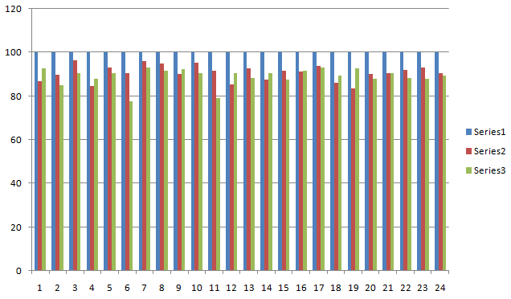
Series1 shows line segmentation, series2 shows word segmentation and series3 shows character segmentation.

