HANDWRITTEN AND PRINTED BENGALI SCRIPT CHARACTER SEGMENTATION USING MORPHOLOGICAL ANALYSIS

A Thesis Submitted
By
Pritilata Biswas
ID: 1103017
Sumaia Afrin Prity
ID: 1103057
Parvez Abedin Siddique
ID: 1103094

Under the Supervision of
Arifa Islam Champa

Lecturer
Department of Computer Science and Engineering
Bangladesh Army International University of Science and Technology


Bachelor of Science in Computer Science and Engineering
Bangladesh Army International University of Science and Technology
Fall, 2019 Semester

HANDWRITTEN AND PRINTED BENGALI SCRIPT CHARACTER SEGMENTATION USING MORPHOLOGICAL ANALYSIS

A Thesis submitted to the Department of Computer Science and Engineering Faculty, Bangladesh Army International University of Science and Technology in partial fulfillment of the requirements for the degree of Bachelor of Science in Computer Science and Engineering.
Pritilata Biswas  Sumaia Afrin Prity  Parvez Abedin Siddique | ID: 1103017  ID: 1103057  ID: 1103094

Department of
Computer Science and Engineering
Bangladesh Army International University of Science and Technology


Fall Semester 2019
July, 2020

Declaration
This is to certify that this thesis is our original work. No part of this work has been submitted elsewhere partially or fully for the award of any other degree or diploma. Any material reproduced in this project has been properly acknowledged.

Pritilata Biswas
Sumaia Afrin Prity
Parvez Abedin Siddique

Approval

The Thesis titled “HANDWRITTEN AND PRINTED BENGALI SCRIPT CHARACTER SEGMENTATION USING MORPHOLOGICAL ANALYSIS” has been submitted to the following respected members of the Board of Examiners in partial fulfillment of the requirements for the degree of Bachelor of Science in Computer Science and Engineering on June 2020 by the following student and has been accepted as satisfactory.
Pritilata Biswas  Sumaia Afrin Prity  Parvez Abedin Siddique | ID: 1103017  ID: 1103057  ID: 1103094

_ _ _ _ _ _ _ _ _ _ _ _ _ _ _ _ _ _  Supervisor  Arifa Islam Champa  Lecturer  Department of CSE  Bangladesh Army International University of Science and Technology | _ _ _ _ _ _ _ _ _ _ _ _ _ _ _ _ _  External Supervisor  Dr. Fakir Sharif Hossain  Head of the Department  Department of EEE  Bangladesh Army International University of Science and Technology
_ _ _ _ _ _ _ _ _ _ _ _ _ _ _ _ _ _
Mohammad Asaduzzaman Khan
Head, Department of CSE
Bangladesh Army International University of Science and Technology

Acknowledgment

First and foremost, we would like to thank God Almighty for giving us the strength to finish this work. The satisfaction that accompanies the successful completion of this thesis would be incomplete without the mention of people whose ceaseless cooperation made it possible, whose constant guidance and encouragement crown all efforts with success. We are grateful to our honorable thesis Supervisor Arifa Islam Champa, Lecturer, Department of Computer Science and Engineering, Bangladesh Army International University of Science & Technology (BAIUST), for the guidance, inspiration, and constructive suggestions which were helpful in the preparation of this thesis. We also convey special thanks and gratitude to Mohammad Asaduzzaman Khan, honorable head of the Department of Computer Science and Engineering, Bangladesh Army International University of Science & Technology (BAIUST), for his kind advice. We would also like to extend our gratitude to all of our teachers for their valuable guidance in every step of ours during the four years of the learning stage. Finally, we would like to thank our friends, seniors, juniors, and the staff of the department for their valuable suggestions and assistance that has helped in the successful completion of the thesis.

Pritilata Biswas
Sumaia Afrin Prity
Parvez Abedin Siddique

TABLE OF CONTENTS
Declaration i
Approval ii
Acknowledgment iii
ABSTRACT x
Chapter 1 1
Introduction 1
1.1. Introduction 1
1.2. Historical Background 1
1.2.1. Earlier Research 2
1.2.2. Recent Research 3
1.3. Future Scope of This Study 5
1.3.1. Future Scopes 5
1.3.2. Recommendations 6
1.4. Limitation of the Study 6
1.5. Advantage over Traditional Method 7
1.6. Objective of this Work 8
1.6.1. Primary objectives 8
1.6.2. Secondary Objectives 8
1.7. Introduction to this Thesis 8
Chapter 2 10
Methodology 10
2.1. Introduction 10
2.2. Optical Character Recognition (OCR) 10
2.2.1. The History of OCR 11
2.2.2. Components of an OCR system 12
2.3. System Overview 12
2.3.1. Bengali Script 14
2.3.2. Image filtering 14
2.3.2.1. Grayscale filtering: 14
2.3.2.2. Bilateral filtering: 15
2.3.3. Image Binarization 15
2.3.5. Horizontal Projection Profile( HPP) 16
2.3.6. Vertical Projection Profile(VPP) 17
2.3.7. Morphological image processing 18
2.3.7.1. Opening and closing 18
2.4. Summary 19
Chapter 3 20
Implementation 20
3.1. Introduction 20
3.2. Dataset 20
3.3. Implementation Tools 20
3.3.1. Environments 21
3.3.1.1. Anaconda Environment 21
3.3.2. Packages 21
3.3.2.1. OpenCV 21
3.3.2.2. Numpy 22
3.3.2.3. Matplotlib 22
3.4. Tesseract Engine 22
3.5. Implementation Details 23
3.6. Taking Input of Bengali Script 24
3.7. Processing 24
3.7.1.1. Grayscale filter 24
3.7.1.2. Bilateral filter 25
3.7.1.3. Binarization 25
3.8. Line Segmentation 25
3.9. Word Segmentation 26
3.10. Character Segmentation 26
3.10.1.1. Opening 27
3.10.1.2. Closing 27
3.11. Novelty of Our Work 28
3.12. Summary 28
Chapter 4 29
Experimental Results 29
4.1. Introduction 29
4.2. Evaluation 29
4.2.1. Preprocessing 29
4.2.1.1. Handwritten script results 30
4.2.1.2. Printed Script Result 32
4.2.2. Line Segmentation 34
4.2.2.1. Handwritten script results 34
4.2.2.2. Printed Script Result 35
4.2.3. Word Segmentation 35
4.2.3.1. Handwritten script results 36
4.2.3.2. Printed Script Result 36
4.2.4. Character Segmentation 37
4.2.4.1. Handwritten script results 37
4.2.4.2. Printed Script Result 38
4.3. Comparing with tesseract 38
4.4. Accuracy 41
4.5. Summary 47
Chapter 5 48
Discussions and Conclusions 48
5.1. Discussions 48
5.2. Suggestion for future Work 48
5.3. Conclusions 49
REFERENCES 50

LIST OF FIGURES
Figure 2.1: The different areas of character recognition [15]. 10
Figure 2.2: Components of an OCR-system [15]. 12
Figure 2.3: System overview. 13
Figure 2.4: Line Segmentation using HPP[2]. 16
Figure 2.5: Word Segmentation using VPP [2]. 17
Figure 2.6: Opening operation [18]. 18
Figure 2.7: Closing operation [18]. 18
Figure 4.1: Preprocessing for Bengali handwritten script. 31
Figure 4.2: Preprocessing for Bengali printed script. 33
Figure 4.3: Line segmentation of Bengali handwritten script using HPP……… 34
Figure 4.4: Line segmentation of Bengali Printed script using HPP. 35
Figure 4.5: Word segmentation of handwritten Bengali script using VPP……… 36
Figure 4.6: Word segmentation of printed Bengali script using VPP. 36
Figure 4.7: Character segmentation of handwritten Bengali script using Morphological image processing. 37
Figure 4.8: Character segmentation of printed Bengali script using Morphological image processing. 38
Figure 4.9: Comparing the result with tesseract. 40
Figure 4.10: line segmentation, word segmentation and character segmentation OF PRINTED SCRIPT. 44
Figure 4.11: line segmentation, word segmentation and character segmentation OF HANDWRITTEN SCRIPT. 46

LIST OF TABLES
Table 2.1: A short OCR chronology………………………………………..……….11
Table 4.1: Line segmentation result……………………………………………….41
Table 4.2: Word segmentation result…………………………………………..…42
Table 4.3: Character Segmentation result……………………………………..43
Table 4.4: Overall accuracy of printed script………………….…………….44
Table 4.5: Line Segmentation result ……………………........................................45
Table 4.6: Word Segmentation result ………………….........................................45
Table 4.7: Character Segmentation result ………...…......................................46
Table 4.8: Overall accuracy of HANDWRITTEN SCRIPT ……………………....47

ABSTRACT

Bengali script segmentation is the most challenging and also an essential key task for any Bangla Optical Character Recognition system. For accurate and proper segmentation it is essential to mark out the properties of Bangla script as well as the exceptions. In this paper, we have tried to present the segmentation process for handwritten and printed Bengali script. In the Bangla OCR system, one of the major challenges is character segmentation. Proper segmentation is hard as there are more than 300 basics, modified and compound characters in the Bengali script as they are topologically connected. Some characters are also overlapped. Here we have used HPP for line segmentation, VPP for word segmentation, and morphological image processing for character segmentation. We have tried to identify the Matra line correctly. Then by using this information, connected components can be tear apart. In our system, the best accuracy of line segmentation is 100% for both the printed and handwritten script. The best accuracy of the word segmentation is 96.41% for printed and 100% for handwritten. Then the best accuracy of the character segmentation is 93.24% for printed and 87.3% for the handwritten script. Thus the proposed method solves the problems of line, word, and character segmentation in Bangla script and thereby helps to build the Bangla OCR system.

Chapter 1

Introduction

Introduction
Since 1950, Optical Character Recognition is a major research area. As we all know, Bengali is one of the richest language of the world ranking 5th as the most spoken native language and ranking 7th as the most spoken language. As a result, in recent years a digitized method for recognizing Bengali characters is started to receive attention for OCR related work with the rapid growth and advertisement of the use of computers in Bangladesh [1].
In the field of OCR, segmentation is one of the most challenging tasks of Bengali character recognition. Many different methods have been proposed on this purpose and many methods have shown high performance. The structure of the Bengali language is quite different. Bengali is written in the Sanskrit script. Bengali script is consists of 50 basic characters including 11 vowels and 39 consonant characters. It is used for representing other languages like Meithei and Manipuri, and there is a time when it used to write Sanskrit within Bengal. Most of the Bengali characters are topologically connected [2]. The Bengali language is ingenious. However, there have not been such a significant number of takes a shot at language preparing for Bengali as have been for some different language, for example, English and Spanish. Numerous vital compositions that were practiced in Bengali in the last century. As innovation back then was not that much advanced, these works were not written in digital form. So it isn't workable for a publisher to print them again without composing the whole writings. For this situation, an OCR will be an incredible assistance for the publisher. An OCR for Bengali would likewise empower users to cause editable records from images that have been produced for particular purposes.

Historical Background
Segmentation of Bengali character is one of the most challenging tasks in making a Bengali Optical Character Recognition (OCR). Till now no such methods are discovered that have 100% accuracy. In comparison with other European languages, the structure of the Bengali language is quite different. There are a large number of characters in Bengali. So we need a robust technique for our research. For the segmentation of Bengali characters, the methods that have been used are Horizontal Projection Profile (HPP), Vertical Projection Profile (VPP), and Morphology.

Earlier Research
In this section, we will review a couple of related work that was done previously based on the segmentation of Bengali characters. Numerous analysts have tended to the issue of character segmentation of Bengali content. Different strategies have been proposed by various authors. Some details of the previous research work on Bengali character segmentation are given bellowed:

Chaudhuri & Pal [3] proposed the first complete Bangla OCR system for printed documents. Using horizontal and vertical projection profile analysis and headline removal technique they segmented the documents into lines, words, and characters. They additionally partitioned the words into three zones utilizing headline and baseline identification strategies.

Mahmud et al 4] proposed an acknowledgment procedure for confined just as consistent printed Bangla characters. This process additionally supports a multi textual style of Bengali content acknowledgment. Preprocessing includes segmentation at different levels. They used piecewise linear scanning, greedy search algorithm, and baseline detection technique for character segmentation.

Mahmud et al [5] utilized projection profile-based techniques for segmenting Bengali content. For character segmentation, they utilized vertical scanning techniques. Depth First Search (DFS) algorithm likewise used for overlapped character segmentation.

Mehedi et al [6] proposed another methodology utilizing characteristic functions and a hamming network for segmentation and acknowledgment of printed Bangla text. They utilized a lot of characteristic functions for segmenting the upper portion (above matra line) and characters that go under the base-line (three-zone approach). It additionally utilizes a combination of Flood-fill and Boundary-fill algorithm for segmenting a few characters that can't be segmented utilizing a conventional approach.

Sattar et al [7] proposed a condition-based methodology for overlapped character segmentation. They examine the width of a single character, on the off chance that it is sufficiently large, at that point check for the overlapped character ‘ekar’. They didn't discuss other sorts of overlapping problems.

Rownak et al [8] utilized curved scanning for overlapped character segmentation.

Garain and Chaudhuri [9] proposed a statistical analysis based technique for segmenting contacting characters in printed Bengali content. They noticed that contacting characters happen for the most part at the center of the center zone and by assessing the pixel designs and their relative situation as for the anticipated center zone certain associated focuses with contacting were found. The geometric shape is cut at these focuses and the OCR scores are noted. The best score gives the ideal outcome.

In most of the previously mentioned work, they separated the words into three zones, yet blunder in benchmark identification decreases the general precision of the division procedure. There are a lot of issues related to overlapped character segmentation what's more. Unfortunately, none of the talked strategies resolve these issues.

Recent Research
There are a lot of research works done on Bengali characters in recent years. Several studies have focused on the segmentation of Bengali characters. These studies have been applied to different approaches to different complicated cases and achieved high performance.
Some details of the recent year research works on Bengali characters segmentation are given bellowed:

Zahan & Selim [1] proposed a complete and robust segmentation technique for printed Bengali script. They have noticed that segmentation is difficult as there are more than 300 basic, modified, and compound characters in the content. They are topologically connected and some are overlapped. They have used the analysis of connected components based on the two-zone approach. In their research work, they tried to find out the matra line properly and they divided the script into two zones. Then they collected the connected components observing the matra line. Their proposed methods solve many problems of character segmentation of Bengali script and thereby increase the overall accuracy in the field of optical character recognition.

Gupta & Patel [10] proposed various methodologies to segment a text-based image at various levels of segmentation. They tried to retrieve specific information from the entire image and discuss various factors affecting the segmentation process. Then they reviewed available techniques of segmentation. Their special attention was given to handwriting recognition.

Basu & Sarkar [11] utilized a fuzzy technique for the segmentation of handwritten Bangla word images. They had worked in two steps. In the first step, they identified the black pixels constituting the matra in the target image by utilizing a fuzzy feature. In the second step, they identified some of the black pixels on the matra as segment points by using three fuzzy features. Their methods have certain limitations but it can be considered as a significant step for the development of a full-fledged Bangla OCR system.

Bishnu & Chaudhury [12] proposed a method for the segmentation of handwritten Bangla text into characters. In their system, as they detected different zone across the height of the word, they have proposed a technique for recursive contour following in one of the zones across the height of the word to find out the boundary within which the main portion of the character lies. Their algorithm gives fairly good results if the sequent characters are not touching in the zone of contour following.

Mehedi & Alim [13] presented a new approach to segment and recognize printed Bangla text using characteristic functions and hamming network. In their system, they have proposed a new algorithm to detect and separate text lines, words, and characters from printed Bangla text. This algorithm uses a combination of the Flood-fill and Boundary-fill algorithm to segment some characters that cannot be segmented using the traditional approach. They have used a hamming network for recognition schemes.

Bhowmik & Roy [14] proposed a segmentation scheme of Bangla handwritten words with some unconventional and easy to implement the technique. They have proposed an area-based algorithm for the skew detection of the Bangla specimen skewed handwritten words from their self prepared database. Their analysis of the directional chain code extracted the feature for segmentation. Finally Multilayer Perception (MLP) Neural networks recognize the segmenting points.

In most of the previously mentioned works, the researcher showed high performance and also high accuracy.

Future Scope of This Study
From 1950s character recognition is an active area of research. Many techniques for recognition of Characters have been suggested. But still, an efficient OCR for the recognition of handwritten Bengali characters does not exist. Few steps have been taken for Handwritten and printed character recognition. Various challenges are identified which may provide more lively interest to the researchers. These challenges are difficult to identify the diverse human writing styles, different angles of letters, different shapes and sizes of letters, pure input quality, low accuracy rate in recognition, etc. Hence, a lot of research work is to be done to solve these difficulties. In the future, the area of recognition of constrained print is expected to decrease. In the case of handwritten text, our segmentation process can give better output if there exists enough space between characters. In the future, we will try to develop our work in the area of the handwritten script more accurately.

Future Scopes
Our proposed strategy can help to increase the segmentation and recognition accuracy for Bangla printed text. Though as the proposed method failed to give better results for character segmentation, we have a plan to use HMM (Hidden Markov model) for character segmentation. In that case, the system will take the word as input and will give characters as output. Though we need a large data set as we have to train each character with all possible modifiers, yet we think the system will give better results.

Recommendations
Bangla is one of the most widely spoken languages in the world. Though Bangla is a very rich and old language, the matter of regret is that its computerization has not yet gone much far. Dedicated research and development for Bangla computerization have just been started from the last decade. In the computerization of any language, one of the vital tasks is to develop an efficient and effective Optical Character Recognition (OCR) system for the respected language. To store a million pages of paper documents into electronic form, OCR is the key tool. Otherwise, if those are entered by typing manually, the efficiency, effectiveness, and correctness will drastically fall. As a result, all the effort will go in vain.
For Bangla, there is no good OCR solution until now. But, our government and private organizations have huge quantities of Bangla paper documents that are so important that those should be stored for a long period. To do so, making electronic copies of those documents are unparalleled and it can be done by using a high-quality Bangla OCR system. But, to implement an OCR the foremost step in the recognition process is the script segmentation of the document image. Since the written form of Bangla documents is more complex than that of many other languages, Bangla script segmentation is of great importance for creating a Bangla OCR system.

Limitation of the Study
The main obstacle of our method is distorted image, not aligned image as we have scanned the script horizontally, vertically but not in slop. The result has a few limitations in the case of line, word, and character segmentation. For line segmentation, the system will not be able to give correct results if the line is skewed more than 30 degrees clockwise or anti-clockwise. The system has a limitation of segmenting connected lines as well. That means it will not be able to segment a line correctly if the line collides with the upper or lower line of the text. For word segmentation, the system fails to segment a word correctly if the inter-word gap gets equal to the inter-character gap of a line. For character segmentation, the system has a few limitations. Firstly, our proposed method will not be able to segment overlapped characters. Secondly, it will not be able to segment a character if it overlaps with another character. Finally, since we’re unable to detect baseline the system fails to separate the modifiers from the characters.

Advantage over Traditional Method
Segmentation has various methodologies to segment a Bengali text image. In this section, we will discuss it and will also discuss the advantage of our method. The methods that are used to execute the segmentation of text images are smearing approach, pixel counting approach, stochastic approach, water flow approach, histogram approach [2].

In the smearing approach, it will smear all the continuous black pixels towards the horizontal axes for segmenting. Which means it will fill the white spaces between the black pixels with black pixels. This process will be valid for a predefined threshold value. The smeared area is called boundary growing area. This smeared area defines separate lines or words.

In pixel counting approach for line segmentation, there is two way to execute segmentation, with and without guidelines. This algorithm is designed in such a way that it can tolerate a certain less number of black pixels in a white row when there is no guideline. When the guideline is given then it arises a problem when any character extends guideline boundary. This approach cannot be utilized when the image contains a higher degree of skew, overlapped character, and when there is the irregular spacing between text lines.
In a stochastic approach, it verifies the nonlinear line between overlapped text lines. It follows a probabilistic algorithm. In this approach, the image is partitioned into small cells. Then following hidden Markov modeling the segmentation paths will be searched. When there are fewer black pixels in the touching component then the path of higher probability will cross. However, this approach will not work when there are maximum black pixels in the contacting point.
In the waterfall approach, a suppositional flow of water will be given to the image from left to right and top to bottom. This is expected from this approach is that the flow of water will fill up the gaps between the lines. Now the area that is not a wetted area of the image will indicate the text lines and the wetted area indicates the gap. Finally, the image will be divided into two different stripes. One is for text line and another is for line spacing. And the angle of this process will be determined from some mathematical functions.
Our work is based on a histogram approach. In the histogram approach, it will identify the text lines automatically and then will segment it. It can be elaborated onto the upper level of segmentation. This is a simple and fast method to characterize line segments. The Histogram approach works in three or four steps. We will discuss in detail this approach in chapter 4 about how this approach works. In comparison with the traditional approach, this approach works very well. It identifies the location of the text lines and words. It reduces the excluded region from the text line of the image step by step. Some equation provides the average height of the lines and length of the words.
The overall discussion provides a clear view of the advantage of our method over the traditional method.

Objective of this Work
To accomplish thesis work we make a list of some objectives that we must achieve during the work. Our primary and secondary objectives are stated below-

Primary objectives
The primary and main objective of this research is to develop an effective strategy for segmenting printed Bengali scripts using morphological analysis which can help to build an efficient optical character recognition (OCR) system.

Secondary Objectives
To obtain this primary objective the following sub-objectives must also be achieved:
- Reduce the segmentation error and time.
- Define the structuring element properly.
- Determine the matra line by the morphological opening operation.
- Remove connectedness of character using morphological closing operation.
- Comparative analysis between existing and proposed methods.

Introduction to this Thesis
Bangla character recognition has become a vital issue in the last few years but it is a huge challenge to get good performance due to the segmentation and many of them are similar. It remains largely unsolved due to the presence of many ambiguous characters and excessively swigs Bangla handwriting. Even many flourished existing methods do not lead to satisfactory performance in practice that related to Bangla character recognition. We mainly focused on the segmentation process which is the backbone of the recognition phase. At the preprocessing part, the input image is processed by using various filters like the grayscale filter, bilateral filter, skew angle correction, and binarization. Then for segmentation purposes, the lines of Bengali script are segmented by horizontal projection profile (HPP) and then words for each line are segmented by vertical projection profile (VPP). Here HPP and VPP are part of structural analysis. This Structural analysis is the process of breaking words down into their basic parts to determine word meaning. Finally, for character segmentation, we used basic operations like opening and closing of Morphological Image Processing. In our system, we mainly tried to identify the lines, words, and also the characters properly for the Bengali script that solves the problem of making a good Optical Character Recognition system and thereby increases the accuracy of the segmentation process.

Chapter 2

Methodology

Introduction
In this thesis, we have tried to complete the segmentation processes properly for Bengali scripts that help to build a robust Optical Character Recognition (OCR) system. As proper segmentation is the most challenging part for building the OCR system, here the overall methods of segmentation processes are described completely.

Optical Character Recognition (OCR)
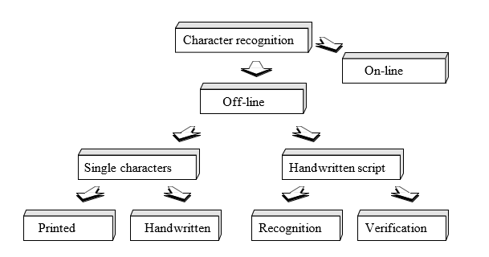
Optical Character Recognition deals with the problem of recognizing optically processed characters. Optical recognition is performed off-line after the writing or printing has been completed, as opposed to on-line recognition where the computer recognizes the characters as they are drawn. Both handwritten and printed characters may be recognized, but the performance is directly dependent upon the quality of the input documents [15].
Figure 2.1: The different areas of character recognition [15].
In Figure 2.1, the different fields of character recognition like off-line and on-line fields are visualized. For off-line single characters, the documents can be printed and handwritten. Besides, for the handwritten script, recognition and verification are the most important stages. The more constrained the input is, the better will the performance of the OCR system be. However, when it comes to totally unconstrained handwriting, OCR machines are still a long way from reading as well as humans. However, the computer reads fast and technical advances are continually bringing the technology closer to its ideal.

The History of OCR
Methodically, character recognition is a subset of the pattern recognition area. However, it was character recognition that gave the incentives for making pattern recognition and image analysis matured fields of science. The overall OCR chronology from the 1870s to 1986s is shown by the following Table 2.1:
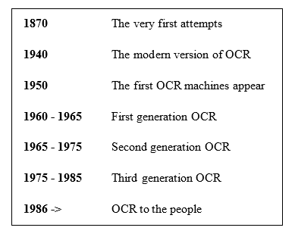
Table 2.1: A short OCR chronology [15].
Here, Table 2.1 indicates the short chronology of OCR from the earlier periods to today’s generation. Although OCR machines became commercially available already in the 1950s, only a few thousand systems had been sold worldwide up to 1986. The main reason for this was the cost of the systems. However, as hardware was getting cheaper, and OCR systems started to become available as software packages, the sale increased considerably. Today a few thousand is the number of systems sold every week, and the cost of an omnipotent OCR has dropped with a factor of ten every other year for the last 6 years.

Components of an OCR system
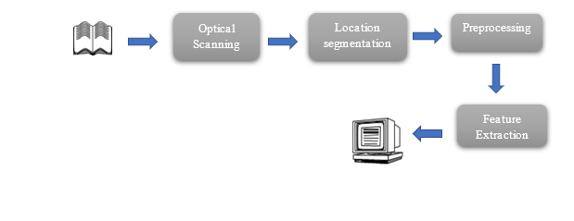
A typical OCR system consists of several components. The complete OCR system consists of a scanner, the recognition component, and OCR software that interacts with the other components to store the computerized document on the computer. The process of inputting the material into the computer begins with the scanner taking a picture of the printed material. The components of an OCR system are illustrated by the following Figure 2.2:
Figure 2.2: Components of an OCR-system [15].
In Figure 2.2, a common setup of OCR is visualized. The first step in the process is to digitize the analog document using an optical scanner. When the regions containing text are located, each symbol is extracted through a segmentation process which is the most important task. The extracted symbols may then be preprocessed and eliminate noise to facilitate the extraction of features in the next step. The identity of each symbol is found by comparing the extracted features with descriptions of the symbol classes obtained through a previous learning phase. Finally, contextual information is used to reconstruct the words and numbers of the original text.

System Overview
In our system, we completed our tasks by the following steps:
- Taking image as input from the Bengali Scripts.
- Processing the input image by applying various filters.
- Segmenting the lines by following Horizontal Projection Profile (HPP).
- Segmenting the words by following Vertical Projection Profile (VPP).
- Finally, segmenting the characters properly by using the operations of Morphological image processing. All the steps are graphically represented in figure 2.3.
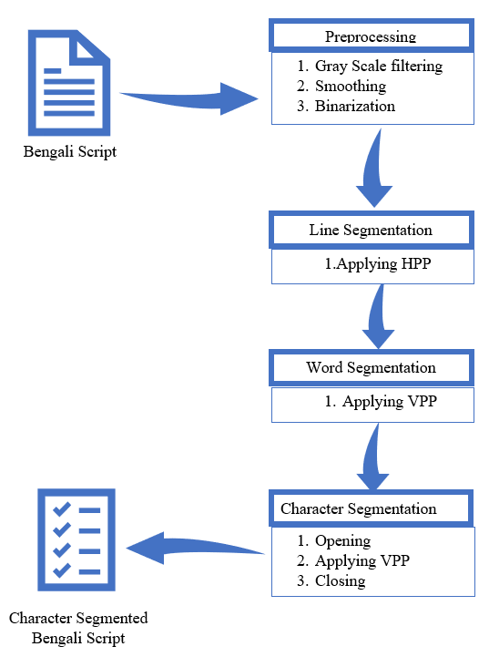
Figure 2.3: System overview.

Bengali Script
Bangla scripts are moderately complex patterns. The alphabet of Bangla script consists of 50 characters with 11 vowels and 39 consonants. They are the basic characters of the Bangla language. Each word in Bangla scripts is composed of several characters joined by a horizontal line (called ‘Matra’ or head-line) at the top. Often there may be different composite characters and vowel and consonant signs(‘Kaar’ and ‘Falla’ symbols). This makes the development of an OCR for Bangla printed scripts a highly challenging task. In Bangla, the writing style is from left to right. The upper case / lower case concept is absent in Bangla. Most of the characters have a line in the upper zone. When they form a word by sitting side by side they are connected through this line. This line is called “Matra” or “Head-line”. Those characters have “Matra” on them are connected with another character in the upper zone through their “Matra”. Some connected components are seen to be connected in the lower zone (modified vowels and consonants) [1].

Image filtering
Filtering is a technique for modifying or enhancing an image. For example, we can filter an image to emphasize certain features or remove other features. Image processing operations implemented with filtering include smoothing, sharpening, and edge enhancement. Filtering is a neighborhood operation, in which the value of any given pixel in the output image is determined by applying some algorithm to the values of the pixels in the neighborhood of the corresponding input pixel. A pixel's neighborhood is some set of pixels, defined by their locations relative to that pixel [16].

Grayscale filtering:
A grayscale (or gray level) image is simply one in which the only colors are shades of gray. The reason for differentiating such images from any other sort of color image is that less information needs to be provided for each pixel. ‘Gray’ color is one in which the red, green, and blue components all have equal intensity in RGB space, and so it is only necessary to specify a single intensity value for each pixel, as opposed to the three intensities needed to specify each pixel in a full-color image. Often, the grayscale intensity is stored as an 8-bit integer giving 256 possible different shades of gray from black to white. If the levels are evenly spaced then the difference between successive gray levels is significantly better than the gray level resolving power of the human eye. Grayscale images are very common, in part because much of today's display and image capture hardware can only support 8-bit images. Besides, grayscale images are entirely sufficient for many tasks and so there is no need to use more complicated and harder-to-process color images. OpenCV provides us some tools to generate a grayscale image by grayscale filtering. This simply generates the average of RGB channel and put it between 0-255 so that only black and white image remains [16].

Bilateral filtering:
The main aim of image smoothing is to remove noise in digital images. It is a classical matter in digital image processing to smooth image. And it has been widely used in many fields, such as image display, image transmission, and image analysis, etc. Image smoothing has been a basic module in almost all the image processing software. So, it is worth studying more deeply. Image smoothing is a method of improving the quality of images. The image quality is an important factor for the human vision point of view. The image usually has noise which is not easily eliminated in image processing. The quality of the image is affected by the presence of noise. Many methods are there for removing noise from images. Many image processing algorithms can’t work well in a noisy environment, so the image filter is adopted as a preprocessing module. However; the capability of conventional filters based on pure numerical computation is broken down rapidly when they are put in a heavily noisy environment. The median filter is the most used method, but it will not work efficiently when the noise rate is above 0.5. So, here we used the bilateral filtering to smoothing our image. A bilateral filter is a non-linear, edge-preserving, and noise-reducing smoothing filter for images. It replaces the intensity of each pixel with a weighted average of intensity values from nearby pixels. This weight can be based on a Gaussian distribution. Crucially, the weights depend not only on Euclidean distance of pixels but also on the radiometric differences. This preserves sharp edges [16].

Image Binarization
Image binarization is the process of taking a grayscale image and converting it to black-and-white, essentially reducing the information contained within the image from 256 shades of gray to 2: black and white, a binary image. This is sometimes known as image thresholding, although thresholding may produce images with more than 2 levels of gray. It is a form of segmentation, whereby an image is divided into constituent objects. This is a task commonly performed when trying to extract an object from an image. The process of binarization works by finding a threshold value in the histogram – a value that effectively divides the histogram into two parts, each representing one of two objects (or the object and the background). It is known as global thresholding. Most thresholding algorithms work by using some type of information to decide where the threshold is. Sometimes the information is statistical and uses the mean, median, entropy, other times information is in the form of shape characteristics of the histogram. Otsu’s algorithm is one of the classical thresholding algorithms introduced by Nobuyuki Otsu in 1979. The algorithm works by exhaustively searching for the threshold that minimizes the weighted within-class variance, or put another way maximizes the between-class variance. Here, we used Otsu’s algorithm [16].

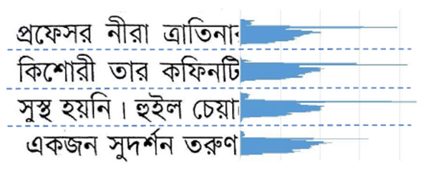
Horizontal Projection Profile( HPP)

Figure 2.4: Line Segmentation using HPP[2].
Text line segmentation has been performed by filtering the input image horizontally. The recurrence of dark pixels in each line is counted to construct the row histogram which is shown in figure 2.4. The situation between two continuous lines, where the number of pixels in a row is zero then it is considered as a boundary between the lines. For detecting this gap or boundary between lines we have used a horizontal projection profile (HPP). Horizontal Projection Profile (HPP) is the projection profile of an image along a horizontal axis. HPP is determined for each line as the entirety of all segment pixel esteems inside the line. The following sample’s output is the result of applying HPP [2].

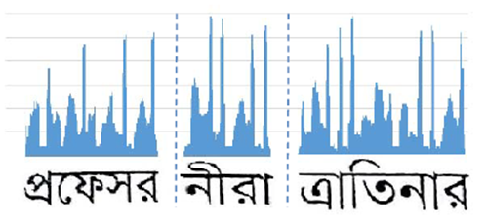
Vertical Projection Profile(VPP)

Figure 2.5: Word Segmentation using VPP [2].
After a line has been identified, we need to identify words in each line for word segmentation. the number of dark pixels in each column is determined to build a column histogram which is shown in figure 2.5. The portion of the line with constant dark pixels is thought of to be a word in that line. On the other hand, if no dark pixel is found in some vertical sweep that is considered as the separating between words. Along these lines various words in various lines are isolated. This separation or gap between words is calculated by a vertical projection profile (VPP). The projection profile along the vertical axis is called a vertical projection profile. VPP is calculated for every column as the sum of all row pixel values inside the column [2].

Morphological image processing
Morphology is a broad set of image processing operations that process images based on shapes [17]. In a morphological operation, each pixel in the image is adjusted based on the value of other pixels in its neighborhood.

Opening and closing

Opening and closing are the operations of morphological image processing. Opening removes small objects from the foreground (usually taken as the bright pixels) of an image, placing them in the background, while closing removes small holes in the foreground, changing small islands of background into the foreground. These techniques can also be used to find specific shapes in an image [17]. In image processing, closing is, together with opening, the basic workhorse of morphological noise removal. Opening removes small objects, while closing removes small holes.

Figure 2.6: Opening operation [18].
Figure 2.7: Closing operation [18].
Here figure 2.6 indicates the output of opening and figure 2.7 indicates the output of closing operations. The operations are applied upon the full character element. The deepness of the image element depends on the attribute that is used in the time of the operation. For opening operation, if a big attribute is used then it will be completely removed. On the other side, the closing operation simply opposite of opening. That means by using a big attribute it will be bolder.

Summary
A detailed overview of our system has been given in this chapter. The overview also includes the explanation of the different methods that are applied to make a strong OCR system.

Chapter 3

Implementation

Introduction
The entire segmentation of Bengali characters is done in three stages. To start with, we take the image of normal format as a contribution of the framework and do some preprocessing to show better performance. This preprocessing includes conversion of the image into a gray image, after the gray conversion we will use a bilateral filter. It will remove noise from the image and will make it smooth. Then we will convert the image up to 256 gray levels to a black and white image which is called binary image. Then skew angle correction will be applied. Then we send the prepared image as the input of the principal phase of the framework which is line segmentation. In this stage, we segment each line from the content and make an individual line. This is the input of the second phase of the framework which is word segmentation. In this stage, we segment words from each line and creating individual words too. At that point, this is the third stage as input which is character segmentation. Here, we segment characters from each word lastly the output is individual characters. In this chapter, the reader will get a detailed concept of the entire implementation process.

Dataset
Our dataset consists of some scanned images randomly taken from the book “আবারোটুনটুনিওআবারোছোটাচ্চু” by Muhammed Zafar Iqbal. For scanning, we used HP DeskJet Ink Advantage 4675 All-in-One Printer. The printer can scan the document in the resolution of 300 dpi. For handwritten images, we used the lines from the same book and wrote them in A4 paper. After that, the image was scanned by the same HP Desk Jet Ink Advantage 4675 All-in-One Printer. The handwritten images are collected from some of the students of Bangladesh Army International University of Science & Technology.

Implementation Tools
To perform the segmentation processes completely several development environments, and packages are used. Here is a list of tools used in the total research process-

Environments

Anaconda Environment
This is the main python environment that has been used to develop our system’s implementation.
Anaconda is a free and open-source distribution of the Python and R programming languages for scientific computing that aims to simplify package management and deployment. Package versions are managed by the package management system conda. The Anaconda distribution includes data-science packages suitable for Windows, Linux, and macOS. Anaconda distribution comes with 1,500 packages selected from PyPI as well as the conda package and virtual environment manager. It also includes a GUI, Anaconda Navigator, as a graphical alternative to the command-line interface. The big difference between conda and the pip package manager is how to package dependencies are managed, which is a significant challenge for Python data science and the reason conda exists [19].

Packages

OpenCV
Our RGB images need to be processed for further steps so, we use this OpenCV to do that.OpenCV (Open source computer vision) is a library of programming functions mainly aimed at real-time computer vision. Originally developed by Intel, it was later supported by Willow Garage then Itseez which was later acquired by Intel. The library is cross-platform and free for use under the open-source BSD license. OpenCV supports some models from deep learning frameworks like TensorFlow, Torch, PyTorch after converting to an ONNX model and Caffe according to a defined list of supported layers [20].

Numpy
For manipulating the images as arrays we used the Numpy package of python. It is a popular Python library used for performing array-based numerical computations. The canonical implementation of NumPy used by most programmers runs on a single CPU core and is parallelized to use multiple cores for some operations. This restriction to a single-node CPU-only execution limits both the size of data that can be handled and the potential speed of NumPy code [21].

Matplotlib
Matplotlib is a plotting library for the Python programming language and its numerical mathematics extension NumPy. It provides an object-oriented API for embedding plots into applications using general-purpose GUI toolkits like Tkinter, wxPython, Qt, or GTK+. There is also a procedural "pylab" interface based on a state machine (like OpenGL), designed to closely resemble that of MATLAB, though its use is discouraged. SciPy makes use of Matplotlib. Matplotlib was originally written by John D. Hunter, since then it has an active development community, and is distributed under a BSD-style license. Michael Droettboom was nominated as matplotlib's lead developer shortly before John Hunter's death in August 2012, and further joined by Thomas Caswell. Matplotlib 2.0.x supports Python versions 2.7 through 3.6. Python 3 support started with Matplotlib 1.2. Matplotlib 1.4 is the last version to support Python 2.6. Matplotlib has pledged to not support Python 2 past 2020 by signing the Python 3 Statement [22].

Tesseract Engine
We used the most popular Tesseract OCR engine to benchmark our methodology. Tesseract is an open-source OCR engine that was developed at HP between 1984 and 1994. Tesseract began as a Ph.D. research project [5] in HP Labs, Bristol, and gained momentum as a possible software and/or hardware add-on for HP’s line of flatbed scanners. The motivation was provided by the fact that the commercial OCR engines of the day were in their infancy, and failed miserably on anything but the best quality print.
Since HP had independently-developed page layout analysis technology that was used in products, (and therefore not released for open-source) Tesseract never needed its page layout analysis. Tesseract, therefore assumes that its input is a binary image with optional polygonal text regions defined. Processing follows a traditional step-by-step pipeline, but some of the stages were unusual in their day, and possibly remain so even now. The first step is a connected component analysis in which outlines of the components are stored. This was a computationally expensive design decision at the time but had a significant advantage: by inspection of the nesting of outlines, and the number of child and grandchild outlines, it is simple to detect inverse text and recognize it as easily as black-on-white text. Tesseract was probably the first OCR engine able to handle white-on-black text so trivially. At this stage, outlines are gathered together, purely by nesting, into Blobs. Blobs are organized into text lines, and the lines and regions are analyzed for fixed pitch or proportional text. Text lines are broken into words differently according to the kind of character spacing. Fixed pitch text is chopped immediately by character cells. Proportional text is broken into words using definite spaces and fuzzy spaces. Recognition then proceeds as a two-pass process. In the first pass, an attempt is made to recognize each word in turn. Each satisfactory word is passed to an adaptive classifier as training data. The adaptive classifier then gets a chance to more accurately recognize the text lower down the page. Since the adaptive classifier may have learned something useful too late to contribute top of the page, a second pass is run over the page, in which words that were not recognized well enough are recognized again. A final phase resolves fuzzy spaces and checks alternative hypotheses for the x-height to locate small cap text.
Tesseract is an OCR engine with support for Unicode and the ability to recognize more than 100 languages out of the box. It can be trained to recognize other languages. It is also a popular OCR for the Bengali script. In our thesis will evaluate our result corresponding to the result of the Tesseract OCR engine [23].

Implementation Details
The implementation of our system had done in five stages:

- Taking image input from the Bengali scripts.
- Preprocessing the input image by using several filters, correcting skew angles, and binarization.
- Segmenting lines by following Horizontal Projection Profile (HPP).
- Segmenting words by following Vertical Projection Profile (VPP).
- Eventually, segmenting characters by using Morphological Image Processing operations.

Taking Input of Bengali Script
Bangla is one of the most widely spoken languages in the world. More than 180 million people
across the globe use this language. In Bangla script, there are 11 vowels and 39 consonant s(total
of 50) characters, which are called basic characters. Bangla scripts are moderately complex patterns. Each word in Bangla scripts is composed of several characters joined by a horizontal line (called ‘Matra’ or head-line) at the top. In our system, the text digitization of the Bengali script is done by a scanner having a resolution of 100 to 300 dpi. Then the image will go for the preprocessing stage.

Processing
The image resulting from the scanning process may contain a certain amount of noise. Depending on the resolution on the scanner and the success of the applied technique for thresholding, the characters may be smeared or broken. Some of these defects, which may later cause poor recognition rates, can be eliminated by preprocessing the image to smooth the digitized characters. In this preprocessing step, a general image is taken as input at a minimum resolution of 100 dpi and a maximum resolution of 300 dpi. Then the input image is passed into several filters like grayscale and bilateral filters. Finally, we will go for image binarization and skew angle correction. The processing of these steps are described below:

Grayscale filter
At first, the input image is converted into a grayscale image by using the grayscale filter. This filter gradually converts all the colors in our images to some shade of gray. The input image which was 3 channel RGB image will be converted into a 1 channel grayscale image.

Bilateral filter
Then we will apply the bilateral filter on that image. A bilateral filter is a non-linear, edge-preserving, and noise-reducing smoothing filter for images. It replaces the intensity of each pixel with a weighted average of intensity values from nearby pixels. This preserves sharp edges. Thus, using this filtered noise will be removed and the image will be smoother.

Binarization
After that, we will go for image binarization. Through binarization, the image is converted to a two-tone image. This image binarization converts an image of up to 256 gray levels to a black and white image. Here we have used Otsu's threshold technique. In Otsu’s threshold technique it converted the 256-gray level into 2 color levels by simply dividing them by 256. If the quotient is between 0-.5 then the pixel will be 0 means in the range of white or if the quotient between .5-1 then the pixel will be 1 means it will be in the range of black.

Line Segmentation
Histogram strategy can without much of a stretch be reached out to more significant levels of segmentation. In this section, a detailed description of line segmentation will be given. A Y histogram is utilized to segment the text lines. After the preprocessing step is completed, we need to find the Y histogram of the image. The histogram contains two values, upper value, and lower value. Each text line assembles the upper value of the histogram. The histogram shows the added pixels for each y value. The space between the upper value and the lower value represents an area where the text lines exist. After obtaining all the text lines we need to execute a strategy to apply a limit to get line separation in the whole text. This limit is relative to the normal length of the lines in the text. This step identifies the location of the text lines.
For each line calculation, when the HPP gets continuous black pixels then counts it as the upper. Then it steps forward horizontally and counts the white pixels. So far as it gets white pixels it steps forward horizontally to the down. Then when it started getting continuous black pixels, HPP counts it as lower and draws a line. The process will continue doing the same thing and as a result, we will get the text lines segmented within the whole image.

Word Segmentation
In this section, a detailed description of word segmentation will be given. An X histogram is utilized to segment words. An X histogram projection that is applied to each line distinguished takes out potential words. X histogram is quite similar to the Y histogram. The histogram also contains two values, the right value, and the left value. Here each text line is used to identify each word using the right value and left value. When a line is drawn the value of each line will be sent to the function of word segmentation.

For each word calculation, when the VPP gets continuous black pixels then count it as left. Then it steps forward vertically and counts the white pixels. So far as it gets white pixels it steps forward vertically and goes ahead. After getting continuous white pixels when it gets any black pixels then consider it as space and count it as right. We have calculated each word by pixel-wise. As we have checked each word vertically, the vertical projection profile counted continuous white pixel as a word and when it finds out any space VPP counted it as another word.

Character Segmentation
Character segmentation is the most difficult part of the overall segmentation process. Two major
characteristics of Bangla script which make it more difficult and erroneous in case of character
level segmentation are – Matra line and Character overlap. Bangla words are connected through
matra (head) line. In our approach, we tried to detect the matra line then by removing it, we can find the characters. The overall accuracy of the segmentation process is very much dependent on the proper detection of the matra line as it is the core component of character segmentation. If we take the horizontal projection profile (used inline separation) of a line or a word, then the highest number of black pixels denotes the matra line. But it may take more than one iterations. But this technique is not so feasible. So, we tried to find a structural element corresponding to the matra line. With that structural element, we apply the morphological image processing operations. How these operations worked are described below:

Opening
This opening operation removes the matra line more efficiently and for that, we need a structural element. Because structural elements can easily find matra lines more efficiently than the HPP because matra lines do not continue and HPP works better when the target element is continued. Structural element nothing but a 2D matrix that contains a special shape of the target element. We know the shape of the matra line is a rectangle. So, we need a structural element that is a rectangle and also we must not remove the matra line completely. Because completely removing the matra line can be a very bad decision for further feature extraction for the OCR. Because in Bengali script some characters cannot be identified without the matra line. So, we take a structural element that will leave at least 1 row of the pixel, and from that pixel, we can get back our matra line. So, after identifying the matra line we simply do the opening operation and get the characters separated from each other. Now, we can simply use the VPP operation to find every individual character.

Closing
The matra line is an important part of the Bengali script. So, without the matra line, the feature extraction will be inaccurate. The matra line can be get backed by using the closing of the morphological image processing operation. For that, we need the same structural element that we used before for opening morphological image processing operation. By simply applying a closing morphological image processing operation on the image with the structural element our matra lines will be backed.

Novelty of Our Work
The foremost objective of this work is to segment the Bengali characters from a text image. The result of this thesis paper will give a detailed report of the line, word, and character segmentation using two methods, histogram method and morphology. Our work will be helpful for further work of Bengali character recognition. To work with the Bengali OCR principle task is to obtain the segmentation of Bengali characters which is the most complicated task. We tried our best to segment the Bengali characters. And we are thinking of working with this research work for further OCR related research work. There are varieties of research work done on the segmentation of Bengali characters. Among all of them, the histogram-based methods and the morphology-based methods are very efficient because the histogram requires only one pass through the pixels.

Summary
This chapter gives the implementation details of our entire system. It gradually implies how the system acts with its processes with the help of several methods and their applications. In this way, the segmentation processes that are lines, words, and characters are described here completely.

Chapter 4

Experimental Results

Introduction
In our system, there are five steps. In this chapter, we will analyze that our proposed research is successful to achieve its objectives. The experimental result contains the output image of our segmentation process step by step. We have shown the results of the steps with details.

Evaluation
In this thesis, we have tried to take two types of Bengali documents like the handwritten and printed document. These two documents are taken as the input image. Then for the first stage, these images are filtered using the grayscale filter, bilateral filter, image binarization, and checking for skew angle correction. After getting a binary image we proceed for the segmentation process. For segmentation, the text line is extracted by applying HPP, and as a result, words are also separated by using the VPP procedure. Finally, we have done the character segmentation using Morphological Image Processing operations that are opening and closing. Thus, the text lines, words, and characters of our scanned images are segmented.

Preprocessing
When the input image is passed into the preprocessing stage, then the output of both handwritten and printed image of Bengali scripts are:

Handwritten script result
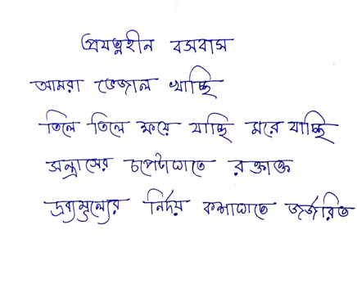
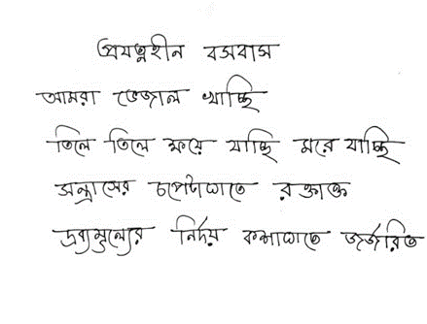
- Input image

- Applying Grayscale filter
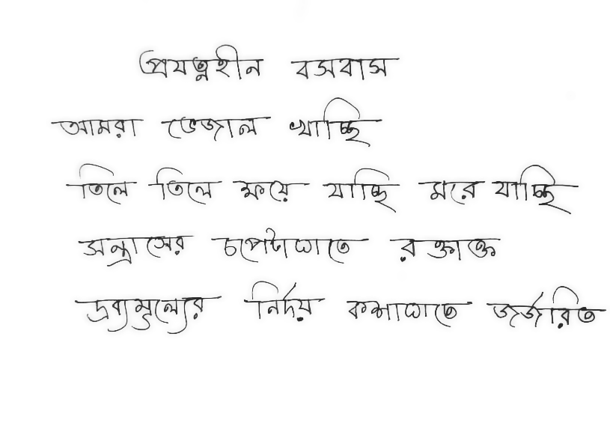
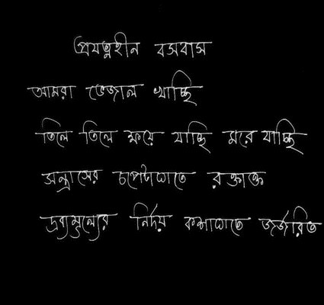
- Applying Bilateral filter

- Image Binarization
Figure 4.1: Preprocessing for Bengali handwritten script.

Printed Script Result
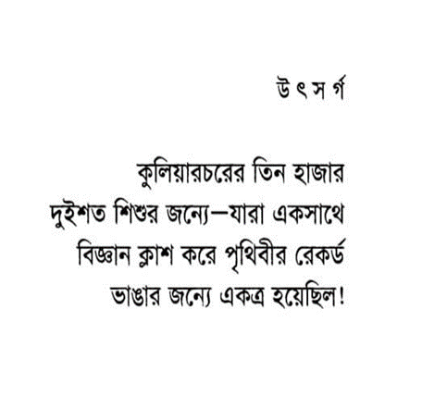
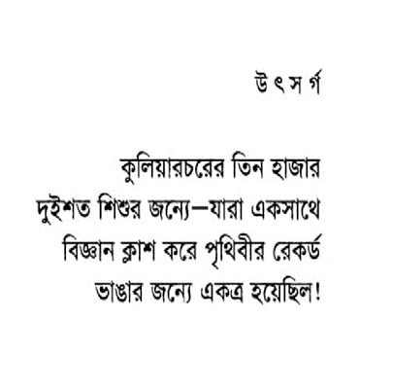
(a)Input image
(b) Applying Grayscale filter
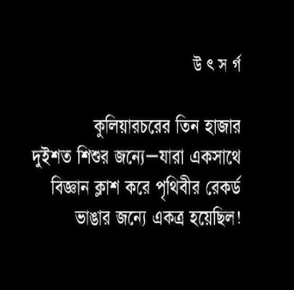
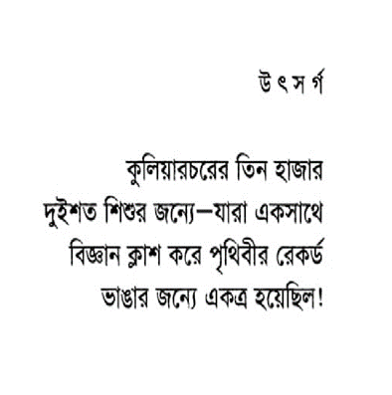
(c)Applying Bilateral filter

(d) Image Binarization

Figure 4.2: Preprocessing for Bengali printed script.
In Figure 4.1 and Figure 4.2, the preprocessing of the handwritten script and the printed script is shown. Here (a) indicates an RGB image or general image of the Bengali script as input. (b) is the result of applying the grayscale filter which turns the RGB input image into a grayscale image. Then (c) indicates the result of applying a bilateral filter which removes the noise of the image and smoothes it. The final stage of preprocessing is shown in (d), where if any skewness is present it will correct it and finally we get the binary image after image binarization, and thus the image is ready for segmentation stage.

Line Segmentation
After the preprocessing stage, the binary image will go for segmenting its line by applying the horizontal projection profile. The outputs are:

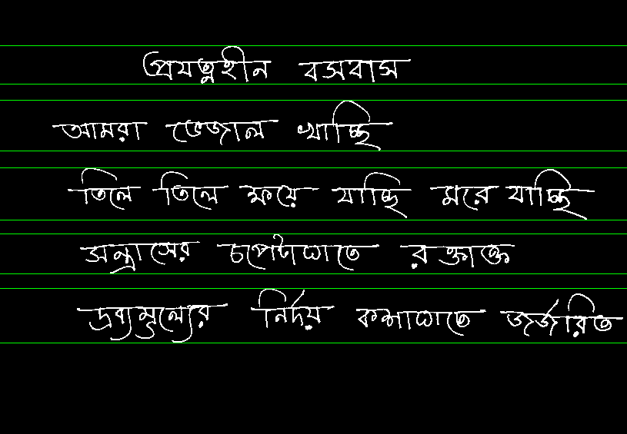
Handwritten script result

Figure 4.3: Line segmentation of Bengali handwritten script using HPP.

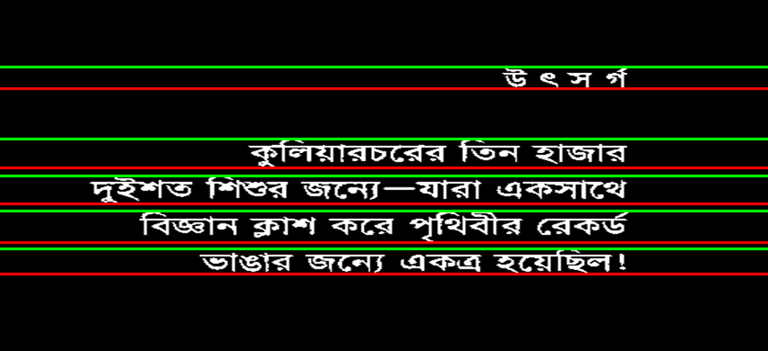
Printed Script Result

Figure 4.4: Line segmentation of Bengali Printed script using HPP.
Here for line segmentation, we used Horizontal Projection Profile (HPP). The outputs of applying HPP on the handwritten and printed script are displayed in Figure 4.3 and Figure 4.4.

Word Segmentation
After line segmentation, the image is turned into word segmentation. The outputs are:

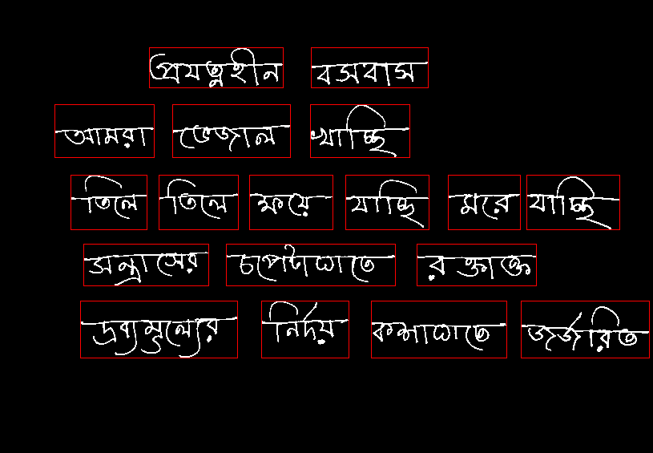
Handwritten script result

Figure 4.5: Word segmentation of handwritten Bengali script using VPP.

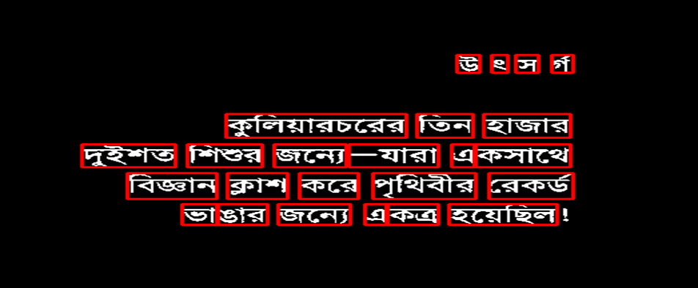
Printed Script Result

Figure 4.6: Word segmentation of printed Bengali script using VPP.
Here, for word segmentation, Vertical Projection Profile (VPP) is used. Figure 4.5 and Figure 4.6 depicts the result of applying VPP for both handwritten and printed Bengali script.

Character Segmentation
The final stage of our system is the character segmentation. The outputs are:

Character segmentation is the final step of the segmentation process. Here, Figure 4.7 and Figure 4.8 depict the result of character segmentation where for segmenting characters we used morphological opening and closing operations.

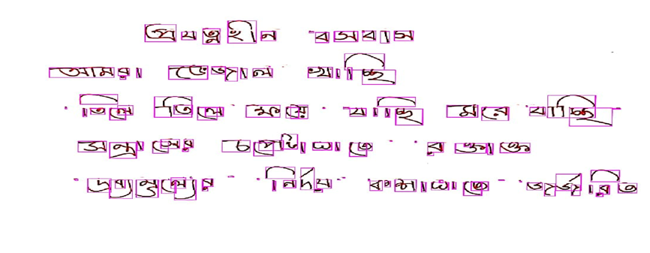
Handwritten script result
Figure 4.7: Character segmentation of handwritten Bengali script using Morphological image processing.

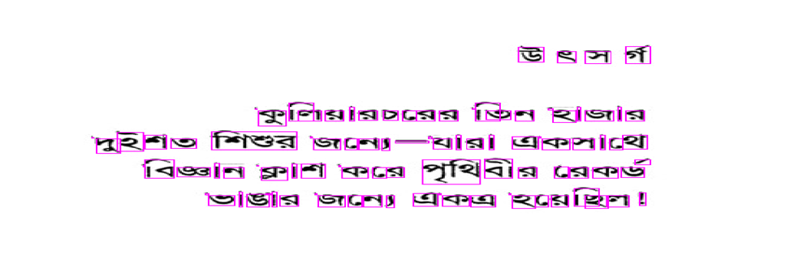
Printed Script Result
Figure 4.8: Character segmentation of printed Bengali script using Morphological image processing.

Comparing with tesseract
In Figure 4.9, we compared the result of our methodology with the result of the tesseract OCR engine. We tested several images and the result of a random image is provided. Here, we can see that the Tesseract OCR is not capable of recognizing the characters of 4th row at all. But our methodology can recognize that part.

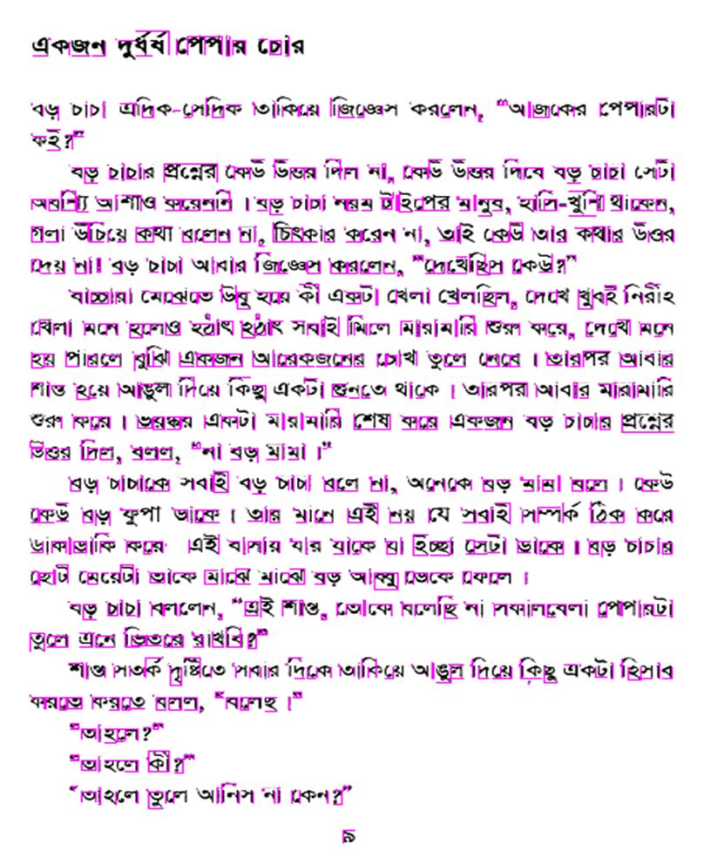
- Segmentation result from our methodology
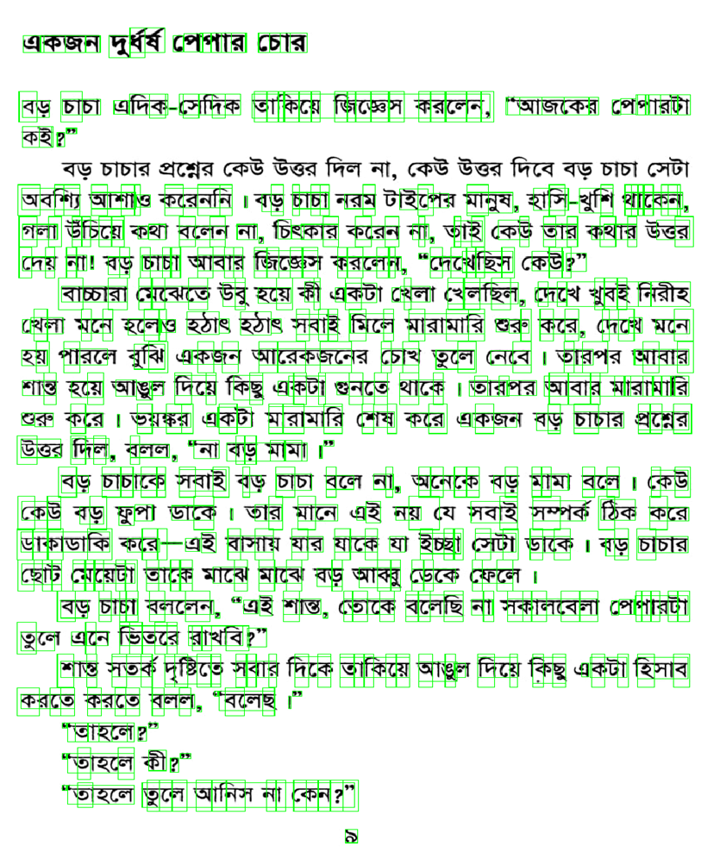
(b) segmentation result from tesseract
Figure 4.9: Comparing the result with tesseract.

Accuracy
Table 4.1: Line segmentation result.
No of image | Total number of lines | Successfully Segmented | Accuracy (%)
1 | 30 | 30 | 100
2 | 31 | 31 | 100
3 | 28 | 28 | 100
4 | 32 | 32 | 100
5 | 26 | 26 | 100
6 | 27 | 27 | 100
7 | 29 | 29 | 100
8 | 31 | 31 | 100
9 | 29 | 29 | 100
10 | 28 | 28 | 100
11 | 28 | 28 | 100
12 | 30 | 30 | 100
13 | 29 | 29 | 100
14 | 31 | 31 | 100
15 | 29 | 29 | 100
16 | 24 | 24 | 100
17 | 34 | 34 | 100
18 | 30 | 30 | 100
19 | 29 | 29 | 100
20 | 30 | 30 | 100
21 | 29 | 29 | 100
22 | 29 | 29 | 100
23 | 29 | 29 | 100
24 | 29 | 29 | 100

In table 4.1, we showed the result that we obtained from the line segmentation on 24 pages form the printed dataset.

Table 4.2: Word segmentation result.
No of Image | Total number of word | Successfully segmented | Accuracy (%)
1 | 259 | 225 | 86.87
2 | 282 | 253 | 89.72
3 | 223 | 215 | 96.41
4 | 256 | 217 | 84.77
5 | 187 | 174 | 93.05
6 | 187 | 169 | 90.37
7 | 178 | 171 | 96.07
8 | 236 | 224 | 94.92
9 | 222 | 200 | 90.09
10 | 214 | 204 | 95.33
11 | 224 | 205 | 91.52
12 | 226 | 193 | 85.40
13 | 189 | 175 | 92.59
14 | 208 | 182 | 87.5
15 | 223 | 204 | 91.48
16 | 215 | 196 | 91.16
17 | 229 | 215 | 93.89
18 | 238 | 205 | 86.13
19 | 163 | 136 | 83.44
20 | 290 | 261 | 90.00
21 | 135 | 122 | 90.37
22 | 272 | 250 | 91.91
23 | 220 | 205 | 93.18
24 | 183 | 166 | 90.71

In table 4.2, we showed the result that we obtained from the word segmentation on 24 pages form the printed dataset.

Table 4.3: Character Segmentation result.
No of Image | Total number of character | Successfully segmented | Accuracy (%)
1 | 1204 | 1115 | 92.61
2 | 1043 | 888 | 85.14
3 | 1257 | 1139 | 90.61
4 | 1079 | 951 | 88.14
5 | 1299 | 1178 | 90.69
6 | 1293 | 1006 | 77.80
7 | 1467 | 1365 | 93.05
8 | 1293 | 1187 | 91.80
9 | 1193 | 1103 | 92.46
10 | 1173 | 1063 | 90.62
11 | 1289 | 1021 | 79.20
12 | 1051 | 953 | 90.68
13 | 1139 | 1005 | 88.24
14 | 957 | 868 | 90.70
15 | 1107 | 970 | 87.62
16 | 768 | 704 | 91.67
17 | 1169 | 1090 | 93.24
18 | 1046 | 935 | 89.39
19 | 986 | 913 | 92.59
20 | 1121 | 987 | 88.05
21 | 1235 | 1119 | 90.60
22 | 1233 | 1088 | 88.24
23 | 1289 | 1134 | 87.98
24 | 1141 | 1022 | 89.57

In table 4.3, we showed the result that we obtained from the character segmentation on 24 pages form the printed dataset.

In figure 4.10 we plotted the full result of our system that we obtained from the line, word, and character segmentation on 24 pages form the printed dataset.

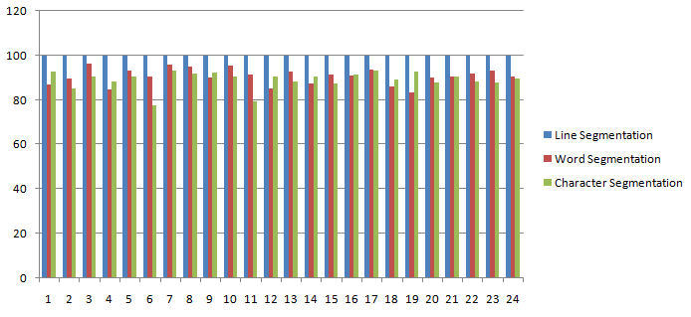

Figure 4.10: Line Segmentation, Word Segmentation and Character Segmentation of
printed script.
Table 4.4: Overall accuracy of printed script.
Types of  Segmentation | Best Accuracy  (%) | Average Accuracy  (%)
Line  Segmentation | 100 | 100
Word  Segmentation | 96.41 | 90.70
Character  Segmentation | 93.24 | 89.20

Table 4.4 shows the best accuracy and average accuracy for our input images. Our line segmentation shows 100% accuracy for all the input data. And we have got 96.41% accuracy as the best accuracy of word segmentation for input image number 3. And finally, we have got 93.24% accuracy as the best accuracy for character segmentation for input image number 17.
Table 4.5: Line Segmentation result.
No of image | Total number of lines | Successfully Segmented | Accuracy (%)
1 | 5 | 5 | 100
2 | 6 | 6 | 100
3 | 5 | 5 | 100
4 | 7 | 7 | 100
5 | 6 | 6 | 100
6 | 7 | 7 | 100
7 | 5 | 4 | 80
8 | 6 | 6 | 100
9 | 6 | 5 | 83.33
10 | 7 | 7 | 100
11 | 5 | 5 | 100
12 | 7 | 7 | 100

In table 4.5 we showed the result that we obtained from the line segmentation on 12 pages form the handwritten dataset.
Table 4.6: Word Segmentation result.
No of image | Total number of words | Successfully Segmented | Accuracy (%)
1 | 17 | 15 | 88.24
2 | 19 | 17 | 89.47
3 | 17 | 14 | 82.35
4 | 27 | 27 | 100
5 | 22 | 20 | 90.91
6 | 19 | 17 | 89.47
7 | 20 | 16 | 80.00
8 | 20 | 19 | 95.00
9 | 25 | 18 | 72.00
10 | 19 | 19 | 100
11 | 18 | 18 | 100
12 | 24 | 23 | 95.83

In table 4.6 we showed the result that we obtained from the word segmentation on 12 pages form the handwritten dataset.

Table 4.7: Character Segmentation result.
No of image | Total number of characters | Successfully Segmented | Accuracy (%)
1 | 63 | 55 | 87.30
2 | 79 | 64 | 81.01
3 | 82 | 59 | 71.95
4 | 113 | 84 | 74.34
5 | 79 | 53 | 67.09
6 | 99 | 69 | 69.70
7 | 64 | 44 | 68.75
8 | 92 | 59 | 67.05
9 | 78 | 50 | 64.11
10 | 82 | 55 | 67.07
11 | 83 | 61 | 73.49
12 | 102 | 76 | 74.51

In table 4.7 we showed the result that we obtained from the character segmentation on 12 pages form the handwritten dataset.

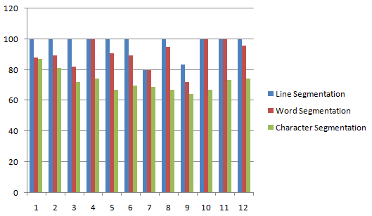

Figure 4.11: Line Segmentation, Word Segmentation and Character Segmentation of
handwritten script.

Here, in figure 4.11, we plotted the full result of our system that we obtained from the line, word, and character segmentation on 12 pages form the handwritten dataset.

Table4.8: Overall accuracy of handwritten script.
Types of  Segmentation | Best Accuracy  (%) | Average Accuracy  (%)
Line  Segmentation | 100 | 96.94
Word  Segmentation | 100 | 90.27
Character  Segmentation | 87.30 | 72.19

Table 4.8 shows the best accuracy and average accuracy for our input images. Our line segmentation shows 100% accuracy for several handwritten input data. And we have got 100% accuracy as the best accuracy of word segmentation for input image numbers 4, 10, and 11. And finally, we have got 87.30% accuracy as the best accuracy for character segmentation for input image number 1.

Summary
We have mainly focused on the segmentation procedure. For this segmentation, we use two types of Bengali script like the handwritten and printed script as input. As segmentation is the key task for building a good optical character recognition system so the main challenging processes of handwritten and printed scripts segmentation results are gradually displayed in this chapter.

Chapter 5

Discussions and Conclusions

Discussions
A methodology for the segmentation of Bengali contents has been introduced in this paper. The approach proposed from the earliest starting point of checking a text image to convert it into a binary image, noise removal, skew angle correction, line segmentation, word segmentation, and character segmentation. It is a difficult task in the character segmentation part when two characters are in some joined together. Our main motive of this work is to segment Bengali characters from the text image. To segment Bengali characters, we have performed line segmentation, word segmentation, and character segmentation. Our line segmentation works almost properly, our word segmentation also works with very little errors and our character segmentation works with some errors. This chapter contains an overview of our work and the future recommendation of this work.

Suggestion for future Work
The future possibility is to actualize the rest of the calculation and lead an extensive correlation of the different strategies as talked about in the paper. This work will give straightforwardness to analysts, researchers, and architects working with text images and give them application explicit calculation determination information to grasp the need of accomplishing quicker and effective methods to segment Bengali characters from a text image. In the future, much more work can be done with this research work.
- As a sample, more datasets need to be collected.
- We all know the Bengali script has not only basic characters but also some compound characters and modifiers. So attention should be given there.
- Future works can also be on the overlapping characters.
- The segmentation approach can be concentrated on recognition-based.

Conclusions
Segmentation is one of the most challenging tasks in the field of OCR. In our research work, we tried to perform some methodology for segmenting Bengali characters from text images. It is quite difficult to achieve 100% accuracy for line, word, and character segmentation. We have studied a lot for this purpose and learned a lot about segmentation. This field is quite interesting. We had to go through the Bengali script and had to classify them by their structure. Working with these was both difficult and interesting.
We have applied some filters as the preprocessing of this research work. After getting a preprocessed image we have applied some methodology for getting line, word, and character segmentation respectively. We have gone through many difficulties to segment the Bengali contents by their line, word, and character. Still, our work was going on and on for getting better performance. Finally, for the printed script, we have got 100% average accuracy for line segmentation, 90.70% average accuracy for word segmentation , and 89.20% average accuracy for character segmentation. And for the handwritten script, we have got 96.94% average accuracy for line segmentation, 90.27% average accuracy for word segmentation and 72.19% average accuracy for character segmentation. So the main objective of our thesis to determine the segmentation of handwritten and printed script has been done completely.

REFERENCES
- Milky Mahmud, S.M., Shahrier, N., DelowarHossain, A.S.M., TarequeMohmudChowdhury, M., Abdus Sattar, M.: “An Efficient Segmentation Scheme for the Recognition of Printed Bangla characters.” In: Proceedings of ICCIT 2003, pp. 283–286 (2003).
- T. Zahan, M.R. Selim, M.S. Rahman, M.Z. Iqbal, (2018). “Connected Component Analysis Based Two Zone Approach for Bangla Character Segmentation.” 1-4. 10.1109/ICBSLP.2018.8554684.
- B. B. Chaudhuri and U. Pal, “A Complete Printed Bangla OCRSystem,” Pattern Recognition, Vol. 31, No. 5, pp. 531—549, 1998.
- J. U. Mahmud, M. F. Raihan, and C. M. Rahman, “A complete OCR system for continuous Bengali characters,” In: Proceedings of the TENCON, 1372–1376, 2003.
- S.M. Milky Mahmud, NazibShahrier, A.S.M DelowarHossain, Md.TarequeMohmudChowdhury, and Md.Abdus Sattar, “An EfficientSegmentation Scheme for the Recognition of Printed Bangla characters,” Proceedings of ICCIT, pp 283-286, 2003.
- Md. Al Mehedi Hasan, Md. Abdul Alim, and Md. Wahedul Islam “A New Approach to Bangla Text Extraction and Recognition from Textual Image”, Proceedings of ICCIT, 2005.
- Md. Abdus Sattar, Khaled Mahmud, Humayun Arafat, and A. F. M.NoorUzZaman, “Segmenting Bangla Text for Optical Recognition,” ICCIT, 2007. ISBN: 978-1-4244-1550-2, pp. 1-6.
- AhnafFarhanRownak, Md. FazleRabby, Sabir Ismail, and Md. Saiful Islam,‘’ An Efficient Way for Segmentation of Bangla Characters in Printed Document Using Curved Scanning’’ 5th International Conference on Informatics, Electronics and Vision (ICIEV), 2016.
- U. Garain and B. B. Chaudhuri, “Segmentation of touching characters in printed Devnagari and Bangla scripts using fuzzy multifactorial analysis,” IEEE Trans. Syst. Man Cybern., Part C 32: 449–459, 2002.
- Gupta Mehula*, Patel Ankitab, Dave Namratac, GoradiaRahuld, and SaurinShethe (2014) “Text-Based Image Segmentation Methodology”, ScienceDirect: Elsevier Ltd.
- Basu, S., Sarkar, R., Das, N., Kundu, M., Nasipuri, M., Basu, D.K. (2007) “A Fuzzy Technique for Segmentation of Handwritten Bangla Word Images”, 2007 International Conference on Computing: Theory and Applications (ICCTA'07) : IEEE.
- A. Bishnu, B.B. Chaudhuri (1999) “Segmentation of Bangla handwritten text into characters by recursive contour following”, Proceedings of the Fifth International Conference on Document Analysis and Recognition. ICDAR '99: IEEE.
- Md. Al Mehedi Hasan, Md. Abdul Alim, Md. Wahedul Islam (2005) “A New Approach to Bangla Text Extraction and Recognition From Textual Image”, Proceedings of the Fifth International Conference on Document Analysis and Recognition: ICCIT.
- T. K. Bhowmik, A. Roy and U. Roy, “Character Segmentation for Handwritten Bangla Words Using Artificial Neural Network,” Proceeding of the First IAPR TC3 NNLDAR Workshop, Seoul, 2005.
- Md. MahbubAlam, Dr. M. AbulKashem (2010) 'A Complete Bangla OCR System for Printed Characters', JCIT, 01(01)
- M. Nitzberg and T. Shiota, "Nonlinear Image Filtering with Edge and Corner Enhancement" in IEEE Transactions on Pattern Analysis & Machine Intelligence, vol. 14, no. 08, pp. 826-833, 1992.doi: 10.1109/34.149593
- Vogt, P., Riitters, K.H., Estreguil, C. et al. “Mapping Spatial Patterns with Morphological Image Processing”. Landscape Ecol 22, 171–177 (2007). https://doi.org/10.1007/s10980-006-9013-2.
- https://homepages.inf.ed.ac.uk/rbf/HIPR2
- D. Christine, “Conda works with Linux, OSX, and Windows, and is language-agnostic, which allows us to use it with any programming language or even multi-language projects.”, (21 May 2015). "Conda for Data Science". Archived from the original on 16 June 2015. Retrieved 16 Jun 2015.
- Marangoni, Maurício, and Denise Stringhini. “High-Level Computer Vision Using OpenCV.” 2011 24th SIBGRAPI Conference on Graphics, Patterns, and Images Tutorials (2011): 11-24.
- M. Bauer, M. Garland. 2019. “Legate NumPy: accelerated and distributed array computing”. In Proceedings of the International Conference for High-Performance Computing, Networking, Storage and Analysis (SC ’19). Association for Computing Machinery, New York, NY, USA, Article 23, 1–23. DOI: https://doi.org/10.1145/3295500.3356175.
- J. D. Hunter, "Matplotlib: A 2D Graphics Environment," in Computing in Science & Engineering”, vol. 9, no. 3, pp. 90-95, May-June 2007, DOI: 10.1109/MCSE.2007.55.
- R.W. Smith, “The Extraction and Recognition of Text from Multimedia Document Images”, Ph.D. Thesis, University of Bristol, November 1987.

