



Lab – 03 & 04



Submitted by: Submitted to:

Aaradhya Bhatiya Alok Jhaldiyal Sir 500108359

R2142221035

Batch - B2(Graphics & Gaming)

**Lab 03: 29th August**

**IPv4 Overview**

* **IPv4**: The fourth version of the Internet Protocol, used to identify devices on a network.
* **Size**: 32-bit address (e.g., 192.168.1.1), divided into four octets (0-255).
* **Address Classes**:
  + **Class A**: 0-126 (Large networks) - Subnet Mask: 255.0.0.0
  + **Class B**: 128-191 (Medium networks) - Subnet Mask: 255.255.0.0
  + **Class C**: 192-223 (Small networks) - Subnet Mask: 255.255.255.0
  + **Class D**: 224-239 (Multicast) - Not applicable
  + **Class E**: 240-255 (Experimental) - Not applicable
* **Loopback Range**: 127.0.0.0 - 127.255.255.255 (used for testing).

**Private IP Ranges**

* **Class A**: 10.0.0.0 - 10.255.255.255
* **Class B**: 172.16.0.0 - 172.31.255.255
* **Class C**: 192.168.0.0 - 192.168.255.255
* All other addresses are public.

**Example of Private Addressing by Class**

1. **Class A**:
   * **Range**: 10.0.0.0 - 10.255.255.255
   * **Hosts per Network**: 16,777,214
   * **Usable Range**: 10.0.0.1 - 10.255.255.254
2. **Class B**:
   * **Range**: 172.16.0.0 - 172.31.255.255
   * **Hosts per Network**: 65,534
   * **Usable Range**: 172.16.0.1 - 172.31.255.254
3. **Class C**:
   * **Range**: 192.168.0.0 - 192.168.255.255
   * **Hosts per Network**: 254
   * **Usable Range**: 192.168.0.1 - 192.168.0.254

**Additional Concepts**

* **Subnetting**: Divides networks using subnet masks (e.g., Class C mask: 255.255.255.0).
* **DHCP**: Automatically assigns IP addresses and network settings.
* **IPv4 Size**: 32-bit addressing.

**Star Topology Network:**

* **Star Topology**: A network setup where all devices (e.g., PCs) connect to a central hub or switch.
* **Central Switch**: Acts as the main point for communication between devices. Each PC has a direct connection to the switch.
* **Common Usage**: Widely used in LANs because it is simple to manage and troubleshoot.

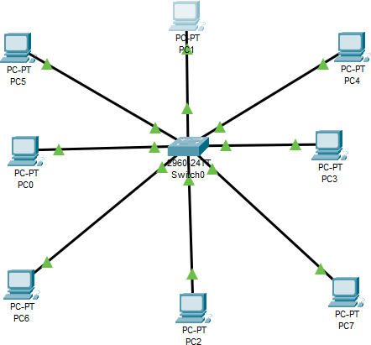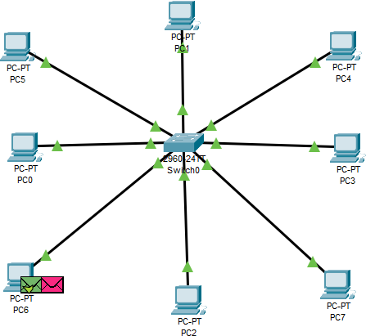

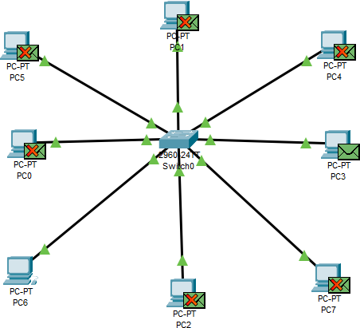



**Ethernet Frame Transmission in a Network Using a Switch:**

1. **Initial Frame Transmission**:
   * **PC0** sends an Ethernet frame to the switch (**Switch0**).
   * The frame contains the **destination MAC address** (hardware address) of **PC1**.
2. **Switch Behavior**:
   * The switch examines the **destination MAC address** in the frame.
   * If the switch does not yet know which port is associated with **PC1**, it will **flood** the frame to all connected ports except the one from which it received the frame.
   * Every connected device receives the frame, but only **PC1** recognizes its own MAC address and processes the frame. Other devices ignore it.
3. **Learning Process**:
   * When **PC1** responds, the switch learns and records which port **PC1** is connected to. This is known as **building the MAC address table**.
   * The MAC address table stores the **MAC address** and corresponding **port number** for each device on the network.
4. **Subsequent Communications**:
   * For future transmissions, the switch uses its MAC address table to **directly forward** frames to the correct port associated with **PC1**, without flooding the network.
   * This makes communication more efficient, reducing unnecessary network traffic and improving overall network performance.

By following this process, a switch efficiently manages network traffic, optimizing data flow between devices.

**Lab 04: 5th September**

***ACTIVITY:*** *Class B Subnetting for 30,000 Devices*

**Objective:**

To perform subnetting for a network that needs to accommodate 30,000 devices using Class B IP addressing and implement it on Packet Tracer.

**Network Requirements:**

* Number of Devices: 30,000
* IP Class: Class B
* Class B Subnet Mask: 255.255.0.0 (or 11111111.11111111.00000000.00000000)

**Steps for Subnetting:**

1. Identifying the Need for Subnetting:
   * The number of devices (30,000) requires more than the default Class B configuration allows without subnetting.
2. Finding the Closest Power of 2:
   * The closest power of 2 that satisfies the requirement for 30,000 devices is 2^15 = 32,768 hosts.
   * We will need 15 bits for hosts and reduce 1 bit from the available bits for subnetting.
3. Subnet Mask Calculation:
   * Default Class B subnet mask: 11111111.11111111.00000000.00000000 (/16)
   * To accommodate 30,000 devices, we reduce 1 bit for subnetting:
     + New Subnet Mask: 11111111.11111111.10000000.00000000 (or /17)
     + Subnet Mask: 255.255.128.0
4. Subnetting Calculation:
   * Number of Subnets: 2^(number of changed bits) = 2^1 = 2 subnets
   * Number of Hosts per Subnet: 2^(unchanged bits) - 2 = 2^15 - 2 = 32,766 hosts (subtracting 2 for network and broadcast addresses)

Subnets:

With the new subnet mask, we can create 2 subnets, each capable of handling up to 32,766 hosts.

* Subnet 1 (SN1):
  + Network Address: 172.168.0.0
  + Broadcast Address: 172.168.127.255
  + Usable IP Range: 172.168.0.1 to 172.168.127.254
* Subnet 2 (SN2):
  + Network Address: 172.168.128.0
  + Broadcast Address: 172.168.255.255
  + Usable IP Range: 172.168.128.1 to 172.168.255.254
  + 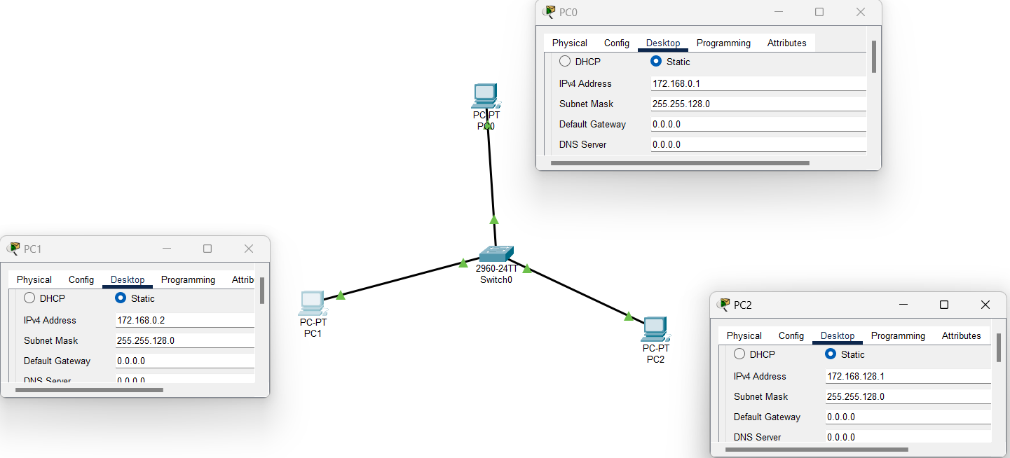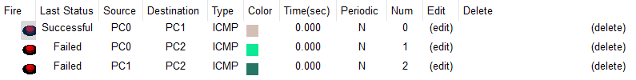Test the connectivity between devices within the same subnet and across subnets to verify the configuration.

In the network setup shown above the PCs have the following IPs:

* **PC0:** 172.168.0.1
* **PC1:** 172.168.0.2
* **PC2:** 172.168.128.1

From the ping test results:

* **PC0 to PC1** is **successful** because they are in the same subnet (Subnet 1).
* **PC0 to PC2** and **PC1 to PC2** fail because **PC2** is in a different subnet (Subnet 2), and there is no router to handle inter-subnet communication.