Minister of Education, Culture and Research of Moldova

Technical University of The Republic of Moldova

Software Engineering and Automatics

**REPORT**

Laboratory Work No.4 Software Testing

Performed by: A. Chirosca

st. gr. FAF-161

Checked by: M.Catruc

a.univ.

Chisinau 2018-2019

**Objective:**

1. Study white-box testing techniques

|  |  |  |  |
| --- | --- | --- | --- |
| Id | Description | Input(age) | Output |
| TC_SC_01 | Test case which will traverse all statements at least once. | a=4  b=5  c=6 | Print "Values contains symbols or characters" |
| TC_BC_01 | Test case which will traverse ‘No’ branch from the first decision point. | a=2  b=2  c=% | Print "Values contains symbols or characters" |
| TC_BC_02 | Test case which will traverse ‘Yes’ branch from the first decision point and No for the other. | a=-1  b=4  c=7 | Print Invalid input!" |
| TC_BC_03 | Test case which will traverse ‘Yes’ branch from the first and second decision point and No for the other. | a=2  b=2  c=10 | Print "Not a triangle" |
| TC_BC_04 | Test case which will traverse ‘Yes’ third decision point. Also it will traverse ‘No’ branches from other | a=4  b=4  c=4 | Print "Equilateral triangle!" |
| TC_BC_05 | Test case which will traverse ‘Yes’ branch from the first second third and fifth. Also it will traverse ‘No’ braches from fourth | a=4  b=4  c=6 | Print "Isoscel triangle!" |
| TC_BC_06 | Test case which will traverse ‘Yes’ branch from the first second third and sixth. Also it will traverse ‘No’ braches for fourth and fifth | a=4  b=5  c=6 | Print "Scalen triangle" |
| TC_MCC_01 | Test case which will test next possible outcomes for second decision point:  T T T T F F | a=4  b=4  c=4 | Print "Equilateral triangle!" |
| TC_MCC_02 | Test case which will test next possible outcomes for second decision point:  T T T F T T | a=4  b=4  c=6 | Print "Isoscel triangle!" |
| TC_MCC_03 | Test case which will test next possible outcomes for second decision point:  F F F F F F | a=4  b=5  c=6 | Print "Scalen triangle" |
| TC_MCC_04 | Test case which will test next possible outcomes for third decision point:  T F F F F F | 17 | Print Invalid input!" |
| TC_MCC_05 | Test case which will test next possible outcomes for third decision point:  T T F F F F | a=2  b=2  c=10 | Print "Not a triangle" |

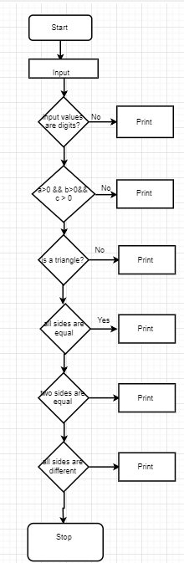 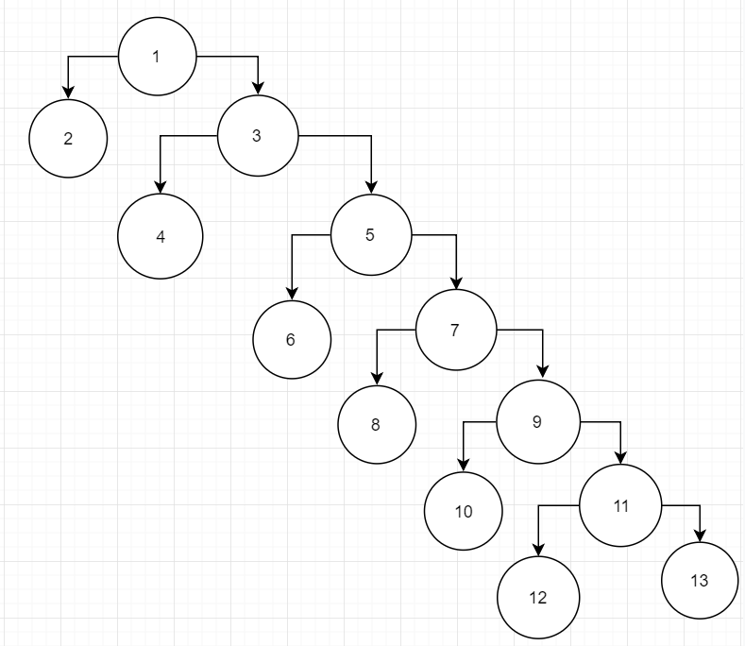

***C = E – N + 2 = 1***

*E –* the number of edges

*N –* the total number of nodes

C = 14 - 15 + 2 =1