Database:

**Database used: SQLITE**

Database Name: Library.db



Table: BOOK

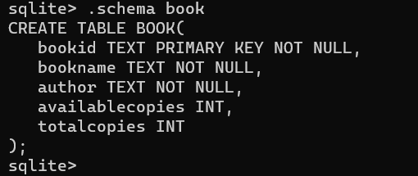

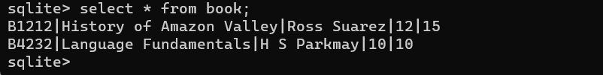

Table: SUBSCRIPTION

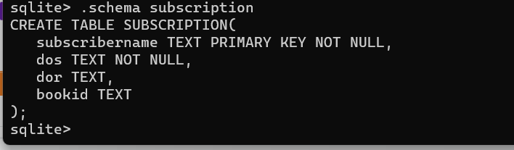

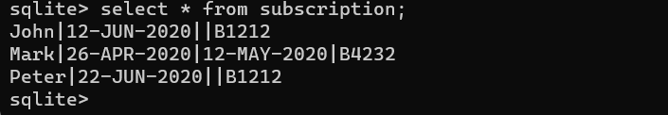

**Project: LibraryEurekaServer**

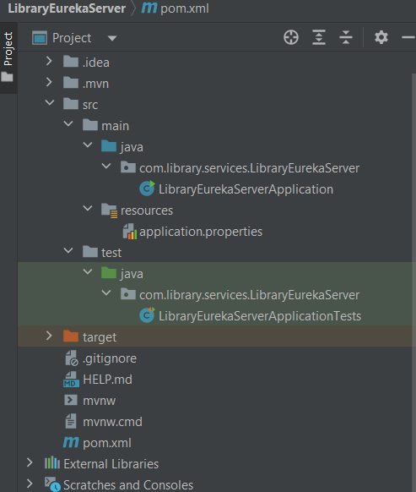

**Project: LibraryBookService**

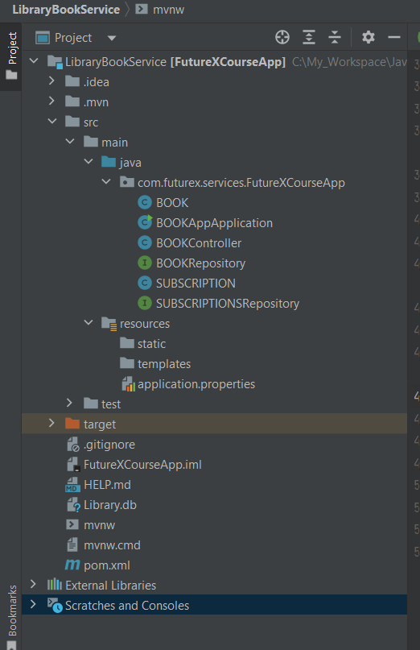

**Project: LibrarySubscriberService**

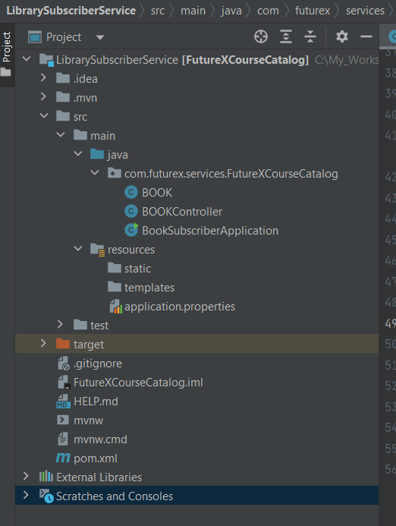

Unit Test Screenshot:

