AI STUDY ASSISTANT USING RETRIEVAL-AUGMENTED GENERATION (RAG)
A Project Report
In the partial fulfilment of the award of the degree of
B.Tech
Under
Academy of Skill Development


Submitted by:
ARINDAM SARDAR



MAULANA ABUL KALAM AZAD UNIVERSITY OF TECHNOLOGY, WB

CERTIFICATE FROM THE MENTOR
This is to certify that ARINDAM SARDAR has completed the project titled AI STUDY ASSISTANT USING RETRIEVAL-AUGMENTED GENERATION (RAG) under my supervision during the period from August to October which is in partial fulfilment of requirements for the award of the B.Tech and submitted to the Department of Information Technology of MAULANA ABUL KALAM AZAD UNIVERSITY OF TECHNOLOGY.

DATE: | Signature of the Mentor
ACKNOWLEDGMENT
I take this opportunity to express my deep gratitude and sincerest thanks to my project mentor, Mr. Mahendra Datta for giving the most valuable suggestions, helpful guidance, and encouragement in the execution of this project work.
I would like to give a special mention to my colleagues. Last but not least I am grateful to all the faculty members of the Academy of Skill Development for their support.

(Note: All entries of the proforma of approval should be filled up with appropriate and complete information of approval in any respect will be summarily rejected.)

1. Name of the Student:
ARINDAM SARDAR
2. Title of the Project : AI STUDY ASSISTANT USING RETRIEVAL-AUGMENTED GENERATION (RAG)

3.Name and Address of the Guide : Mr. Mahendra Datta.
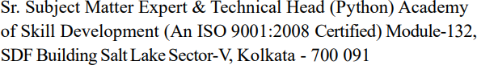

- Educational Qualification of the Guide : Ph.d* M.tech* B.E*/B.Tech * MCA* M.Sc*


- Working and Teaching experience of the Guide : …….Years
- Software used in the Project:
- VS CODE
- Python
- Ollama 3.2
- Streamlit

Signature of the Guide Date:
Name: Mr. Mahendra Datta Subject Matter Expert
Signature, Designation, Stamp of the
Project Proposal Evaluator



Abstract
Students today work with large volumes of study material: lecture slides, textbook chapters, handwritten-style notes converted to text, and PDF handouts. Finding the answer to a specific question inside these documents is slow, and general-purpose chatbots are not a reliable substitute, because they answer from their training data rather than from the student’s own syllabus and can produce confident but incorrect statements, a behaviour known as hallucination.
This project presents an AI Study Assistant built on Retrieval-Augmented Generation (RAG). The student places PDF, text, or Markdown files in a folder. The system extracts the text page by page, splits it into overlapping chunks of 800 characters, converts each chunk into a numerical vector using the all-MiniLM-L6-v2 sentence-embedding model, and stores the vectors with their source file and page number in a local ChromaDB vector database.
When the student asks a question, the question is embedded with the same model and the four most similar chunks are retrieved using cosine similarity. These chunks are placed in a prompt together with the question and sent to a large language model (LLM) that is instructed to answer only from the supplied context, to cite its sources as [1], [2], and to say so when the notes do not contain the answer. The LLM can be Claude through the Anthropic API, or a free local model such as Llama 3.1 (8B) running through Ollama, so that the complete system can work offline without an API key.
The application is written in Python and uses Streamlit for the web interface. Every answer is accompanied by an expandable Sources panel that shows the file name, page number, and the retrieved text, so the student can verify the answer against the original material. The project demonstrates that a small, low-cost, privacy-preserving RAG pipeline can run on an ordinary laptop with 16 GB of RAM and give study answers that are grounded in the user’s own documents.
Keywords: Retrieval-Augmented Generation, Large Language Model, Sentence Embeddings, Vector Database, ChromaDB, Ollama, Streamlit, Study Assistant.
Chapters page no.
Abstract
Chapter 1: Introduction | 6
Chapter 2: Related Work | 8
Chapter 3: Literature Survey | 9
Chapter 4: Methodology | 11
• Proposed Model
• Data acquisition and pre-processing
• Embedding, retrieval and answer generation
• Implementation
Chapter 5: Performance Analysis and comparison of the models | 14
Chapter 6: Application Screenshots | 15
Chapter 7: Result Analysis | 17
Chapter 8: Conclusion and Future Work | 18
Chapter 9: References | 19
Chapter 1

Introduction
A student preparing for an examination or writing a project report constantly needs to look things up in their own study material. The material is usually spread over many PDF files and notes, and a keyword search such as Ctrl+F only works when the student remembers the exact wording used by the author. A question such as “what are the main commands in the C language?” may be answered in the notes under a heading like “Basic statements and keywords”, which a keyword search would never find.
Large language models (LLMs) such as GPT, Llama, and Claude can explain concepts in natural language, but they have two weaknesses for this purpose. First, their knowledge comes from general training data and not from the student’s own syllabus. Second, they can generate plausible-sounding but wrong answers when they do not know something. Retrieval-Augmented Generation (RAG) addresses both problems by first retrieving the relevant passages from a document collection and then asking the LLM to answer using only those passages.
Retrieval-based approaches search by meaning rather than by exact words. Each passage and each question is converted into a vector of numbers (an embedding) such that texts with similar meaning have vectors that are close to each other. A vector database can then find the passages closest to a question in milliseconds.
In this project, a complete RAG-based study assistant was designed and implemented in Python. It indexes the student’s own PDF and text files, retrieves the most relevant passages for each question, and generates a clear, tutor-style answer with citations that point back to the file name and page number.

Background of Study Assistance Tools
Early study aids were printed indexes, glossaries, and later full-text search in electronic documents. Search engines improved this with ranking functions such as TF-IDF and BM25, which score documents by how often the query words appear. These methods are fast and simple, but they cannot match a question with a passage that uses different words for the same idea.
With neural language models, text can be represented as dense vectors that capture meaning. Sentence-level embedding models make it possible to compare a whole question with a whole paragraph. When combined with generative models, this gives systems that can both find and explain information. Open-weight models that run on consumer hardware, together with tools such as Ollama, now allow such systems to run entirely on a personal computer.

Importance of RAG for Studying
Retrieval-Augmented Generation is particularly suitable for study assistance. Some key advantages are:
- Answers grounded in the student’s material: the model is given the relevant passages and told to use only them, which keeps the answer aligned with the syllabus.
- Reduced hallucination: if the context does not contain the answer, the assistant is instructed to say so instead of inventing one.
- Verifiable citations: every answer lists the source file and page number, so the student can read the original text.
- No retraining required: new notes are added by copying a file and re-running the indexing script; the model itself never has to be fine-tuned.
- Privacy and low cost: with a local model, the documents never leave the computer and no paid service is required.

Problem Statement
Students cannot efficiently search large collections of study documents by meaning, and general chatbots do not know the contents of their notes and may give unreliable answers. There is a need for a simple, low-cost tool that answers questions directly from the student’s own documents, shows where the answer came from, and can run on an ordinary laptop.

Objectives
The objectives of this project are:
- To build an ingestion pipeline that reads PDF, TXT, and Markdown files and splits them into overlapping chunks with page-level metadata.
- To generate semantic embeddings for the chunks and store them in a persistent local vector database.
- To retrieve the most relevant chunks for a natural-language question using cosine similarity.
- To generate answers with an LLM that uses only the retrieved context and cites its sources.
- To provide a simple web interface using Streamlit, with a Sources panel for verification.
- To support both a cloud LLM (Claude) and a free local LLM (Llama 3.1 through Ollama), so the system can run without an API key.
Chapter 2

Related Work
The design of this project builds on several lines of earlier research and on widely used open-source tools. This chapter summarises the work that is most closely related.

Retrieval-Augmented Generation
Lewis et al. (2020) introduced Retrieval-Augmented Generation for knowledge-intensive natural language processing tasks. Their model combines a pre-trained sequence-to-sequence generator with a dense retriever that fetches passages from an external index, and they showed that this approach produces more specific and factual output than a generator alone. The same idea, in a simpler form where retrieved text is placed directly into the prompt of an LLM, is used in this project.

Dense Passage Retrieval
Karpukhin et al. (2020) showed that dense vector representations of questions and passages, learned with a dual-encoder model, can outperform traditional sparse retrieval such as BM25 for open-domain question answering. This supports the use of embeddings and nearest-neighbour search in place of keyword matching.

Sentence Embeddings
Reimers and Gurevych (2019) proposed Sentence-BERT, which adapts transformer models to produce sentence embeddings that can be compared efficiently with cosine similarity. Compact models distilled from larger transformers, such as MiniLM (Wang et al., 2020), keep much of the quality at a fraction of the size. The all-MiniLM-L6-v2 model used in this project belongs to this family and is small enough to run on a CPU.

Vector Databases
Vector databases store embeddings together with metadata and support approximate nearest-neighbour search. ChromaDB is an open-source embedded vector database that can persist data on local disk and is easy to use from Python, which makes it a good fit for a single-user study tool. Other widely used options include FAISS, Pinecone, Weaviate, and Qdrant.

Open-Weight and Cloud LLMs
Meta’s Llama family of open-weight models (Touvron et al., 2023, and later releases) can be downloaded and run locally. Ollama packages such models and exposes them through a simple local API and Python library. Cloud models such as Claude are accessed through an API and are generally stronger, but require an API key and usage-based payment. This project supports both so that the user can choose between quality and cost or privacy.

Frameworks and Existing Tools
Frameworks such as LangChain and LlamaIndex provide ready-made components for RAG pipelines. In this project the pipeline is written directly with a few small Python modules, which keeps the code short and makes each stage (extract, chunk, embed, store, retrieve, generate) easy to understand and explain.
Chapter 3

Literature Survey

Traditional Methods for Searching Study Material
The simplest method is exact keyword search. It is fast but brittle: synonyms, paraphrases, and spelling differences cause relevant passages to be missed. Ranking functions such as TF-IDF and BM25 weight terms by their frequency and rarity and give better ordering of results, but they still depend on word overlap between the query and the text.

Large Language Models and Hallucination
Large language models produce fluent answers by predicting the next token, and they store knowledge only implicitly in their parameters. When a question falls outside what they learned, or concerns a private document, they may still produce an answer that sounds correct but is not. Providing relevant source text in the prompt is a practical way to reduce this problem, because the model can copy and rephrase facts from the context rather than recalling them.

Retrieval-Augmented Generation Pipelines
A typical RAG pipeline has an offline indexing stage and an online query stage. In the indexing stage, documents are loaded, cleaned, split into chunks, embedded, and stored. In the query stage, the user question is embedded, the top-k most similar chunks are retrieved, a prompt is assembled, and the LLM generates the answer. Important design choices are the chunk size, the amount of overlap, the embedding model, the number of retrieved chunks (k), and the instructions given to the LLM.
Chunking
Chunks that are too small lose context, and chunks that are too large dilute the meaning and waste the LLM’s context window. A fixed window with some overlap, as used here (800 characters with 150 characters overlap), is a common and simple baseline. More advanced strategies split by paragraph, heading, or sentence boundary.
Similarity Measures
Cosine similarity compares the angle between two vectors and is the usual choice for text embeddings. For two vectors A and B it is computed as (A · B) / (‖A‖ ‖B‖). Values close to 1 indicate very similar meaning. This project configures the ChromaDB collection to use cosine distance.
Local versus Cloud Language Models
Cloud LLMs give the best answer quality and need no local hardware, but require internet access, an API key, and payment, and they send the retrieved text to an external server. Local models avoid these issues but are smaller and slower on a typical laptop. The table below summarises the main approaches discussed in the literature and in practice.
Table 1: Comparison of approaches to answering questions from study material
Approach | Strengths | Limitations
Keyword search (Ctrl+F) | Instant; no setup; exact matches | Misses synonyms and paraphrases; no explanation
TF-IDF / BM25 ranking | Good ranking by term importance; no GPU or model needed | Still depends on shared words; returns passages, not answers
General chatbot (no retrieval) | Fluent explanations; broad knowledge | Not aware of the student’s notes; may hallucinate
RAG with cloud LLM | Grounded answers; best language quality | Needs internet, API key, and payment; data leaves the device
RAG with local LLM (this project) | Grounded, private, free after download; works offline | Smaller models; slower on CPU; needs 8–16 GB RAM

Summary of the Survey
The survey shows that dense retrieval with compact embedding models, combined with an instruction-following LLM, is a well-established way to answer questions from a private document set. The remaining engineering decisions are about simplicity, cost, and privacy, which this project addresses by using only open-source components and an optional local LLM.
Chapter 4

Methodology

4.1 Proposed Model
The proposed system has two phases. In the indexing phase (ingest.py), the documents in the data folder are read, split into overlapping chunks, embedded, and stored in ChromaDB. In the query phase (app.py and rag.py), the student’s question is embedded, the most similar chunks are retrieved, and an LLM generates a grounded answer that is shown with its sources. Figure 1 shows the overall architecture.
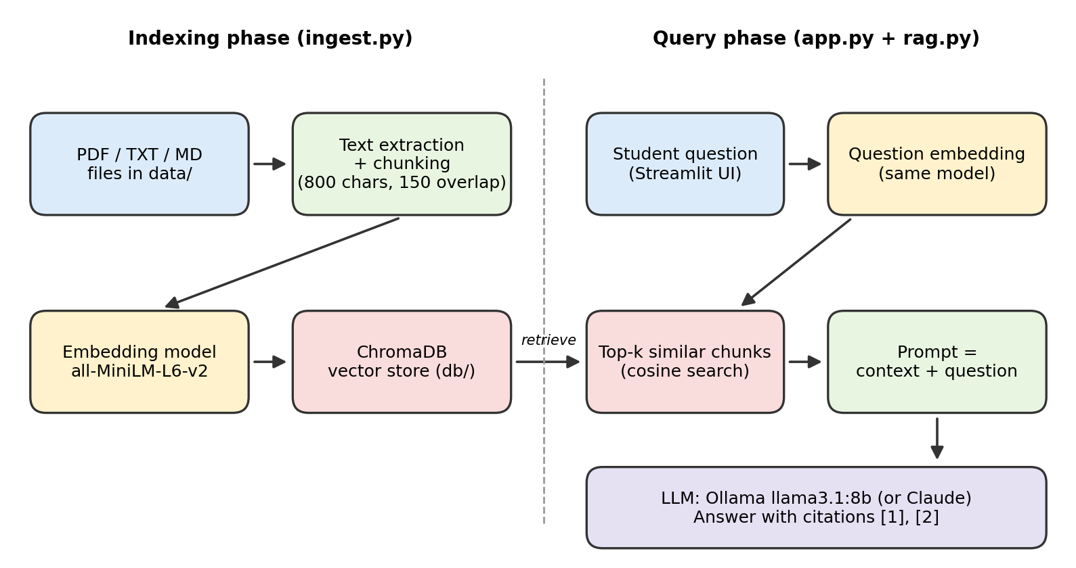
Figure 1: Architecture of the AI Study Assistant

4.2 Data Acquisition and Pre-processing
Data acquisition
The input data are the student’s own study files placed in the data folder. The supported formats are PDF (.pdf), plain text (.txt), and Markdown (.md). No external dataset is used. PDFs must contain a text layer; scanned image-only PDFs have no extractable text and must first be processed with OCR.
Text extraction
PDF files are read with the pypdf library, page by page, so that every extracted text block keeps its page number. Text and Markdown files are read as UTF-8 and treated as a single page. Pages that return no text are skipped.
Chunking
Each page’s text is divided into windows of 800 characters, and each new window starts 650 characters after the previous one, giving an overlap of 150 characters. The overlap prevents a sentence or definition that falls on a boundary from being cut in two and lost. Empty chunks are removed. Each chunk is given a unique ID in the form filename-page-chunkNumber and metadata containing the source file name and page number.
CHUNK_SIZE, OVERLAP = 800, 150

def chunk(text: str):
step = CHUNK_SIZE - OVERLAP
pieces = (text[i:i + CHUNK_SIZE] for i in range(0, len(text), step))
return [p for p in pieces if p.strip()]

Listing 1: Chunking function (ingest.py)

4.3 Embedding and Vector Storage
Every chunk is converted to a 384-dimensional vector using the all-MiniLM-L6-v2 model from the Sentence-Transformers library. The model is about 90 MB, runs on a CPU, and is downloaded automatically the first time the indexer runs. The vectors, the chunk text, and the metadata are stored in a persistent ChromaDB collection named “notes” in the local db folder, configured with cosine distance. The upsert operation is used, so running the indexer again updates existing chunks instead of duplicating them.

4.4 Retrieval
At question time, the question is embedded with the same model, and ChromaDB returns the k most similar chunks (k = 4 by default). Each hit keeps its text, source file, and page number. Using the same embedding model for indexing and querying is essential, because vectors from different models are not comparable.

4.5 Answer Generation
The retrieved chunks are numbered [1] to [4] and joined into a context block, which is sent to the LLM with the question. A system prompt controls the behaviour of the model: it must answer only from the context, cite sources with the bracketed numbers, explain clearly like a tutor, and state that it cannot find the answer when the context does not contain it. The answer and the list of hits are returned to the interface.
SYSTEM = (
"You are a study assistant. Answer ONLY using the provided context. "
"Cite sources like [1], [2]. If the context doesn't contain the answer, "
"say you can't find it in the notes. Explain clearly, as a tutor would."
)

def answer(question: str, k: int = 4):
hits = retrieve(question, k)
context = "\n\n".join(
f"[{i+1}] ({h['source']}, p.{h['page']})\n{h['text']}"
for i, h in enumerate(hits)
)
resp = ollama.chat(model=MODEL, messages=[
{"role": "system", "content": SYSTEM},
{"role": "user", "content": f"Context:\n{context}\n\nQuestion: {question}"},
])
return resp["message"]["content"], hits

Listing 2: Retrieval-augmented answer function (rag.py, Ollama version)
Two LLM back ends were implemented. The first calls Claude through the Anthropic API and needs an API key in the ANTHROPIC_API_KEY environment variable. The second calls a local model through Ollama and needs no key. Only the few lines that call the model differ; retrieval and prompting are identical.

4.6 User Interface
The interface is a Streamlit web page (app.py). It has a title, a text box for the question, a spinner while the answer is generated, the answer rendered as Markdown, and an expandable Sources panel. The panel lists each source as “[n] file name (p. page)” with the first 300 characters of the retrieved text, so the student can check the answer.

4.7 Implementation Details
Table 2: Project files and their roles
File / Folder | Purpose
data/ | Folder where the student places PDF, TXT, and MD study files
ingest.py | Reads files, chunks text, creates embeddings, and stores them in ChromaDB
rag.py | Retrieval (retrieve) and answer generation (answer) using the LLM
app.py | Streamlit user interface
db/ | Persistent ChromaDB vector store created automatically
requirements.txt | List of Python dependencies

Table 3: Software and hardware used
Item | Details
Programming language | Python 3.10 or later
Editor / environment | Visual Studio Code with a Python virtual environment (.venv)
Libraries | chromadb, sentence-transformers, pypdf, streamlit, ollama (optional: anthropic)
Embedding model | all-MiniLM-L6-v2 (384 dimensions)
LLM (local) | Llama 3.1 8B (or Llama 3.2 3B) served by Ollama
LLM (cloud, optional) | Claude through the Anthropic API
Hardware | Windows laptop, 16 GB RAM; an NVIDIA GPU is optional and speeds up answers

How to run
python -m venv .venv
.venv\Scripts\activate
pip install -r requirements.txt
pip install ollama
ollama pull llama3.1:8b
python ingest.py
streamlit run app.py

Chapter 5

Performance Analysis and Comparison of the Models
The retrieval stage (embedding model plus vector database) is the same for every configuration, so the main difference in performance comes from the LLM that writes the answer and from the retrieval settings. This chapter compares the model options that were considered for the project.

5.1 Comparison of Language Models
Table 4: Comparison of LLM options (approximate, general characteristics)
Option | Size / location | Needs internet and API key | Typical hardware | Cost
Llama 3.2 (3B) via Ollama | About 2 GB, local | No (after download) | 8 GB RAM is enough | Free
Llama 3.1 (8B) via Ollama | About 4.7 GB, local | No (after download) | 16 GB RAM recommended | Free
Claude via Anthropic API | Cloud-hosted | Yes | Any computer | Pay per use

In general, the larger model follows instructions such as “answer only from the context” and “cite sources” more reliably and explains concepts more clearly than the smaller one. The smaller model responds faster and uses less memory. The cloud model gives the highest quality and speed but cannot be used offline. For a laptop with 16 GB of RAM, Llama 3.1 (8B) was chosen as the default local model.

5.2 Effect of Retrieval Settings
Table 5: Effect of key retrieval parameters
Parameter | If too small | If too large
Chunk size (800 characters) | Chunks lose context; definitions are split | Chunks mix topics; retrieval is less precise
Overlap (150 characters) | Sentences at boundaries can be cut | More duplicate chunks and larger index
Top-k (4 chunks) | Answer may miss needed information | Prompt grows; irrelevant text can confuse the model

Chapter 6

6.3 Application Screenshots
The following screenshots were taken from the working application running on a Windows laptop with the Llama model served locally by Ollama. The study document used for testing was a lecture PDF on C programming (“Lecture 2 C- Programing.pdf”).
Step 1: Indexing the PDF
Running python ingest.py inside the virtual environment loads the embedding model, reads the PDF, and stores its chunks in ChromaDB. The terminal reports the number of chunks indexed (13 chunks for the test PDF).
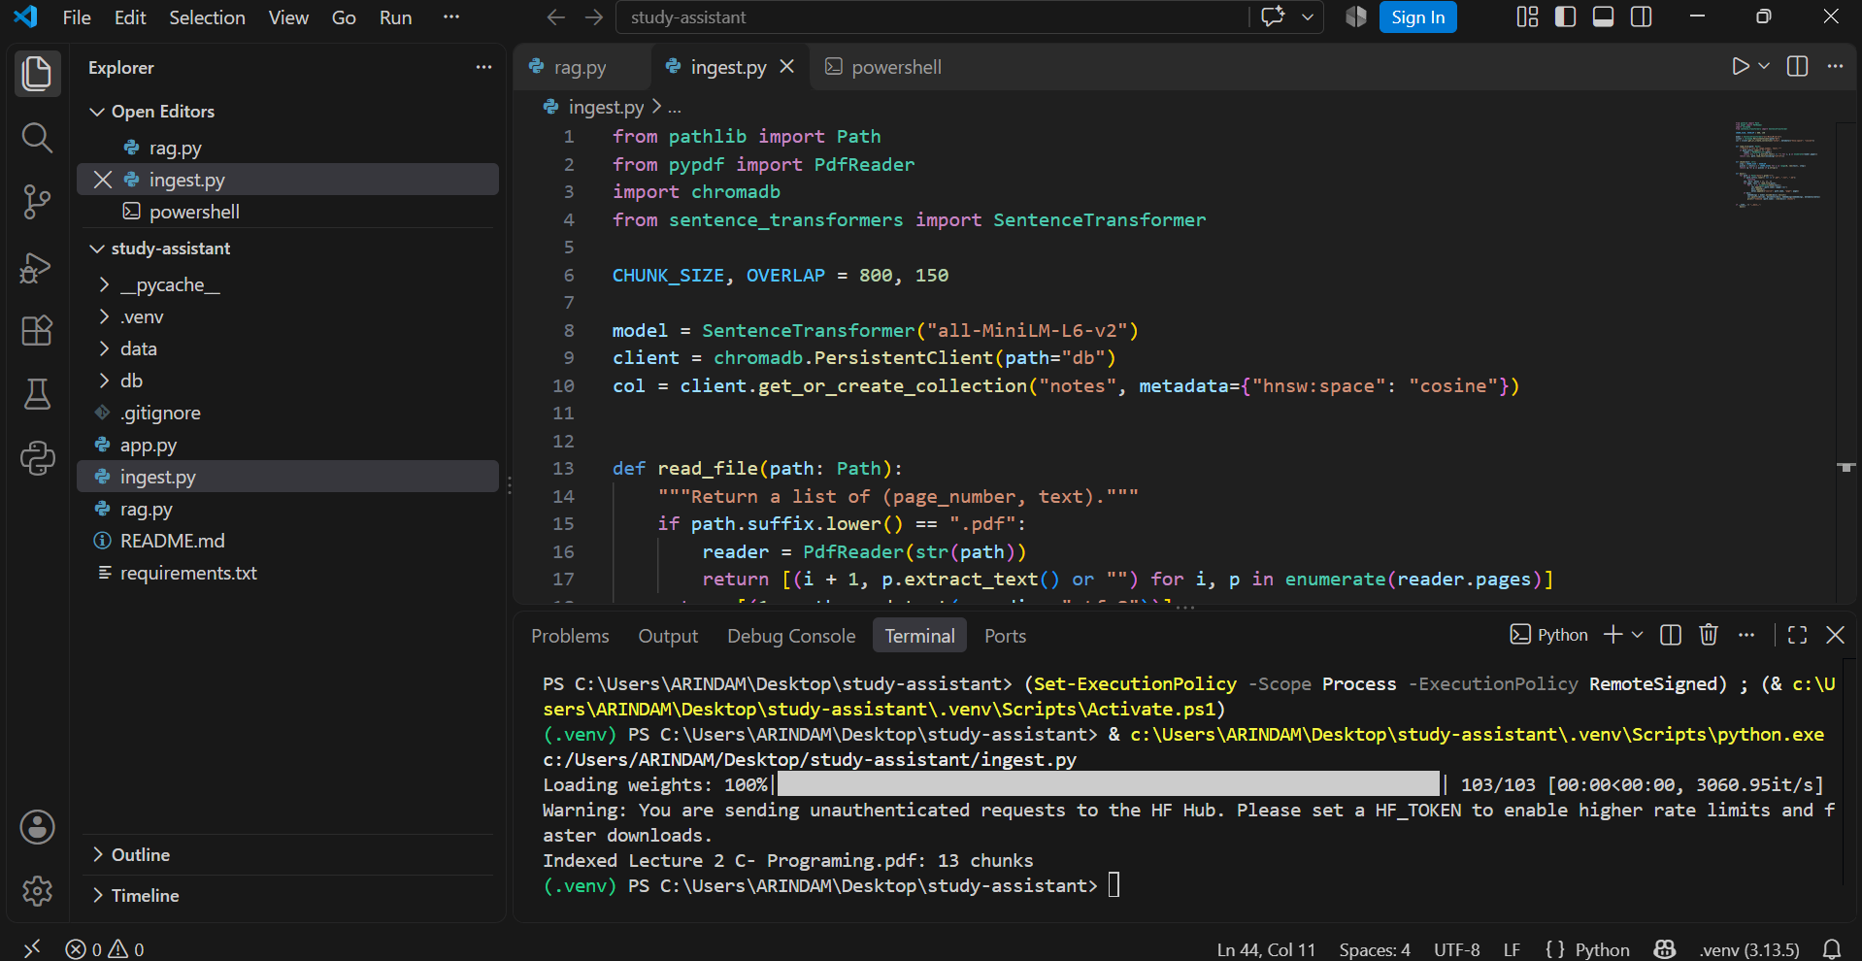
Figure 2: Indexing the study PDF with ingest.py (13 chunks indexed)
Step 2: Asking a question
The student types a question into the Streamlit page. In this test the question contained a spelling mistake (“Prinf()” instead of “printf()”). Because retrieval works on meaning rather than exact words, the assistant still found the correct passages and answered from them, citing the file name and page number.
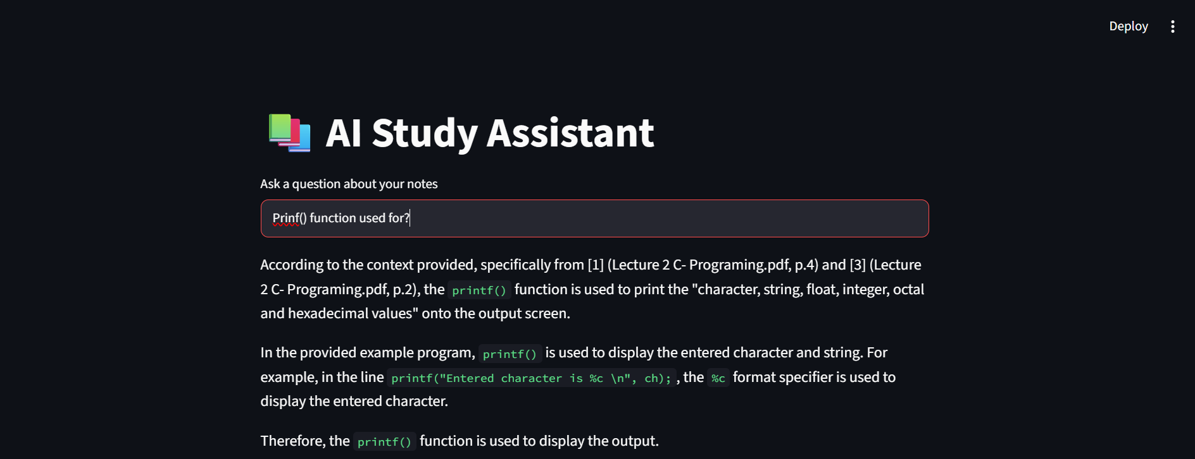
Figure 3: Answer to a question with a spelling mistake, with citations [1] and [3]
Step 3: Checking the sources
Expanding the Sources panel shows exactly which chunks were retrieved, with the file name, page number, and the beginning of each chunk. This lets the student verify the answer against the original notes.
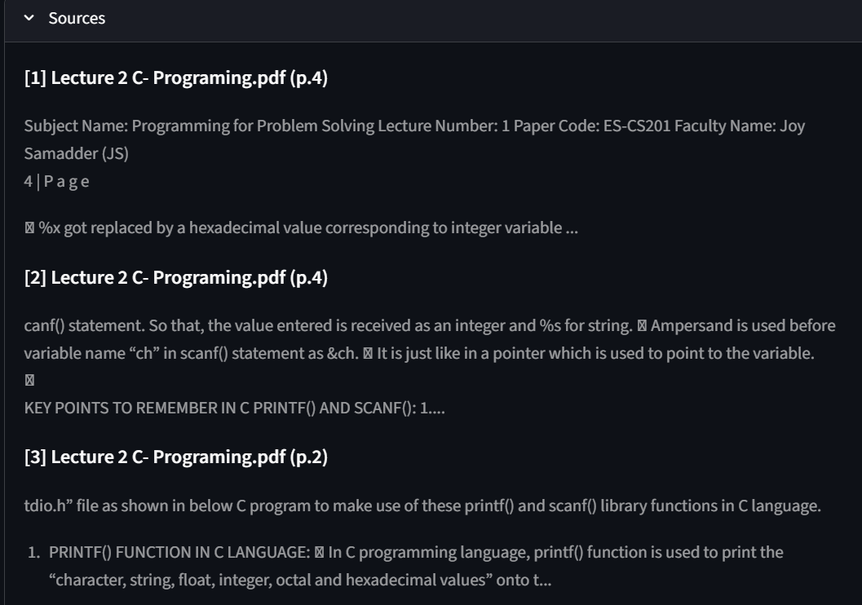
Figure 4: Sources panel showing the retrieved chunks and their page numbers
Step 4: Another question
The same question typed correctly gives a structured answer that lists the value types handled by printf() and cites page 2 of the PDF. The Sources panel is collapsed by default and can be expanded on demand.
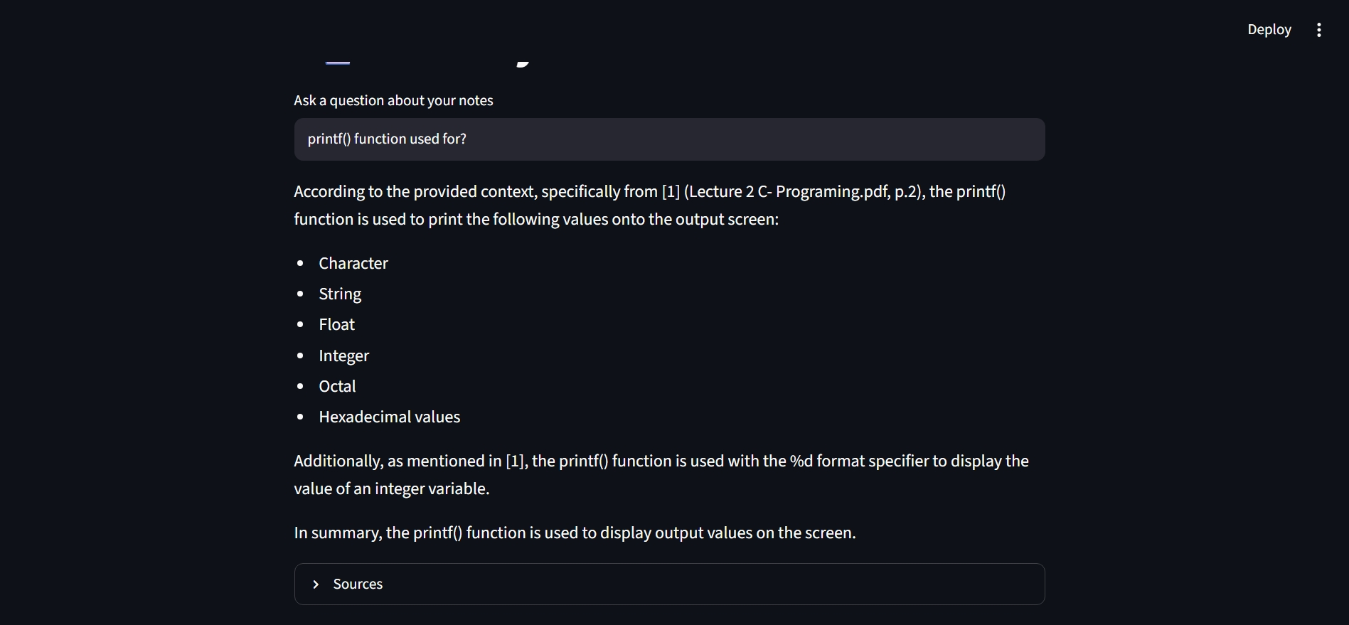
Figure 5: Answer to the corrected question

Chapter 7

Result Analysis
This chapter discusses what the design and the development work showed about the behaviour of the system.

7.1 Observations
- Retrieval quality depends on the document text. Text-based PDFs index well. Scanned PDFs produce no text and therefore zero chunks, so no answers can be found until OCR is applied.
- Question wording matters less than in keyword search, because matching is by meaning, but questions on topics that the documents do not cover correctly lead to the “cannot find it in the notes” reply.
- The instruction prompt is important. Telling the model to use only the context and to cite sources makes answers verifiable, and the Sources panel lets the student check them.
- Model size affects answer quality. The 8B model is expected to follow the prompt rules more reliably than the 3B model, at the cost of more memory and time.

7.2 Challenges Faced and Solutions
Table 8: Problems encountered and how they were solved
Problem | Solution
Authentication error from the Claude API (no API key found) | Set the ANTHROPIC_API_KEY environment variable in the same terminal that runs Streamlit, or switch to the local Ollama version which needs no key
ModuleNotFoundError: No module named ‘ollama’ | Activate the .venv and run pip install ollama; start the app with streamlit run app.py in that terminal
Ollama error: model ‘llama3.2’ not found (404) | Download the model with ollama pull, and make sure the MODEL name in rag.py matches the name shown by ollama list
Slow first answer | The model is loaded into memory on the first request; later answers are faster. A smaller model or a GPU can also help
Old data remaining after deleting a file | Delete the db folder and run python ingest.py again

7.3 Limitations
- Only text is indexed; images, diagrams, tables stored as images, and handwriting are not understood.
- Fixed-size chunking can still split a topic across chunks.
- Small local models can occasionally ignore the instruction to use only the context.
- The system answers single questions and does not yet remember earlier turns of the conversation.
Chapter 8

Conclusion and Future Work

Conclusion
This project designed and implemented an AI Study Assistant that uses Retrieval-Augmented Generation to answer questions from a student’s own PDF and text documents. The system extracts and chunks the documents, embeds them with all-MiniLM-L6-v2, stores them in ChromaDB, retrieves the most relevant chunks for each question, and uses an LLM to write a tutor-style answer with citations. By supporting both Claude and a local Llama model through Ollama, it can run either with a cloud API or fully offline on a laptop with 16 GB of RAM.
The project shows that a useful, verifiable study tool can be built from a few small Python files and open-source components, and that grounding the model in retrieved text, combined with an explicit instruction to refuse when the notes lack the answer, is an effective way to reduce hallucination.

Future Work
- Quiz and flashcard mode: retrieve chunks on a topic and generate multiple-choice questions or flashcards.
- Conversation memory: keep previous turns in the session so that follow-up questions work.
- File upload in the interface: let the student upload documents and index them from the web page.
- Better chunking: split by headings, paragraphs, or sentences instead of fixed character windows.
- Hybrid search and re-ranking: combine keyword (BM25) and vector search and re-rank the results.
- OCR support: extract text from scanned PDFs and images automatically.
- Automatic evaluation: build a test set and measure retrieval and faithfulness scores regularly.
Chapter 9

References
- Lewis, P., Perez, E., Piktus, A., et al. (2020). Retrieval-Augmented Generation for Knowledge-Intensive NLP Tasks. Advances in Neural Information Processing Systems (NeurIPS) 33.
- Karpukhin, V., Oguz, B., Min, S., et al. (2020). Dense Passage Retrieval for Open-Domain Question Answering. Proceedings of EMNLP 2020.
- Reimers, N., and Gurevych, I. (2019). Sentence-BERT: Sentence Embeddings using Siamese BERT-Networks. Proceedings of EMNLP-IJCNLP 2019.
- Wang, W., Wei, F., Dong, L., et al. (2020). MiniLM: Deep Self-Attention Distillation for Task-Agnostic Compression of Pre-Trained Transformers. NeurIPS 33.
- Touvron, H., Lavril, T., Izacard, G., et al. (2023). LLaMA: Open and Efficient Foundation Language Models. arXiv:2302.13971.
- Sentence-Transformers documentation, https://www.sbert.net
- ChromaDB documentation, https://docs.trychroma.com
- Ollama documentation, https://ollama.com
- Streamlit documentation, https://docs.streamlit.io
- Anthropic documentation, https://docs.anthropic.com
- pypdf documentation, https://pypdf.readthedocs.io

