LAB ASSIGNMENT :-2
Date :-19/01/2026

Name : Arindam Jana
RollNo:UG/02/BTCSECSF/2023/002
RegNo: AU/2023/0009020
Sction: “E”

Q1. Make a schema first and then insert 6 documents. • Roll_no=[1,2,3,4,5,] • Name=["Ram","Alex","John","Bob","Mukesh",”Danny”] • Age=[20,19,40,55,30,28] • Salary=[546.7,333.4,666.7,678.4,245.6,546.3] • City=["A","B","C","D","E",”F”] • Phone_no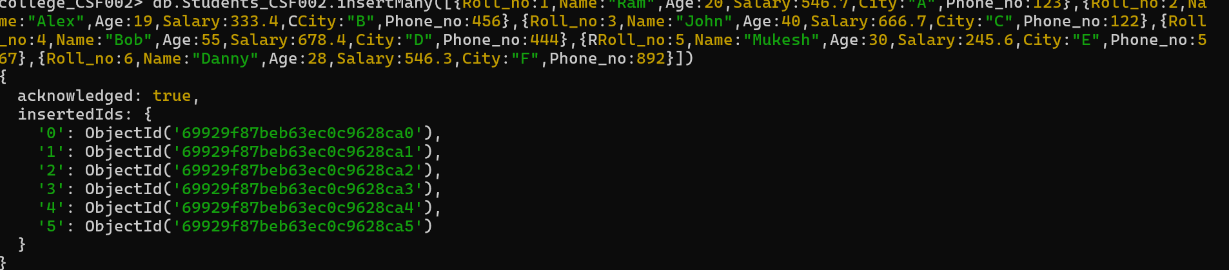=[123,456,122,444,567,892]
Q2. Write a query to update the name of RAM to SAM.
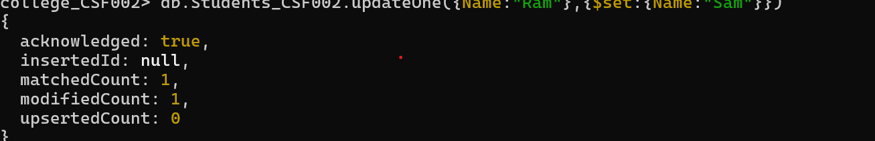Q3. Write a query to display only the cities present in that collection.
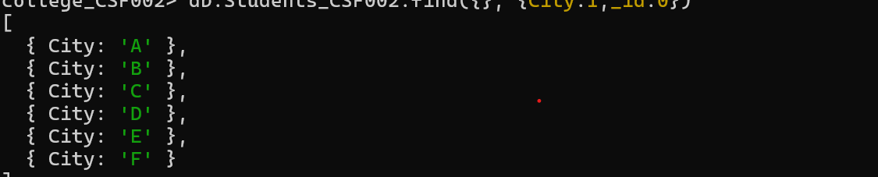Q4. Write a query to update the salary by 10%.
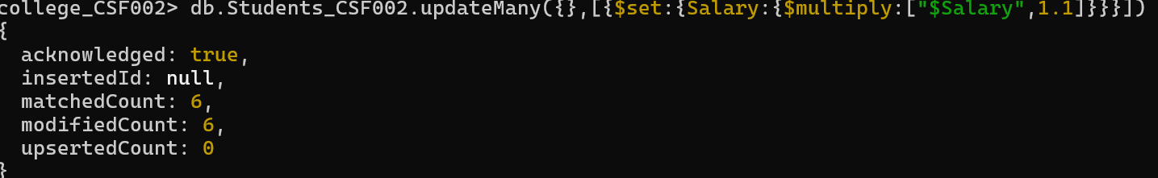
Q5. Write a query to display all the documents in ascending and descending order of age.
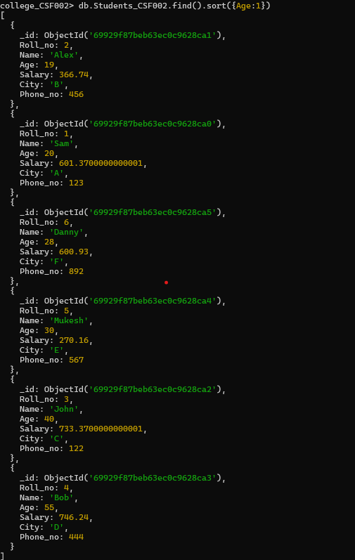
Q6. Write a query to display all the documents with City → A,B,C

.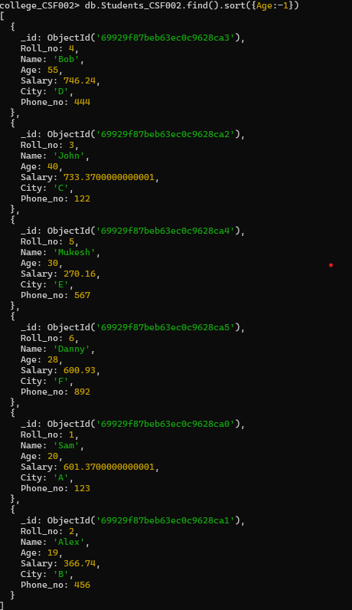
Q7. Write a query to display only two documents from the entire collection.
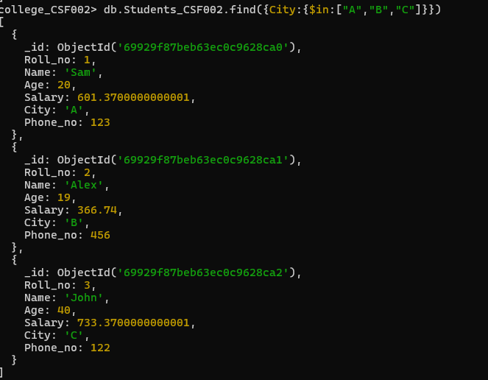
Q8. Write a query to delete a document with ROLL_NO:5.
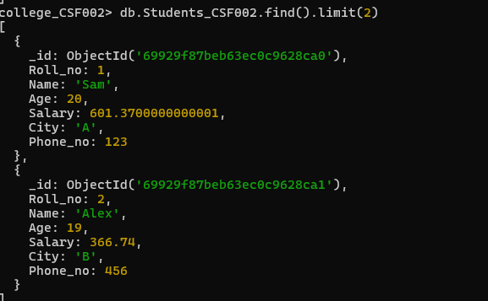
Q9. Write a query to display all the documents with AGE greater than 20.
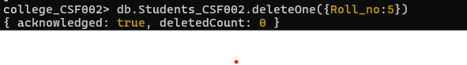
Q10. Write a query to display all the documents with AGE less than 20.
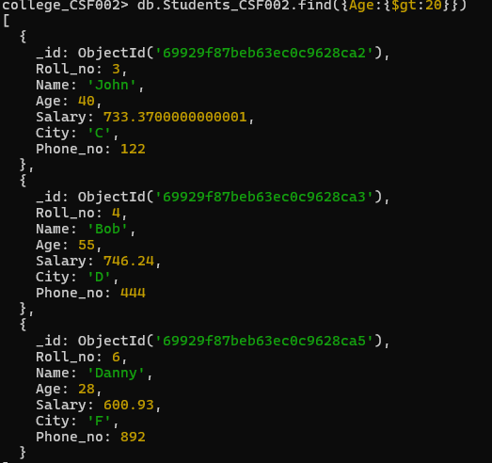
Q11. Write a query to display all the documents with AGE equals to 20.
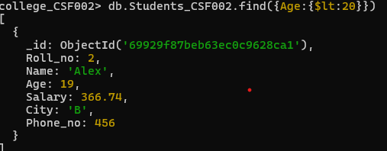
Q12. Write a query to display all the documents with AGE not equals to 20.
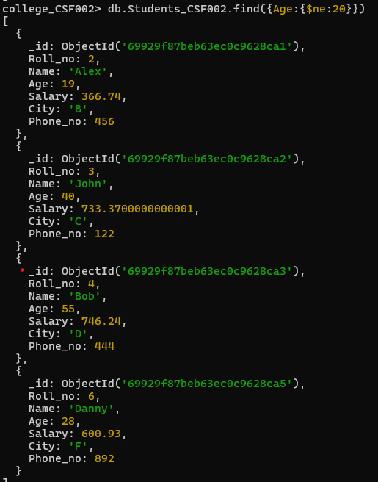
Q13. Write a query to display all the documents where AGE is greater than equals to 30.

