**ROBOTRON**

# HARDWARE DESIGN INFORMATION:

The Chassis is made up of MDF provided, two wheels at the rear end are connected to the motors fitted at the bottom of the Chassis, and one castor wheel is used in the front end. Arduino and motor controller are fixed on the top where the ultrasonic sensors are also fitted, and these are connected using the breadboard also fitted on the top; the battery and the battery holder are fitted at the bottom of the Chassis at the rear end of the whole setup, all the components are connected using wires, and the two ultrasonic sensors are placed at an obtuse angle such that they can detect the obstacle at any angle and move accordingly. The sensors are attached to two pieces of cardboard stuck to the MDF Chassis Board. Arduino UNO, Motor Driver and sensors are connected using male-male and male-female jumper cables. Then the modified C++ code was uploaded to the Arduino. Finally, the rover was ready to test.

Parts List:

1. Arduino UNO

2. MDF Chassis Board

3. DC Motor

4. Motor Driver

5. Castor Wheel

6. AA Battery

7. AA Cell Holder

8. Bluetooth Module

9. Male-to-Male Jumper Cable

10. Arduino Cable

11. Wheel

12. Arduino Cable

13. Sensors

14. Breadboard

15. Cardboard

16. Nuts and Bolts

# Assembly, Setup, and Calibration Instructions

Motors are connected to the motor controller, Arduino controls all the necessary action, which is connected to the motor controller and thus provides necessary information to operate it also the ultra sonic sensors feeds the information to the Arduino; all of this are connected via wires.

This robot is calliberated such that whenever the robots detects an obstacle it would try to make a turn trying to avoid the obstacle thus making it the implacable for solving maze.

# Observation:

The rover moves forward initially and when an obstacle comes in front of one of the sensors it will accordingly change its direction. If the left sensor detects the obstacle first the rover will start moving in the right direction and vice-versa. At whatever angle the wall is to the rover, it will either move in the right or left direction based on which sensor detects first.

# Failed attempt records:

1. Motor Driver was not working so we had to replace it with the new one.
2. The jumper cables were not assembled in a proper manner. Hence the rover was not even moving.
3. Only one sensor was used initially so it did not detect the obstacle with a certain angle.
4. Then the two sensors were not placed at a proper angle so it did not worked.
5. While testing on a temporary maze, our first five attempts failed. The wheels were not co-ordinating well.

# Photos:

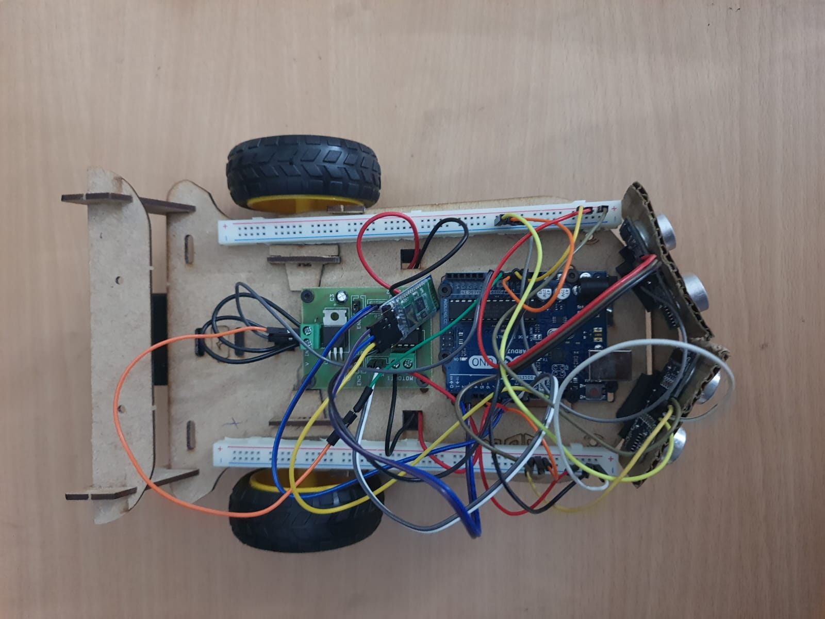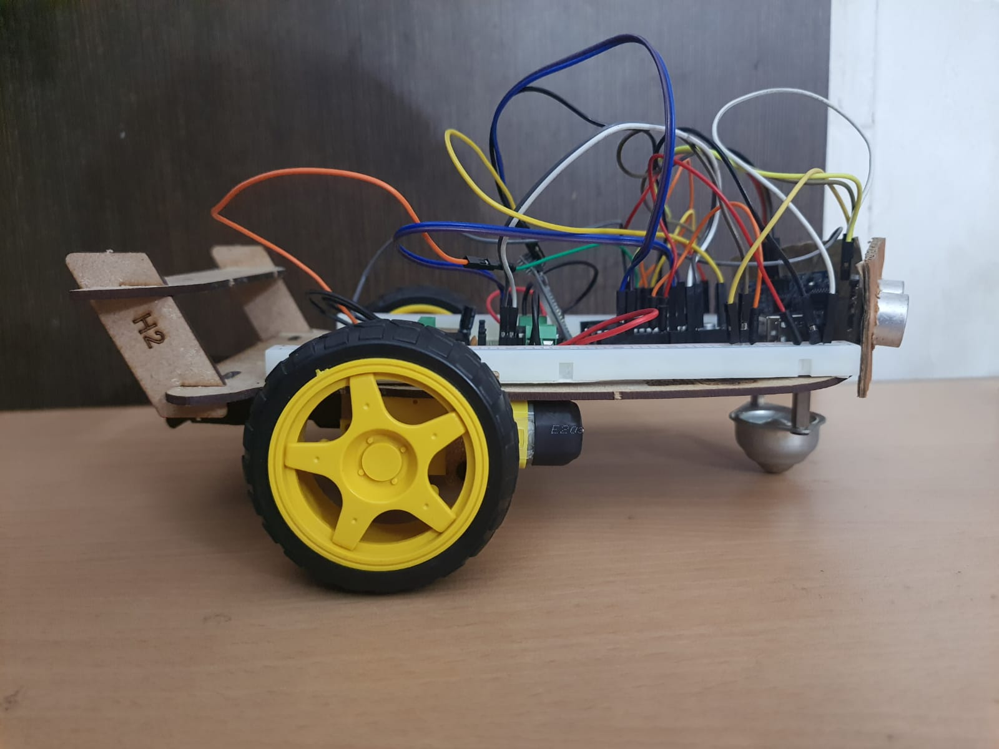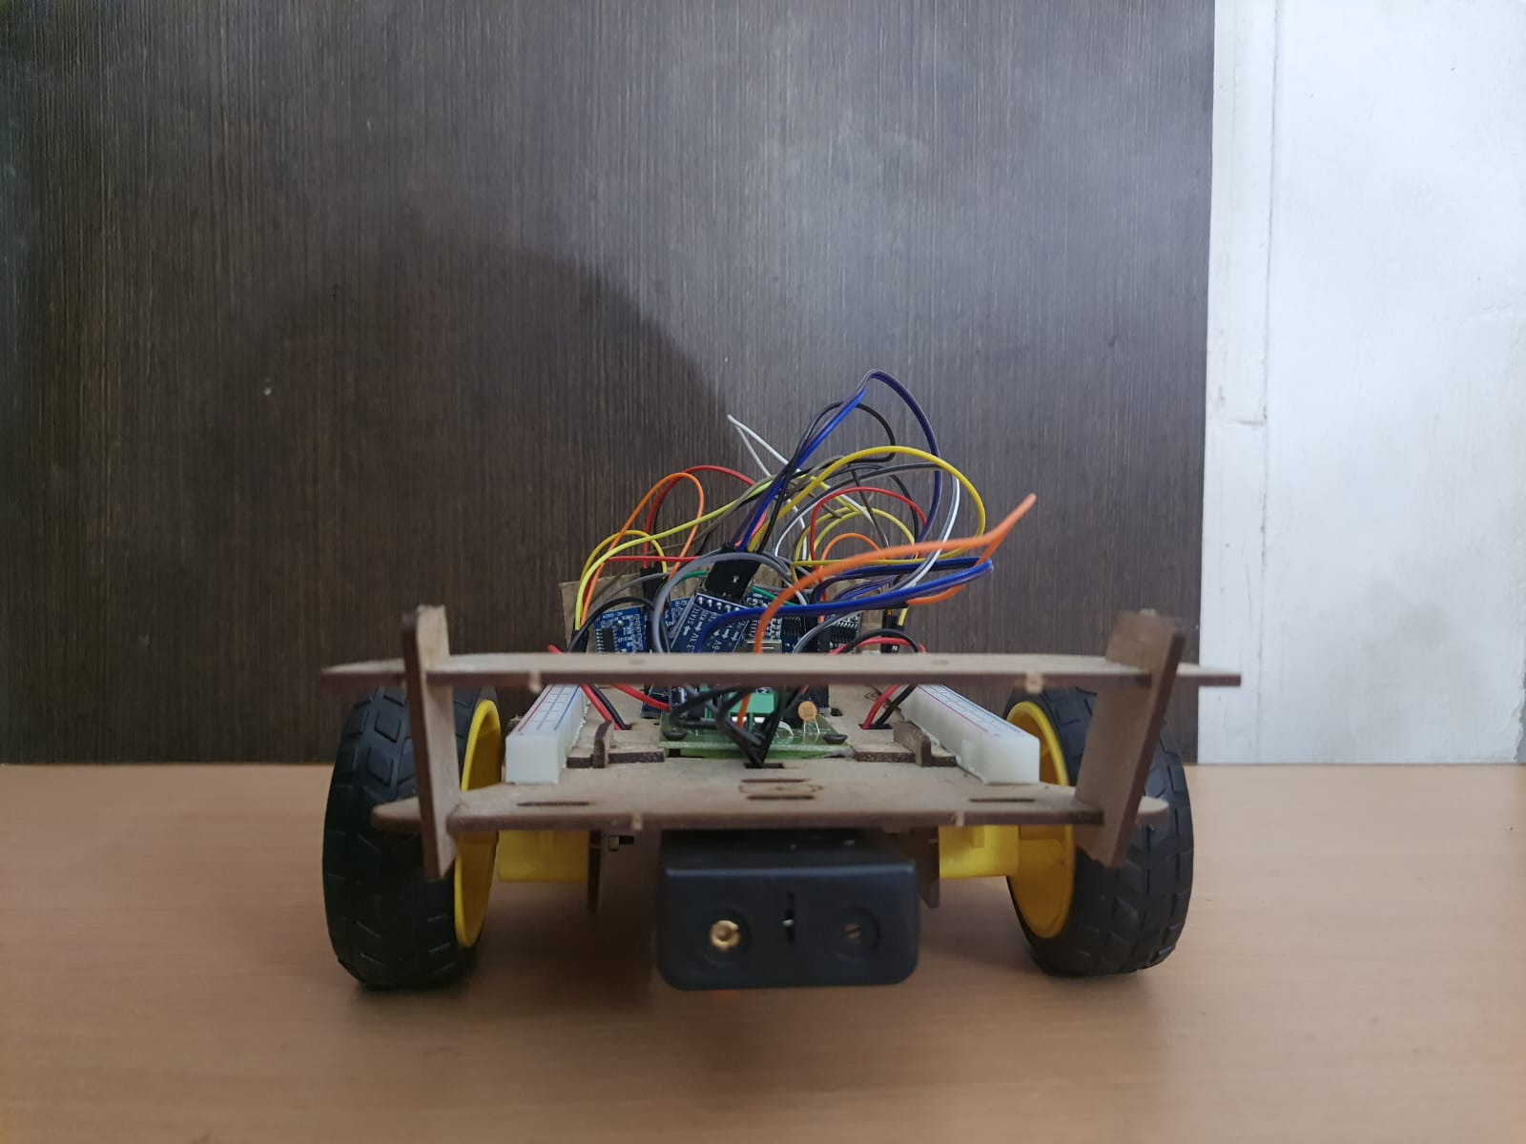

# Credits:

# Manuel and rest is our own idea.

# 