**ASSIGNMENT –1: Flowchart and Algorithm**

1. Write an algorithm to determine the maximum of three numbers. Also draw the corresponding flow chart.

Algorithm:

Step 1: Input three numbers A, B, C

Step 2: Check if A is greater than B.

Step 3: If True, check whether A is greater than C. If True, then Print A is the largest number.

Step 4: If False, check if B is greater than C. If True, then Print B is the largest number.

Step 5: If C is greater than both A and B, then Print C is the largest number.

Flowchart:

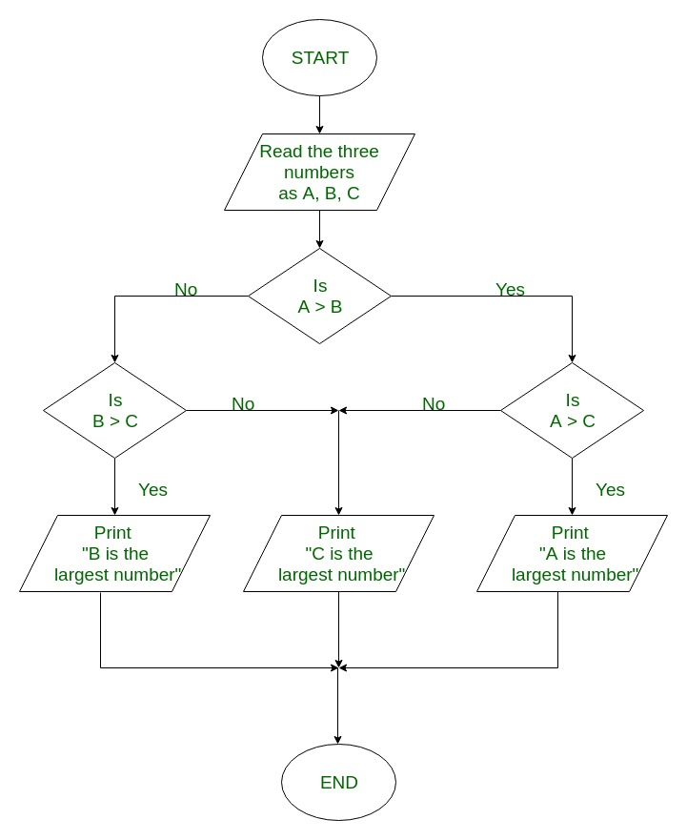

1. Write an algorithm to determine the sum of individual digits of a given integer. Also draw the corresponding flowchart.

Algorithm:

Step 1: Input the number in n

Step 2: Sum = 0

Step 3: Check if n is greater than 0. If no, Print Sum.

Step 4: If yes, sum=sum+(n%10)

Step 5: n=n/10 and then Goto Step 3

Flowchart:

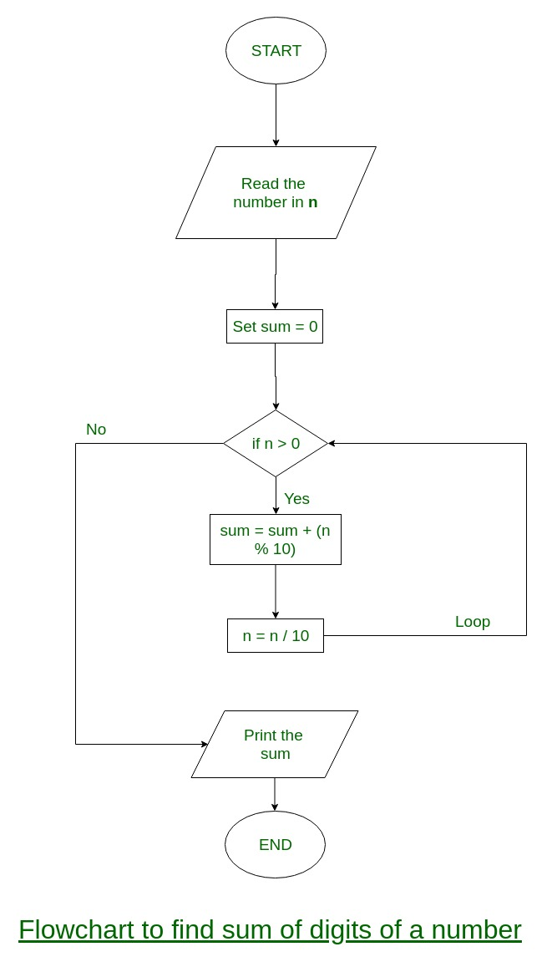

1. Write an algorithm to print the reverse of a number read as input. Also draw the corresponding flow chart

Algorithm:

Step 1: Input the number in n

Step 2: Rev = 0

Step 3: Check if n is greater than 0, if no Print reverse number stored in rev

Step 4: if yes, rev = rev*10 + n%10

Step 5: n=n/10, then Goto Step 3

Flowchart:

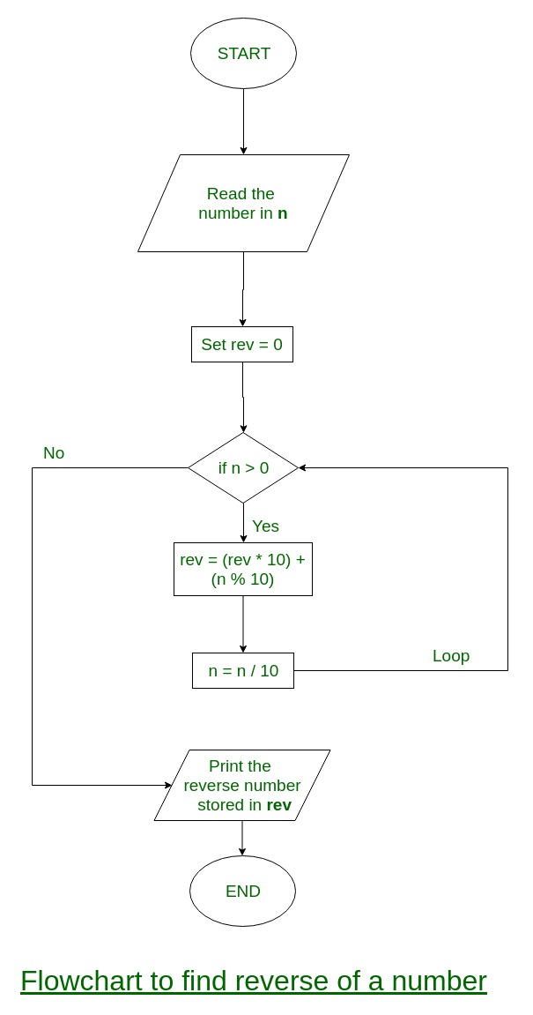

1. Write an algorithm to determine whether a given number is prime or not. Also draw the corresponding flowchart.

Algorithm:

Step 1: Input a number n

Step 2: Check if n is an integer, if no, then it is not prime

Step 3: Check if n is positive, if no, then it is not prime

Step 4: Initiate i=2

Step 5: Check if i is greater than or equal to n. if Yes, then it is a prime number

Step 6: If no, divide n by i

Step 7: Check if the division returns a remainder. If No, then it is not a prime

Step 8: If yes, i=i+1, then Goto Step 5

Flowchart:

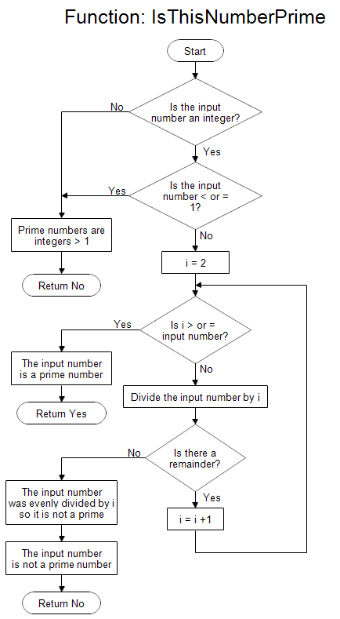

1. Write an algorithm to generate the first 100 prime numbers. Also draw the corresponding flow chart.

Algorithm:

Step 1: Initiate count =0 and i=2

Step 2: Check if i is prime, if yes Print I, if no Goto Step 5

Step 3: count =count+1

Step 4: Check if count =100, if Yes then STOP

Step 5: If no, i=i+1 Goto Step 2

Flowchart:

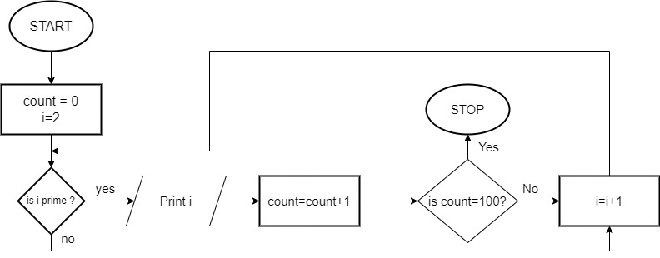

1. Draw a flowchart to input three numbers in the variables a, b and c and hence to find the roots of the quadratic equation ax 2 + bx + c = 0. Consider carefully the zero input values of the coefficients a, b and c.

Algorithm:

Step 1: Input the coefficients of the quadratic expressions as a,b,c

Step 2: Check if a = 0, STOP

Step 3: Calculate D= sqrt(b*b – 4*a*c)

Step 4: Check if D>0, if false, Check if d=0, if no, then the roots are imaginary

Step 5: If D=0, r1= -b/(2*a) and r2 = -b(2*a)

Step 6: if D>0, r1= ((-b+D)/(2*a)) and r2=((-b-D)/(2*a))

Step 7: Print r1 and r2

Flowchart:

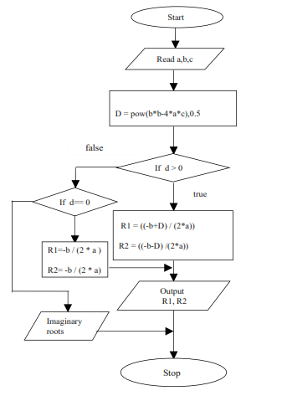

yes

Is a = 0