**Company – Siemens**

**Indicator – RSI 14 close**

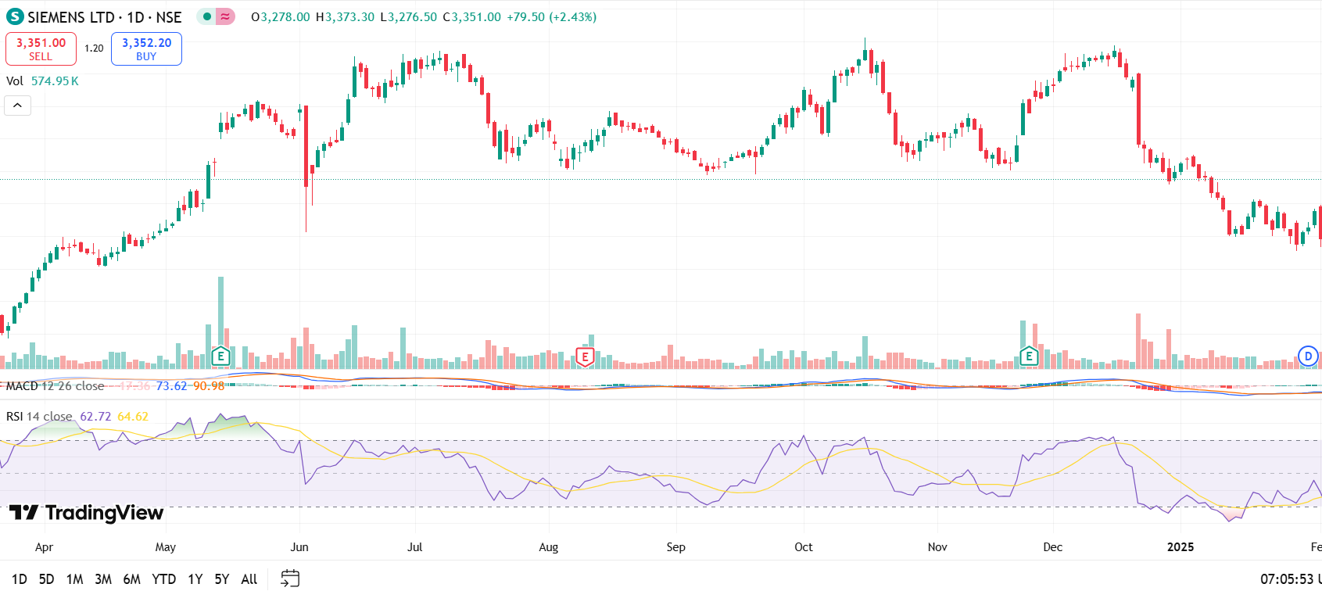

Analysis- Applying RSI as learned in theory works very well over here as well

Strategy –

If RSI breaks the 70 barrier for 1-2 days continuously, expect it to grow due to momentum, hence buy

If it backs down from the 70 mark, expect a fall in price

Similar analysis for RSI less than 30 but we don’t see RSI falling below 30 much

**Indicator – MACD -12-26 with Signal**

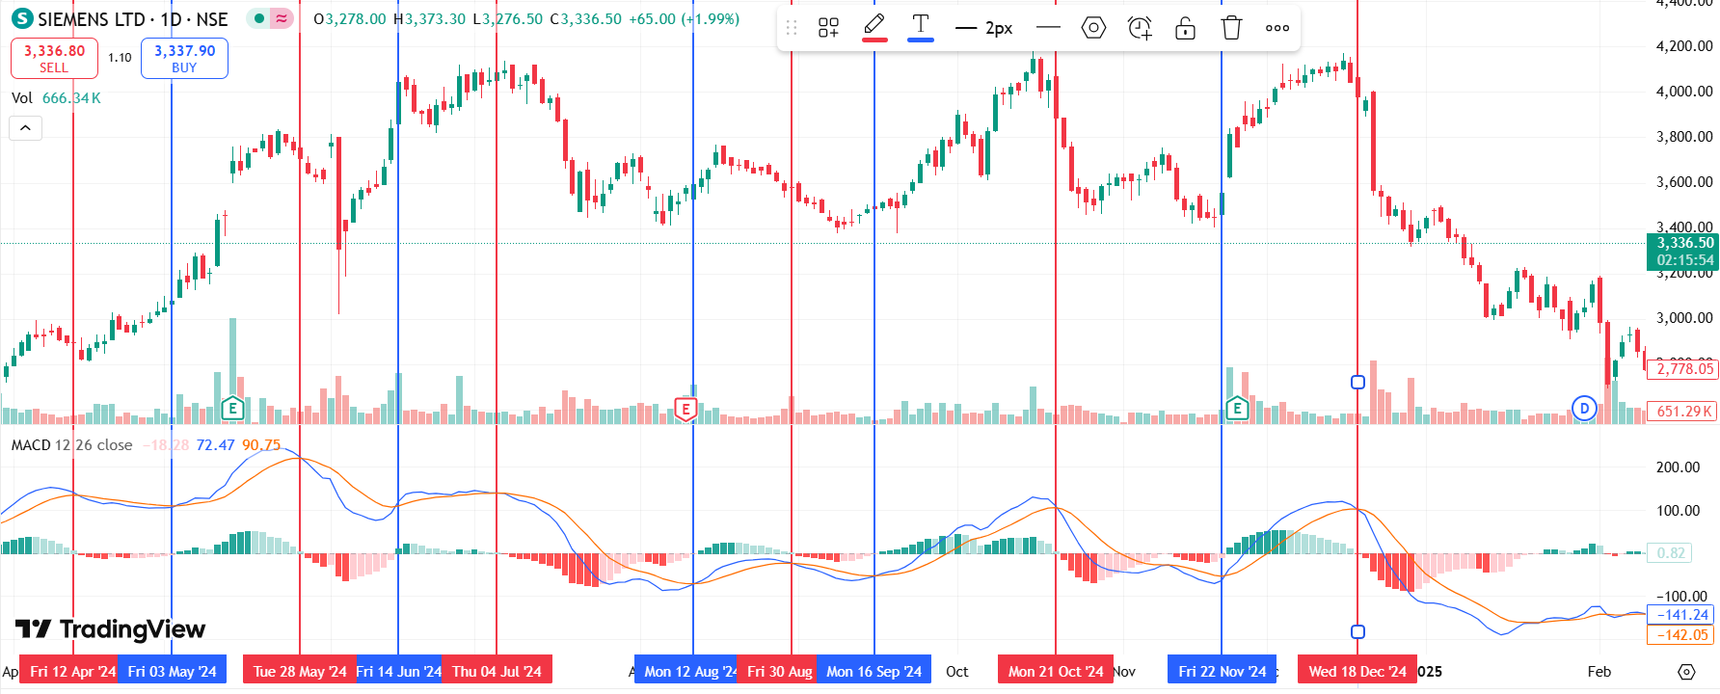

Red vertical line = sell/short ; blue = buy

Analysis – MACD shows good results 7/11 times, which is fairly good

Strategy –

1. The sentiment is bullish when the MACD line crosses the EMA wherein MACD line is greater than the EMA. When this happens, the trader should look at buying opportunities.
2. The sentiment is bearish when the MACD line crosses below the EMA wherein the MACD line is lesser than the EMA. When this happens, the trader should look at selling opportunities.

Bollinger Bands

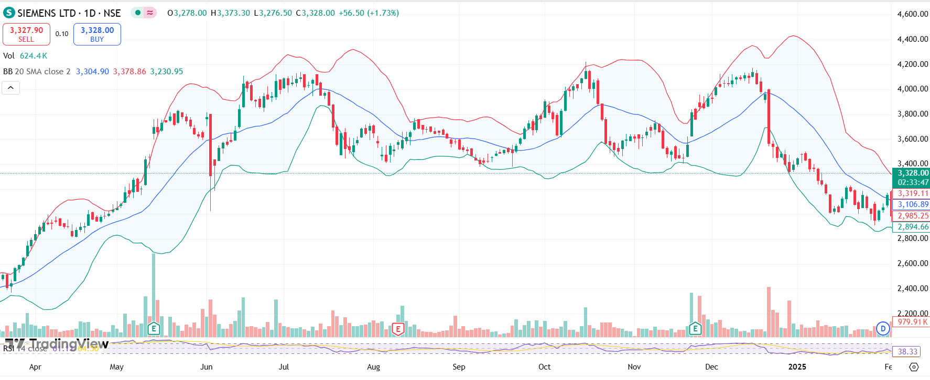

Analysis -- Seems to fail a lot as the stock was rarely stable, there was always an uptrend and sometimes strong downtrend as well. Only seemed to work from July end to September end as that period was relatively stable

Strategy -- A trader will try to sell when the price reaches the top of the band and will execute a buy when the price reaches the bottom of the band.

**SIGNALS**

**29 May 2024**

Price increase earlier stabilised by spinning tops

RSI = 64.3

MACD signalling to sell/short

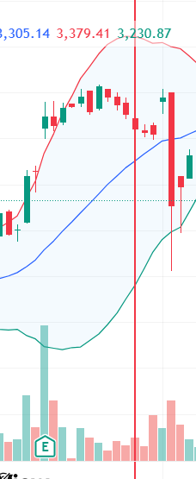

**5 July 2024**

Many dojis, the quiet before the storm

RSI = 64.6

MACD signalling to sell/short

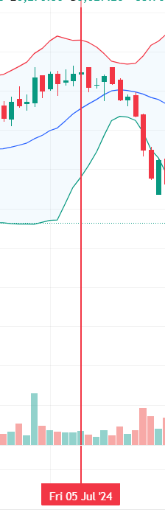

**25 Nov 2024**

Bullish marubozu-like

RSI = 61

MACD signalling to buy

High volumes indicating smart money

