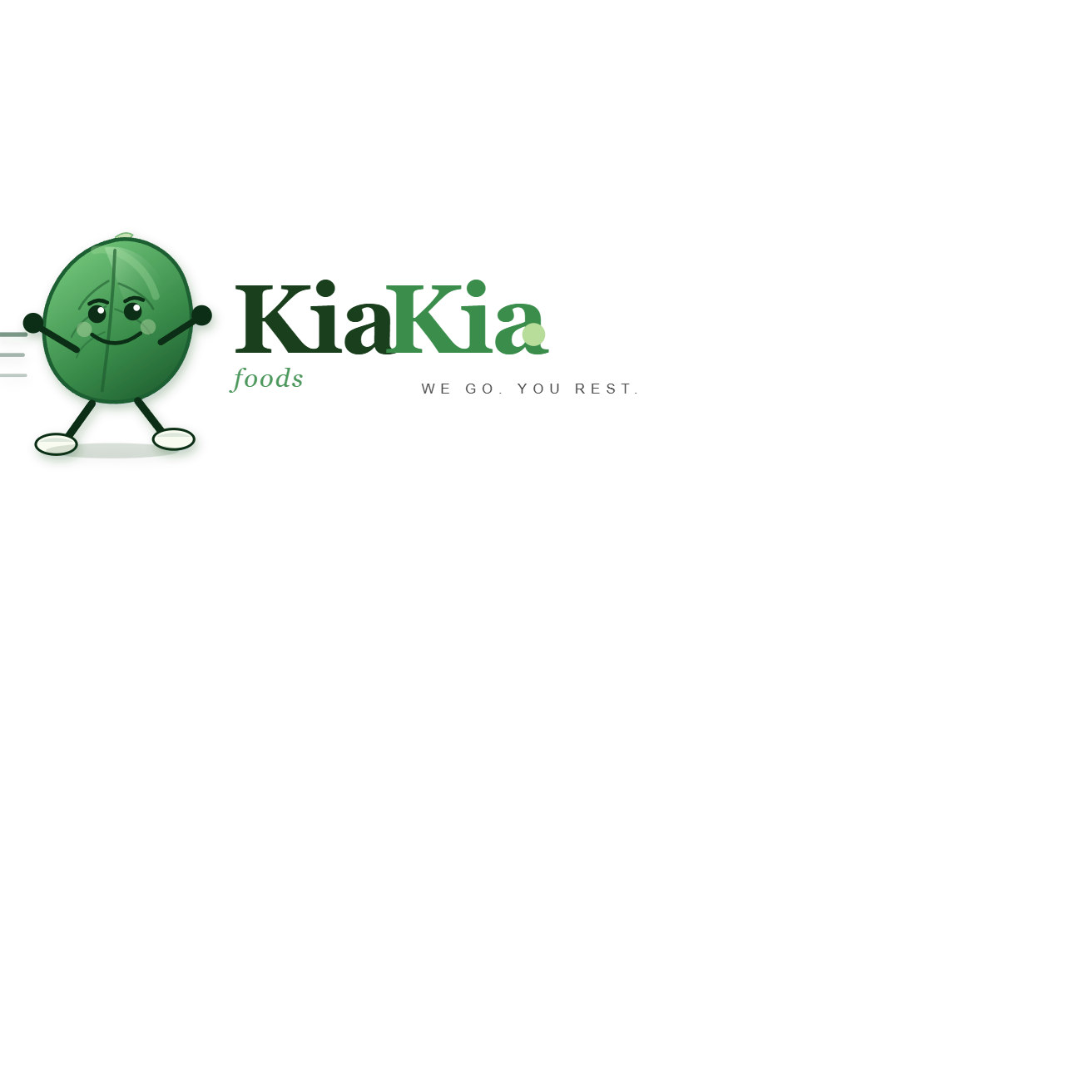
BUSINESS PROPOSAL FOR CHURCH GRANT SUPPORT
KiaKia Foods
Date: 13 July 2026
Submitted To: CYON, Holy Family Catholic Church, Life Camp, Abuja
Prepared by: KiaKia Foods Management Team
Location: Abuja, Nigeria

1. Executive Summary
KiaKia Foods is a growing grocery sourcing and last-mile delivery business serving households and professionals in Abuja. Our model helps families save time, avoid market stress, and receive affordable groceries at their doorstep. We are applying for a church grant to strengthen our operations, serve more families, and create dignified jobs for young people in our community.
2. Problem Statement
Many households in our service area face three recurring challenges: (1) limited time to shop physically, (2) unstable access to fresh and reliable market goods, and (3) expensive, uncoordinated delivery options. These challenges affect working families, elderly people, and single parents most.
3. Our Solution
KiaKia Foods aggregates customer orders, assigns trained runners for market sourcing, and coordinates grouped estate deliveries. This method lowers delivery cost per household, improves service reliability, and supports transparent order tracking.
4. Mission Alignment with CYON and Parish Community Impact
This proposal aligns with CYON and parish values of service, stewardship, and youth formation through practical economic opportunity. The business creates impact through household food access, fair work opportunities, and skill development pathways for young adults in the church community. Our service also supports vulnerable members through planned and assisted grocery access.
5. Target Beneficiaries
Primary beneficiaries include working families, church members, elderly households, and low-mobility customers in Abuja estates. Secondary beneficiaries include runners, dispatch riders, and support staff employed through expanded operations.
6. Operational Plan (12-Month)
Phase 1 (Months 1-3): Increase sourcing capacity, standardize operations, and onboard additional runners and dispatch riders.
Phase 2 (Months 4-8): Expand to additional estates and improve service reliability through route batching.
Phase 3 (Months 9-12): Consolidate quality controls, retention programs, and financial reporting.
7. Grant Request and Use of Funds
Requested Church Grant: N2,000,000
Budget Item | Amount (NGN) | Purpose
Working Capital for Bulk Sourcing | N700,000 | Stabilize product availability and pricing
Logistics and Delivery Expansion | N450,000 | Rider support, fuel, route execution, service consistency
Operations Technology and Tools | N250,000 | Order management improvements and reporting tools
Staff Recruitment and Training | N250,000 | Onboard and train runners/operations assistants
Customer Growth and Outreach | N200,000 | Community awareness and service adoption
Contingency and Risk Buffer | N150,000 | Manage volatility and emergency needs
Total | N2,000,000
8. Financial Outlook (Year 1)
Metric | Projected Amount (NGN)
Projected Annual Revenue | N42,000,000
Projected Direct Operating Costs | N28,500,000
Projected Gross Margin | N13,500,000
Projected Net Surplus (after overhead) | N6,800,000
9. Key Performance Indicators
- Number of active households served
- On-time delivery rate
- Cost-per-delivery and delivery margin
- Runner productivity and retention
- Number of jobs sustained/created
- Number of vulnerable households supported
10. Governance, Accountability, and Reporting
KiaKia Foods commits to transparent stewardship of grant funds. We will submit periodic reports to the church covering fund utilization, impact metrics, business performance, and lessons learned. We welcome oversight and advisory support from church leadership.
11. Risk Management
Main risks include market price volatility, logistics delays, and demand fluctuations. Mitigation actions include bulk purchase planning, estate-based batching, reserve buffers, and ongoing process controls through our order management system.
12. Closing Statement
With church grant support, KiaKia Foods will scale responsibly, deepen community service, and strengthen household food access while creating meaningful livelihoods. We respectfully request your partnership to make this expansion possible.
Prepared by:
KiaKia Foods Management Team

