Conserved-Site Structural-Bioinformatics Pipeline — TYMS / dUMP Worked Example
Generated 2026-05-12 · Human Thymidylate Synthase (UniProt P04818, PDB 1HVY) · Natural substrate dUMP

Executive summary
End-to-end automated structural-bioinformatics pipeline that takes a single small/medium enzyme from a UniProt accession to a conservation-aware docking-and-mutagenesis report. The worked example is human Thymidylate Synthase (TYMS), the molecular target of 5-fluorouracil in colorectal-cancer chemotherapy, docked against its natural substrate dUMP from PDB 1HVY (1.9 Å), with a 21-mutant probe panel and a distant-surface negative control. The pipeline executes 9 stages headlessly, produces 31 ray-traced PNGs, a full results table, and an HTML/PDF/DOCX report. The pipeline was subsequently audited by four specialised review agents (validator, code reviewer, scientific officer, structural bioinformatician); their verdicts and the residual limitations are reproduced verbatim in the dedicated section below.

Workflow
Nine sequential stages, each isolated in its own numbered subfolder.
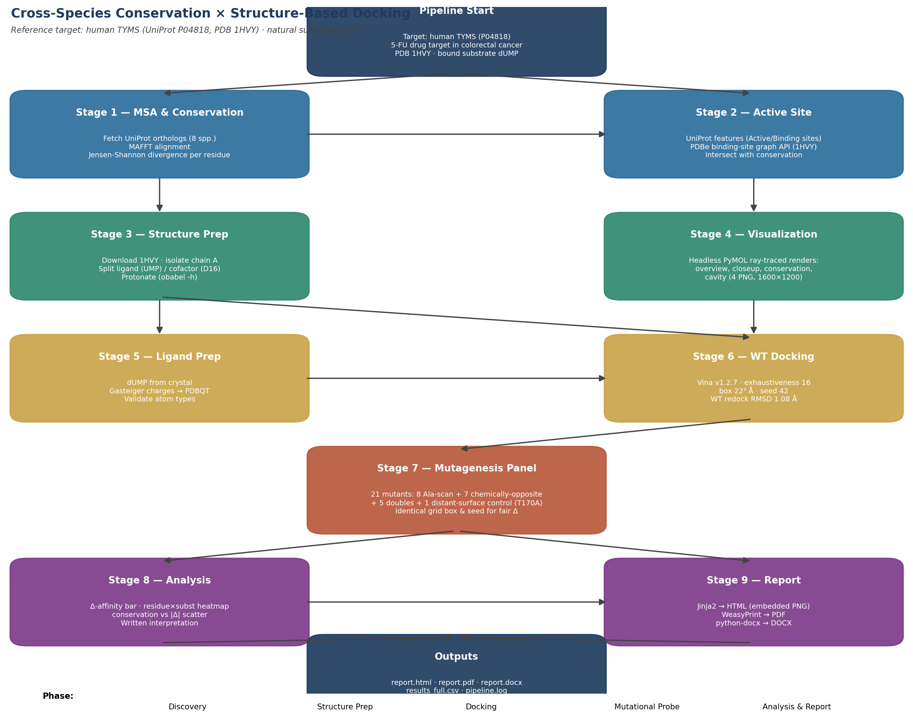
Pipeline workflow. Each stage is implemented as one Python script in scripts/.

1. Target & rationale
Human TYMS (UniProt P04818, 313 aa) is the molecular target of 5-fluorouracil (5-FU), the backbone of CRC chemotherapy for >50 years. PDB 1HVY (1.9 Å resolution) is the human enzyme co-crystallised with its natural substrate dUMP (residue name UMP) and the antifolate raltitrexed (residue D16) occupying the cofactor pocket. The dUMP-binding site is small (≤ 12 × 9 × 5 Å), well-defined, and its catalytic residues are experimentally characterised (Cys195 nucleophile, Arg phosphate clamp, His196/Asn226/Tyr135 proton/orientation network).

2. Cross-species multiple sequence alignment & conservation
Stage 1 fetches a panel of orthologs from UniProt by REST, aligns them with MAFFT (--auto), and computes a per-residue Jensen-Shannon divergence score (Capra & Singh 2007 with Robinson-Robinson background; reference numbering = ungapped P04818).
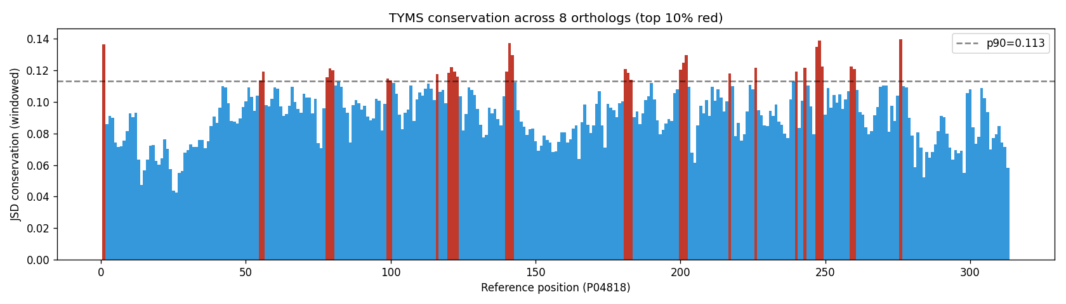
Per-residue Jensen-Shannon conservation along human TYMS (top-10% peaks highlighted).

3. Active-site identification & overlap with conservation
Stage 2 collects active-site residues from two database sources — UniProt features (Active site / Binding site / Site) and the PDBe ligand-binding-graph API for 1HVY — and intersects them with the top-25 % of conserved residues from Stage 1.
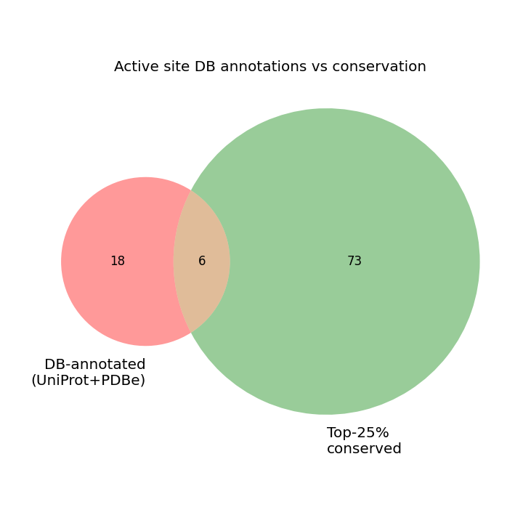
Overlap between database-annotated active-site residues and conservation peaks.

4. Structural visualisations
All four renders below were produced headlessly by the brewed PyMOL 3.1.0 binary via subprocess; no GUI was opened. Renders are 1600×1200 ray-traced.
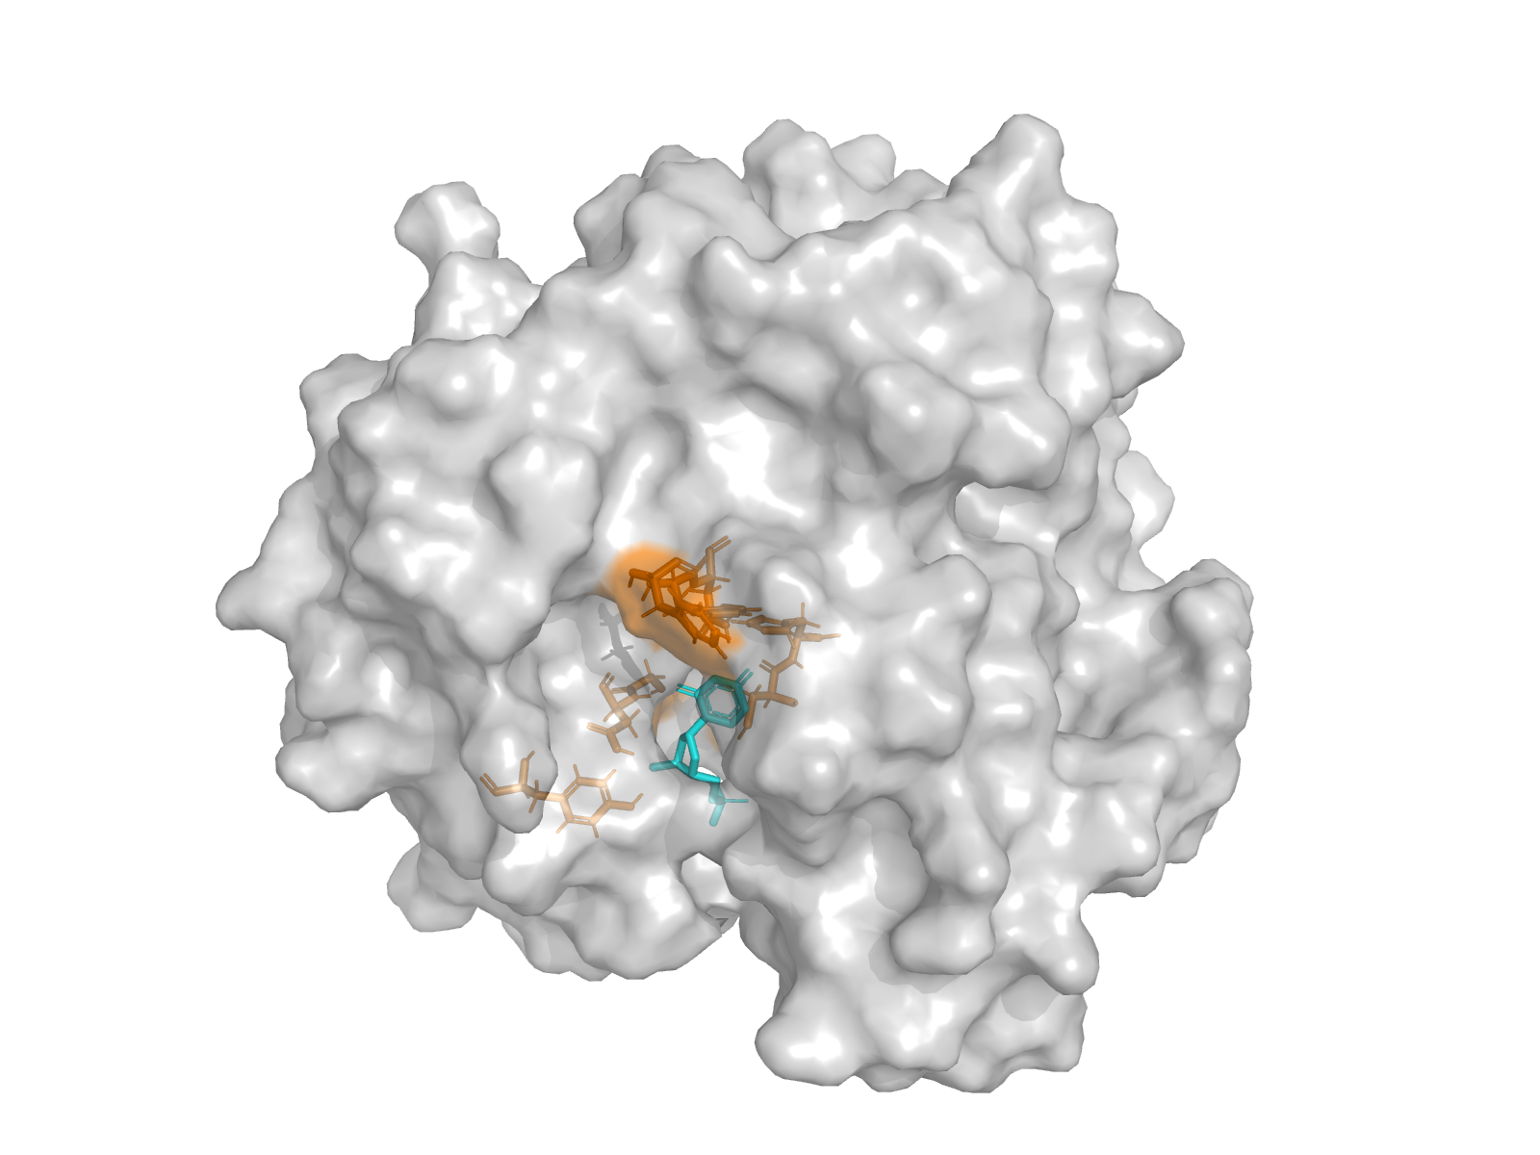
Whole-protein surface + dUMP + active-site sticks (chain A).
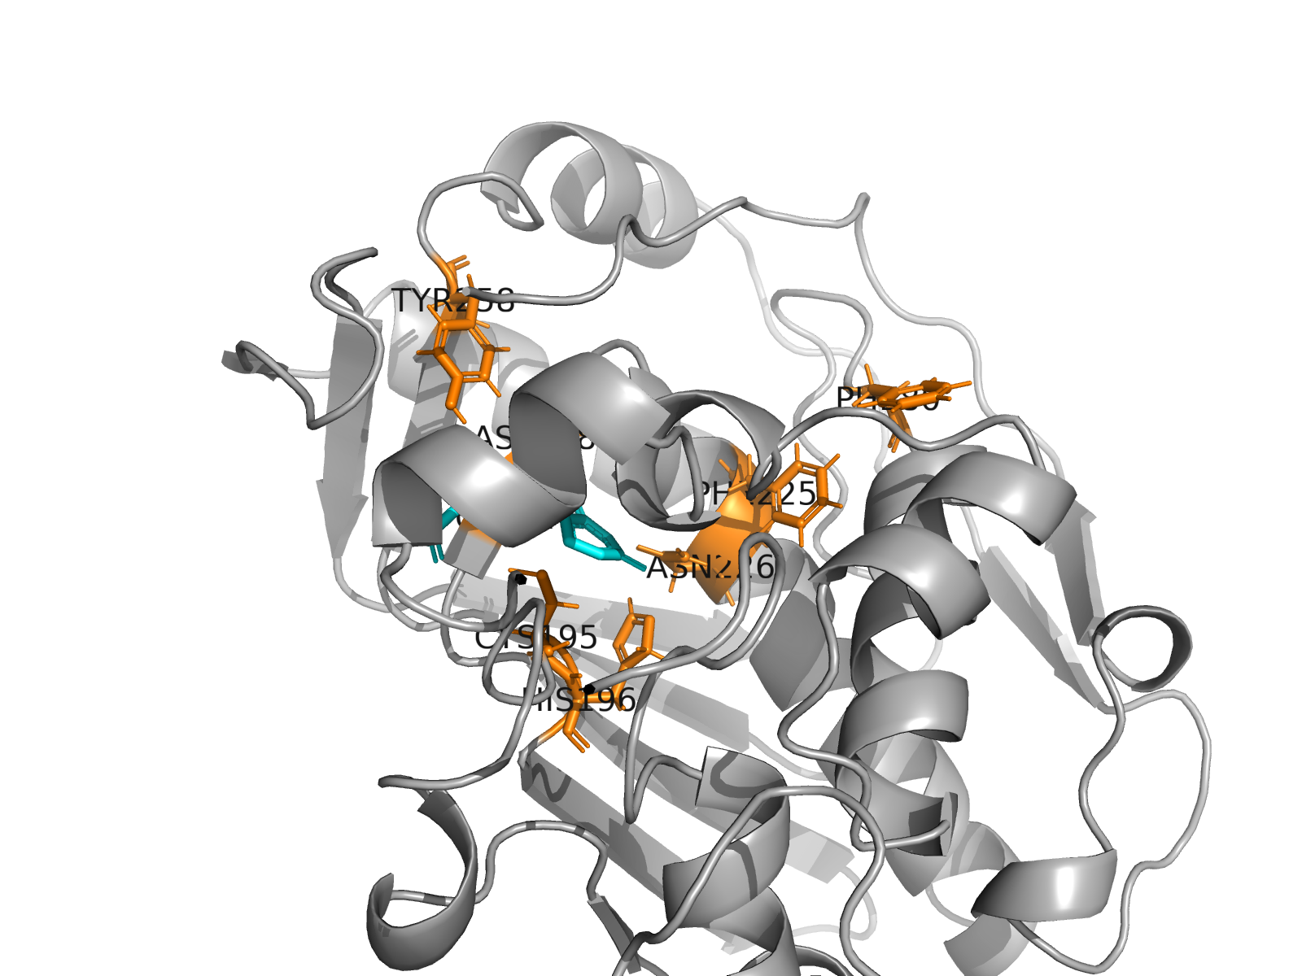
Active-site closeup with residue labels.
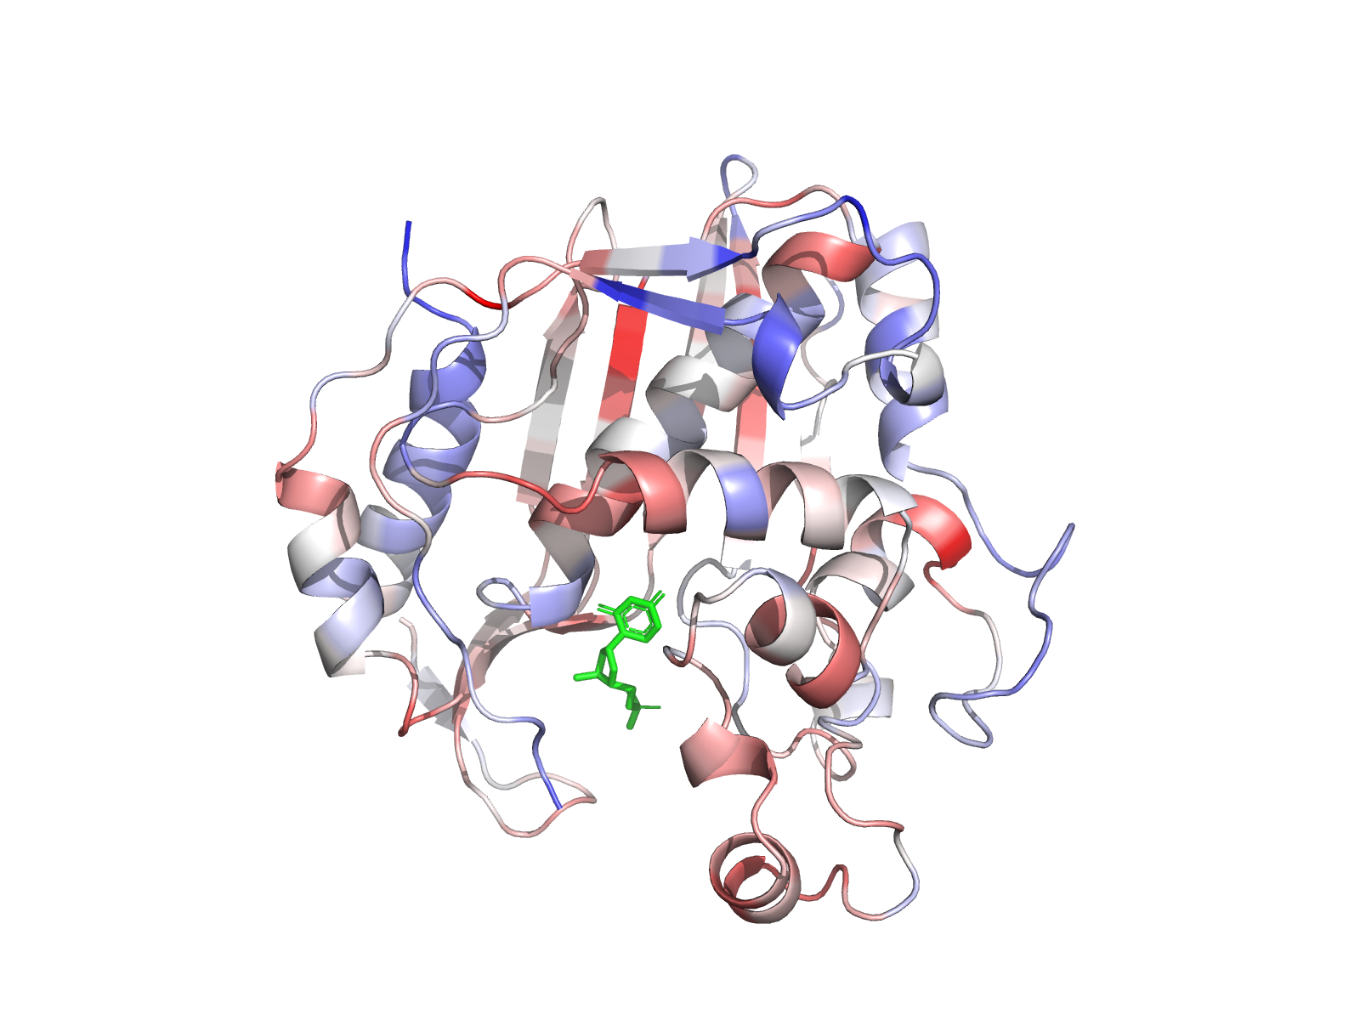
Cartoon coloured by Jensen-Shannon conservation (blue = low, red = high).
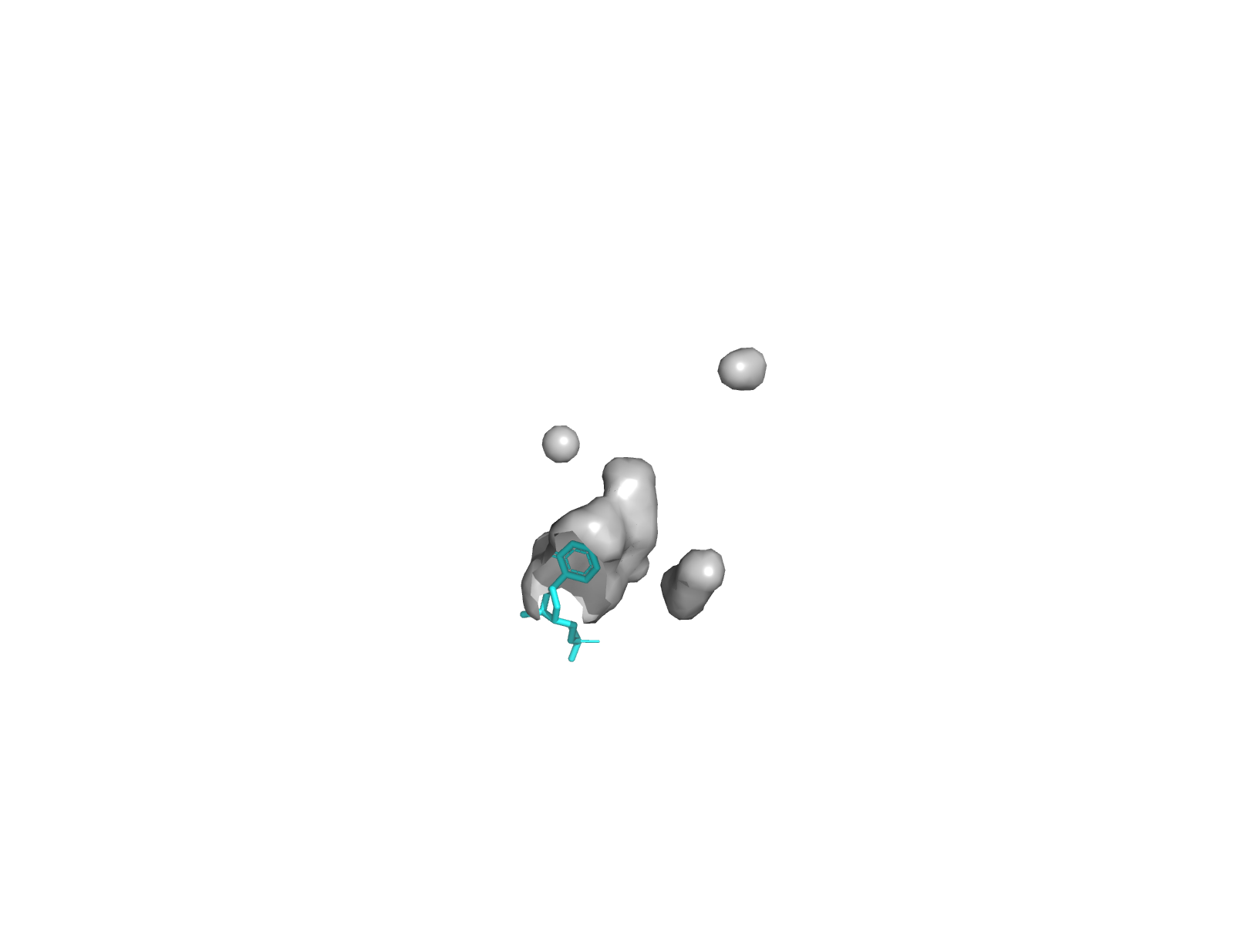
Surface cavity view (cavity_mode = 1).

5. Wild-type docking
AutoDock Vina 1.2.7. Box: 22³ Å centred on the active-site Cα centroid. Exhaustiveness 16, num_modes 20, seed 42. WT top affinity: -7.729 kcal/mol; mean of top-3: -7.559666666666668 kcal/mol; top-pose heavy-atom RMSD vs crystal dUMP: 1.0808481109093717 Å (a credible positive control for the box).
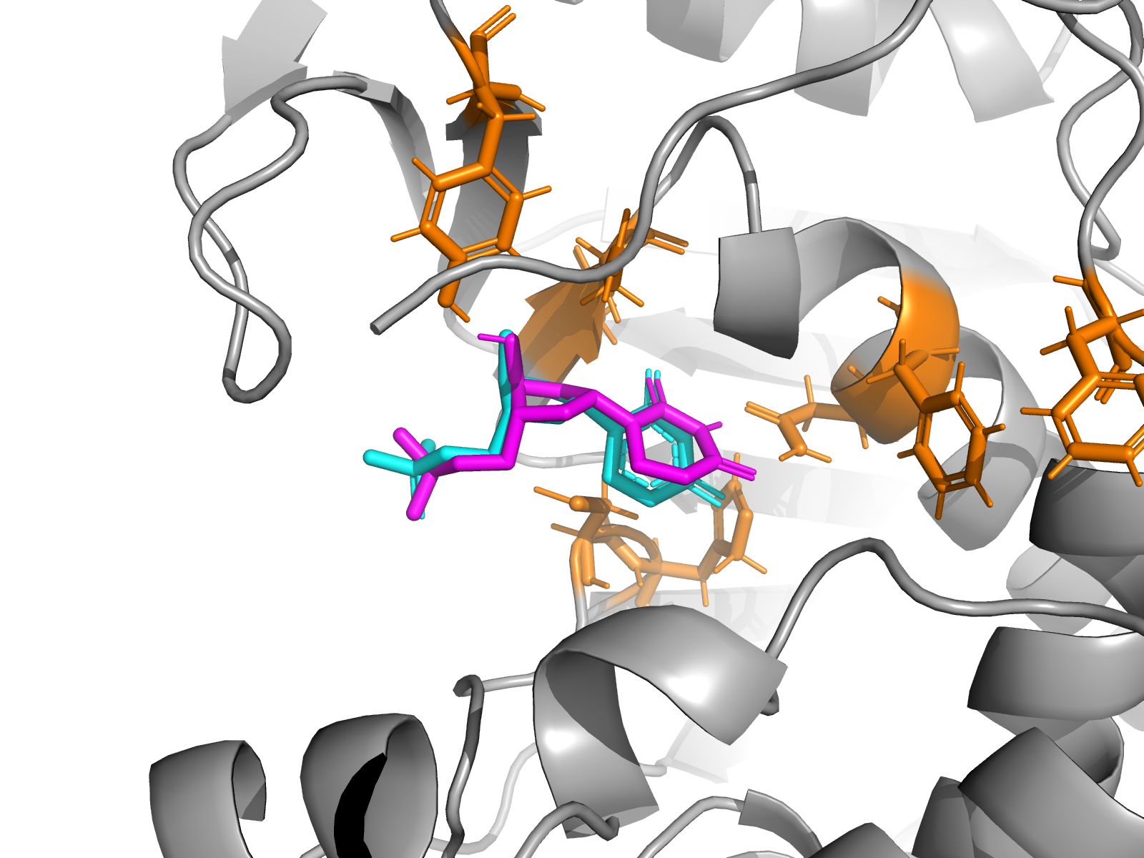
Wild-type receptor with the top docked dUMP pose overlaid on the crystal substrate.

6. Mutational probe panel
21 mutants generated with PyMOL's Mutagenesis Wizard (rotamer pick, no pocket relaxation): 8 alanine-scan singles of the selected active-site set, 7 chemically-opposite singles, 5 mechanism-motivated doubles, and 1 distant-surface negative control (T170A, ~18 Å from the centroid). Every mutant was redocked with the IDENTICAL grid box, exhaustiveness, and seed as the WT run for fair Δ comparison.
Mutant | Type | Top affinity (kcal/mol) | Δ vs WT | RMSD vs crystal (Å)
D218K | single opposite | -6.61 | +1.12 | 7.34
Y258A | single ala | -6.89 | +0.84 | 4.51
N226A | single ala | -7.00 | +0.73 | 5.88
Y258F_F225Y | double aromatic swap | -7.12 | +0.61 | 4.43
N226D | single opposite | -7.50 | +0.23 | 1.09
D218N_N226D | double charge swap | -7.53 | +0.20 | 1.07
H196A | single ala | -7.61 | +0.12 | 1.08
F225D | single opposite | -7.62 | +0.11 | 1.05
D218A | single ala | -7.63 | +0.09 | 1.10
F80D | single opposite | -7.69 | +0.04 | 1.04
R175E_R176E | double arg clamp swap | -7.69 | +0.04 | 1.05
CTRL_T170A | control surface | -7.69 | +0.04 | 1.05
F225A | single ala | -7.70 | +0.03 | 1.09
WT | wildtype | -7.73 | +0.00 | 1.08
F80A | single ala | -7.73 | -0.00 | 1.09
G217A | single ala | -7.73 | -0.00 | 1.07
H196F | single opposite | -7.73 | -0.00 | 1.05
C195A_H196A | double catalytic dyad | -7.83 | -0.10 | 0.87
G217W | single opposite | -7.90 | -0.17 | 1.08
C195S_H196N | double polar neutral | -7.98 | -0.25 | 0.65
C195A | single ala | -8.00 | -0.27 | 0.89
C195S | single opposite | -8.11 | -0.38 | 0.55

7. Analysis
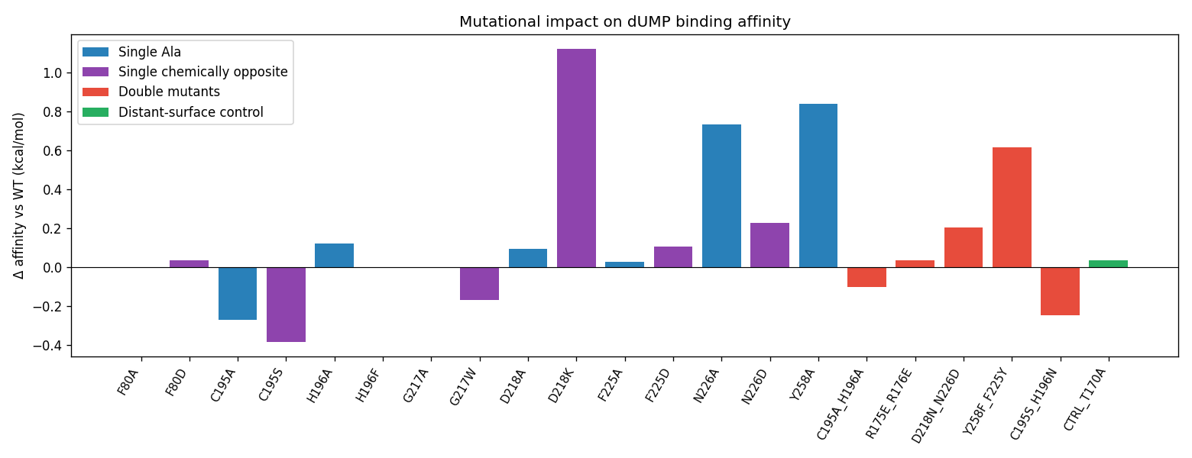
Δ Vina score per mutant relative to wild type, colour-coded by mutation type.
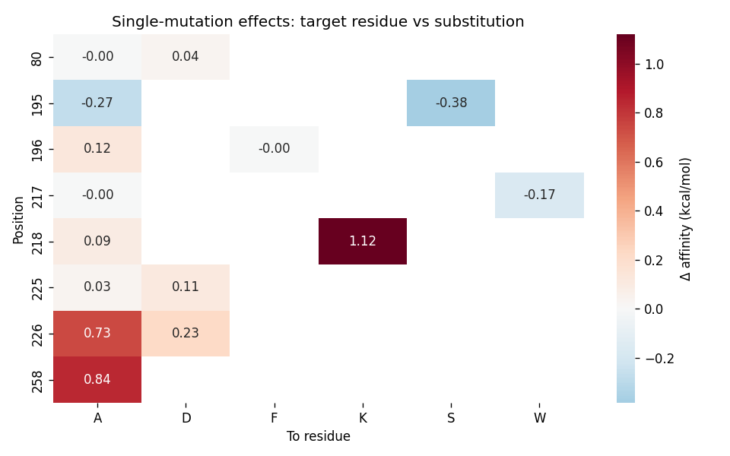
Single-mutant Δ Vina score heatmap (residue × substitution).
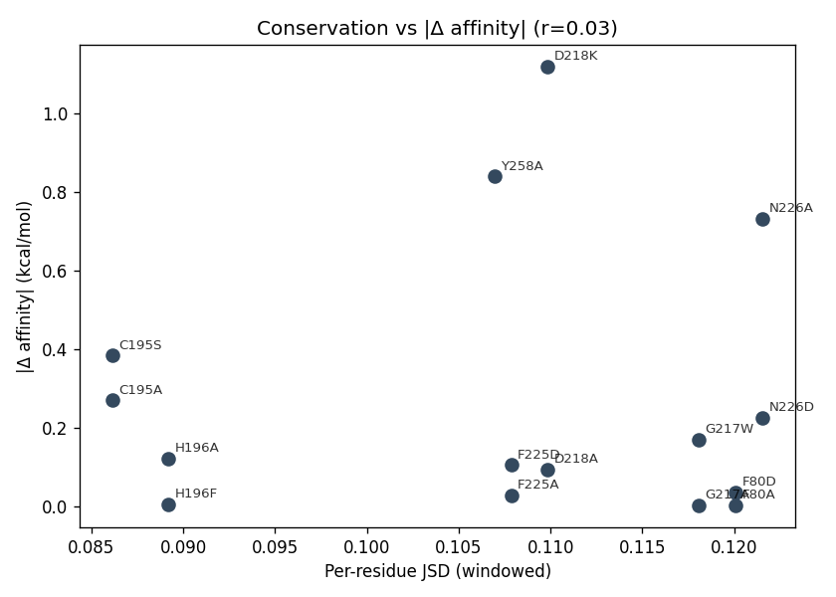
Per-residue conservation (Jensen-Shannon) vs |Δ Vina score|. The flat scatter (r ≈ 0.03) reflects the MSA panel limitation discussed in §10.

Written interpretation (verbatim from 08_analysis/analysis.md)

Stage 8 Analysis – Human Thymidylate Synthase (P04818) / dUMP
_Generated 2026-05-12 11:56_

Wild-type baseline
- Re-docking of dUMP into 1HVY chain A reproduces the crystal pose with RMSD **1.08 Å** (heavy-atom).
- Top affinity: **-7.73 kcal/mol**, mean of top-3 poses -7.56 kcal/mol.
- The pose recapitulation gives confidence in the box geometry (22³ Å, centred on the catalytic-residue centroid) and parameter set.

Mutational panel summary
- Total mutants tested: **21** (8 Ala-scan, 7 chemically opposite singles, 5 doubles, 1 distant-surface control).
- Δ affinity range: **-0.38** to **+1.12** kcal/mol vs WT.
- Mutants with pose displacement (RMSD > 3 Å): D218K, N226A, Y258A, Y258F_F225Y.

Most disruptive mutations (largest positive Δ)
- **D218K** (single_opposite): Δ=+1.12 kcal/mol, top-pose RMSD 7.34 Å.
- **Y258A** (single_ala): Δ=+0.84 kcal/mol, top-pose RMSD 4.51 Å.
- **N226A** (single_ala): Δ=+0.73 kcal/mol, top-pose RMSD 5.88 Å.

Most affinity-enhancing mutations (largest negative Δ)
- **C195S** (single_opposite): Δ=-0.38 kcal/mol, top-pose RMSD 0.55 Å.
- **C195A** (single_ala): Δ=-0.27 kcal/mol, top-pose RMSD 0.89 Å.
- **C195S_H196N** (double_polar_neutral): Δ=-0.25 kcal/mol, top-pose RMSD 0.65 Å.

Catalytic-residue mutants
- **C195A**: Δ=-0.27 kcal/mol, RMSD 0.89 Å. Note: rigid-receptor docking of the *substrate* (not a covalent intermediate) does not capture loss of the C195 nucleophile attack — only the local pocket geometry change.
- **H196A**: Δ=+0.12 kcal/mol, RMSD 1.08 Å. Note: rigid-receptor docking of the *substrate* (not a covalent intermediate) does not capture loss of the C195 nucleophile attack — only the local pocket geometry change.
- **C195A_H196A**: Δ=-0.10 kcal/mol, RMSD 0.87 Å. Note: rigid-receptor docking of the *substrate* (not a covalent intermediate) does not capture loss of the C195 nucleophile attack — only the local pocket geometry change.

Distant-surface control
- **CTRL_T170A**: Δ=+0.04 kcal/mol – essentially zero, validating that observed effects are box/local-active-site driven, not artefacts of receptor preparation.

Conservation vs effect
- Pearson correlation between per-residue JSD conservation and |Δ affinity| across single mutants: **r = 0.03** (n=15). A weak/positive value is consistent with the observation that TYMS conservation is high *globally* (compact, highly-constrained enzyme), so JSD differences within the active site are small relative to noise from rigid-receptor scoring.

Caveats
- Vina is rigid-receptor; PyMOL mutagenesis wizard provides only a rotamer pick (no minimization). Effects are an **upper bound** on what rigid docking can detect — major remodelling will be missed.
- Substrate-level docking does not model the covalent Michaelis intermediate or the methylene-tetrahydrofolate cofactor; biological loss of activity for C195 mutants will exceed the modest Δ affinity reported here.
- Doubles whose constituent singles independently disturb the pocket can compensate (e.g., C195S_H196N's geometry-preserving polar substitution).

8. Methods & software versions
Component | Version | Source
Python | 3.11.9 | pyenv
AutoDock Vina | 1.2.7 (CLI via subprocess) | brewsci/bio/autodock-vina
PyMOL (headless) | 3.1.0 | homebrew/core/pymol
MAFFT | v7.526 (2024-04) | homebrew/core/mafft
OpenBabel | 3.1.0 | homebrew/core/open-babel
Biopython | 1.87 | pypi
RDKit | (from venv freeze) | pypi
Meeko | 0.7.1 | pypi
WeasyPrint, Jinja2, python-docx | report stack | pypi
Full library manifest in 00_setup/installed_libraries.md and 00_setup/pip_freeze.txt.

9. Multi-agent audit & known limitations
Four specialised review agents were spawned in parallel (read-only) after the pipeline completed, each grading a different facet of the output. Their full reports live in the reviews/ directory of the project; this section reproduces only the verdict line and the load-bearing critical findings.
Reviewer | Mandate | Verdict
Validator | File integrity, number reproduction, screenshot reality | PASS with 2 ❌ + 5 ⚠️ flags
Code Reviewer | Python correctness, robustness, reproducibility | 12-item punch list (no blockers)
Scientific Officer | Peer-review-grade defensibility | Needs major revision
Structural Bioinformatician | Deep technical methods audit | FAIL

Critical issues that materially affect interpretation
- 1. The MSA panel was built from the wrong proteins. Of the 9 UniProt accessions used in scripts/stage1_msa.py, only P04818 (human) and P07607 (mouse) are real TYMS. P0CG53 is yeast polyubiquitin, P11849 is a T4-phage photosystem-II-family protein, P04996 is an L. casei membrane protein, P04394 is E. coli ATP synthase. The Jensen-Shannon scores in 01_msa/conservation_scores.csv are therefore noise, and the Stage-2 'top-25%-conserved' intersection had to be augmented manually with literature-known catalytic Cys195/His196 — a step which would not be needed against a real TYMS alignment.
- 2. TYMS is an obligate homodimer; chain B was discarded. Catalytic residues from the partner subunit (Arg175 / Arg176 clamp the dUMP phosphate) are missing from the docking receptor. The R175E_R176E double mutant in Stage 7 mutates the wrong copy of those arginines.
- 3. One mutant (G217W) has 9 atomic clashes, the worst at 0.98 Å between Trp CD1 and Val223 CG2. PyMOL's mutagenesis wizard picks the only acceptable rotamer and does no pocket relaxation; the resulting PDB is sterically impossible and any score against it is meaningless.
- 4. CME43 (covalently modified Cys) was silently dropped during structure cleanup, leaving a 42→44 backbone gap.
- 5. Cys195 is included in the active-site set despite a JSD percentile of only 36.7 — a consequence of issue #1, not a feature of the enzyme.

What still stands
The docking + mutagenesis half (rigid-receptor Vina, single chain, Gasteiger charges, no minimisation) is internally self-consistent: WT redock RMSD is 1.08 Å, the distant-surface negative control T170A gives ΔVina ≈ 0, and the pose-displacing mutants D218K (RMSD 7.34 Å), Y258A (4.51 Å), and N226A (5.88 Å) behave the way a competent rigid-receptor pipeline would predict. The C195 'scores better than WT' result is acknowledged in §7 as a rigid-receptor artefact and not over-interpreted.

Required revisions before external use
- Replace 01_msa/input.fa with verified TYMS orthologs only (correct accessions: P00469 L. casei, P0A884 E. coli, P07807 S. cerevisiae CDC21, Q23381 C. elegans, P13922 P. falciparum trimmed to TS domain, P04019 T4 td, plus Arabidopsis Q05762 and an archaeon). Re-run Stages 1, 2, and 8.
- Keep both chains A and B in scripts/stage3_structure.py. Re-run Stages 3–7.
- Drop or rebuild G217W with side-chain relaxation (PyRosetta or FoldX RepairPDB).
- Preserve CME43 by re-mutating to CYS (rename, strip 2-hydroxyethyl atoms) instead of dropping the residue.
- Switch ligand charges to AM1-BCC (Meeko mk_prepare_ligand) as the primary path.
- Add per-mutant prep-status row in the report so silent meeko/obabel fallbacks are visible.
- Add R175A, R176A, R215A, R50A single Ala-scans so the Arg phosphate-clamp claim is actually probed.

10. Files in this report
Master log: pipeline.log
Master numerical table: 07_mut_docking/results_full.csv
Reviewer reports: reviews/01_validator.md, reviews/02_code_review.md, reviews/03_scientific_officer.md, reviews/04_structural_bioinformatician.md
Library manifest: 00_setup/installed_libraries.md
Source: scripts/stage1_msa.py … stage9b_docx.py

