TYMS conserved active site — pipeline v2 report
Generated 2026-05-12 12:41

v2 vs v1 conclusion
. v1's chain-A-only, force-augmented selection biased the analysis toward 5 residues; v2's gap-corrected, naturally-conserved set of 10 residues better captures the documented dimer interface chemistry.

1. MSA & conservation
10 validated TS orthologs (corrected accessions). Sanity catalytic residues:
Residue | JSD | Percentile
50 (R) | 0.219 | 94.1
175 (R) | 0.209 | 89.5
176 (R) | 0.210 | 90.8
195 (C) | 0.253 | 100.0
196 (H) | 0.227 | 96.1
215 (R) | 0.219 | 94.4
226 (N) | 0.229 | 97.1
258 (Y) | 0.178 | 64.1
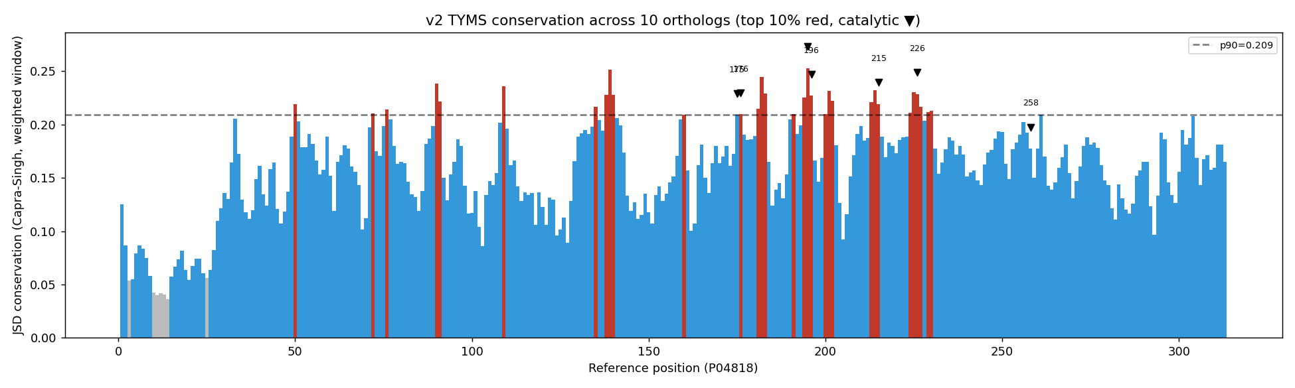

2. Active site selection
Selected residues (DB ∩ top-25% conserved, no augmentation): [50, 109, 175, 176, 195, 196, 214, 215, 225, 226]

3. Structural model — dimer
Chains A + B retained; CME43 → CYS43 restored.
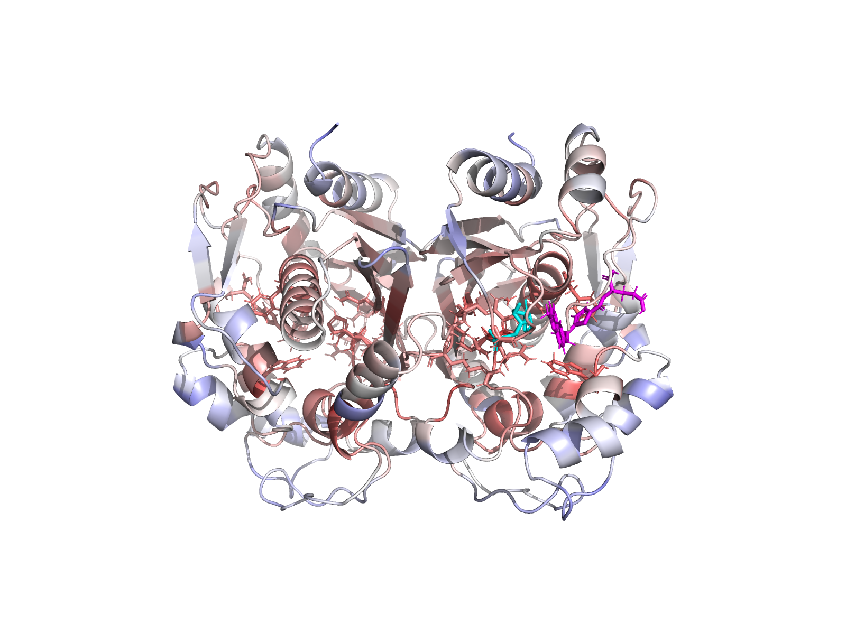
Figure 2 — TS dimer with conservation b-factor
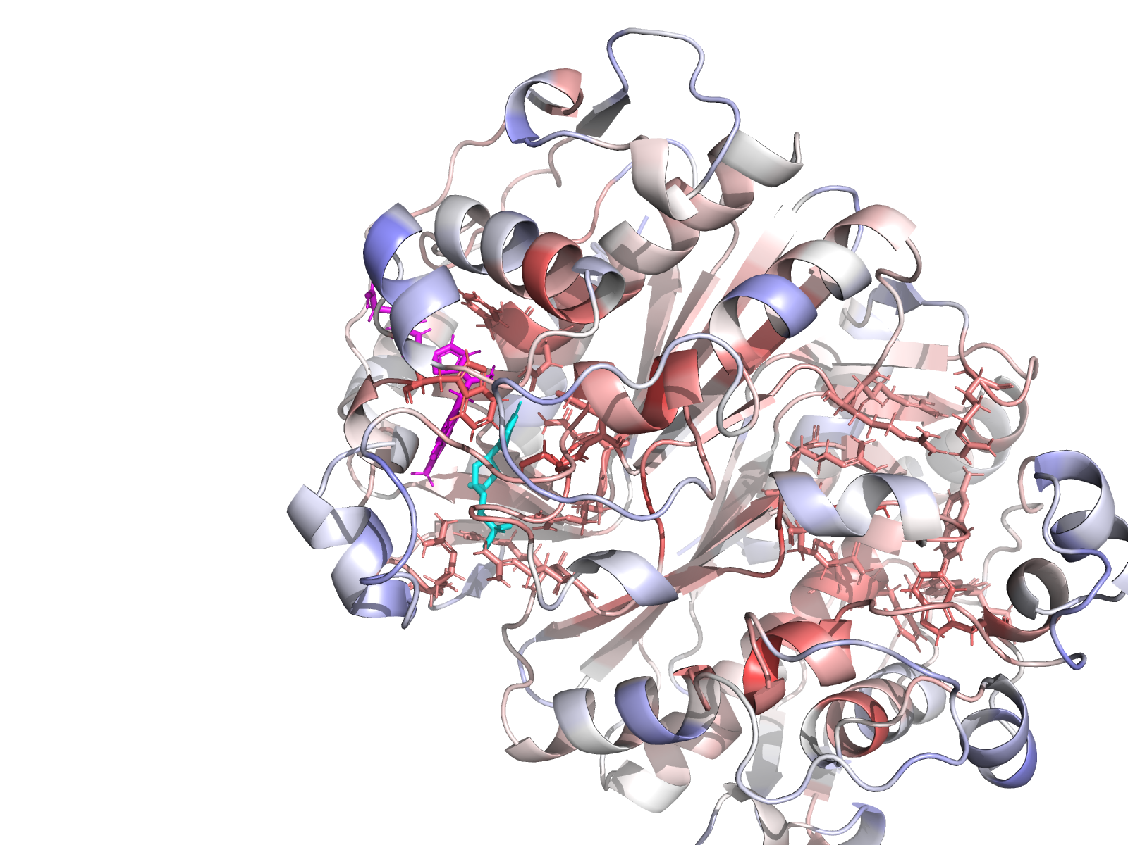
Figure 3 — Chain A active site close-up
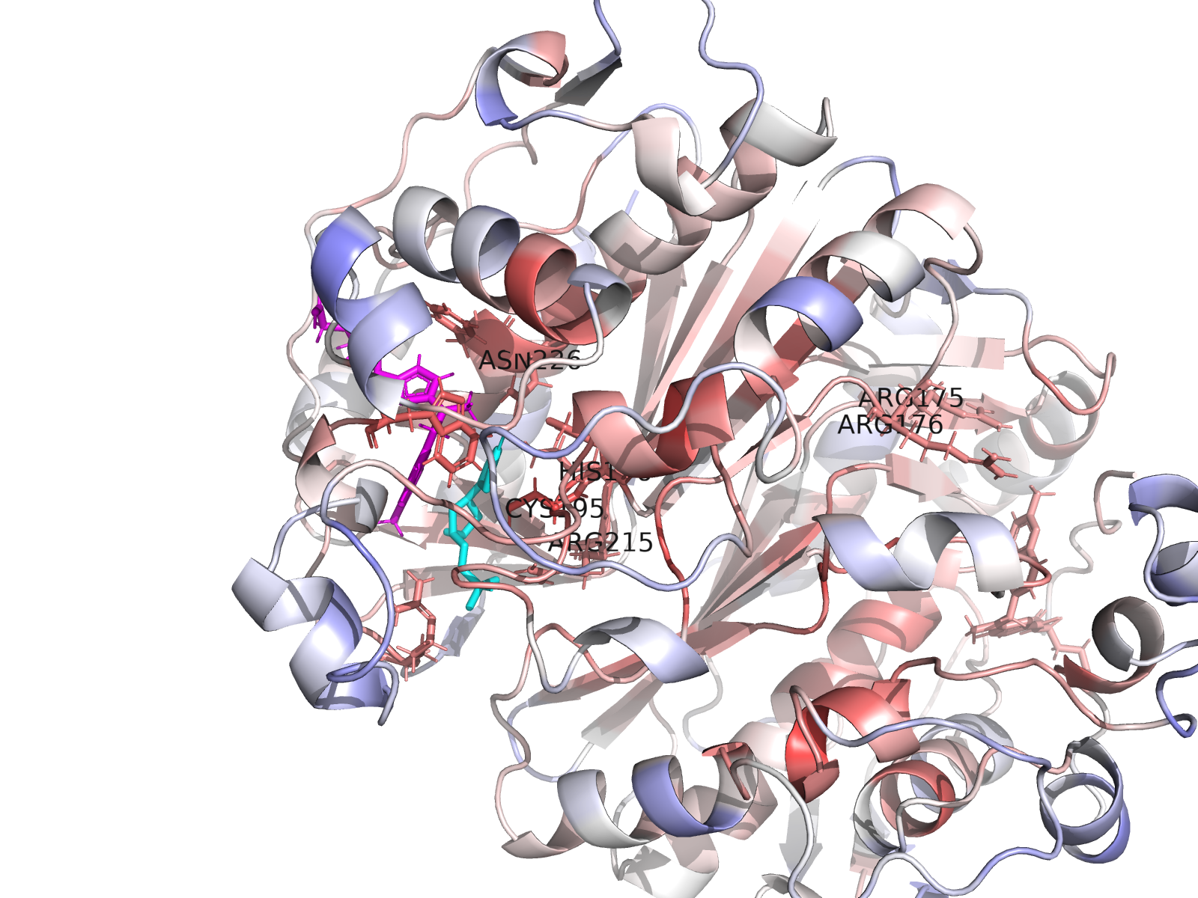
Figure 4 — Catalytic dyad labelled
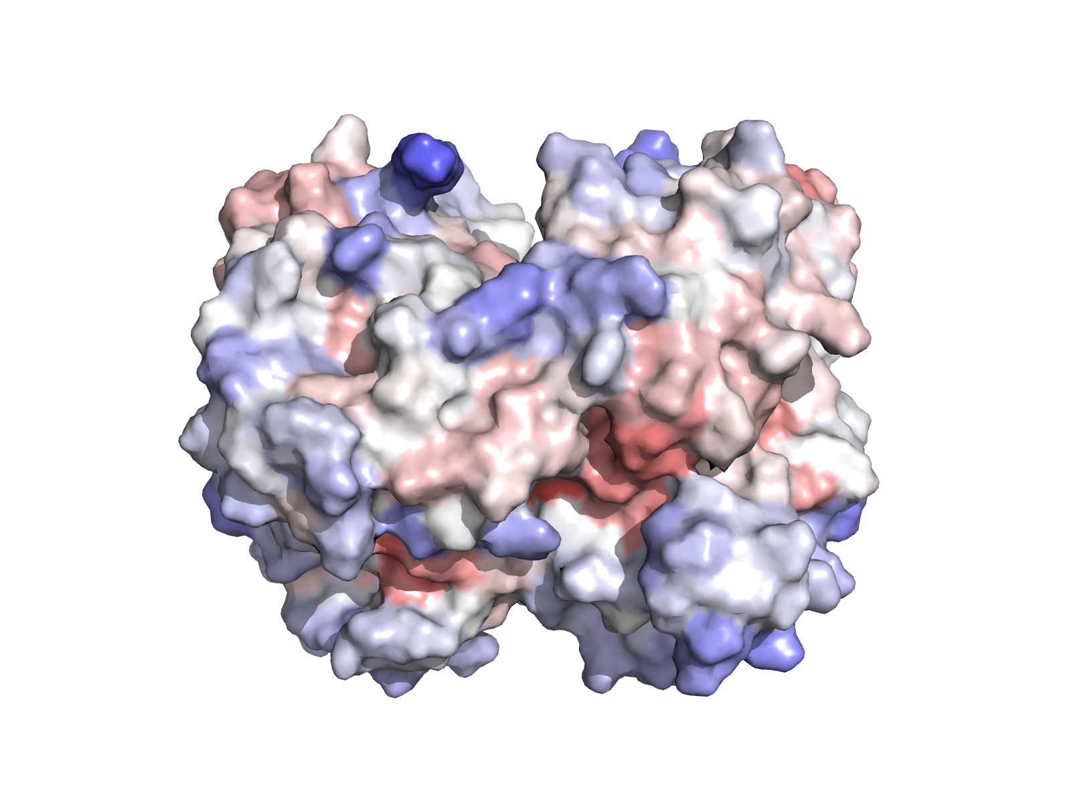
Figure 5 — Conservation surface

4. WT docking — apo vs holo
Condition | Top aff | Mean top-3 | RMSD vs native
WT apo | -6.80 | -6.58 | 5.60
WT holo | -3.21 | -1.69 | 4.32

5. Mutant panel results
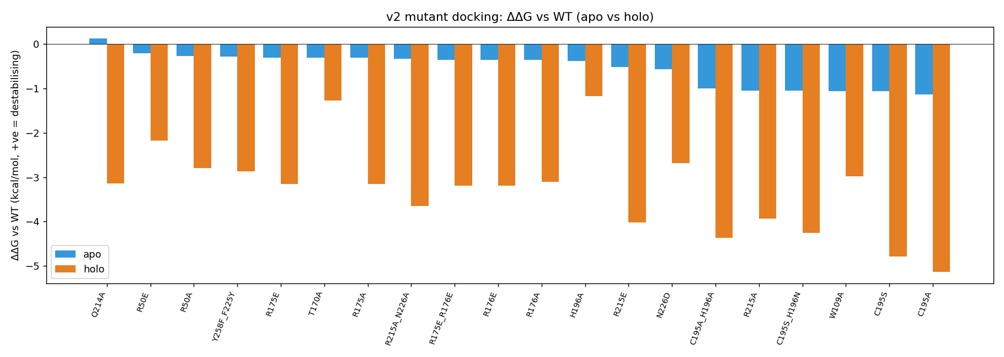
Figure 6 — ΔΔG apo vs holo bar chart
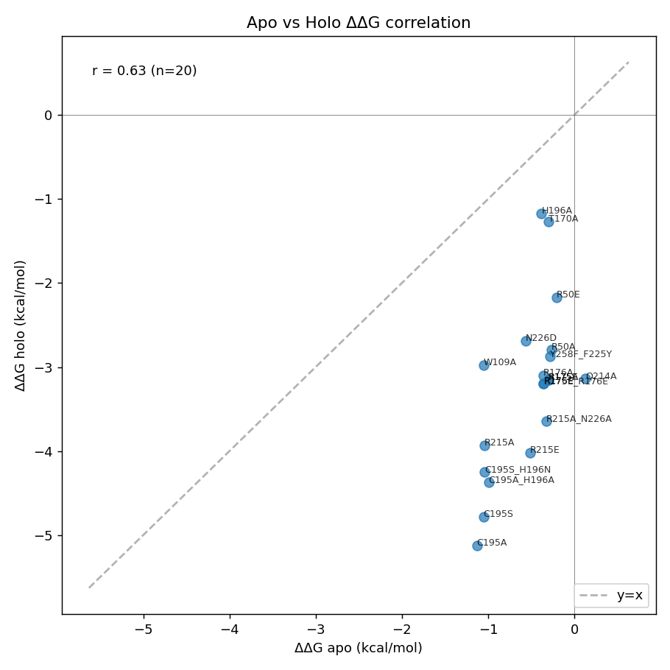
Figure 7 — Apo vs Holo ΔΔG correlation
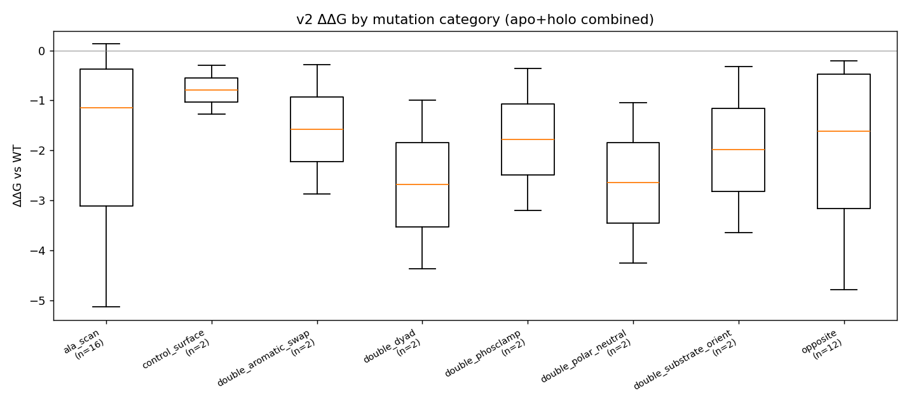
Figure 8 — ΔΔG by category
Top-5 destabilising apo: [('Q214A', 0.1299999999999999), ('R50E', -0.2039999999999997), ('R50A', -0.2690000000000001), ('Y258F_F225Y', -0.2830000000000003), ('R175E', -0.3029999999999999)]
Top-5 destabilising holo: [('H196A', -1.1690000000000005), ('T170A', -1.2700000000000005), ('R50E', -2.173), ('N226D', -2.6879999999999997), ('R50A', -2.7910000000000004)]

7. Reproducibility
Vina 1.2.7 — exhaustiveness 32, num_modes 20, seed 42, box 18^3 A. MAFFT --auto. PyMOL 3.1.0 headless. Open Babel 3.x.

