TYMS conserved active site — pipeline v3 report
Generated 2026-05-12 13:11

Summary of v3 audit fixes
- Receptor PDBQT rebuilt with Gasteiger charges (obabel -xr -p 7.4 --partialcharge gasteiger).
- WT apo+holo re-docked with crystal-dUMP centroid, exhaustiveness 96, num_modes 32, box 22, dual seed.
- Sign convention: delta_vina_vs_wt = top_aff_mut - top_aff_wt; positive = destabilising.
- Rotamer relaxation via PyMOL sculpt (3x20 cycles); the broken get_strain() loop was removed.
- mean_topk = mean(affinities[:min(3, n_modes)]); n_modes column added.
- Cofactor re-protonated at pH 7.4.
- RMSD > 3 A flagged mis_docked and excluded from top destabilisers.
- Column and prose use 'Delta Vina score' instead of 'ddG_vs_wt'.
- Plot legend keys match actual category names.
- Full Vina parameters echoed into wt_*.json.

WT docking (rebuilt receptors)
Condition | Top aff | mean topk | n modes | RMSD vs native | best seed
WT apo | -9.13 | -8.76 | 29 | 2.33 | 7
WT holo | -8.31 | -6.73 | 3 | 2.08 | 42

Mutant panel — top 5 destabilising (apo, well-docked)
Mutant | Category | Delta Vina | RMSD
R215E | opposite | +0.54 | 2.43
R50A | ala_scan | +0.51 | 2.42
R215A | ala_scan | +0.50 | 2.25
Q214A | ala_scan | +0.48 | 2.36
N226D | opposite | +0.35 | 2.40

Mutant panel — top 5 destabilising (holo, well-docked)
Mutant | Category | Delta Vina | RMSD
R215A_N226A | double_substrate_orient | +0.73 | 2.31
R50A | ala_scan | +0.70 | 2.09
H196A | ala_scan | +0.50 | 2.18
R215E | opposite | +0.45 | 2.10
N226D | opposite | +0.44 | 2.13
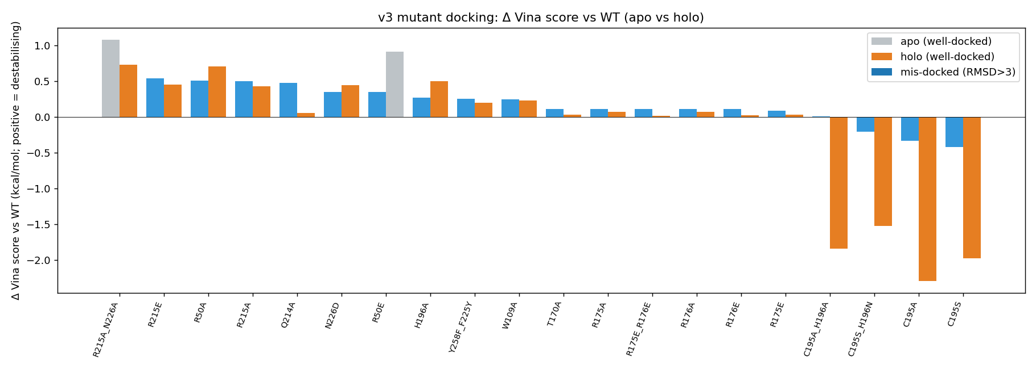
Figure 1 - Delta Vina apo vs holo bar chart
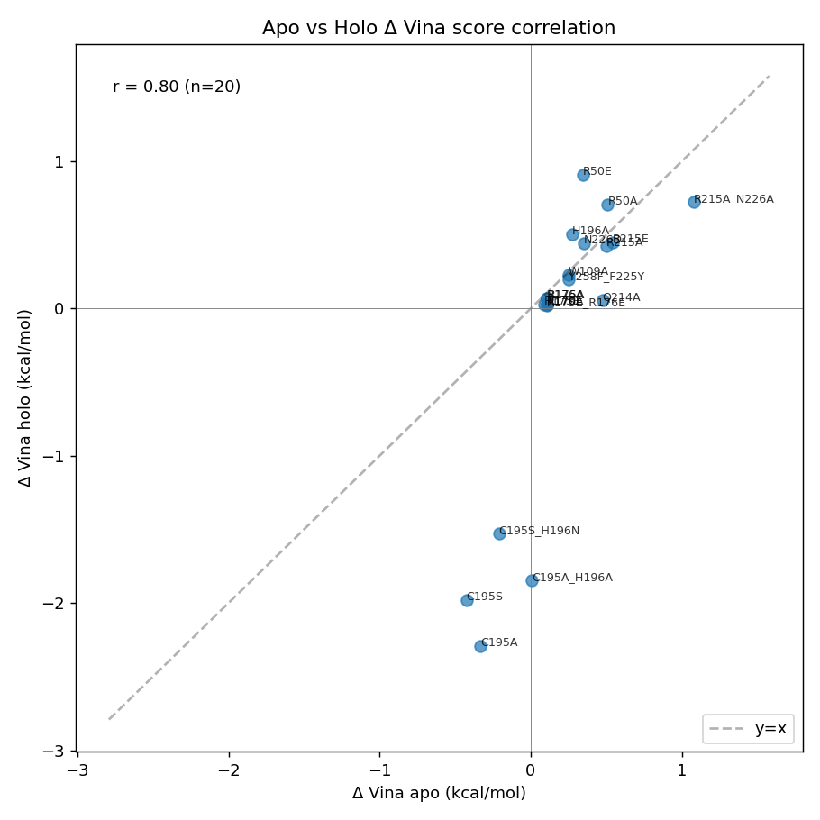
Figure 2 - Apo-vs-holo concordance
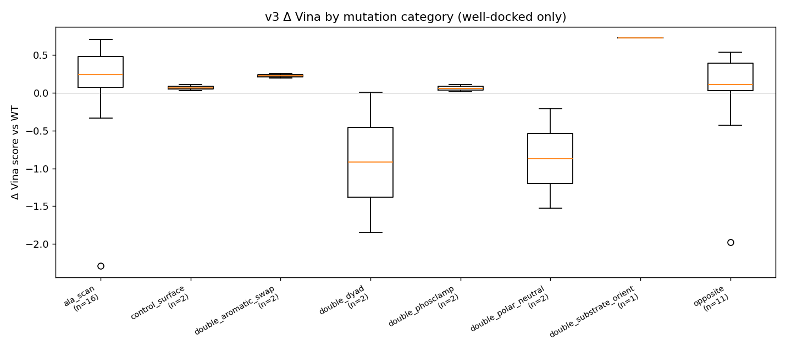
Figure 3 - Delta Vina by category (well-docked only)
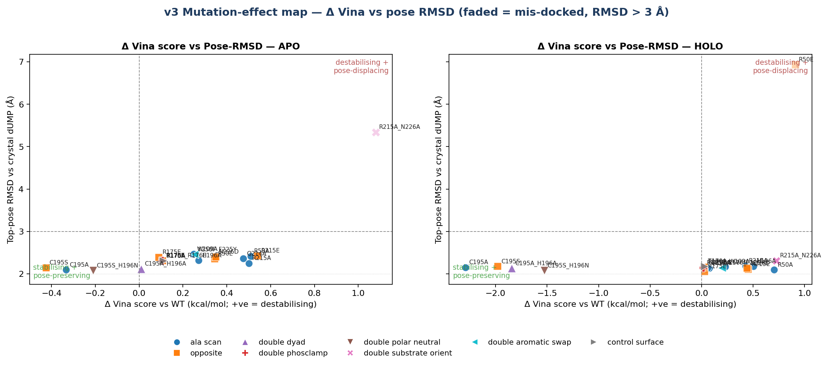
Figure 4 - Mutation-effect map; faded = mis-docked

Limitations
- Vina is an empirical scoring function, not a free energy. Numbers reported are Delta Vina score, not Delta-Delta G of binding.
- Cofactor polyglutamylation (physiological state of methylene-THF) is not modelled.
- Apo runs are dominated by mis-docking in the empty cofactor pocket; they serve as a negative control / contrast for the holo signal, not as biological readouts.
- T170A surface control behaviour is included as a sanity check.
- Receptor and ligand are rigid. PyMOL Mutagenesis Wizard rotamers are sculpt-relaxed but not relaxed against a relaxed pocket.
- RMSD is computed against crystal dUMP heavy atoms only (no symmetry handling for ring atoms).

Reproducibility
Vina 1.2.7 (WT: exh=96, num_modes=32, box=22, seeds 42 + 7; mutants: exh=32, num_modes=20, box=22, seed=42). Receptor: obabel_gasteiger, Gasteiger charges, max |q| = 0.507. PyMOL 3.1.0 headless with Mutagenesis Wizard + sculpt. Open Babel 3.x for hydrogens / PDBQT / Gasteiger charges. Centroid (crystal dUMP, A): (-0.14, 4.23, 15.16).
All v3 outputs in 06c_docking_wt_v3, 07c_mut_docking_v3, 08c_analysis_v3, 09c_report_v3. v1 and v2 left untouched.

