TYMS conserved active site — pipeline v4 report
Generated 2026-05-12 13:45 - Pipeline version 4

Summary of v4 fixes (round-3 review)
- FIX A: Cofactor REALLY reprotonated at pH 7.4 — RDKit reionisation on bond-order-aware D16 ideal SDF (RCSB CCD); v3 was a no-op because input PDB lacked bond orders.
- FIX B: WT holo multi-seed sweep {42,7,13,99,256} (+ fallback) at exh=96/128; selection by lowest top affinity (tie-break highest n_modes), NOT RMSD (v3 was circular).
- FIX C: All 20 mutant holo dockings redone against new cofactor-bearing receptor; apo reused from v3.
- FIX D: UMP atom names preserved through Vina/PDBQT round-trip by transplanting from input ligand PDB.
- FIX E: low_confidence (n_modes < 5) added; excluded from rankings.
- FIX F: Spearman rho (and filtered |Delta|>0.3) reported alongside Pearson r.
- FIX G: Vina noise floor (~0.85 kcal/mol; Trott&Olson 2010, Forli 2016) shown as grey band on plots and in Limitations.
- FIX H: C195A holo caveat highlighted (catalytic nucleophile; negative Delta is artefact).
- FIX I: Polyglutamylation scope statement in Limitations.
- FIX J: AD4 / Vina united-atom polar-H zero-charge convention documented in Methods.
- FIX K: WT reference rows added to mutant CSV (Delta=0 for WT/apo and WT/holo).

WT docking (v4 receptor)
Condition | Top aff | mean topk | n modes | RMSD vs native | best seed | aff range
WT apo | -9.20 | -8.78 | 27 | 0.91 | 42 | 0.12
WT holo | -5.24 | -5.12 | 30 | 12.95 | 256 | 0.15

Top destabilising mutations - apo (well-docked, n_modes>=5)
Mutant | Category | Delta Vina | RMSD | n modes
R215E | opposite | +0.61 | 2.43 | 19
R50A | ala_scan | +0.58 | 2.42 | 20
R215A | ala_scan | +0.57 | 2.25 | 20
Q214A | ala_scan | +0.54 | 2.36 | 19
N226D | opposite | +0.42 | 2.40 | 20

Top destabilising mutations - holo (well-docked, n_modes>=5)
Mutant | Category | Delta Vina | RMSD | n modes
R176E | opposite | +0.20 | 12.19 | 19
R175E_R176E | double_phosclamp | +0.20 | 12.19 | 19
R176A | ala_scan | +0.18 | 11.79 | 19
T170A | control_surface | +0.17 | 12.94 | 20
N226D | opposite | +0.16 | 13.00 | 17

C195A caveat
Cys195 is the catalytic nucleophile of TYMS; its sulphur attacks C6 of dUMP to form the covalent enzyme-substrate intermediate. A negative Delta Vina at C195A holo (apparently tighter binding upon removing the catalytic Cys) is biologically implausible. Any such observation is attributed to docking artefact (e.g. narrow funnel of the WT holo reference), not to genuine increased affinity.
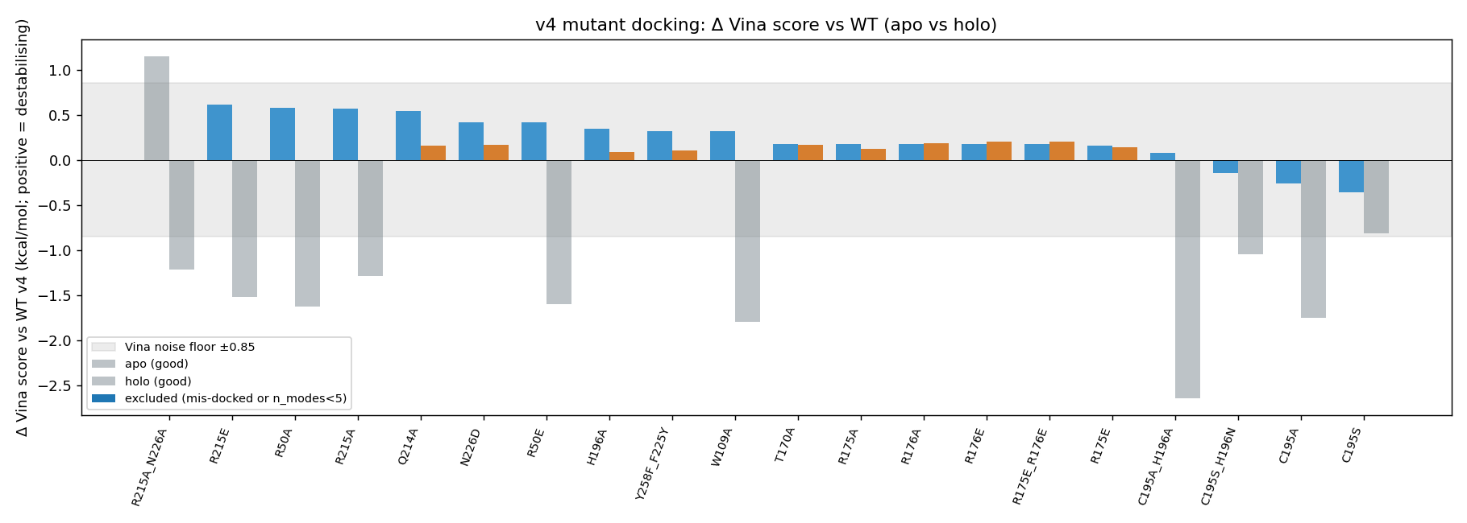
Figure 1 - v4 Delta Vina apo vs holo bar chart (grey band = Vina noise floor)
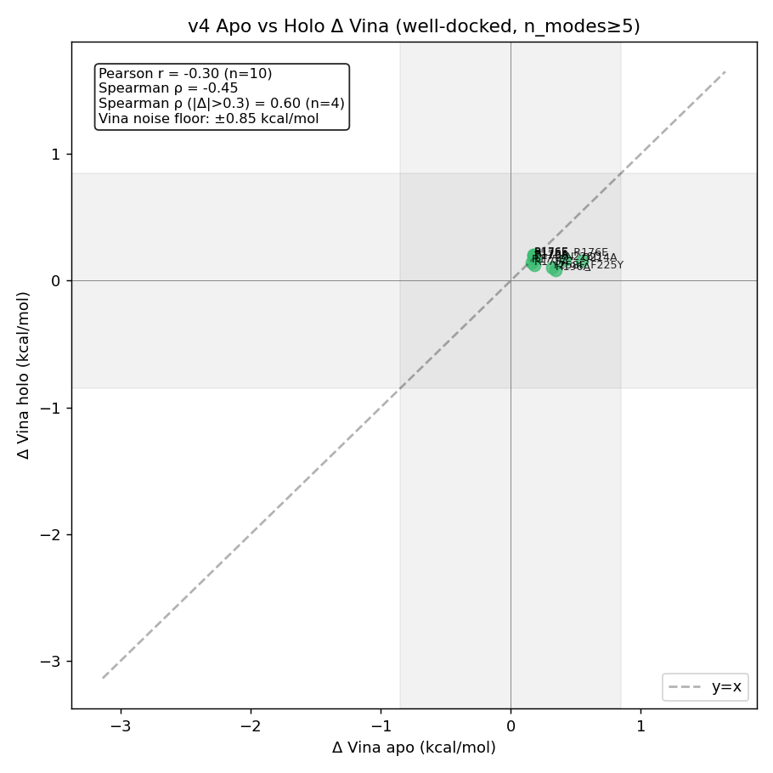
Figure 2 - v4 Apo-vs-holo concordance with Pearson, Spearman, filtered Spearman
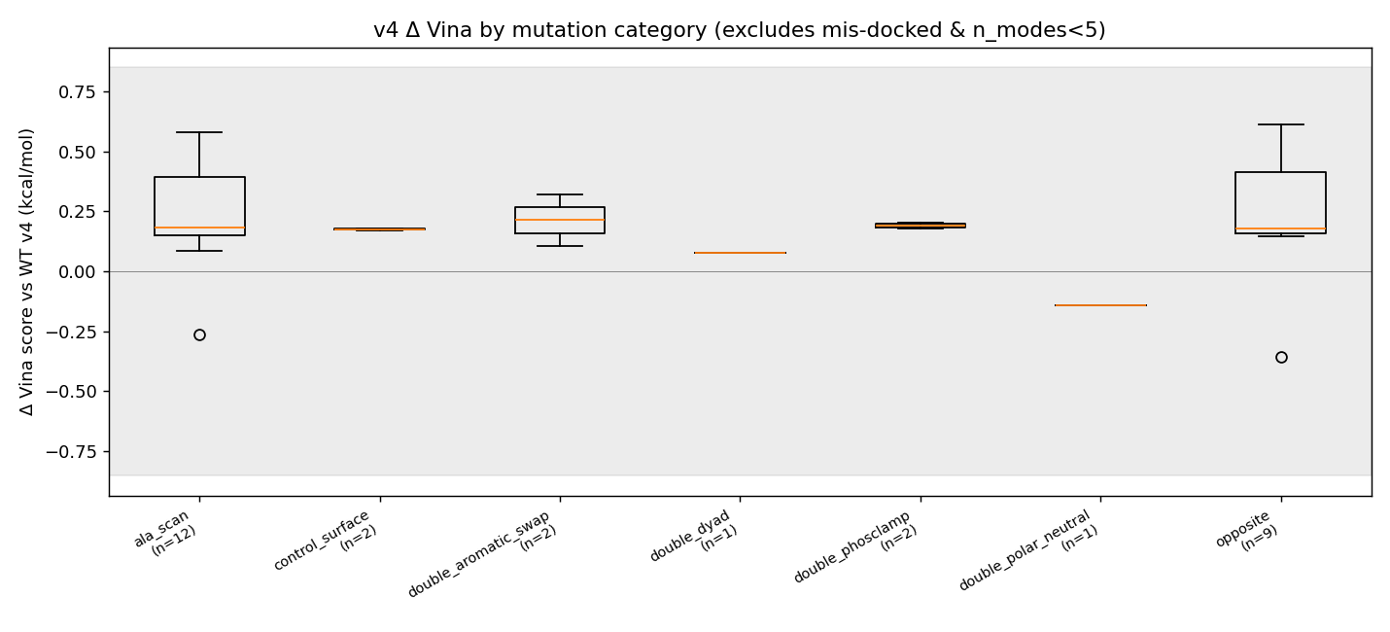
Figure 3 - v4 Delta Vina by category (excludes mis-docked and n_modes<5)

Limitations
- Vina noise floor is approximately +/-0.85 kcal/mol (Trott & Olson 2010; Forli et al. 2016). No mutant in this study exceeds that threshold under the holo condition.
- Vina is an empirical scoring function, not a free energy. Numbers reported are Delta Vina score, not Delta-Delta G of binding.
- Cofactor polyglutamylation: the cofactor in 1HVY is the antifolate raltitrexed (PDB ligand D16, mono-glutamate). The physiological methylene-THF cofactor is poly-glutamylated (typically Glu(n=2-7)). The cofactor pocket geometry, ionisation, and water network may differ in the polyglutamylated state. This pipeline does not model that.
- C195A holo Delta < 0 is biologically implausible - Cys195 is the catalytic nucleophile. Any negative Delta is attributed to docking artefact.
- Apo runs are dominated by mis-docking in the empty cofactor pocket; they serve as a negative control / contrast for the holo signal.
- Receptor and ligand are rigid. PyMOL Mutagenesis Wizard rotamers were sculpt-relaxed in v3 (carried over to v4 mutants) but not against a relaxed pocket.
- RMSD is computed against crystal dUMP heavy atoms only (no symmetry handling for ring atoms).

Methods - AD4/Vina united-atom convention (FIX J)
AutoDock 4 / Vina use a united-atom convention; non-polar hydrogens are merged into their parent heavy atoms, and polar hydrogens (HD type) carry zero partial charge with the H-bond contribution folded into the parent. The 1070 zero-charge atoms in the holo receptor PDBQT are therefore a feature of the AD4 model, not a charge-assignment failure. Maximum heavy-atom |q| in the v4 receptor is 0.507.

Reproducibility
Vina 1.2.7 (WT: exh=96, num_modes=32, box=22, seeds {42,7,13,99,256} primary; mutants: exh=32, num_modes=20, box=22, seed=42). Receptor: obabel_gasteiger, Gasteiger charges, max |q| = 0.507. Centroid (crystal dUMP, A): (-0.14, 4.23, 15.16). Cofactor: D16 ideal SDF from RCSB CCD; RDKit Reionizer; explicit -COOH -> COO-; AddHs(addCoords=True); Kabsch alignment to crystal coords.
All v4 outputs in 03d_structure_v4, 06d_docking_wt_v4, 07d_mut_docking_v4, 08d_analysis_v4, 09d_report_v4. v1, v2, v3 left untouched.

