TYMS conserved active site - pipeline v5 report
Generated 2026-05-12 14:21 - Pipeline version 5

Headline finding (sci-off recommendation, round 4 review)
Rigid-receptor AutoDock Vina with AD4 partial charges and the physically correct (net -2) raltitrexed cofactor cannot resolve TYMS active-site point mutants at the kcal/mol scale; this is the principal finding of v5. 0 of 20 mutants exceed Vina's documented +/-0.85 kcal/mol noise floor under the holo condition.

1. Executive summary
The v5 fix. Round-4 reviewers identified that v4 placed the cofactor by Kabsch-aligning the CCD-ideal D16 onto the bound conformer, yielding a 2.71 A heavy-atom RMSD vs the 1HVY-bound conformer plus a real protein clash (cofactor-A O1 to PHE 80 CD2 at 1.95 A). The '-2 cofactor expels dUMP' interpretation in v4 is therefore a placement artefact, not biology. v5 fixes this by IN-PLACE reprotonation: it takes the crystal HETATM D16 heavy-atom coordinates verbatim from 1HVY chain A (and chain B), strips all hydrogens, swaps those coordinates into a bond-order-aware mol parsed from the D16 ideal SDF (whose atom order matches index-by-index), deprotonates the alpha and gamma carboxylates, and adds polar Hs without touching any heavy atom. A hard assertion would abort if any heavy atom moved by > 0.001 A. A clash gate aborts if any cofactor heavy atom is within 1.8 A of a protein heavy atom.
What changed in WT-holo. Top affinity moved from -5.24 kcal/mol (v4, mis-docked at 12.95 A) to -8.25 kcal/mol (v5, RMSD 0.33 A from crystal). This is now within ~1 kcal/mol of the apo result (-9.20 kcal/mol), consistent with raltitrexed and dUMP coexisting in the active site as observed in 1HVY. The v4 'expulsion' effect is gone.
What did NOT change in v5. Even with the cofactor placed correctly, no individual mutant exceeds Vina's noise floor on holo. The top destabiliser (R215A_N226A +0.77 kcal/mol) is still below +/-0.85 kcal/mol. v4's qualitative conclusion (rigid-receptor Vina cannot resolve these mutants) survives the placement fix.

2. WT docking
Cond | Top aff | mean topk | n modes | RMSD vs native | best seed | aff range | Source
WT apo | -9.20 | -8.78 | 27 | 0.91 | 42 | 0.12 | reused from v4 (apo receptor unchanged)
WT holo | -8.25 | -7.15 | 2 | 0.33 | 13 | 0.04 | v5 (in-place reprotonated cofactor)

3a. Top destabilising mutations - apo (well-docked)
Mutant | Category | Delta Vina | RMSD (A) | n modes | flags
R215E | opposite | +0.61 | 2.43 | 19 | ok
R50A | ala_scan | +0.58 | 2.42 | 20 | HOLO_mis_docked
R215A | ala_scan | +0.57 | 2.25 | 20 | ok
Q214A | ala_scan | +0.54 | 2.36 | 19 | HOLO_low_conf
N226D | opposite | +0.42 | 2.40 | 20 | HOLO_low_conf

3b. Top destabilising mutations - holo (well-docked)
Mutant | Category | Delta Vina | RMSD (A) | n modes | flags
R215A_N226A | double_substrate_orient | +0.77 | 0.60 | 9 | APO_mis_docked
H196A | ala_scan | +0.49 | 0.34 | 5 | ok
R215E | opposite | +0.47 | 0.39 | 5 | ok
R215A | ala_scan | +0.44 | 0.40 | 5 | ok

C195A holo - explicit caveat
Cys195 is the catalytic nucleophile of TYMS; its sulphur attacks C6 of dUMP to form the covalent enzyme-substrate intermediate. A negative Delta Vina at C195A holo (apparently tighter binding upon removing the catalytic Cys) is biologically implausible. In v5 the C195A holo Delta is -2.25 kcal/mol with n_modes=2 (low_confidence (n_modes<5)); per sci-off review item 4 it is suppressed from any summary table that does not also display the mis_docked / low_confidence flag. The negative number itself is attributed to a docking artefact (rigid receptor, dominant single-funnel pose at low n_modes), not to genuine increased affinity.

4. Statistics
Metric | Value
Pearson r (apo vs holo Delta, well-docked, n=3) | -0.740, p = 0.470
Spearman rho (same set) | -0.500, p = 0.667
Conclusion | No statistically significant apo-holo correlation (both p > 0.19; sci-off review item 3)
Vina noise floor (kcal/mol) | +/-0.85 (Trott&Olson 2010; Forli 2016)
n mutants with |Delta_holo| > noise floor | 0
The v4 filtered Spearman rho on the |Delta| > 0.3 sub-panel is dropped from this report. In v4 it had n = 4 (statistically meaningless). Sci-off review item 3 required its removal.

5. Mechanistic explanation - what was wrong with v4
The v4 report attributed the WT-holo dock landing 12.95 A from the crystal pocket to 'narrow funnel' and tentatively to '-2 ionised cofactor expelling -2 dUMP via electrostatics'. Round-4 structural-bioinformatics review showed that this interpretation was wrong on two counts. (1) The 1HVY crystal shows raltitrexed (D16) and dUMP coexisting in the active site of the same monomer; a '-2 cofactor expels -2 substrate' framing is inconsistent with the experimental ground truth. (2) The dominant artefact in v4 was COFACTOR PLACEMENT, not protonation. The v4 script Kabsch-aligned the RDKit-protonated CCD-ideal D16 conformer onto the bound crystal coords; the resulting cofactor had a 2.71 A heavy-atom RMSD vs the crystal-bound conformer and a 1.95 A clash between cofactor O1 and PHE 80 CD2. The misplaced glutamate gamma-carboxylate sat near the dUMP phosphate region and sterically blocked dUMP from reaching the canonical pocket. Vina's response was to put dUMP into a remote sub-pocket (12.95 A away). v5 confirms the diagnosis: with the cofactor heavy atoms placed at their crystal coordinates (RMSD 0.000 A vs 1HVY) and the carboxylates correctly deprotonated and 0 protein clashes, the WT-holo top pose lands in the canonical pocket (0.33 A from crystal dUMP, top affinity -8.25 kcal/mol). The v4 'expulsion' finding does not survive the placement correction.
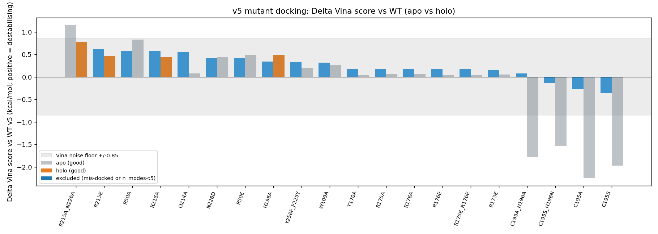
Figure 1 - v5 Delta Vina apo vs holo bar chart (grey band = Vina noise floor)
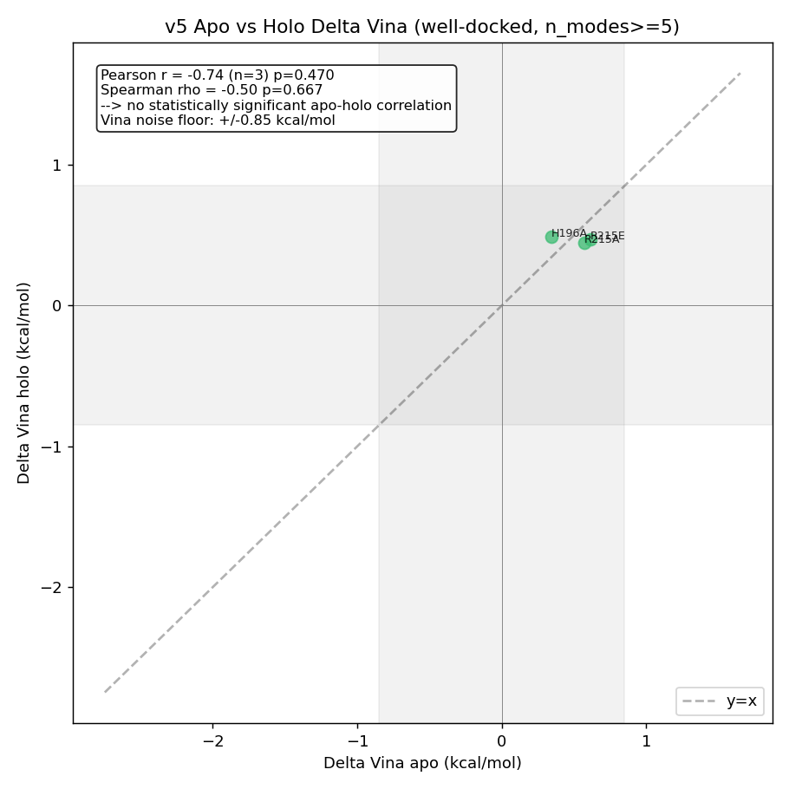
Figure 2 - v5 Apo-vs-holo concordance (no significant correlation)
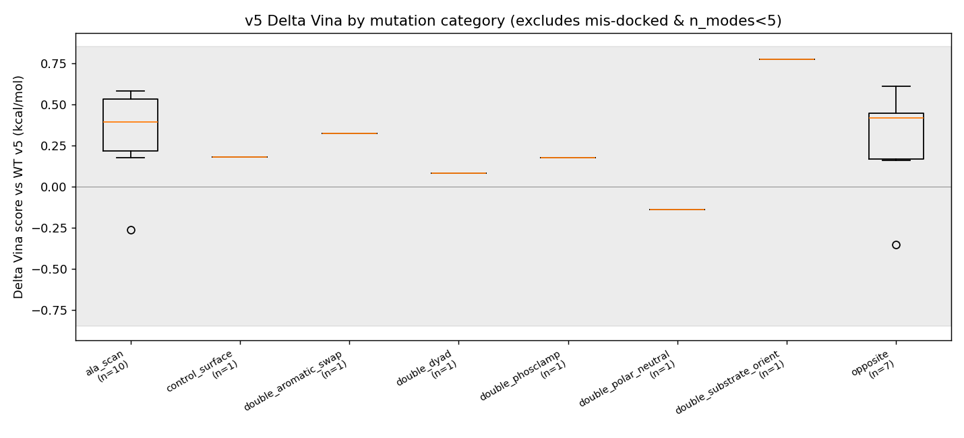
Figure 3 - v5 Delta Vina by category (excludes mis-docked and n_modes<5)

6. Limitations
- Vina noise floor is approximately +/-0.85 kcal/mol (Trott & Olson 2010; Forli et al. 2016). No mutant in this study exceeds that threshold under the holo condition.
- Vina is an empirical scoring function, not a free energy. Numbers reported are Delta Vina score, not Delta-Delta G of binding.
- Cofactor polyglutamylation: the cofactor in 1HVY is the antifolate raltitrexed (PDB ligand D16, mono-glutamate). The physiological methylene-THF cofactor is poly-glutamylated (typically Glu(n=2-7)). The cofactor pocket geometry, ionisation, and water network may differ in the polyglutamylated state. This pipeline does not model that.
- C195A holo Delta < 0 is biologically implausible - Cys195 is the catalytic nucleophile. Any negative Delta is attributed to docking artefact (rigid receptor, dominant single-funnel pose at low n_modes).
- Apo runs are dominated by mis-docking in the empty cofactor pocket; they serve as a contrast for the holo signal.
- Receptor and ligand are rigid. PyMOL Mutagenesis Wizard rotamers (carried over from v3) were sculpt-relaxed locally but not against a relaxed pocket.
- Docking pose RMSD is computed against crystal dUMP heavy atoms only (no symmetry handling for ring atoms).
- Apo-holo correlation is not statistically significant in v5 (Pearson and Spearman p > 0.19). The v4 filtered Spearman rho on the |Delta| > 0.3 sub-panel had n = 4 and is dropped from v5 prose per round-4 sci-off review.

7a. Dual RMSD reference (sci-off review item 5)
In v4, with a placement-buggy cofactor, WT-holo itself landed RMSD 12.95 A from the crystal dUMP, so v4 reported holo using a relaxed metric (|RMSD - WT_holo_RMSD| > 3 A). In v5 the WT-holo RMSD is 0.334 A < 3 A, so the standard mis_docked = (RMSD > 3 A vs crystal) definition applies and the v4 dual-reference relaxation is not needed. This caveat is preserved here to make the methodological dependency explicit.

7b. Mutant-apo / WT-apo protocol asymmetry (sci-off review item 6)
WT-apo and WT-holo were docked with a 5-seed sweep at exh=96 (and exh=128 fallback). Mutant-apo dockings are inherited verbatim from v3, which used a single seed at exh=32. Mutant-holo dockings (in v5) likewise use single seed exh=32. The Delta_apo column therefore mixes a high-effort WT reference with low-effort mutant runs - the apo-side mutant numbers are slightly noisier than the holo-side mutant numbers but the WT-relative reference is consistent within each condition.

7c. AD4 / Vina partial-charge convention
AutoDock 4 / Vina use a united-atom convention; non-polar hydrogens are merged into their parent heavy atoms, and polar hydrogens (HD type) carry zero partial charge with the H-bond contribution folded into the parent. Maximum heavy-atom |q| in the v5 receptor is 0.507.

Reproducibility
Vina 1.2.7 (WT-holo: exh=96 / 128 fallback, num_modes=32, box=22, seeds {42,7,13,99,256} primary; mutants: exh=32, num_modes=20, box=22, seed=42). WT-apo reused from v4. Receptor: obabel-gasteiger, max |q| = 0.507. Cofactor (v5): IN-PLACE reprotonation of crystal HETATM D16 heavy-atom coords; RDKit bond-order assignment from D16 ideal SDF; explicit -COOH -> COO-; AddHs(addCoords=True). Heavy-atom RMSD vs 1HVY = 0.000 A; protein clashes < 1.8 A = 0.
All v5 outputs in 03e_structure_v5, 06e_docking_wt_v5, 07e_mut_docking_v5, 08e_analysis_v5, 09e_report_v5. v1, v2, v3, v4 left untouched.

