Computer Vision Brain Tumor Analysis
Academic Computer Vision Project
Vasileios Troupis

1. Objective
The objective of this academic project is to apply classical computer vision and image-processing techniques to a provided brain image and isolate three target tumor regions. The workflow includes grayscale conversion, thresholding, connected-component labeling, region-area measurement, morphological processing and boundary extraction. The project is intended as an educational image-processing exercise and not as a medical diagnostic system.

2. Input Image and Preprocessing
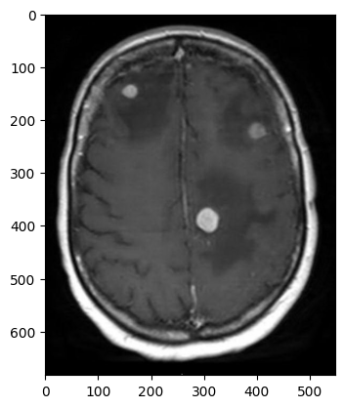
Figure 1. Original brain image used as input.
The RGB image is converted to grayscale so that subsequent processing can operate on a single intensity channel. Two thresholding approaches are then evaluated: manual thresholding and Otsu's automatic thresholding method.

3. Initial Thresholding
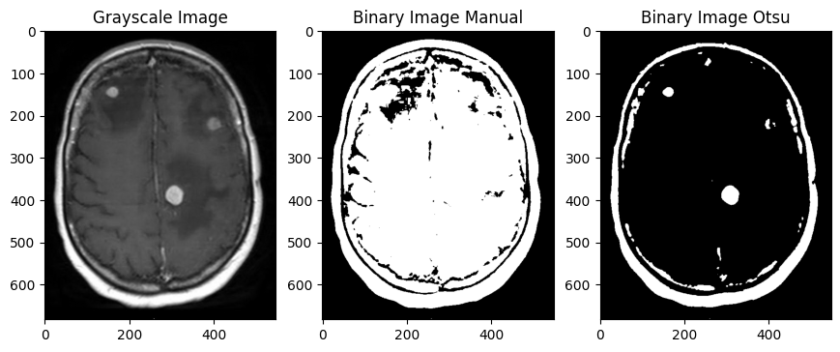
Figure 2. First manual threshold test (50) compared with Otsu thresholding.
A manual threshold value of 50 does not separate the regions of interest clearly enough, so a second manual threshold value is evaluated.

4. Threshold Selection
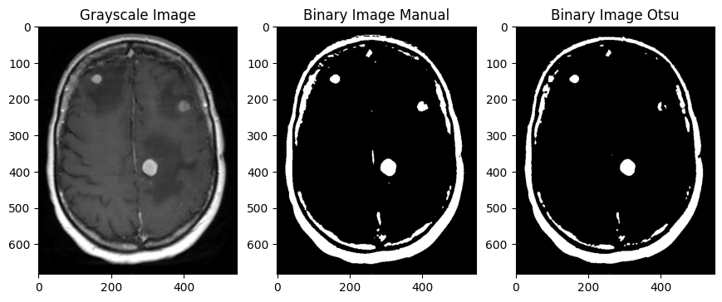
Figure 3. Manual threshold 100 compared with Otsu thresholding.
For this specific image, a manual threshold of 100 provides a clearer visual separation of the three target regions than the Otsu result, particularly for the smaller region on the right side of the image. The manually thresholded image is therefore used in the following processing steps.

5. Connected-Component Labeling
Connected-component labeling with connectivity = 1 assigns a unique label to each separate foreground region in the binary image. By inspecting the labeled components, the three labels corresponding to the target tumor regions can be selected and combined into a single binary mask.
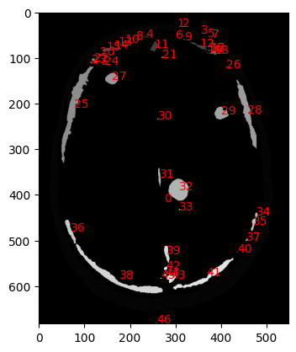
Figure 4. Connected components and their assigned labels.

6. Tumor Region Isolation and Area Measurement
The three selected connected components are combined into a single binary mask. The components are then labeled again so that the area of each detected region can be calculated in pixels.
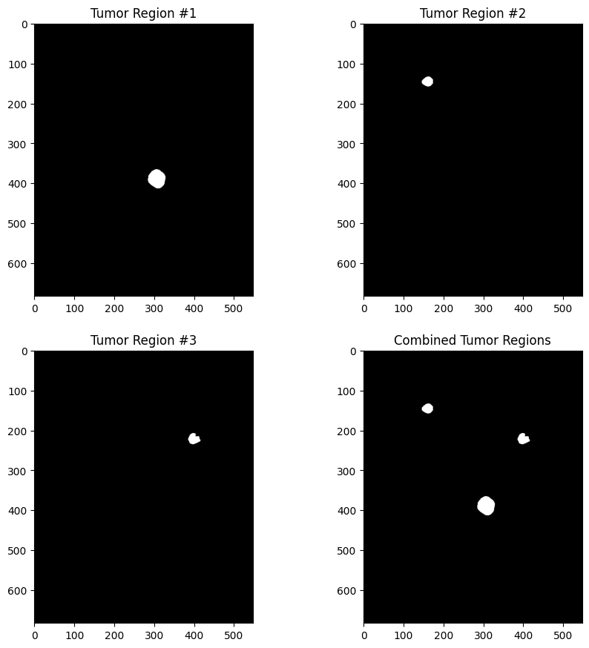 | 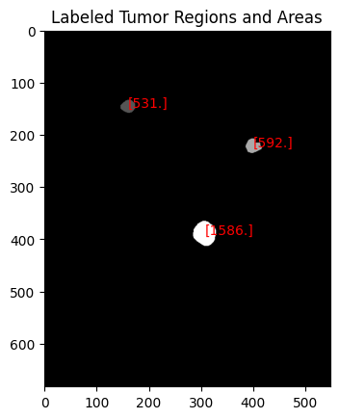
Figure 5. Individual and combined tumor regions. | Figure 6. Labeled regions and measured areas.

The measured region areas are 531, 592 and 1586 pixels respectively. The first two regions have similar areas, while the third region is substantially larger.

7. Structuring Element and Boundary Extraction
A diamond-shaped structuring element is used for morphological processing. Dilation expands the binary regions. Subtracting the original mask from the dilated mask gives an approximation of the outer boundary, while erosion is used when deriving the inner boundary.
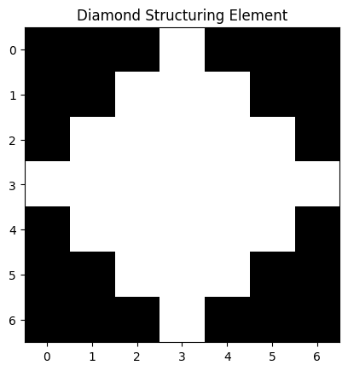 | 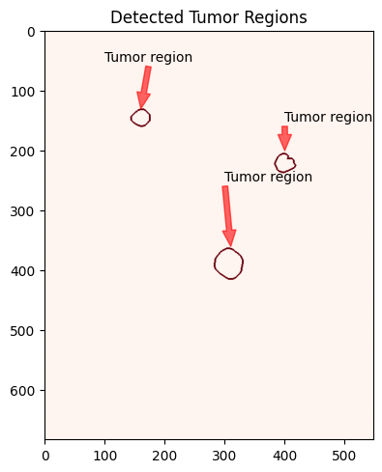
Figure 7a. Diamond structuring element. | Figure 7b. Detected outer boundaries.

8. Morphological Operations
The final stage compares dilation, erosion, opening and closing. Opening is erosion followed by dilation, whereas closing is dilation followed by erosion. The inner and outer boundaries are also extracted for visual comparison.
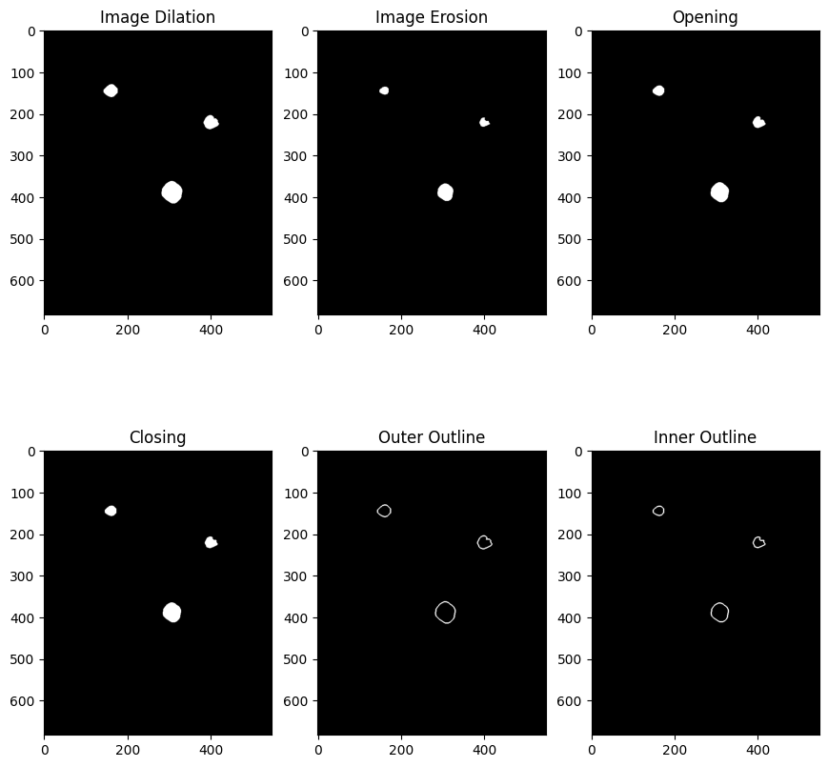
Figure 8. Dilation, erosion, opening, closing, outer outline and inner outline.

9. Final Visualization and Conclusion
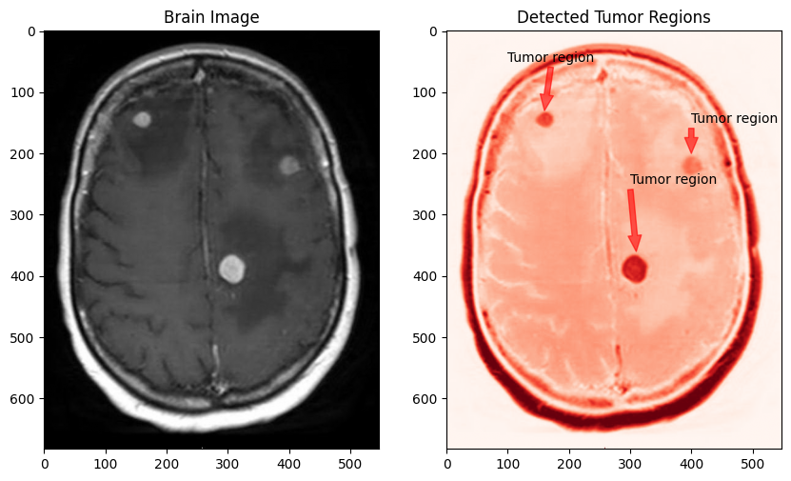
Figure 9. Original brain image and visualization of the three target tumor regions.
The project demonstrates a classical image-processing pipeline for isolating predefined regions of interest from a brain image. Manual thresholding, connected-component analysis and morphological operations are combined to identify, measure and visualize the three target regions.
Educational disclaimer: This project is for educational and computer vision demonstration purposes only. It is not a medical diagnostic system and must not be used for clinical diagnosis or medical decision-making.

