DengFeng Qiao Yi He MingYi Wang

CREATE DATABASE universityHR;

CREATE TABLE STAFF (

staffId SERIAL PRIMARY KEY,

staffName VARCHAR(100) NOT NULL,

staffDOB DATE NOT NULL,

staffFaculty INT

);

CREATE TABLE FACULTY (

facultyId SERIAL PRIMARY KEY,

facultyName VARCHAR(100) NOT NULL,

NoOfStaff INT

);

INSERT INTO FACULTY (facultyName, NoOfStaff)

VALUES ('Engineering', 50),

('Science', 30),

('Arts', 20);

INSERT INTO STAFF (staffName, staffDOB, staffFaculty)

VALUES ('John Doe', '1985-10-15', 1),

('Alison Green', '1982-04-23', 2),

('Kieran West', '1978-09-10', 3);

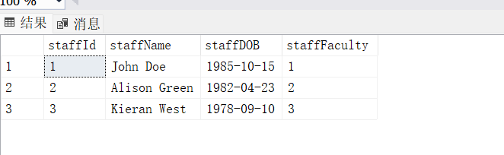

SELECT facultyName FROM FACULTY WHERE NoOfStaff < 75;

SELECT \* FROM STAFF WHERE staffDOB BETWEEN '1980-01-01' AND '1989-12-31';

SELECT staffId AS ID, staffName AS Name, staffDOB AS DOB, staffFaculty AS Faculty

FROM STAFF

ORDER BY staffName DESC;

UPDATE STAFF SET staffFaculty = 1 WHERE staffName = 'Alison Green';

DELETE FROM STAFF WHERE staffName = 'Kieran West';

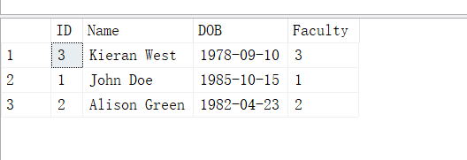

SELECT 28964 \* 1.185 AS Result;

SELECT DISTINCT productType FROM PRODUCT;

SELECT DISTINCT productName FROM PRODUCT WHERE productType = 'Loan';

SELECT \* FROM EMPLOYEE WHERE firstName LIKE 'S%';

SELECT \* FROM EMPLOYEE

WHERE (firstName LIKE 'S%' OR firstName LIKE 'T%')

AND department = 'Operations';

CREATE TABLE CUSTOMER (

custID INT PRIMARY KEY IDENTITY(1,1),

firstName NVARCHAR(100),

lastName NVARCHAR(100),

DOB DATE

);

CREATE TABLE ACCOUNT (

accountID INT PRIMARY KEY IDENTITY(1,1),

custID INT FOREIGN KEY REFERENCES CUSTOMER(custID),

productCode NVARCHAR(10),

availableBalance DECIMAL(18, 2),

pendingBalance DECIMAL(18, 2)

);

